Pregunta 1:

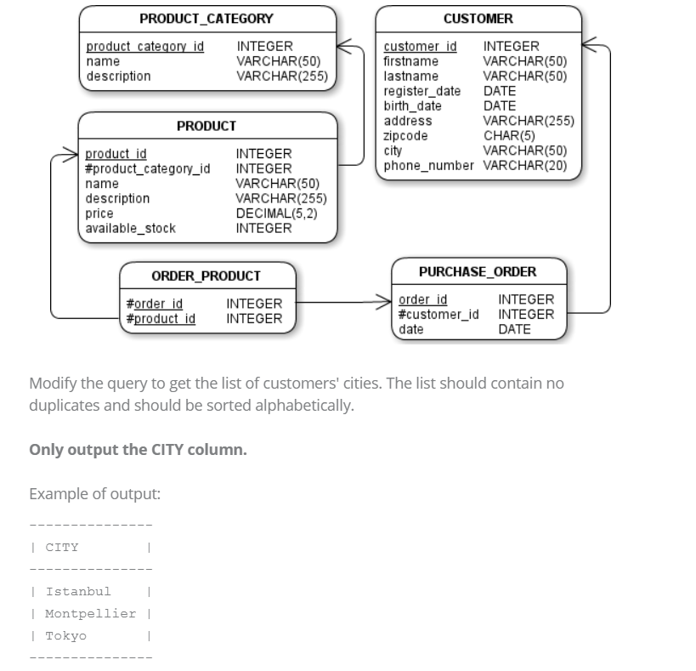

Solución:

SELECT distinct city

FROM customer

order by city;

Pregunta 3:

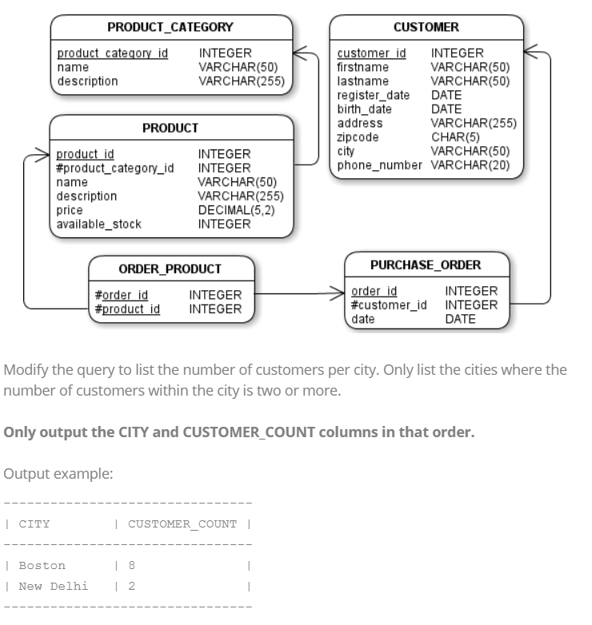

Solución:

SELECT city, count(*) CUSTOMER_COUNT

FROM customer

group by city

having count(*)>=2

Pregunta 4:

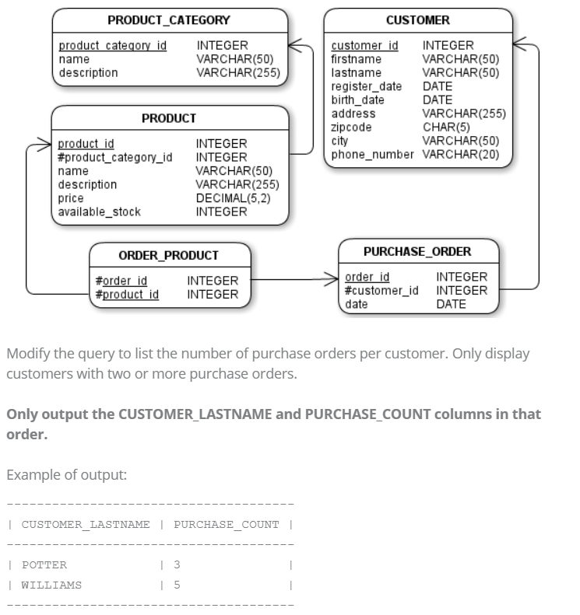

Solución:

SELECT c.lastname CUSTOMER_LASTNAME, count(*) PURCHASE_COUNT

FROM customer c join purchase_order po on c.customer_id=po.customer_id

group by c.customer_id

having count(*)>=2

Pregunta 5

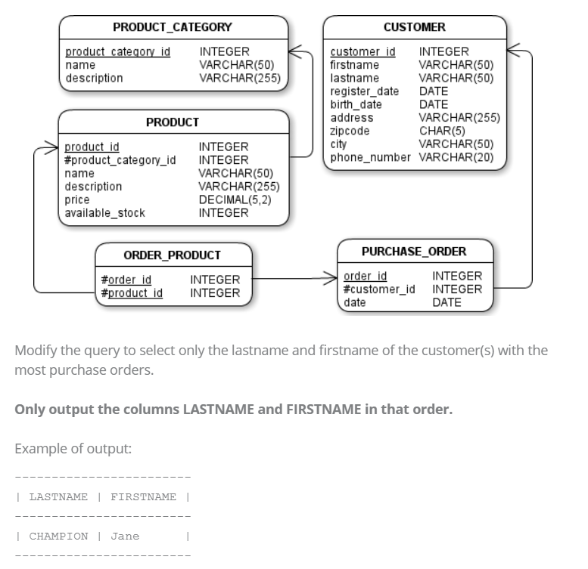

Solución:

SELECT lastname LASTNAME, firstname FIRSTNAME

FROM customer c

where (

    select count(*)

    from purchase_order

    where customer_id=c.customer_id

)>=all(

    select count(*)

    from purchase_order

    group by customer_id

)

Pregunta 6

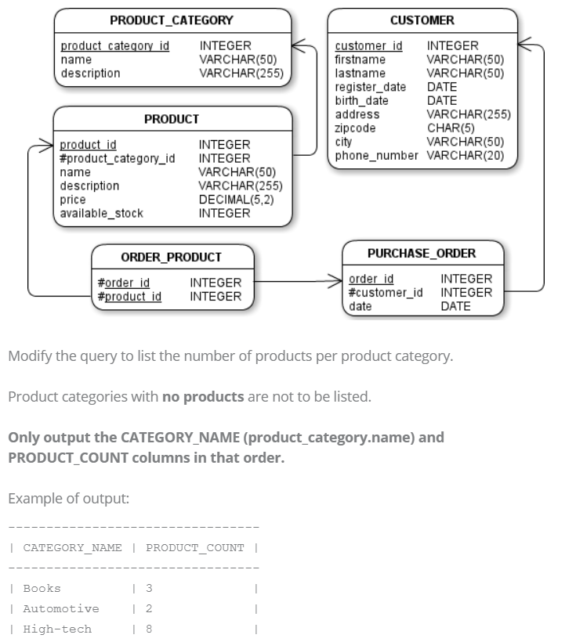

Solución:

SELECT pc.name CATEGORY_NAME, count(*) PRODUCT_COUNT

FROM product p inner join product_category pc

on p.product_category_id=pc.product_category_id

group by p.product_category_id;

Pregunta 7:

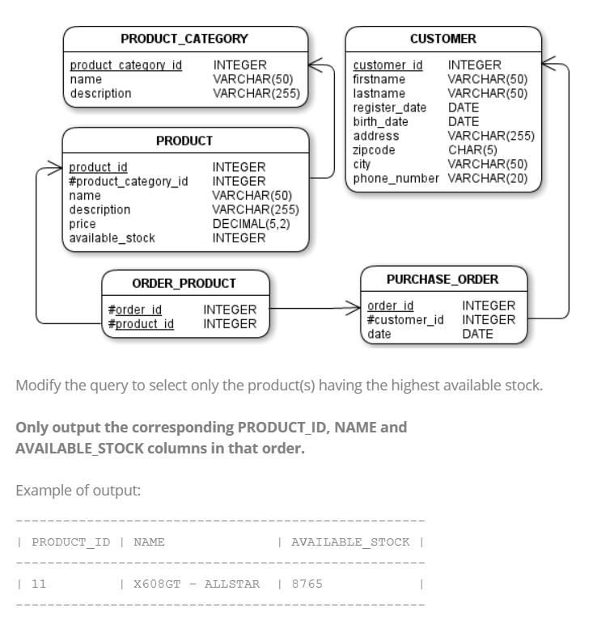

Solución:

SELECT product_id PRODUCT_ID, name NAME, available_stock AVAILABLE_STOCK

FROM product

where AVAILABLE_STOCK>=ALL(

    select distinct available_stock

    from product

)

Pregunta 10:

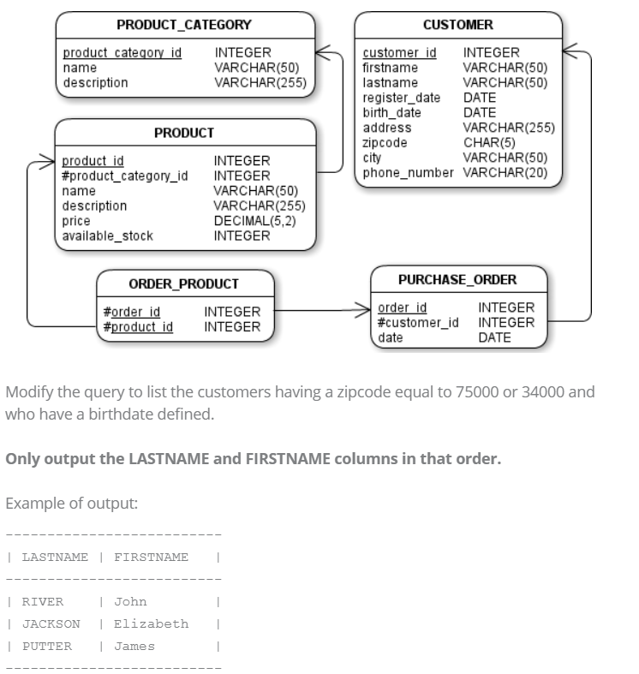

Solución:

SELECT lastname LASTNAME, firstname FIRSTNAME

FROM customer

where zipcode in ('75000','34000') and birth_date is not null