Generic Blank Game Design Document (GDD)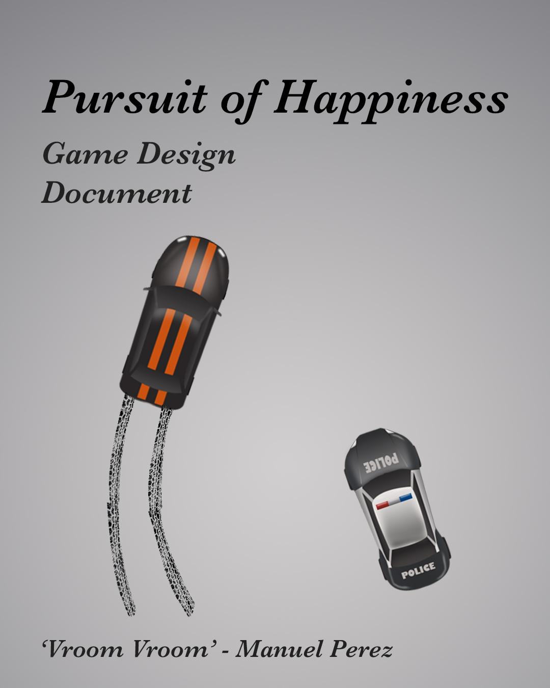

Your Game Logo

Here

***‘This game will rock your world!’*** - Manuel Perez

|  |  |
| --- | --- |
| Table of Contents  [1 Game Overview](https://n-xovwktmtjsnaxyc2mwes2xu7pohqedmdm6zjw5q-2lu-script.googleusercontent.com/userCodeAppPanel%23)  [2 High Concept](https://n-xovwktmtjsnaxyc2mwes2xu7pohqedmdm6zjw5q-2lu-script.googleusercontent.com/userCodeAppPanel%23)  [3 Unique Selling Points](https://n-xovwktmtjsnaxyc2mwes2xu7pohqedmdm6zjw5q-2lu-script.googleusercontent.com/userCodeAppPanel%23)  [4 Platform Minimum Requirements](https://n-xovwktmtjsnaxyc2mwes2xu7pohqedmdm6zjw5q-2lu-script.googleusercontent.com/userCodeAppPanel%23)  [5 Competitors / Similar Titles](https://n-xovwktmtjsnaxyc2mwes2xu7pohqedmdm6zjw5q-2lu-script.googleusercontent.com/userCodeAppPanel%23)  [6 Synopsis](https://n-xovwktmtjsnaxyc2mwes2xu7pohqedmdm6zjw5q-2lu-script.googleusercontent.com/userCodeAppPanel%23)  [7 Game Objectives](https://n-xovwktmtjsnaxyc2mwes2xu7pohqedmdm6zjw5q-2lu-script.googleusercontent.com/userCodeAppPanel%23)  [8 Game Rules](https://n-xovwktmtjsnaxyc2mwes2xu7pohqedmdm6zjw5q-2lu-script.googleusercontent.com/userCodeAppPanel%23)  [9 Game Structure](https://n-xovwktmtjsnaxyc2mwes2xu7pohqedmdm6zjw5q-2lu-script.googleusercontent.com/userCodeAppPanel%23)  [10 Game Play](https://n-xovwktmtjsnaxyc2mwes2xu7pohqedmdm6zjw5q-2lu-script.googleusercontent.com/userCodeAppPanel%23)  [10.1 Game Controls](https://n-xovwktmtjsnaxyc2mwes2xu7pohqedmdm6zjw5q-2lu-script.googleusercontent.com/userCodeAppPanel%23)  [10.2 Game Camera](https://n-xovwktmtjsnaxyc2mwes2xu7pohqedmdm6zjw5q-2lu-script.googleusercontent.com/userCodeAppPanel%23)  [10.2.1 HUD](https://n-xovwktmtjsnaxyc2mwes2xu7pohqedmdm6zjw5q-2lu-script.googleusercontent.com/userCodeAppPanel%23)  [10.2.2 Maps](https://n-xovwktmtjsnaxyc2mwes2xu7pohqedmdm6zjw5q-2lu-script.googleusercontent.com/userCodeAppPanel%23)  [11 Players](https://n-xovwktmtjsnaxyc2mwes2xu7pohqedmdm6zjw5q-2lu-script.googleusercontent.com/userCodeAppPanel%23)  [11.1 Characters](https://n-xovwktmtjsnaxyc2mwes2xu7pohqedmdm6zjw5q-2lu-script.googleusercontent.com/userCodeAppPanel%23)  [11.2 Metrics](https://n-xovwktmtjsnaxyc2mwes2xu7pohqedmdm6zjw5q-2lu-script.googleusercontent.com/userCodeAppPanel%23)  [11.3 States](https://n-xovwktmtjsnaxyc2mwes2xu7pohqedmdm6zjw5q-2lu-script.googleusercontent.com/userCodeAppPanel%23)  [11.4 Weapons](https://n-xovwktmtjsnaxyc2mwes2xu7pohqedmdm6zjw5q-2lu-script.googleusercontent.com/userCodeAppPanel%23)  [12 Player Line-up](https://n-xovwktmtjsnaxyc2mwes2xu7pohqedmdm6zjw5q-2lu-script.googleusercontent.com/userCodeAppPanel%23)  [13 NPC](https://n-xovwktmtjsnaxyc2mwes2xu7pohqedmdm6zjw5q-2lu-script.googleusercontent.com/userCodeAppPanel%23)  [13.1 Enemies](https://n-xovwktmtjsnaxyc2mwes2xu7pohqedmdm6zjw5q-2lu-script.googleusercontent.com/userCodeAppPanel%23)  [13.1.1 Enemy States](https://n-xovwktmtjsnaxyc2mwes2xu7pohqedmdm6zjw5q-2lu-script.googleusercontent.com/userCodeAppPanel%23)  [13.1.2 Enemy Spawn Points](https://n-xovwktmtjsnaxyc2mwes2xu7pohqedmdm6zjw5q-2lu-script.googleusercontent.com/userCodeAppPanel%23)  [13.2 Allies / Companions](https://n-xovwktmtjsnaxyc2mwes2xu7pohqedmdm6zjw5q-2lu-script.googleusercontent.com/userCodeAppPanel%23)  [13.2.1 Ally States](https://n-xovwktmtjsnaxyc2mwes2xu7pohqedmdm6zjw5q-2lu-script.googleusercontent.com/userCodeAppPanel%23)  [13.2.2 Ally Spawn Points](https://n-xovwktmtjsnaxyc2mwes2xu7pohqedmdm6zjw5q-2lu-script.googleusercontent.com/userCodeAppPanel%23)  [14 Art](https://n-xovwktmtjsnaxyc2mwes2xu7pohqedmdm6zjw5q-2lu-script.googleusercontent.com/userCodeAppPanel%23)  [14.1 Setting](https://n-xovwktmtjsnaxyc2mwes2xu7pohqedmdm6zjw5q-2lu-script.googleusercontent.com/userCodeAppPanel%23)  [14.2 Level Design](https://n-xovwktmtjsnaxyc2mwes2xu7pohqedmdm6zjw5q-2lu-script.googleusercontent.com/userCodeAppPanel%23)  [14.3 Audio](https://n-xovwktmtjsnaxyc2mwes2xu7pohqedmdm6zjw5q-2lu-script.googleusercontent.com/userCodeAppPanel%23)  15 Genre  16 Minimum Viable Product (MPV)  [17 Wish List](https://n-xovwktmtjsnaxyc2mwes2xu7pohqedmdm6zjw5q-2lu-script.googleusercontent.com/userCodeAppPanel%23)  [18 Bibliography](https://n-xovwktmtjsnaxyc2mwes2xu7pohqedmdm6zjw5q-2lu-script.googleusercontent.com/userCodeAppPanel%23) | Game Development Team Members    PRODUCER  Manuel Perez    PRODUCTION MANAGER  Manuel Perez    PRODUCTION COORDINATOR  Manuel Perez  GAME DESIGNERS  Manuel Perez  SYSTEMS/IT COORDINATOR  Manuel Perez  PROGRAMMERS  Manuel Perez  TECHNICAL ARTISTS  Manuel Perez  AUDIO ENGINEERS  Manuel Perez  UX TESTERS  Manuel Perez |

|  |
| --- |
|  |

# 1 Game Overview

Title: Pursuit of Happiness

Platform: MacOS

Genre: Endless racing game

Rating: (7+) ESRB

Target: Casual gamer (aging from 7 - 30)

Release date: Nov, 2019

Publisher: Manuel's Games

Pursuit of Happiness is an endless racing game where you, an escapee from a nearby jail, manages to obtain a fast car in hopes to escape his destiny of rotting in prison. As you begin to drive, you have to maneuver through incoming cars as obstacles to avoid getting caught by the police. The farther you get without crashing into any obstacle the more points you accrue. However, as time passes, your car begins to speed up, so it becomes harder to escape.

# 2 High Concept

Pursuit of Happiness sets you as an escapee from a nearby jail where you have to run away from the police who is trying to catch you in a high speed chase.

# 3 Unique Selling Points

* Amazing music
* Fun gameplay
* Cool crashing effect

# 4 Platform Minimum Requirements

MAC

OS: Mac OS X 10.8+

Graphics card: Intel HD Graphics 4000

# 5 Competitors / Similar Titles

N/A

# 6 Synopsis

In an attempt to regain your freedom, you decide to escape prison, and travel far away as possible in a high speed chase with the police. There is no other option besides freedom!

# 7 Game Objectives

The objective is to survive as long as possible without crashing into any obstacle.

# 8 Game Rules

This game level is an endless road where you are being pursued by police while trying to avoid crashing into incoming cars. The car always begins in the same position, and has a constant sideway speed. The speed of the incoming obstacles speeds up as time progresses.

# 9 Game Structure

Menu to Game back to Menu

to Instructions back to Menu

to Credits back to Menu

to Quit Game

# 10 Game Play

10.1 Game Controls

move right

move right



move left

move left

## 10.2 Game Camera

The camera never shifts anywhere, it remains completely still and follows the Player as they maneuver through the incoming obstacles.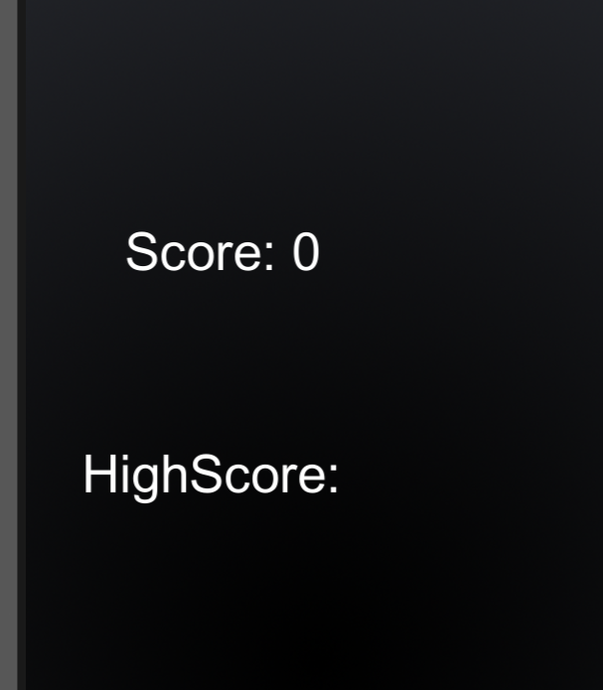

### 10.2.1 HUD

The game contains only a sidebar as a HUD displaying the Player’s current score, and after they’ve crashed, their own High Score.

# 11 Players

## 11.1 Characters

The main character drives a very fast Black Viper.

You never get to see the main character in this version

of the game.

## 11.2 Metrics

Max Health: N/A

Attack Damage: N/A

## 11.3 States

Move: Player moves the character. It can only move left to right with some parameters in place.

Death: The death animation happens in slow motion and the way it moves as it unfolds depends on where the Black Viper was hit as well as how hard/fast the impact of the collision was.

## 11.4 Weapons

There is no weapons in this game.

# 12 Player Line-up

# 13 NPC

## 13.1 Enemies

### 13.1.1 Enemy States

Move: These cars drive down vertically across the road. They do not switch lanes at any point.

Death: If they do not hit the player, they simply cease to exist after crossing the road completely. If they do collide with the player, the death animation is also in slow motion.

### 13.1.2 Enemy Spawn Points

Cars spawn all across the road and don’t obey road laws. These enemies can be considered simply as obstacles, as they are supposed to be regular cars with regular people trying to get to places.

## 13.2 Allies / Companions

### 13.2.1 Ally States

This game does not contain allies.

# 14 Art

## 14.1 Setting

This game takes place in a highway as regular people are driving to get to the places they need to go to, and the player tries to bypass them without crashing.

## 14.2 Level Design

The intended design of this level is for cars to spawn at any part of the top of the road and drive down along the road, meanwhile our player is at the bottom of the road trying to bypass all the incoming cars.

## 14.3 Audio

| **Name** | **Category** | **Description** |
| --- | --- | --- |
| 50 Cent - In Da Club | Background music | Plays during the game. |

## 15 Genre

Pursuit of Happiness is a pure survival game, with a top down racing aspect that makes it a fun experience. The only goal in this game is to see how far you can go without crashing, so it doesn’t delve into any other genre which I believe makes it purely survival.

## 16 Minimum Viable Product (MPV)

* One player character to choose from (Black Viper).
* Built for the MAC platform

# 17 Wish List

* More characters to choose from for the player.
* More sounds throughout the game to make the overall experience better.
* Rolling credits.
* More complex obstacles.

## 18 Bibliography

Car art: sujit1717 - Free Top Down Car Sprites by Unlucky Studio <https://opengameart.org/content/free-top-down-car-sprites-by-unlucky-studio>

BG Song: 50 Cent - In Da Club <https://www.youtube.com/watch?v=R4PT3eftYwQ>

Youtube tutorials:

* Charger Games - Unity Racing Game Development Tutorial For Beginners-Create A Complete 2D Game With Unity(Windows & Android) <https://www.youtube.com/playlist?list=PLytjVIyAOStpcOGg6HIHhnnOZAdxkAr1U>
* Brackeys - How to make a Dodge The Blocks game (Livestream) - Unity Tutorial <https://www.youtube.com/watch?v=tyAutnOlsfA>