TP STI2D SIN
Alban
FRANÇOIS
STI2D2 Groupe A

Question 1. Il ne se passe rien.
Question 2. Il faut écrire un programme.
Question 3.

void setup()
{
pinMode(GPIO18,OUTPUT);
}

void loop()
{
digitalWrite(GPIO18,HIGH)
delay(500)
digitalWrite(GPIO18,LOW)
delay(500)
}

7 Démarche
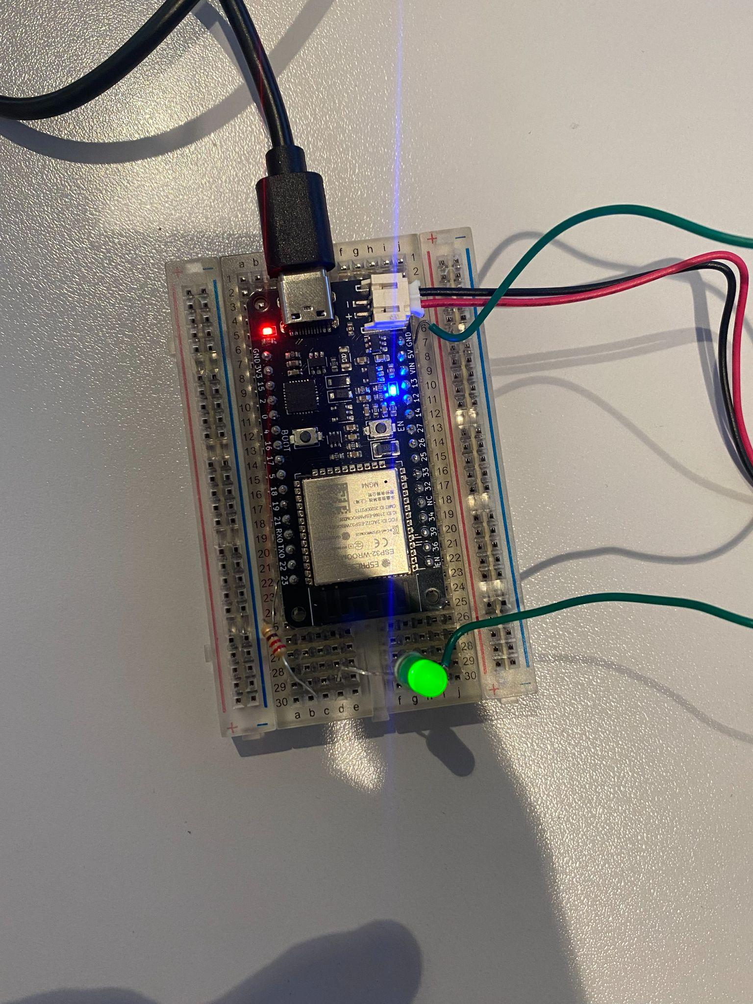
Photo du montage
https://mail-attachment.googleusercontent.com/attachment/u/0/?ui=2&ik=8c70edae45&attid=0.2&permmsgid=msg-a:r-7014464109650105569&th=1a0f13a79391a10c&view=att&zw&disp=safe&saddbat=ANGjdJ_WTMkPG6vUybY4hUKPNWW_ulBq3whqBy5Wb0vHB5hGq_0xE2A7C1QuDcA6erlnNgWScymQQvdgfgTWNDUYX6NnI-qgjOb278bUQQwPIYjbO8pNv1aKmiTW4fCk4EgkUNPllhXGhohw9goBfgu5M3AF0a4jasNHmDwbC-2A6BSYe_Ocb3lhOib280POyT3vpih9TFjN7F8MGHMtRNGPgHRqoVUgdpYD6QRd2WXYW2ifIscHLkEXAHnavjkBRRdOYnZlprFfnyvDor7bLdet1cASQDGiCMdXmKuvfC1bsNILI9bW-j0ZD8eScKvyslVG0gcRD6Sk1Y7GRQjfsP61G_B32CWS7_V8bluKQ_Mbh9WXLq30kVp9TrpgsbuGuEE2F9yougw-0G43QZWdoUgUusTEPkCv3ALqIbWmY6u4ebmop9Je0oJrlSuXEevK5dkAUbPUh4ogij9mR2C9QyrvPQBxCcrb_dQraLciWfUf_ZE8IrN9ac0TVOOVw-rYLgVFxCRYa77Dnjel7UgadRD7vrjHh6KJJIAD7CTdbOQHn5UL_fIwJ6amL0evZWDBa6f4MEhIBM7x4sy1pCnprPgfBJqDGJiFfOnQguME9RYbAakenuZtJuAbCMArmtzXBOTrI6tpMYbuUxkZAIx3W9Q5Roe3deRDeS3cv0rUBLszUmCzVf_jCTKElSz2dkC2RD8OoDMExtRhN5XgVGf468FS1jYus2wq_7b44OQwVa3-aP-S2iqQkleKGmQpjm48e_7JrTdZYkwPgoJrCeXP5Q7WcXdUFYCf80z4D_22GBYsktyDPcJFtm9s6nkvS5zc9iJh2fRz8d--JgvFFlBflPI7dgd3QDlUfgZh1aLMrl0fMwicB_2NzLmt6ZPZBJtnaMrWGmetdnKgvH_Drm9UAPMMRmU9nEE4h44O1et5HFF_P2tTWoy_-rblNizKZIMywMSBzBGi5PkJNhr38ctcJ6YXryyvcN8lJwzARk7L-wmuoGJmDp9Eeik4Pkkn07fpfZ8kQlBarZx691VvvpNU2zEZ7QEUaT394JFtEnF8wA

3. https://drive.usercontent.google.com/download?id=1ndtWRR-gmVcXA6lpNDwNOVz00Ncbn2NG&export=download&authuser=0

4. https://drive.usercontent.google.com/download?id=1d72x1nkU7DRu5ZBKe6PU-VOj_xp0fdtw&export=download&authuser=0

5. il ne se passe rien de spéciale le la led clignote toujours donc si on inverse LOW et HIGH il ne se passe rien

