Part 1: Describe your project

- Describe your project and explain how it should work, what purpose it will serve
The idea is to create a platform where big farmers could manage the geospatial information from their fields and the actions taken on them. The user will be able to register a field ID and create or upload any number of polygons related to this field from a web interface. This polygons could have a classification or type like boundary polygon or action polygon, some notes and a date related to them.

- Why did you choose to do this project? (Is it something you’re passionate about? Is it something you’re curious about? Is there an element that will challenge you? Are you solving a problem? Are you doing it for a friend/family/client? Are you trying to make an existing product better?)
I’m really interested in Geographic Information Systems or GIS. I’m currently working on a company where I use a lot of this info, but there is always very difficult for clients to share and view their maps or polygons. So I think this system could improve the communication we currently have with our clients.

Part 2: Strategy

- Identify who the target audience/users will be. Will it be Business to Business users or Business to Customers?
This will be mostly for Business, because they usually have more fields to manage, so this tool will have more sense to them than a small farmer that only have 2 or 3 fields. But it’s no closed to them either.

- Come up with questions for your users. You can ask family or friends to answer the questions, or write down answers for yourself.
Which person of your company will be interested in using something like this?
How many different fields are tracked by your company?
Does someone on your team has experience with GIS software?
If so, what software have you used before?
Are you currently using some other solution to store the geospatial data of your fields?
Which kind of files do you use? KML? Shapefile? another one?
Do you need to keep track of the actions taken in the field?

- Define your goals with this project.
Build a JSON API capable of store and retrieve geospatial information.
Build a frontend capable of create, show and edit geospatial information.
Build a frontend capable of show the list of fields related to a user.
Read and create a polygon from a file shared by a user.

- Make a list of all of the features and opportunities that you can think of for your project (this is brainstorming, so don’t limit yourself to things you think you can or cannot do at this point)
Create a user
Log in as a user
Log in as an administrator
Create polygons on a map
Create points in the map with specific information
The user could create notes related to polygons or points
Classify polygons by type
Create relationships between polygons. Ex. A big field could have some smaller fields inside.
Each field should have at least one base polygon and you could add polygons on top of that
The user could see a list of all their fields and edit its information
The user could see all his fields in a map.
The user could filter the list of fields based on the area shown in the map.
The user could filter the fields he sees in the map
The user could edit the polygons created
The user could see the total area of the polygon he is creating
The user could delete a polygon
The user could delete a field
The user could upload a KML file and create a polygon based on this file
The user could download the polygons he has created.
The administrator could see every field created and its polygons

- Come up with a “budget” in terms of time and effort for your project and come up with a number that will represent your resources (time to work, time to research, time for debugging, time for finishing touches to make it presentable).
I’m expecting to spend at least 24 hours working on this project, so I’ll be distributing 24 points between my releases.

- Take the list of opportunities/features and rate them in each category of 1. Importance and 2. Feasibility. Rate at a scale of 1-5, 1 being the least and 5 being the most. Choose only the features/opportunities that bring the most value.

5-Create a user
5-Log in as a user
2-Log in as an administrator
5-Create polygons on a map
3-Create points in the map with specific information
4-The user could create notes related to polygons or points
5-Classify polygons by type
3-Create relationships between polygons. Ex. A big field could have some smaller fields inside.
4-Each field should have at least one base polygon and you could add polygons on top of that
5-The user could see a list of all their fields and edit its information
5-The user could see all his fields in a map.
4-The user could filter the list of fields based on the area shown in the map.
3-The user could filter the fields he sees in the map
4-The user could edit the polygons created
4-The user could see the total area of the polygon he is creating
5-The user could delete a polygon
5-The user could delete a field
4-The user could upload a KML file and create a polygon based on this file
4-The user could download the polygons he has created.
3-The administrator could see every field created and its polygons

I’ll be focused on 5’s first and then on 4’s. I’ll leave 3’s at the end if I have time.

- Define your releases (recommended 3, but this can be changed based on your budget). Group components into staged offerings that meaningfully increase the product’s value to users (and yourself based on your goals).

Release 1:
Stage: In this release I’ll be working on a broader version of the backend of the system. I’ll create a JSON API on Ruby On Rails to manage the polygons, projects and users. I’ll define the basic interactions for the API. At the end of this stage, the user will be able to create, show and delete fields, polygons and users through a JSON API
Cost: 10 points

Release 2:
Stage: For this release, I’ll be focus on the Frontend of the project. Create the basic views for the system using React and Semantic UI. At the end of this release, the frontend should be connected to the backend and have some basic functionalities.
Cost: 5 points

Release 3:
Stage: This part will be entirely used for integrating the mapping component Leaflet to the backend. At the end of this stage, the user will be able to create, show, edit and delete polygons from the Frontend.
Cost: 6 points

Release 4:
Stage: The final stage is intended for debugging the app, improving the UX and UI, and adding missing features to the backend if necessary. At the end of this stage, the project will be finished.
Cost: 3 points

Part 3: Scope - Create Contextual Use Scenarios

- Identify the scenarios you need (possible situations users might find themselves in when using your app/website). You will need at least 2 scenarios illustrated for this homework assignment, but more is recommended depending on your project’s needs.

- Develop each story with user actions, asking why the user acts, when/how often does this happen, and if data is exchanged? What design principles apply?

- Communicate each scenario visually through diagrams and/or sketched storyboards. Use whichever tools you wish, but make sure that the end result is included in your assignment (pdf copy, photo, screenshot, etc).

- Remember, these are not wireframes or mockups - these are visual sketches of the narrative of scenarios and actions a user will take. Though they are “rough” sketches, they still need to make sense and be presentable as if you are explaining how it works to a client or stakeholder.

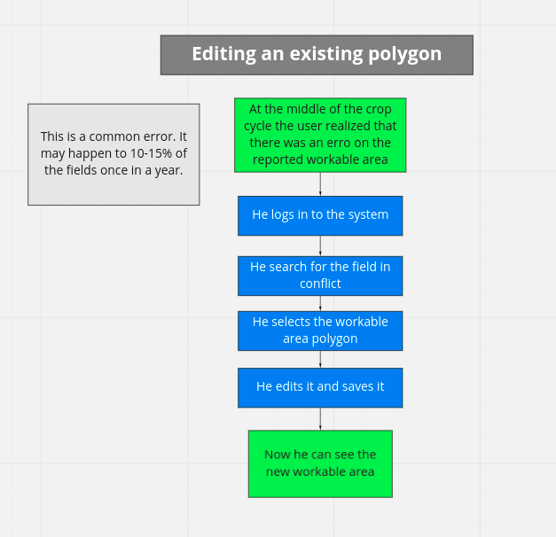

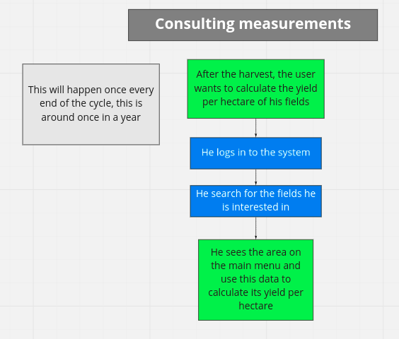

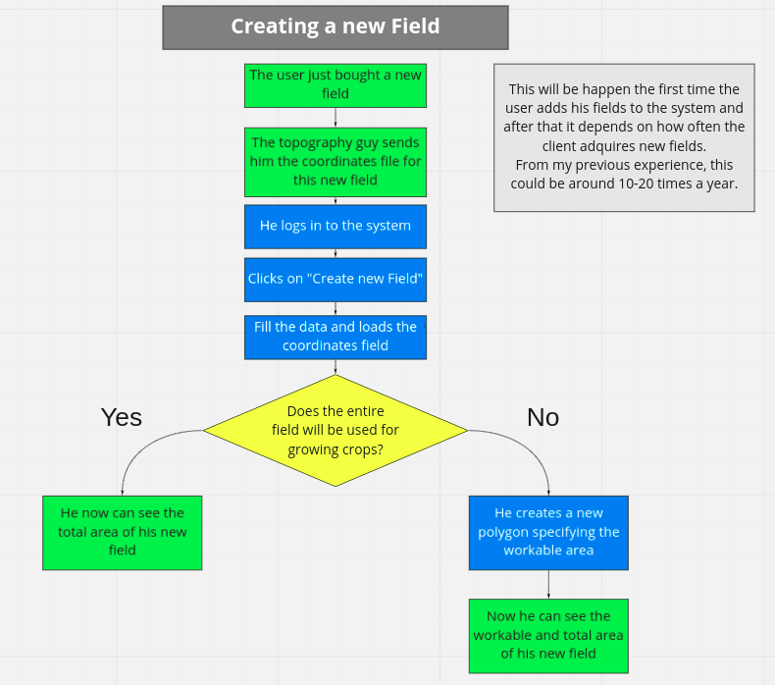

Part 4: Structure

- Identify the type of Information Architecture Structure that your app/site will need and create a diagram for it using a “visual vocabulary”
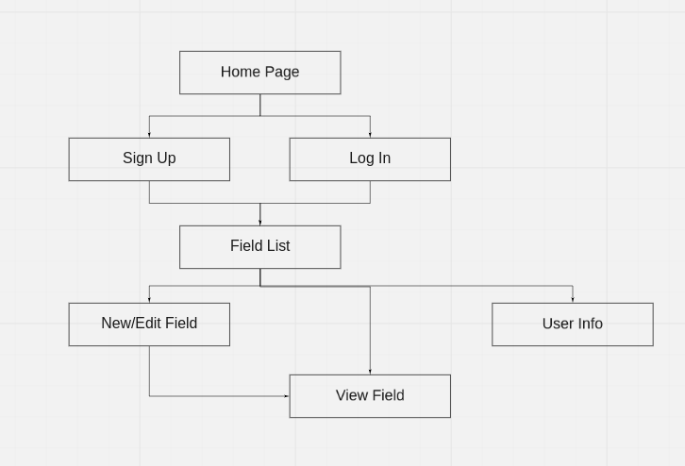

- Which organizing principles are you going to use for your project? Audience? Geography? Other?
It is targeted for people between 25 and 60 years old, with previous knowledge of agriculture and small knowledge of computer systems, located in Latin America. Owner of farms or workers at big agricultural companies.

Part 5: Skeleton

- Choose a wireframe tool and create wireframes for your app/website.
- Before you start, create some thumbnail sketches on a piece of paper first. Take photos of these sketches and include it in your assignment.
- When done with your wireframes, share it with a partner/ friend/ TA. The person will need to answer the following questions: Is anything important missing? Is the most important content noticed first? Is there anything that shouldn’t be here? Which content is related - and how? Can you get to all of the major areas from here? Should you be able to?
- Save the original wireframes in your assignment folder.
- Make any changes to the wireframes based on the partner’s feedback, and save those copies in the assignment as well - label them well to distinguish the two versions.
You can find these wireframes on the folder “wireframes” of this repo.

Part 6: Surface/ UI

- Add any notes, decisions, sketches, images, etc. relating to the Visual design and User Interface of your project. What colour schemes, fonts, and other design decisions would match your goals and objectives established with the rest of your “business” plan?

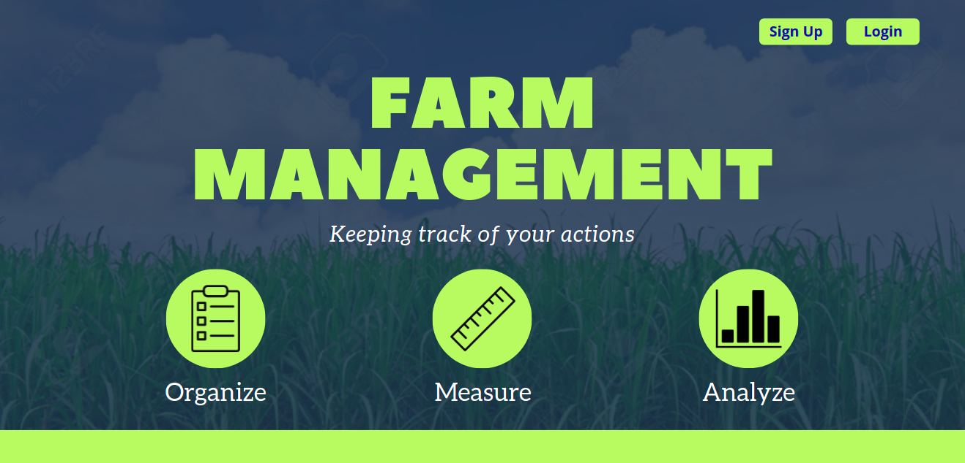
I worked in this on classes. It was inspired from a Canva template. I was thinking to use something link this. But for this project to work, the UI must be friendlier, so I thought that less vibrant and more brighter colors may work for this.
I designed this color palette in coolors to start with.

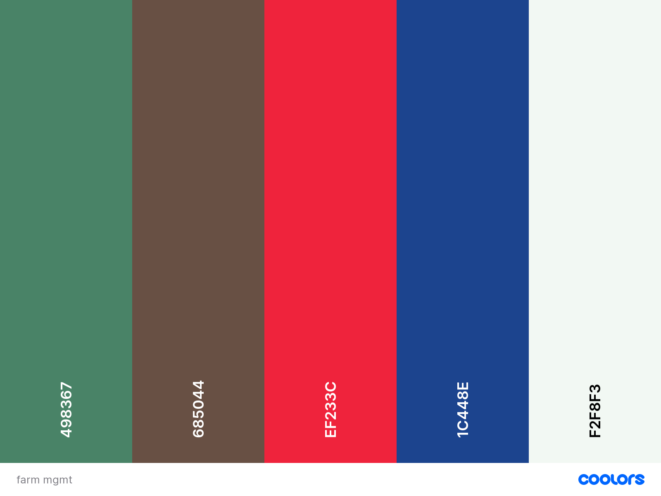
To achieve the friendly, no complicated feel I’m looking for, I decided to use the font “Source Sans Pro”. I find this font very easy to look at and very simple.


- Think of exercises done in the UI/UX classes and come up with ideas to design your project for the most successful User Experience.

Part 7: ERD’s (Entity Relationship Diagrams)

- Before you start coding and building your final project, it is very important to plan out your database schema, and the relationships between the resources (entities) of your database.

- Identify all of the resources (tables) that you will need in your database, and create ERD’s (diagrams) to represent their relationships.

- Share these diagrams with a partner (a TA or instructor would be best)and get some feedback to make sure that these relationships make sense, and if they make the most sense for how your app/website will work

- Include these diagrams in your assignment folder.

