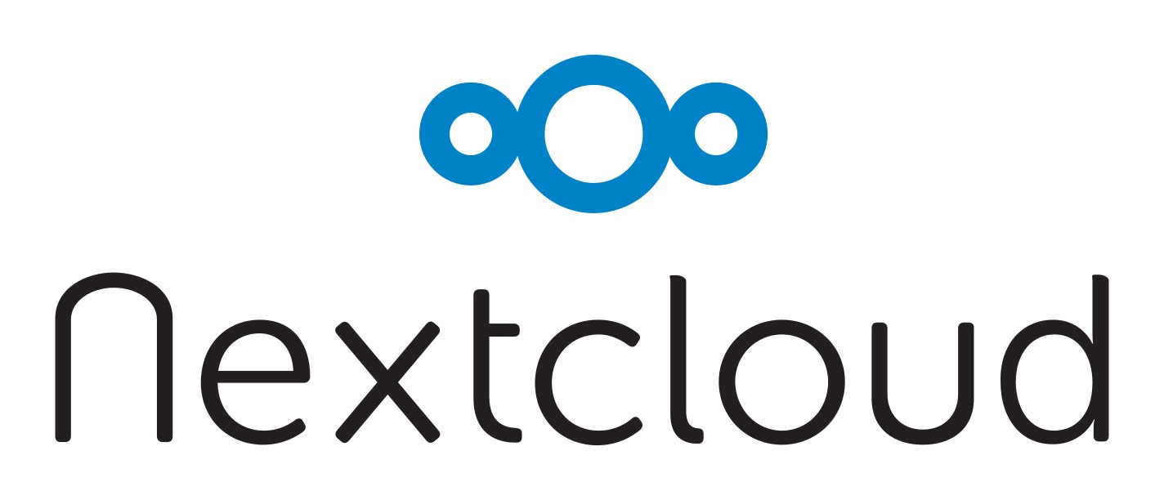

About Nextcloud

Welcome to Nextcloud, your self-hosted file sync and share solution.

Nextcloud is the open source file sync and share software for everyone from individuals to large enterprises and service providers. Nextcloud provides a safe, secure and compliant file sync and share solution on servers you control.

With Nextcloud you can share one or more folders on your PC, and sync them with your Nextcloud server. Place files in your local shared directories, and those files are immediately synced to the server, and then to other PCs via the desktop client. Not near a desktop client? No problem, simply log in with the web client and manage your files there. The Android and iOS mobile apps allow you to browse, download and upload photos and videos.

Whether using a mobile device, a workstation, or a web client, Nextcloud provides the ability to put the right files in the right hands at the right time on any device in one simple-to-use, secure, private and controlled solution.

All example pictures & music are licensed under Creative Commons Attribution.