ojito
no pueden entrar menores de 8 años
asi que nani tiene que llevar dni

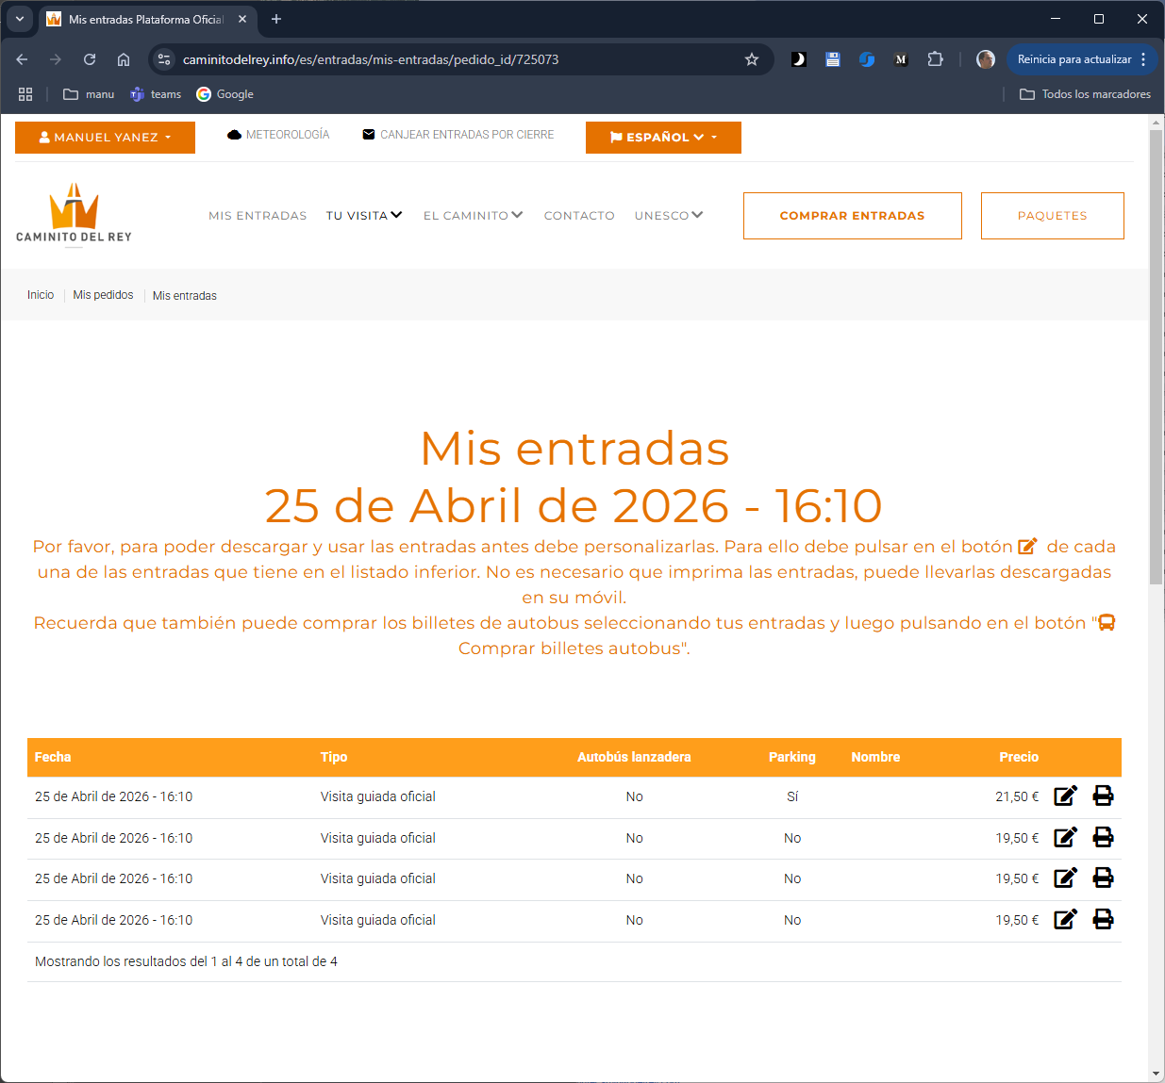

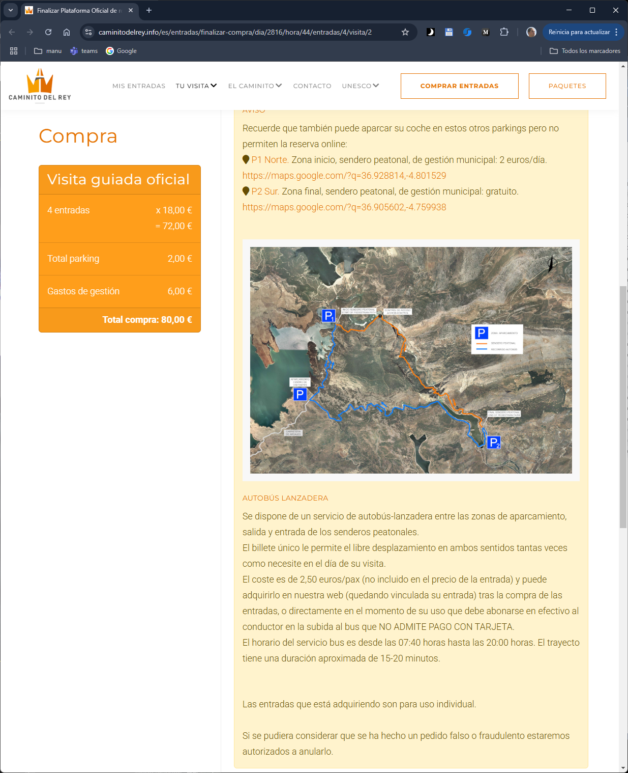

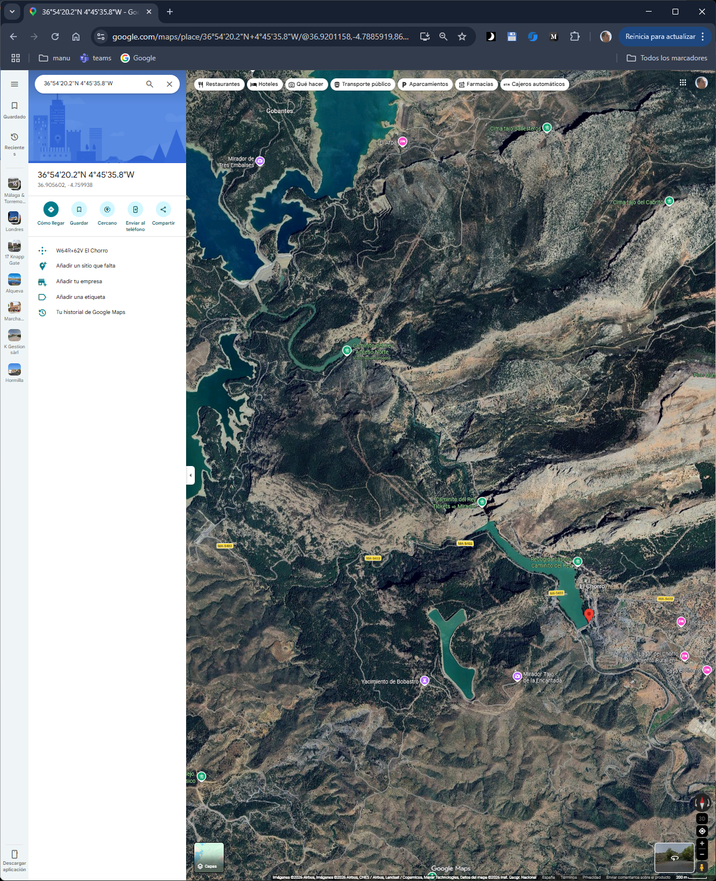

https://www.google.com/maps/place/36%C2%B054'20.2%22N+4%C2%B045'35.8%22W/@36.905602,-4.7625129,1998m/data=!3m2!1e3!4b1!4m4!3m3!8m2!3d36.905602!4d-4.759938?entry=ttu&g_ep=EgoyMDI2MDMwNC4xIKXMDSoASAFQAw%3D%3D

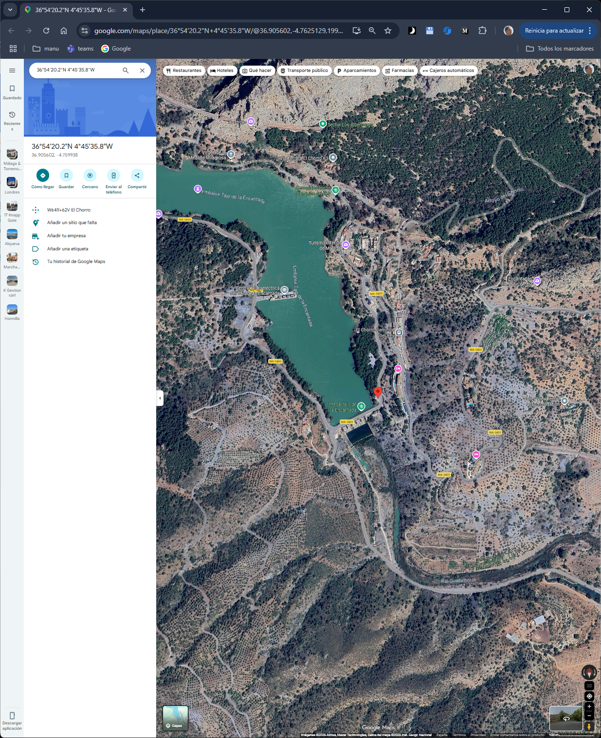

https://www.google.com/maps/place/36%C2%B055'43.7%22N+4%C2%B048'05.5%22W/@36.928814,-4.8041039,1997m/data=!3m2!1e3!4b1!4m4!3m3!8m2!3d36.928814!4d-4.801529?entry=ttu&g_ep=EgoyMDI2MDMwNC4xIKXMDSoASAFQAw%3D%3D

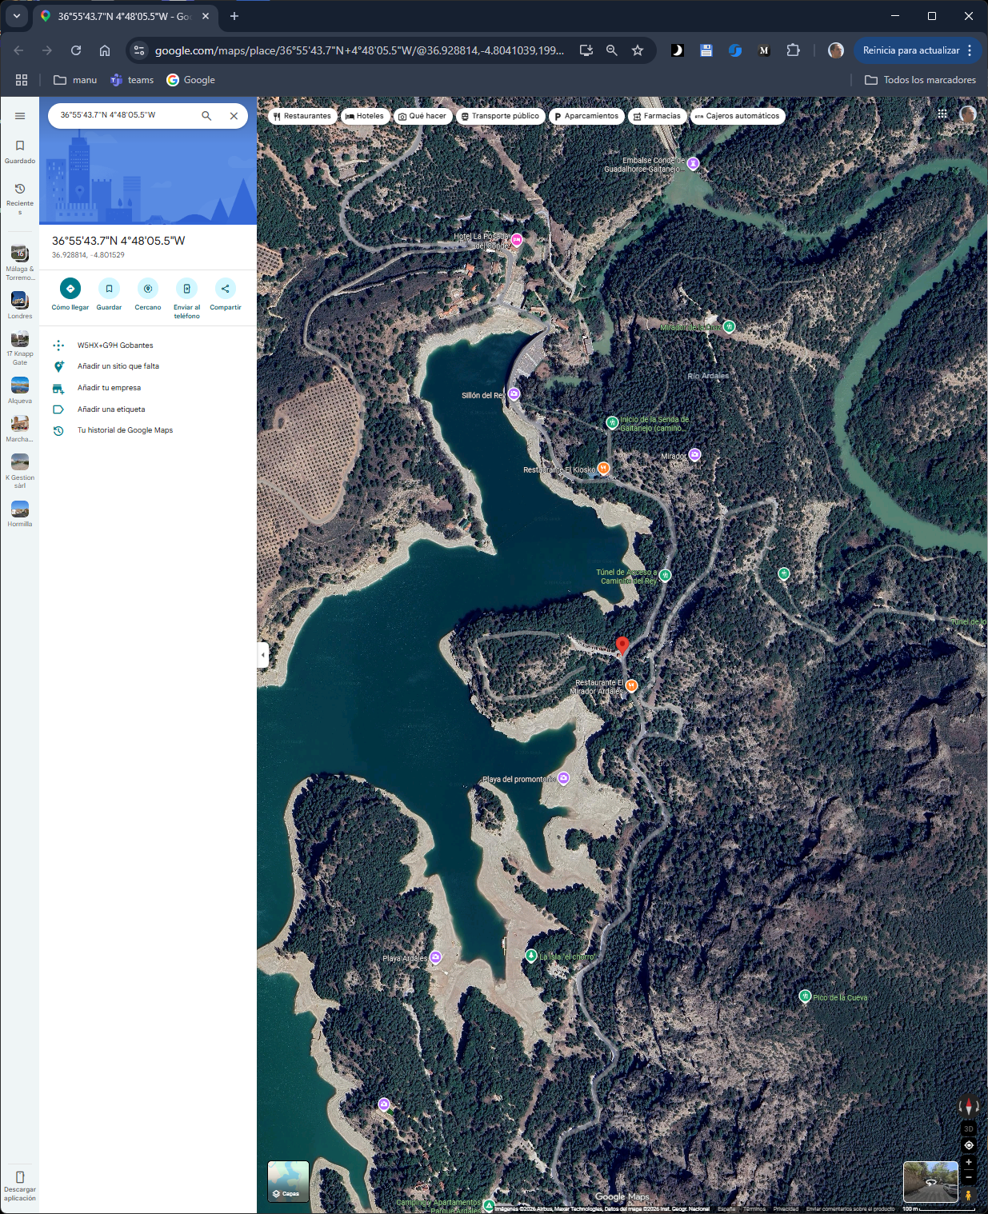

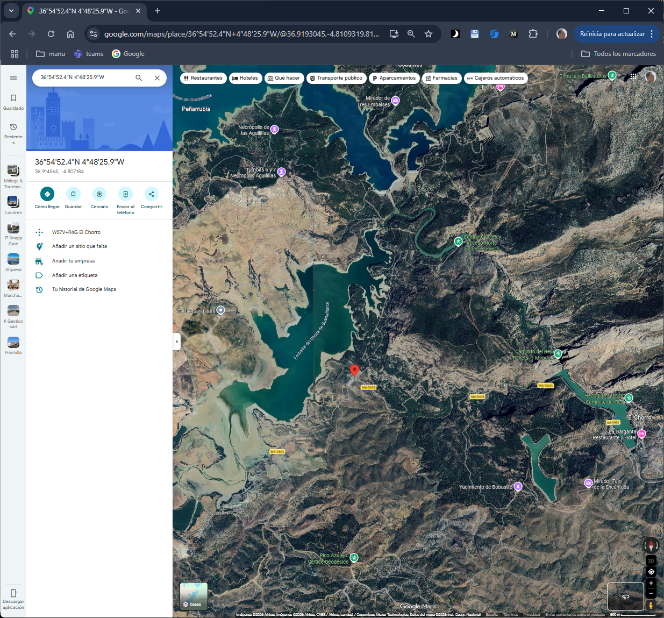

https://www.google.com/maps/place/36%C2%B054'52.4%22N+4%C2%B048'25.9%22W/@36.9154105,-4.8114829,1517m/data=!3m1!1e3!4m4!3m3!8m2!3d36.9145654!4d-4.8071836?entry=ttu&g_ep=EgoyMDI2MDMwNC4xIKXMDSoASAFQAw%3D%3D

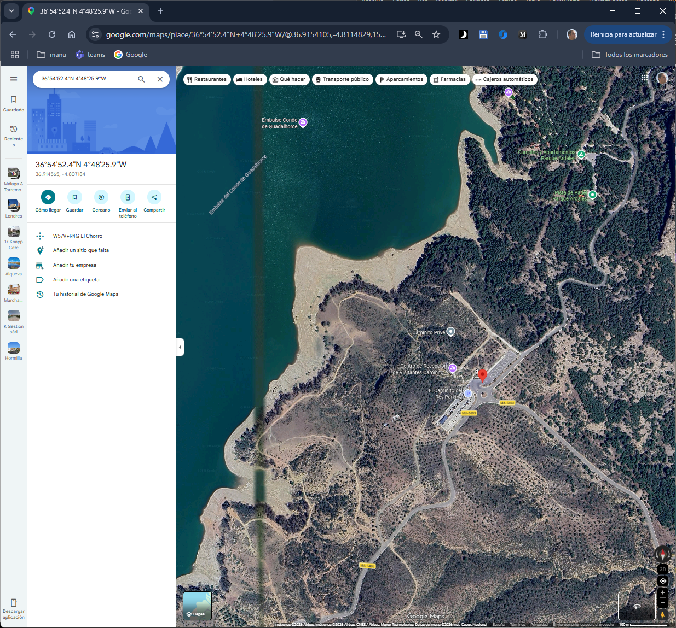

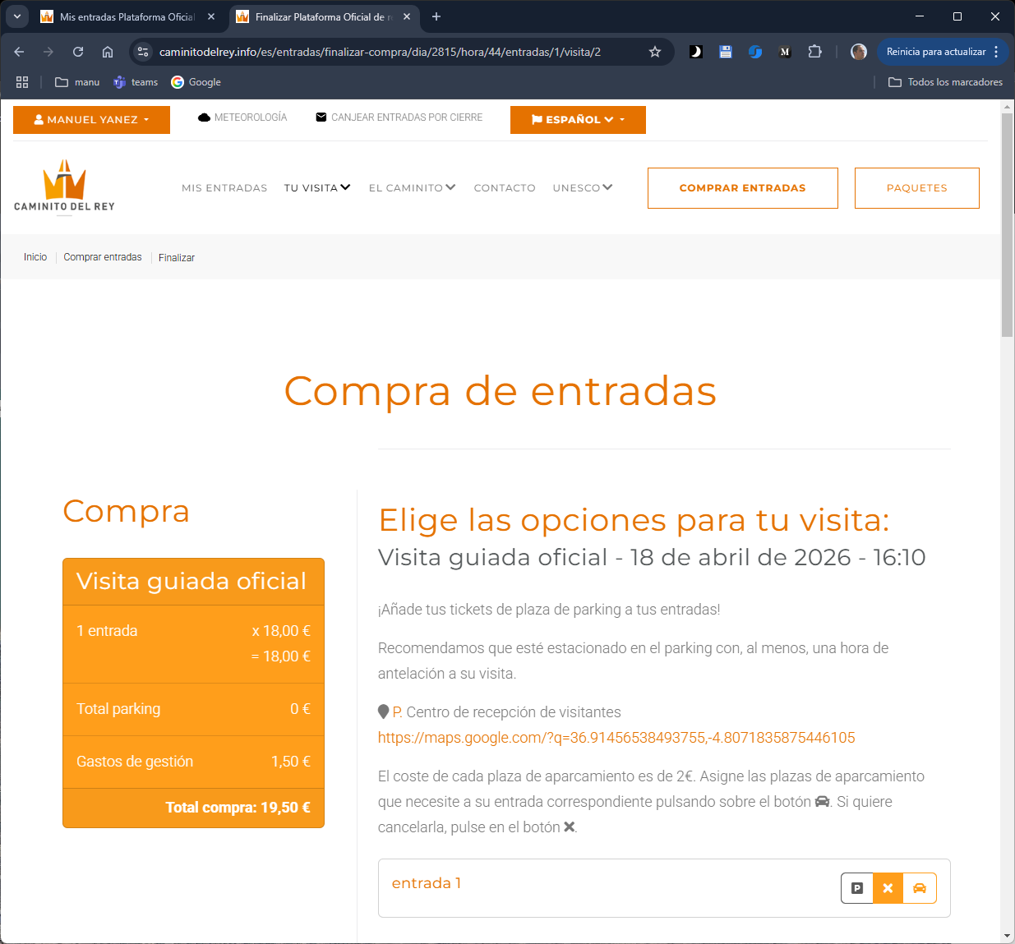

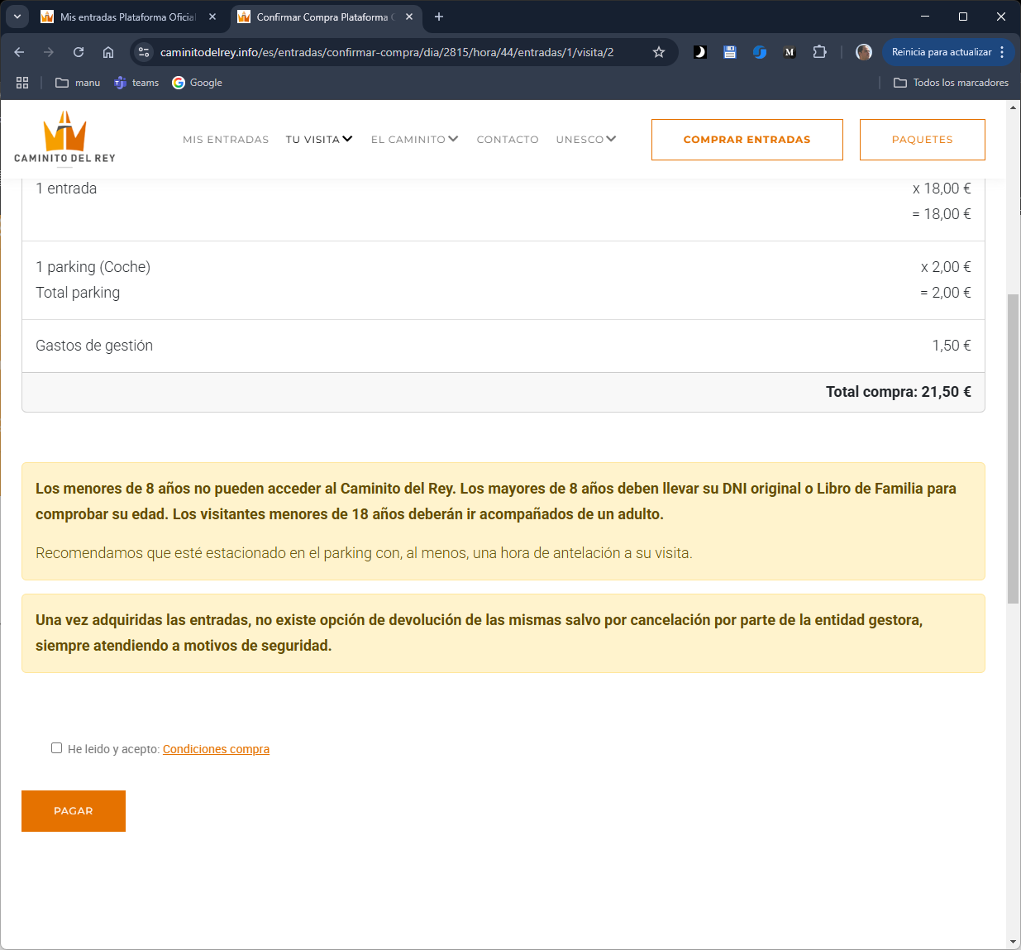

https://www.caminitodelrey.info/

