**DML COMMANDS**

**CREATE TABLE EMPLOYEE_EXP05_CSA_41(EMP_ID INT PRIMARY KEY, EMP_NAME VARCHAR(20),DEPT VARCHAR(20), SALARY INT);**

table EMPLOYEE_EXP05_CSA_41 created.

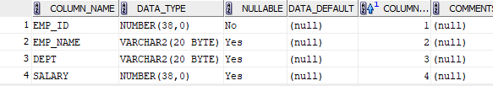

**DESC EMPLOYEE_EXP05_CSA_41;**

Name Null Type

-------- -------- ------------

EMP_ID NOT NULL NUMBER(38)

EMP_NAME VARCHAR2(20)

DEPT VARCHAR2(20)

SALARY NUMBER(38)

**INSERT INTO EMPLOYEE_EXP05_CSA_41 VALUES(1, 'DAVID SMITH','MARKETTING',5000);**

1 rows inserted.

**INSERT INTO EMPLOYEE_EXP05_CSA_41 VALUES(2, 'OLIVIA OCTAVIOUS','ROBOTICS',5000);**

1 rows inserted.

**INSERT INTO EMPLOYEE_EXP05_CSA_41 VALUES(3, 'COULSON','LOGISTICS',5000);**

1 rows inserted.

**INSERT INTO EMPLOYEE_EXP05_CSA_41 VALUES(4, 'ANTHONY','TECHNICAL',5000);**

1 rows inserted.

**INSERT INTO EMPLOYEE_EXP05_CSA_41 VALUES(5, 'DANIEL HARRIS','PRODUCTION',5700);**

1 rows inserted.

**INSERT INTO EMPLOYEE_EXP05_CSA_41 VALUES(6, 'CHARLES BROWN','SALES',3000);**

1 rows inserted.

**INSERT INTO EMPLOYEE_EXP05_CSA_41 VALUES(7, 'ROBERT','MARKETTING',8200);**

1 rows inserted.

**INSERT INTO EMPLOYEE_EXP05_CSA_41 VALUES(8,'SHERLOCK','MARKETTING',9000);**

1 rows inserted.

**SELECT * FROM EMPLOYEE_EXP05_CSA_41;**

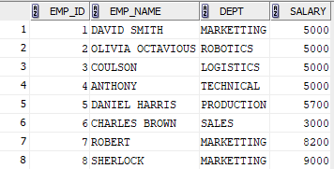

**SELECT EMP_NAME FROM EMPLOYEE_EXP05_CSA_41 WHERE SALARY > 7000;**



**UPDATE EMPLOYEE_EXP05_CSA_41 SET SALARY = 8200 WHERE EMP_NAME = 'DAVID SMITH';**

1 rows updated.

**SELECT SALARY FROM EMPLOYEE_EXP05_CSA_41 WHERE EMP_NAME = 'DAVID SMITH';**



**DELETE FROM EMPLOYEE_EXP05_CSA_41 WHERE EMP_ID = 6;**

1 rows deleted.

**SELECT * FROM EMPLOYEE_EXP05_CSA_41;**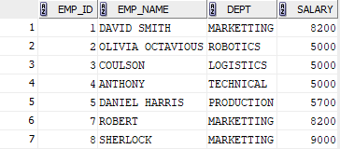

**SELECT EMP_NAME FROM EMPLOYEE_EXP05_CSA_41 WHERE NOT (EMP_NAME LIKE 'D%' OR EMP_NAME LIKE 'O%');**

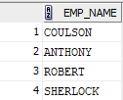

**SELECT DEPT, SUM(SALARY) AS TOTAL_SALARY FROM EMPLOYEE_EXP05_CSA_41 GROUP BY (DEPT);**

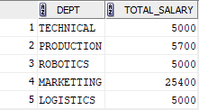

**UPDATE EMPLOYEE_EXP05_CSA_41 SET SALARY = SALARY + (0.5*SALARY) WHERE DEPT='PRODUCTION';**

1 rows updated.

**SELECT SALARY FROM EMPLOYEE_EXP05_CSA_41;**

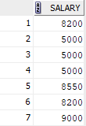

**DELETE FROM EMPLOYEE_EXP05_CSA_41 WHERE SALARY < 7000;**

3 rows deleted.

**SELECT * FROM EMPLOYEE_EXP05_CSA_41;**

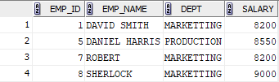

**SELECT EMP_NAME,SALARY FROM EMPLOYEE_EXP05_CSA_41 WHERE SALARY =(SELECT MIN(SALARY) FROM EMPLOYEE_EXP05_CSA_41);**



**UPDATE EMPLOYEE_EXP05_CSA_41 SET SALARY = 8200 WHERE DEPT='MARKETTING';**

3 rows updated.

**SELECT SALARY FROM EMPLOYEE_EXP05_CSA_41;**

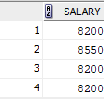

**INSERT INTO EMPLOYEE_EXP05_CSA_41 VALUES(9,'ASHBORN','MARKETTING',9000);**

1 rows inserted.

**INSERT INTO EMPLOYEE_EXP05_CSA_41 VALUES(10,'MARGARIT','MARKETTING',9000);**

1 rows inserted.

**SELECT EMP_NAME FROM EMPLOYEE_EXP05_CSA_41 WHERE EMP_NAME LIKE 'A%';**



**SELECT EMP_NAME FROM EMPLOYEE_EXP05_CSA_41 WHERE EMP_NAME LIKE '%IT%';**

**SELECT UPPER(DEPT)FROM EMPLOYEE_EXP05_CSA_41;**

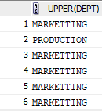

**SELECT * FROM EMPLOYEE_EXP05_CSA_41 WHERE DEPT LIKE 'M%R%' AND DEPT LIKE '%KET%';**

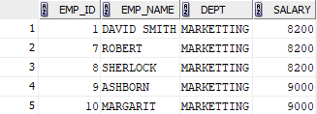

**SELECT DISTINCT UPPER(REVERSE(DEPT)) FROM EMPLOYEE_EXP05_CSA_41;**

