**CHAPTER 1**

**INTRODUCTION**

This Hostel Room Allotment project is developed in favour of the hostel management team which helps them to save the records of the students about their rooms and other things. It helps them from the manual work from which it is very difficult to find the record of the students and the information about their allotted rooms.

This solution is developed on the plight of the hostel management team, through this they cannot require so efficient person to handle and manage the affairs of the students in the hostel, all you need to do is to login as administrator and you can see the information of all the students who have obtained and registered their hostel form, click verify to ascertain their eligibility and allocate them to the available hostel.

In this web application, we also give access to students to login and check their allotted rooms which will in turn solve the confusion among students after they have been allotted the room. They can update their basic profile like their email id, contact number, etc.,

Identification of the problems of the existing hostel management leads to the development of computerized solution that will be compatible to the existing hostel management with the solution which is more users friendly and more GUI oriented. We can improve the efficiency of the hostel management, thus overcome the drawbacks of the existing management.

**OBJECTIVE:**

The main objectives of this project work are that:

* The admin can see and access the student’s data.
* This also will reduce the manual work of the persons in admin panel.
* It helps the admin to know the number of students that can leave in a room and a block.
* To ensure that the number of student staying in a room does not exceed specified limit.
* Help the admin to disseminate information to students without calling for a meeting or moving room to room.

The system helps the admin to:

* Allot different students to their different rooms.
* Edit the details of the students and modify the students’ records.

**CHAPTER 2**

**LITERATURE SURVEY**

A literature review is a text of a scholarly paper, which includes the current knowledge including substantive findings, as well as theoretical and methodological contributions to a particular topic.

**Area chosen**: **Web applications**

**2.1 Web:**

A web project is the process of developing and creating a Web site, activities in a network which are aimed at a pre-defined goal. The network can be both accessible for everyone, as in the [Internet](https://en.wikipedia.org/wiki/Internet), or only for certain people, as an [intranet](https://en.wikipedia.org/wiki/Intranet). The goal of Web projects is the transfer of static and dynamic content - both directly to end users, as well as indirectly through means of various kinds of interfaces. Web projects are based on [TCP/IP](https://en.wikipedia.org/wiki/TCP/IP) technology and concern the transfer of static and dynamic content. A Web project involves many aspects, including [programming](https://en.wikipedia.org/wiki/Programming_language) and the accompanying [software](https://en.wikipedia.org/wiki/Software) development, Web business, [Web server](https://en.wikipedia.org/wiki/Web_server) and network administration, [hosting](https://en.wikipedia.org/wiki/Hosting_service), graphics/design, the development and administration of [databases](https://en.wikipedia.org/wiki/Database), construction of [interfaces](https://en.wikipedia.org/wiki/Interface_(computing)), project management and quality assurance, [search engine optimization](https://en.wikipedia.org/wiki/Search_engine_optimization), the maintenance of data in content management/editing systems and much more.

**2.2 HTML:**

Hypertext Mark-up Language (HTML) is the standard [mark-up language](https://en.wikipedia.org/wiki/Markup_language) for creating [web pages](https://en.wikipedia.org/wiki/Web_page) and [web applications](https://en.wikipedia.org/wiki/Web_application). With [Cascading Style Sheets](https://en.wikipedia.org/wiki/Cascading_Style_Sheets) (CSS) and [JavaScript](https://en.wikipedia.org/wiki/JavaScript) it forms a triad of cornerstone technologies for the [World Wide Web](https://en.wikipedia.org/wiki/World_Wide_Web). Browsers receive HTML documents from a [webserver](https://en.wikipedia.org/wiki/Webserver) or from local storage and render them into multimedia web pages. HTML describes the structure of a web page [semantically](https://en.wikipedia.org/wiki/Semantic) and originally included cues for the appearance of the document. [HTML elements](https://en.wikipedia.org/wiki/HTML_element) are the building blocks of HTML pages. With HTML constructs, [images](https://en.wikipedia.org/wiki/Img_(HTML_element)) and other objects, such as forms, may be embedded into the rendered page. It provides a means to create [structured documents](https://en.wikipedia.org/wiki/Structured_document) by denoting structural [semantics](https://en.wikipedia.org/wiki/Semantics) for text such as headings, paragraphs, lists, [links](https://en.wikipedia.org/wiki/Hyperlink), quotes and other items. HTML elements are delineated by *tags*, written using [angle brackets](https://en.wikipedia.org/wiki/Bracket#Angle_brackets).

**2.3 CSS:**

Cascading Style Sheets (CSS) is a [style sheet language](https://en.wikipedia.org/wiki/Style_sheet_language) used for describing the [presentation](https://en.wikipedia.org/wiki/Presentation_semantics) of a document written in a [mark-up language](https://en.wikipedia.org/wiki/Markup_language).Although most often used to set the visual style of [web pages](https://en.wikipedia.org/wiki/Web_page) and user interfaces written in [HTML](https://en.wikipedia.org/wiki/HTML) and [XHTML](https://en.wikipedia.org/wiki/XHTML), the language can be applied to any [XML](https://en.wikipedia.org/wiki/XML) document, including [plain XML](https://en.wikipedia.org/wiki/Plain_Old_XML), [SVG](https://en.wikipedia.org/wiki/Scalable_Vector_Graphics) and [XUL](https://en.wikipedia.org/wiki/XUL), and is applicable to rendering in [speech](https://en.wikipedia.org/wiki/Speech_synthesis), or on other media. Along with HTML and [JavaScript](https://en.wikipedia.org/wiki/JavaScript), CSS is a cornerstone technology used by most websites to create visually engaging webpages, user interfaces for [web applications](https://en.wikipedia.org/wiki/Web_applications), and user interfaces for many mobile applications.

**2.4 PHP**:

PHP is a [server-side scripting](https://en.wikipedia.org/wiki/Server-side_scripting) language designed primarily for [web development](https://en.wikipedia.org/wiki/Web_development) but also used as a [general-purpose programming language](https://en.wikipedia.org/wiki/General-purpose_programming_language). Originally created by [Rasmus Lerdorf](https://en.wikipedia.org/wiki/Rasmus_Lerdorf)  in 1994, the PHP [reference implementation](https://en.wikipedia.org/wiki/Reference_implementation) is now produced by The PHP Development Team. PHP originally stood for Personal Home Page,but it now stands for the [recursive acronym](https://en.wikipedia.org/wiki/Recursive_acronym) PHP: Hypertext Pre-processor. PHP code may be embedded into [HTML](https://en.wikipedia.org/wiki/HTML) or HTML5 [mark-up](https://en.wikipedia.org/wiki/Markup_language), or it can be used in combination with various [web template systems](https://en.wikipedia.org/wiki/Web_template_system), [web content management systems](https://en.wikipedia.org/wiki/Web_content_management_system) and [web frameworks](https://en.wikipedia.org/wiki/Web_framework).

**2.5 MySQL:**

MySQL is an [open-source](https://en.wikipedia.org/wiki/Open-source) [relational database management system](https://en.wikipedia.org/wiki/Relational_database_management_system) (RDBMS). Its name is a combination of "My", the name of co-founder  [Michael Widenius](https://en.wikipedia.org/wiki/Michael_Widenius)' daughter,and "[SQL](https://en.wikipedia.org/wiki/SQL)", the abbreviation for [Structured Query Language](https://en.wikipedia.org/wiki/Structured_Query_Language). The MySQL development project has made its [source code](https://en.wikipedia.org/wiki/Source_code) available under the terms of the [GNU General Public License](https://en.wikipedia.org/wiki/GNU_General_Public_License), as well as under a variety of [proprietary](https://en.wikipedia.org/wiki/Proprietary_software) agreements. MySQL was owned and sponsored by a single [for-profit](https://en.wikipedia.org/wiki/Business) firm, the [Swedish](https://en.wikipedia.org/wiki/Sweden) company [MySQL AB](https://en.wikipedia.org/wiki/MySQL_AB), now owned by [Oracle Corporation](https://en.wikipedia.org/wiki/Oracle_Corporation).For proprietary use, several paid editions are available, and offer additional functionality. MySQL is a central component of the [LAMP](https://en.wikipedia.org/wiki/LAMP_(software_bundle)) open-source web application software stack (and other "[AMP](https://en.wikipedia.org/wiki/List_of_AMP_packages)" stacks). LAMP is an acronym for "[Linux](https://en.wikipedia.org/wiki/Linux), [Apache](https://en.wikipedia.org/wiki/Apache_HTTP_Server), MySQL, [Perl](https://en.wikipedia.org/wiki/Perl)/[PHP](https://en.wikipedia.org/wiki/PHP)/[Python](https://en.wikipedia.org/wiki/Python_(programming_language))". Applications that use the MySQL database include: [TYPO3](https://en.wikipedia.org/wiki/TYPO3), [MODx](https://en.wikipedia.org/wiki/MODx), [Joomla](https://en.wikipedia.org/wiki/Joomla), [WordPress](https://en.wikipedia.org/wiki/WordPress), [phpBB](https://en.wikipedia.org/wiki/PhpBB), [MyBB](https://en.wikipedia.org/wiki/MyBB), and [Drupal](https://en.wikipedia.org/wiki/Drupal). MySQL is also used in many high-profile, large-scale [websites](https://en.wikipedia.org/wiki/Website), including [Google](https://en.wikipedia.org/wiki/Google) (though not for searches), [Facebook](https://en.wikipedia.org/wiki/Facebook),[Twitter](https://en.wikipedia.org/wiki/Twitter), [Flickr](https://en.wikipedia.org/wiki/Flickr).

**2.6 XAMPP:**

XAMPP is a [free and open source](https://en.wikipedia.org/wiki/Free_software) [cross-platform](https://en.wikipedia.org/wiki/Cross-platform) [web server](https://en.wikipedia.org/wiki/Web_server) [solution stack](https://en.wikipedia.org/wiki/Solution_stack) package developed by Apache Friends, consisting mainly of the [Apache HTTP Server](https://en.wikipedia.org/wiki/Apache_HTTP_Server), [MariaDB](https://en.wikipedia.org/wiki/MariaDB) [database](https://en.wikipedia.org/wiki/Database), and [interpreters](https://en.wikipedia.org/wiki/Interpreter_(computing)) for scripts written in the [PHP](https://en.wikipedia.org/wiki/PHP) and [Perl](https://en.wikipedia.org/wiki/Perl) [programming languages](https://en.wikipedia.org/wiki/Programming_language). XAMPP stands for Cross-Platform (X), Apache (A), MariaDB (M), PHP (P) and Perl (P). It is a simple, lightweight Apache distribution that makes it extremely easy for developers to create a local web server for testing and deployment purposes. Everything needed to set up a web server – server application (Apache), database (MariaDB), and scripting language (PHP) – is included in an extractable file. XAMPP is also cross-platform, which means it works equally well on Linux, Mac and Windows. Since most actual web server deployments use the same components as XAMPP, it makes transitioning from a local test server to a live server extremely easy as well.

**CHAPTER 3**

**REQUIREMENT SPECIFICATIONS**

**Hardware requirements**

In hardware requirement we require all those components which will provide us the platform for the development of the project. The minimum hardware required for the development of this project is as follows:

* Processor - Pentium –IV
* Speed - 1.1 Ghz
* RAM - 256 MB(min)
* Hard Disk - 20 GB
* Key Board - Standard Windows Keyboard
* Mouse - Two or Three Button Mouse
* Monitor - SVGA

These all are the minimum hardware requirement required for our project. We want to make our project to be used in any type of computer therefore we have taken minimum configuration to a large extent.128 MB ram is used so that we can execute our project in a least possible RAM.5 GB hard disk is used because project takes less space to be executed or stored.

**Software requirements**

Software’s can be defined as programs which run on our computer it acts as petrol in the vehicle. It provides the relationship between the human and a computer. It is very important to run software to function the computer. Various softwares are needed in this project are:

* Front-End: HTML, CSS & PHP
* Back-End: MySQL

**CHAPTER 4**

**DESIGN**

Design is the creation of a [plan](https://en.wikipedia.org/wiki/Plan_(drawing)) or [convention](https://en.wikipedia.org/wiki/Convention_(norm)) for the construction of an object, system. Design has different connotations in different fields. Web design encompasses many different skills and disciplines in the production and maintenance of websites. The different areas of web design include web graphic design, [interface design](https://en.wikipedia.org/wiki/Interface_design), authoring, including standardised code and [proprietary software](https://en.wikipedia.org/wiki/Proprietary_software).

* 1. **Entity Relationship Diagram (ER diagram):**

An entity-relationship diagram (ERD) is a graphical representation of an information system that shows the relationship between people, objects, places, concepts or events within that system. Hostel database system consists of hostel details, room details, student details.

The ER diagram for the database is as shown below:

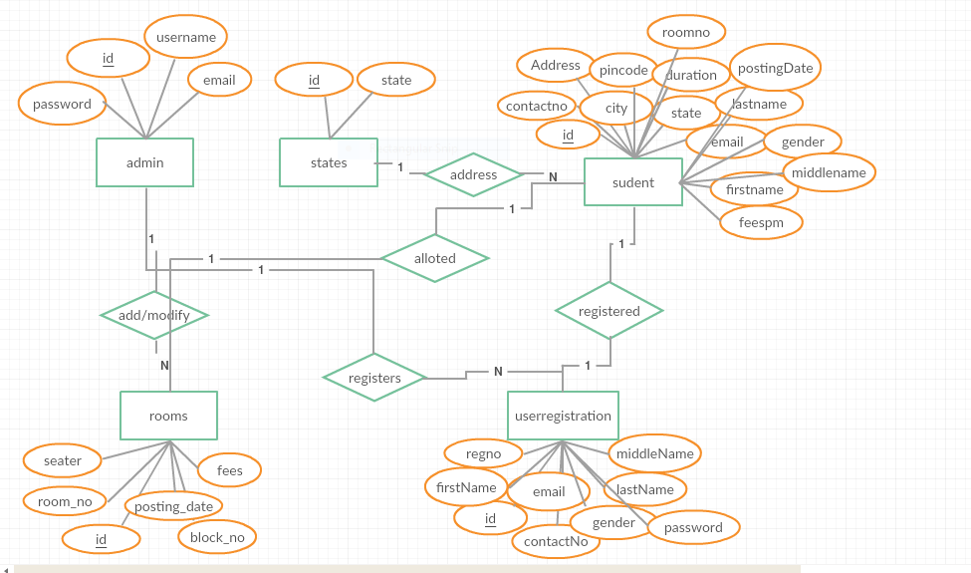

Fig. No (1)

**4.2 Relational schema:**

A set of attributes is called a **relation schema**. A relation schema is also known as **table schema**. A relation schema can be thought of as the basic [information](http://ecomputernotes.com/fundamental/information-technology/what-do-you-mean-by-data-and-information) describing a table or relation. It is the logical definition of a table. Relation schema defines what the name of the table is. This includes a set of column names, the [data type](http://ecomputernotes.com/java/data-type-variable-and-array/explain-data-types-in-java)s associated with each column.

**Relational schema** may also refer to as database schema. Adatabase schema is the collection of relation schemas for a whole database. **Relational or** Database schema is a collection of meta-data. **Database schema** describes the structure and constraints of data representing in a particular domain. A **Relational schema** can be described a blueprint of a database that outlines the way data is organized into tables. This blueprint will not contain any type of data. In a relational schema, each tuple is divided into fields called **domains**. 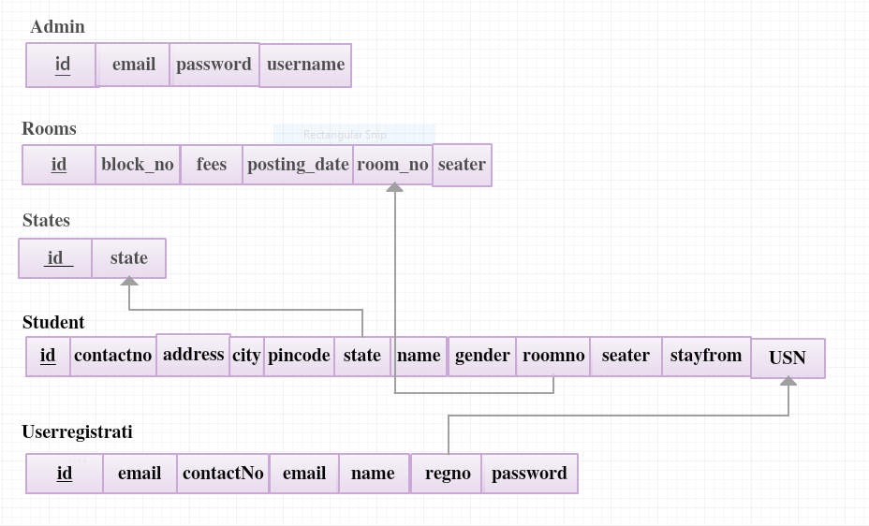

Fig.No(2)

**CHAPTER 5**

**IMPLEMENTATION**

The project takes shape during the implementation phase. This phase involves the construction of the actual project result. Programmers are occupied with encoding, designers are involved in developing graphic material, contractors are building, the actual reorganization takes place. It is during this phase that the project becomes visible to outsiders, to whom it may appear that the project has just begun. The implementation phase is the doing phase, and it is important to maintain the momentum. At the end of the implementation phase, the result is evaluated according to the list of requirements that was created in the definition phase. It is also evaluated according to the designs.

**CHAPTER 6**

**TESTING**

**OVERVIEW**

Testing enables making objective assessments regarding the degree of conformance of the system to stated requirements and specifications. Testing verifies that the system meets the different requirements including, functional, performance, reliability, security, usability and so on. This verification is done to ensure that we are building the system right. In addition, testing validates that the system being developed is what the user needs. In essence, validation is performed to ensure that we are building the right system. Apart from helping make decisions, the information from software testing helps with risk management.

**TESTING OBJECTIVES:**

* + - Testing is the process of executing a program with the intent of finding an error.
    - A good test case is one that has high profitability of finding an as yet discovered error.

A successful test is one that uncovers a yet undiscovered error. The developed system was tested whether it satisfies all the user requirements by taking series of test cases as below.

**6.1 CODE TESTING:**

This was done side by side with coding. This examined the logic of our program. Every path of program was tested.

**6.2 UNIT TESTING:**

In [computer programming](https://en.wikipedia.org/wiki/Computer_programming), unit testing is a [software testing](https://en.wikipedia.org/wiki/Software_testing) method by which individual units of [source code](https://en.wikipedia.org/wiki/Source_code), sets of one or more computer program modules together with associated control data, usage procedures, and operating procedures, are tested to determine whether they are fit for use. Unit testing finds problems early in the [development cycle](https://en.wikipedia.org/wiki/Development_cycle).

**6.3 INTEGRATION TESTING:**

Integration testing is the phase in [software testing](https://en.wikipedia.org/wiki/Software_testing) in which individual software modules are combined and tested as a group. It occurs after [unit testing](https://en.wikipedia.org/wiki/Unit_testing) and before [validation testing](https://en.wikipedia.org/wiki/Verification_and_validation_(software)). Integration testing takes as its input [modules](https://en.wikipedia.org/wiki/Module_(programming)) that have been unit tested, groups them in larger aggregates, applies tests defined in an integration [test plan](https://en.wikipedia.org/wiki/Test_plan) to those aggregates, and delivers as its output the integrated system ready for [system testing](https://en.wikipedia.org/wiki/System_testing).

**6.4 VALIDATION TESTING:**

Validation Testing ensures that the product actually meets the client's needs. It can also be defined as to demonstrate that the product fulfills its intended use when deployed on appropriate environment.

**6.5 SYSTEM TESTING:**

System testing of software or hardware is testing conducted on a complete, integrated system to evaluate the system's compliance with its specified [requirements](https://en.wikipedia.org/wiki/Requirements). System testing falls within the scope of [black-box testing](https://en.wikipedia.org/wiki/Black-box_testing), and as such, should require no knowledge of the inner design of the code or logic.

**6.6 OUTPUT TESTING:**

After performing the validation testing, the next step is output testing of our project since no system could be useful if it does not produce the output in the required format. Output with the format required by the user is compared.

**6.7 USER ACCEPTENCE TESTING:**

User acceptance is a type of testing performed by the Client to certify the system with respect to the requirements that was agreed upon. This testing happens in the final phase of testing before moving the software application to Market or Production environment.

**6.8 TESTING CASES:**

|  |  |  |  |  |
| --- | --- | --- | --- | --- |
| **SL No** | **Test case** | **Description** | **Expected result** | **Status** |
| **1.** | Successful startup of the application and the admin/user are expected to login. | Login test. | Successful login and access to their accounts. | Passed |
| **2.** | Admin adding or modifying room details. | Click on add rooms/manage rooms link. | Add and modification options are displayed. | Passed |
| **3.** | Admin registering or managing students. | Click on student registration/manage students link. | Student registration form or edit options are displayed. | Passed |
| **4.** | Student viewing their account and update data or change password. | Click on My account link. | User updates account or changes password. | Passed |
| **5.** | Student room details view. | Click on My room link. | Can view the student details and the rooms allotted to them. | Passed |

Fig. No (4)

**SNAPSHOTS**

Home page, descripion, contact details of hostel.

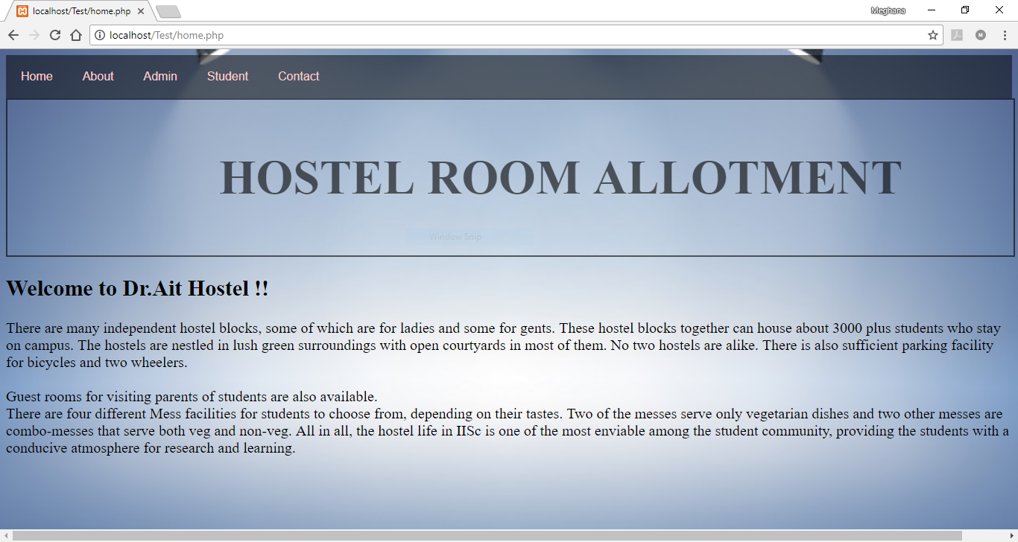

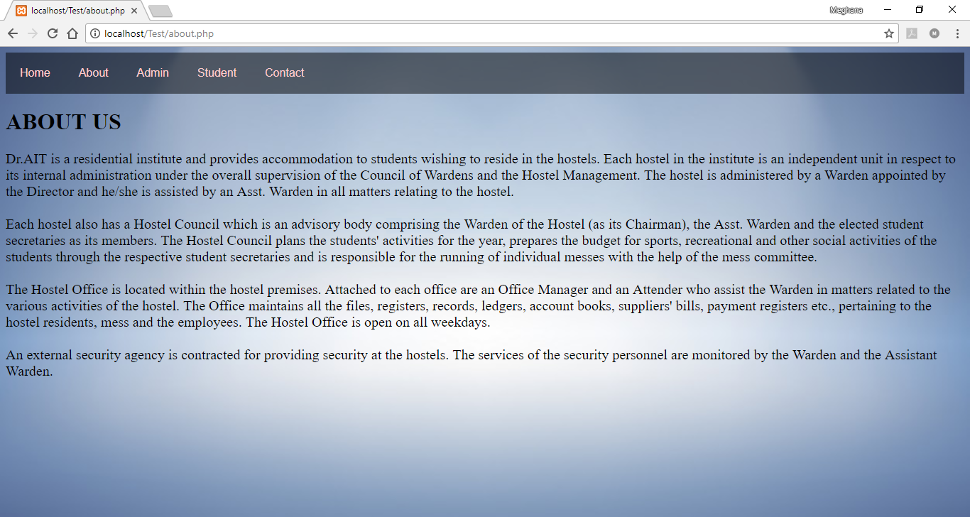

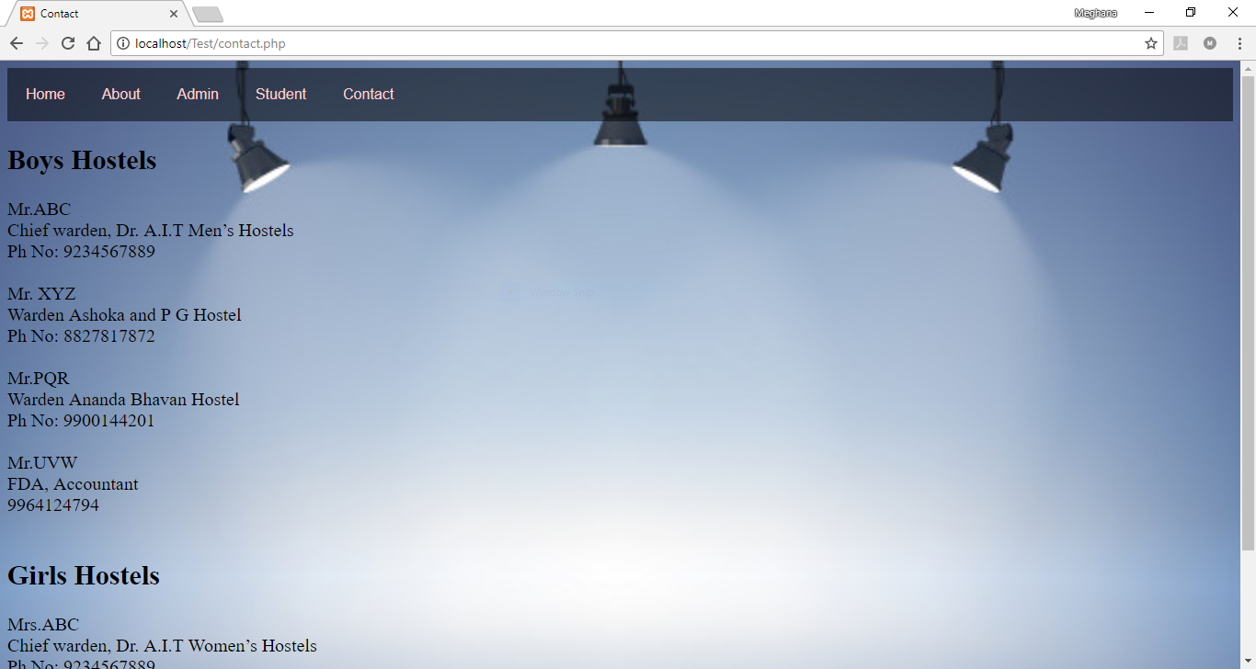

Admin/Student login:

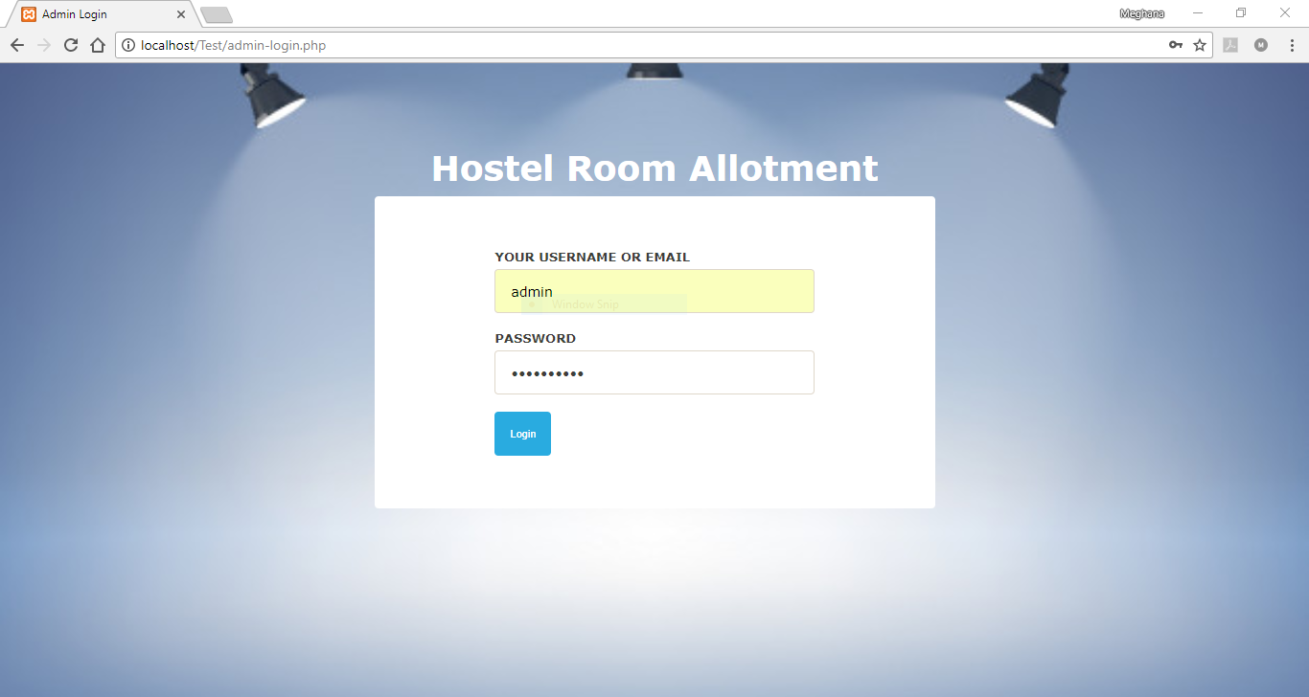

Admin Dashboard, profile:

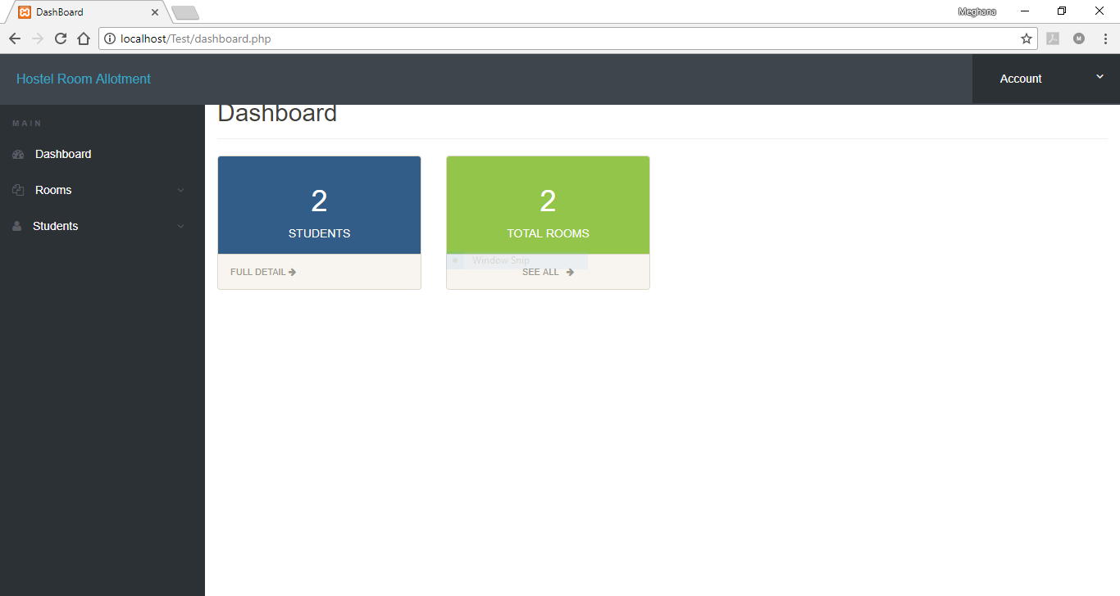

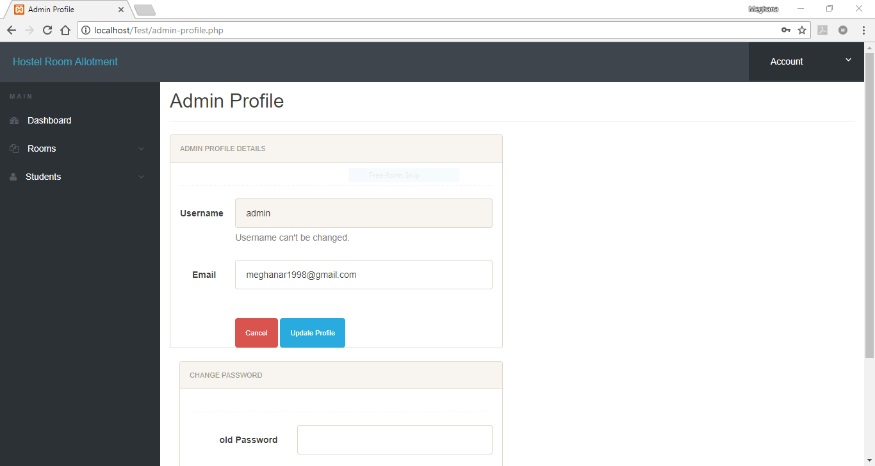

Add/Modify rooms by admin:

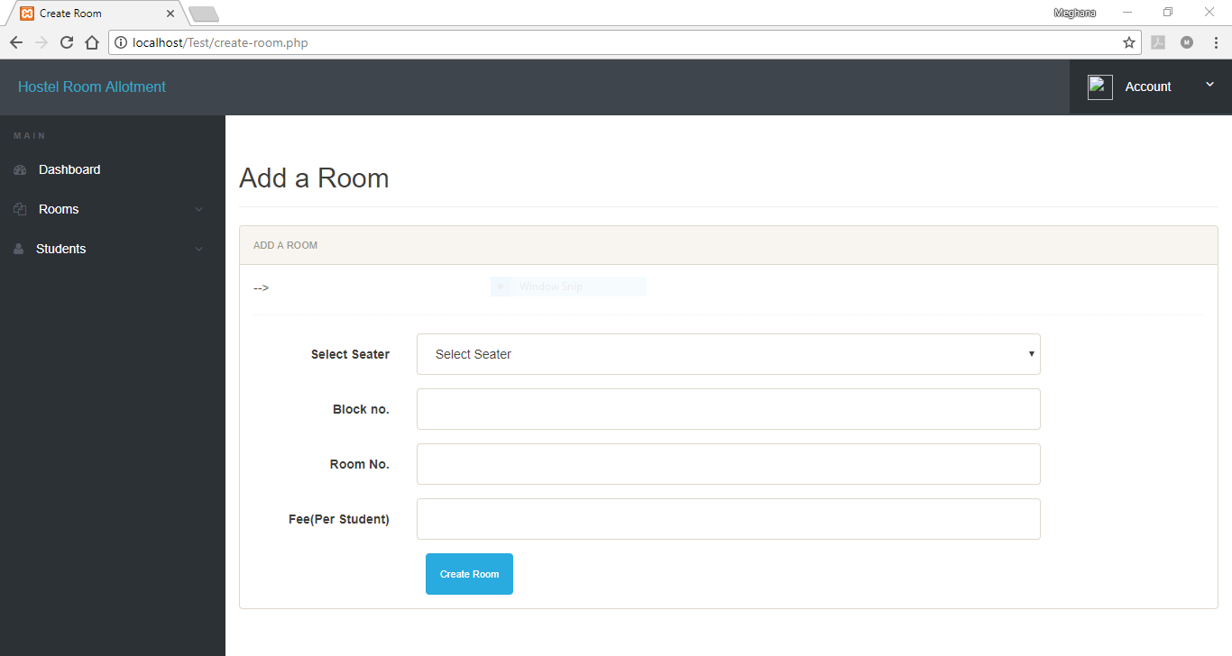

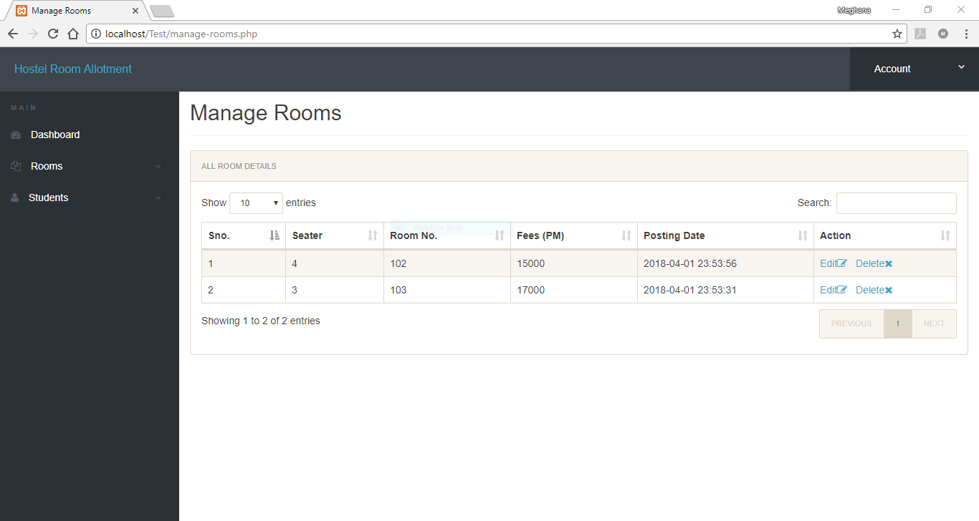

Student registration/ Manage Students by admin:

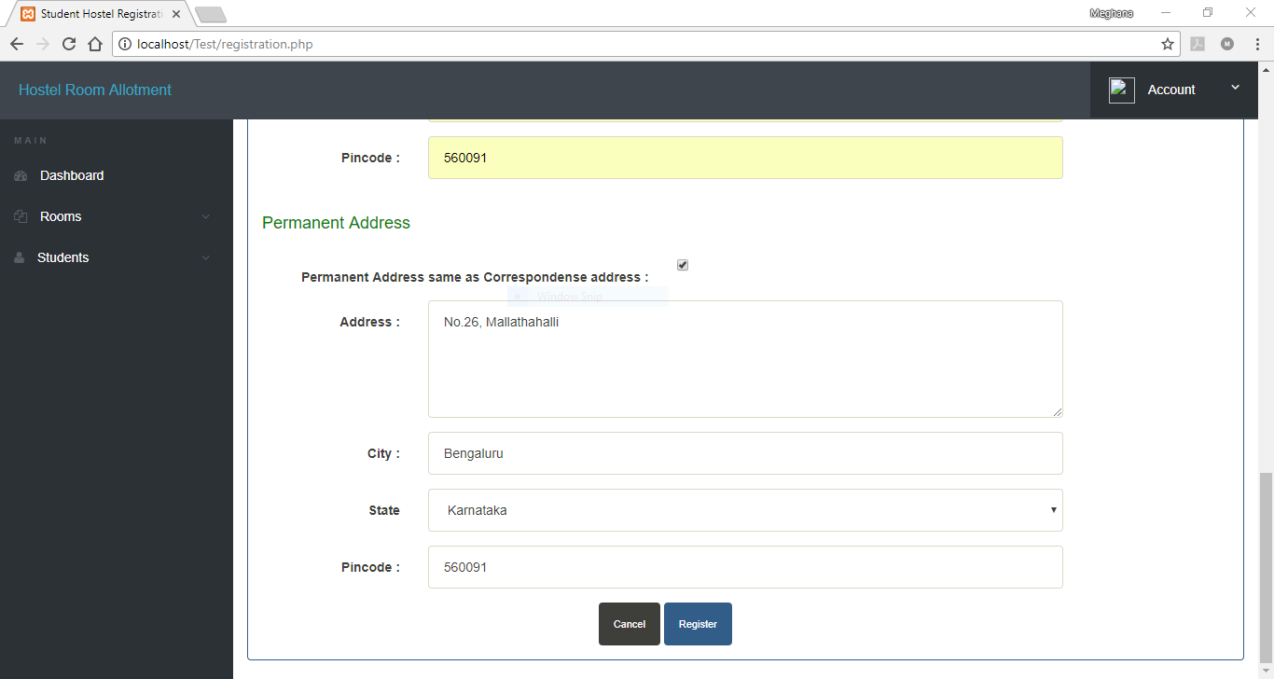

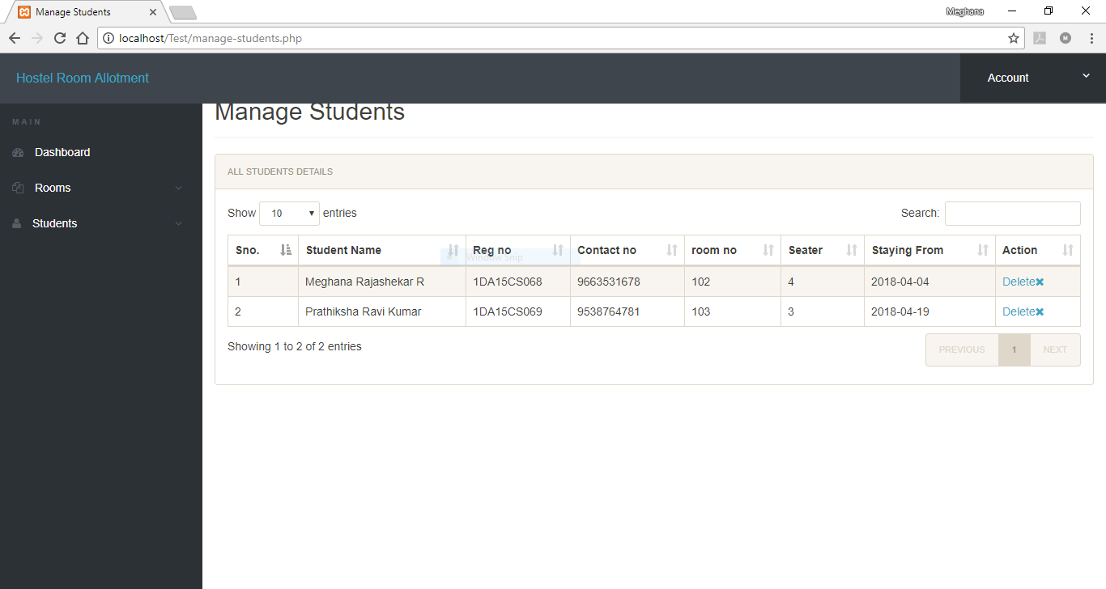

Student dashboard:

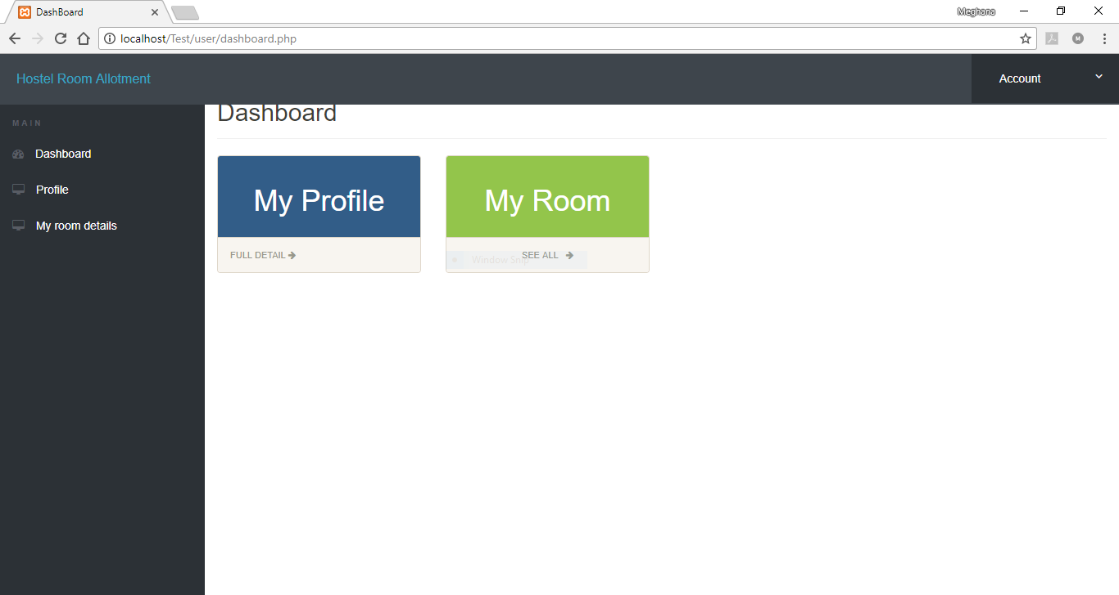

Student profile, room details:

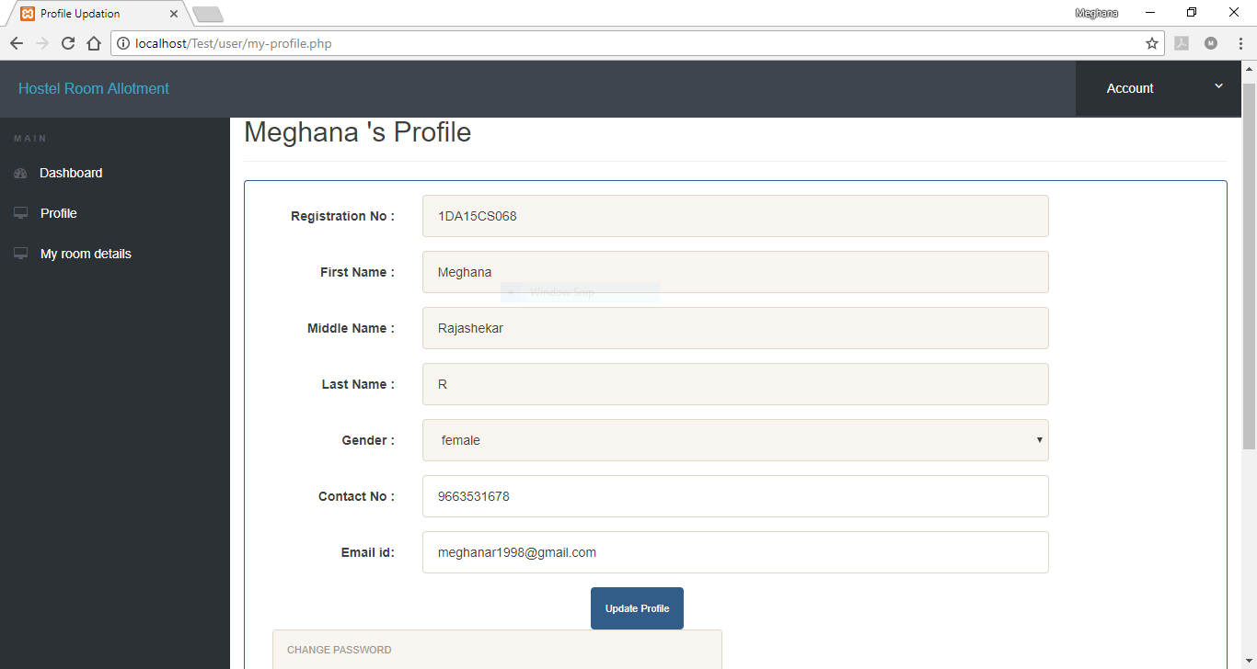

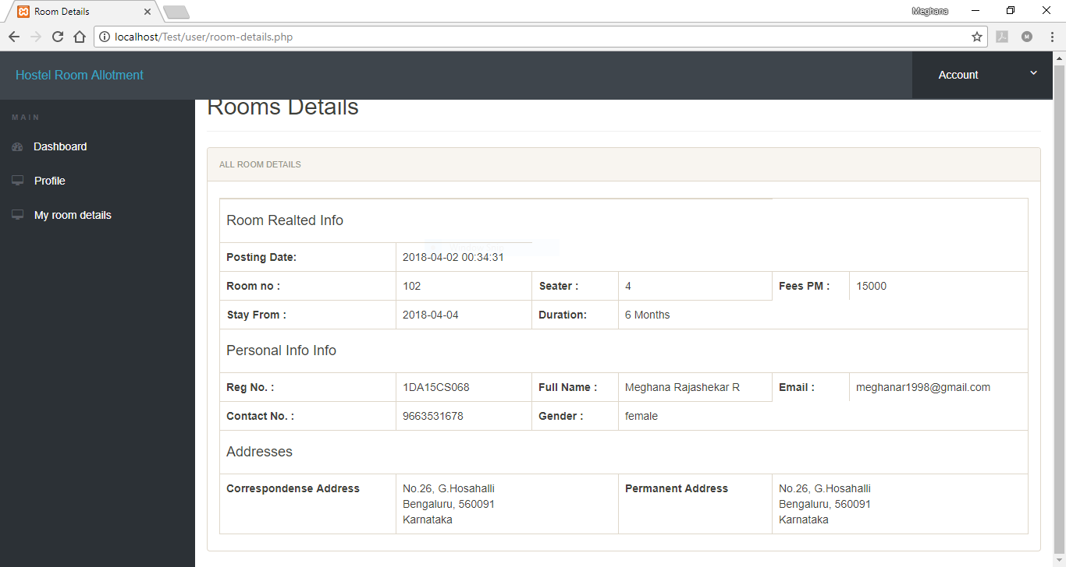

**CONCLUSION**

The main vision is to create an online platform for the hostel to manage their students and allot rooms to them. It provides data about the students admitted to the hostel and manage the details by admin. It also gives access to students to view their allotted rooms and edit their basic details such as their email-id contact number. The admin is also given the access for addition and deletion of rooms in the hostel along with updating of fees for each room. The objective of this project was to create an easy platform for the hostel management team to make their work easy with better GUI.

The disadvantages of traditional methods such as maintaining a record of students along with their room details and their updating has been made easy with a computerized system. So here we are generating the web pages using HTML and CSS.

**REFERENCES**

### [W3Schools Online Web Tutorials](https://www.w3schools.com/)

### [HTML Tutorial - W3Schools](https://www.w3schools.com/html/)

### [PHP Tutorial](https://www.tutorialspoint.com/php/)

https://www.tutorialspoint.com/php/

* Nations, Daniel. ["Web Applications"](http://webtrends.about.com/od/webapplications/a/web_application.htm). About.com*.* Retrieved 20 January 2014.
* Alex Chaffee (2000-08-17). ["What is a web application (or "webapp")?"](http://www.jguru.com/faq/view.jsp?EID=129328). Retrieved 2008-07-27.
* James Duncan Davidson, Danny Coward (1999-12-17).[Java Servlet Specification ("Specification") Version: 2.2 Final Release](http://java.sun.com/products/servlet/download.html). [Sun Microsystems](https://en.wikipedia.org/wiki/Sun_Microsystems). pp. 43–46*.* Retrieved 2008-07-27.
* ["Dynamic HTML and XML: The XMLHttpRequest Object"](http://developer.apple.com/internet/webcontent/xmlhttpreq.html). Apple Inc*.* Retrieved 2008-06-25.