**Data Types and Operations**

1. **Write programs to use all the data types and given arithmetic operations.**

**Program**

public class Main {

public static void main(String[] args) {

int i1 = 4, i2 = 2, ia = i1, ib = i2;

float f1 = 8, f2 = 3, fa = f1, fb = f2;

double d1 =4.5, d2 = 3.2, da = d1, db = d2;

char c1 = 's', c2 = 'm', ca = c1, cb = c2;

System.out.println("Addition:");

System.out.println("int: \t\t\t " + i1 + " + " + i2 + " = " + (i1 + i2));

System.out.println("float: \t\t\t " + f1 + " + " + f2 + " = " + (f1 + f2));

System.out.println("double: \t\t " + d1 + " + " + f2 + " = " + (d1 + d2));

System.out.println("char: \t\t\t " + c1 + " + " + c2 + " = " + (c1 + c2));

System.out.println("\nSubtraction:");

System.out.println("int: \t\t\t" + i1 + " - " + i2 + " = " + (i1 - i2));

System.out.println("float: \t\t\t" + f1 + " - " + f2 + " = " + (f1 - f2));

System.out.println("double: \t\t" + d1 + " - " + f2 + " = " + (d1 - d2));

System.out.println("char: \t\t\t" + c1 + " - " + c2 + " = " + (c1 - c2));

System.out.println("\nMultiplication:");

System.out.println("int: \t\t\t" + i1 + " * " + i2 + " = " + (i1 * i2));

System.out.println("float: \t\t\t" + f1 + " * " + f2 + " = " + (f1 * f2));

System.out.println("double: \t\t" + d1 + " * " + f2 + " = " + (d1 * d2));

System.out.println("char: \t\t\t" + c1 + " * " + c2 + " = " + (c1 * c2));

System.out.println("\nDivision:");

System.out.println("int: \t\t\t" + i1 + " / " + i2 + " = " + (i1 / i2));

System.out.println("float: \t\t\t" + f1 + " / " + f2 + " = " + (f1 / f2));

System.out.println("double: \t\t" + d1 + " / " + f2 + " = " + (d1 / d2));

System.out.println("char: \t\t\t" + c1 + " / " + c2 + " = " + (c1 / c2));

i1++; f1++; d1++; c1++;

System.out.println("\nIncrement:");

System.out.println("int: \t\t\t" + ia + "++ = " + i1);

System.out.println("float: \t\t\t" + fa + "++ = " + f1);

System.out.println("double: \t\t" + da + "++ = " + d1);

System.out.println("char: \t\t\t" + ca + "++ = " + c1);

i2--; f2--; d2--; c2--;

System.out.println("\nDecrement:");

System.out.println("int: \t\t\t" + ib + "-- = " + i2);

System.out.println("float: \t\t\t" + fb + "-- = " + f2);

System.out.println("double: \t\t" + db + "-- = " + d2);

System.out.println("char: \t\t\t" + cb + "-- = " + c2);

}

}

**Output**

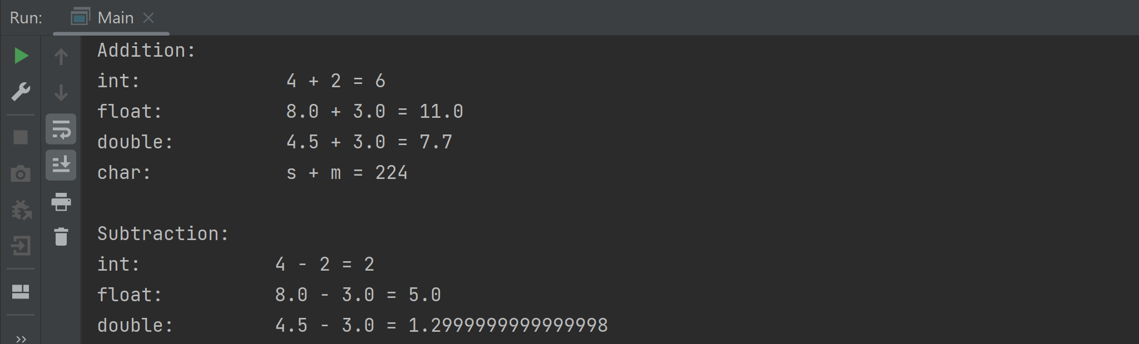

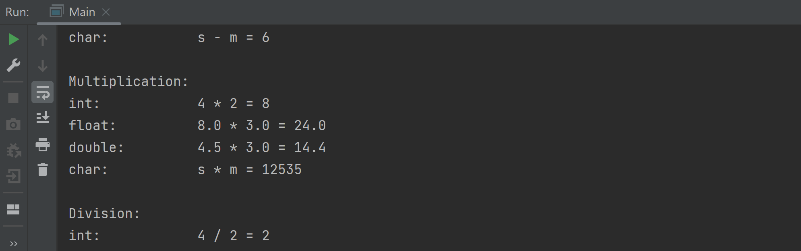

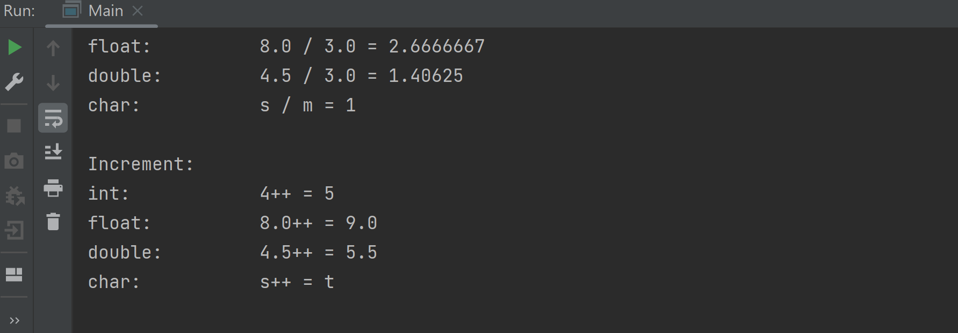

1. **Write program to perform all the arithmetic operations given in the table.**

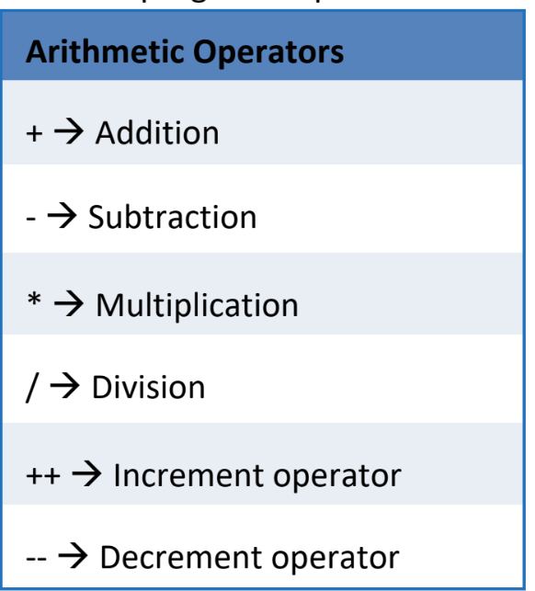

**Program**

import java.util.Scanner;

public class Arithmetic {

public static void main(String[] args){

Scanner input = new Scanner(System.in);

System.out.println("\n Enter 1 for Addition \n Enter 2 for Subtraction \n Enter 3 for Multiplication \n Enter 4 for Division \n Enter 5 for Increment \n Enter 6 for Decrement \n Enter your choice:");

int choice = input.nextInt();

switch (choice){

case 1:

System.out.println("Enter the 1st number:");

int num1 = input.nextInt();

System.out.println("Enter the 2nd number:");

int num2= input.nextInt();

int result = num1+num2;

System.out.println("Result is :" + result);

break;

case 2:

System.out.println("Enter the 1st number:");

num1= input.nextInt();

System.out.println("Enter the 2nd number:");

num2 = input.nextInt();

result= num1-num2;

System.out.println("Result is :" + result);

break;

case 3:

System.out.println("Enter the 1st number:");

num1 = input.nextInt();

System.out.println("Enter the 2nd number:");

num2 = input.nextInt();

result = num1*num2;

System.out.println("Result is :" + result);

break;

case 4:

System.out.println("Enter the 1st number:");

num1 = input.nextInt();

System.out.println("Enter the 2nd number:");

num2 = input.nextInt();

result = num1/num2;

System.out.println("Result is :" + result);

break;

case 5:

System.out.println("Enter the number:");

num1= input.nextInt();

num1= ++num1;

System.out.println("Result is :" + num1);

break;

case 6:

System.out.println("Enter the number:");

num1= input.nextInt();

num1 = --num1;

System.out.println("Result is :" + num1);

break;

default:

System.out.println("Invalid input");

}

}

}

**Output**

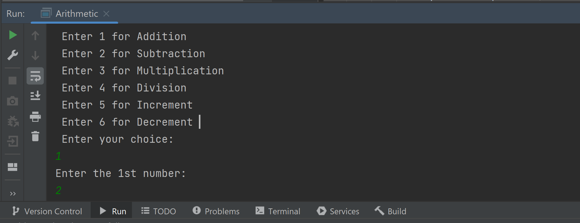

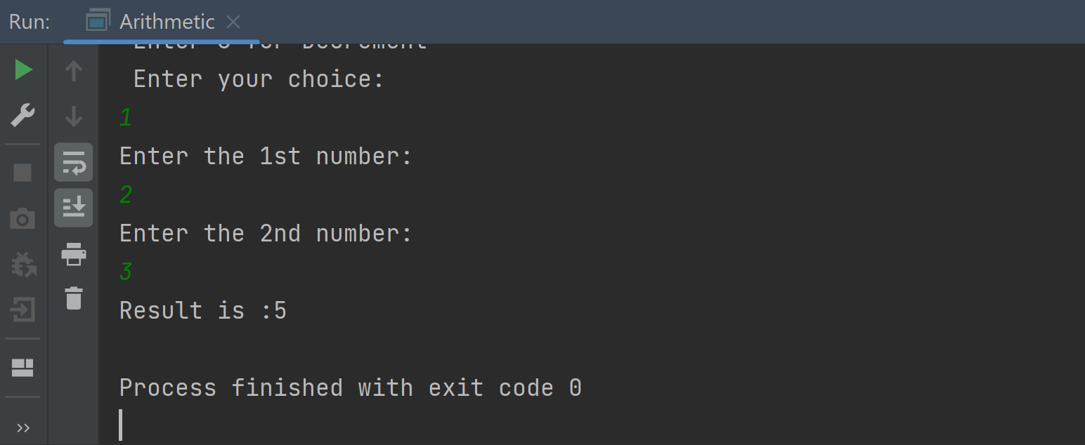

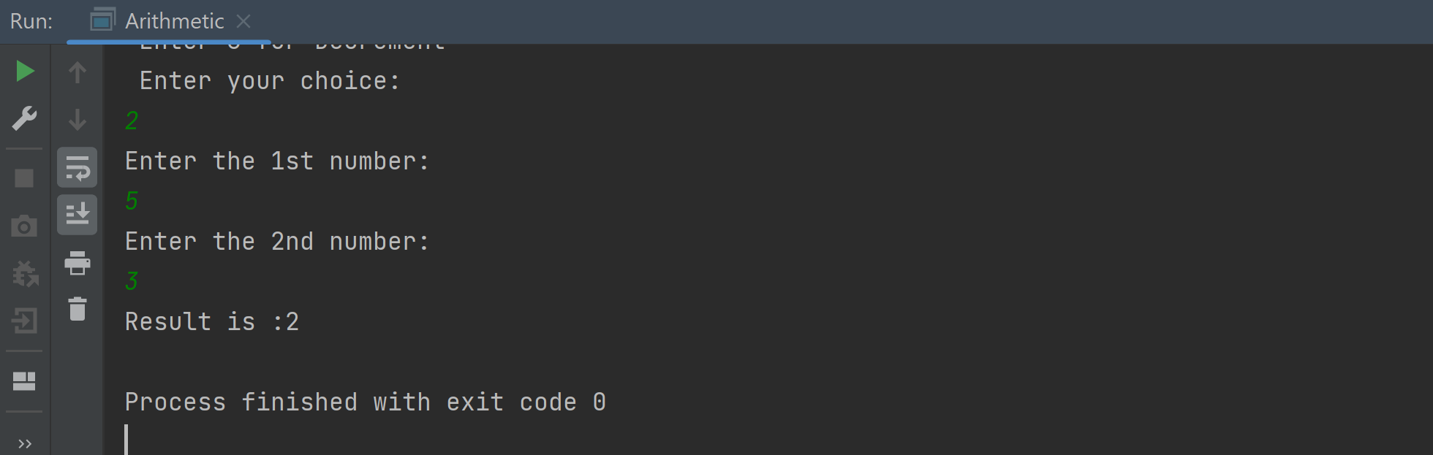

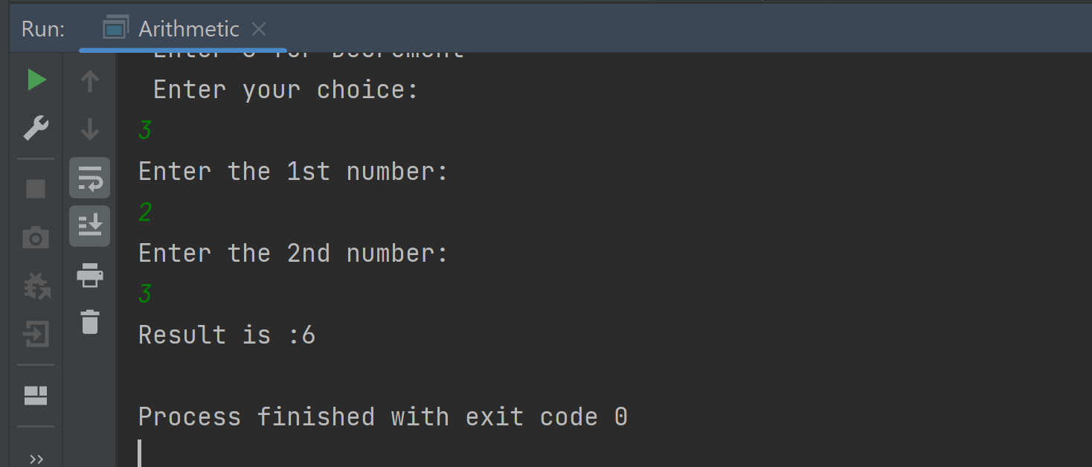

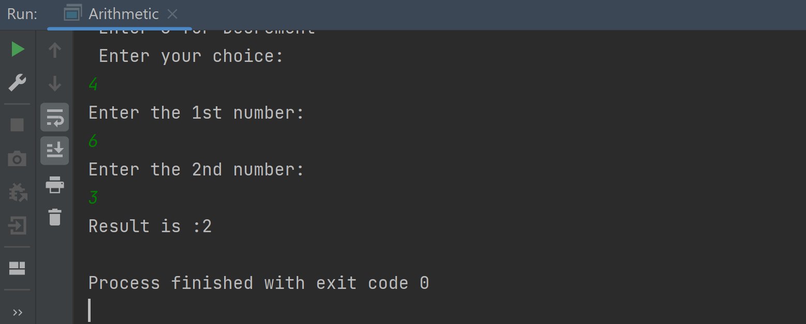

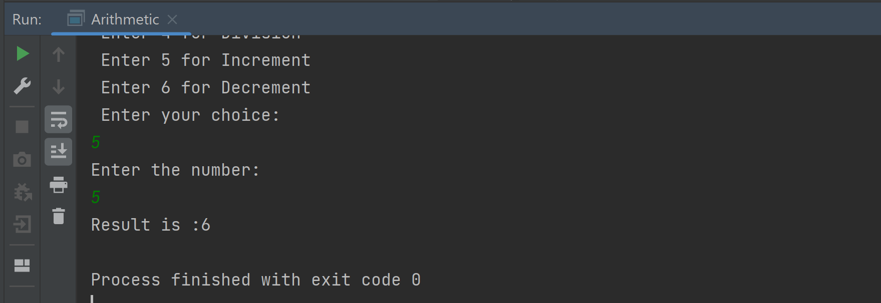

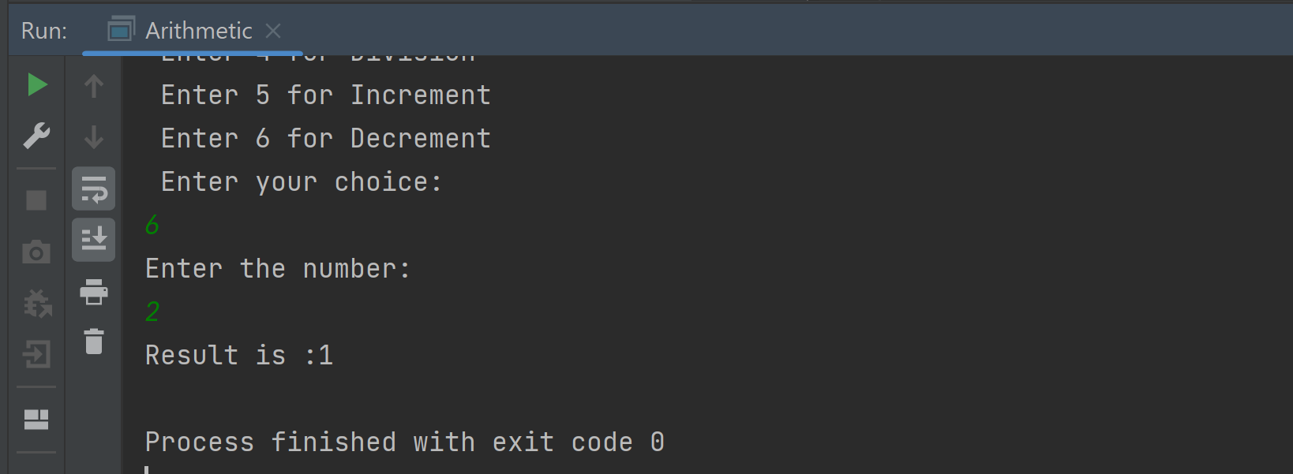

**If Condition**

1. **Write a program to check if a candidate is eligible for the voting or not.**

**Program**

public class Main {

public static void main (String args[]) {

int age = 15;

if (age < 18) {

System.out.println("Not eligible for voting");

} else {

System.out.println("Eligible for voting");

}

}

}

**Output**

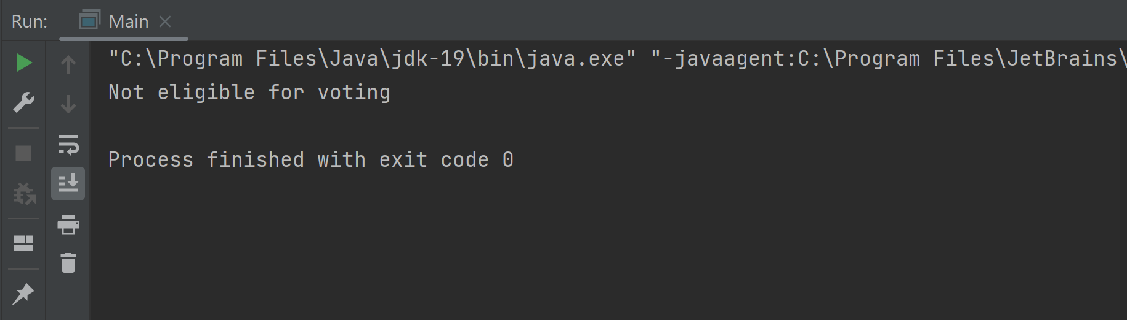

1. **Write a program to check if a number is positive or negative.**

**Program**

public class Main {

public static void main(String[] args) {

int num = 10;

if (num < 0) {

System.out.println("The number is negative");

} else {

System.out.println("The number is positive");

}

}

}

**Output**

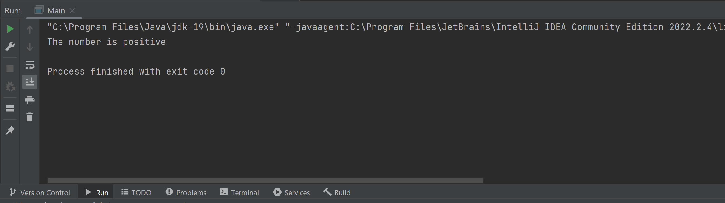

1. **Extend the previous program to check whether the given number is positive, zero or negative.**

**Program**

public class Main {

public static void main(String[] args) {

int num=10;

if(num<0){

System.out.println("The number is negative");

}

else if(num>0){

System.out.println("The number is positive");

}

else if(num==0){

System.out.println("The number is equal");

}

else{

System.out.println("Invalid input");

}

}

}

**Output**

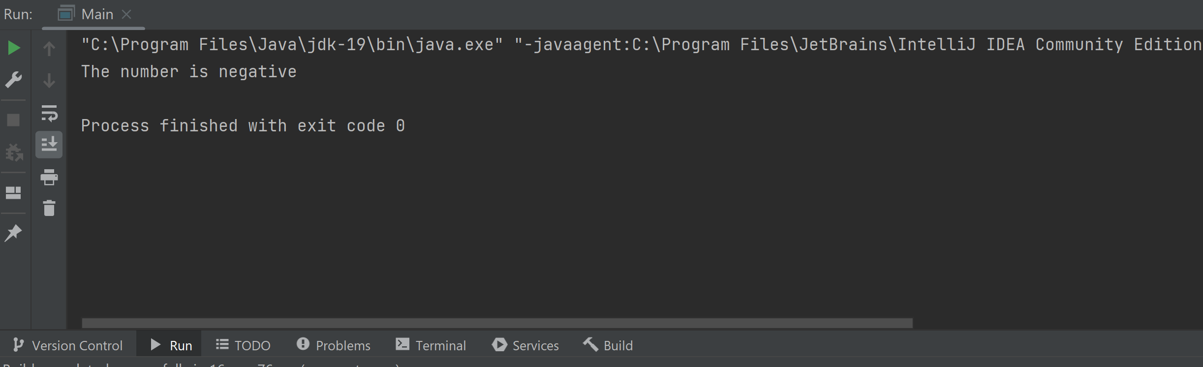

1. **Write a program to find largest of two numbers.**

**Program**

public class Main {

public static void main(String[] args) {

int num1=10;

int num2=5;

if(num1>num2){

System.out.println("Num1 is greater than Num2");

}else{

System.out.println("Num2 is greater than Num1");

}

}

}

**Output**

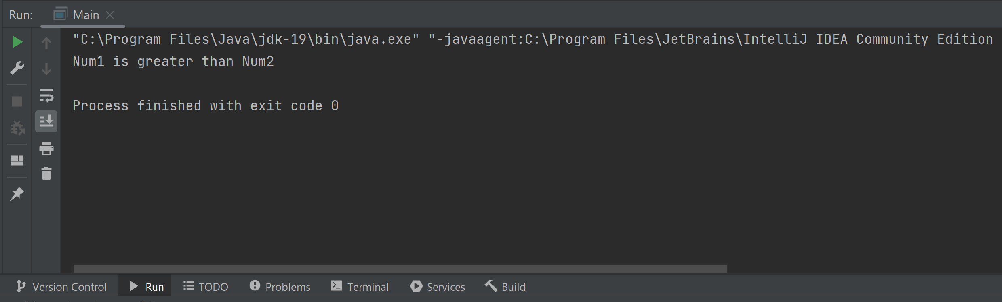

1. **Write a program to check given number is even or odd.**

**Program**

public class Main {

public static void main(String[] args) {

int num=10;

if(num%2==0){

System.out.println("The number is even");

}else{

System.out.println("The number is odd");

}

}

}

**Output**

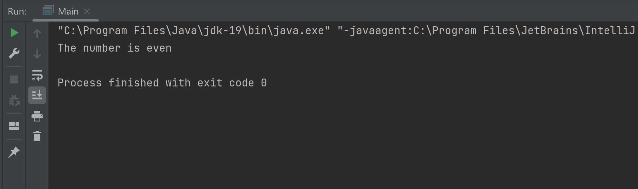

**For Loop**

1. **Write a program to print 10 even numbers and 10 odd numbers.**

**Program**

public class Main {

public static void main(String[] args) {

for (int i = 0; i < 20; i++) {

if (i % 2 == 0) {

System.out.println("Even number" + i);

} else {

System.out.println("Odd number" + i);

}

} }}

**Output**

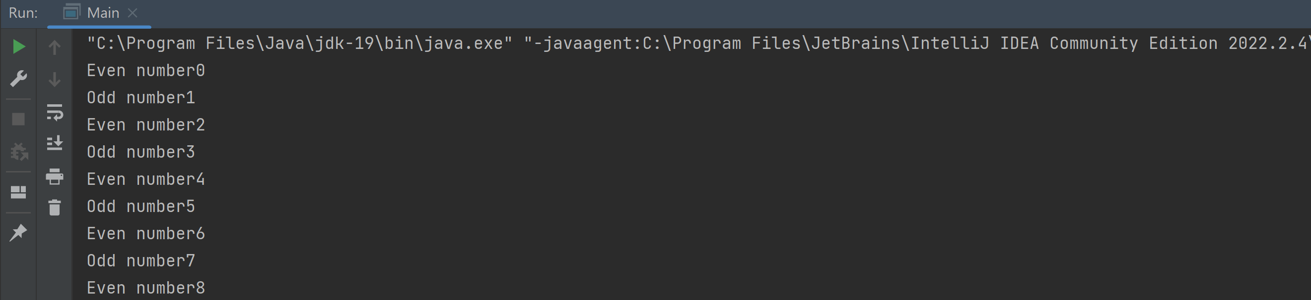

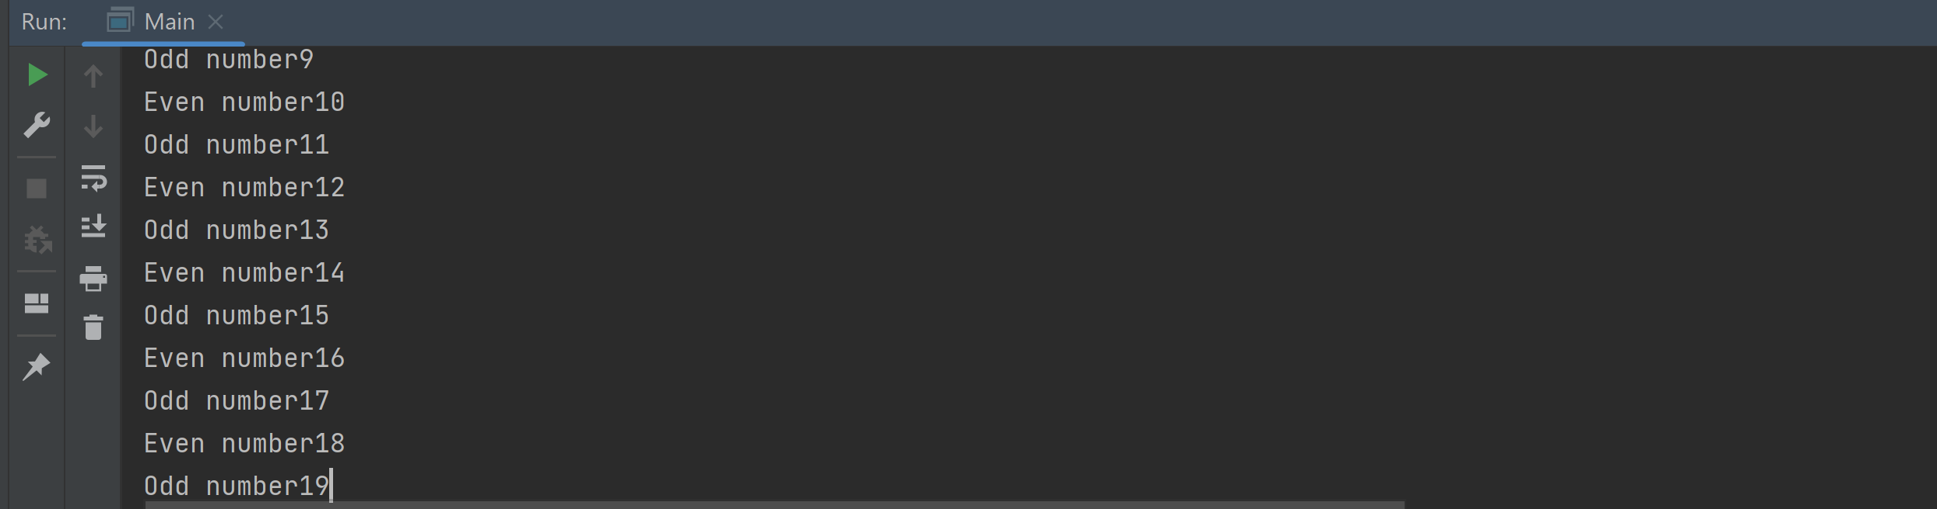

1. **Write a program to find factorial of a number.**

**Program**

public class Main {

public static void main(String args[]){

int i,fact=1;

int num=15;

for(i=1;i<=num;i++){

fact=fact*i;

}

System.out.println("Factorial of "+num+" is: "+fact);

}

}

**Output**

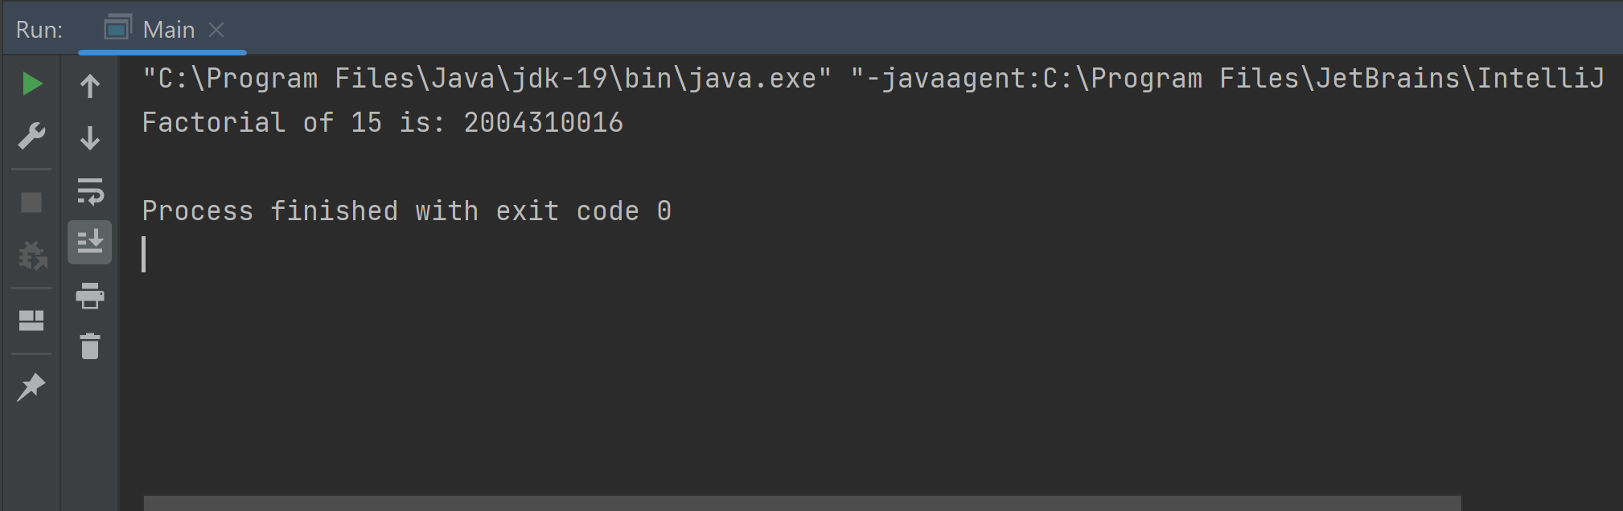

1. **Write a program to generate tables of 10.**

**Program**

public class Main {

public static void main(String[] args) {

int num=10;

int result;

for(int i=0;i<=10;i++){

result=i*num;

System.out.println("10*"+i+"="+result);

}

}

}

**Output**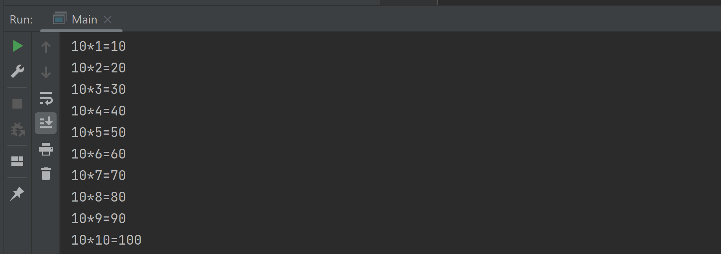

1. **Write a program to add the digits of a number.**

**Program**

public class Main {

public static void main(String[] args) {

String digit="3653653";

int len=digit.length();

int sum=0;

for(int i=0;i<len;i++){

sum+=Integer.parseInt(Character.toString(digit.charAt(i)));

}

System.out.println(sum); }

}

**Output**

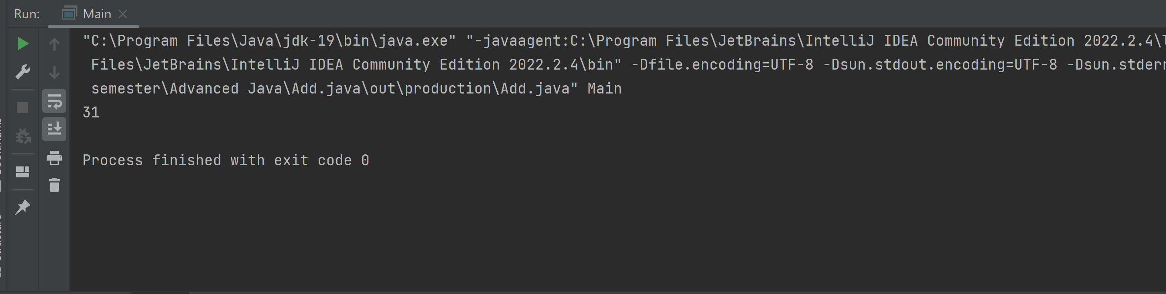

1. **Write a program to reverse the digits of a number.**

**Program**

public class Main {

public static void main(String[] args) {

int num=5678,rev=0;

for (int i = num; i != 0; i /= 10)

{

int x = i % 10;

rev = rev * 10 + x;

}

System.out.println("The reverse of digits of " + num + " is " + rev);

}

}

**Output**

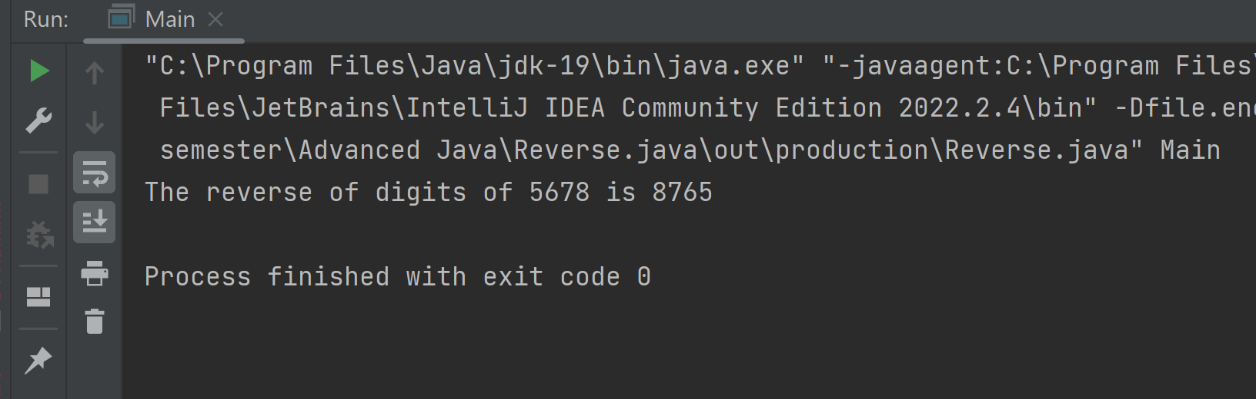

1. **Write a program to generate 10 Fibonacci numbers.**

**Program**

public class Main {

public static void main(String[] args) {

int a=0,b=1;

int c,count=10;

System.out.print(a+" "+b);

for(int i=2;i<count;i++){

c=a+b;

System.out.print(" "+c);

a=b;

b=c;

}

}

}

**Output**

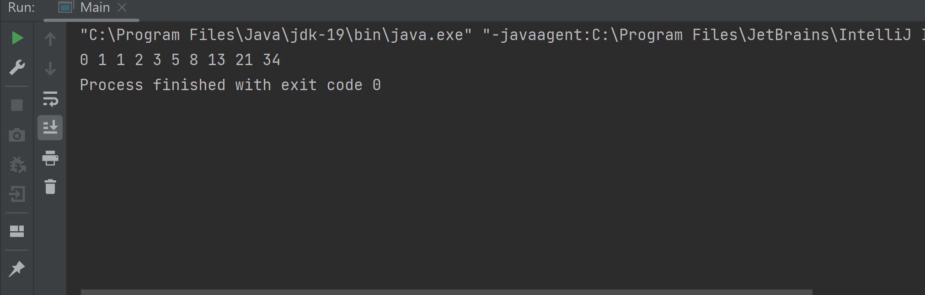

**While Loop**

1. **Write a program to print 10 even numbers and 10 odd numbers.**

**Program**

public class Main {

public static void main(String[] args) {

int num=0;

while(num<20){

num++;

if(num%2==0){

System.out.println(num + "is even ");

}else{

System.out.println(num +"is odd");

}

}

}

}

**Output**

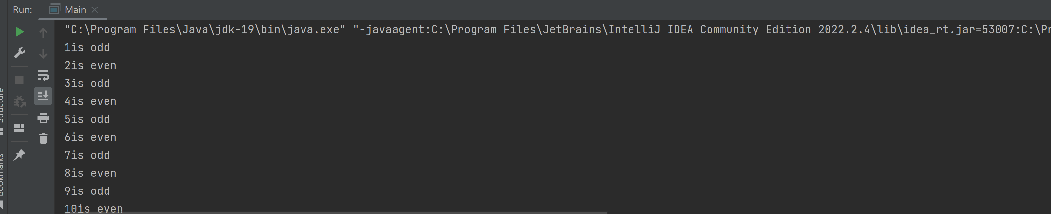

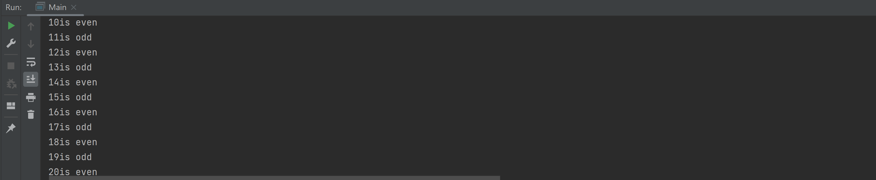

1. **Write a program to find factorial of a number.**

**Program**

public class Main {

public static void main(String[] args) {

int fact=1;

int i=1,num=5;

while(i<=num){

fact=fact*i;

i++;

}

System.out.println("Factorial of "+num+" is: "+fact);

}

}

**Output**

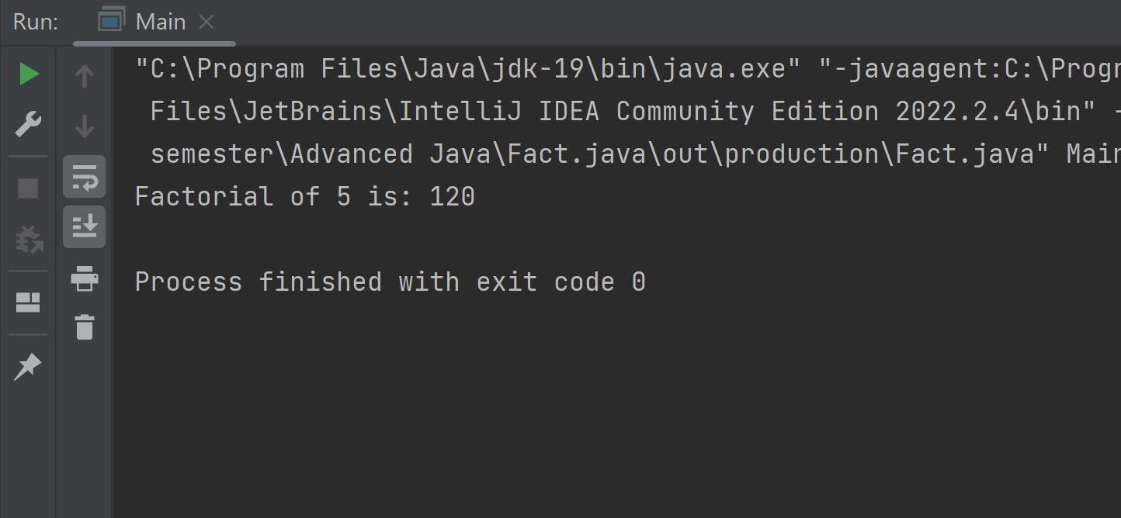

1. **Write a program to generate tables of 10.**

**Program**

public class Main {

public static void main(String[] args) {

int num=10;

int i=1;

while(i<11){

System.out.printf("%d * %d = %d \n", num, i, num * i);

i++;

}

}

}

**Output**

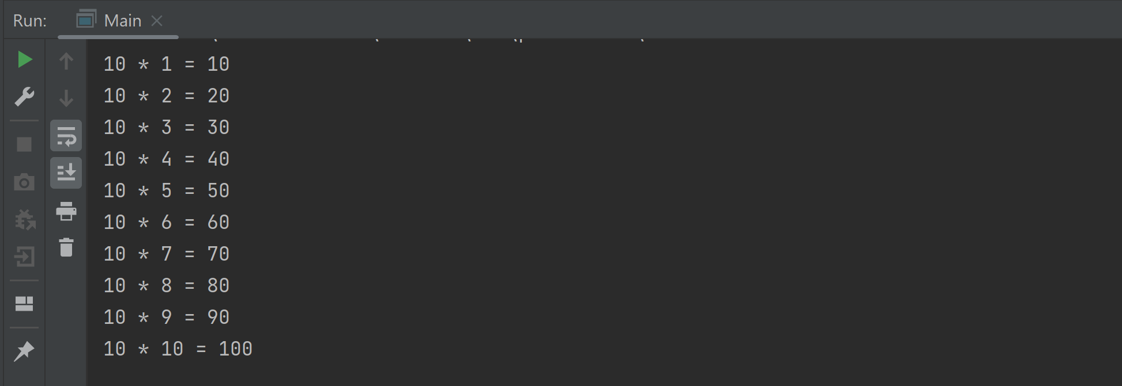

1. **Write a program to add the digits of a number.**

**Program**

public class Main {

public static void main(String[] args) {

int n = 89, sum = 0, i = n;

while (i != 0) {

int x = i % 10;

sum += x;

i /= 10;

}

System.out.println("The sum of digits of " + n + " is " + sum);

}

}

**Output**

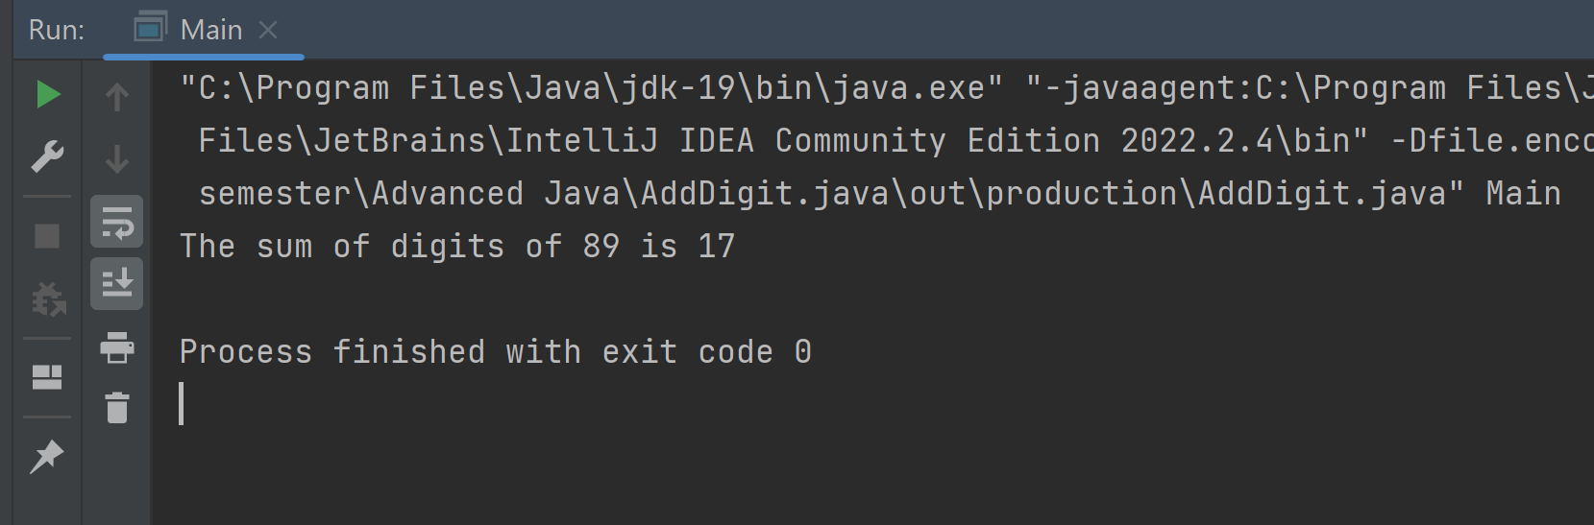

1. **Write a program to reverse the digits of a number.**

**Program**

public class Main {

public static void main(String[] args) {

int rev=0,num=59,i=num;

while (i != 0)

{

int x = i % 10;

rev = rev * 10 + x;

i /= 10;

}

System.out.println("The reverse of digits of " + num + " is " + rev);

}

}

**Output**

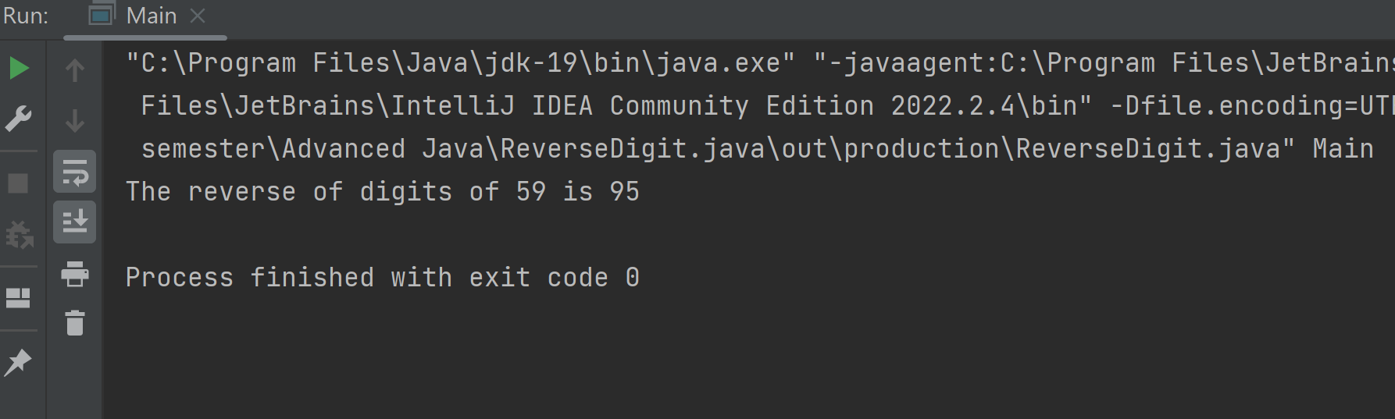

1. **Write a program to generate 10 Fibonacci numbers.**

**Program**

public class Main {

public static void main(String[] args) {

int a = 0, b = 1;

int c, count = 10;

int i = 0;

while (i < count) {

System.out.print(a + " ");

c = a + b;

a = b;

b = c;

i++;

}

}

}

**Output**

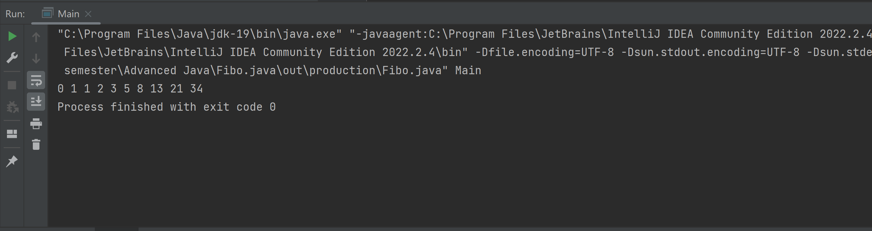

**Do-While Loop**

1. **Write a program to print 10 even numbers and 10 odd numbers.**

**Program**

public class Main {

public static void main(String[] args) {

int num=0;

do{

num++;

if(num%2==0){

System.out.println(num + "is even ");

}else{

System.out.println(num +"is odd");

}

}while(num<20);

}

}

**Output**

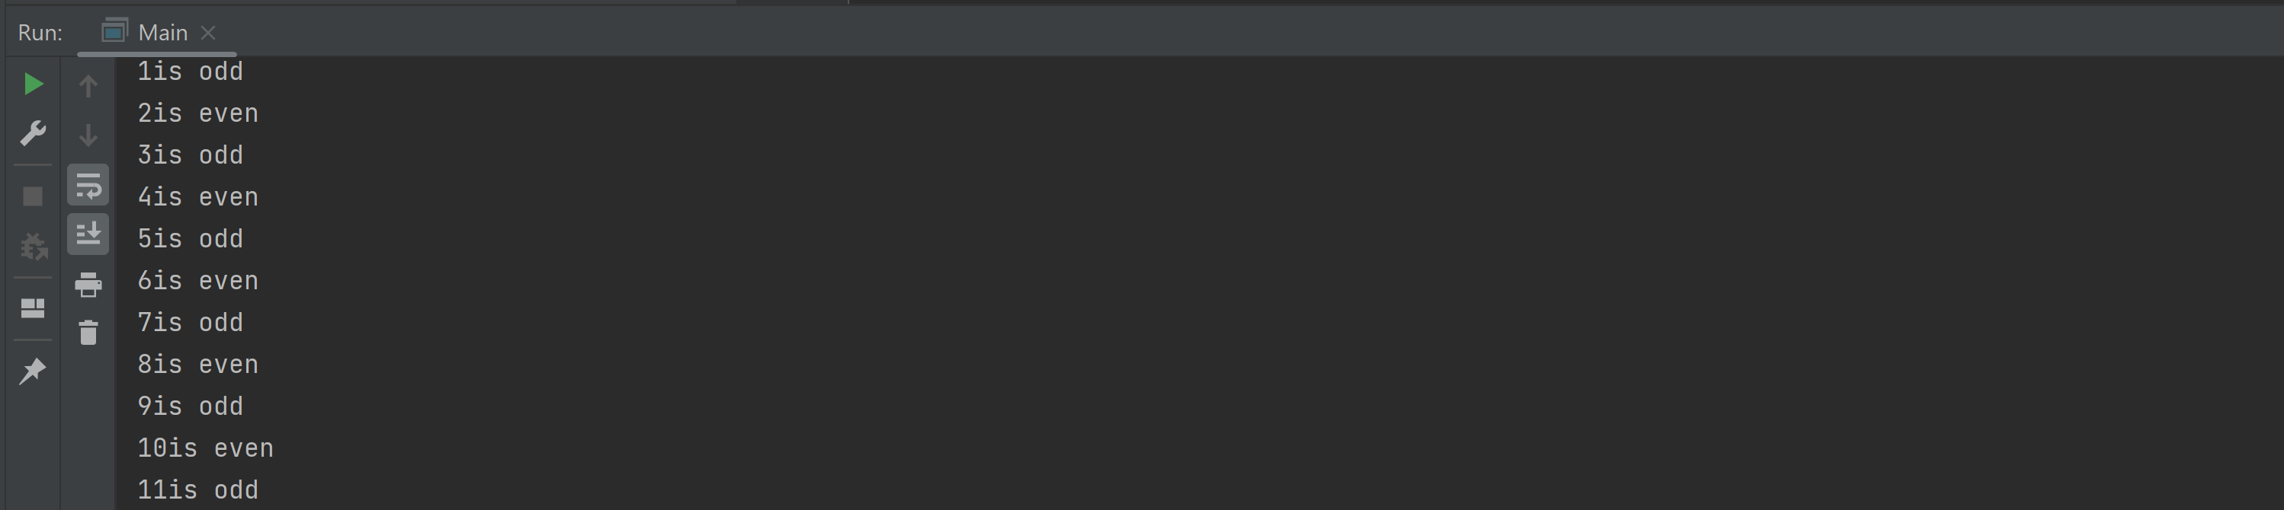 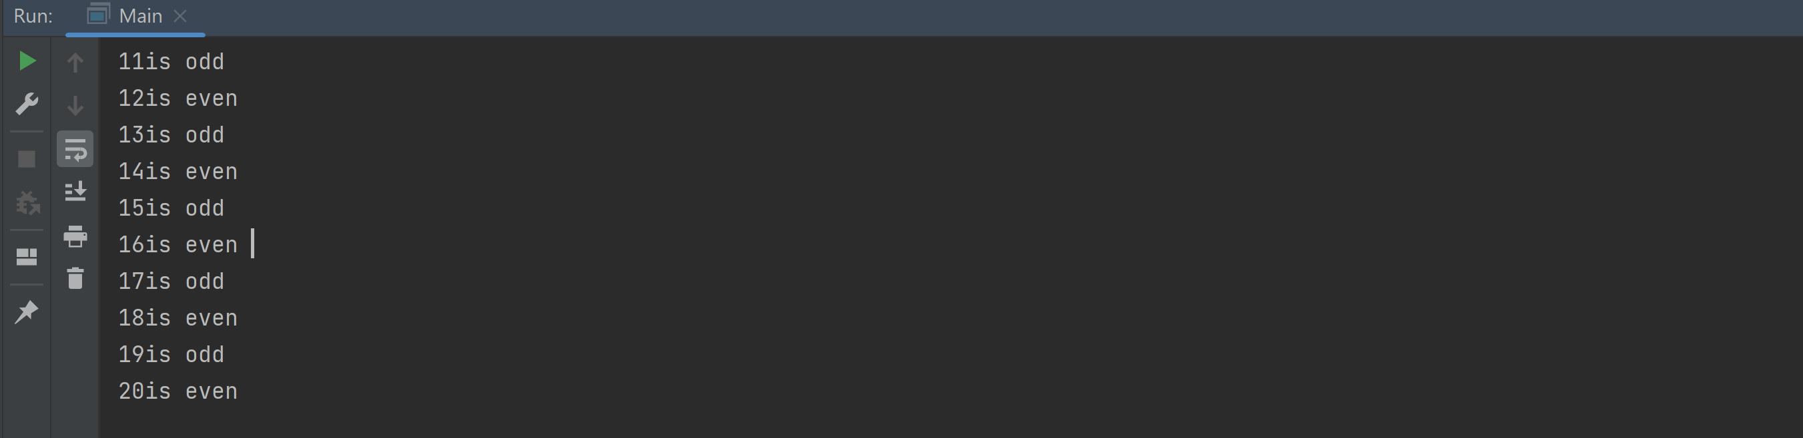

1. **Write a program to find factorial of a number.**

**Program**

public class Main {

public static void main(String[] args) {

int fact=1;

int i=1,num=5;

do{

fact=fact*i;

i++;

}while(i<=num);

System.out.println("Factorial of "+num+" is: "+fact);

}

}

**Output**

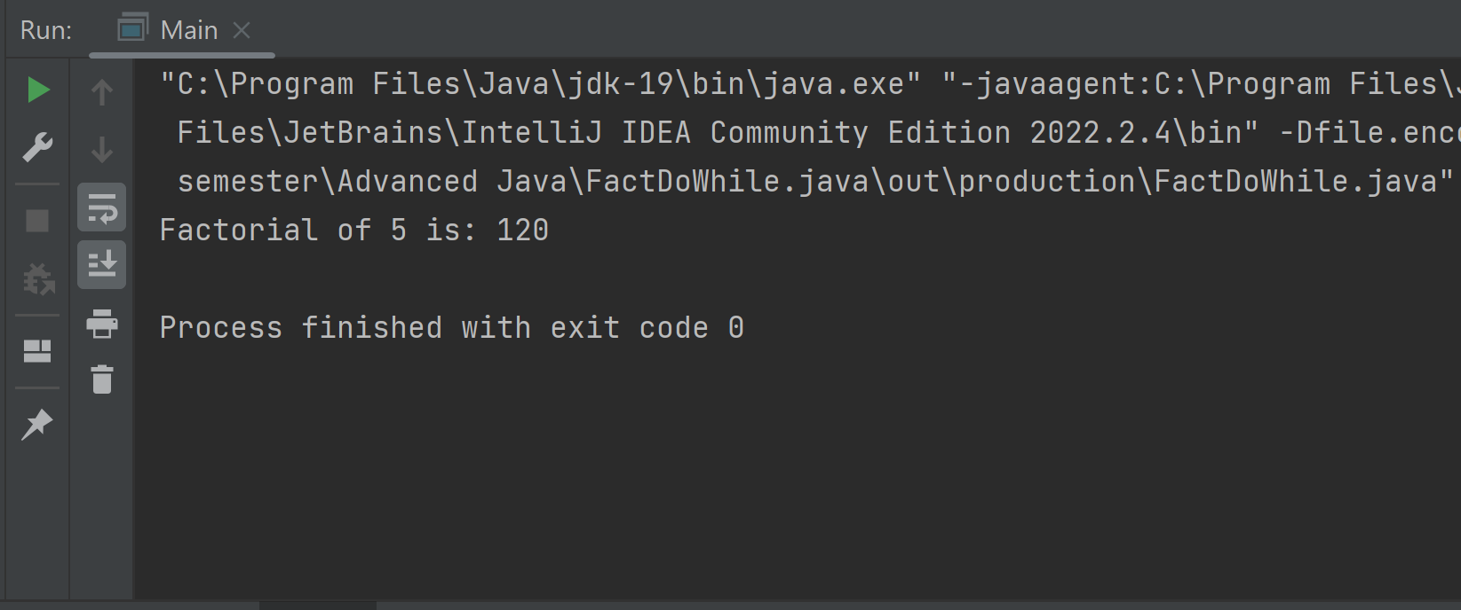

1. **Write a program to generate tables of 10.**

**Program**

public class Main {

public static void main(String[] args) {

int num=10;

int i=1;

do{

System.out.printf("%d * %d = %d \n", num, i, num * i);

i++;

}while(i<11);

}

}

**Output**

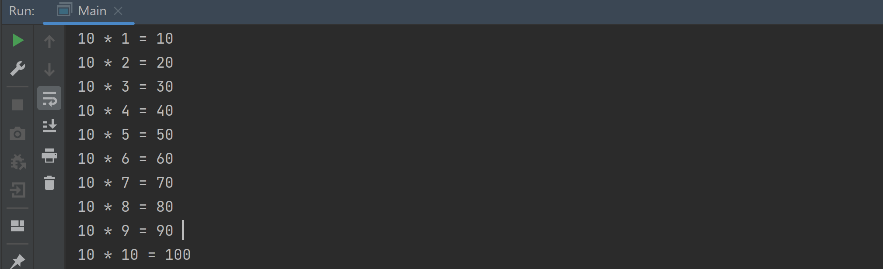

1. **Write a program to add the digits of a number.**

**Program**

public class Main {

public static void main(String[] args) {

int n = 89, sum = 0, i = n;

do {

int x = i % 10;

sum += x;

i /= 10;

}while (i != 0);

System.out.println("The sum of digits of " + n + " is " + sum);

}

}

**Output**

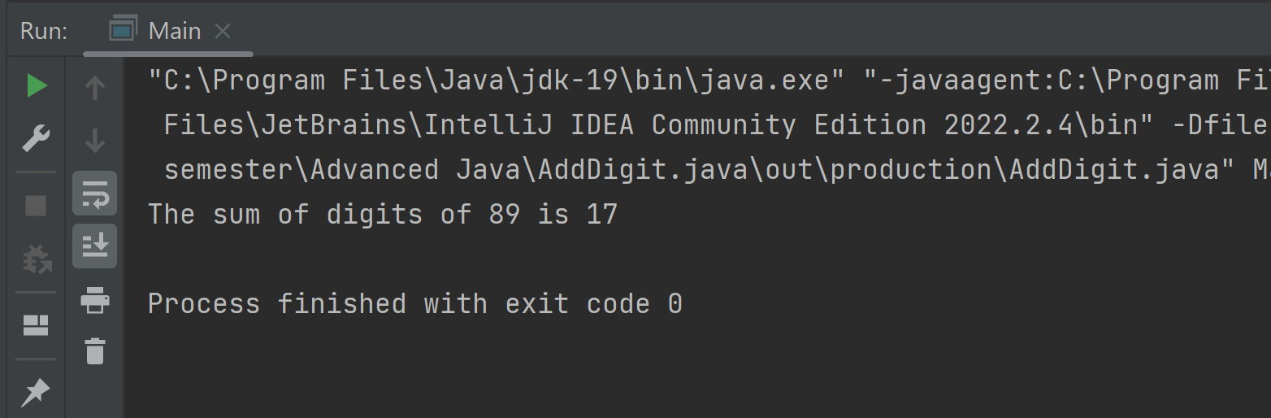

1. **Write a program to reverse the digits of a number.**

**Program**

public class Main {

public static void main(String[] args) {

int rev=0,num=59,i=num;

do{

int x = i % 10;

rev = rev * 10 + x;

i /= 10;

} while (i != 0);

System.out.println("The reverse of digits of " + num + " is " + rev);

}

}

**Output**

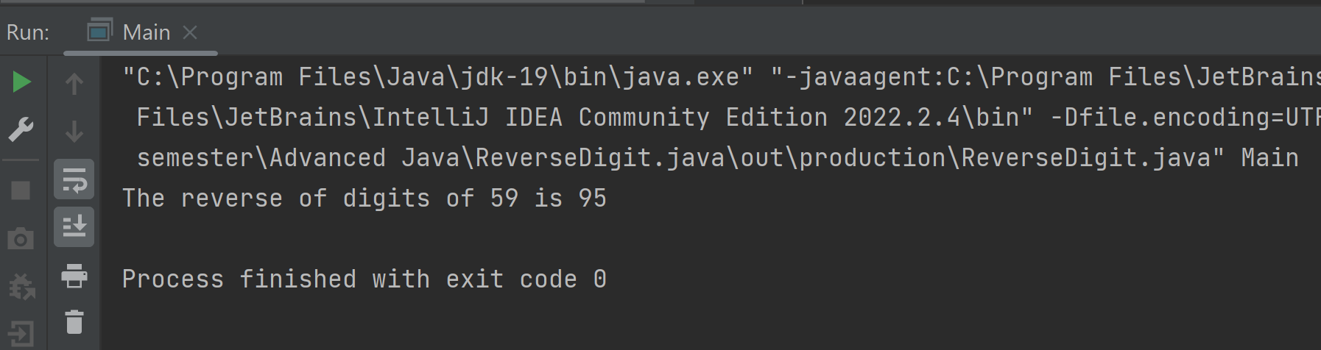

1. **Write a program to generate 10 Fibonacci numbers.**

**Program**

public class Main {

public static void main(String[] args) {

int a = 0, b = 1;

int c, count = 10;

int i = 0;

do {

System.out.print(a + " ");

c = a + b;

a = b;

b = c;

i++;

} while (i < count);

}

}

**Output**

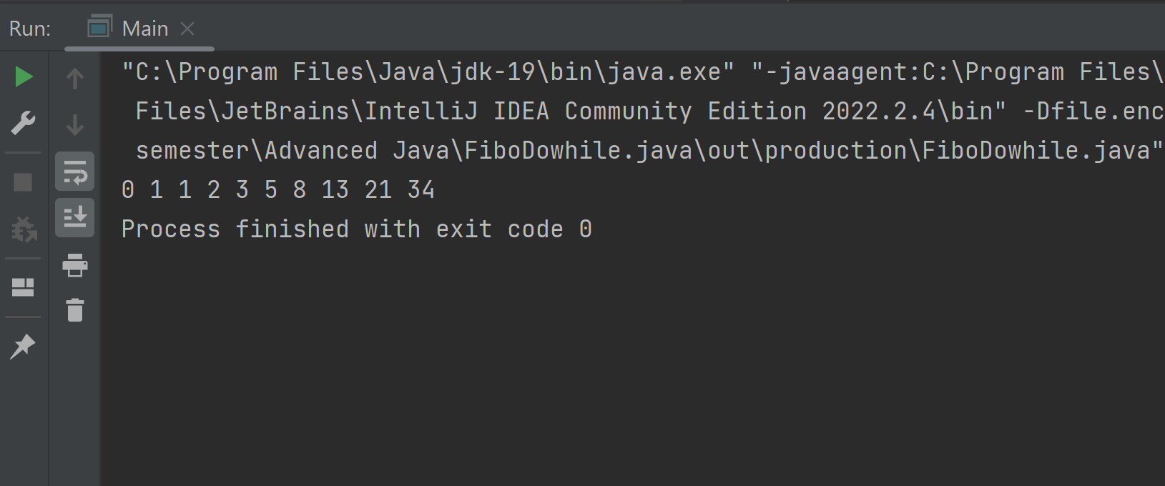

**Case Study**

1. **An Amusement Park company wants one application for their billing counter to enable ticket sale. Assume the Amusement Park authorities approached Max to get this application developed. This application should have ticket prize as Rs 400 per person and if a person buys more than 10 tickets then person is eligible for 10 percent discount. Calculate the total bill or amount according to the number of tickets that are sold.**

**Program**

**public class Main {**

public static void main(String[] args) {

int price = 400;

int number = 25;

int amount, discount;

if (number > 10) {

amount = price * number;

discount = amount * 10 / 100;

amount = amount - discount;

} else {

amount = price * number;

discount = 0;

}

System.out.println("The total amount for " + number + " tickets at rate of Rs." +

price + " per ticket is " + amount);

System.out.println("You received Rs." + discount + " as discount");

}

}

**Output**

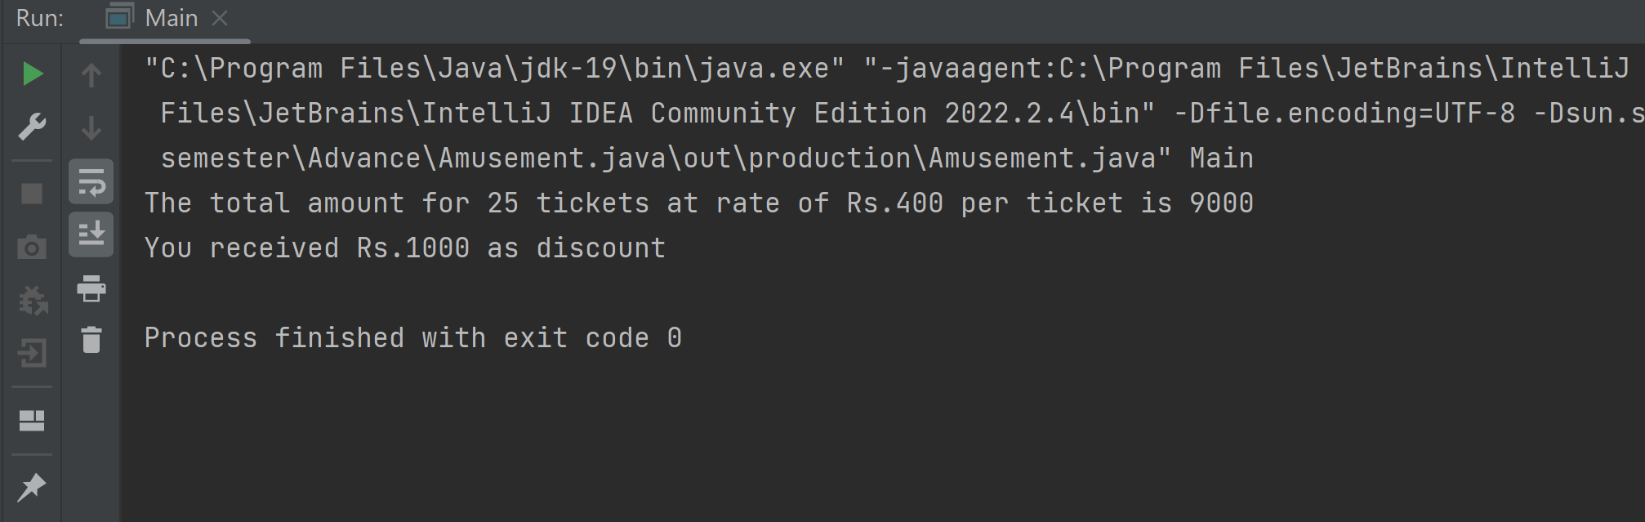

1. **John and Paul went to watch a movie in theatre where they need to buy two tickets. There are two types of tickets, one Golden category and other as silver category. If they buy tickets for silver category, then per person a ticket should cost Rs.150 and for golden category ticket should cost them Rs.200 each. Considering this scenario, write a program for theatre ticket booking application scenario.**

**Program**

public class Main {

public static void main(String[] args) {

String category = "golden";

int price = 0;

if(category.equals("golden"))

{

price = 200;

}

else if (category.equals("silver"))

{

price = 150;

}

System.out.println("The category chosen is " + category + " and price is Rs. " + price);

}

}

**Output**

