## Table 4.1 Year of shop establishment.

|  |  |  |
| --- | --- | --- |
| **Year** | **No. of respondents** | **Percentage (%)** |
| Before 1990 | 1 | 2 |
| 1991 – 1995 | 0 | 0 |
| 1996 – 2000 | 3 | 6 |
| 2001 – 2005 | 3 | 6 |
| 2006 – 2010 | 10 | 20 |
| 2011 – 2015 | 15 | 30 |
| 2016 – 2020 | 18 | 36 |
| **Total** | **50** | **100** |

(Source: Primary Data)

## Fig. 4.1 Year of shop establishment

|  |  |  |  |  |  |  |  |
| --- | --- | --- | --- | --- | --- | --- | --- |
| 40  35  30  25  20  15  10  5  0 |  | | | | | | |
|  | Before | 1991 - | 1996 - | 2001 - | 2006 - | 2011 - | 2016 - |
|  | 1990 | 1995 | 2000 | 2005 | 2010 | 2015 | 2020 |
| **Interpretation** |  |  |  |  |  |  |  |

From the above information we can interpret that more (36%) shops were established from 2016-2020 and no shops were established from 1991-1995.

## Table 4.2 Year of shop computerization.

|  |  |  |
| --- | --- | --- |
| **Year** | **No. of respondents** | **Percentage (%)** |
| Before 1990 | 0 | 0 |
| 1991 – 1995 | 0 | 0 |
| 1996 – 2000 | 0 | 0 |
| 2001 – 2005 | 2 | 4 |
| 2006 – 2010 | 4 | 8 |
| 2011 – 2015 | 14 | 28 |
| 2016 – 2020 | 30 | 60 |
| **Total** | **50** | **100** |

(Source: Primary Data)

## Fig. 4.2 Year of shop computerization

70

60

50

40

30

20

10

0

Before 1991 - 1996 - 2001 - 2006 - 2011 - 2016 -

1990 1995 2000 2005 2010 2015 2020

**Interpretation**

From the above information we can interpret that more(60%) shops were computerized from 2016-2020 and no shops were computerised before 2000.

## Table 4.3 Satisfaction after computerization.

|  |  |  |
| --- | --- | --- |
| **Yes/No** | **No. of respondents** | **Percentage (%)** |
| Yes | 50 | 100 |
| No | 0 | 0 |
| **Total** | **50** | **100** |

(Source: Primary Data)

## Fig. 4.3 Satisfaction after computerization

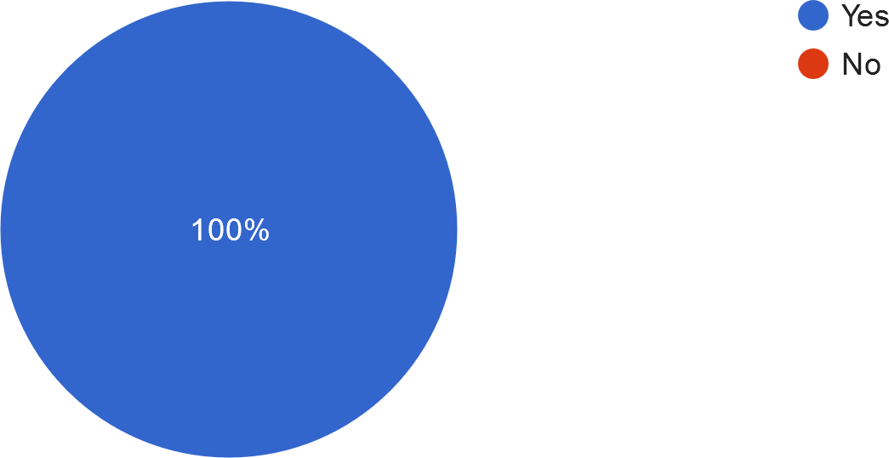

**Interpretation**

From the above information we can interpret that 100% of the population are satisfied after computerization.

## Table 4.4 Advantages after computerization of shop.

|  |  |  |
| --- | --- | --- |
| **Advantages** | **No. of respondents** | **Percentage (%)** |
| Less time consuming | 5 | 10 |
| Safe and reliable | 4 | 8 |
| All of the above | 41 | 82 |
| **Total** | **50** | **100** |

(Source: Primary Data)

## Fig. 4.4 Advantages after computerization of shop

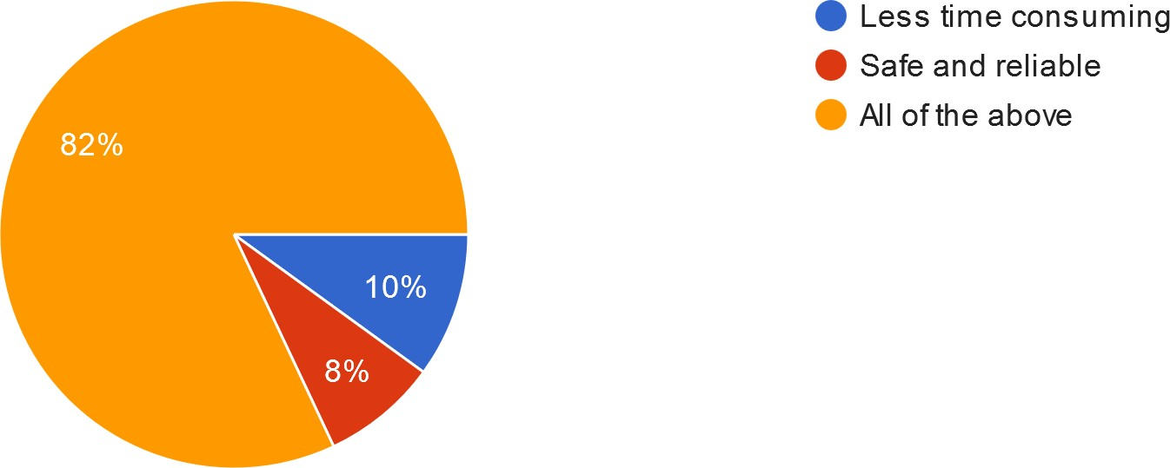

**Interpretation**

From the above information we can interpret that 82% of the population chose ‘All of the above’, which means both the factors are advantages after computerization.

## Table 4.5 Most used operation done in the computer.

|  |  |  |
| --- | --- | --- |
| **Operations** | **No. of respondents** | **Percentage (%)** |
| Billing/Accounting | 6 | 12 |
| Inventory Management | 5 | 10 |
| All of the above | 39 | 78 |
| **Total** | **50** | **100** |

(Source: Primary Data)

## Fig. 4.5 Most used operation done in the computer

Billing/Accounting Inventory Management All of the above

**Interpretation**

From the above information we can interpret that 78% of the population chose ‘All of the above’, which means Billing/Accounting and Inventory management is the most used operation done in computers.

## Table 4.6 Interest in purchasing the latest computer/software available in the market.

|  |  |  |
| --- | --- | --- |
| **Yes/No/Later** | **No. of respondents** | **Percentage (%)** |
| Yes | 20 | 40 |
| No | 13 | 26 |
| Later | 17 | 34 |
| **Total** | **50** | **100** |

(Source: Primary Data)

## Fig. 4.6 Interest in purchasing the latest computer/software available in the market

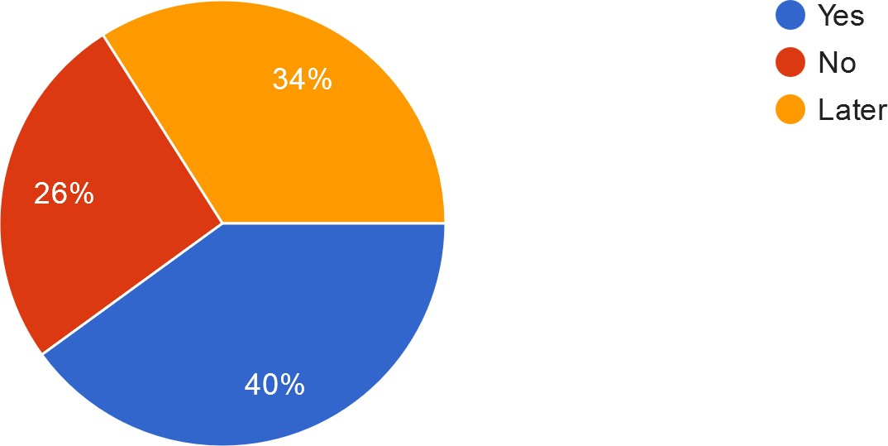

**Interpretation**

From the above information we can interpret that 40% of the population is interested in purchasing the latest computer/software available in the market.

## Table 4.7 Favorite computer brand.

|  |  |  |
| --- | --- | --- |
| **Brands** | **No. of respondents** | **Percentage (%)** |
| Apple | 8 | 16 |
| Samsung | 11 | 22 |
| Hp | 23 | 46 |
| Dell | 4 | 8 |
| Lenovo | 2 | 4 |
| Asus | 1 | 2 |
| Lg | 1 | 2 |
| **Total** | **50** | **100** |

(Source: Primary Data)

## Fig. 4.7 Favorite computer brand

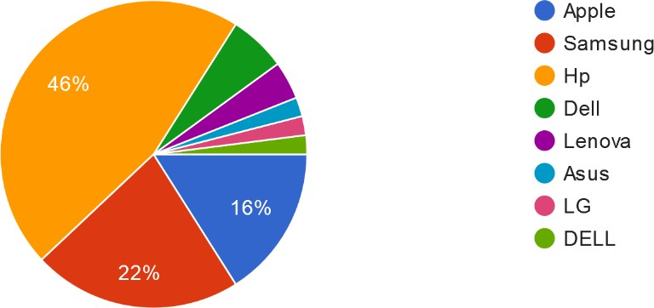

**Interpretation**

From the above information we can interpret that 16% of the population chose Apple, 22% of the population chose Samsung, 46% of the population chose Hp as their favorite computer brands.

## Table 4.8 Satisfaction with the computerization & technological advancement by the management.

|  |  |  |
| --- | --- | --- |
| **Satisfaction level** | **No. of respondents** | **Percentage (%)** |
| 1 | 0 | 0 |
| 2 | 6 | 12 |
| 3 | 44 | 88 |
| **Total** | **50** | **100** |

(Source: Primary Data)

## Fig. 4.8 Satisfaction with the computerization & technological advancement by the management

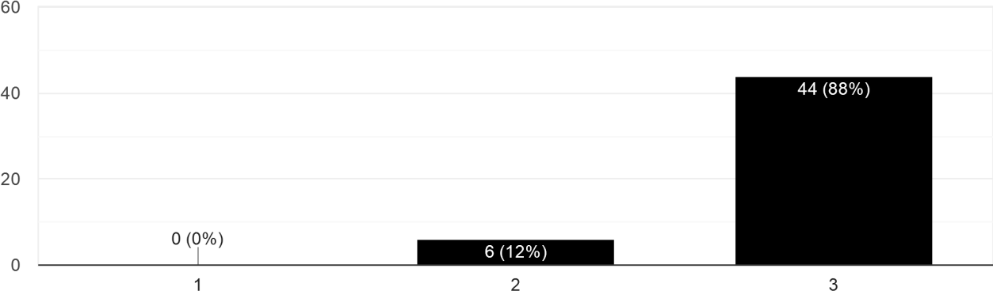

**Interpretation**

From the above information we can interpret that 88% of the population chose ‘3’, As their satisfaction level with the computerization & technological advancement by the management.

## Table 4.9 Management’s interest in upgrading the information technology in your retail shop.

|  |  |  |
| --- | --- | --- |
| **Yes/No** | **No. of respondents** | **Percentage (%)** |
| Yes | 49 | 98 |
| No | 1 | 2 |
| **Total** | **50** | **100** |

(Source: Primary Data)

## Fig. 4.9 Management’s interest in upgrading the information technology in your retail shop

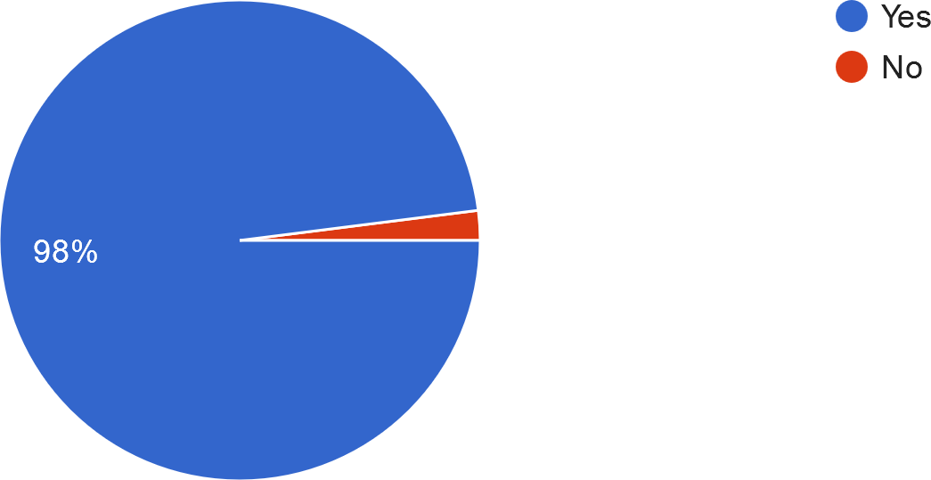

**Interpretation**

From the above information we can interpret that 98% of the population chose the management is interested in upgrading the IT in their retail shop.

## Table 4.10 Customer increase after the shop became computerized.

|  |  |  |
| --- | --- | --- |
| **Increase** | **No. of respondents** | **Percentage (%)** |
| Significant increase | 22 | 44 |
| Minor increase | 22 | 44 |
| No increase | 6 | 12 |
| **Total** | **50** | **100** |

(Source: Primary Data)

## Fig. 4.10 Customer increase after the shop became computerized

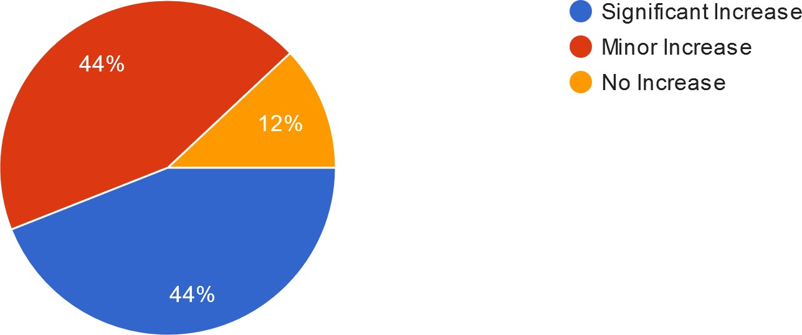

**Interpretation**

From the above information we can interpret that 44% of the population chose ‘Significant increase’, 44% of the population chose ‘Minor increase’ of customers after the shop became computerized.

## Table 4.11 Easiness of billing, accounting, book keeping, and managing.

|  |  |  |
| --- | --- | --- |
| **Yes/No** | **No. of respondents** | **Percentage (%)** |
| Yes | 49 | 98 |
| No | 1 | 2 |
| **Total** | **50** | **100** |

(Source: Primary Data)

## Fig. 4.11 Easiness of billing, accounting, book keeping, and managing

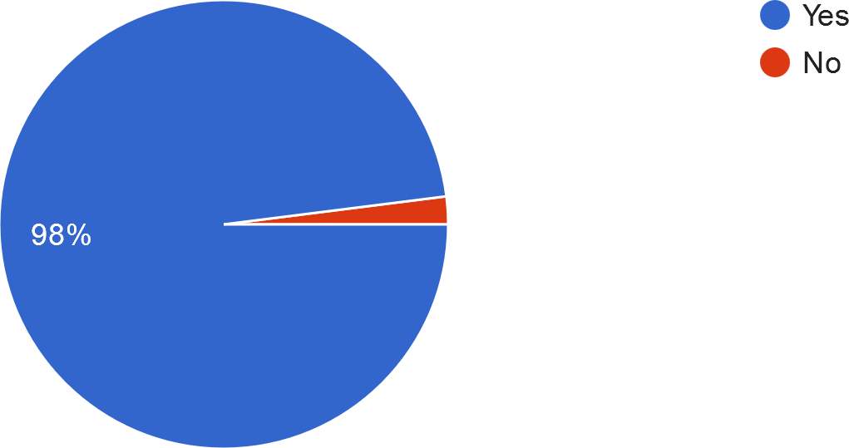

**Interpretation**

From the above information we can interpret that 98% of the population chose ‘Yes’, 2% of the population chose ‘No’.

## Table 4.12 Current situation of workload using computers.

|  |  |  |
| --- | --- | --- |
| **Workload** | **No. of respondents** | **Percentage (%)** |
| High | 9 | 18 |
| Average | 31 | 62 |
| Low | 10 | 20 |
| **Total** | **50** | **100** |

(Source: Primary Data)

## Fig. 4.12 Current situation of workload using computers

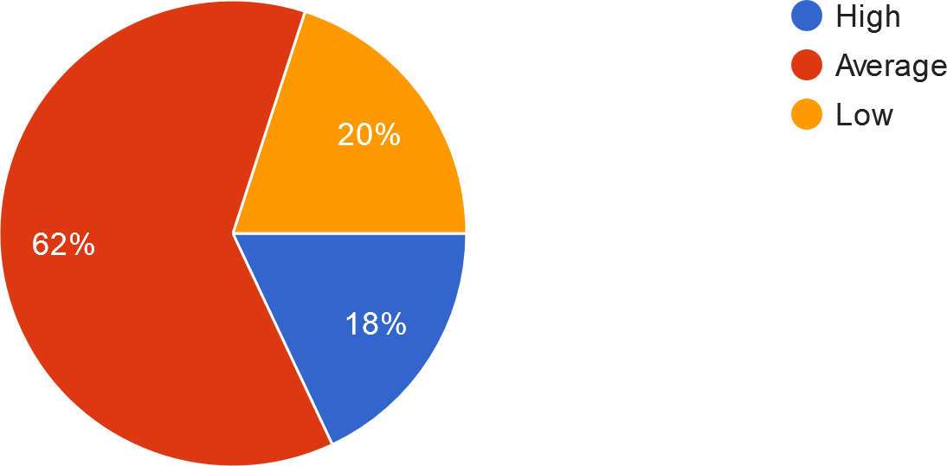

**Interpretation**

From the above information we can interpret that 62% of the population chose the workload of computers as ‘Average’.

## Table 4.13 Significant change in the shop while comparing the before & after experience after computerization.

|  |  |  |
| --- | --- | --- |
| **Yes/No** | **No. of respondents** | **Percentage (%)** |
| Yes | 45 | 90 |
| No | 5 | 10 |
| **Total** | **50** | **100** |

(Source: Primary Data)

## Fig. 4.13 Significant change in the shop while comparing the before & after experience after computerization

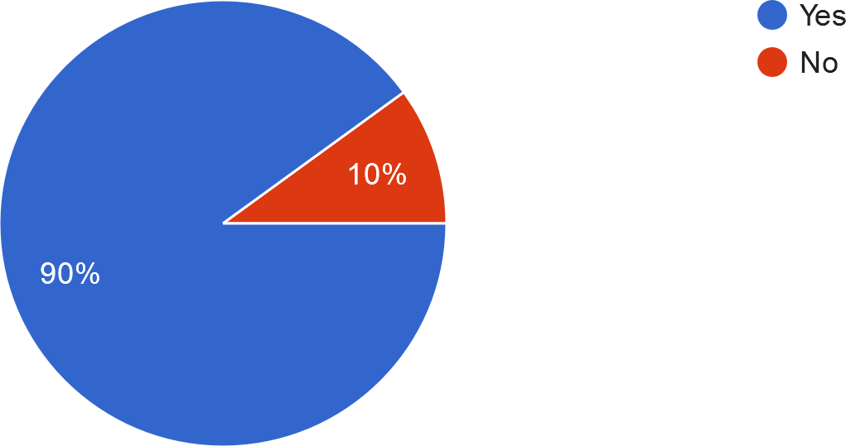

**Interpretation**

From the above information we can interpret that 90% of the population chose there is significant changes in the shop while comparing the before & after experience.

## Table 4.14 Technology used in your retail shop.

|  |  |  |
| --- | --- | --- |
| **Technology** | **No. of respondents** | **Percentage (%)** |
| Customer Relationship  Management (CRM) | 10 | 20 |
| Inventory Tracking  (EDI) | 10 | 20 |
| All of the above | 30 | 60 |
| **Total** | **50** | **100** |

(Source: Primary Data)

## Fig. 4.14 Technology used in your retail shop

Customer Relationship Management (CRM) Inventory Tracking (EDI) All of the above

**Interpretation**

From the above information we can interpret that (60%) both the technology is used in the retail shops.

## Table 4.15 Main purposes of using computers.

|  |  |  |
| --- | --- | --- |
| **Purpose** | **No. of respondents** | **Percentage (%)** |
| Keep a track of product  inventory | 4 | 8 |
| To aid in Accounting  and Billing | 5 | 10 |
| All of the above | 41 | 82 |
| **Total** | **50** | **100** |

(Source: Primary Data)

## Fig. 4.15 Main purposes of using computers

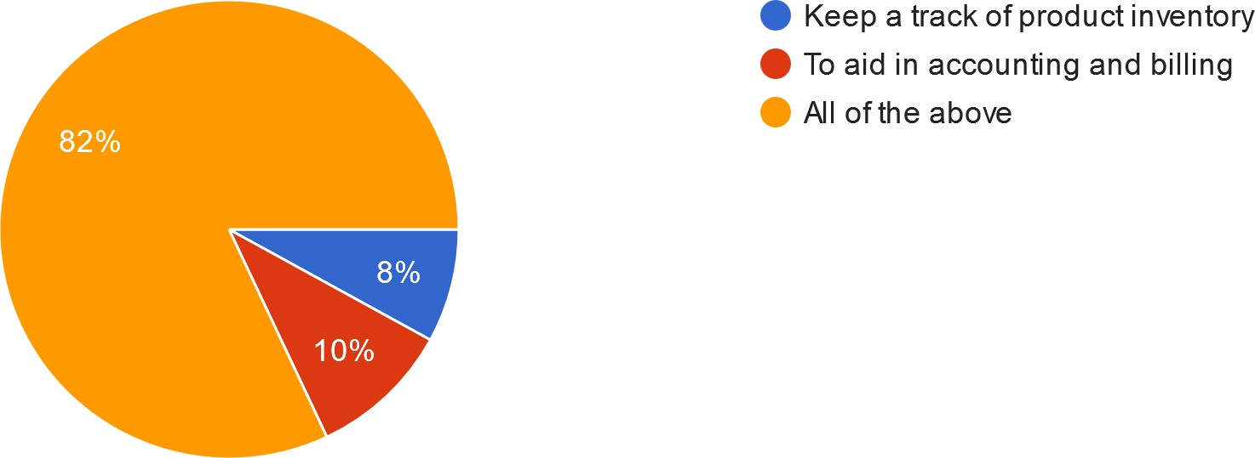

**Interpretation**

From the above information we can interpret that 82% of the population chose ‘All of the above’.

## Table 4.16 Technology to optimize marketing campaigns through computerization.

|  |  |  |
| --- | --- | --- |
| **Technology** | **No. of respondents** | **Percentage (%)** |
| Digitalization | 11 | 22 |
| Supply chain | 12 | 24 |
| All of the above | 27 | 54 |
| **Total** | **50** | **100** |

(Source: Primary Data)

## Fig. 4.16 Technology to optimize marketing campaigns through computerization

Digitalization

Supply chain

All of the above

**Interpretation**

From the above information we can interpret that 54% of the population chose both the technologies to optimize marketing campaigns through computerization.

## Table 4.17 Basic requirement for performing computerization.

|  |  |  |
| --- | --- | --- |
| **Purpose** | **No. of respondents** | **Percentage (%)** |
| Technological innovation  in retailing | 19 | 38 |
| Empirical analysis of  technological innovation | 12 | 24 |
| Identification and analysis  of technology | 19 | 38 |
| **Total** | **50** | **100** |

(Source: Primary Data)

## Fig. 4.17 Basic requirement for performing computerization

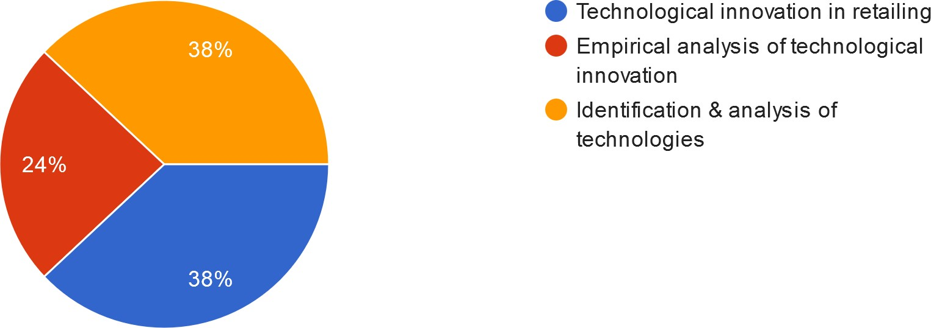

**Interpretation**

From the above information we can interpret that all the purposes have its own importance, thus all the above purposes are required for performing computerization.

## Table 4.18 Average number of customers coming in one day.

|  |  |  |
| --- | --- | --- |
| **Customers** | **No. of respondents** | **Percentage (%)** |
| Less than 100 | 26 | 52 |
| Around 100 | 17 | 34 |
| More than 100 | 7 | 14 |
| **Total** | **50** | **100** |

(Source: Primary Data)

## Fig. 4.18 Average number of customers coming in one day

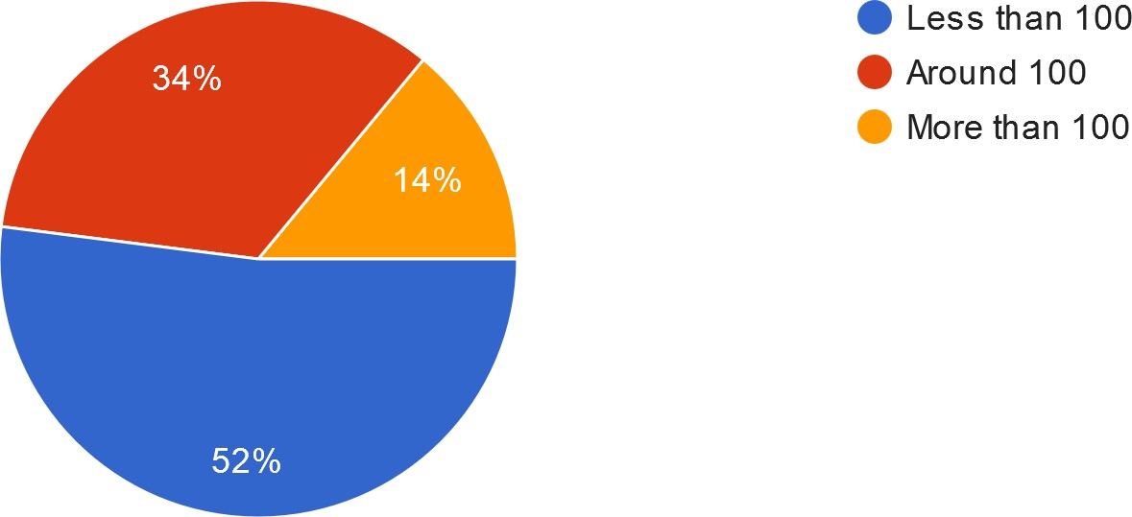

**Interpretation**

From the above information we can interpret that 52% of the average number of customers coming in a day is less than 100. Average customers more than 100 is 14%.

## Table 4.19 Training your employees to use computers.

|  |  |  |
| --- | --- | --- |
| **period** | **No. of respondents** | **Percentage (%)** |
| Always | 33 | 66 |
| Not always | 15 | 30 |
| Never | 2 | 4 |
| **Total** | **50** | **100** |

(Source: Primary Data)

## Fig. 4.19 Training your employees to use computers

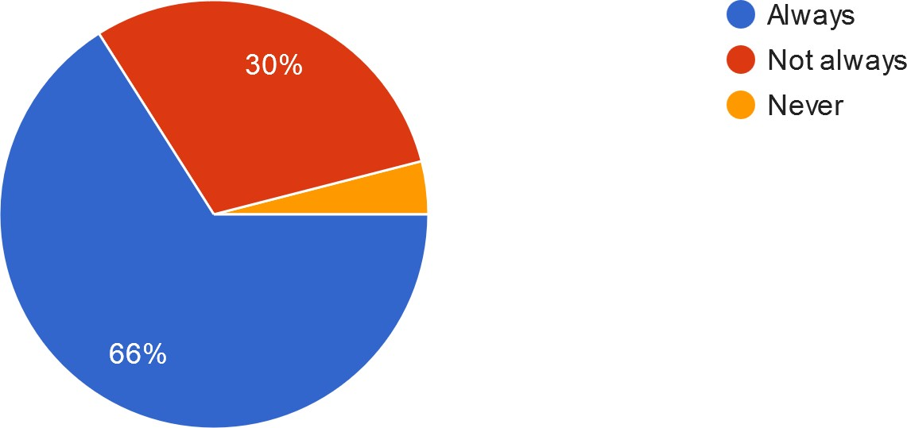

**Interpretation**

From the above information we can interpret that 66% of the population is getting trained to use computers. Only 4% is not getting trained.

## Table 4.20 Customer reviews after computerization.

|  |  |  |
| --- | --- | --- |
| **Satisfaction Level** | **No. of respondents** | **Percentage (%)** |
| Well satisfied | 22 | 44 |
| Satisfactory | 27 | 54 |
| Not satisfied | 1 | 2 |
| **Total** | **50** | **100** |

(Source: Primary Data)

## Fig. 4.20 Customer reviews after computerization

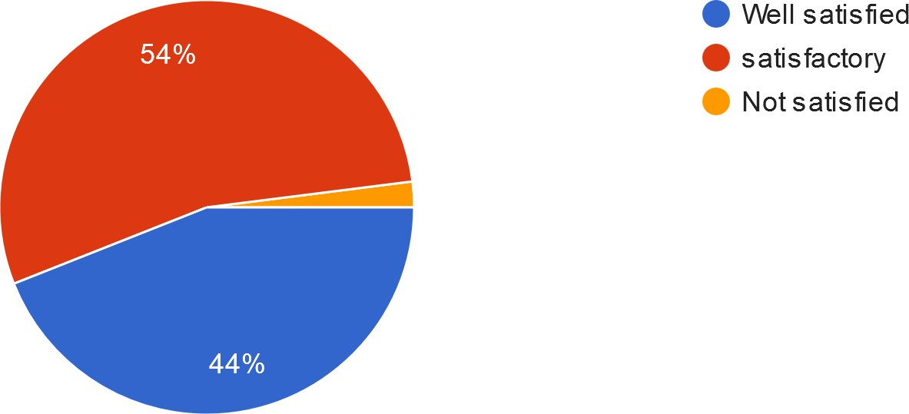

**Interpretation**

From the above information we can interpret that 44% of the customers is well satisfied, 54% is satisfactory and 2% is not satisfied.

## Table 4.21 Technical errors in the computers.

|  |  |  |
| --- | --- | --- |
| **Period** | **No. of respondents** | **Percentage (%)** |
| Often | 7 | 14 |
| Sometimes | 38 | 76 |
| Never | 5 | 10 |
| **Total** | **50** | **100** |

(Source: Primary Data)

## Fig. 4.21 Technical errors in the computers

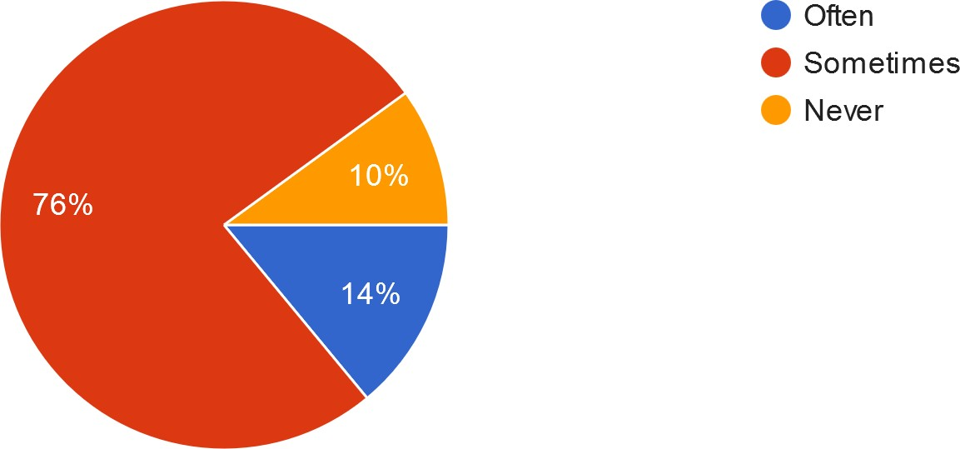

**Interpretation**

From the above information we can interpret that technical error in the computer happens sometimes for 76% of the population.

## Table 4.22 Backups of all data.

|  |  |  |
| --- | --- | --- |
| **Period** | **No. of respondents** | **Percentage (%)** |
| Everyday | 25 | 50 |
| Every week | 13 | 26 |
| Every month | 12 | 24 |
| **Total** | **50** | **100** |

(Source: Primary Data)

## Fig. 4.22 Backups of all data

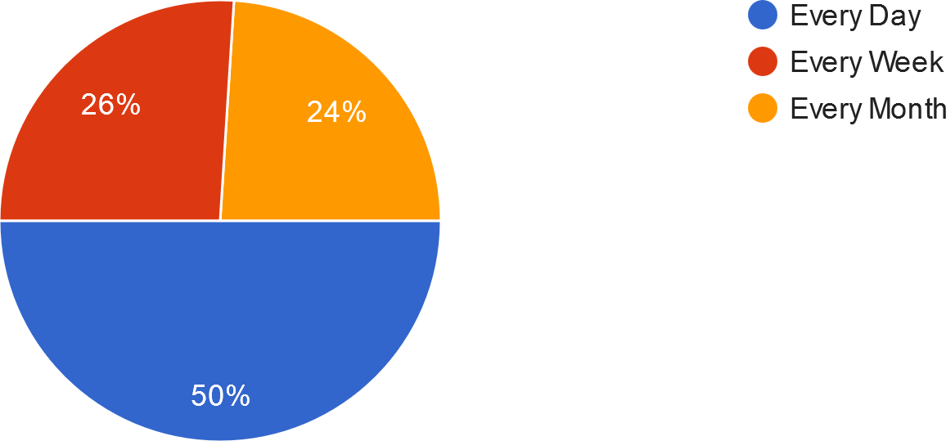

**Interpretation**

From the above information we can interpret that 50% of the population backup the data every day. 26% every week and 24% every month.

## Table 4.23 keeping the data safe from being stolen/hacked.

|  |  |  |
| --- | --- | --- |
| **Measures** | **No. of respondents** | **Percentage (%)** |
| Backed up everything  to another server | 15 | 30 |
| Installed antivirus  software | 10 | 20 |
| Both A & B | 25 | 50 |
| **Total** | **50** | **100** |

(Source: Primary Data)

## Fig. 4.23 keeping the data safe from being stolen/hacked

Backed up everything to another server Installed antivirus software Both A & B

**Interpretation**

From the above information we can interpret that 50% of the population backup everything to another server and also installs antivirus software to keep the data safe from being stolen/hacked.

## Table 4.24 Type of distribution technology played in computerization.

|  |  |  |
| --- | --- | --- |
| **Period** | **No. of respondents** | **Percentage (%)** |
| Conveyors/Sortation  systems | 3 | 6 |
| Automated storage and  retrieval of recordings | 21 | 42 |
| All of the above | 26 | 52 |
| **Total** | **50** | **100** |

(Source: Primary Data)

## Fig. 4.24 Type of distribution technology played in computerization

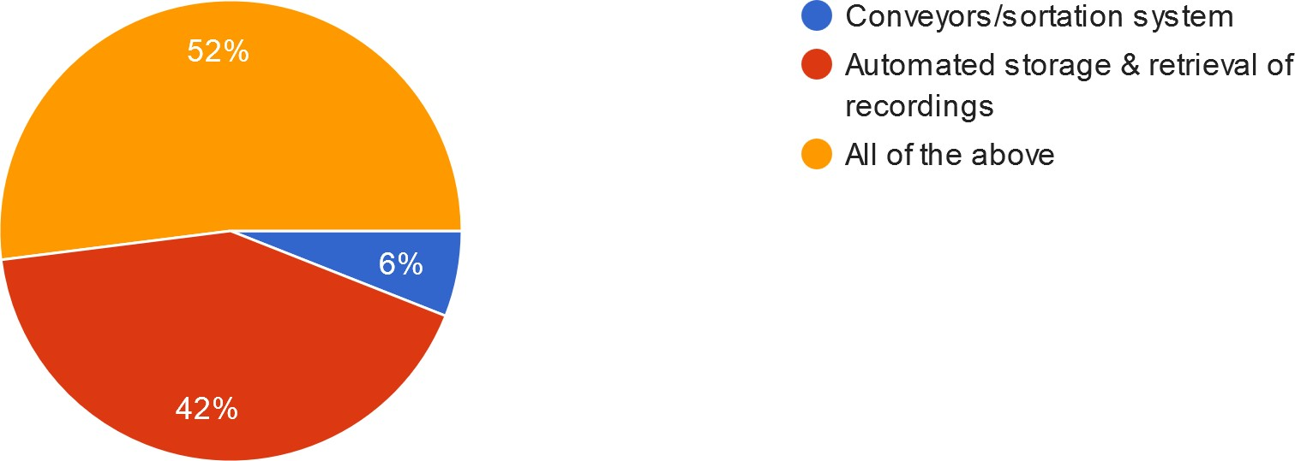

**Interpretation**

From the above information we can interpret that 52% of the population chose both the type of distribution technology played in computerization.

## Table 4.25 Estimated cost for computerizing your retail shop.

|  |  |  |
| --- | --- | --- |
| **Cost** | **No. of respondents** | **Percentage (%)** |
| Less than 3 lakhs | 26 | 52 |
| 3-7 lakhs | 19 | 38 |
| More than 7 lakhs | 5 | 10 |
| **Total** | **50** | **100** |

(Source: Primary Data)

## Fig. 4.25 Estimated cost for computerizing your retail shop

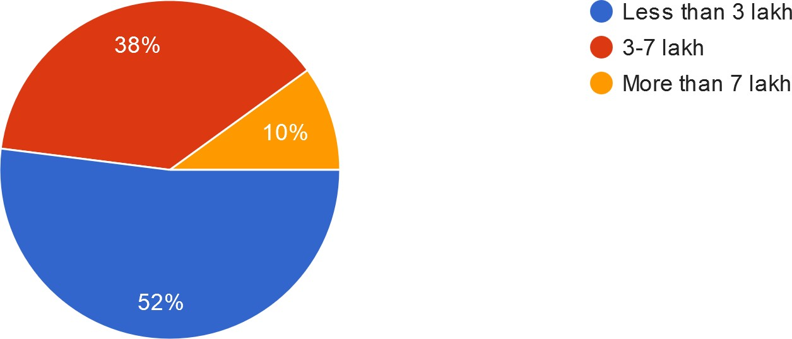

**Interpretation**

From the above information we can interpret that most(52%) of the population had a cost less than 3 lakhs and 38% of the population had 3-7 lakhs for computerization.