## 

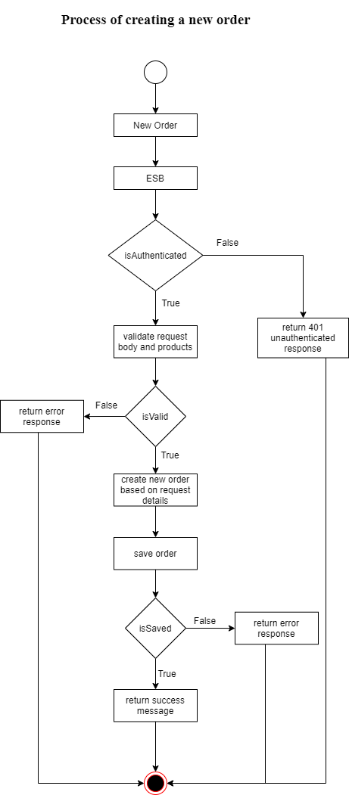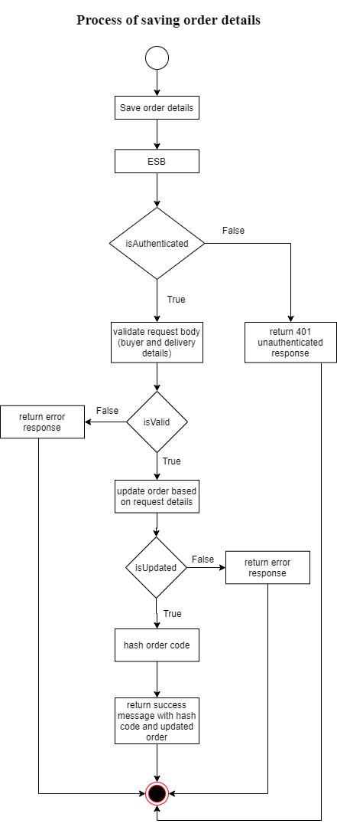

## Process of validating the token

The initial POST request will be sent to the auth service through ESB. (WSO2 EI). The token will be sent as a property in the request and it will be validated. If the token is not present then an error response with status code 422 will be returned.

To validate this token jwt library will be used. If the token is validated then the user will be retrieved from the token id and returned back. Else, an error response with status code 400 will be returned.

**Add a product to shopping cart**

The initial POST request will be sent to the buyer service through ESB. (WSO2 EI).

To add a product to cart, user must be authenticated for this “userAuth” middleware is used to filter the request and allow only authenticated users. Request body must have product id and its quantity. Then the request is validated to check if it contains product data that exist in database also the product quantity requested is less than or equal with its stock else relevant error messages are sent back to the client through ESB. If the request body is validated, it will return the total cart value(value of products * quantity) with the products.

Then user cart will be retrieved from the database using the user’s id. If the cart does not exist, create a new cart by providing user’s ID, products and the total cart value. Else, update the existing cart by adding the new product to cart products and the total cart value.

The cart will be saved/updated and if it fails then an error message will be sent else, the updated user cart object will be sent to the client through ESB.

### Update products quantity in shopping cart

The initial POST request will be sent to the buyer service through ESB. (WSO2 EI).

To update product quantity user must be authenticated. Therefore the “userAuth” middleware is used to filter the authenticated users / requests . Then the request body is validated to check if it contains products. If no products were found that means user has deleted all products from cart, but if products are found then these product data must be validated for this the previous function “validateOrderProducts” will be used. If all the data are validated then retrieve the user cart using the user’s ID and then if there is a cart, then replace previous products with new products along with their quantity and update the cart payment value. Else, create a new cart by providing user’s id, products data and the total payment/cart value.

The cart will be saved/updated and if it fails then an error message will be sent else, the updated user cart object will be sent to the client through ESB.

### Retrieve user’s shopping cart

The initial GET request will be sent to the buyer service through ESB. (WSO2 EI).

To retrieve user’s shopping cart, user must be authenticated. Therefore “userAuth” middleware is used to filter the authenticated users/ requests .

User’s cart will be retrieved from the database by using user id. If the cart contains products, loop through each product and retrieve it from the database using product id and append the product data to the cart product with a new property “data”. This is required to display product image, category, price and other data in the frontend other than only displaying the product ID.

Return the new cart with all product data and if there is no cart found then return an empty object via ESB to the client.