1. Process of Login
2. Process of Registering
3. Process of Adding a product
4. Process of Updating a product
5. Process of Deleting a product
6. Process of Adding Product to cart
7. Process of Updating Products in cart
8. Process of Placing / Saving order
9. Process of Payment of the order
10. Process of Tracking Order
11. Process of Saving Delivery Details.

**Shopping cart management**

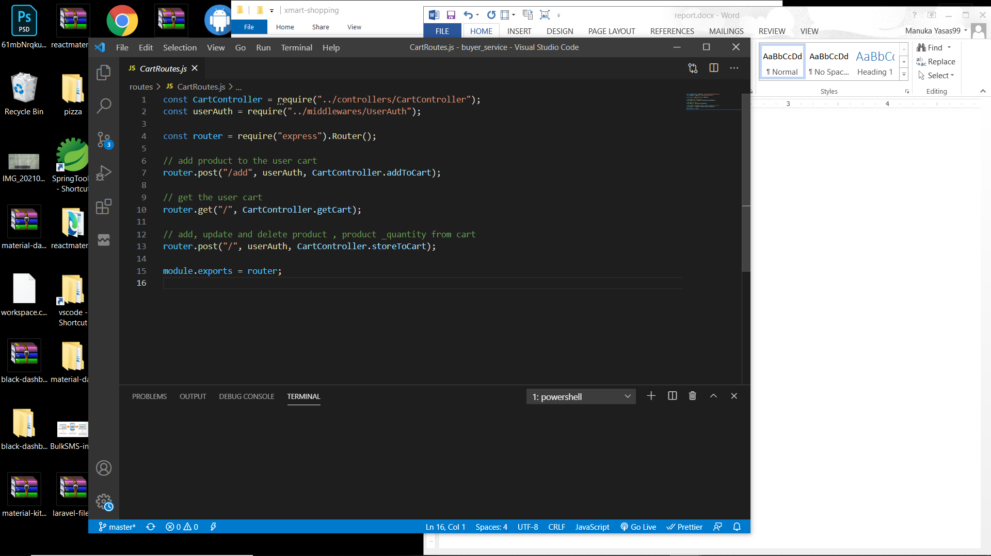

**Add a product to the shopping cart**

Service function to add a product to cart

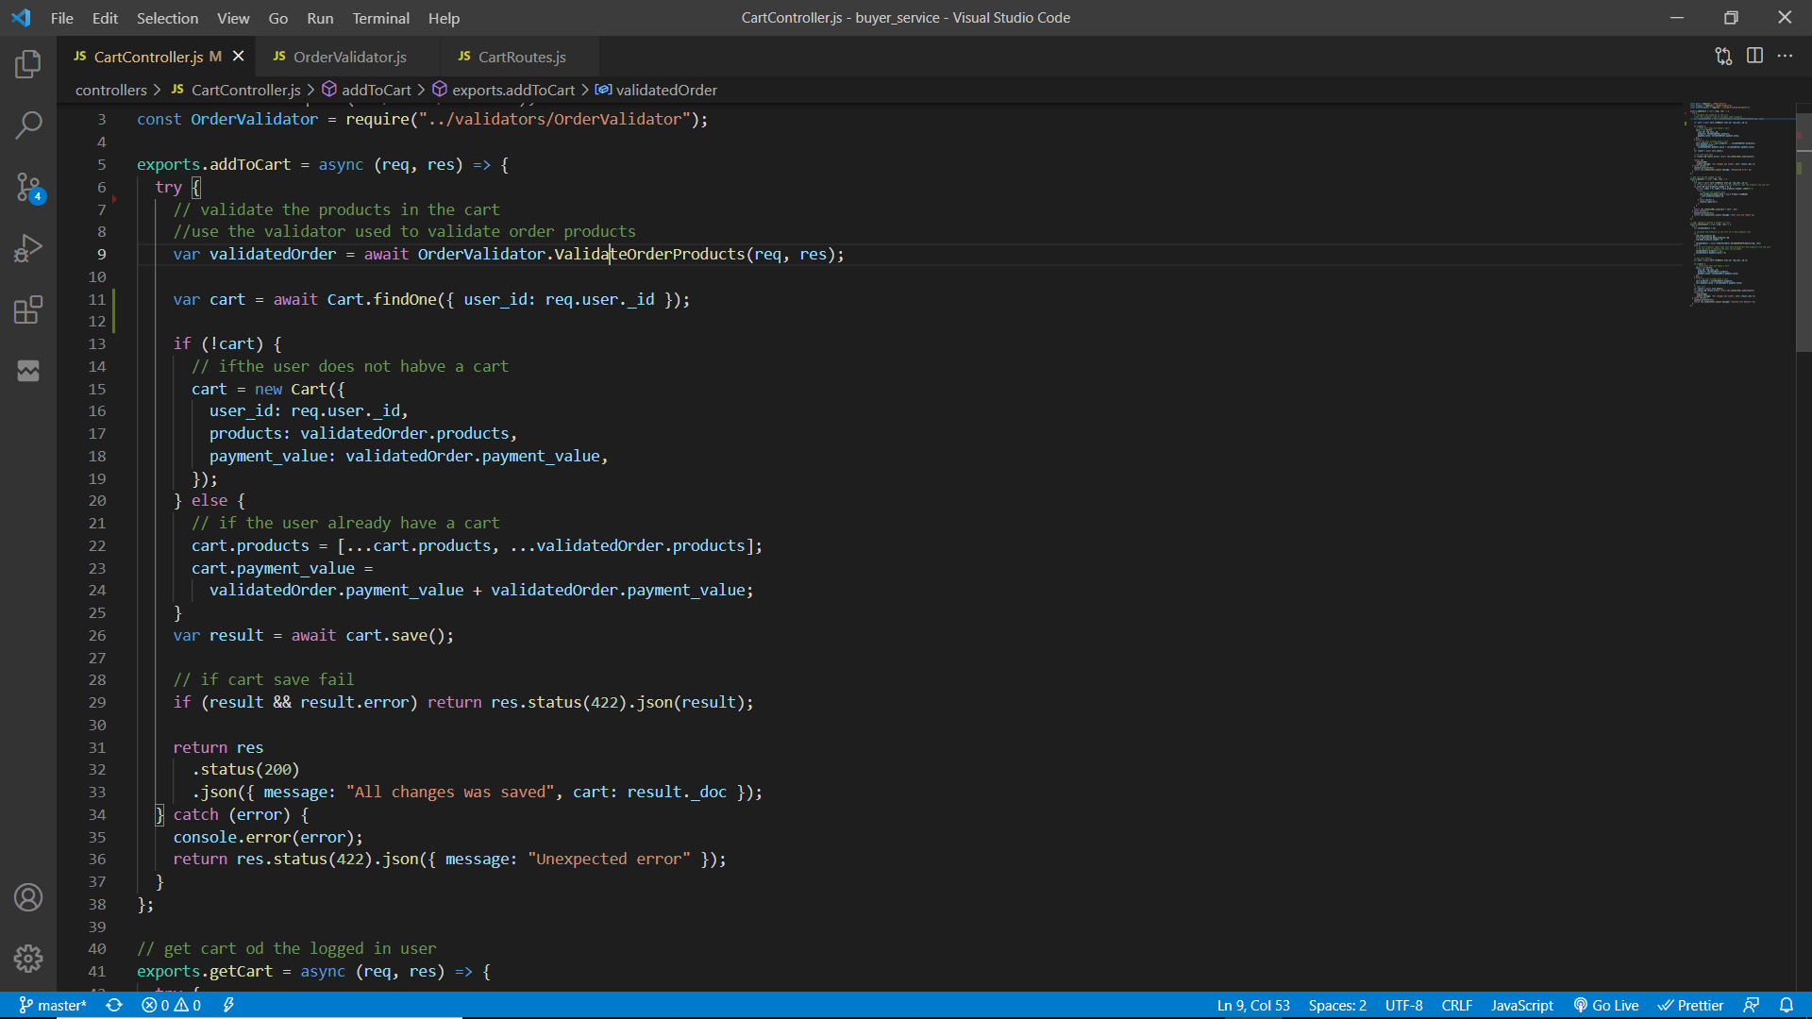

Validator function to validate request body such as valid products, products have stock (validateOrderProducts)

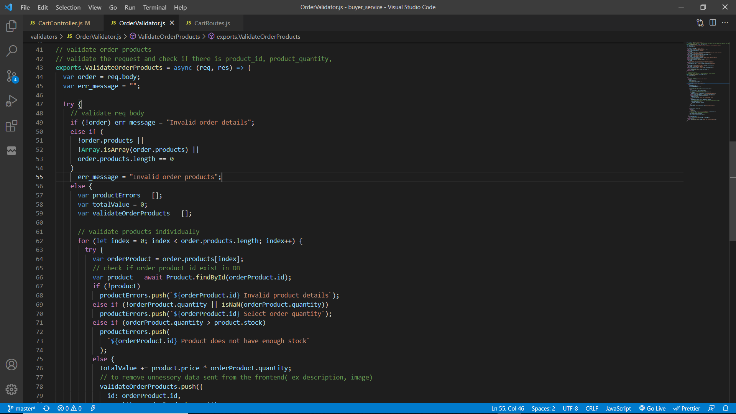

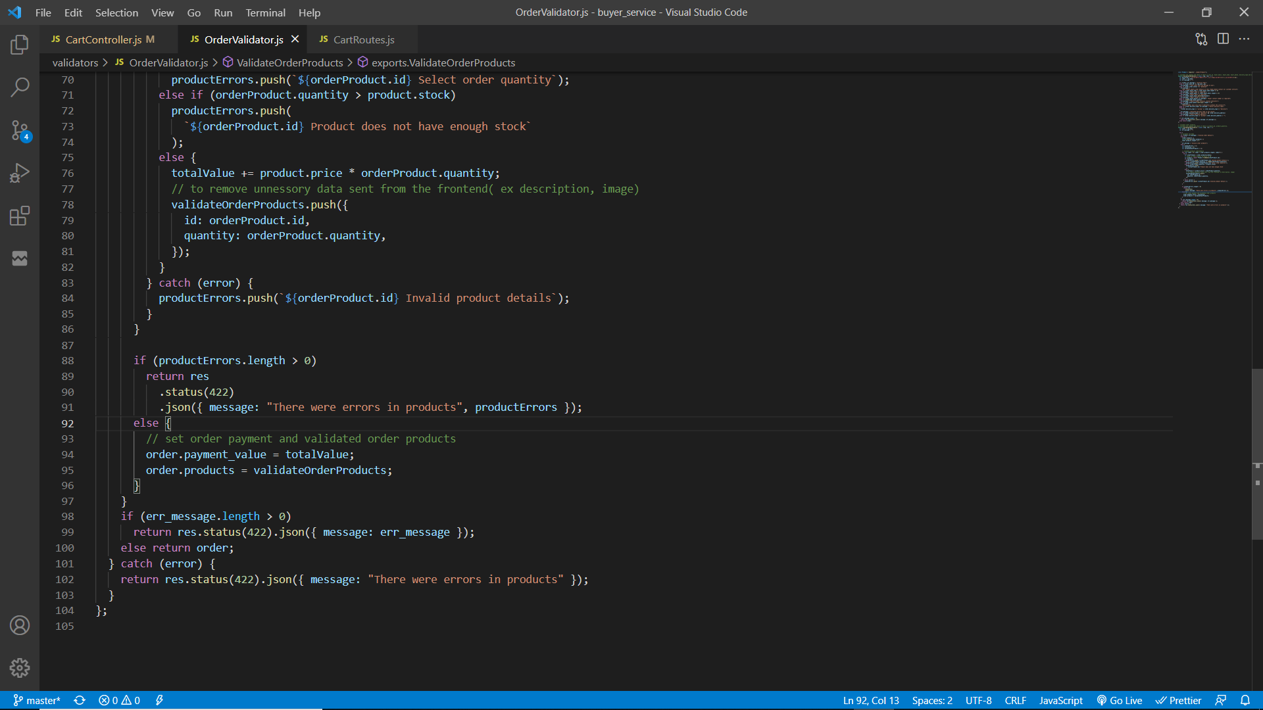

The initial request will be sent to the main application server through ESB. (WSO2 EI).

To add a product to cart, user must be authenticated for this “userAuth” middleware is used to filter the request and allow only authenticated users. Then the request body is validated to check if it contains product data that exist in database also the product quantity requested is less than or equal with its stock else relevant error messages are sent back to the client through ESB.

If the request body is validated, it will return the total cart value(value of products * quantity) and the products.

Then user cart will be retrieved from the database using the user’s id. If the cart does not exist, create a new cart by providing user’s ID, products and the total cart value. Else, update the existing cart by adding the new product to cart products and the total cart value.

The cart will be saved/updated and if it fails then an error message will be sent else, the updated user cart object will be sent to the client through ESB.

**Delete products or update products quantity in shopping cart**

Service function

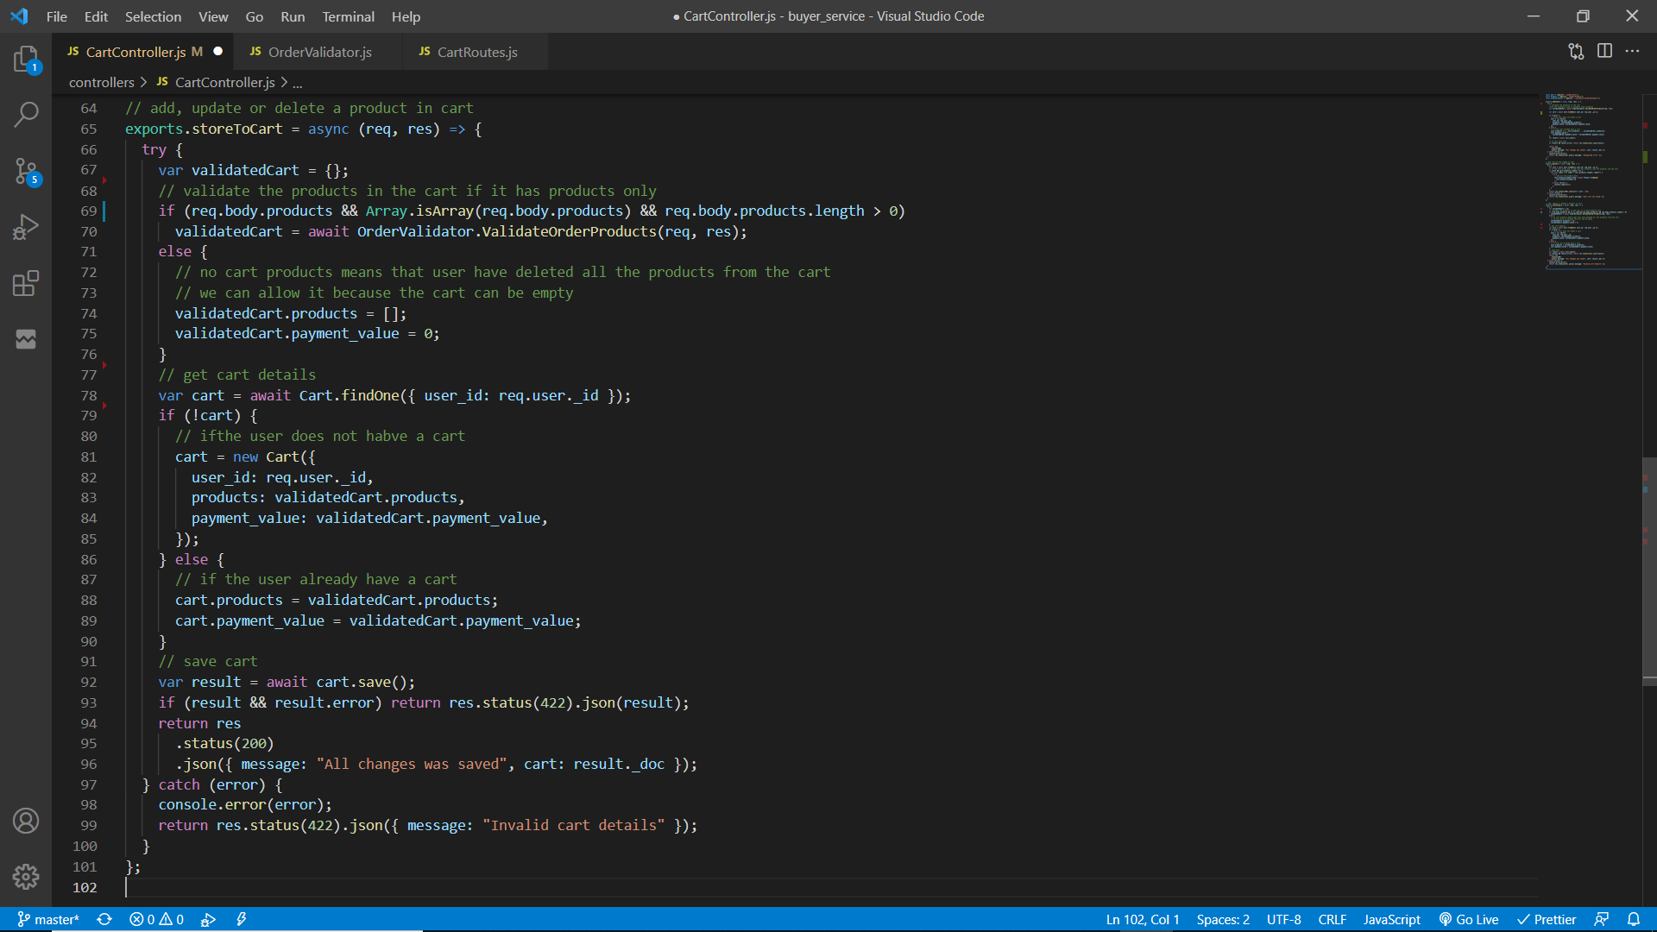

The initial request will be sent to the main application server through ESB. (WSO2 EI).

To update product quantity or delete a product from cart, user must be authenticated. Therefore the “userAuth” middleware is used to filter the authenticated users/ requests . Then the request body is validated to check if it contains products. If no products were found that means user has deleted all products from cart, but if products are found then these product data must be validated for this the previous function “validateOrderProducts” will be used.

If all the data are validated then retrieve the user cart using the user’s ID and then if there is a cart, then update the products data and payment value else create a new cart by providing the user’s id, products data and the total payment/cart value.

The cart will be saved/updated and if it fails then an error message will be sent else, the updated user cart object will be sent to the client through ESB.

**Retrieve user’s shopping cart**

Service function

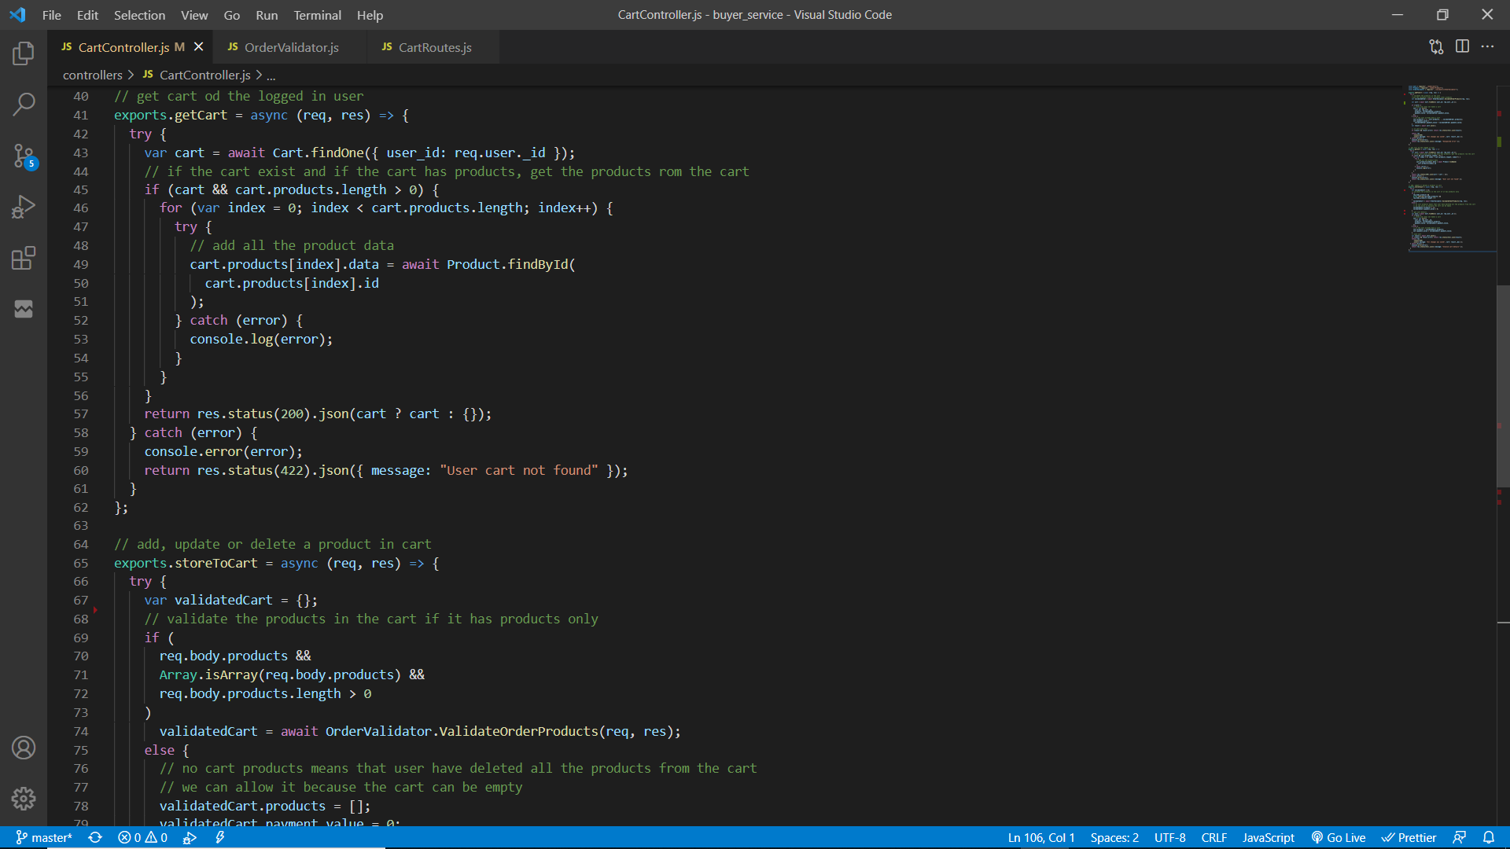

The initial request will be sent to the main application server through ESB. (WSO2 EI).

To retrieve user’s shopping cart, user must be authenticated. Therefore “userAuth” middleware is used to filter the authenticated users/ requests .

User’s cart will be retrieved from the database by using user id. If the cart contains products, loop through each product and retrieve it from the database using product id and append the product data to the cart product with a new property “data”. This is required to display product image, category, price and other data in the frontend other than only displaying the product ID.

Return the new cart with all product data and if there is no cart found then return an empty object via ESB to the client.