# Manual for Software Specification Description Language (SDL)

## Introduction

Software Specification and Description Language (SDL) is a structured notation used to describe software architecture, components, and functionality in a clear and concise manner. Similar to UML (Unified Modeling Language), SDL provides a standardized way to represent various aspects of a software system, making it easier to communicate and document software designs.

## Purpose

The primary purpose of SDL is to serve as a structured and declarative communication medium with AI systems and neural networks. SDL empowers software engineers, architects, and developers to:

Communicate complex software system specifications and descriptions effectively to AI systems and neural networks. Facilitate automated reasoning, inference, and analysis by providing a formalized framework that AI systems can understand and interpret. Enable AI-driven software development processes by leveraging natural language understanding and generation capabilities of AI systems. Enhance collaboration and productivity by enabling seamless interaction between human stakeholders and AI systems in the software development lifecycle.

Foster innovation and experimentation in software design, architecture, and development by leveraging the capabilities of AI systems to generate, analyze, and refine.

### Key Features:

SDL offers several key features that make it a valuable tool for software development and documentation:

1. Structured declarative textual records, descriptors that effectively describe software components and modules to trained machines and neural network-based systems.
2. Intuitive, easily structured descriptors formatted in JSON, facilitating seamless integration and interpretation by both human stakeholders and AI systems.
3. Standardization: SDL follows standardized conventions and syntax, ensuring consistency in how software systems are described and documented.
4. Clarity and Conciseness: SDL promotes clarity and conciseness in design documentation, enabling stakeholders to quickly grasp the essential aspects of a software system.
5. Flexibility: SDL is flexible enough to accommodate various types of software systems, from small applications to large-scale enterprise solutions.

Usage Guidelines:

When using SDL, it's essential to follow certain guidelines to maximize its effectiveness:

* Clearly define the scope and objectives of the software system being described.
* Use consistent naming conventions and terminology throughout the specification.
* Provide detailed descriptions for each component, module, and functionality to ensure clarity and understanding.

Software System Descriptor

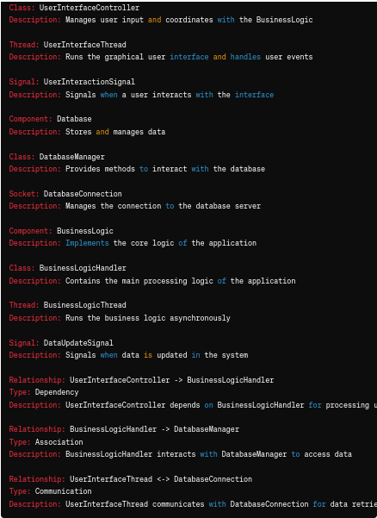

Messages between software components

In this expanded example, we've added specific classes, threads, sockets, and signals to represent low-level components within each high-level component. We've also established relationships between these components to depict how they interact with each other. This text-based description can still be parsed and interpreted by a machine to generate a detailed representation of the software architecture.

**Module:**

In a modular software architecture, a module typically refers to a self-contained unit

1. User Interface (UI) Module
2. Data Access Module
3. Business Logic Module
4. Communication Module
5. Authentication and Authorization Module
6. Logging and Monitoring Module
7. Configuration Management Module
8. Error Handling Module
9. Security Module
10. Reporting Module
11. Integration Module
12. Testing and Quality Assurance Module
13. Caching Module
14. Messaging Module
15. File Management Module
16. Workflow Management Module
17. Localization and Internationalization Module
18. Performance Optimization Module
19. Backup and Recovery Module
20. Task Scheduling Module

**Software Component:**

In software engineering, a component is a reusable and interchangeable software unit with well-defined interfaces that encapsulate specific functionality or behavior.

The GUI components, such as buttons, text fields, menus, and dialogs, can be considered individual software components within the GUI module. Each component has its own functionality and behavior, and they interact with each other and with other modules/components to provide the overall user interface experience.

1. Class

Descriptor_Class is used to describe classes.

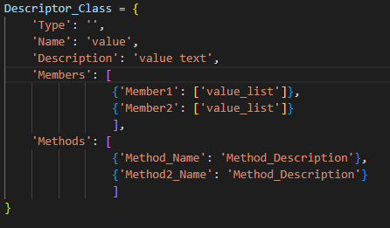

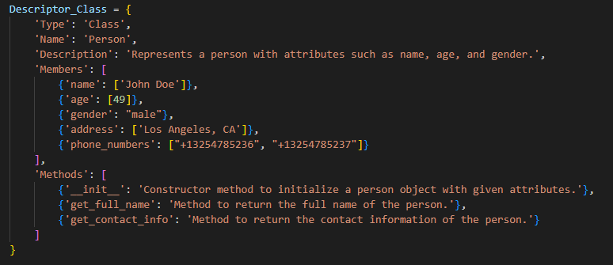

Example1

1. Object
2. Function
3. Method
4. Interface
5. Module
6. Package
7. Library
8. Framework
9. Service
10. Component
11. Plugin
12. Widget
13. Control

This descriptor can be used to describe and control various aspects of a system or component in a software application.

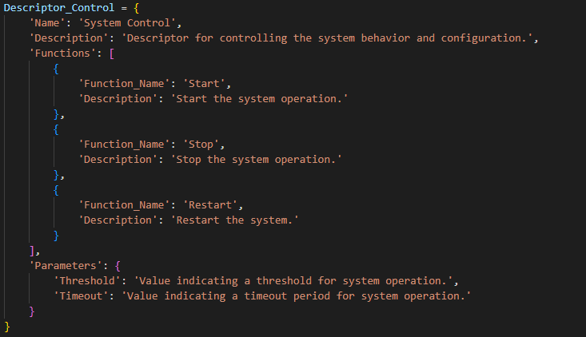

1. Event

The Descriptor_Event describes an event in a software system. Here's the breakdown of its components:

* **Type**: Represents the type of the event. It should be a string value.
* **Name**: Specifies a concise name or title for the event.
* **Description**: Provides a textual description of the event, explaining its purpose or significance.
* **Source**: Indicates the source or origin of the event. It can be a reference to the component or entity that generates or triggers the event.
* **Target**: Represents the target or destination of the event. It can be a reference to the component or entity that receives or handles the event.
* **Data**: Contains the data associated with the event. It can be a list of strings or any structured data that provides additional information about the event.

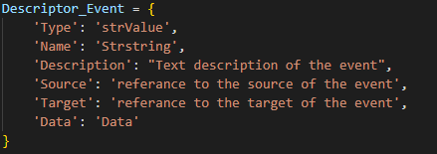

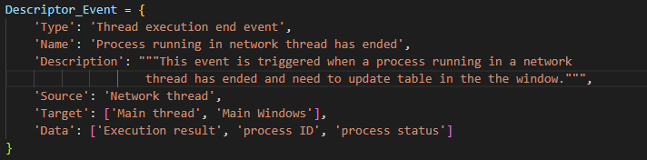

This example illustrates a thread execution end event where a process running in a network thread has ended. The event is triggered by the network thread, and its target is the main thread and main window components. The associated data includes the execution result, process ID, and process status.

1. Descriptor_Listener

The Descriptor_Listener class accepts parameters for the name, description, event type, source, and target during initialization.

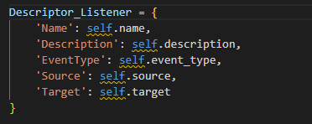

'Name': Specifies the name of the listener, which is set to "Socket Listener".

'Description': Provides a description of the listener's purpose.

'EventType': Indicates the type of events that the listener is designed to handle, set to "Socket event".

'Source': Represents the source or origin of the events the listener listens to, which in this case is a socket.

'Target': Specifies the target component or thread that will handle the events, set to "Main thread".

Example demonstrates how to create an instance of Descriptor_Listener with specific values and generate the listener descriptor using the generate_descriptor method.

1. Database Connection
2. Queue
3. Scheduler

The Descriptor_Scheduler is a utility designed to automate the scheduling and execution of tasks or jobs within a software system. It provides a flexible and reliable mechanism for defining, managing, and coordinating various tasks, enabling efficient automation of repetitive processes and background operations.

Key Features:

* Task Scheduling: The utility enables users to define and schedule tasks at specified times or intervals, providing flexibility and control over task execution.
* Task Management: Users can define tasks with specific properties such as task name, function reference, run cycle period, priority, and status control data, allowing for comprehensive task management and customization.
* Automation: The scheduler automates task execution, reducing manual intervention and streamlining workflow processes.
* Resource Optimization: By automating task scheduling and execution, the utility optimizes resource utilization and enhances system performance.

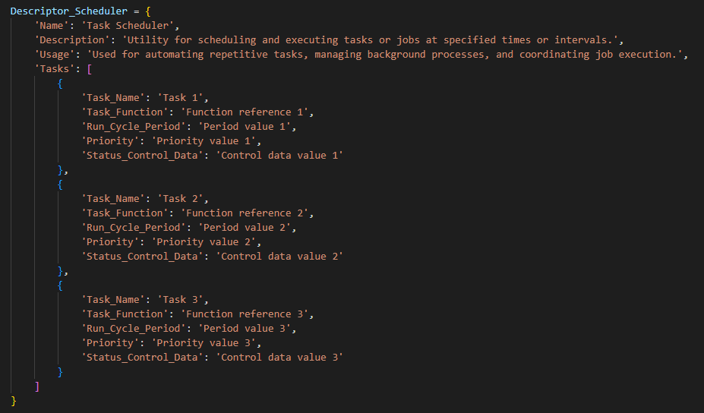

1. Utility

Descriptor_Utility class, which descriptors for utility components or functions within a software system, you can follow a similar approach to the previously created classes.

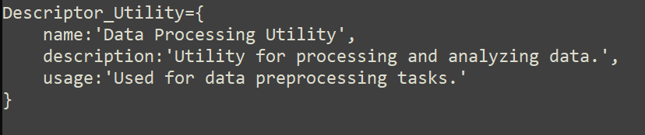

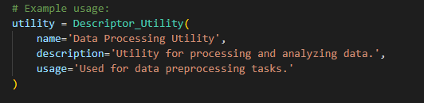

**User Interface or GUI:**

From this perspective, the GUI can be seen as a module because it encapsulates a set of related user interface components, logic, and behavior that work together to provide the user interface of the application.

In summary, the GUI can be viewed as a module that encompasses various GUI components, while each GUI component itself can be considered a component within the GUI module. The distinction between module and component often depends on the level of abstraction and the specific terminology used in a given software development context.

In this example, we have defined three components (UserInterface, Database, and BusinessLogic) along with their descriptions. We've also specified relationships between these components, such as dependencies and associations, along with descriptions to provide additional context.

Once a text-based description like this is provided, a machine could be programmed to parse and interpret the text, generating corresponding diagrams or representations of the software architecture, similar to how UML diagrams are created. This process might involve converting the text into a structured format that can be processed by software tools, which then generate the visual representation based on the provided descriptions and relationships.

In the context of SDL (Specification and Description Language), JSON records can be referenced and utilized within SDL specifications to provide additional details or structure to the description. Here's how you can call JSON records within an SDL context:

Include JSON Records as Documentation:

You can include JSON records within the documentation section of your SDL specification to provide detailed descriptions, examples, or representations of various components, modules, or other elements de scribed in the specification.

Specification MySoftwareSystem {

Description {

// Introduction to the software system

"MySoftwareSystem is a system designed to..."

// Include JSON record for the User Interface Module

"## User Interface Module"

"```json"

// Insert JSON record for User Interface Module here

"```"

}

// Other sections of the SDL specification...

}

## Software Modules

### User Interface (UI) Module

Purpose: Responsible for presenting the user interface to the user and handling user interactions.

Responsibilities: Rendering UI components, managing user input, handling events, and coordinating with other modules for data display and manipulation.

* Example Components: Views, controllers, templates, stylesheets, and UI widgets.
* Example Frameworks/Libraries: PyQt, Tkinter, Angular, React.

This JSON example describes the User Interface (UI) Module, listing various components such as buttons, text fields, checkboxes, etc., along with their purposes and descriptions. Each component is represented as an object within the "components" array.

{

"module": "UserInterface",

"description": "Module responsible for presenting the user interface to the user and handling user interactions.",

"components": [

{

"name": "Button",

"purpose": "Provides interaction",

"description": "Clickable control triggering actions",

"callbackFunction": "handleButtonClick"

},

{

"name": "TextField",

"purpose": "Enables text input",

"description": "Field for entering textual information"

},

{

"name": "Checkbox",

"purpose": "Facilitates binary selections",

"description": "Control for selecting options"

},

{

"name": "RadioButton",

"purpose": "Enables single selections",

"description": "Control for selecting one option"

},

{

"name": "Dropdown",

"purpose": "Offers selection in limited space",

"description": "Compact menu for selecting options"

},

{

"name": "Menu",

"purpose": "Provides access to application features",

"description": "Hierarchical list of options for navigation and commands"

},

{

"name": "DialogBox",

"purpose": "Displays important messages or prompts",

"description": "Modal or modeless window for user interaction"

},

{

"name": "Toolbar",

"purpose": "Provides quick access to common commands",

"description": "Strip of buttons or controls for frequently used actions"

},

{

"name": "ProgressBar",

"purpose": "Indicates progress of ongoing operation",

"description": "Visual representation of completion status"

},

{

"name": "Icon",

"purpose": "Visual representation of actions or objects",

"description": "Graphical symbol or image for visual cue"

}

]

}

### Business Logic Module

Purpose: Implements the core application logic and business rules.

Responsibilities: Processing user requests, executing business operations, enforcing business rules, and orchestrating interactions between different modules.

* Example Components: Service classes, domain objects, business rules/validation logic.
* Example Frameworks/Libraries: Spring, Django, Express.js.

### Data Access Module

Purpose: Handles data access and interaction with the database or external data sources.

Responsibilities: Performing CRUD (Create, Read, Update, Delete) operations on data, managing database connections, and translating data between application and database formats.

* Example Components: Data access objects (DAOs), repositories, database connectors.
* Example Frameworks/Libraries: Hibernate, SQLAlchemy, JDBC.

This JSON example describes the Data Access Module, listing various components such as DatabaseConnection, QueryExecutor, DataMapper, etc., along with their purposes and descriptions. Each component is represented as an object within the "components" array. This is a realistic example of components commonly found in a Data Access Module in software systems that interact with databases.

Data Access Module: This module contains components responsible for handling data access and interaction with the database or external data sources. Components within this module include functionalities such as establishing database connections, executing queries, mapping database entities to application objects, encapsulating data access logic, managing transactions, and caching data.

Database: The database is a separate entity that stores and manages the data. It is not part of the Data Access Module itself but rather the underlying storage system that the Data Access Module interacts with. The database may be relational (e.g., SQL-based databases like MySQL, PostgreSQL) or non-relational (e.g., NoSQL databases like MongoDB, Cassandra).

In summary, while the Data Access Module interacts closely with the database to perform operations such as querying and updating data, the database itself is considered a separate entity external to the module. The Data Access Module abstracts away the specific details of interacting with the database, providing a unified interface for the rest of the application to access and manipulate data.

{

"module": "DataAccess",

"description": "Module responsible for handling data access and interaction with the database or external data sources.",

"components": [

{

"name": "DatabaseConnection",

"purpose": "Establishes connection to the database",

"description": "Manages connection parameters and establishes a connection to the database server."

},

{

"name": "QueryExecutor",

"purpose": "Executes SQL queries",

"description": "Executes SQL queries against the database and retrieves result sets."

},

{

"name": "DataMapper",

"purpose": "Maps database entities to application objects",

"description": "Translates database records into application-specific objects and vice versa."

},

{

"name": "Repository",

"purpose": "Encapsulates data access logic",

"description": "Provides an interface to interact with the database, encapsulating data access logic."

},

{

"name": "Entity",

"purpose": "Represents database entities",

"description": "Defines data models representing entities stored in the database."

},

{

"name": "Migration",

"purpose": "Manages database schema changes",

"description": "Facilitates database schema changes and versioning through migration scripts."

},

{

"name": "Caching",

"purpose": "Caches frequently accessed data",

"description": "Caches query results or frequently accessed data to improve performance."

},

{

"name": "TransactionManager",

"purpose": "Manages database transactions",

"description": "Provides mechanisms to manage database transactions and ensure data integrity."

}

]

}

### Authentication Module

Purpose: Manages user authentication and authorization within the system.

Responsibilities: Authenticating user credentials, managing user sessions, enforcing access control policies, and handling authentication-related operations.

* Example Components: Authentication handlers, session management logic, access control lists (ACLs).
* Example Frameworks/Libraries: Spring Security, Passport.js, Django Authentication.

### Logging Module

Purpose: Provides logging functionality to record application events and errors.

Responsibilities: Logging application events, errors, warnings, and debugging information to various logging targets (e.g., files, databases, consoles).

* Example Components: Logger classes, log message formatters, log handlers.
* Example Frameworks/Libraries: Log4j, Logback, Winston.

### Configuration Module

Purpose: Manages application configuration settings and parameters.

Responsibilities: Loading, storing, and retrieving configuration settings, parsing configuration files, and providing access to configuration values.

* Example Components: Configuration manager classes, configuration file parsers.
* Example Frameworks/Libraries: Spring Boot Configuration, Python ConfigParser, Node.js dotenv.
* Error Handling Module:

Purpose: Handles error handling and exception processing throughout the application.

Responsibilities: Catching and handling exceptions, logging error messages, and providing feedback to users when errors occur.

* Example Components: Exception handlers, error message generators, error response formatters.
* Example Frameworks/Libraries: Spring Boot Exception Handling, Express.js error handling middleware.

### Utility Module

Purpose: Contains reusable utility functions and helper classes used across the application.

Responsibilities: Providing common functionality and helper methods that can be reused across different modules.

* Example Components: Utility classes, helper functions, generic data structures.
* Example Frameworks/Libraries: Apache Commons (Java), lodash (JavaScript), Python standard library.

### Security Module

Purpose: Implements security mechanisms such as encryption, hashing, and protection against common vulnerabilities.

Responsibilities: Implementing security controls, encryption/decryption, input validation, and protection against common security threats (e.g., SQL injection, cross-site scripting).

Example Components: Security handlers, encryption utilities, input validation libraries.

Example Frameworks/Libraries: Spring Security, bcrypt (password hashing), OWASP ESAPI.

### Communication Module

Purpose: Facilitates communication with external systems, services, or APIs.

Responsibilities: Sending and receiving data over various communication protocols, handling network connections, and managing message formats.

* Example Components: Client libraries, request/response handlers, protocol parsers.
* Example Frameworks/Libraries: Retrofit (Java), Axios (JavaScript), Python Requests.
* Reporting Module:

Purpose: Provides functionality for generating and presenting reports based on application data.

Responsibilities: Generating report templates, querying data sources, formatting report output, and presenting reports to users.

Example Components: Report generation classes, report templates, data visualization tools.

Example Frameworks/Libraries: JasperReports, Crystal Reports, Plotly (Python).

### Caching Module

Purpose: Manages caching of frequently accessed data to improve performance.

Responsibilities: Storing frequently accessed data in memory or a cache store, updating cache entries, and evicting stale data.

Example Components: Cache managers, caching policies, cache eviction strategies.

Example Frameworks/Libraries: Ehcache, Redis, Memcached.

### Notification Module

Purpose: Handles sending notifications or alerts to users or other systems.

Responsibilities: Generating and sending notifications via various channels (e.g., email, SMS, push notifications), processing notification preferences, and logging notification events.

* Example Components: Notification services, message templates, notification schedulers.
* Example Frameworks/Libraries: Twilio (SMS), JavaMail (email), Firebase Cloud Messaging.

### Integration Module

Purpose: Facilitates integration with third-party systems or services.

Responsibilities: Implementing integration endpoints, handling data transformation and mapping, and managing communication with external APIs or systems.

* Example Components: Integration adapters, data mapping utilities, API clients.
* Example Frameworks/Libraries: Apache Camel, Spring Integration, Axios (JavaScript).

### Monitoring Module:

Purpose: Implements monitoring and health-checking functionality to ensure the system's stability and performance.

Responsibilities: Monitoring system metrics, collecting and analyzing performance data, and generating alerts or reports based on system health.

* Example Components: Monitoring agents, health check endpoints, dashboard interfaces.
* Example Frameworks/Libraries: Prometheus, Grafana, New Relic.

## Software Components:

### Buttons:

Purpose: Buttons provide a way for users to interact with the application by triggering actions or events when clicked.

Description: Buttons are UI elements typically displayed as clickable controls that perform specific actions when activated by the user. They are commonly used to initiate actions such as submitting forms, navigating to different screens, or executing commands.

{

"name": "Button",

"purpose": "Provides interaction",

"description": "Clickable control triggering actions",

"callbackFunction": "handleButtonClick"

}

### Text Fields:

Purpose: Text fields allow users to input text or data into the application.

Description: Text fields are UI components that enable users to enter textual information, such as names, addresses, or search queries. They provide a means for users to input data into forms or interact with various input fields within the application.

### Checkboxes:

Purpose: Checkboxes allow users to make binary selections or choose multiple options from a list.

Description: Checkboxes are UI controls that present users with a binary choice, typically represented as a small box that can be checked or unchecked. They are commonly used in forms and settings menus to enable users to select one or more options from a list of choices.

### Radio Buttons:

Purpose: Radio buttons allow users to make single selections from a list of options.

Description: Radio buttons are UI controls that present users with a list of mutually exclusive options, allowing them to select only one option at a time. They are often used in forms and dialog boxes where users need to make a single choice from a set of options.

### Drop-down Lists:

Purpose: Drop-down lists provide users with a selection of options in a compact and space-efficient format.

Description: Drop-down lists, also known as select boxes or dropdown menus, present users with a list of options that can be accessed by clicking or tapping on a dropdown arrow. They allow users to choose from a predefined set of options, conserving screen space while providing access to a variety of choices.

### Menus:

Purpose: Menus provide users with access to application features and functionality in a hierarchical or categorized structure.

Description: Menus are UI components that present users with a list of options or commands organized into categories or hierarchies. They are commonly used to provide access to application features such as file operations, settings, or navigation options.

### Dialog Boxes:

Purpose: Dialog boxes display important messages, notifications, or prompts to users, requiring their attention or input.

Description: Dialog boxes are UI windows that appear on top of the main application window to provide users with important information, notifications, or prompts. They often require user interaction, such as acknowledging a message or providing input, before allowing the user to continue interacting with the application.

### Toolbars:

Purpose: Toolbars provide users with quick access to commonly used commands or actions.

Description: Toolbars are UI elements typically located at the top of the application window, containing buttons, icons, or other controls that represent frequently used commands or actions. They provide users with convenient access to common tasks, such as saving, printing, or formatting text.

### Progress Bars:

Purpose: Progress bars indicate the status or progress of an ongoing operation or task.

Description: Progress bars are UI components that visually represent the progress of an ongoing operation or task, such as file downloads, file uploads, or data processing. They provide users with feedback on the status of the operation and an indication of how much time is remaining.

### Icons:

Purpose: Icons visually represent actions, objects, or concepts within the application, providing users with visual cues and navigation aids.

Description: Icons are graphical symbols or images used to represent specific actions, objects, or concepts within the application. They are commonly used in user interfaces to provide visual cues, improve navigation, and enhance the overall user experience by making it easier for users to identify and understand functionality.

In this expanded example, we've added specific classes, threads, sockets, and signals to represent low-level components within each high-level component. We've also established relationships between these components to depict how they interact with each other. This text-based description can still be parsed and interpreted by a machine to generate a detailed representation of the software architecture.

**Software Components:**

**Component Button:**

Purpose: Buttons provide a way for users to interact with the application by triggering actions or events when clicked.

Description: Buttons are UI elements typically displayed as clickable controls that perform specific actions when activated by the user.

They are commonly used to initiate actions such as submitting forms, navigating to different screens, or executing commands.

SDL Representation:

Component Button {

Purpose: "Provides interaction"

Description: "Clickable control triggering actions"

}

Button {

id: submitButton

text: "Submit"

onClicked: {

// Handle submit button click event

}

}

RadioButtonGroup {

id: paymentMethodGroup

RadioButton {

id: creditCardRadioButton

text: "Credit Card"

}

RadioButton {

id: paypalRadioButton

text: "PayPal"

}

onSelectedButtonChanged: {

// Handle radio button selection changes

}

}

**Component Checkbox**

Purpose: Checkboxes allow users to make binary selections or choose multiple options from a list.

Description: Checkboxes are UI controls that present users with a binary choice, typically represented as a small box that can be checked or unchecked. They are commonly used in forms and settings menus to enable users to select one or more options from a list of choices.

SDL Representation:

Component Checkbox {

Purpose: "Facilitates binary selections"

Description: "Control for selecting options"

}

**Drop-down Lists:**

Purpose: Drop-down lists provide users with a selection of options in a compact and space-efficient format.

Description: Drop-down lists, also known as select boxes or dropdown menus, present users with a list of options that can be accessed by clicking or tapping on a dropdown arrow. They allow users to choose from a predefined set of options, conserving screen space while providing access to a variety of choices.

SDL Representation:

Component Dropdown {

Purpose: "Offers selection in limited space"

Description: "Compact menu for selecting options"

}

**Radio Buttons:**

Purpose: Radio buttons allow users to make single selections from a list of options.

Description: Radio buttons are UI controls that present users with a list of mutually exclusive options, allowing them to select only one option at a time. They are often used in forms and dialog boxes where users need to make a single choice from a set of options.

SDL Representation: