Bamazon

A simple but functional inventory management and order placement system developed using node js and mysql as the database.

User Guide

Table of Contents

**Requirements 1**

**Assumptions 1**

**Module One: Customer 1**

**Module Two: Manager 5**

**Module Three: Supervisor 7**

1. **Requirements:**

For detailed specification and requirements please refer to the following link.

https://miami.bootcampcontent.com/Miami-Boot-Camp/MIACOR201801FSF3-Class-Repository-FSF/blob/master/12-Week-mysql/homeWork/homework_instructions.md

1. **Assumptions:**
2. The customer is accustomed to using command line interface for now.
3. Navigate to the source directory of the application.
4. Invoke the command line or the Gitbash utility.
5. **Module One: Customer Module:**

This module can be invoked using the following command at the CLI.



This module has 2 functions built into the application.

1. Displaying the Inventory List.
2. Order placement for Customer.

From the CLI, please type the following to initiate the program as below.

**1.1 Functionality: Displaying Inventory List**

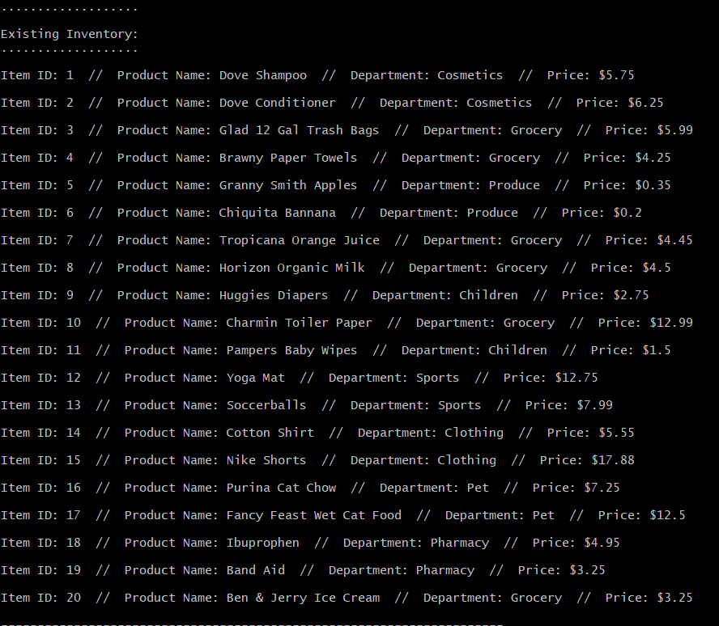

* 1. **Functionality : Order Placement**

Based on the product number, that is unique, the orders can be placed.

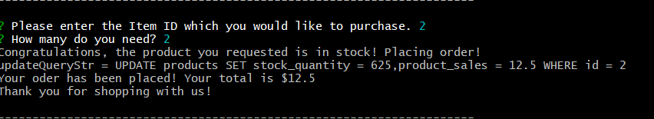

Few validations also occur at the order placement.

1. **Check if the product exists in the inventory list.**

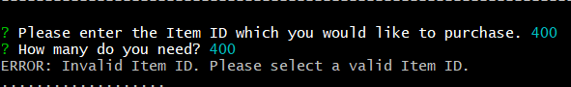

1. **If there is sufficient quantity of inventory available to meet the order.**

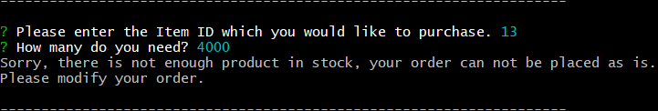

1. **Quantity cannot be entered in fractions.**

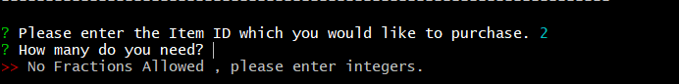

1. **Module Two: Manager Module:**

The manager module can be invoked using the following command at the CLI.



This module has 4 functions built into the application.

1. View Products for Sale
2. View Low Inventory
3. Add to Inventory
4. Add New Product

From the CLI, please type the following to initiate the program as below.

**2.1 Functionality: Displaying Products for Sale**

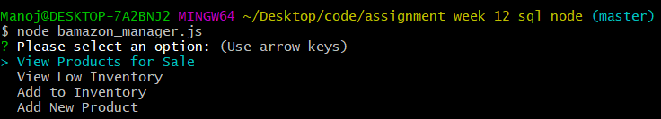

Selecting the highlighted menu option will display the items for sale.

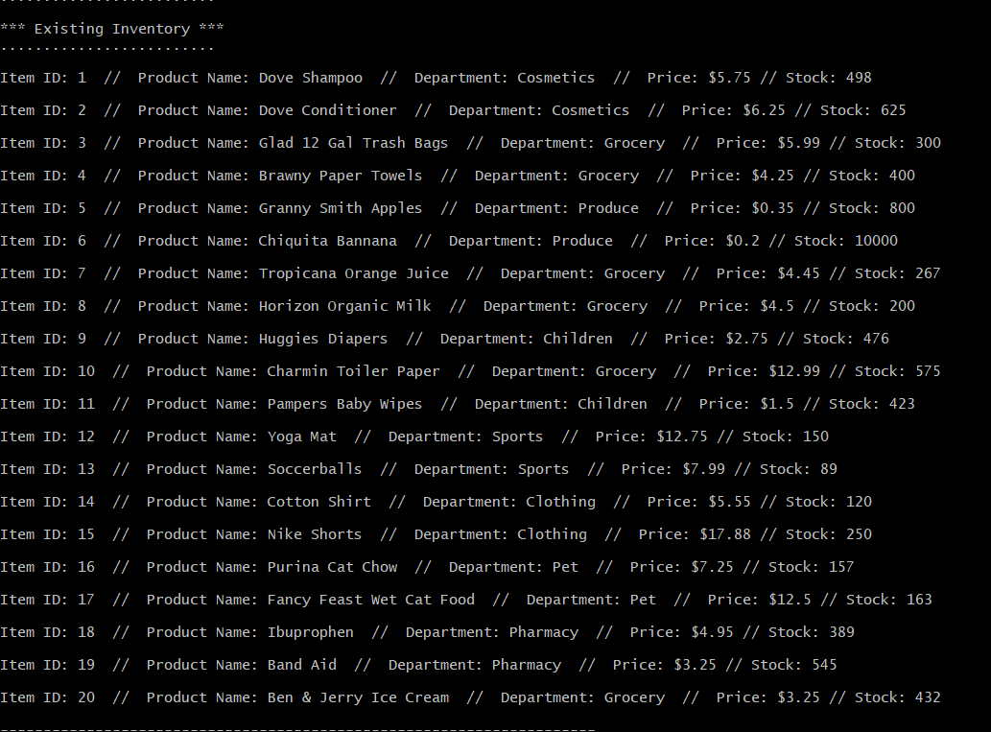

* 1. **Functionality: View Low Inventory**

This option provides the manage a list of all products that are less than 100 numbers in quantity at the store.

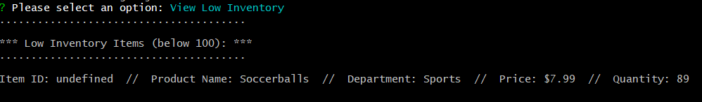

* 1. **Functionality: Add to Inventory**

This option provides the manager an option to update the stock inventory of any product in the store.

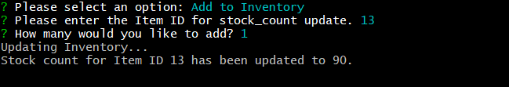

* 1. **Functionality: Add New Product**

This option provides the manager an option to add a new product the store for sale.

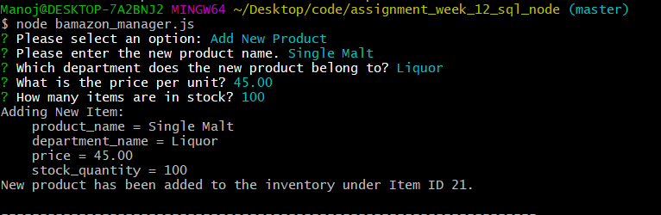

1. **Module Three: Supervisor Module**

This module can be invoked using the following command at the CLI.

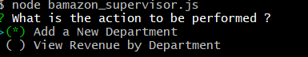

This module has 2 different functions built into the application.

1. Create a new department.
2. View Product Sales by Department.
   1. **Create a new department.**

On selecting the add new department option from the menu, the use is prompted for the new details required to create the new department.

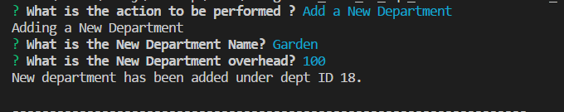

* 1. **View product Sales by Department.**

A validation also occurs at the time of new department creation.

1. **Check if the department exists in the department table.**

