* Initial approach (not layout added) encoding out degree as nodes’ size, and directed links by color

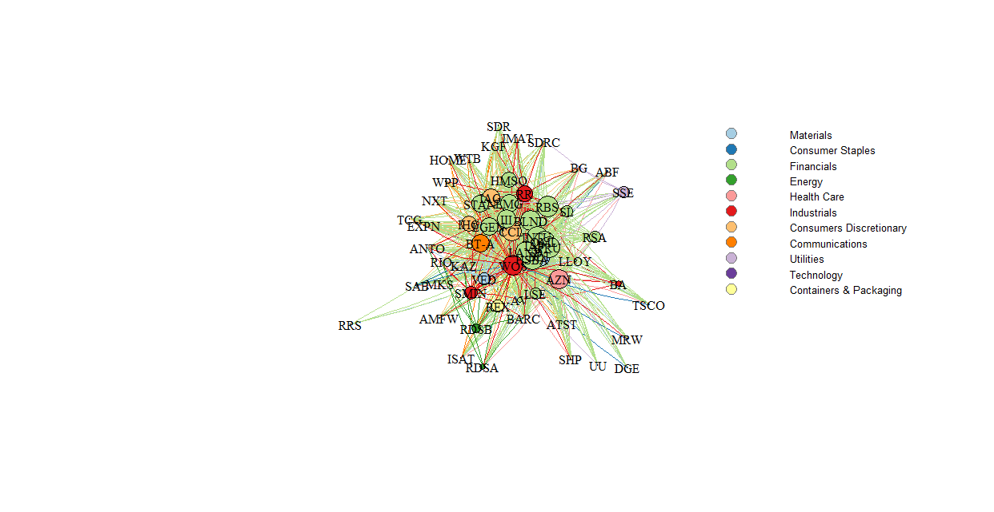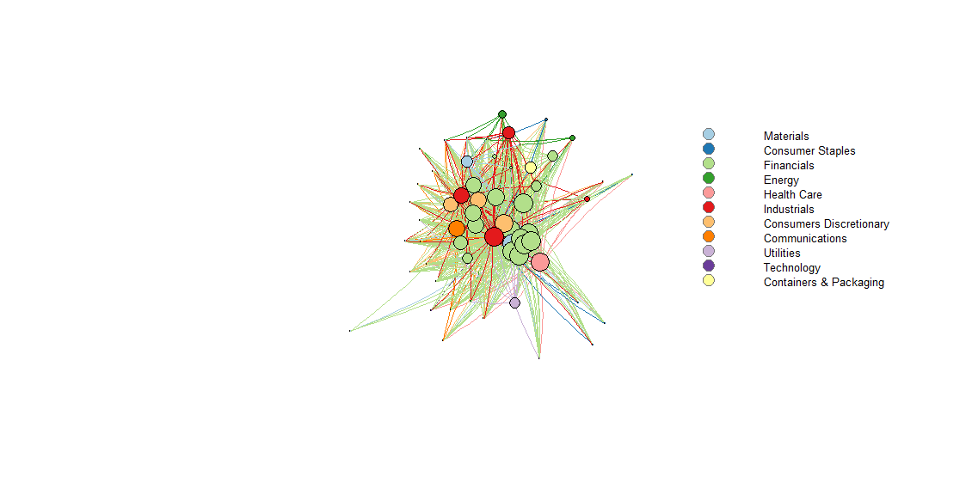

* Fruchterman-Reinhold force-directed layout: edges similar length and avoid crossing as much as possible. **Physical system simulation**: charged particles + springs.

Nodes that share more connections closer to each other!! Slow if huge ~ 1000 (still not a problem)

Possibility of setting ‘weight’ parameter: increases attraction forces when links’ weight higher.

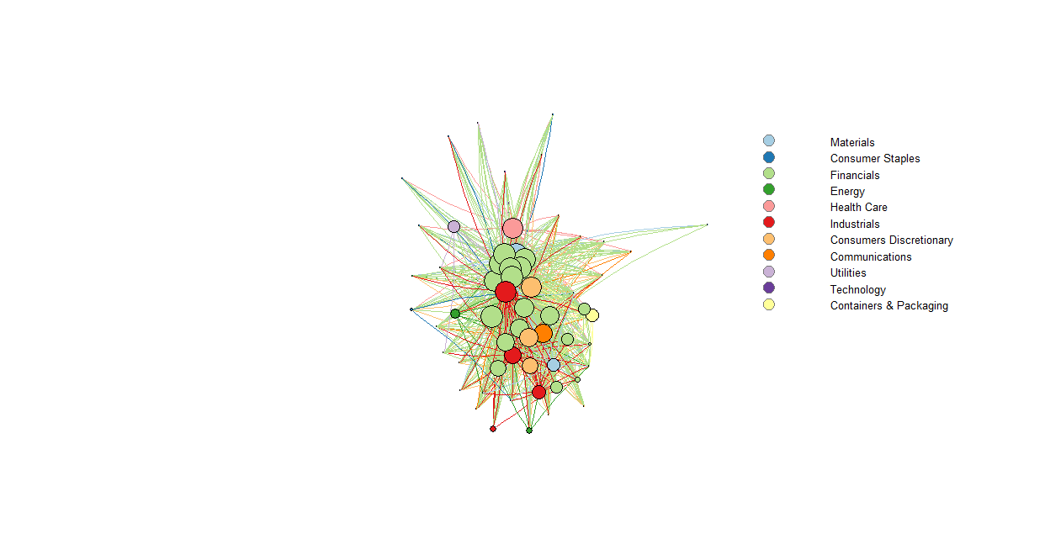

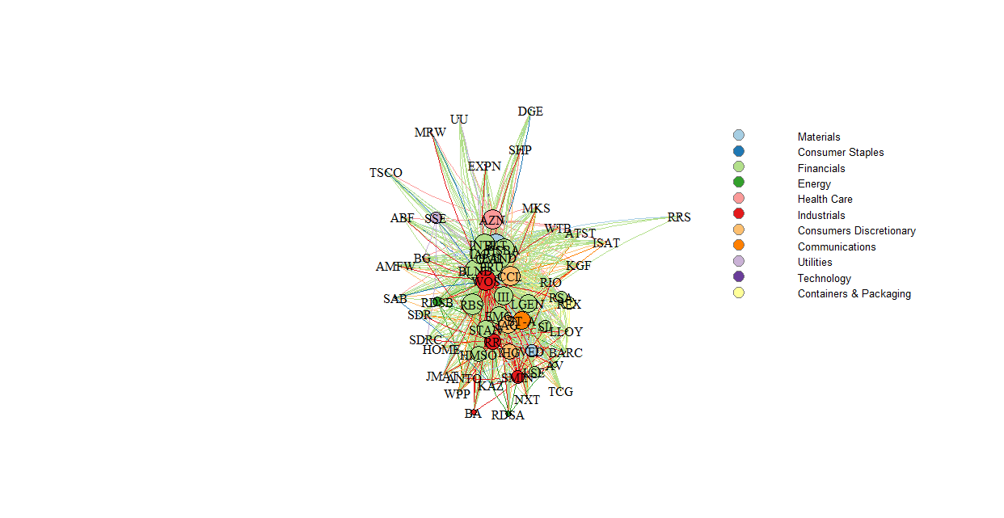

Rescaled Network: need to solve the off-limits problems

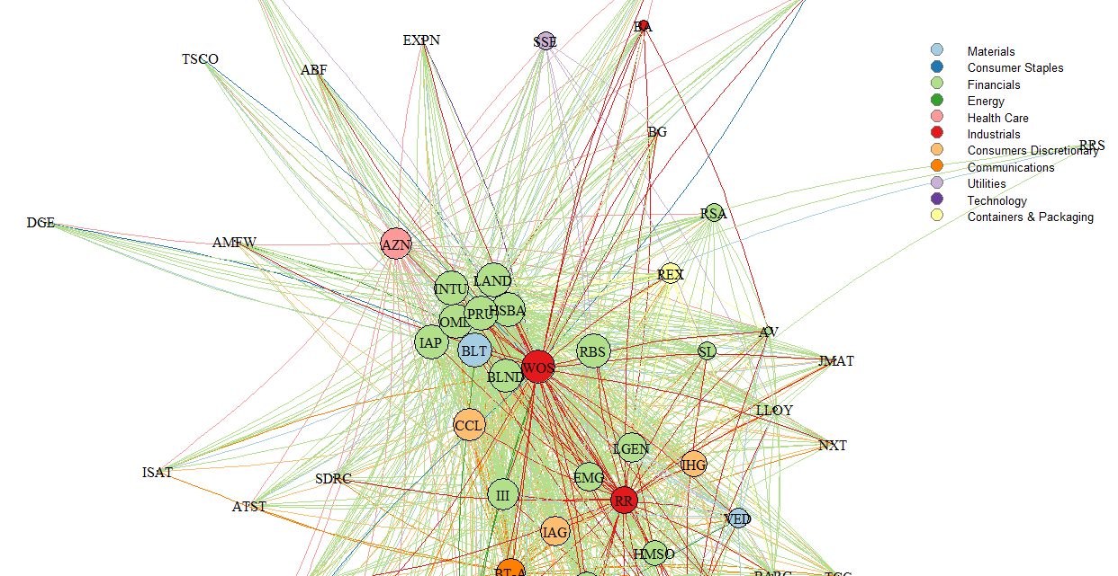

Multidimensional Scaling: useful to find clusters of similar individuals. The problem is that very similar nodes will appear superimposed. MDS layouts are nice because positions and distances have a clear interpretation.

