

Data Science

Manul Sahu ( 72411681)
Mehak ( 72411681)
Kurapati Yashwanth Sai( 72412857)
Simran Vij ( 72413557)

B TECH CSE (AI&DS) 3RD Sem
Section : B
Submitted To : Mr. Devansh Kasaudhan(IBM)



Student Mark Prediction Using ML

1. Introduction
Student Marks Prediction is a data science project that leverages machine learning to forecast students' mathematics examination scores. This predictive system enables educational institutions to:
- Identify at-risk students early in the academic cycle
- Provide targeted interventions and academic support
- Optimize resource allocation for maximum impact
- Automate the assessment process using real demographic and academic data
The project demonstrates the practical application of Linear Regression in educational analytics, transforming raw student data into actionable insights for educators and administrators.

2. Objective
- The main objective of this study is to predict students’ marks based on various features such as Develop an accurate predictive model for math scores using existing student data
- Create an early warning system to identify students needing additional support
- Automate the prediction process to save educators' time and resources
- Provide data-driven insights to improve educational outcomes

3. Dataset Description
Source and Structure:
- Dataset: "Students Performance in Exams" from Kaggle
- File: StudentsPerformance.csv
- Dimensions: 1000 rows × 8 columns
Feature Columns:
- gender: Student's gender (categorical)
- race/ethnicity: Ethnic background classification (categorical)
- parental level of education: Parents' educational background (categorical)
- lunch: Type of lunch program (standard/free/reduced)
- test preparation course: Completion status of test prep course
- math score: Target variable to predict (numerical)
- reading score: Reading examination scores (numerical)
- writing score: Writing examination scores (numerical)
These attributes are used as input features for training the machine learning models. Data preprocessing, normalization, and feature selection are essential steps before model training.

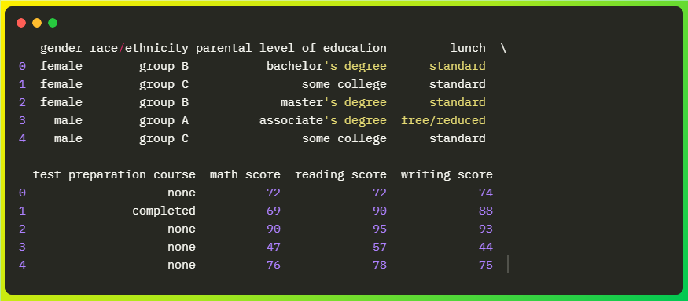
Data Sample:

4. Implementation Details
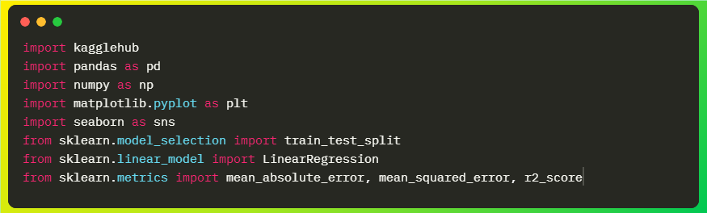
Step 1: Environment Setup and Library Import
Library Purpose Breakdown:
- Pandas & NumPy: Data manipulation and numerical operations
- Matplotlib & Seaborn: Data visualization and plotting
- Scikit-learn: Machine learning models and evaluation metrics

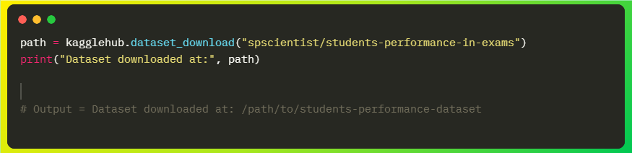
Step 2: Dataset Download

Step 3: Data Preprocessing
Encoding Process:
- Converts categorical text data to numerical codes
- Enables machine learning algorithm compatibility
- Maintains categorical relationships implicitly

Step 4: Feature Selection and Target Definition
Feature-Target Split:
- Input Features (X): 7 variables (gender, race_ethnicity, parental_education, lunch, test_preparation, reading_score, writing_score)
- Target Variable (y): math_score (numerical values 0-100)

Step 5: Data Splitting for Model Validation
Splitting Strategy:
- Training Set: 80% of data (800 samples) for model training
- Testing Set: 20% of data (200 samples) for model evaluation
- Random State: 42 ensures reproducible results

Step 7: Model Training with Linear Regression
Linear Regression Concept:
- Models the relationship between input features and target variable
- Creates a linear equation: y = b₀ + b₁x₁ + b₂x₂ + ... + bₙxₙ
- Learns coefficients that minimize prediction error

5. Results and Analysis
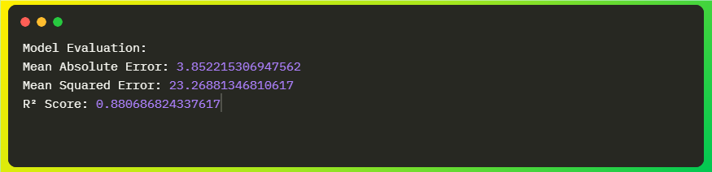
Model Performance Metrics:
Metric Interpretation:
- Mean Absolute Error (MAE) = 3.85
  - On average, predictions are within ±3.85 points of actual scores
  - Represents the typical prediction error magnitude
- Mean Squared Error (MSE) = 23.27
  - Squares errors to penalize larger deviations more heavily
  - Useful for understanding error distribution
- R² Score = 0.881 (88.1%)
  - Indicates that 88.1% of variance in math scores is explained by our model
  - Strong predictive power (closer to 1.0 is better)

6. Visualization - Actual vs. Predicted Scores
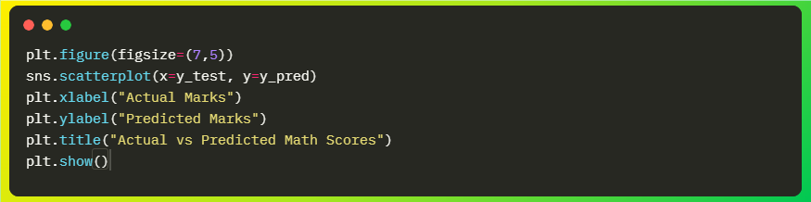
Visual Analysis:
- Points clustered along the diagonal indicate accurate predictions
- Spread from the diagonal shows prediction errors
- Overall pattern demonstrates strong linear relationship

Visualization Output:
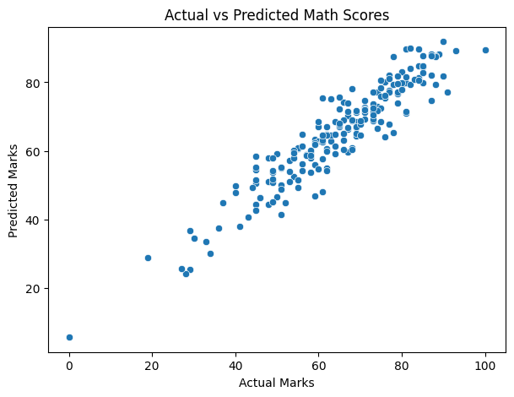

7. Output and Prediction Demonstration
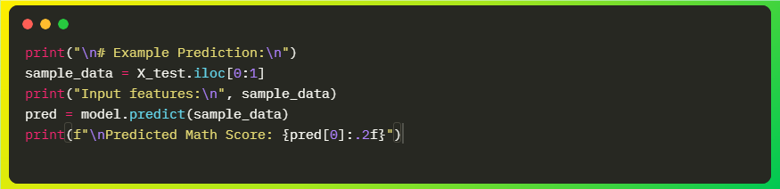
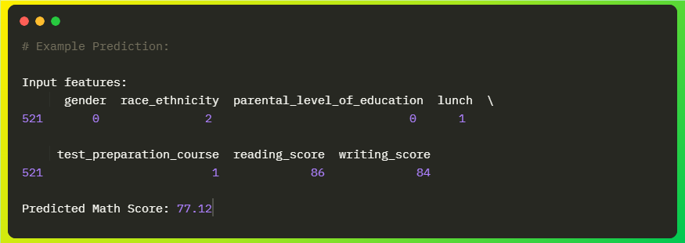
Example Output:
Prediction Interpretation:
- Input Student Profile: Female, ethnic group C, associate's degree parents, standard lunch, completed test prep, reading=86, writing=84
- Predicted Math Score: 77.12
- Model Insight: The model considers multiple factors including correlated reading/writing scores and demographic features

8. Key Insights
Educational Implications:
- Early Intervention: Identify at-risk students before exams
- Resource Allocation: Target support to students with specific demographic profiles
- Curriculum Planning: Use insights to improve teaching strategies
- Parental Involvement: Encourage educational support at home

Limitations and Future Work
Limitation:
- Dataset Scope
  - Limited to specific demographic and geographic context
  - May not generalize to all educational settings
- Model Simplicity
  - Linear Regression assumes linear relationships
  - May miss complex non-linear patterns in data
- Feature Constraints
  - Limited to available dataset features
  - Missing potentially important variables (attendance, homework completion, behavioral data)
Future Enhancements:
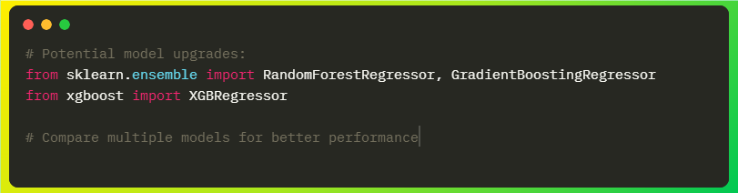
- Advanced Modeling Techniques
- Random Forest
- Gradient Boosting
- XGBoost
- Neural Networks
These are some advanced models with higher accuracy potential and better with noisy data

2. Additional Features
  - Attendance records
  - Homework completion rates
  - Behavioral metrics
  - Extracurricular activities

3. Extended Analysis
  - Multi-subject prediction (reading, writing)
  - Longitudinal performance tracking
  - Cluster analysis for student segmentation

10. Conclusion
The Student Marks Prediction project successfully demonstrates:
Educational Impact:
- ✅ Provides early identification of at-risk students
- ✅ Enables data-driven intervention strategies
- ✅ Automates assessment processes for efficiency
- ✅ Offers insights into factors affecting student performance
Broader Significance:
This project showcases the transformative potential of data science in education, moving from reactive to proactive educational support systems. By leveraging machine learning, educators can:
- Personalize learning experiences based on predicted needs
- Optimize resource allocation for maximum impact
- Improve overall educational outcomes through targeted interventions
- Make informed decisions backed by data-driven insights
The methodology established here serves as a foundation for more sophisticated educational analytics systems that can adapt to diverse learning environments and student populations.

