**Name: Maryam Suhail**

**Reg# 121149**

**Class: BSCS 5C**

**Course: Advanced programming**

**LAB # 3**

**Installing R studio**

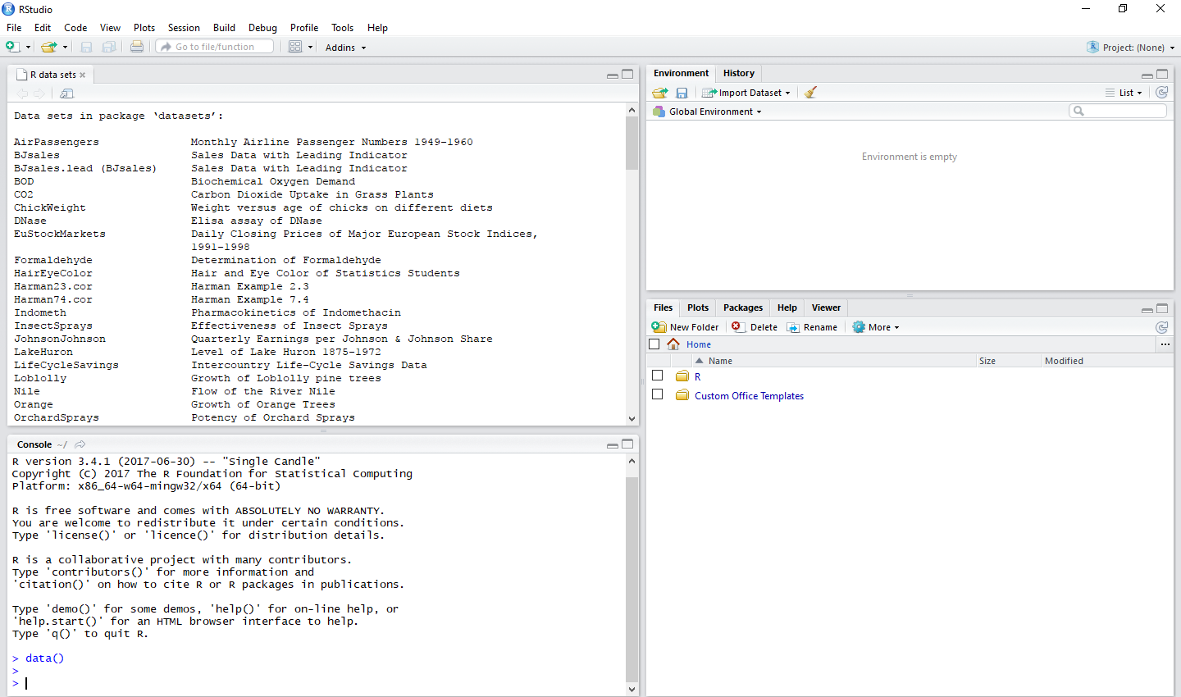

**Introduction**

The purpose of today’s lab is to learn how to install R and R studio and to start working in R studio. R studio is a language used for making graphs. It is used for data analysis on big data bases. We have to work on ‘mtcars’ data sets and plot different graphs.

**Approach**

* Install R and R Studio.
* Get started with basic syntax of R and get acclimatized to the R studio IDE.
* Build your first application using R
* Install the data set ‘mtcars’
* Draw different graphs on the dataset ‘mtcars’

**How to run**

|  |
| --- |
| **Code 1** |

attach(mtcars)

plot(hp, mpg, main = "Horsepower vs Mileage", xlab = "Horsepower", ylab = "Mileage",

pch = 15, col = "red")

text(hp, mpg, row.names(mtcars), cex = 0.6, pos = 4, col = "black")

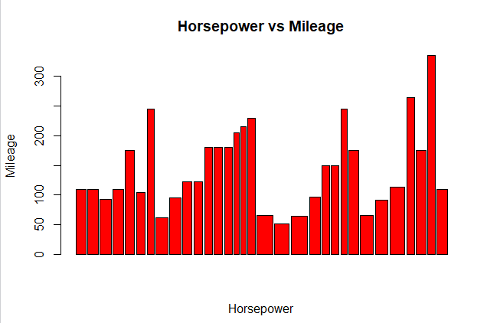

|  |
| --- |
| **Code 2** |

attach(mtcars)

plot(wt, mpg, main = "Milage vs. Car Weight", xlab = "Weight", ylab = "Mileage",

+ pch = 23, col = "green")

text(wt, mpg, row.names(mtcars), cex = 0.6, pos = 4, col = "blue")

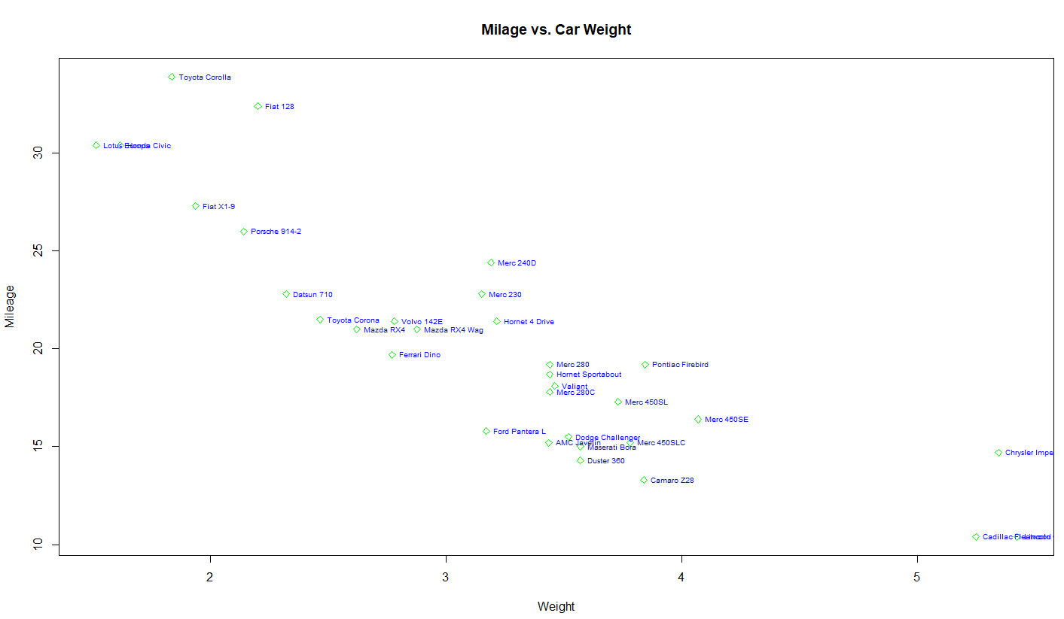

|  |
| --- |
| **Code 3** |

library(ggplot2)

data(mtcars)

attach(mtcars)

boxplot(disp, hp, main = "Displacement vs HorsePower", xlab = "Displacement", ylab = "HorsePower",

pch = 12, col = "yellow")

text(hp, mpg, row.names(mtcars), cex = 0.6, pos = 4, col = "blue")

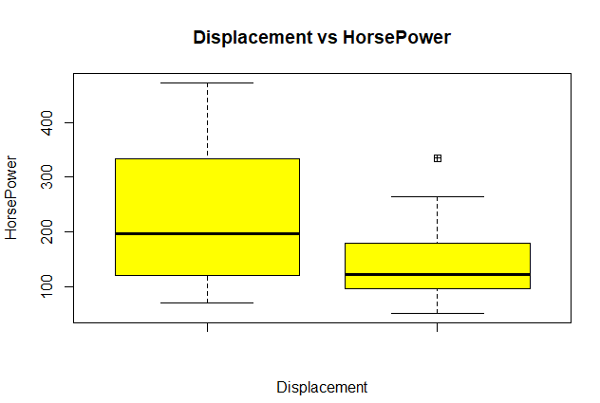

**Analysis**

Different graphs like bar graph, histogram, etc are plotted for the data set ‘mtcars . different parameters are included. The x and y axis parameters are identified and displayed on the graph.

**Link on GitHub**

[**https://github.com/manum23/Lab3.git**](https://github.com/manum23/Lab3.git)