Our Work | Services | About us | Client Testimonials | Contact us
(Link the above buttons to the sections below)

Looking for a reliable partner for your next web development project?  Since 1997, Web Sight has handled over 600 offshore projects in 16 countries.  From Laravel (PHP), React, VueJS, Angular JS to Wordpress and Woocommerce, our experienced team is highly skilled, flexible and speaks English fluently.  If you are looking for an affordable & reliable offshore technology partner to outsource your web development, talk to us! | Get a free quote!  Use the form below to send us your project requirements and we will get back within 1 business day or earlier!  Name*  Email*  Phone Number  Enter your project details*  [Submit]  [] Attach document (if available)  100% privacy guaranteed.

For the sections below, please follow the design at Web App Development | Vayoza Software Solutions

Our Work
We take pride in our work and constantly seek new challenges. Check out some of our recent projects in our portfolio:

E-commerce Web Site for one of England’s Top Cheese Manufacturers | Wordpress Web Site for  Global Market Research Agency | Online E-learning Platform for Legal Education in the Philippines
 | 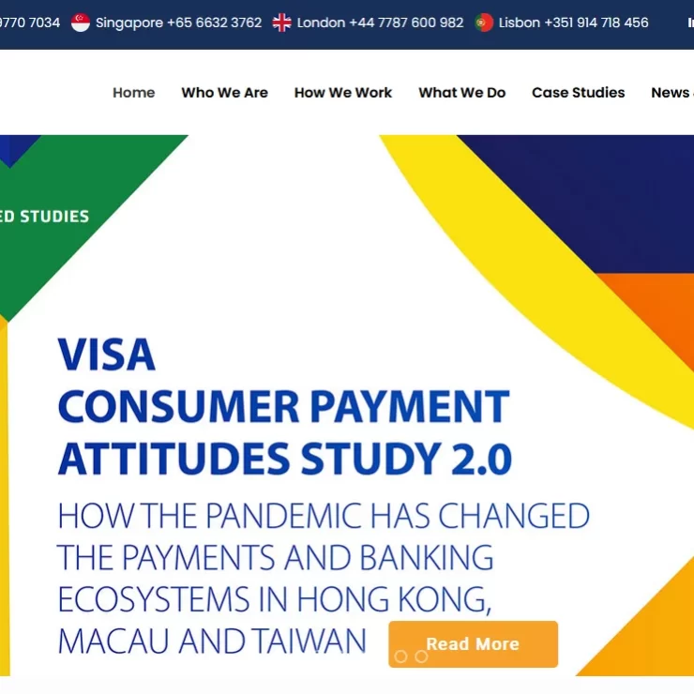 | 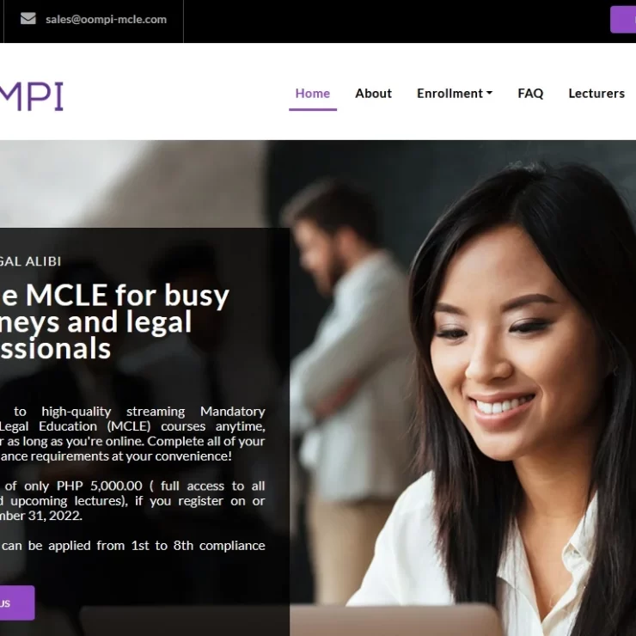
cheshirecheesecompany.co.uk | intuit-research.com | oompi.com

Custom warehouse management solution for a furniture manufacturer | Online Assessment and Classroom Management Software in Malaysia | Web based estimation software  for construction projects
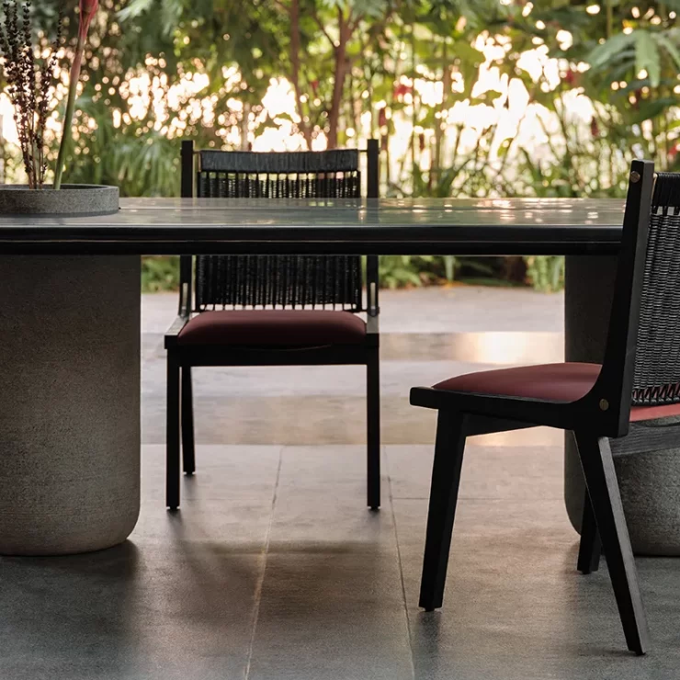 | 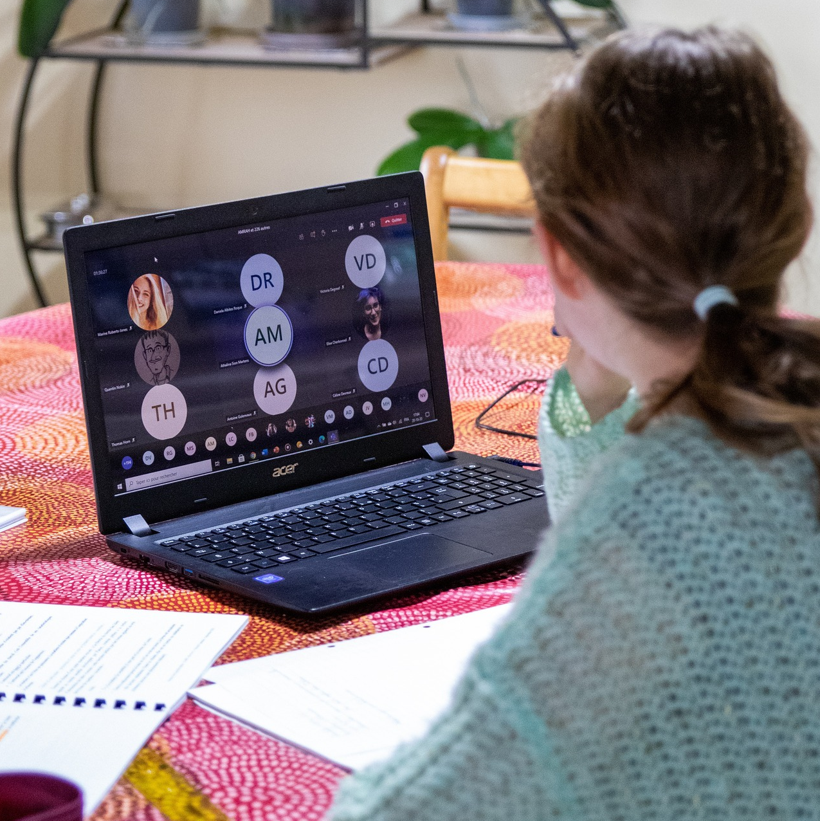 | 

Our Services
Custom Web Application Development | Open Source Web Development | Ecommerce Web Development | IT Staffing Services
Web Sight can help throughout the entire custom web app development process, from ideation and planning to design, development, testing, and deployment. | We offer open source web development services and migration. Our services also include speed optimization, security, SEO and third party module integration. | From Ecommerce platform migration to B2B solutions, we offer secure, scalable, cloud powered Ecommerce solutions that provides your customers with immersive services. | We offer a unique blend of consultation and staff augmentation to ensure seamless integration of new team members into your existing operations.
About us
Web Sight has 27 years of experience in offshore web and mobile development services to organizations across the world, having successfully handled over 750 projects in 16 countries from the United States, UK, Ireland, Spain, New Zealand, Australia to Malaysia, Singapore, Hong Kong, Dubai, Bahrain, Sri Lanka and India.

Some of our global clients include Jaguar Land Rover, Singapore Government, McKinsey (Uk) & Warner Brothers. Web Sight has been an offshore web development partner of CWTV (Joint venture between Warner Bros. and CBS Corporation) for 15+ years. We’ve built numerous web applications for the CW network, such as Intranets, data warehousing applications, program management for the CWTV network.
We have been a registered member of the Software Technology Parks of India, since 2006. We have physical offices in Kerala, India & Macclesfield, Cheshire, UK.
Web Sight Technologies was rated among 'Top Mobile App Development Companies: 2015’ by Outsourcing Gazette (USA).

Client Testimonials
Take content from here

Contact us
Copy the form as seen on top and show it again here at the bottom also

===

Add a Whatsapp chat button (popup) and connect it to +91.9446075840 so clients can send a whatsapp message via web to me,

