GROWTH AND MARKETING PLAN
How we win the first 1,000 daily flower customers and grow to about Rs 1.1 crore in year one
Competitor study, outreach plan, 12-month timeline and revenue model for the flower store and daily subscription.
Prepared for: Client name, Flower business
Date: October 2026
Note: All revenue figures are planning targets based on stated assumptions, not guarantees.

1. The plan on one page
The Indian flower market is crowded at the top and thin in the middle. National gifting brands sell occasions. Puja-flower startups sell a small daily bunch. Hardly anyone sells beautiful, reliable, daily flowers for the home with a proper app-like experience. That gap is where this store should sit.
Item | What we plan
Positioning | Premium, designed flowers for everyday life, with a daily or weekly subscription you can pause in one tap.
Beat the gifting giants on | Local freshness, a daily habit (not only Valentine's Day), and price clarity.
Beat the puja startups on | Design quality, gifting add-ons, delivery slots and a modern store and account experience.
First 90 days | Win 3 housing societies, 100 free trials, about 100 paying subscribers.
Month 12 target | 920 active subscribers and about 1500 one-time orders a month
Year-one revenue | About Rs 108.8 lakh (subscriptions Rs 56.6 lakh, one-time Rs 52.1 lakh)
Marketing budget | Rs 6 lakh over 12 months, about 5.5% of revenue

2. Who we compete with
We looked at three kinds of competitor. We could confirm public facts for some of them but not all, so unverified points are marked and should be checked on their live sites before the plan is finalised.
Competitor | What they do | Where they are strong | Where we can win
FNP and FlowerAura | National gifting. Online orders, 320+ stores for FNP, and a subscription plan being added in new stores. | Brand, reach, wide catalogue, big occasion sales. | Daily habit, local freshness, clear pricing, personal service. They treat subscription as a side product.
Hoovu (Bengaluru) | Puja-flower subscription, founded 2019. Reported turnover about Rs 8 crore, sold through its own site and apps like BigBasket, Zepto and Milkbasket. | Habit, subscription pricing from roughly Rs 125 a month (older listing), quick-commerce distribution. | Designed bouquets, gifting add-ons, mixed everyday plans, better storytelling and design.
Phulwaa* | Sells fresh flowers such as shevanti through Swiggy Instamart. | Instant delivery through a big platform. | Own customer relationship. On a marketplace they own the customer, not the brand.
*We could only confirm the Instamart listing for Phulwaa. Please send us their website or screenshots and we will complete this row. Sources: The Better India, YourStory, India Retailing, Swiggy Instamart.
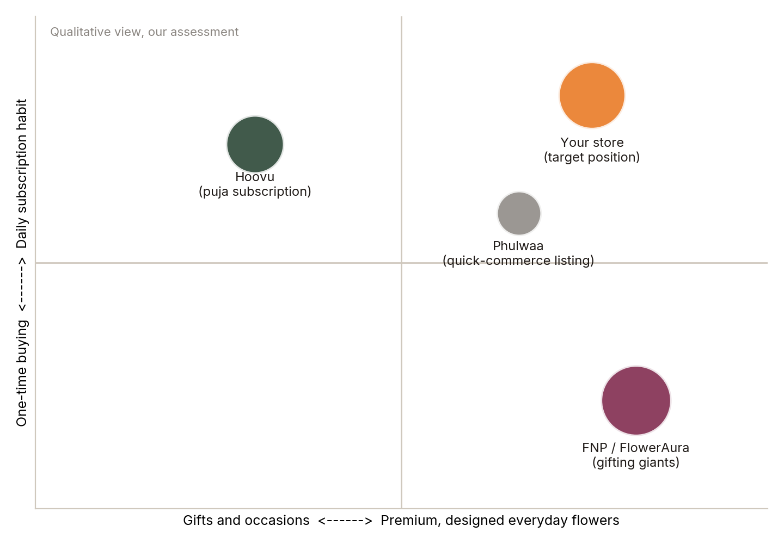
Figure 1. Where each player sits today, and where we want to be. A qualitative view, not market data.
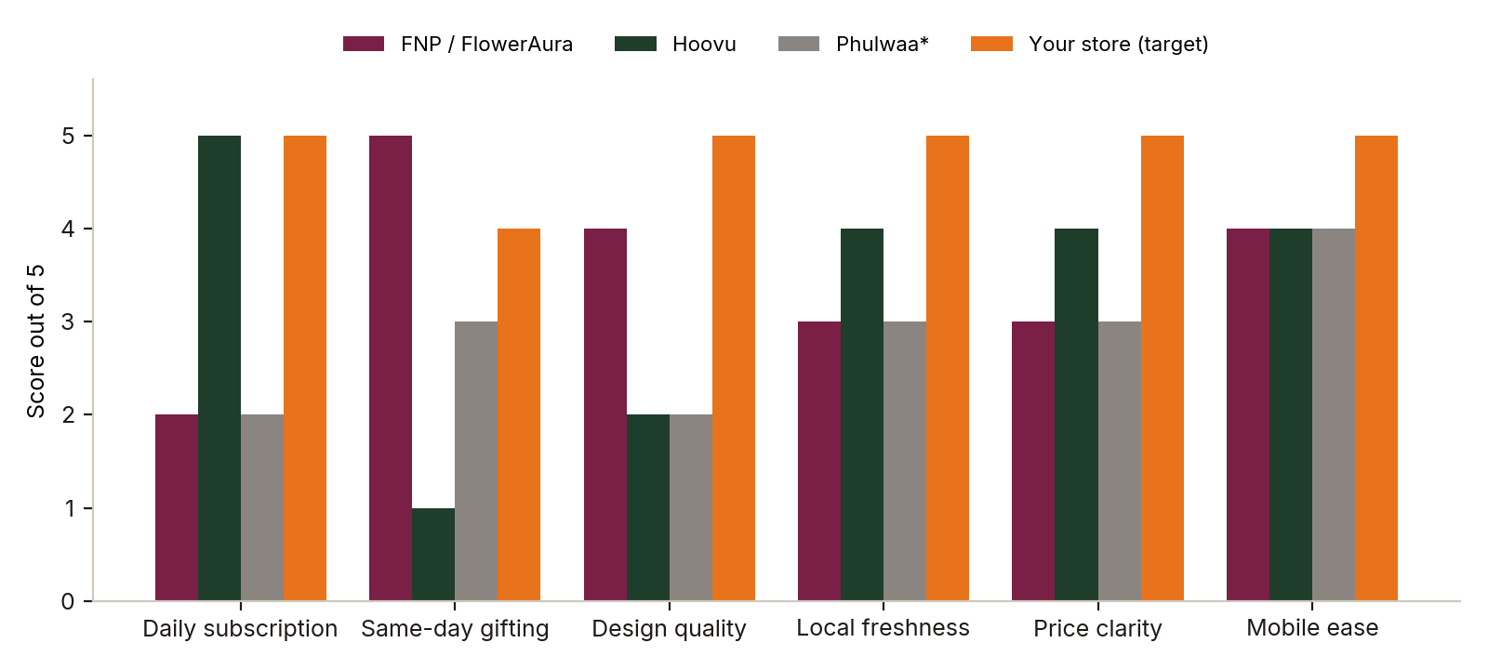
Figure 2. Capability scores out of 5. Competitor scores are our estimates from public information; the last bar is the target we are building toward.

What the competitors are doing, and what we do about it
Their move | Why it works | Our counter
Sell through quick-commerce apps | Instant reach with no ad spend | Use them for awareness only. Move every buyer to our own WhatsApp and store.
Heavy festival and occasion marketing | Big one-day spikes | Own the other 340 days: daily plans, weekly home refresh, office desks.
Low-price puja subscriptions | Habit and repeat orders | Offer a premium tier and one-tap pause, so price is not the only reason to stay.
Large catalogues and discounts | Choice and deals | Curate fewer, better products with clear photos and honest pricing.

3. Our growth strategy
Growth comes from a loop, not a single campaign. Fresh flowers delivered on time create happy customers. They leave reviews and refer neighbours. That lowers the cost of winning the next customer. More subscribers also mean predictable demand, so we waste fewer flowers and earn better margins.
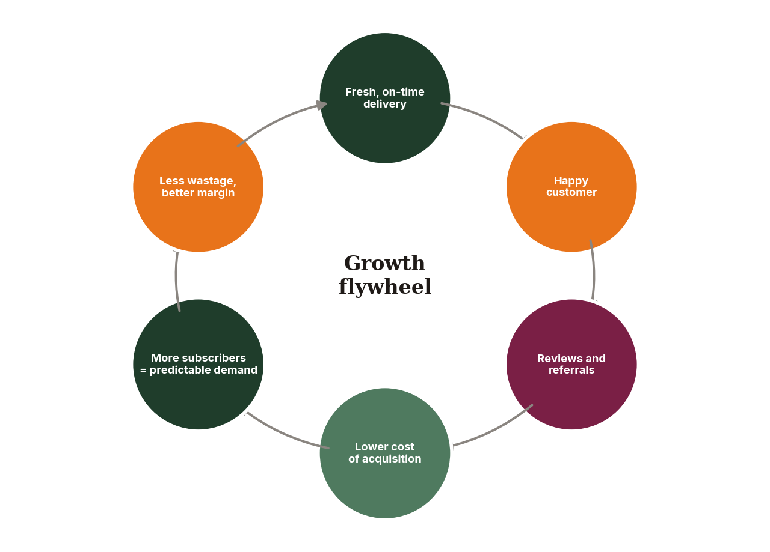
Figure 3. The growth flywheel. Each turn lowers cost and raises margin.

Who we target first
Segment | Why | How we reach them
Apartment residents | Dense, repeat buyers, easy delivery routes | Society activations, resident WhatsApp groups, free trial week
Home offices and cafes | Daily desk and counter flowers, monthly invoices | Walk-in visits, LinkedIn, local business groups
Gift buyers | High order value, occasion-led | Instagram, Google search, add-on gifts and cards
Wedding and event planners | Large repeat orders | Direct outreach and a partner price list

4. Marketing and outreach, step by step

Step 1. Foundation (weeks 1 to 4)
- Publish the site with the SEO already built in: search-friendly pages, sitemap and product schema.
- Claim and fill in the Google Business Profile with photos, hours and service area.
- Set up Instagram and WhatsApp Business with a catalogue and quick replies.
- Collect 20 real photos of the bouquets and the delivery.

Step 2. Pilot in 3 societies (months 1 to 3)
- Pick three nearby housing societies. Speak to the committee first.
- Offer a 7-day free trial to 100 homes. Deliver in the morning so they see it daily.
- Ask each trial customer for one review and one referral. Aim for 30% to convert to paid.

Step 3. Content engine (from month 2)
- Post 4 Reels a week: morning delivery, arranging stems, flower care tips, before and after.
- Use customer photos with permission. Real homes sell better than studio shots.
- Write helpful pages such as "best flowers for puja" and "how long do roses last" to win search traffic.

Step 4. Paid ads (from month 3)
- Start with Rs 500 a day on Meta ads to people within 5 km of delivery areas.
- Run Google search ads for "flower delivery near me" and "daily flower subscription".
- Cut any ad that costs more than the target in the chart below after 2 weeks.

Step 5. Referral and retention (from month 4)
- Give both friends a reward, for example one free bouquet add-on after 30 days.
- Send a WhatsApp reminder before the 9 PM order cut-off and a thank-you after delivery.
- Win back paused subscribers with a "come back" message after 14 days.

Step 6. Corporate, weddings and festivals (from month 5)
- Offer offices a desk-flower plan with one monthly invoice.
- Build a partner price list for planners and decorators.
- Plan festival campaigns six weeks ahead: Diwali, Valentine's Day, Mother's Day and wedding season.

The customer funnel
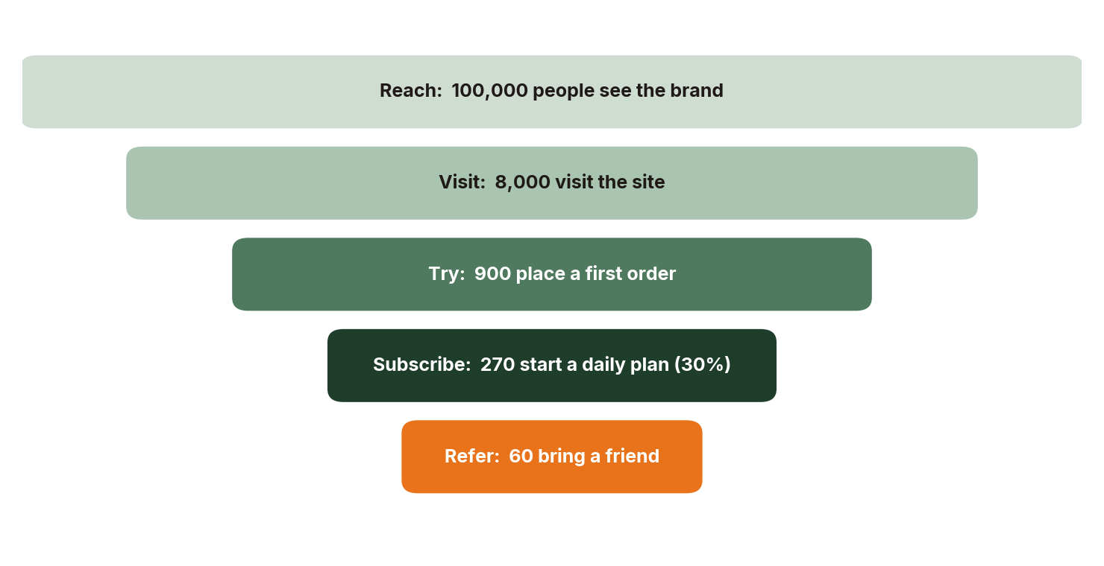
Figure 4. Illustrative monthly funnel at steady state. Percentages are targets to test, not measured results.

5. Budget and channel costs
We start with the cheapest channels (referrals, societies, WhatsApp) and add paid ads once the product and delivery are proven. The total budget is about Rs 6 lakh over the year.
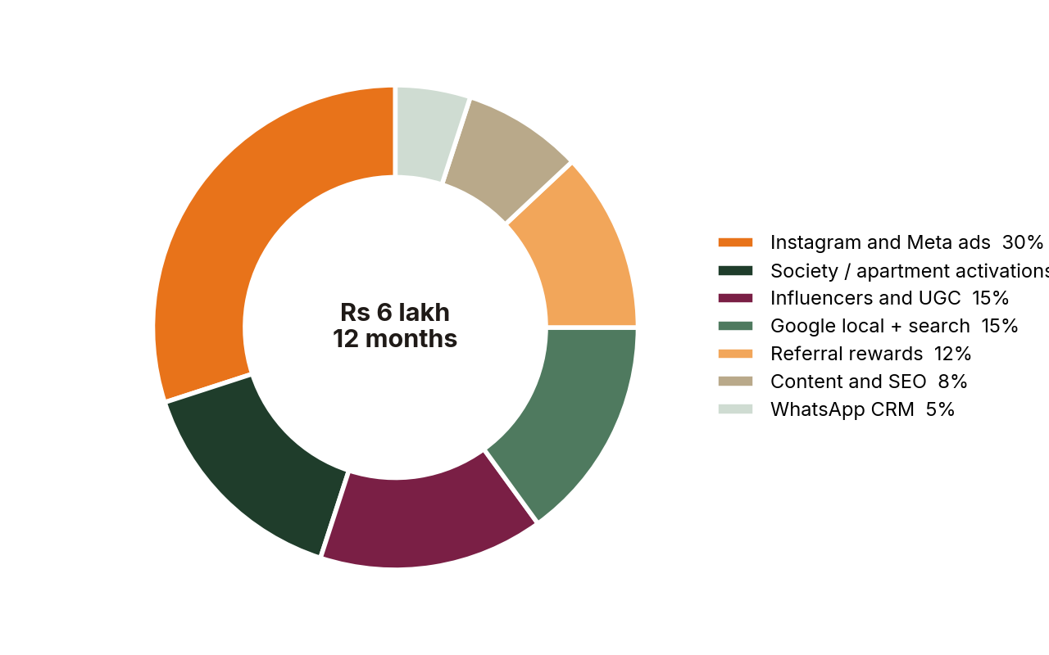
Figure 5. How the Rs 6 lakh marketing budget is split.
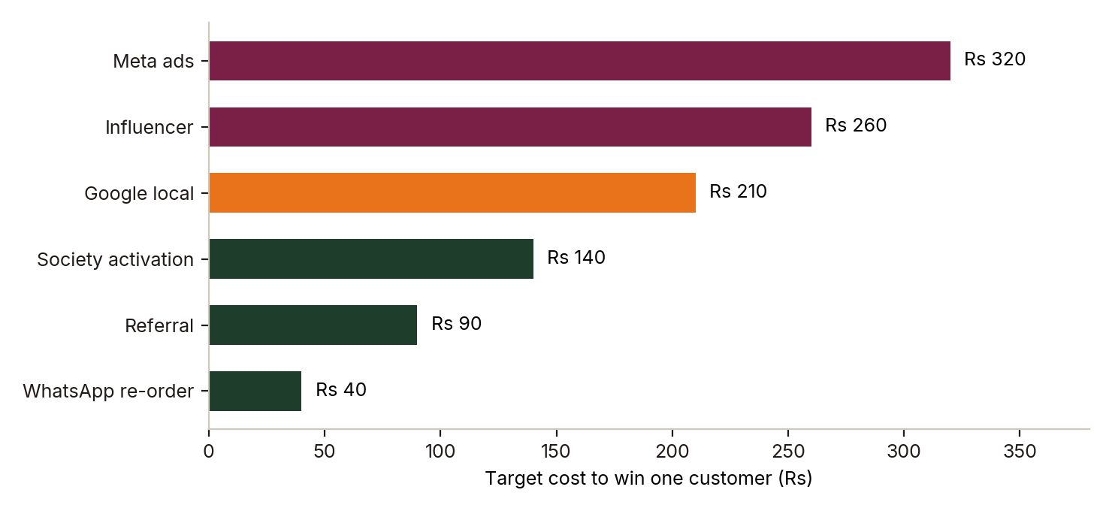
Figure 6. Target cost to win a customer by channel. These are planning targets; real numbers will come from the first 8 weeks of data.
Channel | Monthly spend | What we measure | Stop if
Meta ads | Rs 15,000 | Cost per trial sign-up | Above Rs 400 after 2 weeks
Google local and search | Rs 8,000 | Calls, orders, cost per order | Above Rs 250
Influencers and UGC | Rs 8,000 | Orders using their code | No orders in 3 posts
Society activations | Rs 8,000 | Free trials to paid | Under 20% convert
Referral rewards | Rs 6,000 | Referrals per customer | Under 5%

6. Revenue plan
The model assumes an average subscription of Rs 1,200 a month (about Rs 40 a day) and an average one-time order of Rs 650. Subscribers grow from 30 to 920 and one-time orders from 120 to 1500 a month.
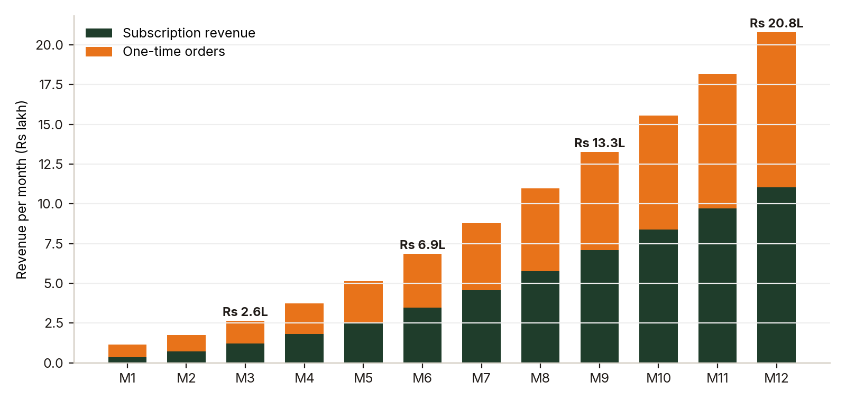
Figure 7. Monthly revenue by source.
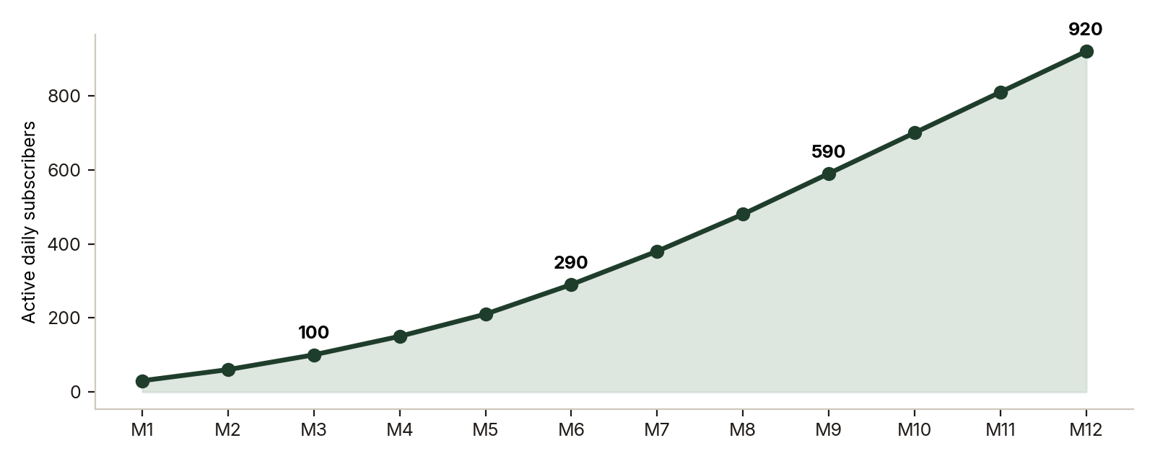
Figure 8. Active daily subscribers by month.
Period | Subscriptions | One-time orders | Total
Quarter 1 (M1 to M3) | Rs 2.3 lakh | Rs 3.3 lakh | Rs 5.5 lakh
Quarter 2 (M4 to M6) | Rs 7.8 lakh | Rs 7.9 lakh | Rs 15.7 lakh
Quarter 3 (M7 to M9) | Rs 17.4 lakh | Rs 15.6 lakh | Rs 33.0 lakh
Quarter 4 (M10 to M12) | Rs 29.2 lakh | Rs 25.4 lakh | Rs 54.5 lakh
Year one | Rs 56.6 lakh | Rs 52.1 lakh | Rs 108.8 lakh
Illustrative. Festival peaks (Diwali, Valentine's Day) would add on top, as would corporate plans.

What it needs to work
Assumption | Value used | Why
Subscription value | Rs 1,200 a month | Roughly Rs 40 a day, between puja bunches and bouquets
One-time order value | Rs 650 | Bouquet plus an add-on such as a card or vase
Gross margin | 35% to 45% | Fresh flowers have wastage; subscriptions reduce it
Trial to paid | 30% | Free week, delivered every morning
Monthly churn | 8% or less | Pause option instead of cancelling

7. Twelve-month timeline
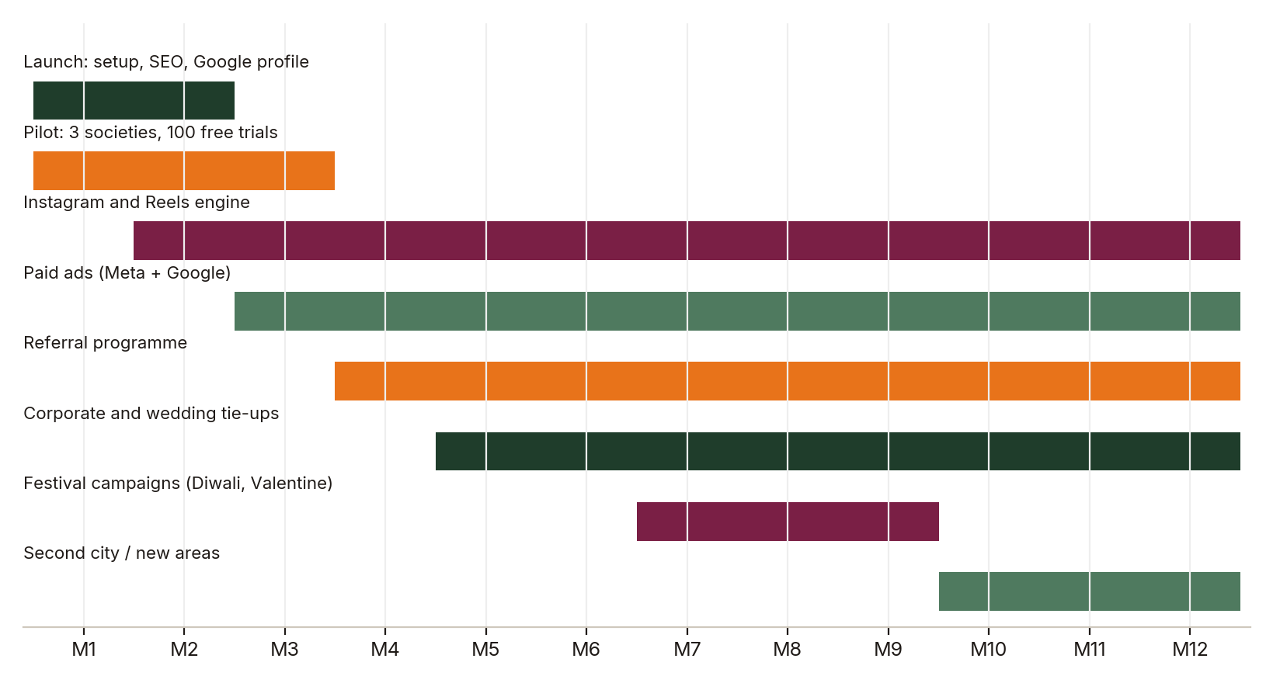
Figure 9. When each activity starts and how long it runs.
Phase | What happens | Goal | Check
Months 1 to 3: Prove | Launch, 3-society pilot, first Reels, Google profile | 100 subscribers, 4.5-star reviews | Trial to paid above 25%
Months 4 to 6: Grow | Paid ads, referrals, corporate outreach | 290 subscribers | Cost per customer under Rs 250
Months 7 to 9: Scale | Festival campaigns, wedding tie-ups, more routes | 590 subscribers | Late deliveries under 3%
Months 10 to 12: Expand | New areas or a second city, loyalty tiers | 920 subscribers | Monthly churn under 8%

8. Risks and how we handle them
Risk | Why it matters | What we do
Flower wastage | Stems wilt and cost money | Order against subscriptions, discount same-day leftovers, track stock daily
Late or missed deliveries | One bad morning loses a subscriber | Pick delivery slots, WhatsApp alerts, failed-delivery redelivery flow
Big brands cut prices | Price wars hurt small players | Compete on freshness, design and service, not on price
Festival demand spikes | Stock and staff run short | Pre-orders and a cut-off time, plan six weeks ahead
Ad costs rise | Paid growth gets expensive | Shift budget to referrals, societies and WhatsApp

9. What to do next
- Confirm the three competitors, especially Phulwaa, with links so we can finish the study.
- Approve the pilot societies and the first 100 free-trial slots.
- Fix the plan prices so the model uses real numbers.
- Set up Google Business Profile, Instagram and WhatsApp Business this week.
- Review results every month against the checks in section 7 and adjust the budget.

This plan sets targets and assumptions. Actual results depend on execution, season, location and competitor action.

