PRODUCT REQUIREMENTS DOCUMENT
Flower E-Commerce
& Daily Subscription Platform
Online flower store with one-time purchase and daily flower delivery subscription
Web Application • Flutter Mobile App • Admin Panel • Daily Subscription

VERSION | 1.0 (Freelance MVP)
DOCUMENT TYPE | Business understanding, feature list and requirements
PLATFORMS | Web application (full stack) | Mobile application (Flutter)
DATE | October 2026

Contents

1 | Product Overview | What the platform is, goals, complete feature list and detailed feature tree
2 | Business Understanding | Customers, order types, daily subscription model, revenue and rules
3 | Core Flows | Visual flows for purchase, daily subscription and delivery
4 | Web Application (Full Stack) | Customer website, admin panel, backend services
5 | Mobile Application (Flutter) | Customer app features, screens and notifications
6 | Orders, Delivery & Notifications | Statuses, delivery slots and customer messages
7 | Functional Requirements | Numbered, prioritised requirement list
8 | Quality Requirements | Security, performance and usability expectations
9 | Business Records | The main information the platform stores
10 | MVP Scope & Success Criteria | What is in, what is out and how launch is judged
11 | Assumptions & Open Decisions | Items to confirm with the client
A | Appendices | Screen inventory and glossary

1. Product Overview

1.1 Purpose of this document
This document describes the business and the product requirements for an online flower platform. Customers can buy flowers once, or subscribe to receive fresh flowers every day. It is written for the client, the project team and anyone who needs to understand what will be built, without deep technical detail.

1.2 Product summary
The platform is an online flower store with two ways to buy. A customer can place a normal one-time order for a chosen date, or start a daily flower subscription where fresh flowers are delivered to the same address on every selected day. The business team manages products, stock, orders, subscriptions and deliveries from a simple admin panel.

One-time purchase  Browse, add to cart, pick a date and slot, pay online. |  | Daily subscription  Subscribe once and receive flowers every day on selected days. |  | Business control  Admin panel for products, stock, orders and the daily delivery list.

1.3 Product areas
Area | What it provides
Online Store | Browse flowers, view details, add to cart and purchase online.
Daily Subscription | Receive flowers every day (or on chosen days) with full control to skip, pause, change or cancel.
Delivery | Select address, delivery date and an available time window.
Customer Account | Manage profile, addresses, orders, payments and subscriptions.
Notifications | Order, payment, delivery and subscription updates by push, SMS or email.
Admin Panel | Manage products, stock, orders, customers, subscriptions and daily deliveries.

1.4 Product goals
- Simple and attractive shopping: a customer can find flowers and finish an order without help.
- Easy daily delivery setup: starting and managing a subscription takes only a few taps.
- Clear daily operations: the business always sees exactly what to prepare and deliver today.
- Focused MVP: only what is needed for ordering and subscriptions, ready to grow later.

1.5 Platform at a glance
The web store, the Flutter mobile app and the admin panel all use one shared backend. This keeps prices, stock, subscription rules and order status identical everywhere.
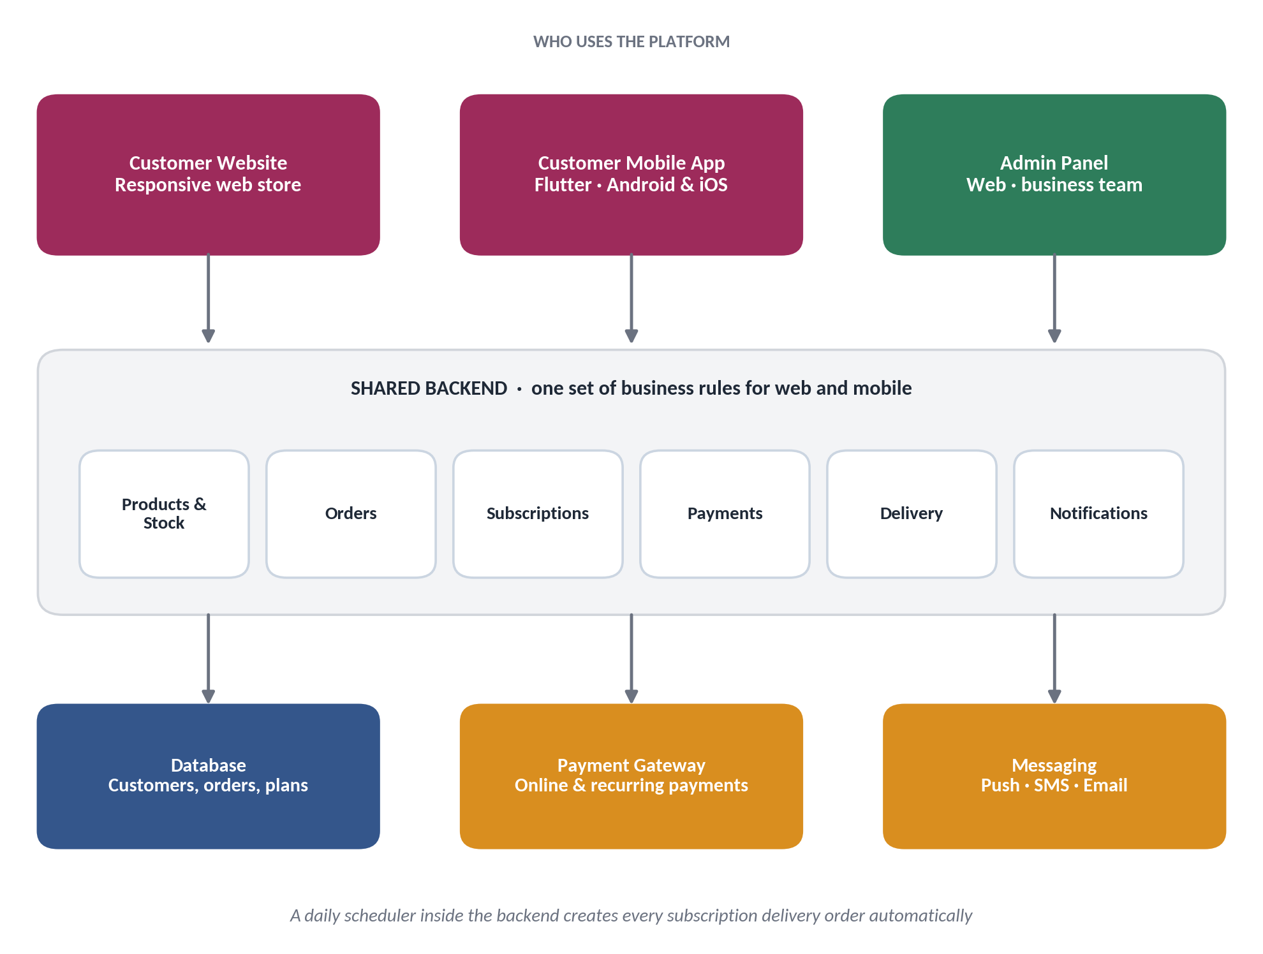
Figure 1 — How the web, mobile and admin parts connect

1.6 Complete feature list
All 65 features of the platform in one place. A dot shows where the feature is available: Web (customer website), Mobile (Flutter app), Admin (admin panel) or Backend (runs automatically).
# | Feature | Web | Mobile | Admin | Backend
ACCOUNT & ACCESS
F-01 | Sign up and login with email or phone OTP | ● | ● | – | –
F-02 | Password recovery | ● | ● | – | –
F-03 | Profile management | ● | ● | – | –
F-04 | Multiple saved addresses with a default address | ● | ● | – | –
F-05 | Secure admin login with role-based access | – | – | ● | ●
DISCOVERY & PRODUCT PAGES
F-06 | Landing page: hero, featured flowers, subscription section, reviews, service area, FAQ, footer | ● | – | – | –
F-07 | Home screen: featured flowers, categories and subscription shortcut | – | ● | – | –
F-08 | Browse by category or occasion | ● | ● | – | –
F-09 | Product search | ● | ● | – | –
F-10 | Basic filters (category, price, availability) | ● | ● | – | –
F-11 | Product detail: gallery, description, size or variant, care information | ● | ● | – | –
F-12 | Related products | ● | – | – | –
F-13 | Add-ons such as greeting cards, vases and small gifts | ● | ● | – | –
F-14 | Favourites / wishlist | ● | ● | – | –
F-15 | Customer reviews and testimonials display | ● | – | – | –
CART & CHECKOUT
F-16 | Add to cart, change quantity, remove items | ● | ● | – | –
F-17 | Coupon code | ● | ● | – | –
F-18 | Recipient details for gifting | ● | ● | – | –
F-19 | Delivery address, date and time slot selection | ● | ● | – | –
F-20 | Gift note and delivery instructions | ● | ● | – | –
F-21 | Order summary with delivery fee and total | ● | ● | – | –
F-22 | Online payment | ● | ● | – | –
F-23 | Order confirmation | ● | ● | – | –
DAILY SUBSCRIPTION (CUSTOMER)
F-24 | Subscribe to an eligible daily plan | ● | ● | – | –
F-25 | Choose delivery days: every day, weekdays or custom days | ● | ● | – | –
F-26 | Choose start date and plan period (7 / 15 / 30 days) | ● | ● | – | –
F-27 | Advance payment for the plan period | ● | ● | – | –
F-28 | View plan, price, next delivery and plan end date | ● | ● | – | –
F-29 | Calendar of upcoming deliveries | ● | ● | – | –
F-30 | Skip a day before the cut-off | ● | ● | – | –
F-31 | Pause and resume subscription | ● | ● | – | –
F-32 | Change delivery days, slot or address where allowed | ● | ● | – | –
F-33 | Renew when the plan ends | ● | ● | – | –
F-34 | Cancel subscription within policy | ● | ● | – | –
F-35 | Subscription delivery history | ● | ● | – | –
ORDERS & DELIVERY (CUSTOMER)
F-36 | Order history and order details | ● | ● | – | –
F-37 | Live order status tracking | ● | ● | – | –
F-38 | Payment history and status | ● | ● | – | –
F-39 | Delivery area check by location | ● | ● | – | ●
F-40 | Reschedule or support flow for failed deliveries | ● | ● | ● | –
NOTIFICATIONS
F-41 | Push notifications for orders, payments and subscriptions | – | ● | – | ●
F-42 | SMS alerts for key events | – | – | – | ●
F-43 | Email confirmations and updates | – | – | – | ●
F-44 | Tomorrow's delivery reminder with Skip option | – | ● | – | ●
F-45 | Plan ending soon reminder | – | ● | – | ●
F-46 | Subscription payment issue alert | – | ● | – | ●
SUPPORT
F-47 | FAQ and help centre | ● | ● | – | –
F-48 | Contact support | ● | ● | – | –
ADMIN PANEL
F-49 | Dashboard: orders today, deliveries due, active subscriptions, pending actions | – | – | ● | –
F-50 | Today's delivery list grouped by slot | – | – | ● | –
F-51 | Print or export the daily delivery list | – | – | ● | –
F-52 | Manage products, prices, images and categories | – | – | ● | –
F-53 | Manage subscription plans and plan periods | – | – | ● | –
F-54 | Stock and availability management | – | – | ● | –
F-55 | View, search and update orders and delivery status | – | – | ● | –
F-56 | View active, paused and cancelled subscriptions and next delivery | – | – | ● | –
F-57 | View customers, addresses, orders and subscriptions | – | – | ● | –
F-58 | Delivery settings: areas, slots, charges and cut-off time | – | – | ● | –
F-59 | Create and manage coupons | – | – | ● | –
F-60 | Basic daily order and sales reports | – | – | ● | –
PLATFORM & BACKEND (AUTOMATIC)
F-61 | Daily scheduler creates next day's orders for all active subscriptions | – | – | – | ●
F-62 | Hold subscription when a recurring payment fails | – | – | – | ●
F-63 | Payment processing, payment status and refunds | – | – | – | ●
F-64 | Cut-off rule locks tomorrow's orders for preparation | – | – | – | ●
F-65 | Regular data backups | – | – | – | ●

1.7 Feature tree — detailed breakdown
Each major feature is shown with its sub-features and the small features inside them. The tag on the right shows where the feature is delivered.

1. ACCOUNT & ACCESS Web · Mobile
- 1.1 Sign up & login
  - Sign up with phone number or email
  - One-time password (OTP) verification
  - Login with phone/email and OTP or password
  - Stay signed in on the device
  - Logout
- 1.2 Password recovery
  - Forgot password link
  - Reset code by SMS or email
  - Set a new password
- 1.3 Profile
  - Name, phone and email
  - Edit personal details
  - Language and notification preferences
- 1.4 Saved addresses
  - Add, edit and delete addresses
  - Set a default address
  - Label addresses (Home, Office, Temple, Shop)
  - Landmark and delivery instructions per address
  - Serviceable-area check when saving
2. PRODUCT DISCOVERY Web · Mobile
- 2.1 Browse
  - Categories (bouquets, loose flowers, garlands, pooja packs)
  - Occasions (birthday, anniversary, festival, gifting)
  - Featured flowers and best sellers
  - New arrivals
- 2.2 Search & filters
  - Search by flower or product name
  - Filter by category, price range and availability
  - Sort by price and popularity
  - Subscription-eligible filter
- 2.3 Product detail
  - Image gallery
  - Name, description and price
  - Size or variant selection
  - Flower care information
  - Availability and next available date
  - Buy once or Subscribe buttons
- 2.4 Extras
  - Related products
  - Add-ons: greeting cards, vases, small gifts
  - Favourites / wishlist (save and re-order)
3. CART & CHECKOUT Web · Mobile
- 3.1 Cart
  - Add items
  - Change quantity and remove items
  - Cart saved while logged in
  - Price and stock check before checkout
- 3.2 Delivery details
  - Choose or add address
  - Recipient name and phone for gifts
  - Delivery date selection
  - Time slot selection
  - Gift message and delivery instructions
- 3.3 Order summary
  - Item list with add-ons
  - Coupon code field
  - Delivery fee and total
  - Order type shown (one-time or subscription)
- 3.4 Order confirmation
  - Order number and summary
  - Expected delivery date and slot
  - Confirmation by push, SMS and email
4. PAYMENTS Web · Mobile · Backend
- 4.1 Online payment
  - UPI, cards, net banking and wallets via payment gateway
  - Secure payment page (no card data stored by us)
  - Payment success and failure screens
  - Retry failed payment
- 4.2 Payment records
  - Payment status per order
  - Payment history for the customer
  - Receipt / invoice for each order
- 4.3 Refunds
  - Refund for cancelled orders as per policy
  - Refund status visible to the customer
  - Admin-initiated refund
5. DAILY SUBSCRIPTION — SETUP Web · Mobile
- 5.1 Plan selection
  - Daily flower plans (for example mixed bunch, pooja pack)
  - Plan price per day and per period
  - Eligible products marked as subscribable
- 5.2 Schedule
  - Delivery days: every day, weekdays only or custom days
  - Start date
  - Plan period: 7, 15 or 30 days
  - Delivery time slot
- 5.3 Address and payment
  - Choose delivery address
  - Advance payment for the plan period
  - Subscription confirmation with first delivery date
6. DAILY SUBSCRIPTION — MANAGEMENT Web · Mobile
- 6.1 Overview
  - Plan name, price and status
  - Next delivery date and slot
  - Plan end date and remaining days
- 6.2 Calendar
  - Upcoming delivery days
  - Skipped and paused days shown
  - Delivered days history
- 6.3 Controls
  - Skip a single day before cut-off
  - Pause for a date range (for example travel)
  - Resume paused subscription
  - Change delivery days, slot or address
  - Cancel subscription as per policy
- 6.4 Renewal
  - Plan ending soon reminder
  - Renew with one tap
  - Renew with a different plan
- 6.5 History
  - Past subscription orders
  - Payments for each plan period
7. ORDERS & DELIVERY TRACKING Web · Mobile
- 7.1 Order list
  - Current and past orders
  - Filter by one-time or subscription orders
  - Reorder a previous order
- 7.2 Order detail
  - Items, amount and payment status
  - Delivery address, date and slot
  - Status timeline: Placed, Confirmed, Preparing, Out for Delivery, Delivered
- 7.3 Delivery issues
  - Report a problem with an order
  - Reschedule after a failed delivery
  - Cancel an order before preparation starts
8. DELIVERY & SCHEDULING RULES Backend · Admin
- 8.1 Service area
  - Serviceable pincodes / areas
  - Delivery check at address entry
- 8.2 Slots
  - Configurable time slots (early morning, morning, evening)
  - Slot capacity limits
  - Available dates shown to customer
- 8.3 Cut-off
  - Daily cut-off time
  - Skip, pause and change locked after cut-off
  - Same-day order rules for one-time orders
- 8.4 Charges
  - Delivery fee by area
  - Free delivery for subscriptions (configurable)
9. NOTIFICATIONS Mobile · Backend
- 9.1 Order updates
  - Order placed
  - Preparing
  - Out for delivery
  - Delivered
- 9.2 Payment updates
  - Payment successful
  - Payment failed with retry link
  - Refund processed
- 9.3 Subscription updates
  - Subscription started
  - Tomorrow's delivery reminder with Skip option
  - Skipped, paused, resumed, renewed or cancelled
  - Plan ending soon
  - Renewal payment issue
- 9.4 Channels
  - Push notifications (mobile app)
  - SMS for key events
  - Email confirmations and receipts
10. SUPPORT & HELP Web · Mobile
- 10.1 Self-help
  - FAQ
  - Delivery and refund policy pages
  - How daily subscription works
- 10.2 Contact
  - Contact form
  - Call or WhatsApp link
  - Order-linked support request
11. ADMIN — CATALOGUE & STOCK Admin Web
- 11.1 Products
  - Add, edit and hide products
  - Prices, images and descriptions
  - Variants and sizes
  - Mark as subscription-eligible
- 11.2 Categories & occasions
  - Create and order categories
  - Assign products to categories and occasions
- 11.3 Subscription plans
  - Create and edit daily plans
  - Set price and plan periods
  - Activate or deactivate plans
- 11.4 Stock & availability
  - In stock / out of stock status
  - Daily available quantity
  - Mark unavailable dates
12. ADMIN — ORDERS & DAILY OPERATIONS Admin Web
- 12.1 Dashboard
  - Orders today and tomorrow
  - Deliveries due by slot
  - Active and paused subscriptions
  - Pending actions (failed payments, failed deliveries)
- 12.2 Today's delivery list
  - One-time and subscription orders combined
  - Grouped by slot and area
  - Address, phone and notes per delivery
  - Print or export the list
- 12.3 Order management
  - Search and filter orders
  - Update status (Confirmed, Preparing, Out for Delivery, Delivered)
  - Mark delivery failed with reason
  - Cancel order and trigger refund
13. ADMIN — SUBSCRIPTIONS & CUSTOMERS Admin Web
- 13.1 Subscriptions
  - List by Active, Paused, Cancelled, Completed
  - View schedule, skips and next delivery
  - Pause, resume or cancel on behalf of customer
- 13.2 Customers
  - Customer list and search
  - Profile, addresses and contact details
  - Order and subscription history
14. ADMIN — SETTINGS, COUPONS & REPORTS Admin Web
- 14.1 Settings
  - Delivery areas, slots and charges
  - Cut-off time
  - Notification templates
  - Admin users and roles
- 14.2 Coupons
  - Create percentage or fixed discount codes
  - Validity dates and usage limit
  - Activate or deactivate
- 14.3 Basic reports
  - Daily orders and deliveries
  - Sales summary by day
  - Subscription count by status
15. PLATFORM & BACKEND AUTOMATION Backend
- 15.1 Daily scheduler
  - Creates next day's orders at cut-off
  - Skips paused and skipped days
  - Ends plans on their last day
- 15.2 Payment handling
  - Confirms payments with the gateway
  - Puts subscription on hold when payment fails
  - Releases hold when payment is fixed
- 15.3 Security & safety
  - Secure login and role-based admin access
  - Encrypted connections
  - Regular data backups
  - Activity logs for admin actions
16. MOBILE-SPECIFIC EXPERIENCE Mobile (Flutter)
- 16.1 App navigation
  - Bottom tabs: Home, Shop, Orders, Subscriptions, Account
  - Splash and welcome screens
- 16.2 Mobile conveniences
  - Push notifications with Skip action
  - Quick reorder
  - Saved login on the device
  - Share product link
- 16.3 Release
  - Android (Play Store) and iOS (App Store) from one Flutter codebase
17. WEB-SPECIFIC EXPERIENCE Web
- 17.1 Landing page
  - Hero with Shop Now and Start Daily Subscription
  - Featured flowers and best sellers
  - How daily subscription works
  - Shop by category or occasion
  - Why choose us, reviews, service area, FAQ and footer
- 17.2 Responsive design
  - Works on desktop, tablet and phone
  - Fast loading product pages

2. Business Understanding

2.1 Business background
Flowers are bought for two very different reasons: special moments (birthdays, anniversaries, gifts) and everyday freshness (home, office, shop counter, temple or reception). Most online flower stores handle the first well but make regular delivery awkward. This platform serves both.
THE OPPORTUNITY
A daily flower subscription turns a one-time buyer into a regular customer. Revenue becomes predictable, demand can be planned a day ahead, and wastage of fresh stock is reduced.

2.2 Customer types
Customer | What they need | Features that serve them
Occasional buyer | Flowers for a specific occasion or date. | Browse, scheduled delivery, quick checkout.
Daily customer | Fresh flowers delivered every morning, such as for home or puja. | Daily subscription, saved address, skip / pause / cancel.
Gift buyer | Send flowers to someone else with a message. | Recipient details, gift note, delivery scheduling.
Business customer | Regular flowers for an office, shop, hotel or venue. | Daily or custom-day plans, saved address, support.

2.3 Order types
Order type | Description
One-time order | The customer buys a specific flower order and chooses one delivery date and slot.
Subscription order | The customer starts a daily plan. Each delivery day automatically creates one delivery order that the business prepares and delivers.

2.4 How the daily subscription works
This is the heart of the business. The model below is the recommended approach for the first release and is confirmed with the client in Section 11.
- The customer picks a flower plan, for example a daily mixed-flower bunch or a daily pooja flower pack.
- The customer chooses delivery days (every day, weekdays only or custom days), a start date and a delivery time slot.
- The customer pays in advance for a plan period, such as 7, 15 or 30 days.
- Every night at a fixed cut-off time, the system creates the next day's delivery orders for all active subscriptions.
- The admin team sees one daily delivery list, prepares the flowers and sends them out.
- The customer receives updates and the cycle repeats until the plan period ends or the customer cancels.

CUT-OFF TIME
Skip, pause and change requests must be made before the daily cut-off (for example 9 PM the night before). After the cut-off, tomorrow's order is locked so the team can prepare with certainty.

2.5 Revenue model
- One-time sales: flowers bought for a chosen date.
- Subscription payments: advance payment for daily delivery plans.
- Add-ons: greeting cards, vases and small gifts at checkout.
- Delivery charges: optional, depending on location or plan.

MVP BUSINESS LOOP
Customer discovers flowers → places an order or subscribes → payment succeeds → business prepares the order → delivery is completed → customer returns.

2.6 Key business rules
ID | Rule
BR-01 | Only products marked available can be purchased or subscribed to.
BR-02 | Delivery dates and slots depend on the customer's serviceable location.
BR-03 | Subscription changes (skip, pause, change) must be made before the daily cut-off.
BR-04 | Each subscription delivery day creates its own order record for the business to fulfil.
BR-05 | A skipped day is not delivered; how it is credited or extended follows the agreed policy.
BR-06 | If a subscription payment fails, the next deliveries are put on hold until it is fixed.
BR-07 | A subscription ends automatically on its last day unless the customer renews.
BR-08 | Refund and cancellation rules are finalised with the client before launch.

2.7 How the business measures success
Orders  Orders placed per day and completed deliveries. |  | Subscriptions  Active daily subscribers and renewals. |  | Delivery  On-time deliveries and failed deliveries.

3. Core Flows
The diagrams below show how customers and the business move through the platform. Pink steps are customer actions and green steps are done by the platform or the business.

3.1 One-time purchase
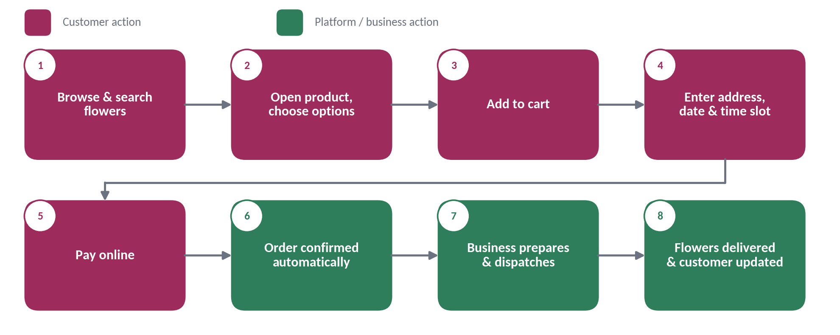
Figure 2 — One-time flower purchase journey

3.2 Daily subscription journey
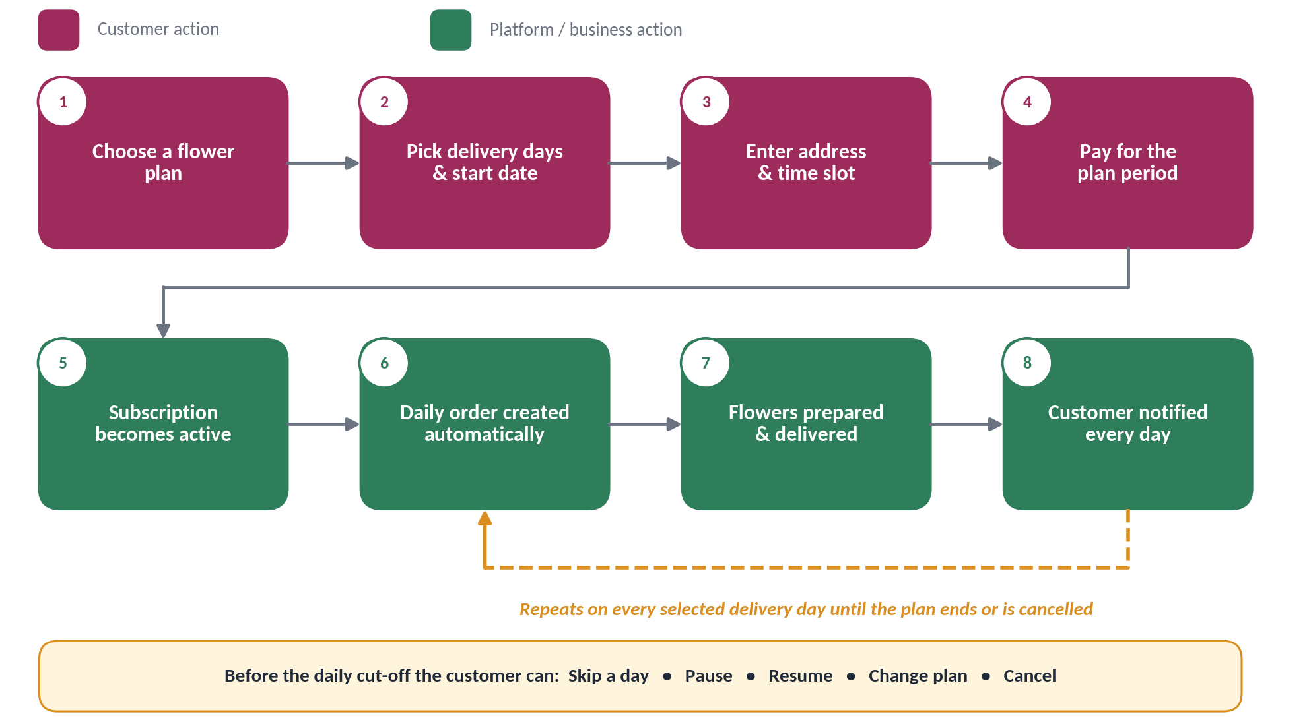
Figure 3 — Daily flower subscription journey

3.3 Daily delivery cycle
This cycle runs every delivery day and connects the customer, the system, the admin team and the delivery person.
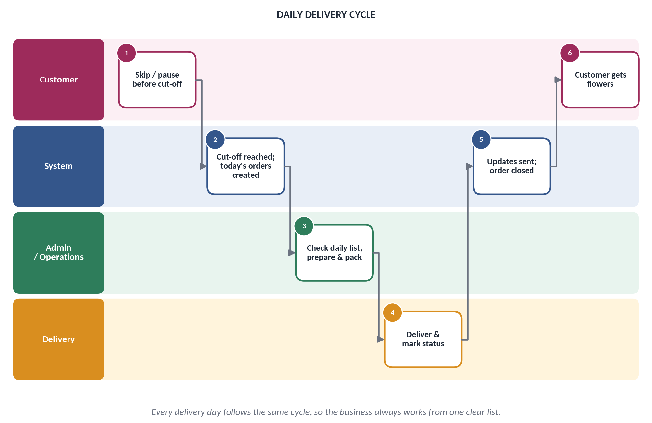
Figure 4 — Daily delivery cycle by role

3.4 Subscription states
A subscription is always in one clear state. The diagram shows how it moves between them.
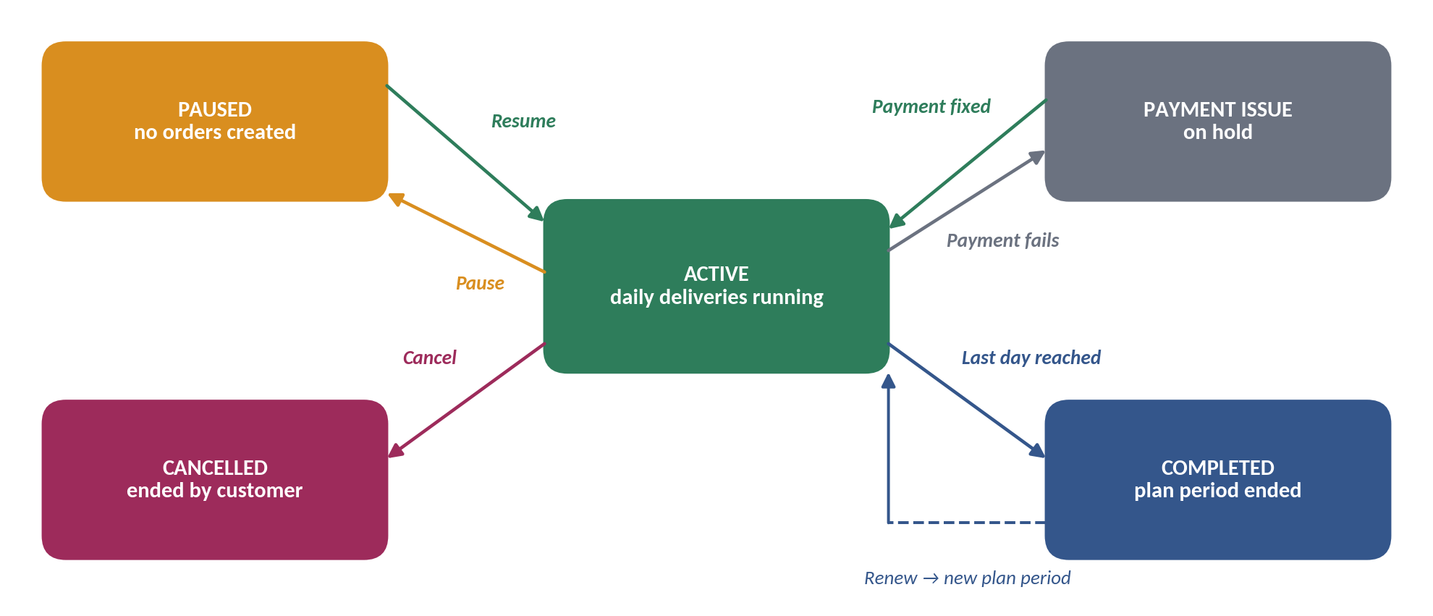
Figure 5 — Subscription lifecycle

3.5 Order status flow
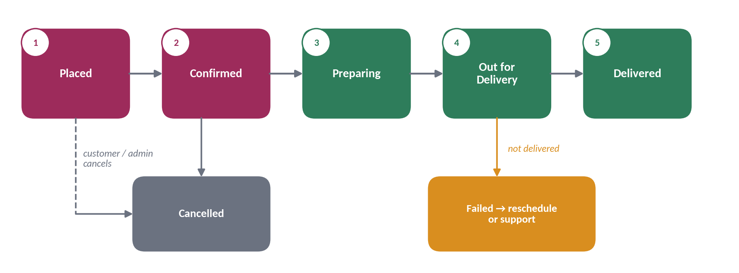
Figure 6 — Order status flow

4. Web Application (Full Stack)
WEB SCOPE
The web part has three layers: the customer website, the admin panel for the business team, and the backend that runs all rules and stores all data. The website is fully responsive and works well on phones.

4.1 Customer website

Landing page
Section | Content
Header | Logo, Shop, Subscriptions, About / Contact, account and cart.
Hero | Clear flower-shopping message with main buttons: Shop Now and Start Daily Subscription.
Featured flowers | Best sellers and new arrivals.
Subscription section | How daily delivery works, plans and starting prices.
Shop by category | Occasion or flower type shortcuts.
Why choose us | Freshness, on-time delivery and service highlights.
Reviews | Customer testimonials.
Service area | Where delivery is available.
FAQ and footer | Common questions, contact details, policies and social links.

Store and product pages
Feature | Details
Category and product grid | Browse by category or occasion with image, name, price and availability.
Search and filters | Search by name; filter by category, price and availability.
Product detail | Image gallery, description, size or variant, and care information.
Buying options | One-time purchase, or Subscribe for eligible products.
Related items and add-ons | Greeting cards, vases and small gifts.

Cart and checkout
Step | Details
Cart | Change quantity, remove items, apply a coupon if enabled.
Delivery details | Choose or add an address and recipient details for gifts.
Date and slot | Pick an available delivery date and time window.
Subscription setup | For plans: choose delivery days, start date and plan period.
Notes | Gift message and delivery instructions.
Payment | Review total and pay online.
Confirmation | Order or subscription confirmation with details.

Customer account
Screen | Features
Profile | Name, phone, email and basic details.
Addresses | Add, edit, delete and set a default address.
My orders | Order history, details and live delivery status.
My subscriptions | Current plan, next delivery, calendar of upcoming days and all controls.
Payments | Payment history and status.
Support | FAQ and contact support.

Subscription management
Action | What the customer can do
View plan | Plan name, price, delivery days, slot and plan end date.
Upcoming deliveries | See the next days on a simple calendar.
Skip a day | Skip any upcoming delivery before the cut-off.
Pause and resume | Pause for a period (for example while travelling) and resume later.
Change plan | Change delivery days, slot or address where allowed.
Renew or cancel | Renew when the plan ends, or cancel following the policy.
History | See all past subscription deliveries.

4.2 Admin panel
The admin panel is used by the business team on the web. It is intentionally simple and focused on daily operations.
Module | Features
Dashboard | Orders today, deliveries due, active subscriptions, pending actions.
Today's delivery list | All one-time and subscription deliveries for the day, grouped by slot, with address and notes. Printable.
Products | Add or edit products, prices, images, categories and availability.
Subscription plans | Create and edit daily plans, prices and plan periods.
Stock | Simple available or out-of-stock status and quantity per day.
Orders | Search, view and update order status and delivery details.
Subscriptions | View active, paused and cancelled subscriptions and next delivery.
Customers | View customer details, addresses, orders and subscriptions.
Delivery settings | Serviceable areas, delivery slots, charges and cut-off time.
Coupons | Create simple discount codes.
Basic reports | Daily orders and basic sales summary.

4.3 Backend — what it does for the business
The backend is the single brain behind the website, the mobile app and the admin panel. It does the following:
Service | Responsibility
Accounts | Sign up, login, password recovery and customer profiles.
Catalogue | Products, categories, prices, stock and availability.
Orders | Create orders, track status and keep order history.
Subscriptions | Plans, delivery days, skip, pause, resume, renew and cancel rules.
Daily scheduler | Every night, creates the next day's orders for all active subscriptions.
Payments | Online payment, advance subscription payment, payment status and refunds.
Delivery | Areas, slots, cut-off rules and delivery status.
Notifications | Sends push, SMS and email messages on every important event.
Admin access | Secure login and role-based access for the business team.

4.4 Suggested technology (kept simple)
Part | Suggestion
Website | Standard responsive web framework (for example React / Next.js).
Backend | Standard server application with a REST API (for example Node.js).
Database | Relational database (for example PostgreSQL).
Payments | One trusted payment gateway supporting online payments (for example Razorpay).
Messaging | Push notifications, SMS and email through standard providers.
Hosting | A simple cloud hosting setup.

These are suggestions only and can be changed to match the freelancer's and client's preference.

5. Mobile Application (Flutter)
MOBILE SCOPE
The mobile app is for customers and is built with Flutter, so one codebase delivers both Android and iOS apps. It focuses on fast shopping, easy daily subscription management and delivery updates. Admin functions stay on the web.

5.1 Main navigation
Tab | Purpose
Home | Featured flowers, categories and a daily subscription shortcut.
Shop | Browse, search and open product details.
Orders | Current and past orders with live status.
Subscriptions | Active plan, upcoming deliveries and controls.
Account | Profile, addresses, notifications and support.

5.2 Mobile features
Area | Features
Access | Welcome screens, sign up, login with phone or email OTP, password recovery.
Browse and search | Home, categories, search and basic filters.
Product | Product details with images, price, options and care information.
Buying | One-time purchase and daily subscription purchase.
Cart and checkout | Cart, address, date and slot, gift note, coupon and payment.
Orders | Order list, order details and delivery status tracking.
Subscriptions | View plan, calendar of upcoming days, skip, pause, resume, renew and cancel.
Addresses | Save and manage multiple delivery addresses.
Favourites | Save favourite products for quick re-ordering.
Notifications | Push notifications for orders and subscriptions.
Support | Help centre, FAQ and contact support.

5.3 Subscription experience on mobile
Managing a daily subscription is the most frequent action on mobile, so it is made quick:
- Subscription card: shows plan, next delivery and status on the Subscriptions tab.
- Upcoming days calendar: each upcoming day can be skipped with one tap before the cut-off.
- Pause for a period: choose from and to dates, for example while travelling.
- Renew reminder: a clear prompt before the plan period ends.

5.4 Mobile notifications
Notification | When it is sent
Order placed | As soon as an order is confirmed.
Payment successful or failed | After every payment attempt.
Order being prepared | When the business starts preparing.
Out for delivery | When the order leaves for delivery.
Order delivered | When delivery is completed.
Tomorrow's delivery reminder | Evening reminder before the cut-off, with a Skip option.
Plan ending soon | Shortly before the plan period ends.
Subscription payment issue | When a renewal payment needs attention.

5.5 Suggested technology (kept simple)
Part | Suggestion
App framework | Flutter, one codebase for Android and iOS.
Data connection | The same backend and API used by the website.
Push notifications | Standard push notification service (for example Firebase).
Payments | Same payment gateway as the website.
Release | Google Play Store and Apple App Store.

6. Orders, Delivery & Notifications

6.1 Order status
Status | Meaning
Placed | Order was created successfully.
Confirmed | The business accepted the order.
Preparing | Flowers are being prepared and packed.
Out for delivery | The order is on its way.
Delivered | The customer received the order.
Cancelled | The order will not be fulfilled.
Failed | Delivery could not be completed.

6.2 Delivery features
- Delivery address and recipient details.
- Available delivery dates and time slots, for example early morning, morning and evening.
- Delivery instructions, such as landmark or gate details.
- Delivery fee where applicable.
- Delivery status updates and a simple reschedule or support flow for failed deliveries.
- Daily cut-off time that locks tomorrow's orders for preparation.

6.3 Customer notifications
Event | Message content | Channel
Order confirmation | Order number, items, amount and expected delivery. | Push, SMS, Email
Payment issue | Payment failed and action required. | Push, SMS
Preparing | Order is being prepared. | Push
Out for delivery | Order is on the way. | Push, SMS
Delivered | Delivery completed. | Push
Subscription started | Plan, delivery days, first delivery date. | Push, Email
Delivery reminder | Tomorrow's delivery, with option to skip. | Push
Subscription update | Skipped, paused, resumed, renewed or cancelled. | Push, Email
Subscription payment issue | Renewal payment needs attention. | Push, SMS, Email

7. Functional Requirements
Priority follows MoSCoW: Must is required for launch, Should is important but can follow, Could is optional.
ID | Requirement | Platform | Priority
FR-01 | Customer can browse available flower products by category. | Web, Mobile | Must
FR-02 | Customer can search and filter products and view product details. | Web, Mobile | Must
FR-03 | Customer can add products to the cart and edit it. | Web, Mobile | Must
FR-04 | Customer can place a one-time order. | Web, Mobile | Must
FR-05 | Customer can select delivery address, date and time slot. | Web, Mobile | Must
FR-06 | Customer can complete online payment. | Web, Mobile | Must
FR-07 | Customer can sign up, log in and recover password. | Web, Mobile | Must
FR-08 | Customer can save and manage multiple addresses. | Web, Mobile | Must
FR-09 | Customer can subscribe to an eligible daily plan. | Web, Mobile | Must
FR-10 | Customer can choose delivery days, start date, slot and plan period. | Web, Mobile | Must
FR-11 | System creates the next day's orders for all active subscriptions at the cut-off time. | Backend | Must
FR-12 | Customer can skip a delivery, pause, resume and cancel within the policy. | Web, Mobile | Must
FR-13 | Customer can renew a subscription when the plan period ends. | Web, Mobile | Must
FR-14 | Customer can view order and subscription history. | Web, Mobile | Must
FR-15 | Customer receives relevant notifications for orders and subscriptions. | Backend, Mobile | Must
FR-16 | Subscription is put on hold when a recurring payment fails. | Backend | Must
FR-17 | Admin can manage products, categories, prices and availability. | Admin Web | Must
FR-18 | Admin can manage subscription plans and view all subscriptions. | Admin Web | Must
FR-19 | Admin can view and update orders and delivery status. | Admin Web | Must
FR-20 | Admin can view today's combined delivery list grouped by slot. | Admin Web | Must
FR-21 | Admin can configure delivery areas, slots, charges and cut-off time. | Admin Web | Must
FR-22 | Admin can view customers and their order history. | Admin Web | Must
FR-23 | Mobile app supports the full core customer journey. | Mobile | Must
FR-24 | Business can create simple coupons. | Admin Web | Should
FR-25 | Admin can print or export the daily delivery list. | Admin Web | Should
FR-26 | Admin can see basic daily order and sales reports. | Admin Web | Should
FR-27 | Customer can offer add-ons such as cards and vases at checkout. | Web, Mobile | Should
FR-28 | Customer can save favourite products. | Web, Mobile | Could
FR-29 | Customer can leave a rating or review after delivery. | Web, Mobile | Could

8. Quality Requirements
Area | Expectation
Ease of use | A first-time customer can order without help; subscription controls are reachable in two taps.
Speed | Pages and screens load quickly on normal mobile internet.
Security | Secure login, encrypted connections, and no card details stored on our servers.
Reliability | Daily orders are created on time every day; failures are logged and alerted.
Compatibility | Website works on current browsers and phones; app supports current Android and iOS versions.
Maintainability | Clean, documented code so features can be added later.
Data safety | Regular backups of orders, customers and subscriptions.

9. Business Records
These are the main pieces of information the platform stores.
Record | Purpose
Customer | Profile and contact information.
Address | Saved delivery and recipient details.
Product | Flower information, price, images and availability.
Subscription plan | Plan name, price, delivery pattern and plan period.
Cart | Items currently selected for purchase.
Order | One-time order or one daily subscription delivery.
Subscription | A customer's active plan, schedule, skips and pauses.
Payment | Payment transaction and status.
Delivery | Delivery slot, status and notes.
Coupon | Discount code and rules.
Notification | Messages sent to the customer.

10. MVP Scope & Success Criteria

10.1 Included in the MVP
- Responsive web landing page and online store.
- Customer account and saved addresses.
- One-time flower ordering.
- Daily subscription plans with skip, pause, resume, renew and cancel.
- Online payment.
- Order and delivery status, and the daily delivery list.
- Transactional notifications.
- Basic admin panel.
- Flutter mobile app for customers (Android and iOS).

10.2 Not in the first release
- AI features and advanced recommendations.
- Loyalty or points system.
- Multi-vendor marketplace.
- Route optimisation and live rider tracking.
- Large analytics dashboards.
- Complex enterprise account workflows.

10.3 Launch success criteria
- A customer can discover flowers and complete a purchase without assistance.
- A customer can start a daily subscription and receive the next scheduled delivery.
- A customer can skip, pause or cancel within the agreed rules.
- The business can see and process the daily delivery list from the admin panel.
- Customers receive clear order, payment and delivery notifications.

11. Assumptions & Open Decisions
The following items affect the design and should be confirmed with the client before development starts. A suggested default is given for each.
Decision | Why it matters | Suggested default
Billing model for daily plans | Decides how and when the customer pays. | Prepaid for a plan period (7 / 15 / 30 days).
Daily cut-off time | Locks orders for preparation. | 9 PM the night before.
Skipped days | Fairness to the customer. | Extend plan end date by skipped days.
Delivery slots | Planning of the delivery team. | Early morning, morning and evening.
Service area | Where delivery is possible. | Defined by pincode or area list.
Delivery charges | Pricing. | Free for subscriptions, flat fee for one-time.
Refund and cancellation policy | Legal and customer trust. | To be provided by the client.
Payment gateway | Setup and fees. | One gateway supporting UPI and cards.
Who delivers | Operations. | Client's own delivery staff, updated by admin.

Appendix A — Screen Inventory
Web | Mobile (Flutter)
Landing page | Home
Shop / category | Shop
Product detail | Product detail
Cart | Cart
Checkout | Checkout
Order confirmation | Order confirmation
My orders | Orders
Subscription pages | Subscriptions
Profile and addresses | Account
Support / FAQ | Support
Admin dashboard | Not applicable
Admin products, plans, orders, subscriptions | Not applicable

Appendix B — Glossary
Term | Meaning
Subscription | A recurring plan where flowers are delivered on selected days.
Plan period | The paid duration of a subscription, such as 30 days.
Cut-off time | The daily time after which tomorrow's orders can no longer be changed.
Delivery slot | A time window in which delivery is expected.
Skip | Not receiving flowers on one specific day.
Pause | Temporarily stopping deliveries for a period.
MVP | Minimum viable product — the focused first release.
Flutter | A framework that builds Android and iOS apps from one codebase.

