Form Builder Support Team Document

Create Form Elements:
To create form element, please drag and drop the elements from the left side to the area given there.
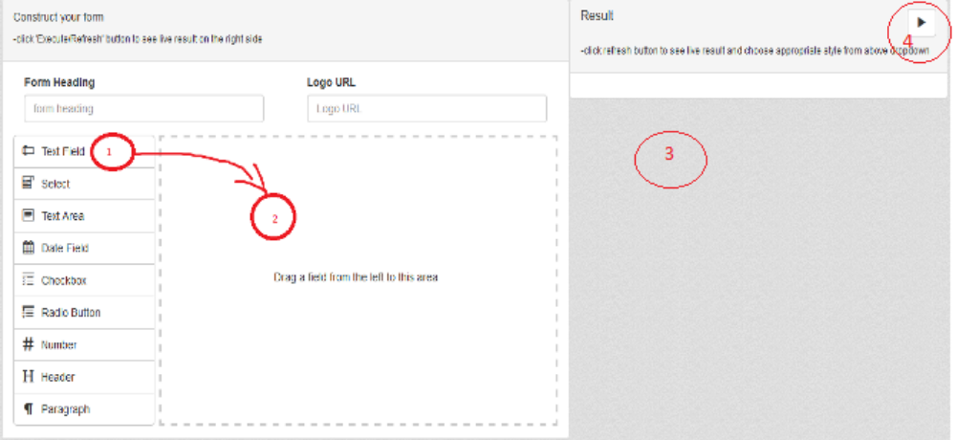
When you drop a field(1) in the area(2), rendered form will appear on the right side(3). To refresh the rendering area(3), you can click run button on the top right(4).

Edit form element attributes
In order to personalize form element for your requirement, you will have to edit attributes. For that click on the Edit(1) icon that is shown in below image.
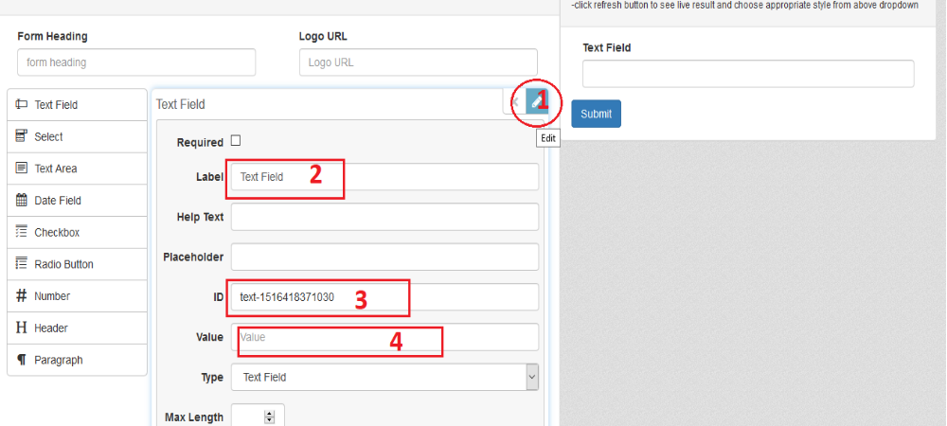
You can edit label(2), element id/name(3) and also set a default value(4).

Conditional Logic:
Conditional logic part of form is used to apply conditional rendering of html elements. Suppose if you want to show/hide an element or a part of form based on the value of a form element, then you can use this section to create such form rules. For eg:
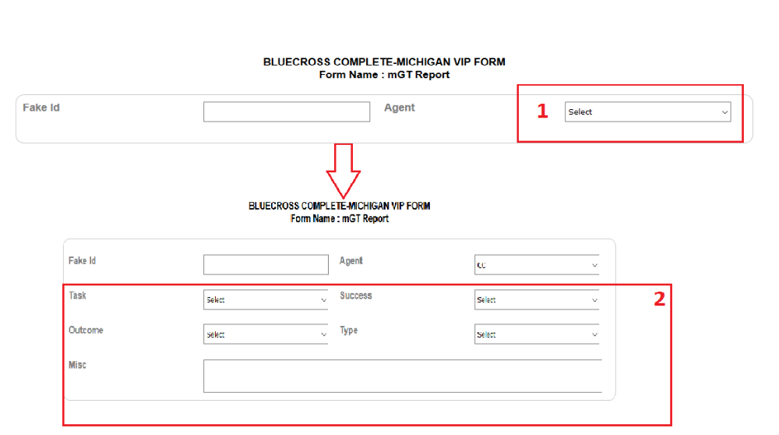
In the above image, when we choose agent(1), then the lower part will be displayed. Based on the value of agent, the values inside select list “task” will change.
Let's see how we can create this form using our tool.
Drag-drop two select elements. Name them as “agent” and “task”. Agent list values are 'CC' and 'CHN'.

In the below image, you can see when you type label(1), the id(2) also changes. Please note the id that we require later for adding conditions/validation to the form. Add options to the select field like below(3)
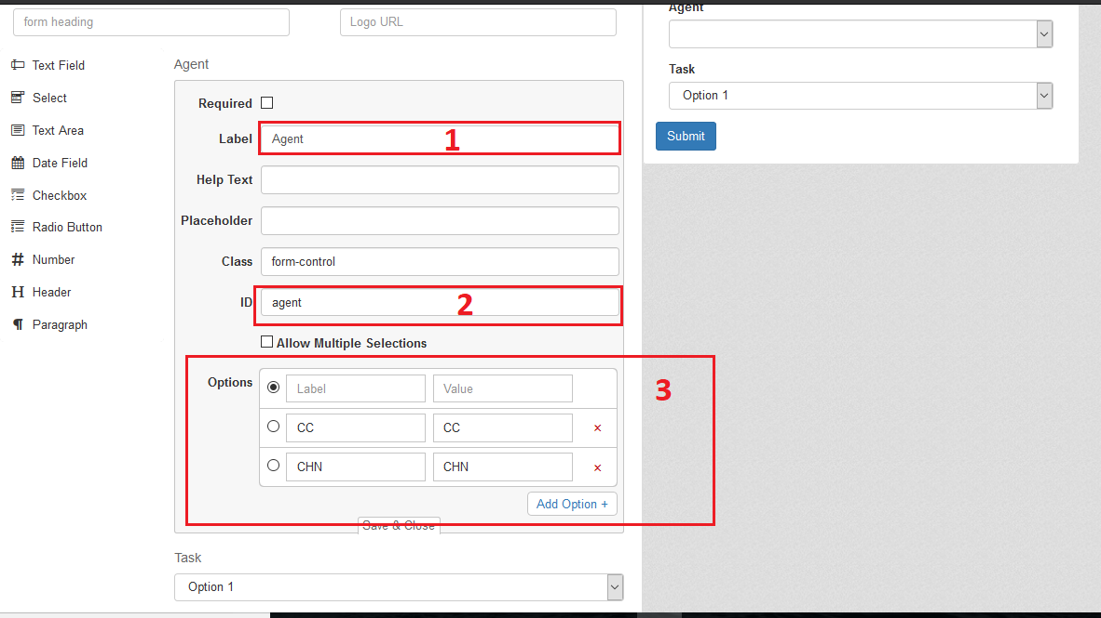
So, form is ready. Now we can add some conditions to the form. We've to display 'task' field only when theres a value selected in 'agent' field. To accomplish that, we'll have to add a rule like below,
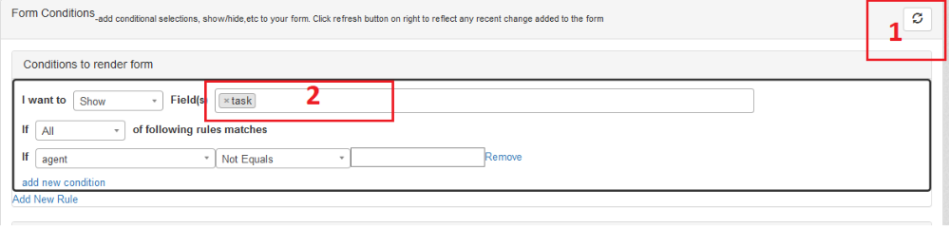
Choose field(s) to hide/show/disable/enable from the list first. Please note that if you are not seeing any field or if you're seeing different name in field list, then please click refresh(1) button. Add a new rule. Here I've added a rule like, show 'task' when 'agent' not equals to ''(empty);

Form Validation
Form validation section is useful if you want to add validation to the form fields.
For example, if the username field is mandatory and you want some value present in the username field, then you can add a validation like below.

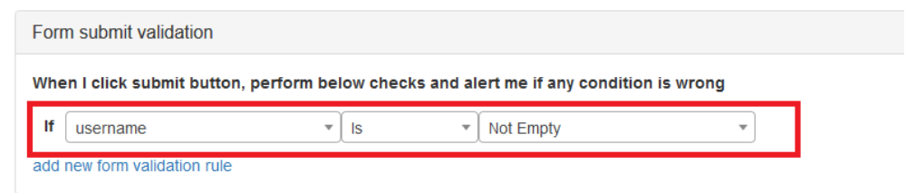
Compute Logic Section

Compute logic section is used to calculate/determine the value of any input field. Here, you can compute or assign the value of a field.
If you want to calculate Total amount by multiplying Rate and amount, then you can add a logic like shown below.
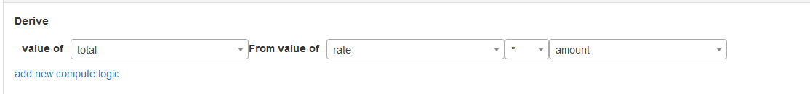
The same thing we can achieve by writing equations in the equation section. Also you can use the equation section if you have more complex equations for the field value calculation
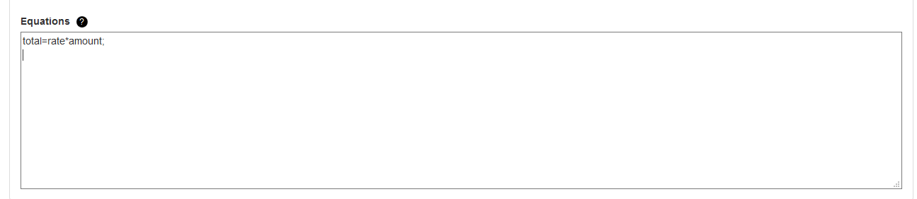
Note: When you write an equation, the operand name must be same as field ID. Each equation should be separated by semicolon(;). And equation must have an operand on the LHS and one or many operand on the RHS.

The other feature of form validation section is the ability to determine the value a field conditionally. Suppose, you want to change (instead of calculating from an equation) the value of product list based on the gender, you can add a rule like below
