Project 1- Lane Detection

Robot Perception

Manohar Anumolu

* Honor Pledge: I pledge on my honor that I have not given or received any unauthorized assistance on this assignment.

Manohar Anumolu

UID 115733039

Project 1

Following Steps were Implemented:

1. Denoise the Image

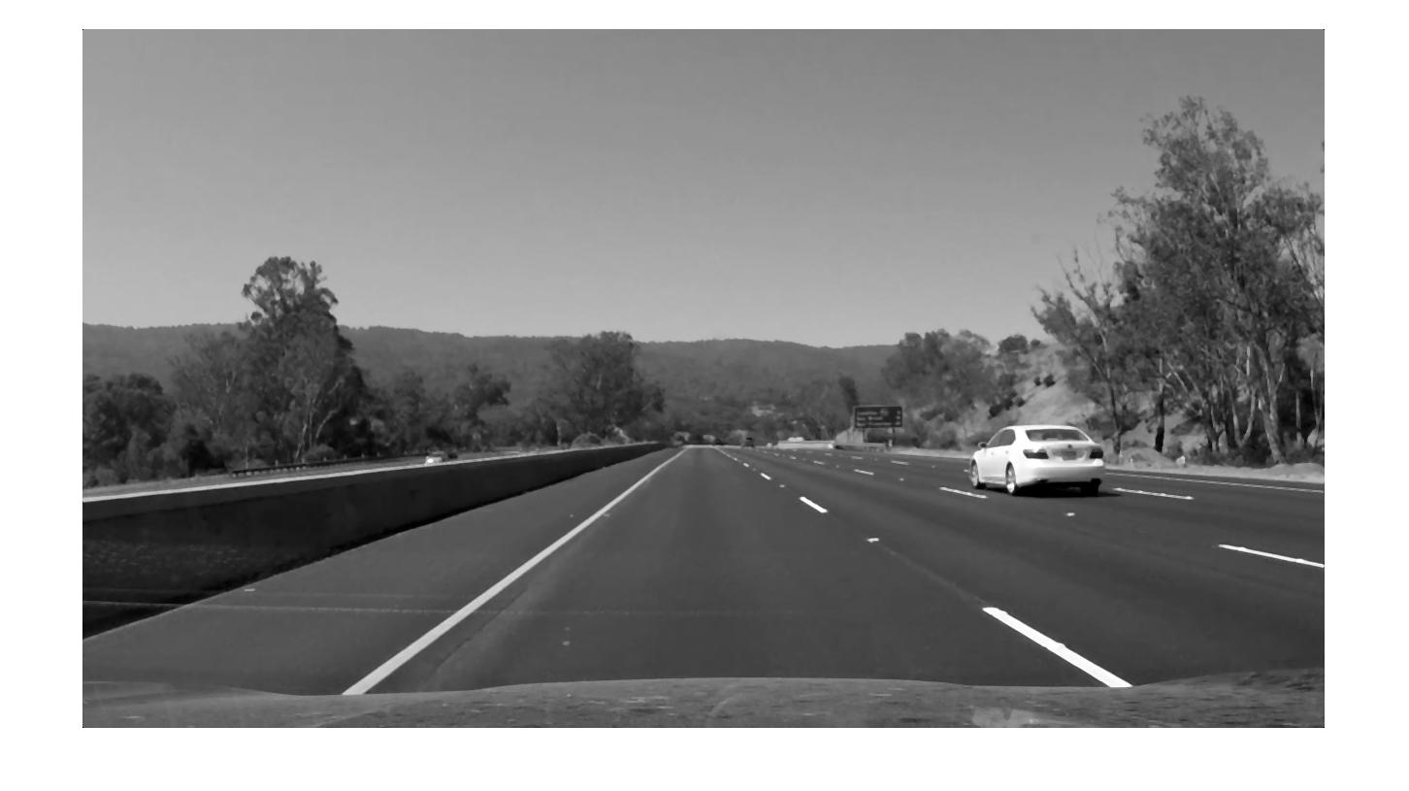

1. Apply Edge Detection (Canny filter was used here)

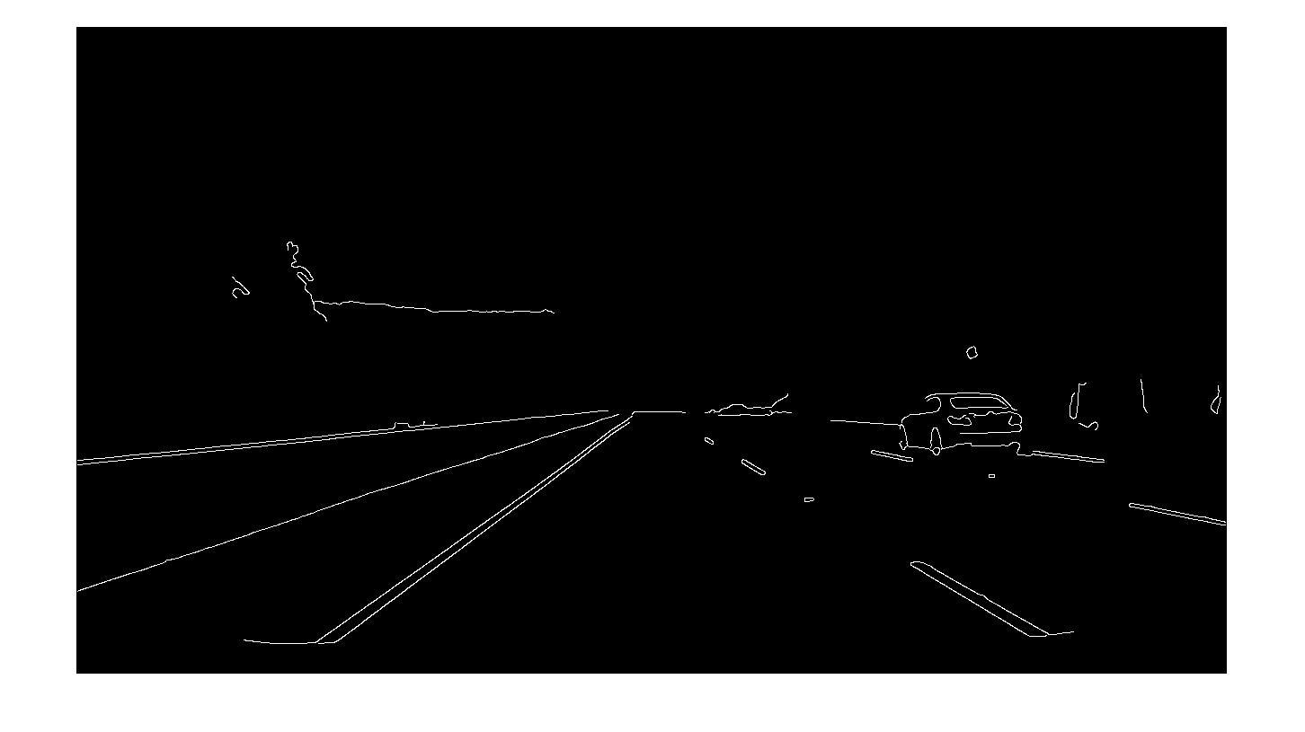

1. Binarize the Edge Detection Output
2. Extract Region of Interest (Using ROIpoly) :

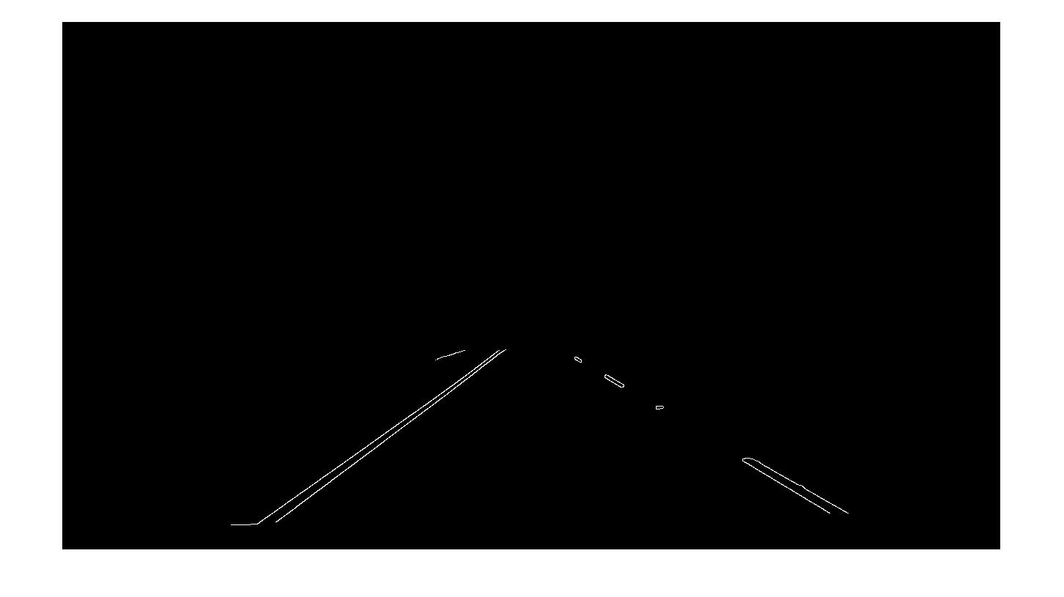

1. Get Hough Lines

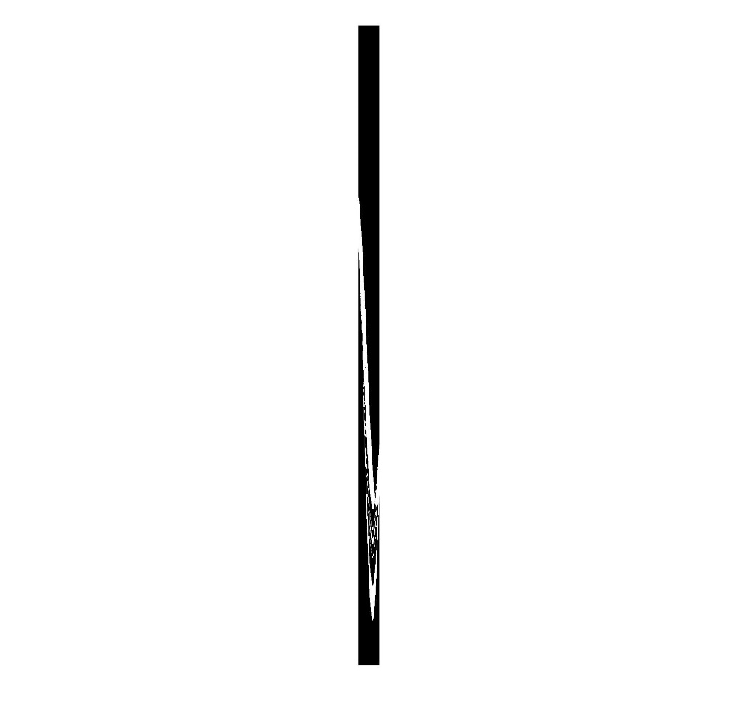

1. Find Peak Hough Lines and add them to original image.

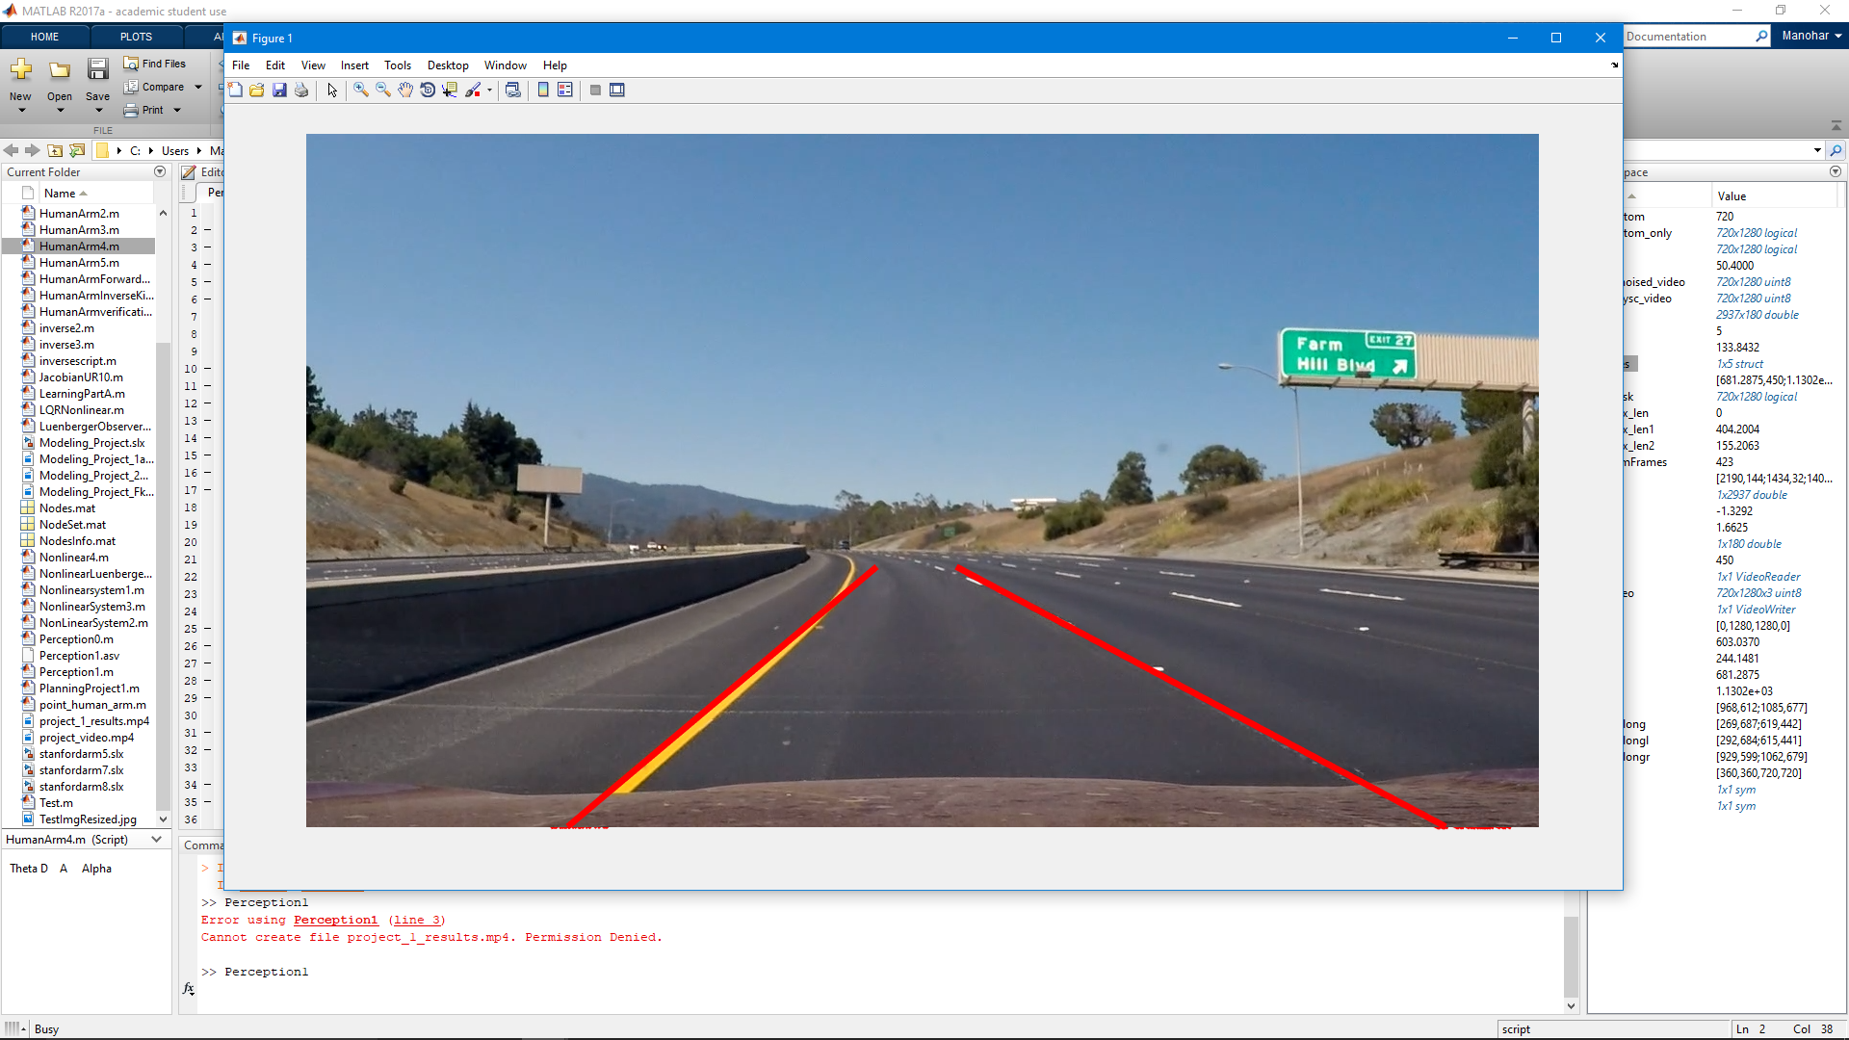

Notes: The Code is Commented. Due to Time Constraints I have taken a Mobile video of the code being run, and will be attached.

Code: Everything can be run, but the mask has to be initialized as I didn’t use the *poly2mask* function, but rather roipoly, which needs to be done by human hands.

*References*

[1] Mathworks Documentation

[2] MATLAB Website for Functions and their usages.