CHAPTER-1
INTRODUCTION

CHAPTER 1
Introduction
1.1 Overview
As organizations rapidly adopt cloud-native architectures, DevOps automation, and microservices, their reliance on machine-to-machine communication has grown exponentially. This shift has led to a massive proliferation of Non-Human Identities (NHIs) — such as service principals, GitHub tokens, API keys, and managed identities — which now vastly outnumber human users in typical enterprise environments. Industry data reveals that NHIs outnumber human identities by ratios ranging from 10:1 to 144:1 in large enterprise cloud environments, yet they receive disproportionately less governance attention. This discrepancy creates a significant security blind spot, making long-lived, unmanaged, or over-privileged machine credentials a primary target for malicious actors seeking to compromise cloud environments.
The consequences of this governance gap are severe and well-documented. Credential-based attacks consistently rank among the top breach vectors globally, with the Verizon 2023 Data Breach Investigations Report identifying credential abuse as the primary attack vector in 49% of all recorded breaches. A single leaked service principal with excessive Azure Active Directory permissions can enable full tenant compromise, lateral movement across subscriptions, and exfiltration of sensitive data at cloud scale. The 2020 SolarWinds supply chain compromise leveraged compromised service principal credentials as a pivotal step in its lateral movement strategy, demonstrating the real-world severity of unmanaged NHIs.
The IA-DevSecOps-Identity-Governance project addresses this challenge by delivering an AI-powered NHI Governance Agent that continuously discovers, classifies, governs, and rotates non-human identities across Azure and GitHub ecosystems. Unlike static secrets scanners or point-in-time audit tools that rely on manual remediation, this agent operates as a continuously running autonomous system. It employs policy-as-code enforcement, anomaly detection, and automated credential rotation to ensure zero standing secrets and least-privilege access at all times.
1.2 Problem Statement
Current approaches to NHI governance in enterprise cloud environments suffer from three fundamental and structural deficiencies. First, monitoring is reactive and point-in-time. Most existing tools detect expiry risks or secret exposures only after the fact, with no automated remediation capability. Operators must manually act upon notifications, introducing delays and operational risk that leaves organizations exposed between audit cycles. Second, tooling is fundamentally siloed across platforms. Certificate monitors operate independently of Azure credential tools, which in turn have no visibility into GitHub tokens or managed identities. No unified system maintains a cross-platform NHI inventory that includes dormant or orphaned identities. Third, existing solutions lack meaningful risk intelligence. Binary expired or not-expired thresholds fail to capture the nuanced risk posture of each identity. A service principal unused for ninety days but still valid often represents a higher risk than a frequently used principal expiring in forty-five days, yet current tools treat these situations identically.
These deficiencies result in tangible and measurable consequences. The OWASP Non-Human Identities Top 10 report of 2025 found that 70% of organizations have plaintext secrets in source code repositories and 47% have unused IAM roles still active in their environments. The Cloud Security Alliance survey of 2024, covering 818 IT and security professionals, found that only 15% of organizations are highly confident in their ability to prevent NHI attacks, while 69% express significant concerns about their current governance posture.
1.3 Objectives
The primary objectives of this project are as follows. First, to continuously discover and build a live inventory of all NHIs across Azure and GitHub ecosystems, including dormant or orphaned identities that traditional tools miss. Second, to implement an AI-driven risk scoring engine that classifies each identity by sensitivity, usage patterns, and privilege scope, flagging anomalous access behaviour in real time. Third, to enforce policy-as-code rulesets using Open Policy Agent and Rego to govern identity thresholds and compliance requirements. Fourth, to execute automated credential rotation workflows triggered by policy violations without requiring human intervention. Fifth, to produce audit-ready NHI inventory reports and rotation compliance dashboards that support CISO alignment and regulatory compliance with SOC 2 and ISO 27001.
1.4 Scope
The scope of this project covers two phases of development and deployment. In the current implemented phase, the system monitors TLS certificate expiry for production-grade domain endpoints and Azure AD service principal credentials through scheduled GitHub Actions workflows. Reports are generated as timestamped HTML files with rolling retention, uploaded as 90-day GitHub Actions artifacts, and conditional SMTP email alerts are dispatched when credentials enter the expiry risk window.
In the proposed evolution phase, the scope expands to encompass autonomous NHI discovery via the Microsoft Graph API and GitHub REST API, AI-driven multi-dimensional risk scoring using LangChain agentic orchestration, policy-as-code enforcement using OPA and Rego, automated credential rotation via Azure Key Vault, and a real-time Azure-hosted NHI inventory dashboard providing live visibility into the complete NHI risk posture.
1.5 Societal Relevance and SDG Alignment
This project aligns with two United Nations Sustainable Development Goals. SDG 9, Industry, Innovation, and Infrastructure, is addressed by building resilient, secure, and automated digital governance infrastructure that supports sustainable industrial automation at enterprise scale. SDG 16, Peace, Justice, and Strong Institutions, is addressed by enforcing institutional accountability in machine identity governance, producing audit-ready evidence trails for regulatory compliance frameworks including SOC 2 and ISO 27001, and reinforcing the institutional security governance and accountability mechanisms that underpin trustworthy digital systems.
1.6 Report Organisation
The remainder of this report is organised as follows. Chapter 2 presents a comprehensive literature survey covering the threat landscape of non-human identities, AI-driven anomaly detection, policy-as-code frameworks, and a review of existing tools and systems. Chapter 3 details the system design including the four-layer architecture, component descriptions, methodology, system requirements specification, and security design principles.

CHAPTER-2
LITERATURE SURVEY

CHAPTER 2
Literature Survey
2.1 Introduction to the Survey
This chapter presents a structured review of research papers, industry reports, and existing tools relevant to non-human identity governance, AI-driven security automation, and policy-as-code enforcement. The survey establishes the theoretical and practical foundations upon which the proposed NHI Governance Agent is built and identifies the gaps in existing approaches that this project addresses.
2.2 Research Papers
2.2.1 Zero-Trust Identity Frameworks for Agentic AI
Narajala et al. (2025) propose a comprehensive Identity and Access Management framework for multi-agent AI systems built on Decentralised Identifiers and Verifiable Credentials. The paper demonstrates the inadequacy of OAuth and OpenID Connect protocols for autonomous AI agents and introduces dynamic, context-aware access control with Zero-Knowledge Proofs [1]. This work is directly relevant to governing AI-driven NHI agents, as the trust and verification challenges for autonomous agents mirror those of non-human service principals in cloud environments.
2.2.2 OWASP Non-Human Identities Top 10
The OWASP NHI Top 10 report of 2025 provides an industry-authoritative ranking of the most critical NHI risks, including improper offboarding, secret leakage in source repositories, and overprivileged identities [2]. The report’s finding that 70% of organizations have plaintext secrets in source repositories and 47% have unused IAM roles still active directly motivates the continuous discovery and automated governance capabilities of the proposed agent.
2.2.3 NHI and Secrets Risk Report 2025
Entro Labs’ enterprise-wide analysis reveals that NHIs grew 44% between 2024 and 2025 and now outnumber human identities at a ratio of 144:1 [3]. The report further identifies that CI/CD workflows account for 26% of secret exposures and that collaboration tools are responsible for one in five exposed secrets. These findings underscore the urgency of automated lifecycle governance for NHIs.
2.2.4 AI-Driven Dynamic Trust Assessment
Published in the World Journal of Advanced Research and Reviews, this paper proposes an AI-driven dynamic trust framework that uses supervised and unsupervised machine learning models to generate adaptive trust scores for identity verification [4]. The approach of computing continuous, behaviour-based trust scores directly informs the design of the risk-scoring engine in the proposed agent.
2.2.5 Zero Trust IAM for Cross-Cloud Federated Networks
Potluri (2024) proposes a federated IAM system spanning AWS, Azure, and Google Cloud, using trust score computation and behavioural modelling to enforce least-privilege access across cloud boundaries [5]. The paper validates that cross-cloud IAM significantly reduces breach resistance and unauthorized access rates.
2.2.6 State of Non-Human Identity Security
The Cloud Security Alliance surveyed 818 IT and security professionals in 2024 and found that only 15% of organizations are highly confident in preventing NHI attacks while 69% express significant concerns [6]. The survey identifies auditing, privilege management, and policy enforcement as the primary pain points in NHI security.
2.2.7 Decentralised Identity Management
Bernabé Murcia et al. (2025) integrate Self-Sovereign Identity, Decentralised Identifiers, Verifiable Credentials, and Zero-Knowledge Proofs into a multi-domain orchestration framework published in Future Generation Computer Systems [7]. This work provides a strong theoretical foundation for verifiable NHI credentials and lifecycle management across distributed computing environments.
2.2.8 IAM in Cloud Environments
Mungoli (2023) examines Identity and Access Management in cloud environments with a focus on Zero Trust Architecture [8]. The paper identifies dynamic resource provisioning as the primary IAM challenge in cloud environments and corroborates the need for real-time NHI governance.
2.2.9 Leadership Compass on NHI Management
KuppingerCole’s 2025 analyst report evaluates the emerging NHI management market, identifying automated lifecycle management, policy enforcement, and AI-powered anomaly detection as the three critical capabilities required for comprehensive NHI governance [9].
2.2.10 Non-Human Identity Solutions Market Study
Research and Markets’ global study documents that the machine-to-human identity ratio exceeds 17:1 in large organizations and projects significant NHI market growth through 2030 [10]. The report confirms that unmanaged NHIs have become a board-level security priority.
2.3 Existing Tools and Systems
2.3.1 HashiCorp Vault
HashiCorp Vault is an industry-standard secrets management platform providing dynamic secrets, encryption as a service, and fine-grained access policies [11]. While Vault is widely adopted as a secrets store, it does not provide autonomous discovery of NHIs across multi-platform environments, AI-driven risk scoring, or agentic governance capabilities that operate continuously without human intervention.
2.3.2 Microsoft Entra Workload ID
Microsoft Entra Workload ID is Microsoft’s identity platform for workloads running in Azure, supporting managed identities and federated credentials [12]. It provides basic lifecycle policies for Azure-native workloads but does not offer AI-driven risk classification, anomaly detection, or cross-platform NHI correlation with GitHub tokens and CI/CD secrets.
2.4 Research Gap and Rationale
The review of existing research and tools reveals a consistent and significant gap: no current solution combines autonomous cross-platform NHI discovery, AI-driven continuous risk scoring, policy-as-code enforcement, and automated credential rotation in a single unified governance agent. The proposed NHI Governance Agent is specifically designed to close this gap by integrating all four capabilities into a continuously operating autonomous system. By enforcing automated rotation workflows triggered by policy thresholds such as token age exceeding 30 days or unused identity for over 7 days, the system closes the security loop without human intervention.
2.5 Feasibility Study
The proposed project is technically feasible due to the robust availability of cloud APIs and AI orchestration frameworks. Technologies such as the Azure SDK, Microsoft Graph API, and GitHub REST API provide the necessary programmatic access to monitor and manage identities across both target platforms. LangChain facilitates the agentic orchestration required for AI-driven risk scoring, while Open Policy Agent supports robust policy-as-code enforcement. Leveraging Azure Key Vault and GitHub Actions ensures that automated rotation pipelines can be securely and reliably executed at enterprise scale.

CHAPTER-3
SYSTEM DESIGN

CHAPTER 3
System Design
3.1 Architectural Overview
The NHI Governance Platform is designed as a four-layer modular architecture with clearly separated concerns across the configuration, monitoring and intelligence, output and reporting, and orchestration layers. This separation ensures that each component can be independently maintained, tested, or replaced without affecting the remainder of the system. The architecture supports both the current operational deployment and the proposed AI-powered evolution, with future capability extensions identified as additive layers that do not disrupt existing functionality.
The system architecture is illustrated in Figure 3.1.
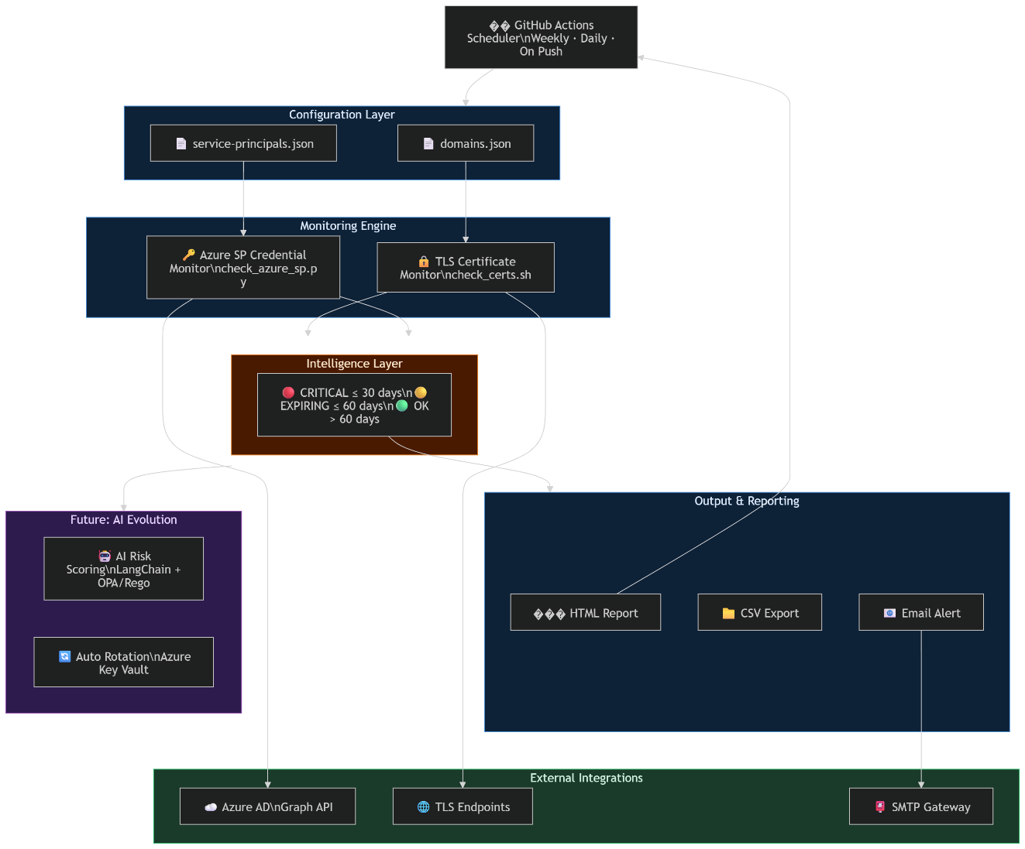
Figure 3.1: Four-Layer System Architecture of the NHI Governance Platform
3.2 Methodology and Planning of Work
The project follows a structured three-phase methodology to ensure continuous security and compliance across the full NHI lifecycle.
Phase 1 covers continuous discovery and inventory. The system integrates with Azure Active Directory (Entra ID), Azure Key Vault, and the GitHub API to build a live inventory of all NHIs. It continuously scans connected ecosystems and captures metadata including credential type, creation date, last usage timestamp, privilege scope, and ownership information. This phase establishes the foundational data layer upon which all subsequent intelligence and governance capabilities depend.
Phase 2 covers classification and anomaly detection. LangChain is used for agentic orchestration to analyse identity behaviour across collected metadata. An AI-driven risk scoring engine classifies each identity based on sensitivity, privilege scope, and historical usage patterns. Anomalous access behaviours such as sudden privilege escalation, access from unexpected IP addresses, or usage by dormant identities are flagged in real time for immediate investigation or automated response.
Phase 3 covers automated governance and remediation. Infrastructure-as-code policies are defined using Open Policy Agent and Rego to encode organisational governance requirements as machine-executable rules. Automated rotation pipelines are triggered via GitHub Actions when policy thresholds are breached, such as credentials exceeding 30 days of age or identities remaining unused for more than 7 days. Azure Managed Identities and Key Vaults are updated as part of the rotation workflow to ensure zero standing secrets are maintained at all times.
3.3 System Requirements Specification
3.3.1 Hardware Requirements
The system is hosted on Microsoft Azure cloud infrastructure. Compute requirements are met by Azure virtual machines or containerised instances running Python-based agentic workflows continuously. Storage for inventory states, policy evaluation logs, and audit records is provided through Azure Monitor and associated secure cloud storage services, with capacity scaled to the volume of NHIs under governance.
3.3.2 Software Requirements
The primary programming language is Python 3.11. External APIs and SDKs include the Azure SDK, Microsoft Graph API, and GitHub REST API for platform integration. Cloud services utilised include Azure Key Vault for secrets management, Azure Managed Identities for authentication, and Azure Monitor for audit logging and telemetry. AI and orchestration components are provided by LangChain for agentic reasoning and Open Policy Agent with Rego for policy-as-code enforcement. CI/CD automation is implemented through GitHub Actions for rotation pipeline execution.
3.3.3 User Requirements
Security teams require an Azure-hosted dashboard to view real-time NHI inventory and risk posture across both Azure and GitHub platforms. CISOs require audit-ready NHI inventory reports and rotation compliance dashboards suitable for regulatory evidence submission. The system must operate autonomously with minimal human intervention, alerting administrators only for critical policy violations that require manual override or approval before execution.
3.3.4 Functional Requirements
The system must continuously discover all NHIs across Azure AD and GitHub, including dormant and orphaned identities. It must dynamically classify identities, calculate composite risk scores based on multi-dimensional inputs, and successfully execute credential rotation across both Azure and GitHub platforms. Policy evaluation must be performed against an OPA/Rego ruleset on each monitoring cycle, with violations triggering automated remediation workflows without requiring human initiation.
3.3.5 Non-Functional Requirements
The system must be highly available, operating continuously without scheduled downtime. It must maintain secure state management ensuring that credential metadata and rotation history are stored with appropriate access controls. The system must adhere strictly to the principle of least-privilege access in its own operational permissions, requesting only the minimum rights necessary to perform discovery, classification, and rotation functions.
3.4 Component Design
3.4.1 Configuration Layer
The configuration layer externalises all monitoring targets into versioned JSON files, enabling operator customisation without modifying core scripts. The file data/domains.json defines the list of TLS endpoints to monitor with support for simple hostnames, custom port specifications, and full SNI override objects. The file data/service-principals.json defines the Azure AD applications to monitor using dual-indexed filtering by application UUID and display name. In the proposed AI evolution, this static configuration is replaced by a live NHI inventory continuously auto-populated through API-driven discovery.
3.4.2 Monitoring and Intelligence Engine
The TLS Certificate Monitor is implemented as a Bash shell script that establishes live TLS handshakes using OpenSSL’s s_client command to retrieve certificate expiry metadata. Per-domain failures are captured individually without aborting the overall scan, ensuring complete execution regardless of individual endpoint availability.
The Azure Service Principal Credential Monitor is implemented as a Python 3 script that queries the Azure CLI and Microsoft Graph API to retrieve both client secret credentials and certificate-based credentials for each configured application. Credentials that have already expired are explicitly excluded from output, focusing operator attention on actionable items.
The Threshold Classification Engine applies a three-tier model shared across all monitoring components. Credentials with thirty or fewer days remaining are classified as CRITICAL. Credentials with sixty or fewer days remaining are classified as EXPIRING. Credentials with more than sixty days remaining are classified as OK.
3.4.3 Output and Reporting Layer
HTML reports are generated as self-contained, timestamped files with colour-coded status indicators. A rolling retention policy automatically removes files beyond the fifteen most recent reports on each execution cycle. CSV exports provide structured tabular data for SIEM ingestion. SMTP email notifications are dispatched conditionally only when credentials are within the expiry risk window.
3.4.4 GitHub Actions Orchestration Layer
Three GitHub Actions workflows govern the platform’s automation. The cert-expiry.yml workflow executes TLS monitoring on a weekly schedule. The azure-sp-expiry.yml workflow executes Azure SP monitoring daily with Azure authentication. The automate-build.yml workflow implements the full DevSecOps build pipeline on every repository push. All workflows execute on a private self-hosted runner pool.
3.5 Security Design Principles
The system’s security posture is governed by consistent design principles applied throughout. No credentials are hardcoded in source code; all secrets are stored as GitHub repository-level encrypted secrets. The monitoring identity holds only read-only permissions, specifically Application.Read.All on the Microsoft Graph API. Azure client secret values are never logged or surfaced in reports. Execution is confined exclusively to the private self-hosted runner pool, and generated reports are excluded from Git tracking.
3.6 Expected Outcome
The project will deliver a deployable NHI Governance Agent paired with an Azure-hosted dashboard providing real-time visibility into NHI inventory and risk posture. The system will successfully execute automated rotation pipelines via GitHub Actions backed by a policy-as-code ruleset. By eliminating long-lived credentials and enforcing continuous least-privilege governance, the agent will measurably reduce the blast radius of credential-based attacks. It will directly support CISO alignment by producing audit-ready reports ensuring regulatory compliance with SOC 2 and ISO 27001.

References
[1] V. S. Narajala et al., “A Novel Zero-Trust Identity Framework for Agentic AI,” arXiv preprint arXiv:2505.19301, 2025. [Online]. Available: https://arxiv.org/abs/2505.19301
[2] OWASP Foundation, “OWASP Non-Human Identities Top 10,” 2025. [Online]. Available: https://owasp.org/www-project-non-human-identities-top-10/
[3] Entro Labs, “NHI & Secrets Risk Report – H1 2025,” 2025. [Online]. Available: https://nhimg.org/2025-state-of-non-human-identities-and-secrets-in-cybersecurity
[4] “Zero-Trust Identity Principles in Next-Gen Networks,” World Journal of Advanced Research and Reviews, vol. 23, no. 03, pp. 3304–3316, 2024.
[5] S. Potluri, “A Zero Trust-Based IAM Framework for Cross-Cloud Federated Networks,” IJERET, vol. 5, no. 2, 2024.
[6] Cloud Security Alliance, “The State of Non-Human Identity Security,” 2024. [Online]. Available: https://cloudsecurityalliance.org/artifacts/state-of-non-human-identity-security-survey-report
[7] J. M. Bernabé Murcia et al., “Decentralised Identity Management for Zero-Trust Multi-Domain Frameworks,” Future Generation Computer Systems, vol. 162, 2025.
[8] N. Mungoli, “Identity and Access Management in Cloud Environments,” ResearchGate, 2023.
[9] KuppingerCole, “Leadership Compass: Non-Human Identity Management,” 2025. [Online]. Available: https://www.kuppingercole.com/research/lc80974/non-human-identity-management
[10] Research and Markets, “Non-Human Identity Solutions, Global, 2024–2030,” Feb. 2026.
[11] HashiCorp, “Vault: Secrets Management and Data Protection,” 2024. [Online]. Available: https://www.vaultproject.io/
[12] Microsoft, “Microsoft Entra Workload ID,” 2024. [Online]. Available: https://learn.microsoft.com/en-us/entra/workload-id/

