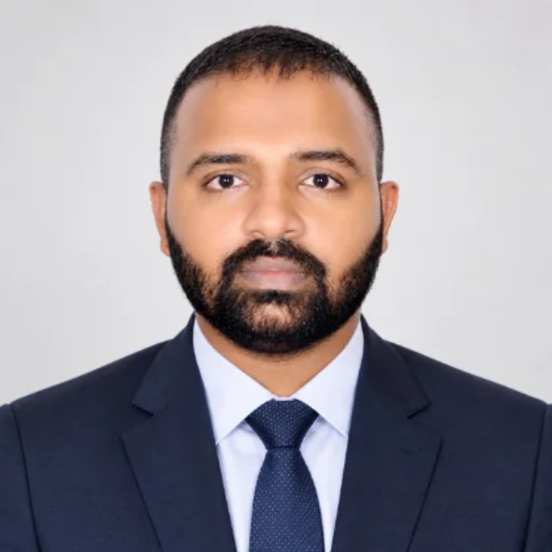 | Manu Prakash  PMP® · CSM® · CSPO®  Project Manager · Automation, OCR and Process Transformation  Dubai, UAE | +971 56 501 2553 | manuprakash61@gmail.com  linkedin.com/in/manu-prakash-pmp®-csm®-cspo®-b8125525 | Portfolio: manuprakash61.github.io/portfolio

Profile
Project Manager with 14 years in maritime disbursements, shipping operations and business process transformation. Currently leading OCR and AI-driven automation at DA-Desk as Product Owner and project lead, taking initiatives from requirements through proof of concept to production adoption. MBA in International Transportation and Logistics Management; PMP, CSM and CSPO certified.

Experience
DA-Desk FZ-LLC (Marcura Group) · Dubai · May 2012 – Present
Project Manager Aug 2019 – Present
- Product Owner for intelligent process automation and AI initiatives: wrote requirements as tickets, defined straight-through-processing rules, built a document-classification proof of concept to replace manual invoice sorting.
- Led OCR rollout and change management; adoption at ~70–80% with measurable gains in touchless processing.
- Project manager for a group-wide OCR platform evaluation, leading a proof of concept toward a buy-vs-build decision with defined success metrics and an operating-procedure workstream.
- Delivered disbursement-account automation improvements across issue resolution and customer communications, including a follow-up tool proof of concept.
- Manage first-tier support and demand triage with development teams.
Assistant Project Manager Jul 2016 – Jul 2019
- Led end-to-end delivery of automation and process-improvement projects, owning timelines, scope and quality.
- Translated business requirements into functional specifications; coordinated user acceptance testing and SQL-based validation.
Business Analyst Apr 2015 – Jun 2016
- Delivered the Port Cost Calculator project end to end, from planning through rollout.
- Acted as functional consultant; designed and delivered proofs of concept for new tools and workflows.
Senior Data Analyst Nov 2014 – Mar 2015
- Built automated recurring reports in SAP BusinessObjects and on-demand customer reports, ensuring data quality and audit readiness.
Operations Executive → Senior Operations Analyst May 2012 – Oct 2014
- Processed voyage disbursement accounts end to end; coordinated with port agents and customers on documentation, verification and settlement.
EXL Service · Cochin
Sr. Associate, Cargill Transportation & Logistics Aug 2011 – May 2012
- Managed ocean freight contracts and rates in GT Nexus; produced rate benchmark analyses across regions.
ABAL Logistics · Ernakulam
Operations Executive Apr 2008 – May 2009
- Handled import/export operations, customs coordination and job-level P&L reporting.

Education
MBA, International Transportation and Logistics Management 2009 – 2011
Indian Maritime University
B.Com, Taxation 2005 – 2008
Mahatma Gandhi University

Certifications
Project Management Professional (PMP)® · Certified ScrumMaster (CSM)® · Certified Scrum Product Owner (CSPO)®

Skills
Product ownership · Project management · Process automation · OCR / intelligent document processing · Straight-through processing · Change management · Requirements and functional specification · User acceptance testing · SQL · SAP BusinessObjects · Jira / Confluence

Languages
English · Hindi · Malayalam · Tamil · Telugu

