

**Excel Project**

**Title:**Olympic Data Analysis

As a skill-based assessment work for Course

Introduction to data Management (INT217)

Submitted by: Submitted to:

Manu Raj Tanima Thakur

12211924 UID:23532

Section: KM076

Roll no :9

**Olympic Data Analysis**

The Olympic Games stand as a testament to humanity's collective pursuit of excellence, unity, and sporting achievement. Since its revival in 1896, the modern Olympics have captivated the world, transcending borders and cultures to bring together athletes from every corner of the globe in the spirit of competition and camaraderie.

In this report, we embark on a journey through Olympic history, delving into data spanning from the inaugural modern Olympics in 1896 to the latest available information up to the 2016 Games. Through meticulous analysis and exploration, we aim to uncover insights, trends, and stories that illuminate the essence of this extraordinary event.

Our project comprises several modules, each offering a unique perspective on Olympic data:

**1. Overall Analysis:**

This section provides a comprehensive overview of the Olympic Games, examining key metrics such as participation trends, host cities, and the evolution of sports. By dissecting the data across decades, we seek to identify overarching themes and milestones that have shaped the Games throughout history.

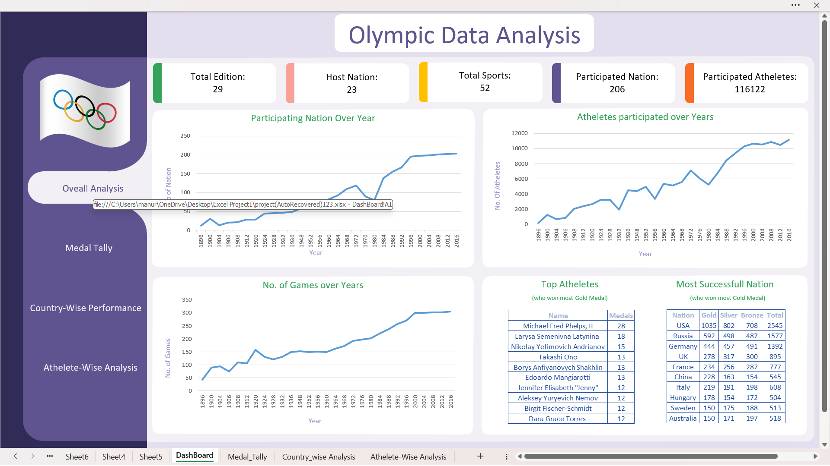

**2. Medal Tally:**

The pursuit of Olympic medals symbolizes the pinnacle of athletic achievement. Here, we analyze the distribution of medals across countries, sports, and disciplines. By examining patterns in medal standings over time, we aim to uncover the rise of dominant nations, the emergence of new contenders, and the enduring rivalries that have defined Olympic competition.

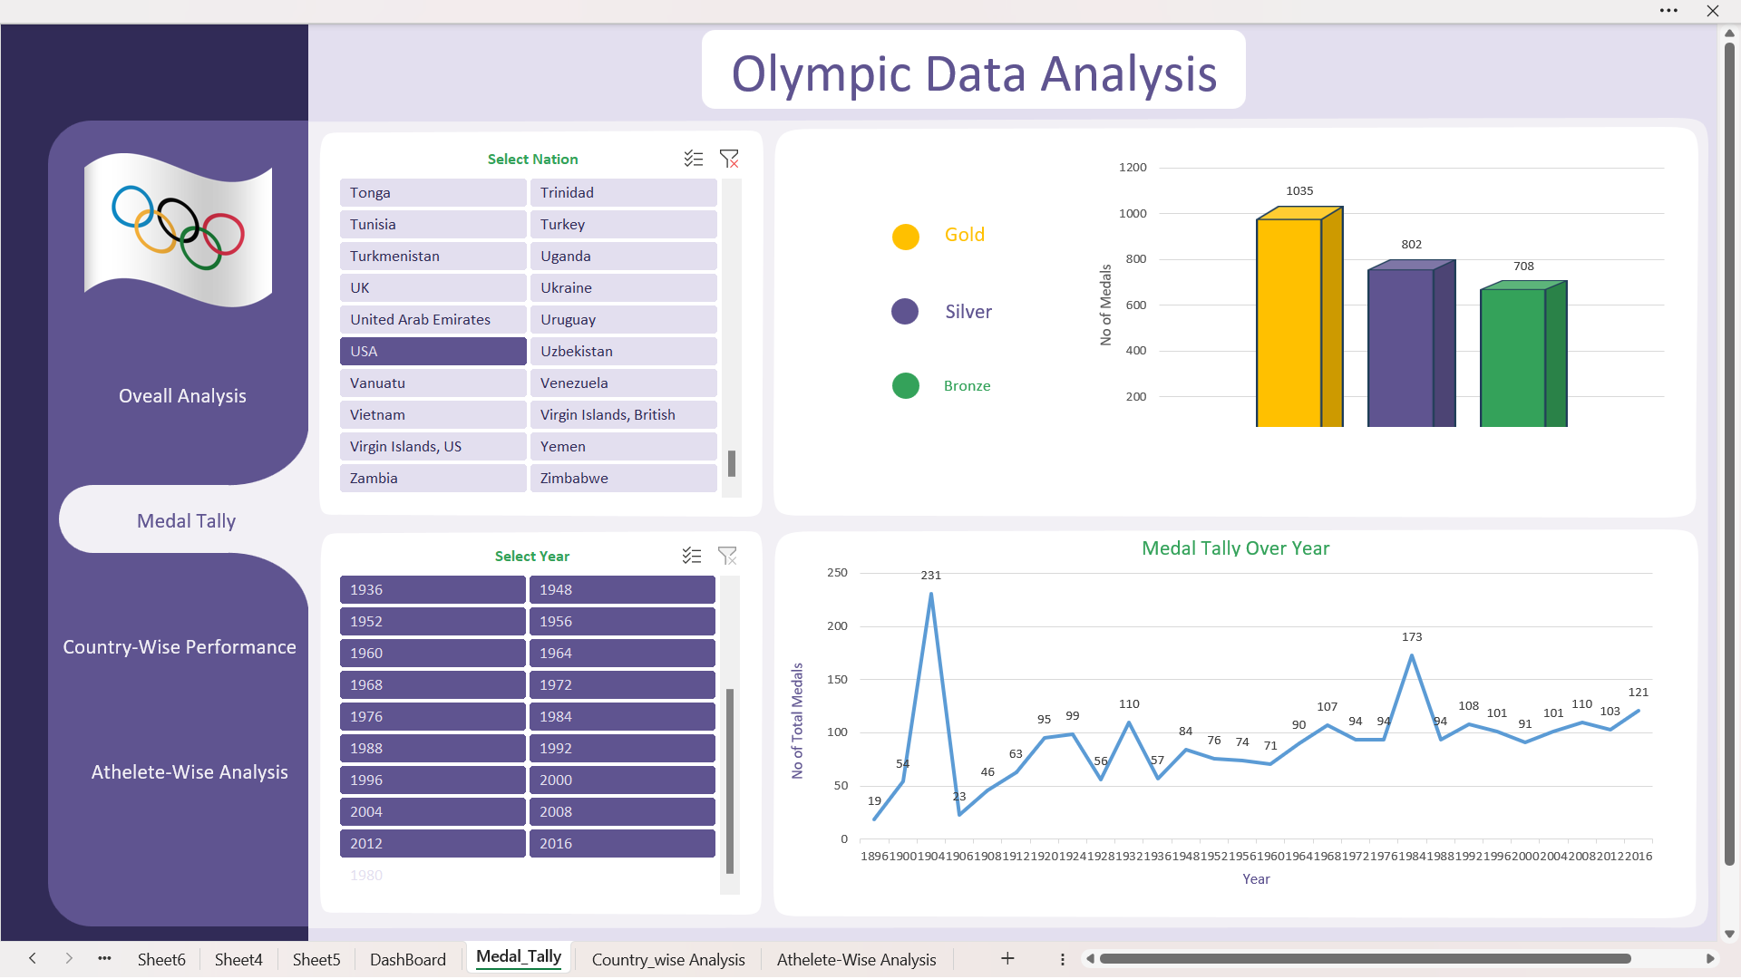

**3. Country-wise Analysis:**

Every nation brings its unique story to the Olympic stage. In this module, we delve into the performance of individual countries, exploring factors such as population size, investment in sports, and geopolitical influences that shape their Olympic success. Through comparative analysis, we aim to understand the varying trajectories of nations on the global sporting arena.

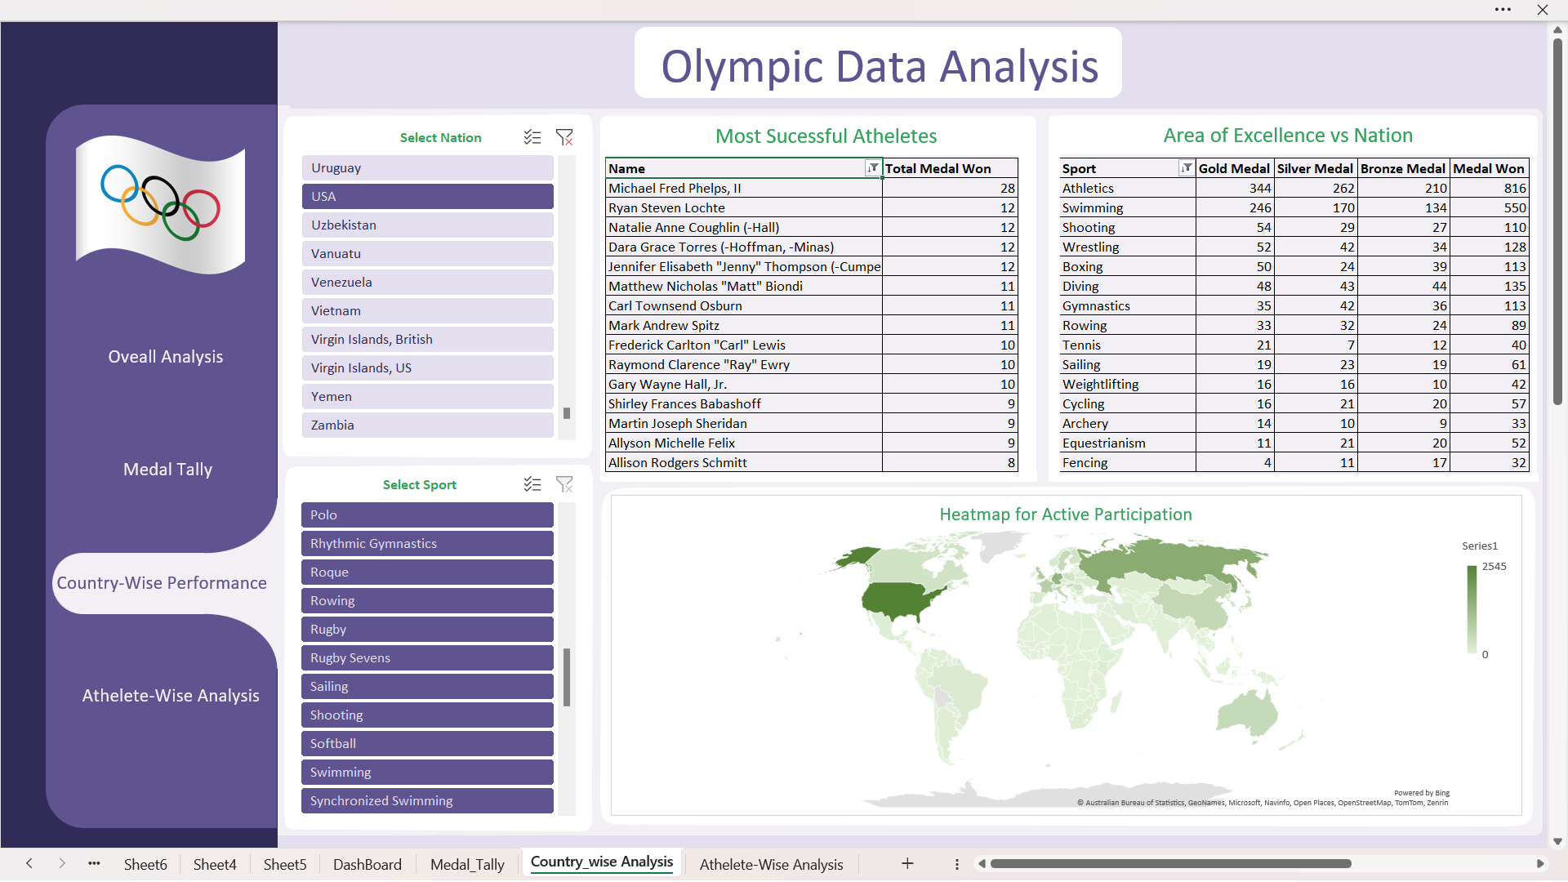

**4. Athlete-wise Analysis:**

At the heart of the Olympics are the athletes, whose dedication, talent, and resilience inspire generations. In this section, we zoom in on the performances of individual athletes, examining their achievements, records, and contributions to Olympic history. By highlighting exceptional individuals and their remarkable journeys, we pay tribute to the human spirit that defines the essence of the Games.

From the grand stadiums of Athens to the iconic arenas of Rio de Janeiro, the Olympic Games have left an indelible mark on history, uniting nations and transcending barriers. Through our analysis, we endeavor to shed light on the rich tapestry of Olympic achievements and offer insights that deepen our appreciation for the enduring legacy of this global sporting spectacle.

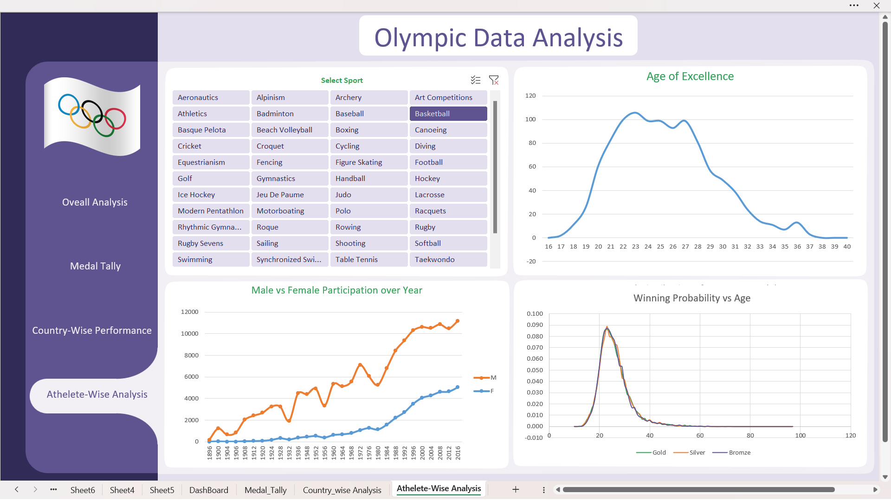

**Result**

As we draw the curtains on our exploration of Olympic data spanning from 1896 to 2016, we are reminded of the timeless allure and enduring legacy of the Games. From humble beginnings in Athens to the grand stages of Rio de Janeiro, the Olympics have evolved into a global phenomenon, captivating audiences with tales of triumph, perseverance, and unity. Through our analysis, we have glimpsed into the intricacies of Olympic history, unraveling the threads that weave together the stories of nations, athletes, and cultures. Yet, beyond the numbers and statistics lies a deeper truth – the Olympic spirit, an intangible force that transcends borders, celebrates diversity, and inspires greatness. As we look ahead to future editions of the Games, may we carry with us the lessons learned from the past, and may the Olympic flame continue to burn brightly as a beacon of hope, friendship, and solidarity for generations to come.

Data set source: [Click to see data_set](https://www.kaggle.com/datasets/heesoo37/120-years-of-olympic-history-athletes-and-results)

Project Drive link: [click to see\](https://docs.google.com/spreadsheets/d/1dt4b4Q6XRzLwCJ7EeMJvoyMem9ZUuuPs/edit?usp=drive_link&ouid=105473698621378156199&rtpof=true&sd=true) (file size: 30mb)(please download as xlsx file for better view of dashboard)