Node JS is a javascript runtime, build on Google open source V8 engine.

REPL (Read , Eval, Print, Loop ):It is an interactive programming environment provided by Node.js that allows you to execute JavaScript code directly in the terminal or command prompt.

Routing defines the way in which the client requests are handled by the application endpoints.

Event Driven Architecture:
three main player: Event Emitter, Event listener, Event Handler.

Npm is both package repositories and command line interface.

Npm-init
Event Loop: each cycle is called Tick
1. -Expired Timers
2. -IO tasking and polling.
3. -setImmediate callback –special time of timer
4. -Closed callback

Express is commenly build on node js
It is one of the most popular framework for jode js
Express contains very robust and useful set of features
Exoress allows to write node js application faster and simplier
with express we can organise nodejs code in MVC architecture.

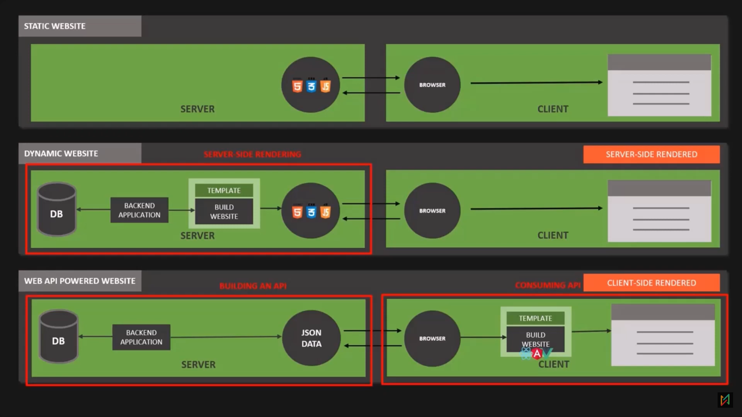
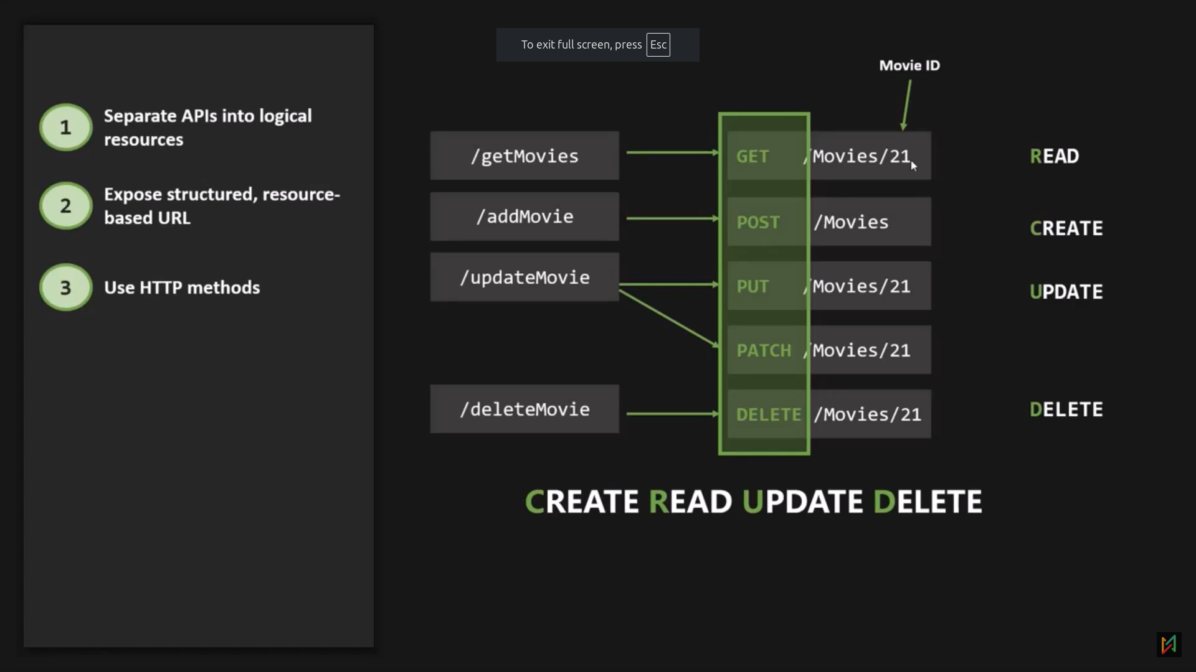
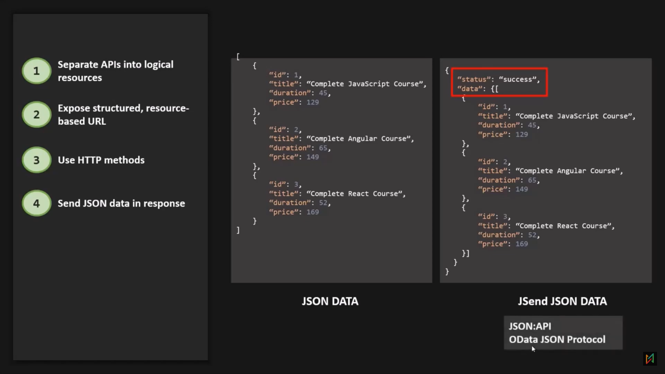
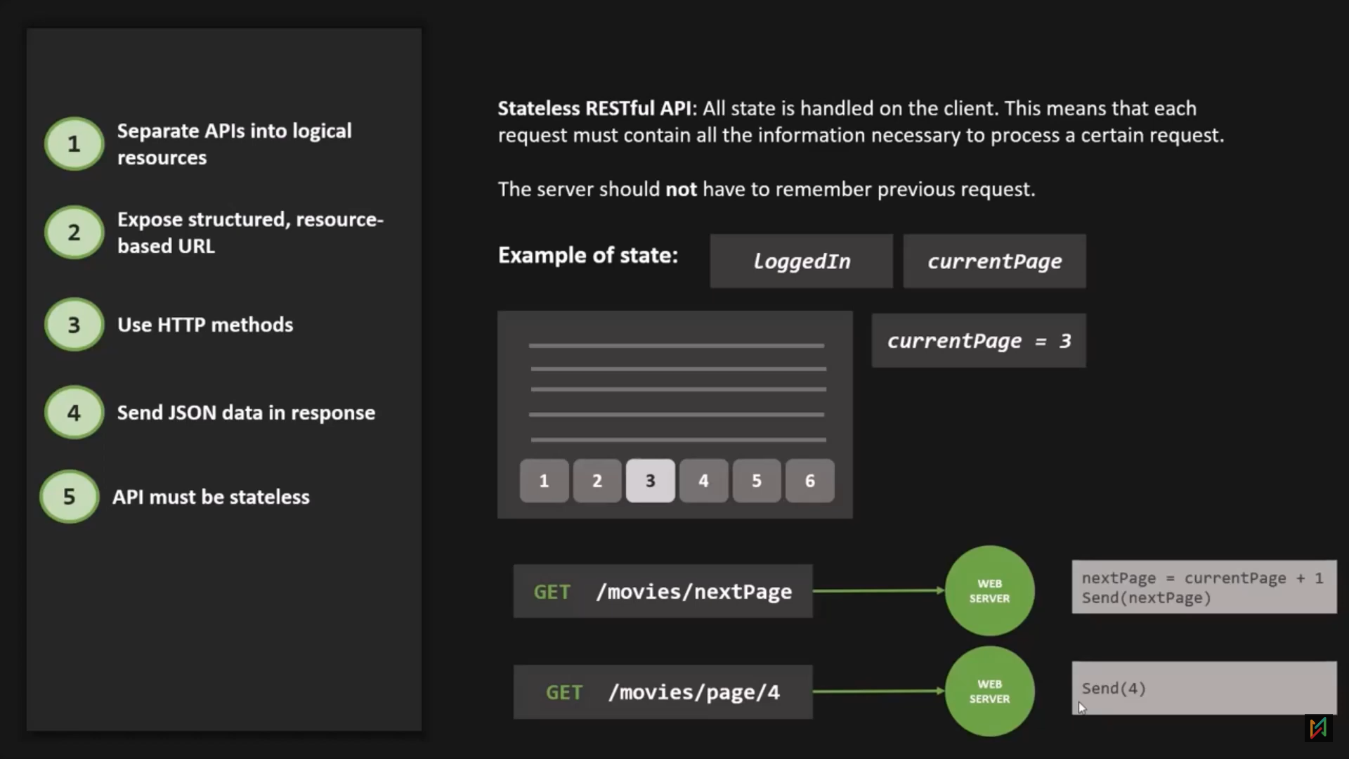
Route Parameter: Route parameters are named URL segments that are used to capture the values specified at their position in URL.

Eg: 127.0.0.1:8000/api/v1/movies/:id Here :id is parameter
//Handling get request with route parameter.
app.get('/api/v1/movies/:id/:name/:x?', (req, res) => { //:id is a route parameter and they are stored in form of string.
//Question mark in the route parameter is used to make the parameter optional.
console.log(req.params);
res.send('Data fetched successfully');
});

To update resource, we have two http method:
1. PUT: It is a method of modifying resources where the client sends data that updates the entire resources.
2. PATCH: It is method of modifying resources where the client sends partial data that is to be updated without modifying the entire data.

MongoDB

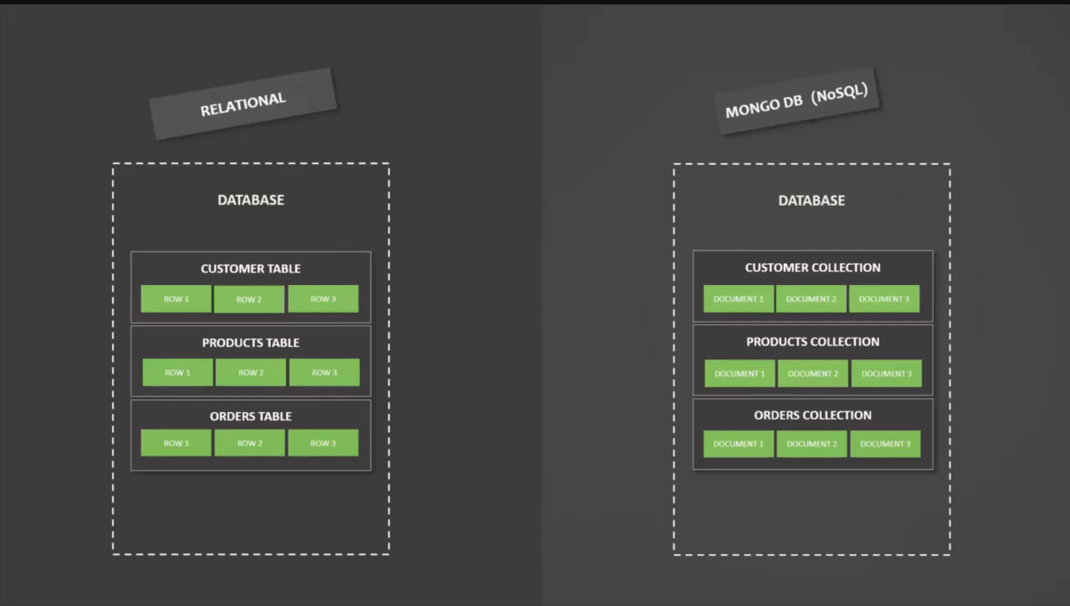
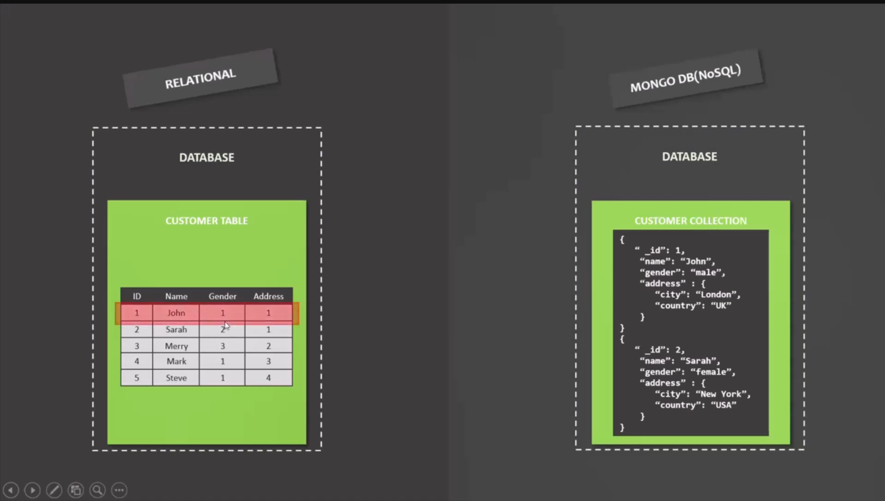

show dbs
// Lists all the databases in the MongoDB instance.
- use local
// Switches to the local database. If it doesn't exist, MongoDB creates it.
- use sampleDB
// Switches to the sampleDB database. If it doesn't exist, MongoDB creates it.
- db.test.insertOne({test:123})
// Inserts a single document with a field test having value 123 into the test collection.
- show collections
// Lists all the collections in the currently selected database.
- db.test.find
// Returns a reference to the find function to query the documents in the test collection.
- db.test.find()
// Retrieves all documents from the test collection.
- db.dropDatabase()
// Deletes the currently selected database and all its collections.
- db.customer.insertOne({name: "Manu Raj",age:21,gender:"Male"})
// Inserts a single document with fields name, age, and gender into the customer collection.
- db.createCollection("Products")
// Creates a new collection named Products in the current database.
- db.createCollection("Test",{capped:true,autoIndexId:true,size:5487986,max:100})
// Creates a capped collection named Test with a maximum size of 5487986 bytes and a maximum of 100 documents.
- db.test.drop
// Returns a reference to the drop function to delete the test collection.
- db.test.drop()
// Deletes the test collection from the current database.
- db.Test.drop()
// Deletes the Test collection from the current database (case-sensitive).
- db.customer.find()
// Retrieves all documents from the customer collection.
- db.customer.insertMany([{name:"Amrish",age:21,gender:"Male"},{name:"Nishant",age:22,gender:"Male"},{name:"Aaryan",age:21,gender:"Male"}])
//used to insert more than 1 collections
- db.customer.insert() : used to insert either 1 or more collectiona t a time but this method is deprecated.
- db.customer.insertMany([{name:"Amrish",age:21,gender:"Male"},{name:"Nishant",age:22,gender:"Male"},{name:"Aaryan",age:21,gender:"Male"}])
// Inserts multiple documents into the customer collection in one operation.
- db.customer.find()
// Retrieves all documents from the customer collection.
- db.customer.findOne()
// Retrieves the first document in the customer collection.
- db.customer.findOne({name:"Manu Raj"})
// Retrieves the first document from the customer collection where the name field is "Manu Raj".
- db.find.find()
// This seems like an invalid command since find is not a collection. It might be a typo.
- db.customer.find({name:"Manu Raj"})
// Retrieves all documents from the customer collection where the name field is "Manu Raj".
- db.customer.find({gender:"Male"})
// Retrieves all documents from the customer collection where the gender field is "Male".

- db.customer.find({gender:"Male"},{_id:false,gender:0})
// Retrieves all documents from the customer collection where gender is "Male", excluding the _id and gender fields from the output.
- db.customer.find({gender:"Male"},{_id:false,gender:0}).pretty()
// Same as the previous command but formats the output to be more human-readable using the pretty() method.

Explanation of the updateMany Operation:
The command:
db.customer.updateMany({gender:"MALE"},{$set:{Country:"India"}})
What it does:
- Filter Criteria ({gender: "MALE"}):
  - This matches all documents in the customer collection where the field gender is equal to "MALE".
- Update Action ({$set: {Country: "India"}}):
  - The $set operator adds a new field Country with the value "India" to all matched documents.
  - If the Country field already exists, its value will be updated to "India".
- Result:
  - The operation returns the following:
{
acknowledged: true,
insertedId: null,
matchedCount: 4,
modifiedCount: 4,
upsertedCount: 0
}
  - matchedCount: 4: Indicates that 4 documents matched the filter criteria.
  - modifiedCount: 4: Indicates that 4 documents were modified.
  - upsertedCount: 0: No new documents were created since upsert was not specified.

Updated State of the Collection:
After executing this operation, all documents in the customer collection with gender: "MALE" will now include the field Country: "India".
Example:
[
{
"_id": ObjectId('67602c64daeaf3178fa5c0ae'),
"name": "Manu Raj",
"age": 21,
"gender": "MALE",

Key Notes:
- updateMany:
  - Modifies all documents that match the filter criteria.
  - Use it when you want to apply changes to multiple documents at once.
- Dynamic Schema:
  - MongoDB allows adding new fields (Country) to documents even if the field does not exist previously.
- Impact on the Data:
  - All documents with gender: "MALE" now have a Country field set to "India".
- Explanation of the deleteOne Operation:
The command:
db.customer.deleteOne({class: 10})
What it does:
- Filter Criteria ({class: 10}):
  - This matches the first document in the customer collection where the field class is equal to 10.
- Action:
  - The deleteOne operation removes the first document that matches the filter criteria.
  - If no document matches, no action will be taken, and deletedCount will remain 0.
- Result:
{
acknowledged: true,
deletedCount: 1
}
  - acknowledged: true: Indicates the operation was successfully sent to the database.
  - deletedCount: 1: Confirms that one document was deleted.

Updated State of the Collection:
After executing this operation, the document with class: 10 has been removed. Assuming the previous state of the collection, the document with the name "Aaryan" (who had the field class: 10) is now deleted.
Remaining Documents:
[
{
"_id": ObjectId('67602c64daeaf3178fa5c0ae'),
"name": "Manu Raj",
"age": 21,
"gender": "MALE",
"Country": "India"
},
{
"_id": ObjectId('67603236daeaf3178fa5c0af'),
"name": "Amrish",
"age": 21,
"gender": "MALE",
"Country": "India"
},
{
"_id": ObjectId('67603236daeaf3178fa5c0b0'),
"name": "Nishant",
"age": 22,
"gender": "MALE",
"Country": "India"
}
]

Key Notes:
- deleteOne vs deleteMany:
  - deleteOne: Removes the first document that matches the criteria.
  - deleteMany: Removes all documents that match the criteria.
- No Match:
  - If no document matches {class: 10}, the result would be:
{ acknowledged: true, deletedCount: 0 }
- Be Careful!:
  - MongoDB operations like deleteOne and deleteMany permanently remove data. Ensure you back up critical data before performing such operations.
Let me know if you need help with restoring data or performing more advanced deletion operations!
- Be Careful!:
- MongoDB operations like deleteOne and deleteMany permanently remove data. Ensure you back up critical data before performing such operations.

//Remove method is deprecated.
In MongoDB, a cursor is an object that allows you to iterate over the results of a query. When you perform a find() operation or any query that retrieves multiple documents, MongoDB returns a cursor, which acts as a pointer to the query's result set. The cursor enables you to process documents one at a time or in batches, making it an efficient way to handle large datasets.
Customer2 data :
[
{
"name": "John",
"gender": "female",
"isMarried": true,
"subscription": {
"type": "yearly",
"renewableDate": {
"Day": 30,
"Month": "June",
"Year": 2025
}
}
},
{
"name": "Alice",
"gender": "female",
"isMarried": false,
"subscription": {
"type": "monthly",
"renewableDate": {
"Day": 15,
"Month": "July",
"Year": 2024
}
}
},
{
"name": "Michael",
"gender": "male",
"isMarried": true,
"subscription": {
"type": "weekly",
"renewableDate": {
"Day": 7,
"Month": "January",
"Year": 2024
}
}
},
{
"name": "Sophia",
"gender": "female",
"isMarried": false,
"subscription": {
"type": "yearly",
"renewableDate": {
"Day": 1,
"Month": "December",
"Year": 2024
}
}
},
{
"name": "David",
"gender": "male",
"isMarried": true,
"subscription": {
"type": "monthly",
"renewableDate": {
"Day": 20,
"Month": "February",
"Year": 2025
}
}
},
{
"name": "Emma",
"gender": "female",
"isMarried": false,
"subscription": {
"type": "weekly",
"renewableDate": {
"Day": 10,
"Month": "March",
"Year": 2024
}
}
},
{
"name": "Liam",
"gender": "male",
"isMarried": true,
"subscription": {
"type": "yearly",
"renewableDate": {
"Day": 25,
"Month": "August",
"Year": 2025
}
}
},
{
"name": "Olivia",
"gender": "female",
"isMarried": false,
"subscription": {
"type": "monthly",
"renewableDate": {
"Day": 5,
"Month": "April",
"Year": 2024
}
}
},
{
"name": "James",
"gender": "male",
"isMarried": true,
"subscription": {
"type": "weekly",
"renewableDate": {
"Day": 28,
"Month": "May",
"Year": 2024
}
}
},
{
"name": "Isabella",
"gender": "female",
"isMarried": true,
"subscription": {
"type": "yearly",
"renewableDate": {
"Day": 12,
"Month": "November",
"Year": 2025
}
}
}
]
db.customer2.updateOne({name:"Isabella"},{$set:{"subscription.type":"monthly"}})
- Purpose: Updates the subscription.type field of the document where the name is "Isabella" to "monthly" in the customer2 collection.
- db.customer.find()
- Purpose: Retrieves all documents in the customer collection.
- db.customer2.find()
- Purpose: Retrieves all documents in the customer2 collection.
- db.customer2.updateOne({name:"Isabella"},{$set:{"subscription.renewableDate.year":2026}})
- Purpose: Updates the subscription.renewableDate.year field for the document where the name is "Isabella" to 2026 in the customer2 collection.
- db.customer2.findOne({name:"Isabella"})
- Purpose: Retrieves the first document where the name is "Isabella" from the customer2 collection.
- db.customer2.findOne({name:"Isabella"}).subscription
- Purpose: Retrieves only the subscription field of the document where the name is "Isabella".
- db.customer2.findOne({name:"Isabella"}).subscription.renewableDate
- Purpose: Retrieves the renewableDate field inside the subscription field of the document where the name is "Isabella".
- db.customer2.findOne({name:"Isabella"}).subscription.renewableDate.Month
- Purpose: Retrieves the Month field inside the renewableDate object of the subscription field for the document where the name is "Isabella".
Working with Arrays:
data:
[
{
"name": "John",
"gender": "female",
"isMarried": true,
"subscription": {
"type": "yearly",
"renewableDate": {
"Day": 30,
"Month": "June",
"Year": 2025
}
},
"address": ["New Jersey", "USA"],
"purchase": [
{ "name": "iPhone", "model": "March", "year": 2023 },
{ "name": "Sony TV", "model": "Sony Bravia", "price": 2100 }
]
},
{
"name": "Emily",
"gender": "female",
"isMarried": false,
"subscription": {
"type": "monthly",
"renewableDate": {
"Day": 15,
"Month": "July",
"Year": 2024
}
},
"address": ["Los Angeles", "USA"],
"purchase": [
{ "name": "MacBook Pro", "model": "M1", "year": 2022 },
{ "name": "AirPods", "model": "Pro", "price": 250 }
]
},
{
"name": "Michael",
"gender": "male",
"isMarried": true,
"subscription": {
"type": "lifetime",
"renewableDate": null
},
"address": ["Sydney", "Australia"],
"purchase": [
{ "name": "Samsung Galaxy", "model": "S21", "year": 2021 },
{ "name": "LG Refrigerator", "model": "Twin Wash", "price": 1800 }
]
},
{
"name": "Sophia",
"gender": "female",
"isMarried": false,
"subscription": {
"type": "weekly",
"renewableDate": {
"Day": 10,
"Month": "August",
"Year": 2024
}
},
"address": ["Toronto", "Canada"],
"purchase": [
{ "name": "Dell Laptop", "model": "Inspiron", "year": 2020 },
{ "name": "Bose Headphones", "model": "700", "price": 400 }
]
},
{
"name": "Ethan",
"gender": "male",
"isMarried": false,
"subscription": {
"type": "bi-annual",
"renewableDate": {
"Day": 25,
"Month": "May",
"Year": 2024
}
},
"address": ["London", "UK"],
"purchase": [
{ "name": "iPad", "model": "Air", "year": 2021 },
{ "name": "PlayStation 5", "model": "Digital Edition", "price": 500 }
]
},
{
"name": "Olivia",
"gender": "female",
"isMarried": true,
"subscription": {
"type": "yearly",
"renewableDate": {
"Day": 1,
"Month": "January",
"Year": 2026
}
},
"address": ["Berlin", "Germany"],
"purchase": [
{ "name": "Huawei P40", "model": "Pro", "year": 2022 },
{ "name": "Samsung TV", "model": "QLED", "price": 1300 }
]
},
{
"name": "Liam",
"gender": "male",
"isMarried": true,
"subscription": {
"type": "monthly",
"renewableDate": {
"Day": 20,
"Month": "March",
"Year": 2024
}
},
"address": ["Mumbai", "India"],
"purchase": [
{ "name": "OnePlus Phone", "model": "9 Pro", "year": 2021 },
{ "name": "Samsung Washing Machine", "model": "EcoBubble", "price": 750 }
]
},
{
"name": "Isabella",
"gender": "female",
"isMarried": false,
"subscription": {
"type": "weekly",
"renewableDate": {
"Day": 5,
"Month": "April",
"Year": 2024
}
},
"address": ["Paris", "France"],
"purchase": [
{ "name": "Asus Laptop", "model": "ZenBook", "year": 2023 },
{ "name": "Dyson Vacuum", "model": "V10", "price": 600 }
]
},
{
"name": "James",
"gender": "male",
"isMarried": true,
"subscription": {
"type": "yearly",
"renewableDate": {
"Day": 15,
"Month": "November",
"Year": 2025
}
},
"address": ["Cape Town", "South Africa"],
"purchase": [
{ "name": "Google Pixel", "model": "7", "year": 2023 },
{ "name": "Sony Camera", "model": "Alpha 7C", "price": 1800 }
]
},
{
"name": "Mia",
"gender": "female",
"isMarried": false,
"subscription": {
"type": "lifetime",
"renewableDate": null
},
"address": ["Tokyo", "Japan"],
"purchase": [
{ "name": "Nintendo Switch", "model": "OLED", "year": 2022 },
{ "name": "Panasonic Microwave", "model": "NN-SN966S", "price": 200 }
]
}
]
YiDtZzhJwP48pguK

