i

Low Level Design

Restaurant Rating Prediction

|  |  |
| --- | --- |
| Written By | Manu Raj |
| Document Version | 1.0 |
| Last Revised Date | 15-Oct-2021 |

 Restaurants Rating Prediction LLD LOW LEVEL DESIGN (LLD)

**Document Control**

**Change Record:**

|  |  |  |  |
| --- | --- | --- | --- |
| **Version** | **Date** | **Author** | **Comments** |
| 1.0 | 15-Oct-2021 | Manu Raj | Introduction  Architecture  Complete Architecture  Description  Unit Test cases |
|  |  |  |  |
|  |  |  |  |
|  |  |  |  |
|  |  |  |  |

|  |
| --- |
| ii |

**Reviews:**

|  |  |  |  |
| --- | --- | --- | --- |
| **Version** | **Date** | **Reviewer** | **Comments** |
|  |  |  |  |

**Approval Status:**

|  |  |  |  |  |
| --- | --- | --- | --- | --- |
| **Version** | **Review Date** | **Reviewed By** | **Approved By** | **Comments** |
|  |  |  |  |  |

Restaurants Rating Prediction LLD iii

Contents

1. Introduction 1

1.1.What is Low-Level design document? 1

1.2.Scope 1

2.Architecture 1

3. Architecture Description 2

3.1 Data Description 2

3.2 Data Gathering 3

3.3 Raw Data Validation 3

3.4 Data Transformation 3

3.5 Database Insertion 3

3.6 Export as `CSV` from Database 3

3.7 Data Preprocessing 3

3.8 Feature Engineering 4

3.9 Parameter Tuning 4

3.10 Model Building 4

3.11 Model Saving 4

3.12 Flask Setup for Data Extraction 4

3.13 GitHub 4

3.14 Deployment 4

4. Unit Test Cases 5

Restaurants Rating Prediction LLD

# Introduction

## What is Low-Level design document?

The goal of LLD or a low-level design document (LLDD) is to give the internal logical design of the actual program code for Food Recommendation System. LLD describes the class diagrams with the methods and relations between classes and program specs. It describes the modules so that the programmer can directly code the program from the document.

## Scope

Low-level design (LLD) is a component-level design process that follows a step-bystep [refinement](https://en.wikipedia.org/wiki/Refinement_(computing)) process. This process can be used for designing data structures, required software architecture, source code and ultimately, performance algorithms. Overall, the data organization may be defined during requirement analysis and then refined during data design work.

# Architecture

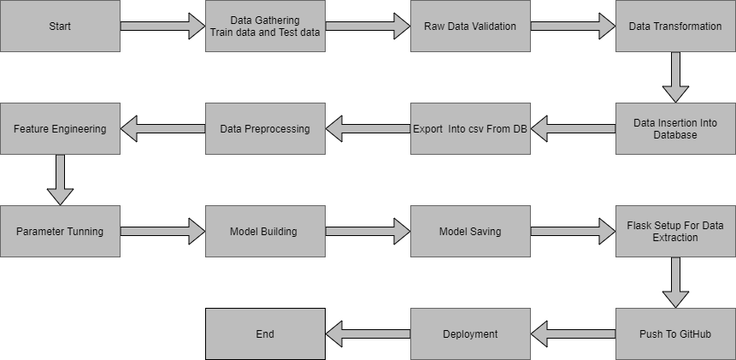

# Architecture Description

## Data Description

Given is the variable name, variable type, the measurement unit, and a brief description. The Restaurants rating prediction is the regression problem. The order of this listing corresponds to the order of numerals along the rows of the database.

|  |  |  |
| --- | --- | --- |
| Name | Data Type | Measurement |
| url | String | URL of the restaurant |
| address | String | Address of the restaurants |
| name | String | Name of the restaurants |
| online_order | String | Online order option is there or not in restaurants. |
| book_table | String | Table Booking option is there or not in restaurants. |
| rate | Float | Rating of the restaurents. |
| votes | String | Total number of votes restaurants have. |
| phone | Integer | Phone number of restaurants. |
| location | String | Location of restaurants. |
| rest_type | String | This column shows which type of dinning services restaurants provide. |
| dish_liked | String | This column shows most liked dishes of the restaurants. |
| cuisines | String | This column shows which type of continental dinning services restaurants provide. |
| approx_cost(for two people) | Float | This column shows approximate cost for two people. |
| reviews_list | String | Review of the restaurants. |
| menu_item | String | List of menu items of restaurants. |
| listed_in(type) | String | Type of dinning style is listed in this column. |
| listed_in(city) | String | City in which restaurant is present is listed here. |

## Data Gathering

Data source: <https://www.kaggle.com/himanshupoddar/zomato-bangalore-restaurants>Train and Test data are stored in .csv format.

## Raw Data Validation

After data is loaded, various types of validation are required before we proceed further with any operation. Validations like checking for zero standard deviation for all the columns, checking for complete missing values in any columns, etc. These are required because The attributes which contain these are of no use. It will not play role in contributing to the sales of an item from respective outlets.

Like if any attribute is having zero standard deviation, it means that’s all the values are the same, its mean is zero. This indicates that either the sale is increasing or decrease that attribute will remain the same. Similarly, if any attribute is having full missing values, then there is no use in taking that attribute into an account for operation. It’s unnecessary increasing the chances of dimensionality curse.

## Data Transformation

Before sending the data into the database, data transformation is required so that data are converted into such form with which it can easily insert into the database. Here, the ‘Item Weight’ and “Outlet Type’ attributes contain the missing values. So they are filled in both the train set as well as the test set with supported appropriate data types.

## Database Insertion

Both train and test data set are inserted into the database. Here MongoDB database is used to store the data set. Separate collections were created for both train and test sets.

## Export as `CSV` from Database

From the database both the train and test data set are exported into the local system and stored into CSV files. Now this CSV file will have proceeded for further processing.

## Data Preprocessing

In data preprocessing all the processes required before sending the data for model building are performed. Like, here the rate column was having rating as eg:4.5/5, therefore we have removed /5 from the rating of the rate column. After that there were missing values in rate , cost , location and rest_type column which we have dropped.

## Feature Engineering

After preprocessing it was found that some of the attributes are not important to the item sales for the particular outlet. So those attributes are removed. Even level encoding is also performed to convert the categorical features into numerical features.

## Parameter Tuning

Parameters are tuned using Randomized searchCV. Two algorithms are used in this problem, Random Forest, and Extra tree regressor. The parameters of all these 2 algorithms are tunned and passed into the model.

## Model Building

After doing all kinds of preprocessing operations mention above and performing scaling and hyperparameter tuning, the data set is passed into all two models, Random Forest, and Extra tree regressor. It was found that Extra tree regressor performs best with the smallest RMSE value i.e and the highest R2 score equals 0.93. So ‘Extra tree regressor’ performed well in this problem.

## Model Saving

Model is saved using pickle library in `.pkl` format.

## Flask Setup for Data Extraction

After saving the model, the API building process started using Flask. Web application creation was created here. Whatever the data user will enter and then that data will be extracted by the model to predict the prediction of sales, this is performed in this stage.

## GitHub

The whole project directory will be pushed into the GitHub repository.

## Deployment

The cloud environment was set up and the project was deployed from GitHub into the Heroku cloud platform.

App link-

# Unit Test Cases.

|  |  |  |
| --- | --- | --- |
| **Test Case Description** | **Pre-Requisite** | **Expected Result** |
| Verify whether the Application URL is accessible to the user | 1. Application URL should be defined | Application URL should be accessible to the user |
| Verify whether the Application loads completely for the user when the URL is accessed | 1. Application URL is accessible 2. Application is deployed | The Application should load completely for the user when  the URL is accessed |
| Verify whether a user is able to see input fields while opening the application | 1. Application is accessible 2. The user is able to see the input fields | Users should be able to see input fields on logging in |
| Verify whether a user is able to enter the input values. | 1. Application is accessible 2. The user is able to see the input fields | The user should be able to fill the input field |
| Verify whether a user gets predict button to submit the inputs | 1. Application is accessible 2. The user is able to see the input fields | Users should get Submit button to submit the inputs |
| Verify whether a user is presented with recommended results on clicking submit | 1. Application is accessible 2. The user is able to see the input fields. 3. The user is able to see the submit button | Users should be presented with recommended results on clicking submit |
| Verify whether a result is in accordance with the input that the user has entered | 1. Application is accessible 2. The user is able to see the input fields. 3. The user is able to see the submit button | The result should be in accordance with the input that the user has entered |