CERTIFICATE

This is to certify that Manu.R of X A2 has successfully completed the computer assignments and projects as prescribed by the ICSE Board for the academic year 2011-2012.

Signature of Internal Examiner Signature of External Examiner

________________________ ____________________________

Name of the institution-
Carmel School,
Padmanabhanagar,
Bangalore-560070.

CERTIFICATE

This is to certify that Anirudh.S.Koushik of X A2 has successfully completed the computer assignments and projects as prescribed by the ICSE Board for the academic year 2011-2012.

Signature of Internal Examiner Signature of External Examiner

________________________ ____________________________

Name of the institution-
Carmel School,
Padmanabhanagar,
Bangalore-560070.

ACKNOWLEDGEMENT

This is to acknowledge that this project has been successfully completed by us, Manu.R and Anirudh.S.Koushik, with the support of our computer teacher, who has helped us with her invaluable guidance and timely advice. This project has been very informative and has served as a very enriching experience.

Thanking you,

Manu.R and Anirudh.S.Koushik
Roll.no-14 Roll.no-05
X A2 X A2

Variable description

Variable | Data Type |  | Description
Class contacts
(1)contacts | String array |  |  | To store contact name
(2)contacts_picture | String array |  |  | To store picture for contacts
(3)phno | String array |  |  | To store phone number of the coatact
(4)i | Int |  |  | Loop control variable
(5)g | Int |  |  | Used as a loop control variable in while loop
(6)c | String |  |  | Used to accept choice
(7)mb | Mobile(class) |  |  | Used for creating an object for  moblile class
(8)o | Exception |  |  | Used to catch an exception
(9)br | BufferedReader |  |  | Used for creating a bufferedReader
(10)d | Int |  |  | Used as a loop control variable in while loop
(11)p | Int |  |  | Used as a loop control variable in while loop
(12)opt | String |  |  | Used to accept choice
(13)j | Int |  |  | Used as a loop control variable in while loop
(14)min | String |  |  | Used for storing minium value
(15)min1 | String |  |  | Used for interchanging array elements
(16)min2 | String |  |  | Used for interchanging array elements
(17)p | Int |  |  | Used for interchanging array index values
(18)q | Int |  |  | Used for interchanging array index values
(19)r | Int |  |  | Used for interchanging array index values
(20)k | Int |  |  | Used to display serial number
(21)q | int |  |  | Used as a loop control variable in while loop
Class world _clock
(1)places |  | String array |  | Used to store places
(2)longitude |  | Double array |  | Use to store longitude
(3)i |  | Int |  | Loop control variable
(4)br |  | BufferedReader |  | Used for creating a bufferedReader
(5)t |  | int |  | Used as a loop control variable in while loop
(6)h |  | String |  | Used to accept time
(7)a |  | String |  | Used for storing first digit of hours and  minutes
(8)b |  | String |  | Used for storing second digits of hours and minutes
(9)c |  | String |  | Used for adding the digits
(10)hr |  | int |  | For converting hr to integer
(11)a1 |  | char |  | For storing first digit of hours
(12)a2 |  | char |  | For storing second digit of hours
(13)u |  | String |  | Used for adding the digits
(14)jjj |  | int |  | Implements formula for obtaining excess  time in a India compared GMT
(15)interhour |  | int |  | Finding the hours from the extra minutes .
(16)intermin |  | int |  | Storing the remaing time as minutes.
(17)hour |  | int |  | Stores the hours at gmt
(18)min |  | int |  | Stores minutes at gmt
(19)tt |  | int |  | Used to accept choice
(20)add_subtimehour |  | int |  | Finding the hours from the extra minutes  in the country compared to GMT
(21)add_subtimemin |  | int |  | Storing the remaing time as minutes.
(22)finalhour |  | int |  | Stores the hours at the place selected
(23)finalmin |  | int |  | Stores the minutes at the place selected
(24)th |  | String |  | For storing finalhour as String
(25)tm |  | String |  | For storing finalmin as String
(26)jk |  | String |  | Used for accepting “yes” or “no”.
Class mobile
(1)o |  | int |  | Loop control variable
(2)aa |  | Mobile1 class |  | For accessing its methods
(2)qq |  | Explode class |  | For accessing its methods
(3)s1 |  | Settings class |  | For accessing its methods
(4)br |  | BufferedReader |  | Used for creating a bufferedReader
Class mobile1
(1)j , w , n , calc , l ,  r , c k , c , ring |  | class |  | Used for creating object for various  classes
(2)h , kkk ,f , q |  | Int |  | Loop control variable
(3)yy , j |  | Int |  | To accept choice from user
(4)opt |  | String |  | Used to accept (string) choice from user
(5)br |  | BufferedReader |  | Used for creating a bufferedReader
Class settings
(1)welcometext |  | Strimg |  | This variable is displayed when the phone is  switched on
(2)sim1 |  | String |  | This stores the service provider of  the simcard
(3)br |  | BufferedReader |  | Used for creating a bufferedReader
(4)d |  | Date class |  | Used to display the system date
(5)j |  | Int |  | Loop control variable
(6)i |  | int |  | Used to accept choice from user
Class messages
(1)indox |  | 2 dimentional  String array |  | Used to store received messages
(2)drafts |  | String array |  | Used to store messages which are drafted
(3)sentm |  | 2 dimentional  String array |  | Used to store sent messages
(4)br |  | BufferedReader |  | Used for creating a bufferedReader
(5)j |  | Int |  | Loop control variable
(6)c,c2,i |  | int |  | To accept choice
(7)hj,kkkk |  | String |  | To accept choice
(8)phno |  | String |  | To store number
(9)mail |  | String |  | To store the message that has been typed
Class contact
(1)br |  | BufferedReader |  | Used for creating a bufferedReader
(2)k |  | int |  | To print serial number of contacts
(3)w,l |  | int |  | Loop control variable
(4)no |  | int |  | To accept choice
(5)c |  | String |  | To accept choice
Class countdown_timer
(1)br |  | BufferedReader |  | Used for creating a bufferedReader
(2)j |  | int |  | Loop control variable
(3)hour,min,sec |  | int |  | Used for accepting hours , minutes , and  Seconds to countdown
Class explode
(1)j |  | int |  | To accept parameters
(2)i |  | int |  | Loop control variable
(3)s2 |  | String |  | Used to accept string value
Class notes
(1)notes |  | 2-dimentional  string array |  | To store notes
(2)br |  | BufferedReader |  | Used for creating a bufferedReader
(3)m,n |  | String |  | To accept choice
(4)count,i,j,w,q |  | int |  | Loop control variable
(5)h |  | int |  | To accept choice
Class calculator
(1)br |  | BufferedReader |  | Used for creating a bufferedReader
(2)j,i |  | int |  | Loop control variable
(3)ch |  | int |  | To accept user’s choice
Class locking
(1)br |  | BufferedReader |  | Used for creating a bufferedReader
(2)o |  | int |  | Loop control variable
Class call
(1)log |  | 2-dimentional  String array |  | To store dialed numbers
(2)no |  | String |  | To store the number to be called
(3)st |  | String |  | To store starting time
(4)et |  | String |  | To store ending time
(5)cd |  | String |  | To store call duration
(6)br |  | BufferedReader |  | Used for creating a bufferedReader
(7)l1 , j , a1 , l |  | int |  | Loop control variable
(8)s |  | Date class |  | To store starting time and ending time
(9)time |  | int |  | Converting starting time into seconds
(10)aftertime |  | int |  | Converting ending time into seconds
(11)callduration |  | int |  | To store the call duration in seconds
Class xandos
(1)c |  | Character array |  | To store the entered value of the grid
(2)user_char |  | char |  | To store the user’s character
(3)comp_char |  | char |  | To store the computer’s character
(4)turn_count |  | int |  | To count the number of turns
(5)winner_char |  | char |  | To store the character that has won
(6)k |  | int |  | Loop control variable
(7)a |  | Int |  | To store a random number
(8)s |  | String |  | To accept choice
(9)br |  | BufferedReader |  | Used for creating a bufferedReader
Class handcricket
(1)br |  | BufferedReader |  | Used for creating a bufferedReader
(2)s , d |  | String |  | To accept user’s choice
(3) score_player_  user |  | int array |  | To store the user’s score
(4) score_player_  comp |  | Int array |  | To store the computer’s score
(5) players_user |  | String array |  | To store the name of the players-user
(6) players_comp |  | String array |  | To store the name of the players-computer
(7)toss |  | String |  | To accept the toss from the user
(8)t , oo , yyy , yy ,  yo |  | int |  | Loop control variable
(9)rand |  | int |  | Generates a random number as the number  To be put by the computer
(10)ur |  | int |  | Accepts the number which the user enters  To add to the score
(11) final_score_  user |  | int |  | Stores the total score scored by the user
(12) final_score_  comp |  | int |  | Stores the total score scored by the  computer
(13)l, da |  | Int |  | Variables to control the number of times  The user plays
(14)s1 , s3 |  | Int |  | To add the scores of individual players
(15)result |  | String |  | Stores the result of the match

Output

Create object of “mobile” class and execute the main method!
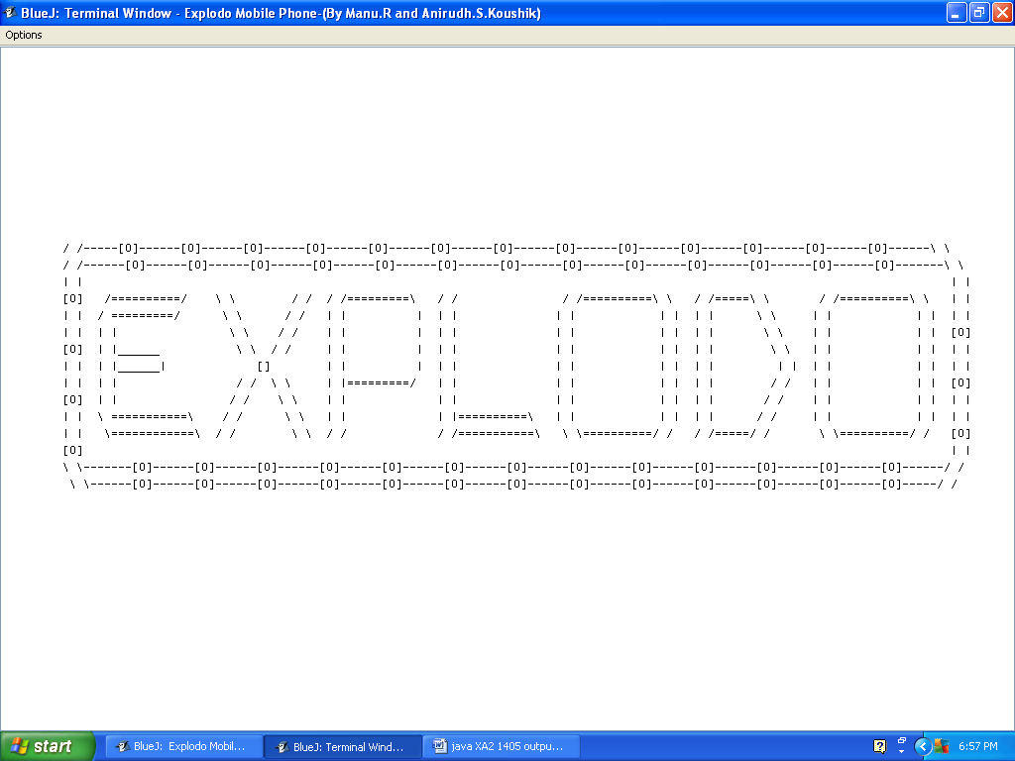
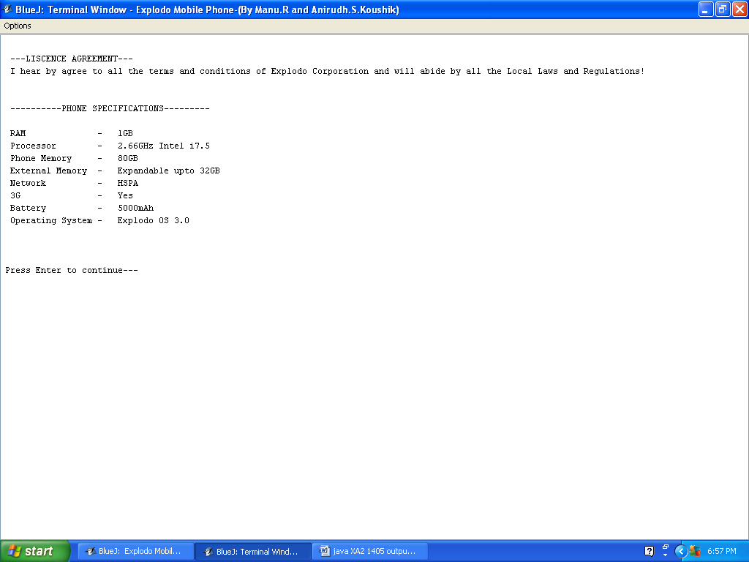

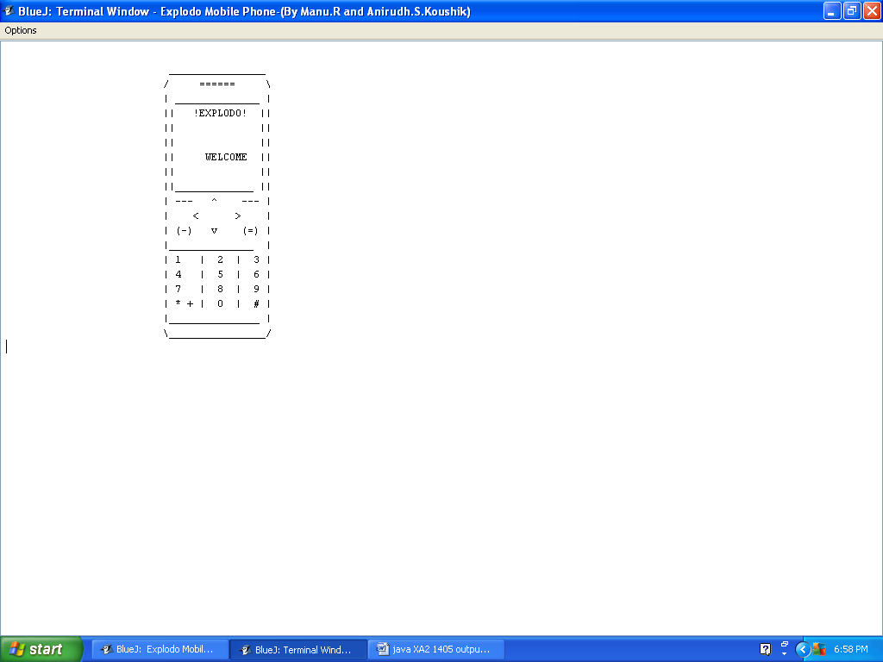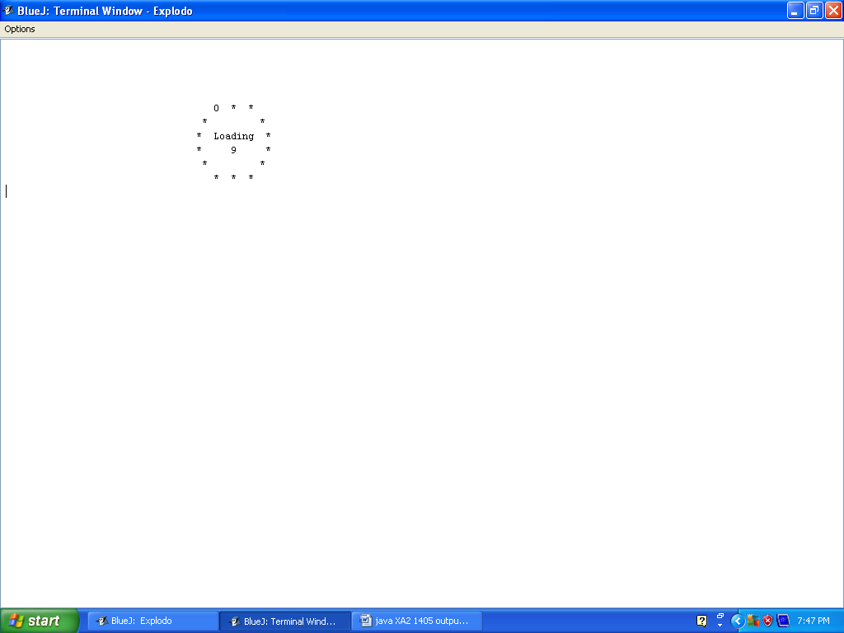

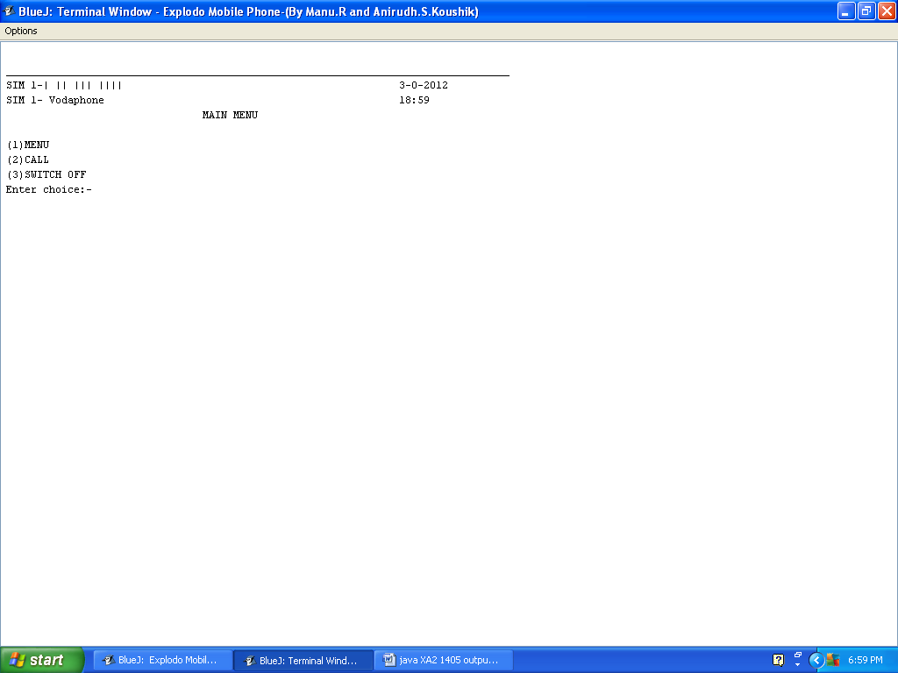
After waiting for 10 seconds…
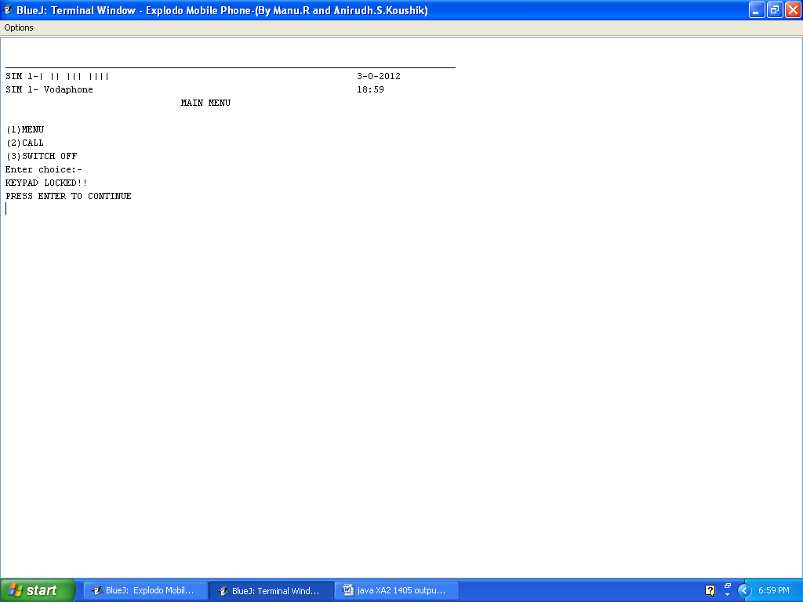
After pressing enter…
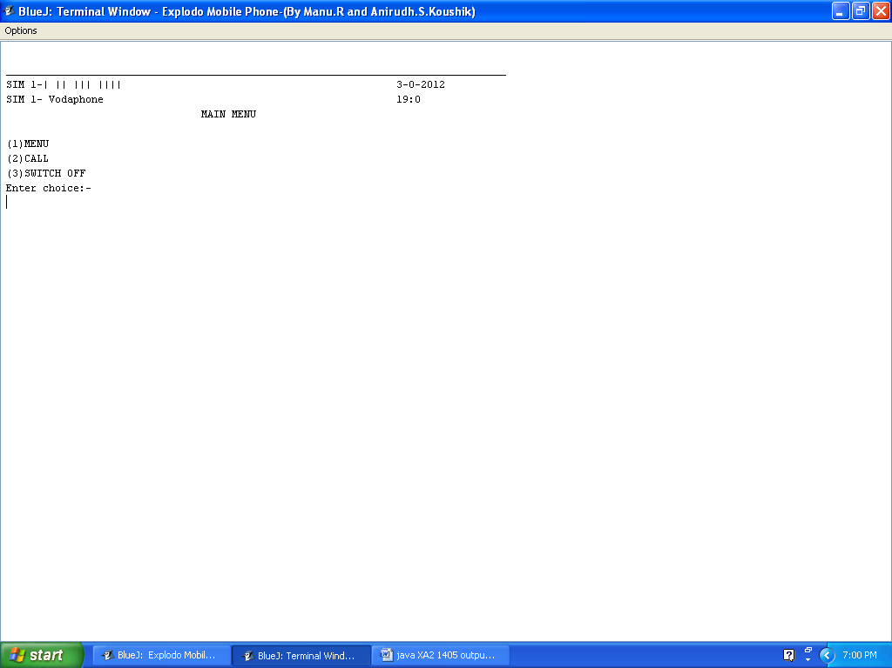
Pressing 1 and then enter…
The main menu…
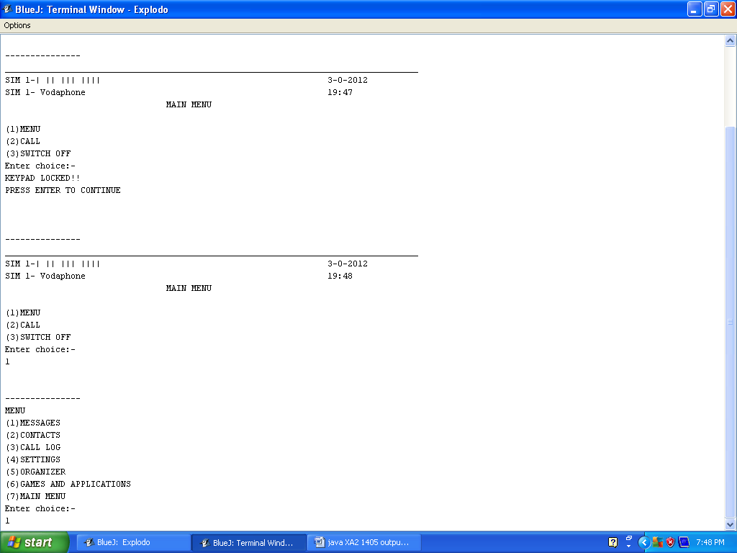
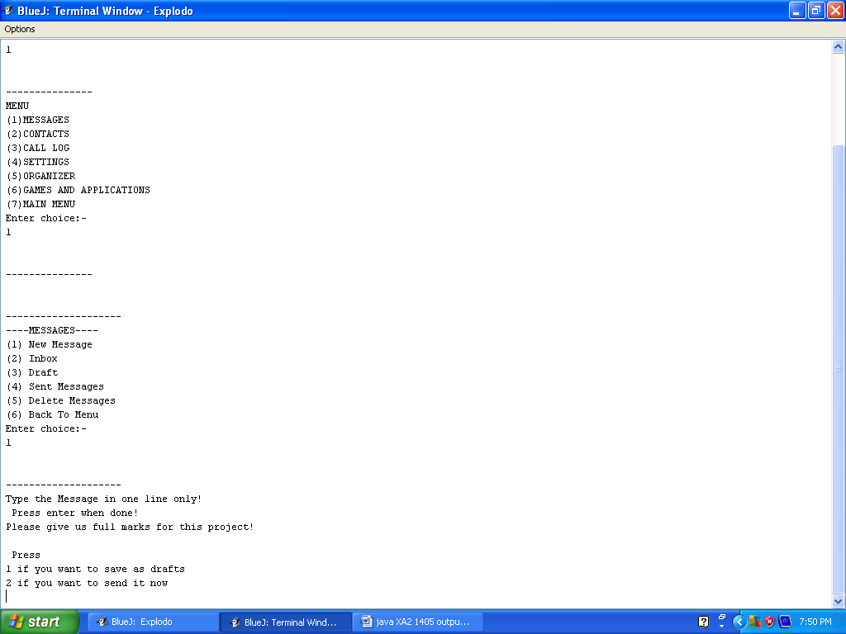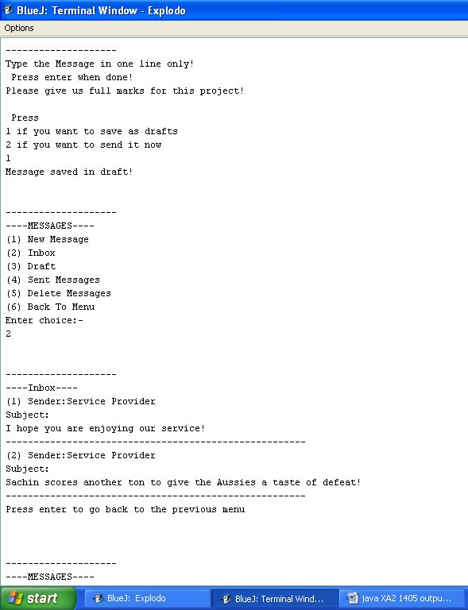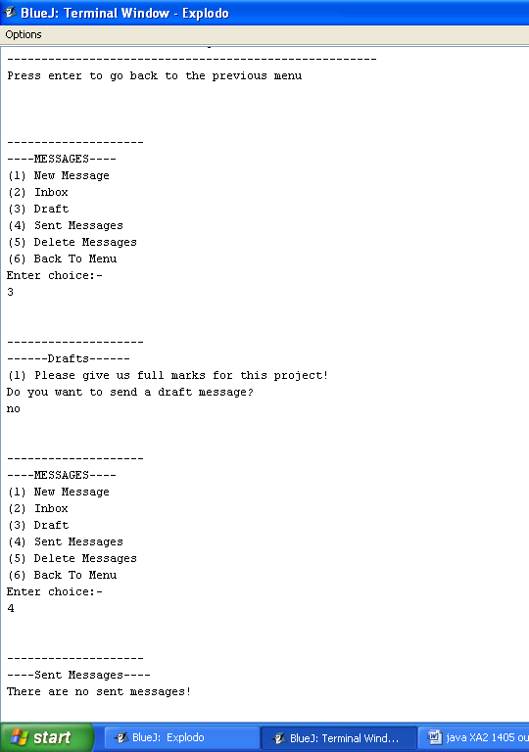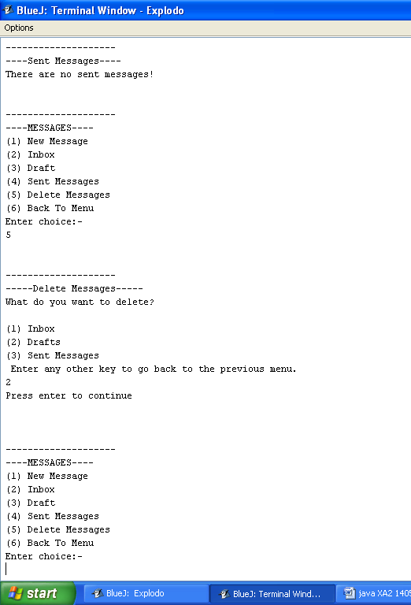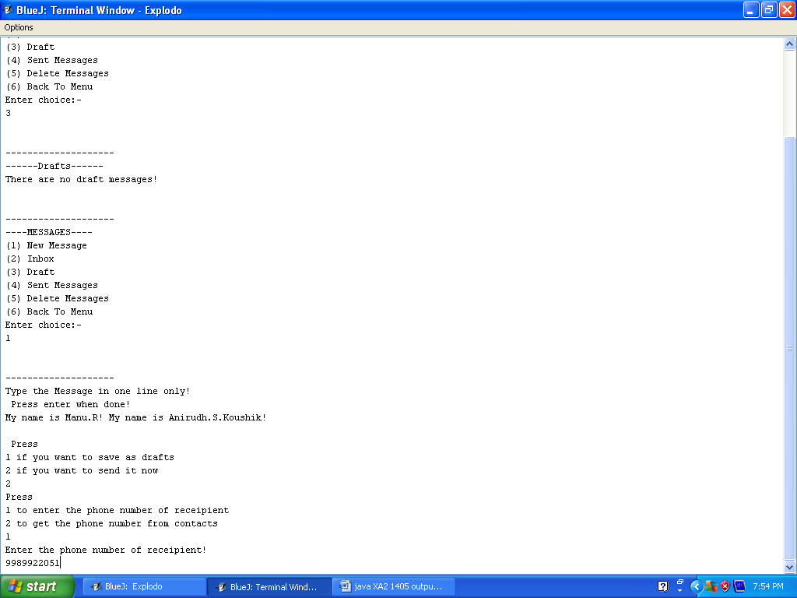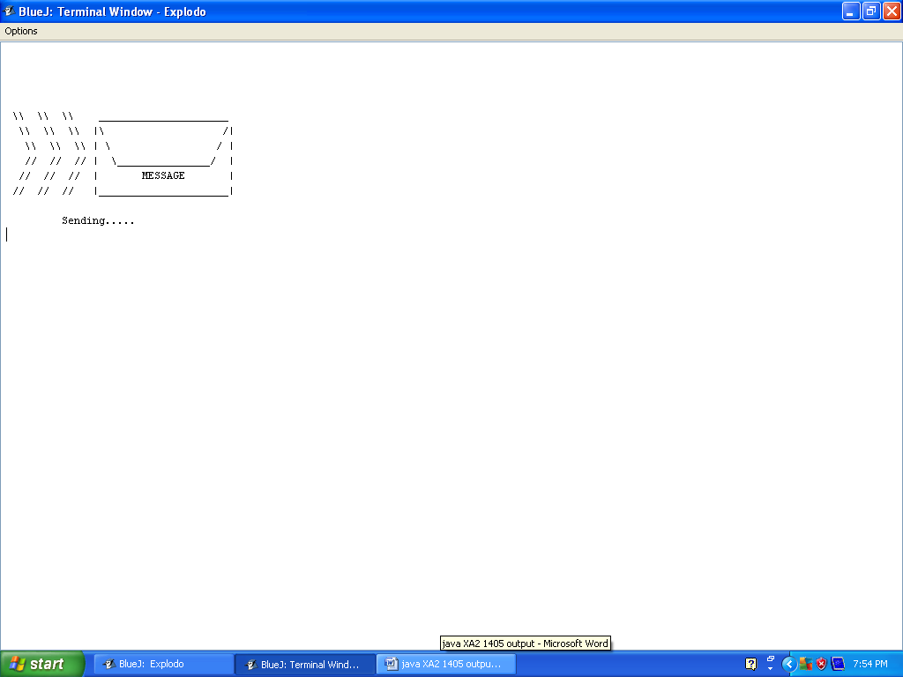
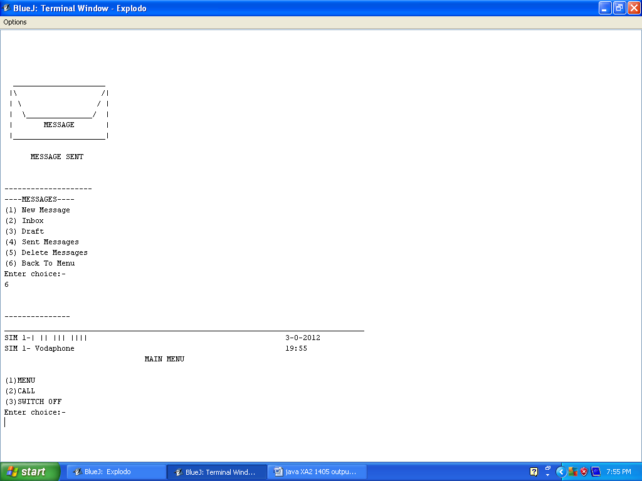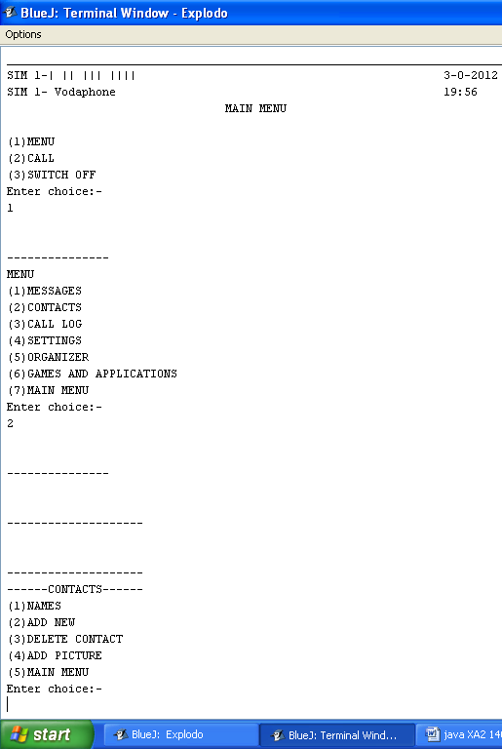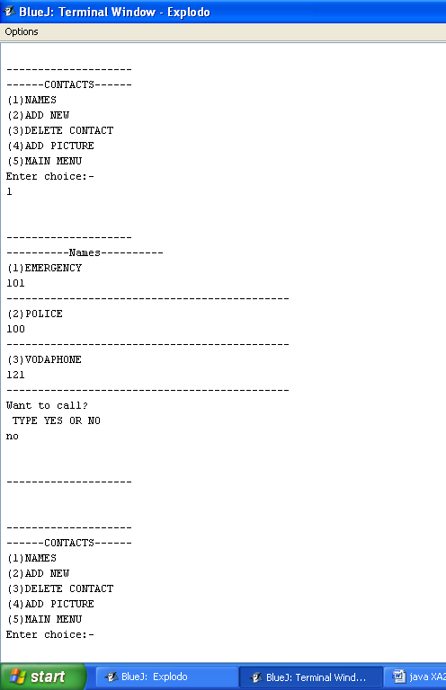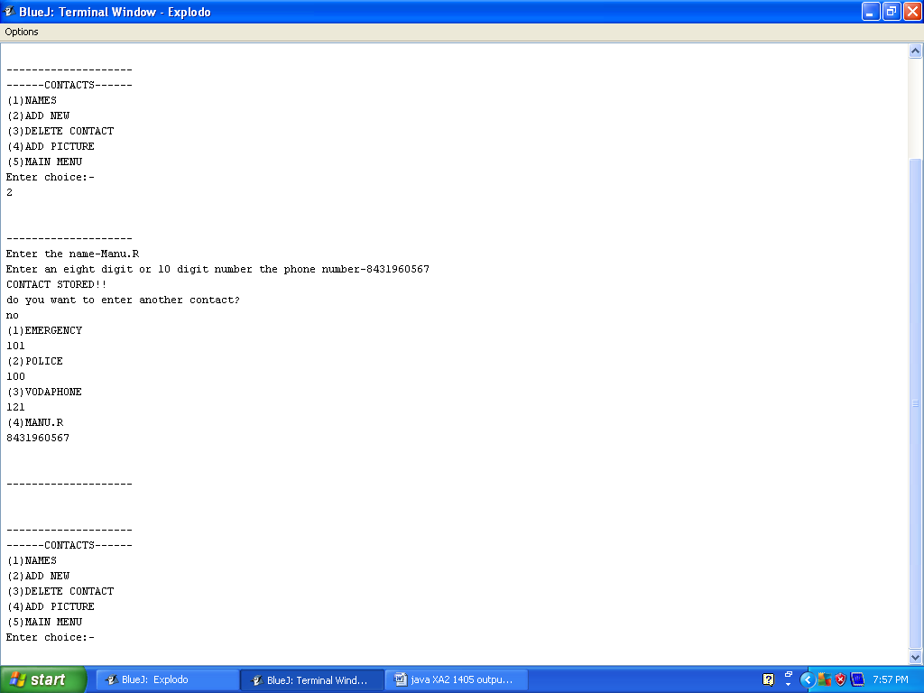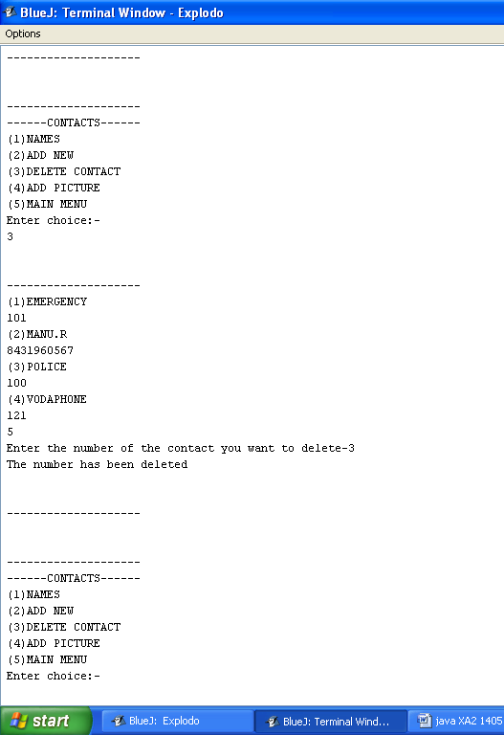The contact is deleted…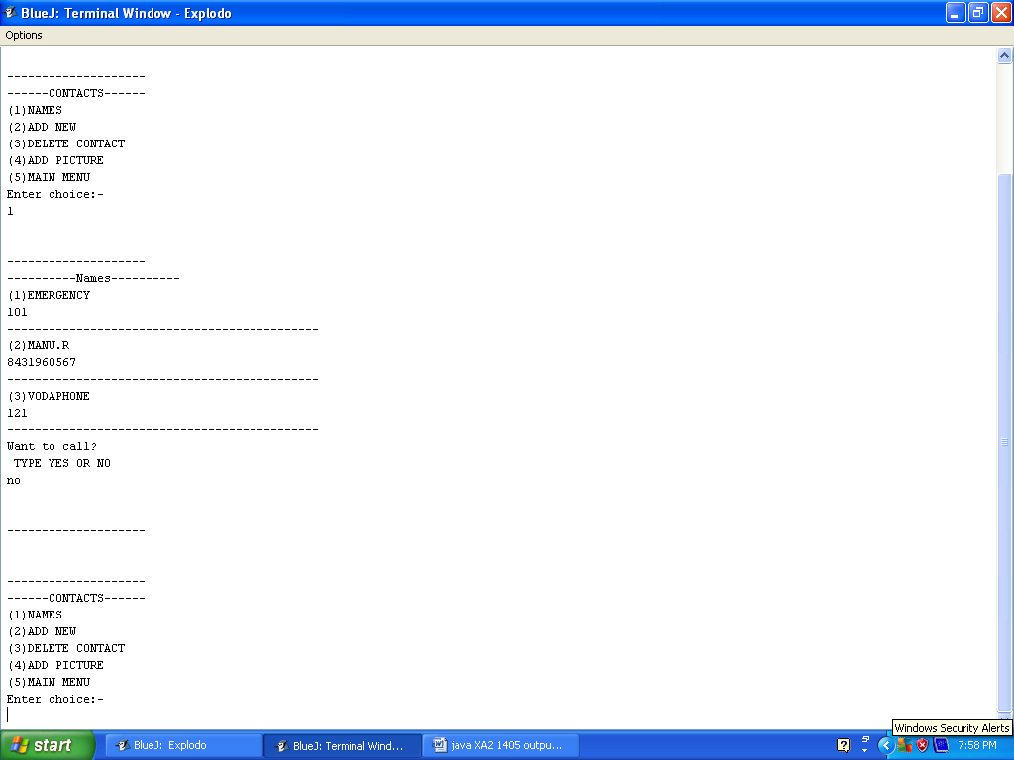
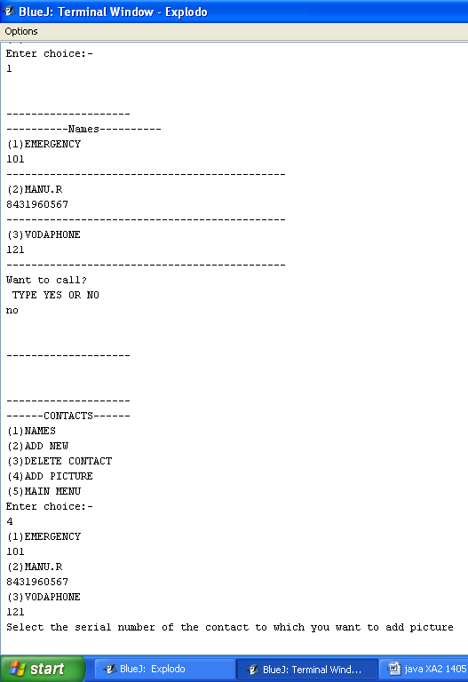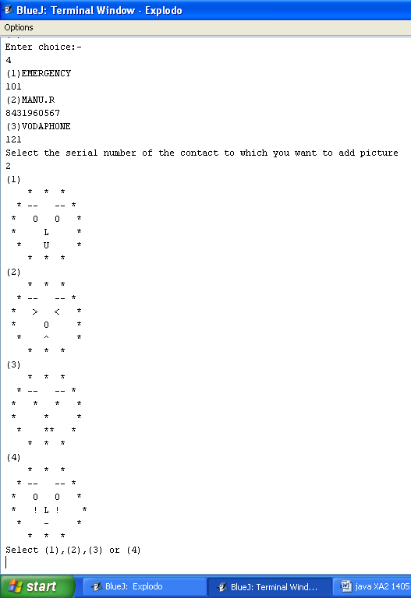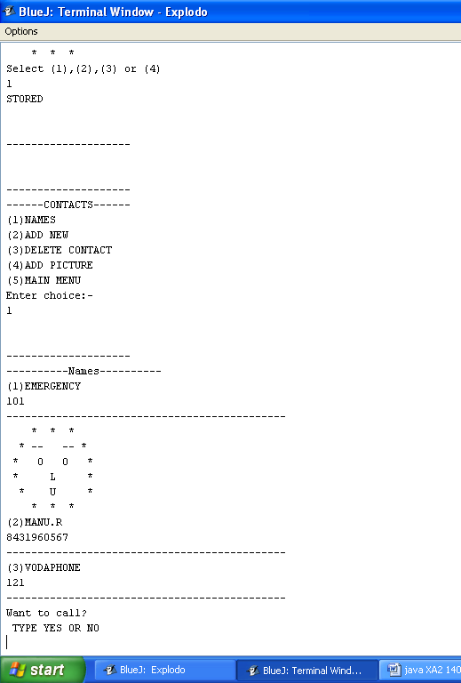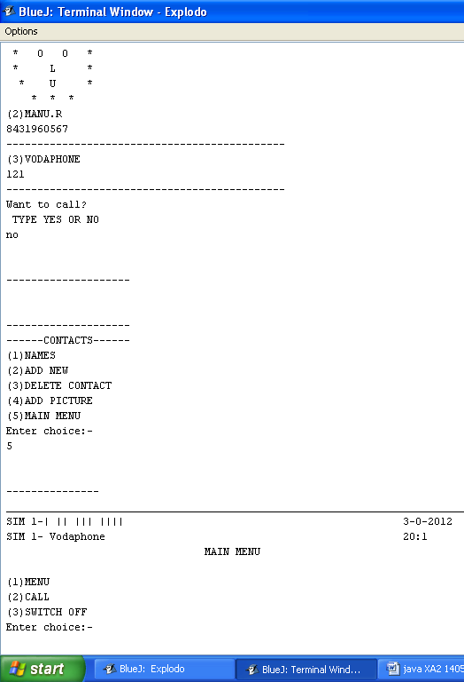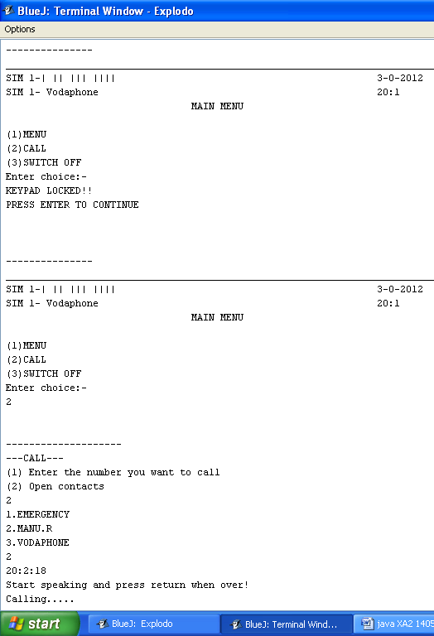
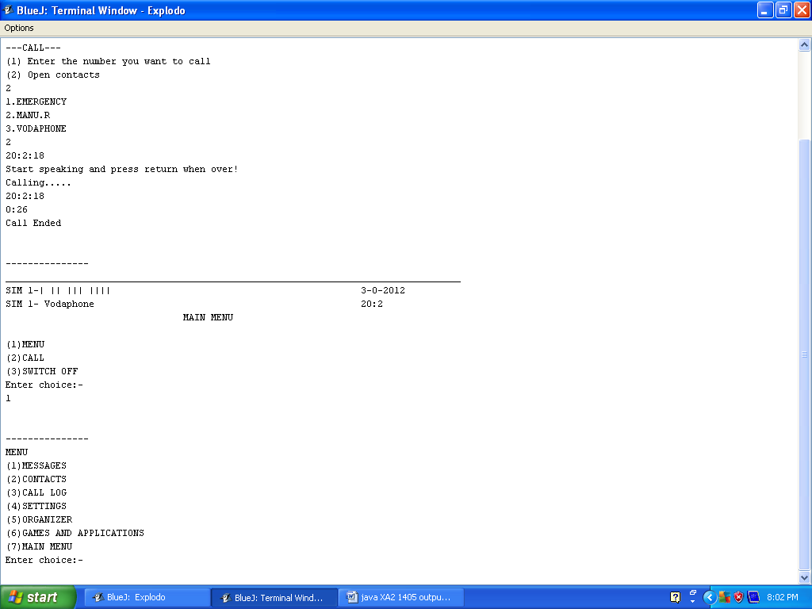
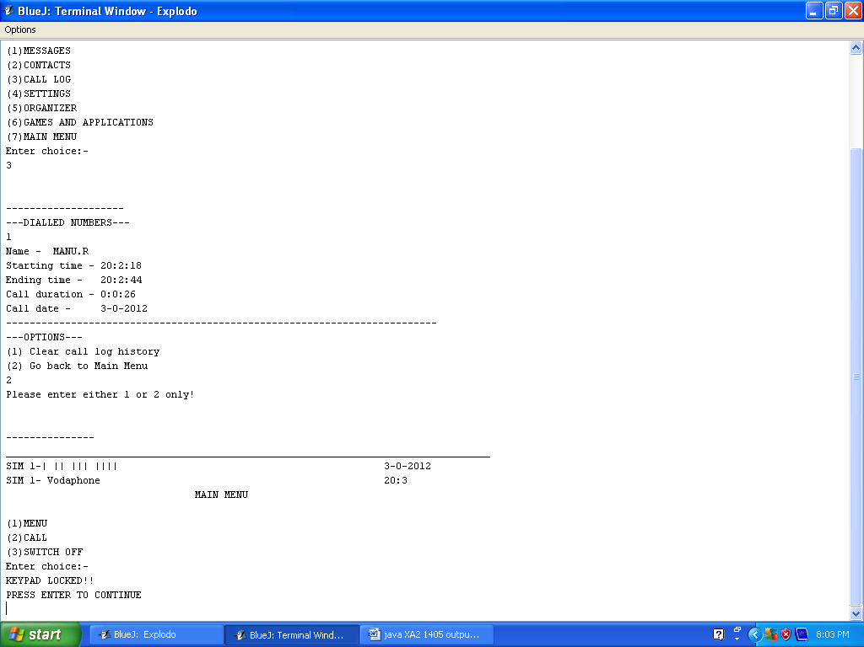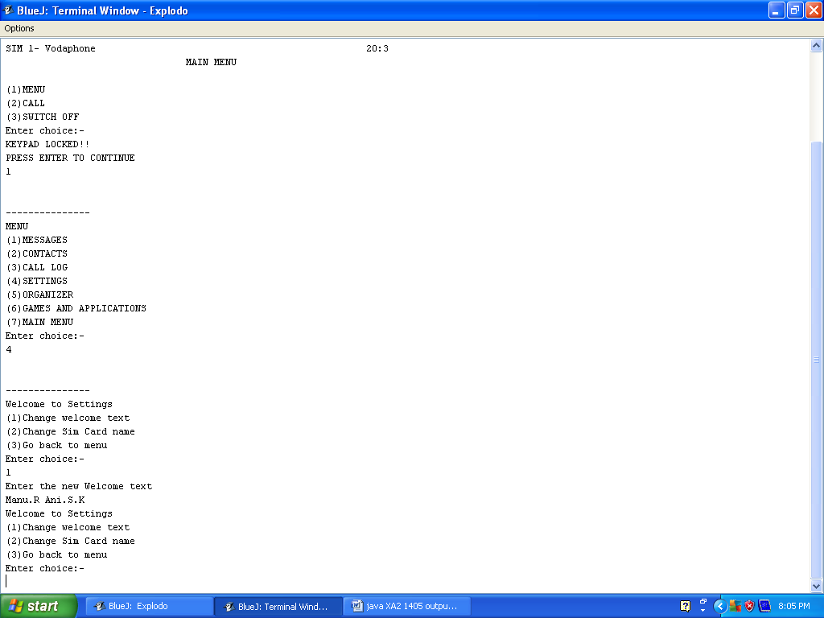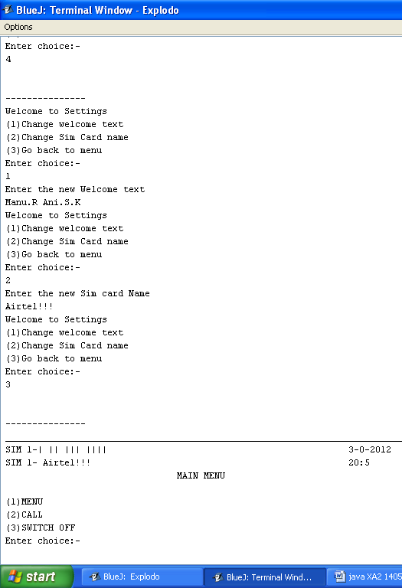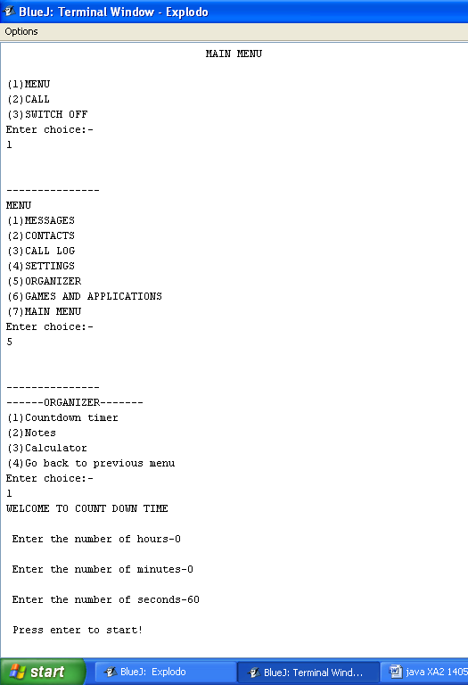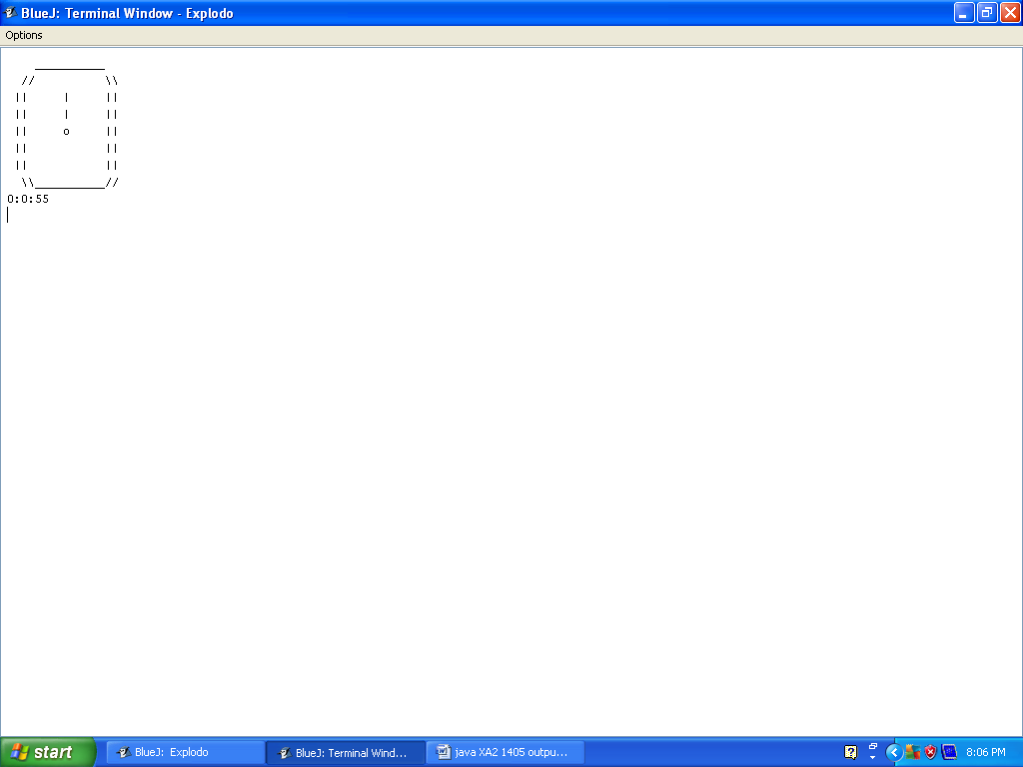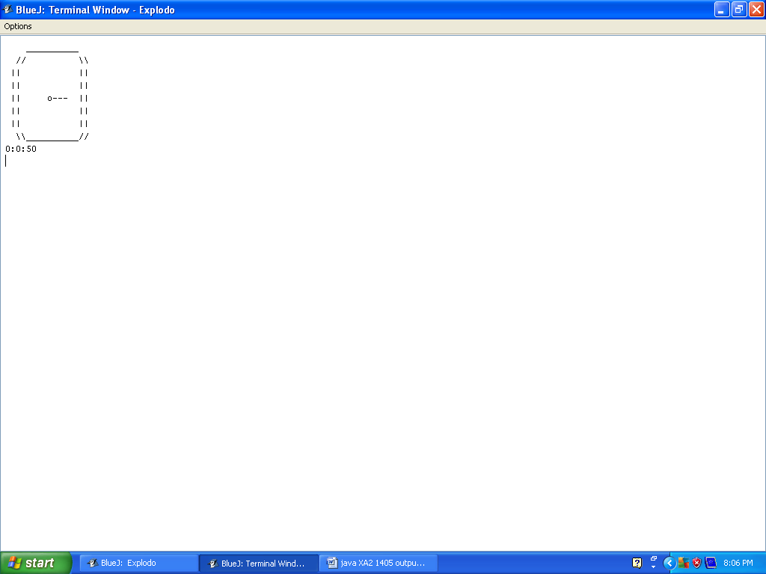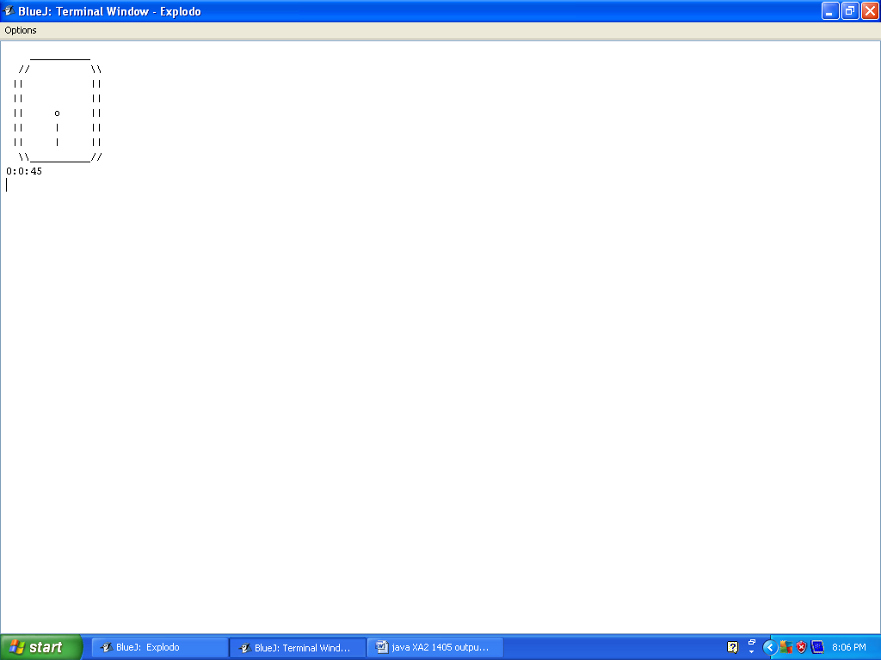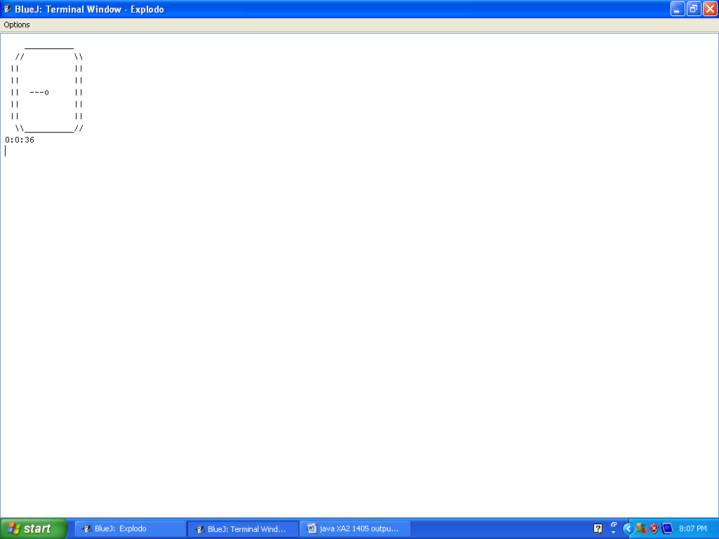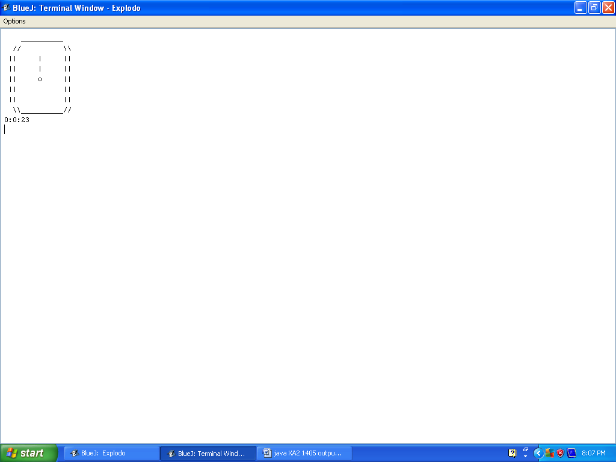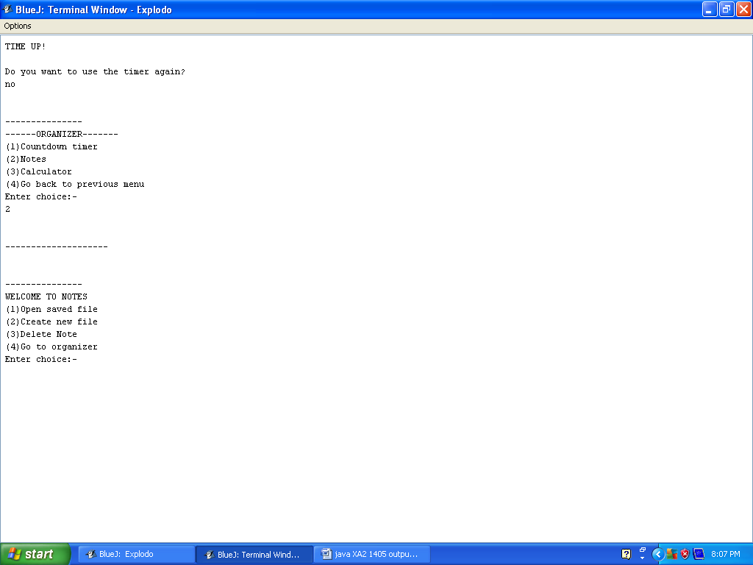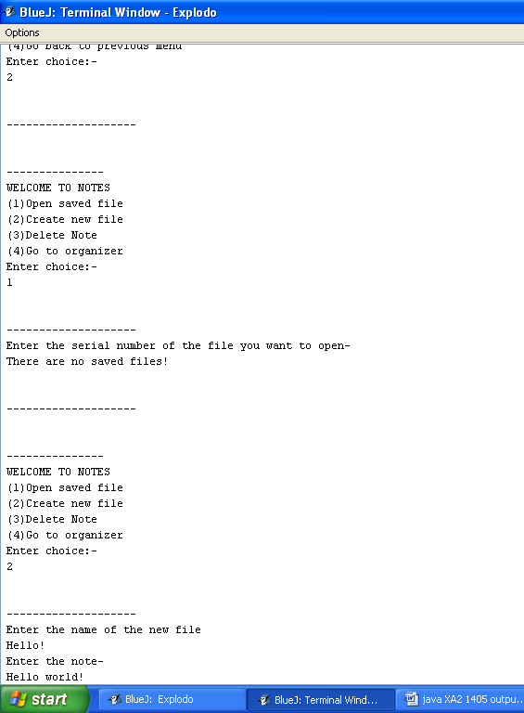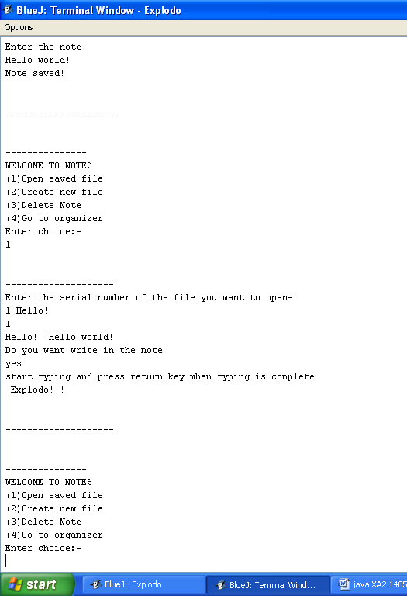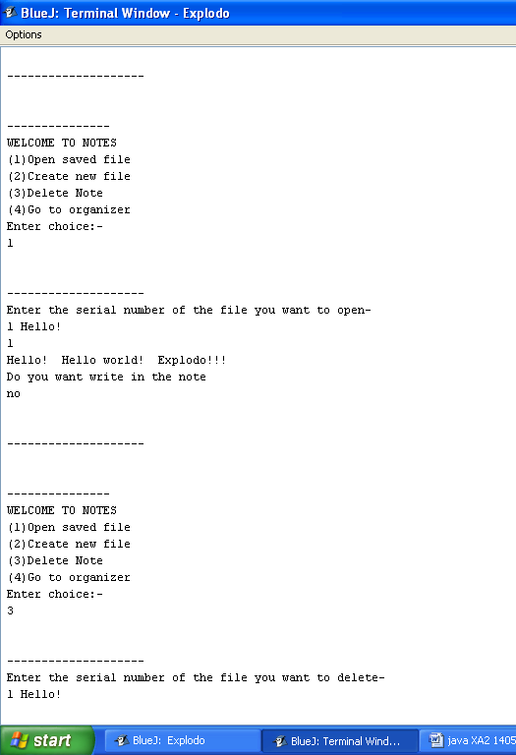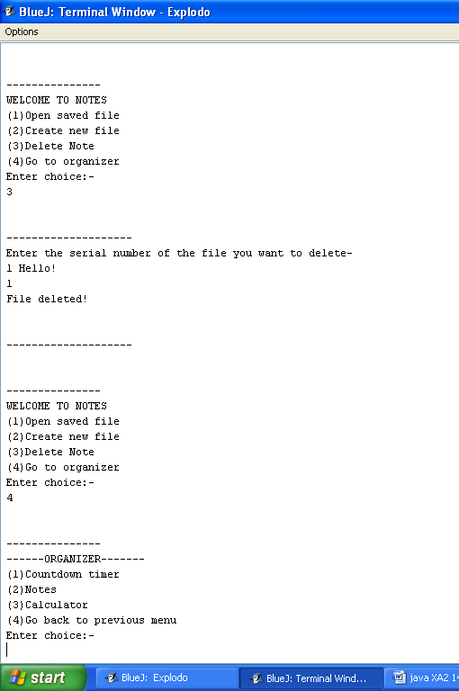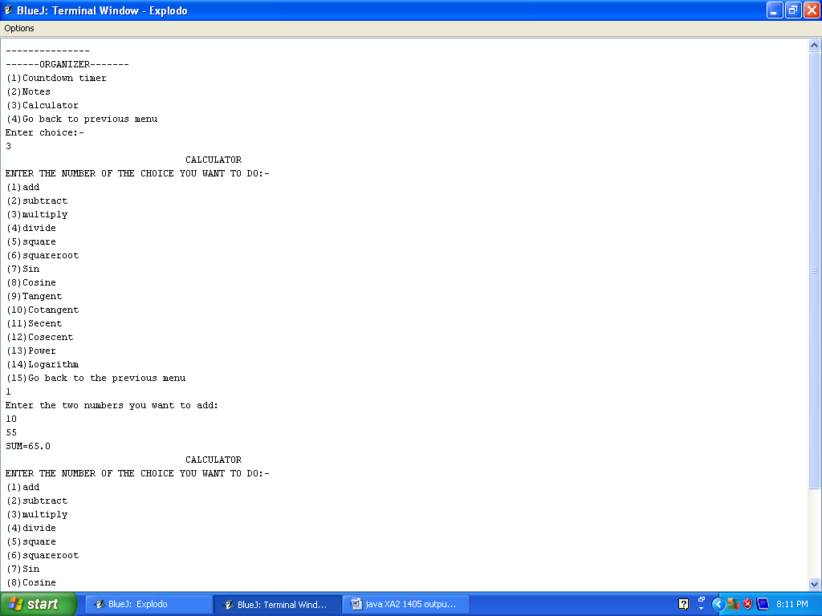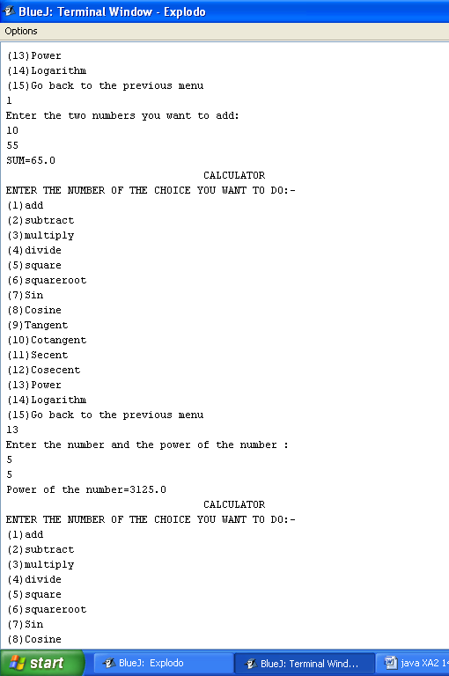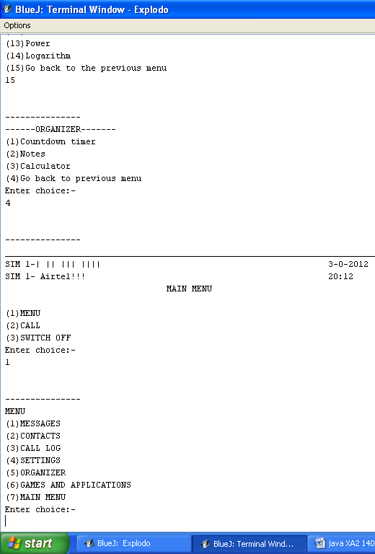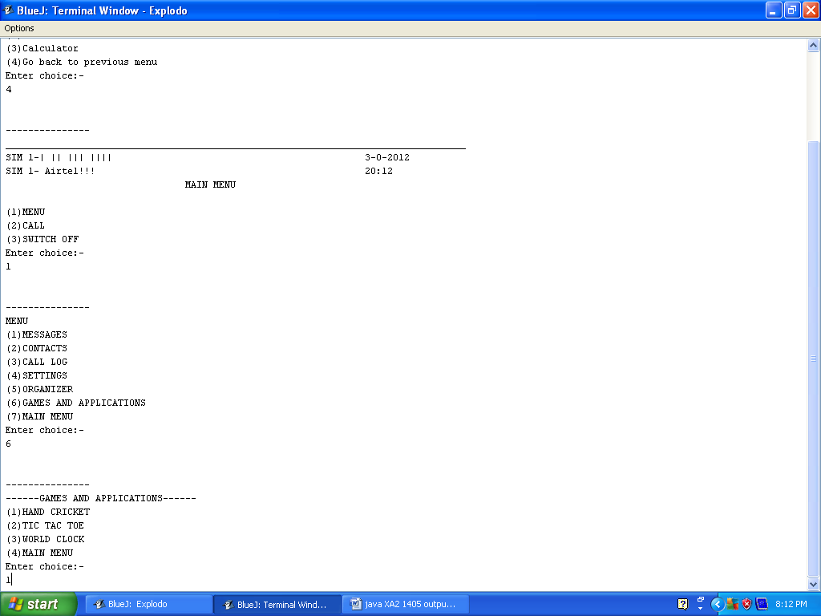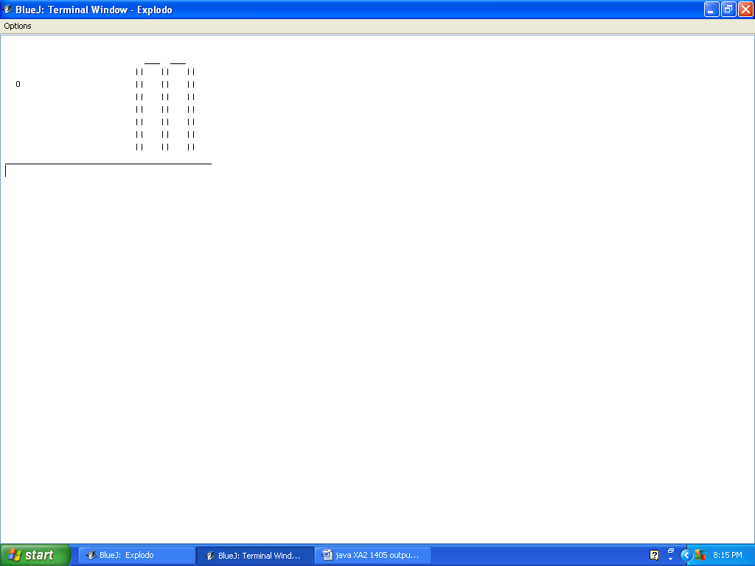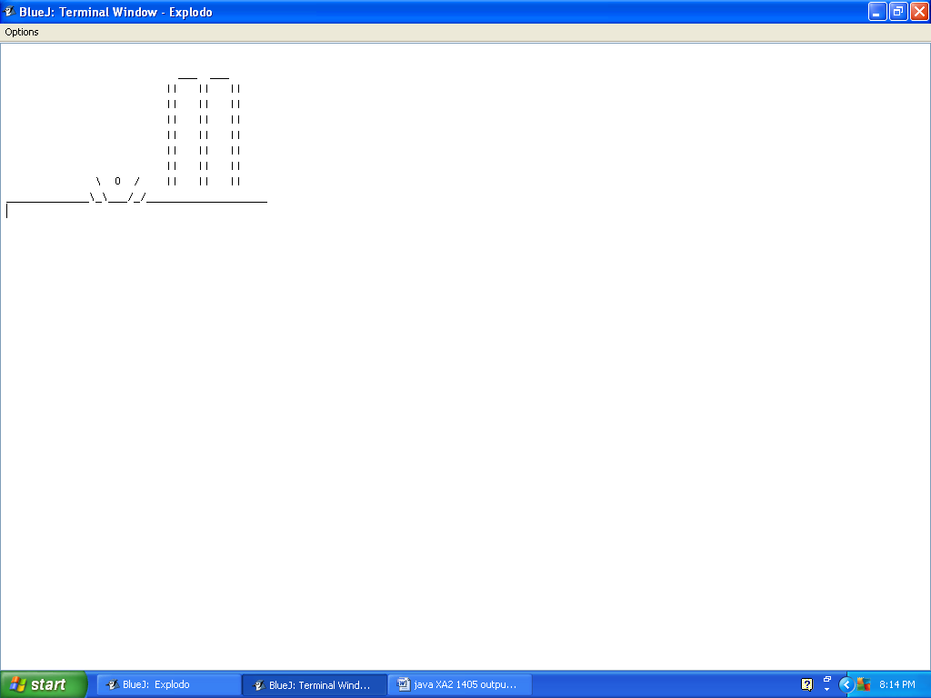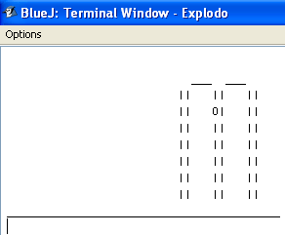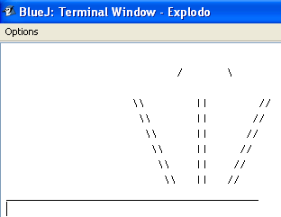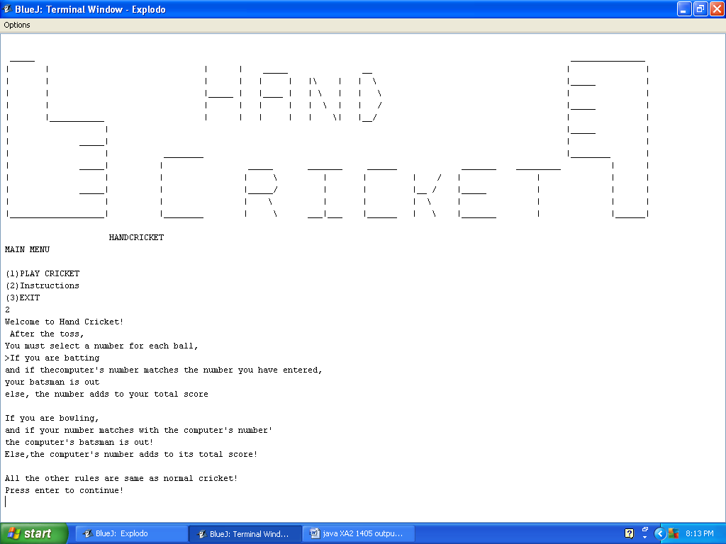
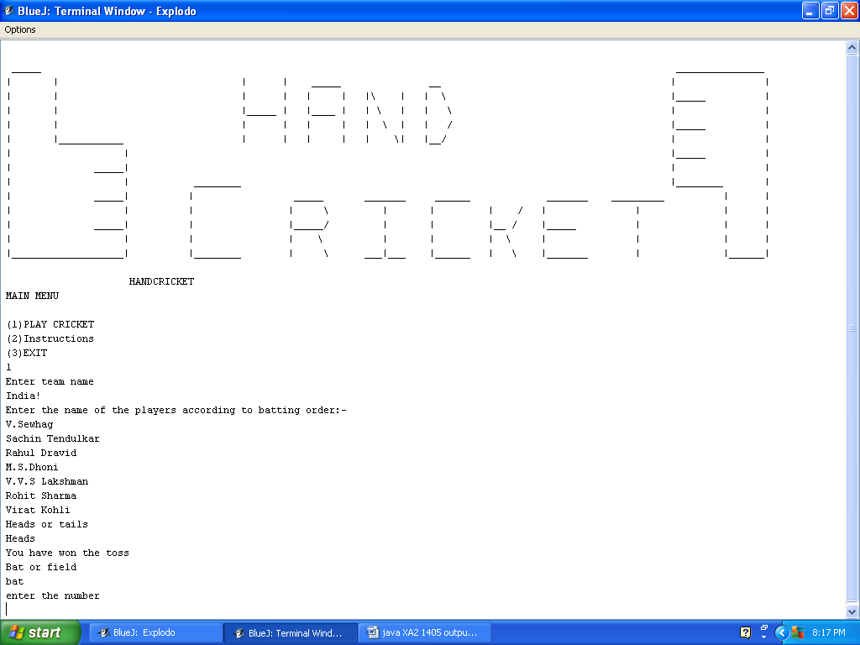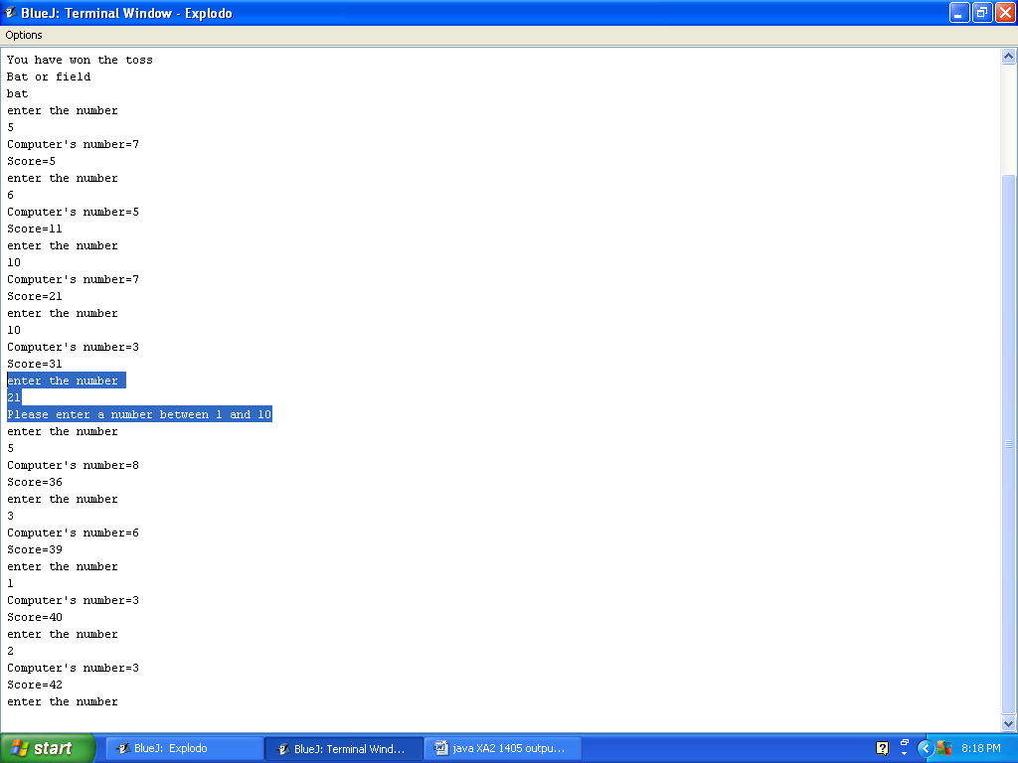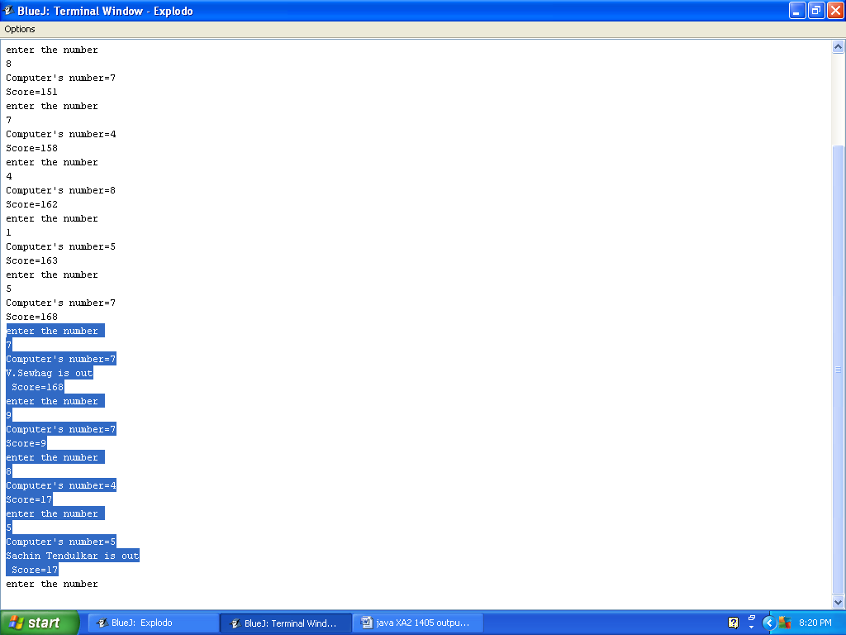

Similarly…The computer bats and the winner is decided!!! Now Tic tac toe!!!
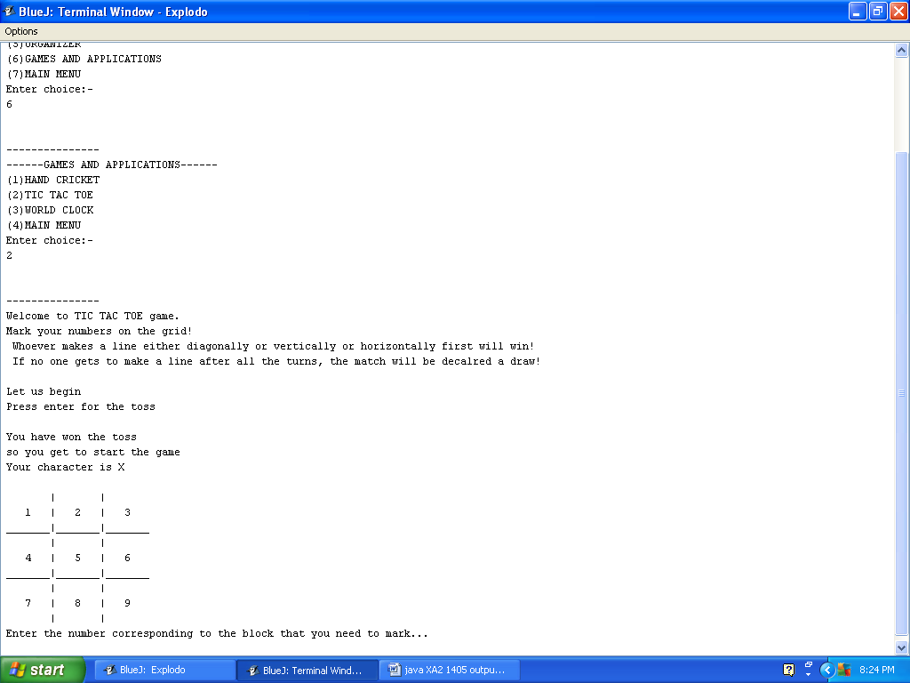d
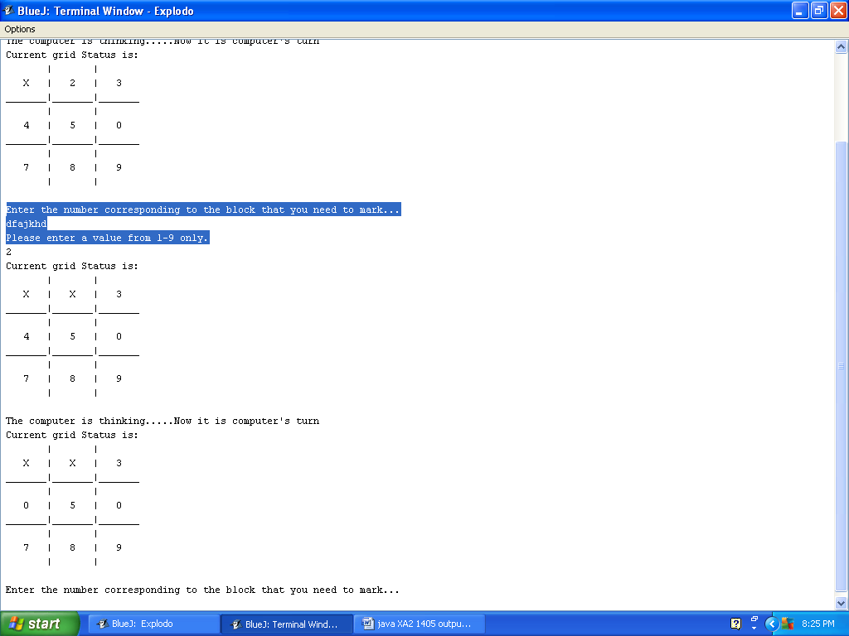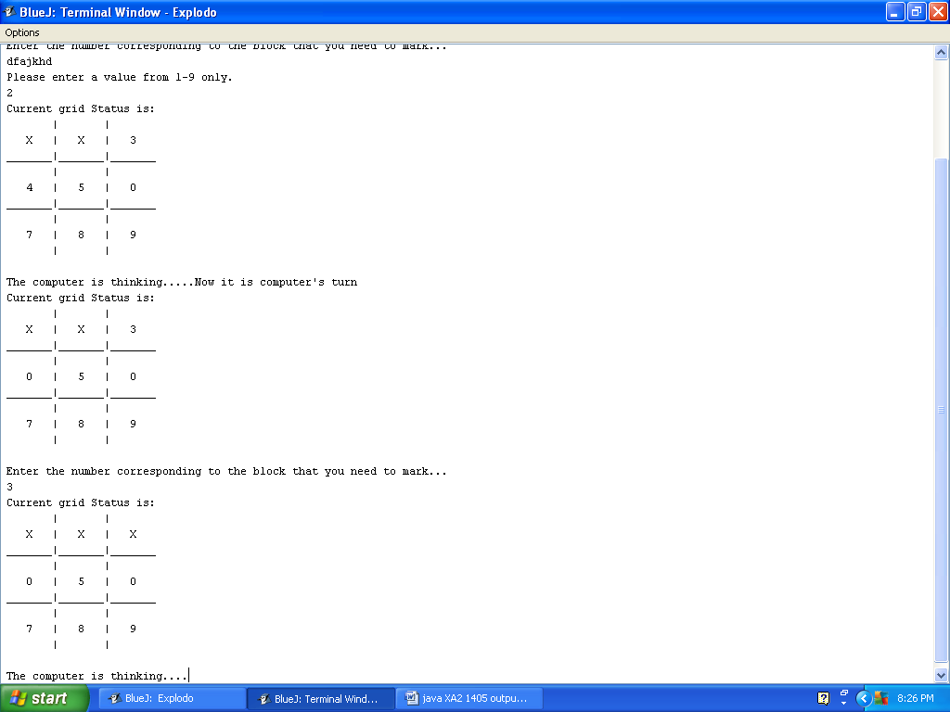Even though the computer gets to play in the end , you
Win!!
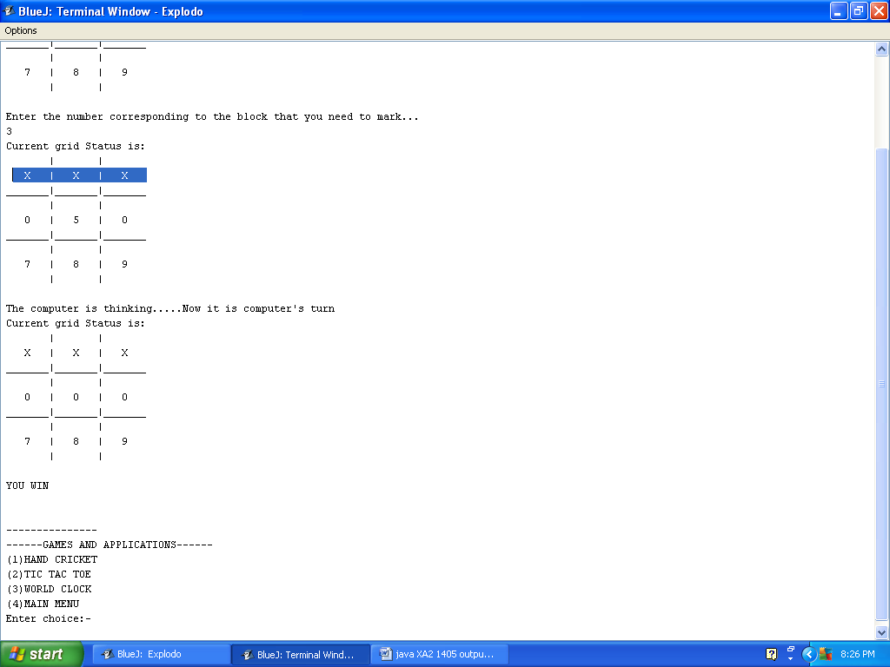

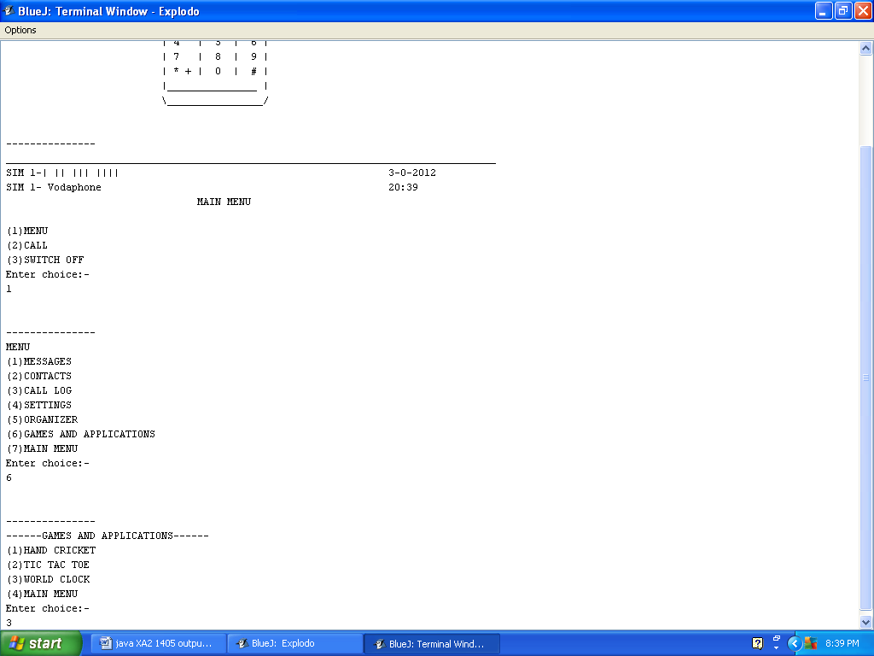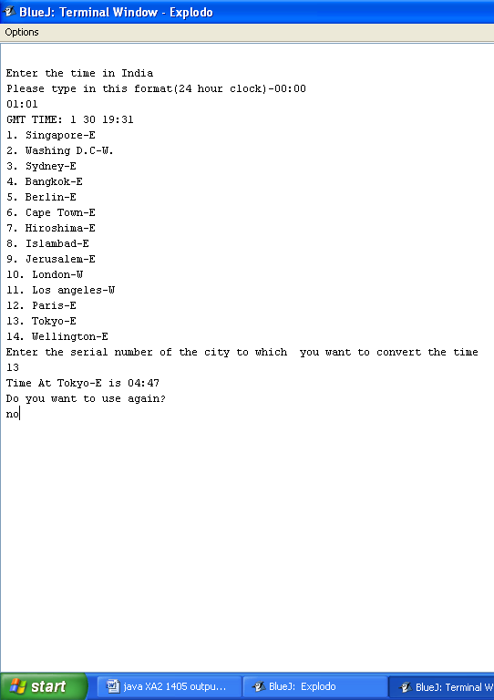
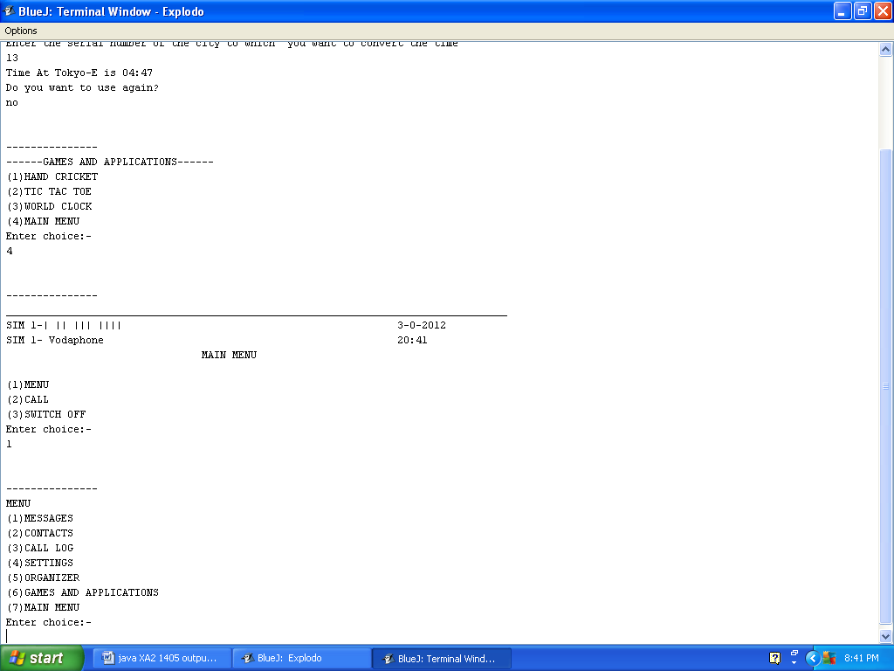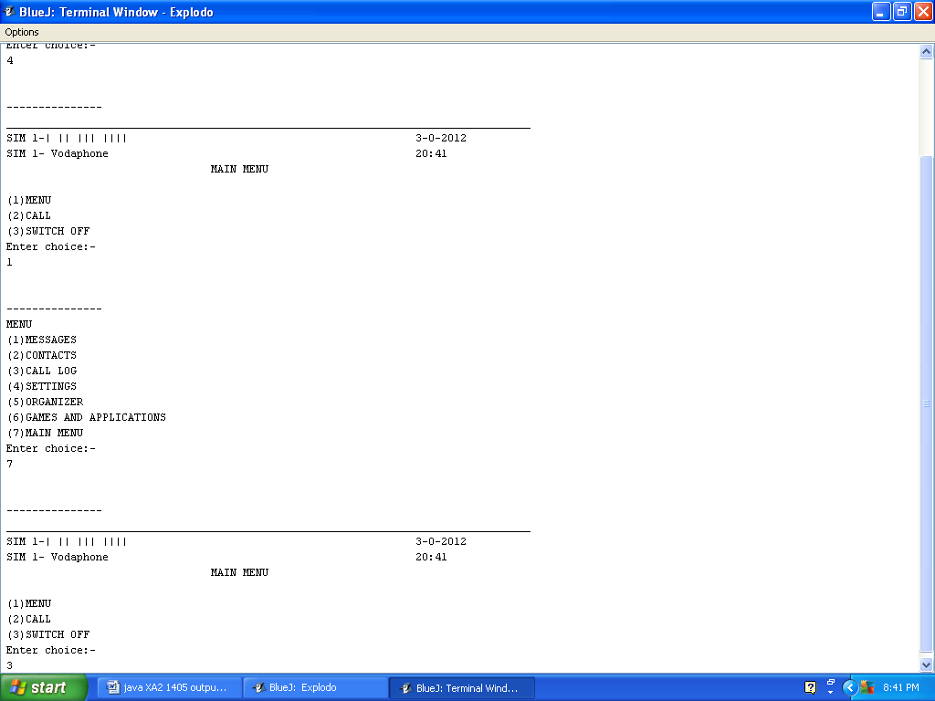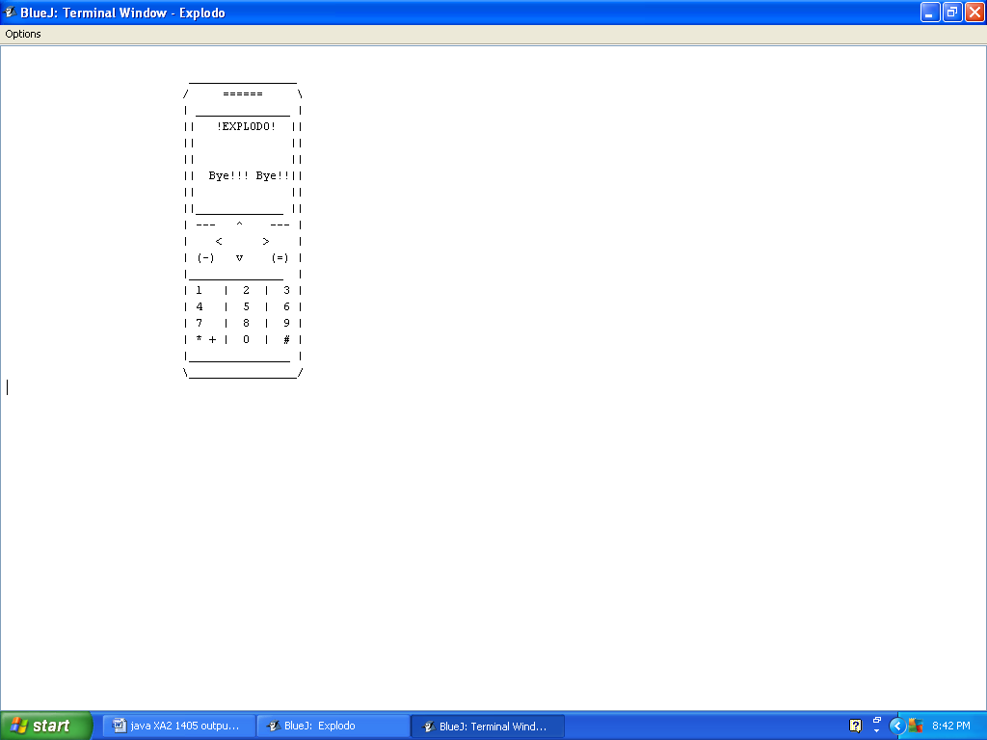

Source code

import java.io.*;
class mobile
{

public void main()throws InterruptedException, IOException
{
explodo qq=new explodo();
qq.explodo();

System.out.println(" ---LISCENCE AGREEMENT---");
System.out.println(" I hear by agree to all the terms and conditions of Explodo Corporation and will abide by all the Local Laws and Regulations! ");
System.out.println(" ");
System.out.println(" ");
System.out.println(" ----------PHONE SPECIFICATIONS---------");
System.out.println("");
System.out.println(" RAM - 1GB");
System.out.println(" Processor - 2.66GHz Intel i7.5");
System.out.println(" Phone Memory - 80GB");
System.out.println(" External Memory - Expandable upto 32GB");
System.out.println(" Network - HSPA");
System.out.println(" 3G - Yes");
System.out.println(" Battery - 5000mAh");
System.out.println(" Operating System - Explodo OS 3.0");
System.out.println("");
System.out.println("");
System.out.println("");
System.out.println("Press Enter to continue---");

BufferedReader br =new BufferedReader(new InputStreamReader(System.in));

String c=br.readLine();

try
{

qq.wait_circle(9);
settings s1=new settings();
qq.phone_start(s1.welcometext);
mobile1 aa=new mobile1();
aa.main();
}
catch(IOException i)
{
System.out.println("Error");
}
}
}

import java.io.*;
class mobile1
{
static int o=0;
static String opt=" ";
static Messages j=new Messages();
static countdown_timer w=new countdown_timer();
static notes n=new notes();
static calculator calc=new calculator();
static handcricket l=new handcricket();
static xandos r=new xandos();
static settings s1=new settings();
static world_clock ck=new world_clock();
static contact c=new contact();
static call ring=new call();
static String default_mes_1="I hope you are enjoying our service!";
static String default_mes_2="Sachin scores another ton to give the Aussies a taste of defeat!";
static String default_mes_3="Your bill for this month is Rs.500. Kindly pay the bill on time,\n to avoid disconnection of service.";
static String default_mes_4="Thank you for paying the bill.";
static String default_mes_5="Hope you have enjoyed our project!";
static String sender_1 ="Service Provider";
static String sender_2 = "Anirudh.S.K and Manu.R";

static void message()throws IOException, InterruptedException
{
explodo qq=new explodo();
qq.wait_circle(1);
Messages j=new Messages();
j.main();
}
static void contact()throws IOException, InterruptedException
{
explodo qq=new explodo();
qq.wait_circle(1);
contact s=new contact();
s.contact();
}
static void organizer()throws IOException, InterruptedException
{
explodo qq=new explodo();
qq.wait_circle(1);
BufferedReader br = new BufferedReader(new InputStreamReader(System.in));
int h;
do
{
h=0;
System.out.println("------ORGANIZER-------\n(1)Countdown timer\n(2)Notes\n(3)Calculator\n(4)Go back to previous menu");
System.out.println("Enter choice:-");
int yy=0;
do
{
h=0;
try
{
yy=Integer.parseInt(br.readLine());
}
catch(Exception yyp)
{
h++;
}
}while(h!=0);

switch(yy)
{

case 1:
countdown_timer w=new countdown_timer();
w.main();
break;

case 2:
n.main();
break;

case 3:
calculator calc=new calculator();
calc.main();
break;

case 4:
main();
break;

default :
System.out.println("Please select from the options");
h++;
}
}while(h!=0);

}
static void games_and_applications()throws IOException, InterruptedException
{
explodo qq=new explodo();
qq.wait_circle(1);
BufferedReader br = new BufferedReader(new InputStreamReader(System.in));
int kkk=0;
do
{
kkk=0;
System.out.println("------GAMES AND APPLICATIONS------\n(1)HAND CRICKET\n(2)TIC TAC TOE\n(3)WORLD CLOCK\n(4)MAIN MENU");
System.out.println("Enter choice:-");
String j=br.readLine();
if(j.equals("1"))
{
handcricket l=new handcricket();
l.menu();
}
else if(j.equals("2"))
{
xandos r=new xandos();
r.maingame();
}
else if(j.equals("3"))
{
ck.calculate();
}
else if(j.equals("4"))
{
main();
}
else
{
System.out.println("Please enter the correct choice!");
kkk++;
}
}while(kkk!=0);

}

static void setting()throws IOException, InterruptedException
{
explodo qq=new explodo();
qq.wait_circle(1);
s1.main();
}

static void main()throws IOException, InterruptedException
{
opt=" ";
explodo qq=new explodo();
qq.wait_circle(2);
if(o<1)
{
j.Messages();
ring.ini();
c.declare1();
c.declare2();
ck.declare();
Messages.inbox[0][0]=sender_1;
Messages.inbox[0][1]=default_mes_1;
}

for(int j=0;j<Messages.inbox.length;j++)
{
if(Messages.inbox[j][0].equals("0"))
{
switch(o)
{
case 1:
Messages.inbox[j][0]=sender_1;
Messages.inbox[j][1]=default_mes_2;
break;

case 2:
Messages.inbox[j][0]=sender_1;
Messages.inbox[j][1]=default_mes_3;
break;

case 3:
Messages.inbox[j][0]=sender_1;
Messages.inbox[j][1]=default_mes_4;
break;

case 4:
Messages.inbox[j][0]=sender_2;
Messages.inbox[j][1]=default_mes_5;
break;
}
break;
}
}
o++;
settings s1=new settings();
BufferedReader br = new BufferedReader(new InputStreamReader(System.in));

int f,q;

System.out.println("__________________________________________________________"+
"________________________");
System.out.print("SIM 1-| || ||| ||||\t\t\t\t\t\t");
s1.date();
System.out.print("SIM 1- "+s1.Sim1()+"\t\t\t\t\t\t");
s1.time();
do
{

locking jjj=new locking();
jjj.locking();
System.out.println("\t\t\t\tMAIN MENU\n\n(1)MENU\n(2)CALL\n(3)SWITCH OFF");
System.out.println("Enter choice:-");

opt=br.readLine();
f=0;
try
{

if(opt.equals("1+*"))
{
System.out.println("KEYPAD LOCKED\nPRESS 1+* TO CONTINUE");
String h=br.readLine();
if(!(h.equals("1+*")))
{
System.out.println("PLEASE TYPE 1+* TO CONTINUE");
h=br.readLine();
while(h.equals("1+*"))
{
System.out.println("PLEASE TYPE 1+* TO CONTINUE");
h=br.readLine();
}
}
main();
}
if(opt.equals("1"))
{
do
{
q=0;

qq.wait_circle(1);
System.out.println("MENU \n(1)MESSAGES\n(2)CONTACTS\n(3)CALL LOG\n(4)SETTINGS\n(5)ORGANIZER\n(6)GAMES AND APPLICATIONS\n(7)MAIN MENU");
System.out.println("Enter choice:-");
String h=br.readLine();

try
{
if(h.equals("1"))
{
message();
}
else if(h.equals("2"))
{
contact();
}
else if(h.equals("3"))
{
ring.log();
}
else if(h.equals("4"))
{
setting();
}
else if(h.equals("5"))
{
organizer();
}
else if(h.equals("6"))
{
games_and_applications();
}
else if(h.equals("7"))
{
main();
}
else
{
throw new IOException();
}
}
catch(IOException m)
{
System.out.println("Please select from the options given");
q++;
}
}while(q!=0);
}
else if(opt.equals("2"))
{

ring.main();

}
else if(opt.equals("3"))
{
explodo xp=new explodo();
xp.phone_start("Bye!!! Bye!!! ");
}
else if(opt.equals(""))
{
main();
}
else if(opt.equals(" "))
{
main();
}
else
{
throw new IOException();
}
}
catch(IOException w)
{
System.out.println("Please select from the options given");
f++;
}
}while(f!=0);
}
}

import java.io.*;
class handcricket
{
void instructions()throws IOException, InterruptedException
{
InputStreamReader x=new InputStreamReader(System.in);
BufferedReader br=new BufferedReader(x);
System.out.println("play cricket\nreturn to main menu?");
String s=br.readLine();
if(s.equals("yes"))
{
menu();
}
}
void exit()throws IOException, InterruptedException
{
e();
}
void play()throws IOException, InterruptedException
{
InputStreamReader x=new InputStreamReader(System.in);
BufferedReader br=new BufferedReader(x);
System.out.println("Enter team name");
String team_name=br.readLine();
String result="";
int[]score_player_user=new int[7];
int[]score_player_comp=new int[7];
System.out.println("Enter the name of the players according to batting order:-");
String[]players_user=new String[7];
for(int i=0;i<players_user.length;i++)
{
players_user[i]=br.readLine();
}
String[]players_comp={"alpha_1","alpha_2","alpha_3","alpha_4","alpha_5","alpha_6","alpha_7"};
int j;
String toss="";
do
{
j=0;
try
{
System.out.println("Heads or tails");
toss=br.readLine();
if(!(toss.equalsIgnoreCase("heads"))&&!(toss.equalsIgnoreCase("tails")))
{
throw new IOException();
}
}
catch(IOException qqq)
{
System.out.println("Please type heads or tails");
j++;
}
}while(j!=0);
toss=toss.toLowerCase();
double t=Math.random()*(1-2)+2;
int h=(int)Math.round(t);
String hh="";
if(h==1)
{
hh="heads";
}
else
{
hh="tails";
}
if(toss.equals(hh))
{
System.out.println("You have won the toss\nBat or field");
int oo;
String d="";
do
{
oo=0;
try
{
d=br.readLine();
if(!(d.equalsIgnoreCase("bat"))&&!(d.equalsIgnoreCase("field")))
{
throw new IOException();
}
}
catch(IOException nnn)
{
System.out.println("Please enter only bat of field");
oo++;
}
}while(oo!=0);
d=d.toLowerCase();
int i=0,u=0;
if(d.equals("bat"))
{ int out=0;
do
{
int rand=99;
int ur=100;
int s1=0;
while(rand!=ur)
{ int yyy;
do
{
yyy=0;
try
{
System.out.println("enter the number ");

ur=Integer.parseInt(br.readLine());
if(ur>10||ur<1)
{
throw new Exception();

}
}
catch(Exception nnnn )
{
System.out.println("Please enter a number between 1 and 10");
yyy++;
}

}while(yyy!=0);

double ttt=(Math.random()*(1-5)+5)+(Math.random()*(1-5)+5);
rand=(int)Math.round(ttt);
System.out.println("Computer's number="+rand);
if(ur==rand)
{

System.out.println(players_user[i]+" is out\n Score="+s1);
score_player_user[u]=s1;
out++;
break;
}
s1=s1+ur;
System.out.println("Score="+s1);
}
i++;
u++;
}while(out<7);
int final_score_user=(score_player_user[0]+score_player_user[1]+score_player_user[2]+score_player_user[3]+score_player_user[4]+
score_player_user[5]+score_player_user[6]);
System.out.println("NAME SCORE\n"+players_user[0]+" "+score_player_user[0]+"\n"+
players_user[1]+" "+score_player_user[1]+"\n"+players_user[2]+" "+score_player_user[2]+"\n"+
players_user[3]+" "+score_player_user[3]+"\n"+players_user[4]+" "+score_player_user[4]+"\n"+
players_user[5]+" "+score_player_user[5]+"\n"+players_user[6]+" "+score_player_user[6]+"\n"+
"TOTAL:- "+final_score_user);

System.out.println("Now you are fielding");
out=0;
int final_score_comp=0;
int l=0,da=0;
do
{
int ur=0,rand=1;
int s2=0;
while(rand!=ur)
{
int yy;
do
{
yy=0;
try
{
System.out.println("enter the number ");
ur=Integer.parseInt(br.readLine());
if(ur>10||ur<1)
{
throw new Exception();
}
}
catch(Exception nnnn)
{
System.out.println("Please enter a number between 1 and 10");
yy++;
}
}while(yy!=0);

double ttt=(Math.random()*(1-5)+5)+(Math.random()*(1-5)+5);
rand=(int)Math.round(ttt);
System.out.println("computer's number="+rand);

if(rand==ur)
{
System.out.println(players_comp[l]+"is out-"+s2);
score_player_comp[da]=s2;
out++;
break;
}

s2=s2+rand;
System.out.println("Computer's score="+s2);

}

final_score_comp=final_score_comp+s2;
if(final_score_comp<final_score_user&&out==7)
{
result=team_name+" has won the match";
System.out.println(team_name+" has won the match");
Thread.sleep(2000);
break;
}
if(final_score_comp==final_score_user)
{
result="Match drawn";
System.out.println("Match drawn");
Thread.sleep(2000);
break;
}
if(final_score_comp>final_score_user)
{
result="Computer has won the match";
System.out.println("Computer has won the match");
Thread.sleep(2000);
break;
}
l++;
da++;
}while(out<7);
System.out.println("NAME SCORE\n"+players_comp[0]+" "+score_player_comp[0]+"\n"+
players_comp[1]+" "+score_player_comp[1]+"\n"+players_comp[2]+" "+score_player_comp[2]+"\n"+
players_comp[3]+" "+score_player_comp[3]+"\n"+players_comp[4]+" "+score_player_comp[4]+"\n"+
players_comp[5]+" "+score_player_comp[5]+"\n"+players_comp[6]+" "+score_player_comp[6]+"\n"+
"TOTAL:- "+final_score_comp+"\nRESULT-"+result);
Thread.sleep(6000);
menu();
}
else if(d.equals("field"))
{
System.out.println("Now you are fielding");
int out=0;
int final_score_comp=0;
int l=0,da=0;
int final_score_user=0;
do
{
int ur=0,rand=1;
int s2=0;
while(rand!=ur)
{
int yyyy;
do
{
yyyy=0;
try
{
System.out.println("enter the number ");
ur=Integer.parseInt(br.readLine());
if(ur>10||ur<1)
{
throw new Exception();
}
}
catch(Exception nnnn)
{
System.out.println("Please enter a number between 1 and 10");
yyyy++;
}
}while(yyyy!=0);

double ttt=(Math.random()*(1-5)+5)+(Math.random()*(1-5)+5);
rand=(int)Math.round(ttt);

System.out.println("Computer's number="+rand);
if(rand==ur)
{
int s3=s2+1;
System.out.println(players_comp[l]+" is out! -"+s3);
score_player_comp[da]=s2;
out++;
break;
}
s2=s2+rand;
System.out.println("Computer's score="+s2);
}

final_score_comp=final_score_comp+s2;

l++;
da++;
}while(out<7);
System.out.println("NAME SCORE\n"+players_comp[0]+" "+score_player_comp[0]+"\n"+
players_comp[1]+" "+score_player_comp[1]+"\n"+players_comp[2]+" "+score_player_comp[2]+"\n"+
players_comp[3]+" "+score_player_comp[3]+"\n"+players_comp[4]+" "+score_player_comp[4]+"\n"+
players_comp[5]+" "+score_player_comp[5]+"\n"+players_comp[6]+" "+score_player_comp[6]+"\n"+
"TOTAL:- "+final_score_comp);
Thread.sleep(5000);
System.out.println("Now you are batting");
i=0;
u=0;
out=0;
result="";
do
{
int ur=0,rand=1;
int s1=0;

while(rand!=ur)
{
int yo;
do
{
yo=0;
try
{
System.out.println("enter the number ");
ur=Integer.parseInt(br.readLine());
if(ur>10||ur<1)
{
throw new Exception();
}
}
catch(Exception nnnn)
{
System.out.println("Please enter a number between 1 and 10");
yo++;
}
}while(yo!=0);

double ttt=(Math.random()*(1-5)+5)+(Math.random()*(1-5)+5);
rand=(int)Math.round(ttt);
System.out.println("Computer's number="+rand);

if(ur==rand)
{
System.out.println(players_user[i]+" are out. Score= "+s1);
score_player_user[u]=s1;
out++;
break;
}

s1=s1+ur;
System.out.println("Score="+s1);

}
final_score_comp=final_score_comp+s1;
if(final_score_comp<final_score_user&&out==7)
{
result=team_name+" has won the match";
System.out.println(team_name+" has won the match");
Thread.sleep(3000);
break;
}
if(final_score_comp==final_score_user)
{
result="Match drawn";
System.out.println("Match drawn");
Thread.sleep(3000);
break;
}
if(final_score_comp>final_score_user)
{
result="Computer has won the match";
System.out.println("Computer has won the match");
Thread.sleep(3000);
break;
}
}while(out<7);
System.out.println("NAME SCORE\n"+players_user[0]+" "+score_player_user[0]+"\n"+
players_user[1]+" "+score_player_user[1]+"\n"+players_user[2]+" "+score_player_user[2]+"\n"+
players_user[3]+" "+score_player_user[3]+"\n"+players_user[4]+" "+score_player_user[4]+"\n"+
players_user[5]+" "+score_player_user[5]+"\n"+players_user[6]+" "+score_player_user[6]+"\n"+
"TOTAL:- "+final_score_user+"\nRESULT - "+result);
Thread.sleep(5000);
menu();
}
else
{
double rr=Math.random()*(1-2)+2;
int k=(int)Math.round(rr);
String dec="";
if(k==1)
{
dec="Bat";
}
else if(k==2)
{
dec="field";
}
System.out.println("you have lost the toss.");
if(dec.equals("Bat"))
{
System.out.println("the computer has chosen to bat first");
System.out.println("Now you are fielding");
int out=0;
int final_score_comp=0;
int l=0,da=0;
int final_score_user=0;
do
{
int ur=0,rand=1;
int s2=0;
while(rand!=ur)
{
int yyo;
do
{
yyo=0;
try
{
System.out.println("enter the number ");
ur=Integer.parseInt(br.readLine());
if(ur>10||ur<1)
{
throw new Exception();
}
}
catch(Exception nnnn)
{
System.out.println("Please enter a number between 1 and 10");
yyo++;
}
}while(yyo!=0);

double ttt=(Math.random()*(1-5)+5)+(Math.random()*(1-5)+5);
rand=(int)Math.round(ttt);

System.out.println("Computer's number="+rand);
if(rand==ur)
{
int s3=s2+1;
System.out.println(players_comp[l]+" is out! -"+s3);
score_player_comp[da]=s2;
out++;
break;
}
s2=s2+rand;
System.out.println("Computer's score="+s2);
}

final_score_comp=final_score_comp+s2;

l++;
da++;
}while(out<7);
System.out.println("NAME SCORE\n"+players_comp[0]+" "+score_player_comp[0]+"\n"+
players_comp[1]+" "+score_player_comp[1]+"\n"+players_comp[2]+" "+score_player_comp[2]+"\n"+
players_comp[3]+" "+score_player_comp[3]+"\n"+players_comp[4]+" "+score_player_comp[4]+"\n"+
players_comp[5]+" "+score_player_comp[5]+"\n"+players_comp[6]+" "+score_player_comp[6]+"\n"+
"TOTAL:- "+final_score_comp);
Thread.sleep(5000);

System.out.println("Now you are batting");
i=0;
u=0;
out=0;
result="";
do
{
int ur=0,rand=1;
int s1=0;

while(rand!=ur)
{
int yyoq;
do
{
yyoq=0;
try
{
System.out.println("enter the number ");
ur=Integer.parseInt(br.readLine());
if(ur>10||ur<1)
{
throw new Exception();
}
}
catch(Exception nnnn)
{
System.out.println("Please enter a number between 1 and 10");
yyoq++;
}
}while(yyoq!=0);

double ttt=(Math.random()*(1-5)+5)+(Math.random()*(1-5)+5);
rand=(int)Math.round(ttt);
System.out.println("Computer's number="+rand);

if(ur==rand)
{
System.out.println(players_user[i]+" are out. Score= "+s1);
score_player_user[u]=s1;
out++;
break;
}

s1=s1+ur;
System.out.println("Score="+s1);

}
final_score_comp=final_score_comp+s1;
if(final_score_comp<final_score_user&&out==7)
{
result=team_name+" has won the match";
System.out.println(team_name+" has won the match");
Thread.sleep(2000);
break;
}
if(final_score_comp==final_score_user)
{
result="Match drawn";
System.out.println("Match drawn");
Thread.sleep(2000);
break;
}
if(final_score_comp>final_score_user)
{
result="Computer has won the match";
System.out.println("Computer has won the match");
Thread.sleep(2000);
break;
}
}while(out<7);
System.out.println("NAME SCORE\n"+players_user[0]+" "+score_player_user[0]+"\n"+
players_user[1]+" "+score_player_user[1]+"\n"+players_user[2]+" "+score_player_user[2]+"\n"+
players_user[3]+" "+score_player_user[3]+"\n"+players_user[4]+" "+score_player_user[4]+"\n"+
players_user[5]+" "+score_player_user[5]+"\n"+players_user[6]+" "+score_player_user[6]+"\n"+
"TOTAL:- "+final_score_user+"\nRESULT - "+result);
Thread.sleep(5000);
menu();
}
else
{
System.out.println("The computer has decided to field first\n you are batting first.");
int out=0;
i=0;
u=0;
do
{
int rand=99;
int ur=100;
int s1=0;
while(rand!=ur)
{
int yy;
do
{
yy=0;
try
{
System.out.println("enter the number ");
ur=Integer.parseInt(br.readLine());
if(ur>10||ur<1)
{
throw new Exception();
}
}
catch(Exception nnnn)
{
System.out.println("Please enter a number between 1 and 10");
yy++;
}
}while(yy!=0);

double ttt=(Math.random()*(1-5)+5)+(Math.random()*(1-5)+5);
rand=(int)Math.round(ttt);
System.out.println("Computer's number="+rand);
if(ur==rand)
{

System.out.println(players_user[i]+" is out\n Score="+s1);
score_player_user[u]=s1;
out++;
break;
}
s1=s1+ur;
System.out.println("Score="+s1);
}
i++;
u++;
}while(out<7);
int final_score_user=(score_player_user[0]+score_player_user[1]+score_player_user[2]+score_player_user[3]+score_player_user[4]+
score_player_user[5]+score_player_user[6]);
System.out.println("NAME SCORE\n"+players_user[0]+" "+score_player_user[0]+"\n"+
players_user[1]+" "+score_player_user[1]+"\n"+players_user[2]+" "+score_player_user[2]+"\n"+
players_user[3]+" "+score_player_user[3]+"\n"+players_user[4]+" "+score_player_user[4]+"\n"+
players_user[5]+" "+score_player_user[5]+"\n"+players_user[6]+" "+score_player_user[6]+"\n"+
"TOTAL:- "+final_score_user);
Thread.sleep(2000);
System.out.println("Now you are fielding");
out=0;
int final_score_comp=0;
int l=0,da=0;
do
{
int ur=0,rand=1;
int s2=0;
while(rand!=ur)
{
int yyw;
do
{
yyw=0;
try
{
System.out.println("enter the number ");
ur=Integer.parseInt(br.readLine());
if(ur>10||ur<1)
{
throw new Exception();
}
}
catch(Exception nnnn)
{
System.out.println("Please enter a number between 1 and 10");
yyw++;
}
}while(yyw!=0);

double ttt=(Math.random()*(1-5)+5)+(Math.random()*(1-5)+5);
rand=(int)Math.round(ttt);
System.out.println("computer's number="+rand);

if(rand==ur)
{
System.out.println(players_comp[l]+"is out-"+s2);
score_player_comp[da]=s2;
out++;
break;
}

s2=s2+rand;
System.out.println("Computer's score="+s2);

}

final_score_comp=final_score_comp+s2;
if(final_score_comp<final_score_user&&out==7)
{
result=team_name+" has won the match";
System.out.println(team_name+" has won the match");
Thread.sleep(2000);
break;
}
if(final_score_comp==final_score_user)
{
result="Match drawn";
System.out.println("Match drawn");
Thread.sleep(2000);
break;
}
if(final_score_comp>final_score_user)
{
result="Computer has won the match";
System.out.println("Computer has won the match");
Thread.sleep(2000);
break;
}
l++;
da++;
}while(out<7);
System.out.println("NAME SCORE\n"+players_comp[0]+" "+score_player_comp[0]+"\n"+
players_comp[1]+" "+score_player_comp[1]+"\n"+players_comp[2]+" "+score_player_comp[2]+"\n"+
players_comp[3]+" "+score_player_comp[3]+"\n"+players_comp[4]+" "+score_player_comp[4]+"\n"+
players_comp[5]+" "+score_player_comp[5]+"\n"+players_comp[6]+" "+score_player_comp[6]+"\n"+
"TOTAL:- "+final_score_comp+"\nRESULT-"+result);
Thread.sleep(5000);
menu();
}
}
}
}
void menu()throws IOException, InterruptedException
{
explodo ddd=new explodo();
ddd.bold();
InputStreamReader x=new InputStreamReader(System.in);
BufferedReader br=new BufferedReader(x);
System.out.println(" _____ _______________\n"+
"| | | | _____ __ | |\n"+
"| | | | | | |\\ | | \\ |_____ |\n"+
"| | |_____ | |____ | | \\ | | \\ | |\n"+
"| | | | | | | \\ | | / |_____ |\n"+
"| |___________ | | | | | \\| |__/ | |\n"+
"| | |_____ |\n"+
"| _____| | |\n"+
"| | ________ |________ |\n"+
"| _____| | _____ _______ ______ _______ _________ | |\n"+
"| | | | \\ | | | / | | | |\n"+
"| _____| | |_____/ | | |__ / |_____ | | |\n"+
"| | | | \\ | | | \\ | | | |\n"+
"|___________________| |________ | \\ ___|___ |______ | \\ |_______ | |______|\n");
int f;

do
{
f=0;
System.out.println(" HANDCRICKET\nMAIN MENU\n\n(1)PLAY CRICKET\n(2)Instructions\n(3)EXIT");
String d=br.readLine();

try
{
if(d.equalsIgnoreCase("1"))
{
play();
}

else if(d.equalsIgnoreCase("2"))
{
System.out.println("Welcome to Hand Cricket!\n After the toss,\nYou must select a number for each ball,\n>If you are batting\nand if the"
+"computer's number matches the number you have entered,\nyour batsman is out\nelse, the number adds to your total score\n\nIf you are bowling,"
+"\nand if your number matches with the computer's number'\nthe computer's batsman is out!\nElse,the computer's number adds to its total score!\n\nAll the other rules are same as normal cricket!");
System.out.println("Press enter to continue!");
String s=br.readLine();
menu();
}

else if(d.equalsIgnoreCase("3"))
{
e();
}
else
{
throw new IOException();
}
}
catch(IOException op)
{
System.out.println("Please enter from the options given above");
f++;
}
}while(f!=0);
}
void e()throws IOException, InterruptedException
{
mobile1 x=new mobile1();
x.main();
}
}

import java.io.*;
class xandos
{
char[]c=new char[9];
char user_char;
char comp_char;
void xandos()throws IOException
{
BufferedReader br=new BufferedReader(new InputStreamReader(System.in));

String s;
int[]x={0,0,0,0,0,0,0,0,0};
for(int i=0,k='1';i<c.length;k++,i++)
{
c[i]=(char)k;
}

boolean[]b=new boolean[9];

int turn_count=0;
int a=1,a100=1;
char winner_char=' ';
int cno=0;

System.out.println("\n | | ");
System.out.println(" 1 | 2 | 3 ");
System.out.println("_______|_______|_______ ");
System.out.println(" | | ");
System.out.println(" 4 | 5 | 6 ");
System.out.println("_______|_______|_______ ");
System.out.println(" | | ");
System.out.println(" 7 | 8 | 9 ");
System.out.println(" | | ");

if(user_char=='X')
{
comp_char='O';
}

else
{
comp_char='X';
}

try
{
do{

a100=1;
turn_count++;

System.out.println("Enter the number corresponding to the block that you need to mark...");
boolean f=true;
while(f)
{
a100=1;

while(a100==1)
{int k;
do
{k=0;
try
{

a=Integer.parseInt(br.readLine());}
catch(Exception c)
{
System.out.println("Please enter a value from 1-9 only.");
k++;
}
}while(k!=0);

if(a<1 || a>9)
{
System.out.println("Please enter a value from 1-9 only.");

}
else
{
a100=0;
}
}

location_decider:
{
if(x[a-1]==0)
{
c[a-1]=user_char;
x[a-1]=1;
f=false;
}
else
{
System.out.println("The block you chose has already been filled.\nPlease enter another block number...");

}
}
}

display_grid();
System.out.print("The computer is thinking");
for(int i=1;i<=5;i++)
{ Thread.sleep(500);
System.out.print(".");
}

if(turn_count<=4)
{
boolean f2=true;
while(f2)
{
cno=(int)(10*Math.random())-1;
comp_location_decider:
{
if(cno>=1 & cno<=9 && x[cno-1]==0)
{
c[cno-1]=comp_char;
x[cno-1]=1;
f2=false;
}

}
}
}

System.out.println("Now it is computer's turn");
display_grid();

if(turn_count>=3)
{
winner_decider:
{
if((c[1-1]=='X' && c[2-1]=='X' && c[3-1]=='X') || (c[4-1]=='X' && c[5-1]=='X' && c[6-1]=='X') || (c[7-1]=='X' && c[8-1]=='X' && c[9-1]=='X') || (c[1-1]=='X' && c[4-1]=='X' && c[7-1]=='X') || (c[2-1]=='X' && c[5-1]=='X' && c[8-1]=='X') || (c[3-1]=='X' && c[6-1]=='X' && c[9-1]=='X') || (c[1-1]=='X' && c[5-1]=='X' && c[9-1]=='X') || (c[3-1]=='X' && c[5-1]=='X' && c[7-1]=='X'))
{
winner_char='X';

}

else if((c[1-1]=='O' && c[2-1]=='O' && c[3-1]=='O') || (c[4-1]=='O' && c[5-1]=='O' && c[6-1]=='O') || (c[7-1]=='O' && c[8-1]=='O' && c[9-1]=='O') || (c[1-1]=='O' && c[4-1]=='O' && c[7-1]=='O') || (c[2-1]=='O' && c[5-1]=='O' && c[8-1]=='O') || (c[3-1]=='O' && c[6-1]=='O' && c[9-1]=='O') || (c[1-1]=='O' && c[5-1]=='O' && c[9-1]=='O') || (c[3-1]=='O' && c[5-1]=='O' && c[7-1]=='O'))
{
winner_char='O';

}
else if(turn_count==5)
{
System.out.println("Match drawn");
}

}

winner_announcer:
{
if(winner_char==user_char)
{
System.out.println("YOU WIN");
Thread.sleep(3000);
break;
}

else if(winner_char==comp_char)
{
System.out.println("YOU LOSE");
Thread.sleep(3000);
break;
}

}
}

}while(turn_count<5);
mobile1.games_and_applications();
}
catch(Exception gggg)
{}

}

void display_grid()
{
System.out.println("Current grid Status is:");
System.out.println(" | | ");
System.out.println(" "+c[0]+" | "+c[1]+" | "+c[2]+" ");
System.out.println("_______|_______|_______ ");
System.out.println(" | | ");
System.out.println(" "+c[3]+" | "+c[4]+" | "+c[5]+" ");
System.out.println("_______|_______|_______ ");
System.out.println(" | | ");
System.out.println(" "+c[6]+" | "+c[7]+" | "+c[8]+" ");
System.out.println(" | | \n");
}

void help()throws IOException
{
BufferedReader br=new BufferedReader(new InputStreamReader(System.in));
System.out.println("Welcome to tic tac toe");
System.out.println("First of all you need to put the toss to decide who should play first");
System.out.println("\n Then the main grid appears\n");

System.out.println(" | | ");
System.out.println(" 1 | 2 | 3 ");
System.out.println("_______|_______|_______ ");
System.out.println(" | | ");
System.out.println(" 4 | 5 | 6 ");
System.out.println("_______|_______|_______ ");
System.out.println(" | | ");
System.out.println(" 7 | 8 | 9 ");
System.out.println(" | | ");
System.out.println("\nNow you should select the block you want to mark your character(X or O as the case may be)\nby entering the number corresponding to the block");
System.out.println("You get to mark your grid every alternative turn.\nThe first player to get a perfect three character line wins.\nThe line my be either horizontal, vertical or diagonal");
System.out.println("\n\nSo what are you waiting for let's start");

}

char toss()
{
int a;
a=(int)((10)*(Math.random()));
char c2;
if(a%2==0)
{c2='X';}
else
{c2='O';}

if(c2=='X')
{
System.out.println("You have won the toss\nso you get to start the game\nYour character is "+c2);
}

else
{
System.out.println("You have lost the toss\nso the computer gets to start the game\nYour character is "+c2);
}
return c2;
}

void maingame()throws IOException
{
explodo xx=new explodo();
xx.wait_circle(1);
System.out.println("Welcome to TIC TAC TOE game.");
System.out.println("Mark your numbers on the grid!"+
"\n Whoever makes a line either diagonally or vertically or horizontally first will win!"+
"\n If no one gets to make a line after all the turns, the match will be decalred a draw!");

BufferedReader br=new BufferedReader(new InputStreamReader(System.in));
System.out.println("\nLet us begin\nPress enter for the toss");
String s=br.readLine();
user_char=toss();
xandos();

}

}

import java.io.*;
import java.util.*;
class call
{
String[][]log=new String[100][5];
String no="";
String st="",et="",cd="";

void p(String abc)
{
System.out.println(abc);
}

void ini()
{
for(int i=0;i<contact.contacts.length;i++)
{
log[i][0]="0";
log[i][1]="0";
log[i][2]="0";
log[i][3]="0";
log[i][4]="0";
}
}
void main()throws IOException,InterruptedException
{System.out.println("\f");
BufferedReader br=new BufferedReader(new InputStreamReader(System.in));
int l1=0;
do
{
p("---CALL---\n(1) Enter the number you want to call\n(2) Open contacts");

int j;
do
{j=0;
try
{

l1=Integer.parseInt(br.readLine());
}
catch(Exception c)
{
System.out.println("Please enter the correct option!.");
j++;
}
}while(j!=0);

switch(l1)
{
case 1:
p("-Enter the number you want to call-");
no=br.readLine();
break;

case 2:
for(int i=0,k=1;i<contact.contacts.length;i++)
{

if(!(contact.contacts[i].equals("0")))
{
System.out.println(k+"."+contact.contacts[i]);
k++;
}
}

int l=0;
do
{j=0;
try
{

l=Integer.parseInt(br.readLine());
}
catch(Exception c)
{
System.out.println("Please enter the correct option!.");
j++;
}
}while(j!=0);

no=contact.contacts[l-1];

break;

default:
p("\nPlease enter either 1 or 2!");
}
}while(l1!=1&l1!=2);

Date s=new Date();
System.out.println(s.getHours()+":"+s.getMinutes()+":"+s.getSeconds());
int time=s.getHours()*3600+s.getMinutes()*60+s.getSeconds();
st=(Integer.toString(s.getHours())+":"+Integer.toString(s.getMinutes())+":"+Integer.toString(s.getSeconds()));
System.out.println("Start speaking and press return when over!");
System.out.print("Calling");
for(int i=1;i<=5;i++)
{ Thread.sleep(500);
System.out.print(".");
}
String j=br.readLine();
Date s1=new Date();
int aftertime=s1.getHours()*3600+s1.getMinutes()*60+s1.getSeconds();
et=(Integer.toString(s1.getHours())+":"+Integer.toString(s1.getMinutes())+":"+Integer.toString(s1.getSeconds()));
int callduration=aftertime-time;
int hours=(int)callduration/3600;
int min=(int)((int)callduration%3600)/60;
int sec=(int)callduration%60;
String Date=(Integer.toString(s.getDate())+"-"+s.getMonth()+"-"+"2012");
cd=(Integer.toString(hours)+":"+Integer.toString(min)+":"+Integer.toString(sec));

System.out.println(s.getHours()+":"+s.getMinutes()+":"+s.getSeconds());
System.out.println(min+":"+sec);

System.out.println("Call Ended");
for(int i=0;i<log.length;i++)
{

if(log[i][0].equals("0"))
{

log[i][0]=no;
log[i][1]=st;
log[i][2]=et;
log[i][3]=cd;
log[i][4]=Date;
break;
}
}

mobile1.main();
}

void log()throws IOException, InterruptedException
{System.out.println("\f");
p("---DIALLED NUMBERS---");
BufferedReader br=new BufferedReader(new InputStreamReader(System.in));
for(int i=0;i<log.length;i++)
{

if(!(log[i][4].equals("0")))
{
System.out.println(i+1);
System.out.println("Name -\t"+log[i][0]);
System.out.println("Starting time -\t"+log[i][1]);
System.out.println("Ending time -\t"+log[i][2]);
System.out.println("Call duration -\t"+log[i][3]);
System.out.println("Call date -\t"+log[i][4]);
System.out.println("-------------------------------------------------------------------------");
}
}

int l=0;
do
{
System.out.println("---OPTIONS---\n(1) Clear call log history \n(2) Go back to Main Menu");

int j;
do
{j=0;
try
{

l=Integer.parseInt(br.readLine());
}
catch(Exception c)
{
System.out.println("Please enter the correct option!.");
j++;
}
}while(j!=0);

switch(l)
{
case 1:
for(int i=0;i<contact.contacts.length;i++)
{
log[i][0]="0";
log[i][1]="0";
log[i][2]="0";
log[i]
[3]="0";
log[i][4]="0";
}
break;

default:
p("Please enter either 1 or 2 only!");

}
}while(l!=1&l!=2);
mobile1.main();
}

}

import java.io.*;
class world_clock
{
static String[]places=new String[100];
static double[]longitude=new double[100];
static void declare()
{
for(int i=0;i<places.length;i++)
{
places[i]="0";
longitude[i]=0.0;
}
places[0]="Singapore-E";
places[1]="Washing D.C-W.";
places[2]="Sydney-E";
places[3]="Bangkok-E";
places[4]="Berlin-E";
places[5]="Cape Town-E";
places[6]="Hiroshima-E";
places[7]="Islambad-E";
places[8]="Jerusalem-E";
places[9]="London-W";
places[10]="Los angeles-W";
places[11]="Paris-E";
places[12]="Tokyo-E";
places[13]="Wellington-E";
longitude[0]=103.51;
longitude[1]=77.2;
longitude[2]=151.10;
longitude[3]=100.35;
longitude[4]=13.25;
longitude[5]=18.22;
longitude[6]=132.30;
longitude[7]=73.10;
longitude[8]=35.10;
longitude[9]=0.3;
longitude[10]=118.15;
longitude[11]=2.20;
longitude[12]=139.45;
longitude[13]=174.46;
}
void calculate()throws IOException, InterruptedException
{ System.out.println("\f");
BufferedReader br = new BufferedReader(new InputStreamReader(System.in));
int t;
String h="";
do{
t=0;
System.out.println("Enter the time in India\nPlease type in this format(24 hour clock)-00:00");
h=br.readLine();
if(!(Character.isDigit(h.charAt(0)) && Character.isDigit(h.charAt(1)) && Character.isDigit(h.charAt(3)) && Character.isDigit(h.charAt(4)) && h.charAt(2)==':'))

{
System.out.println("Please type the values properly");
t++;
}

}while(t!=0);
char a1=h.charAt(0);
char a2=h.charAt(1);
String u="";
u=u+a1+a2;
int hi=Integer.parseInt(u);
u="";
u=u+h.charAt(3)+h.charAt(4);
int m=Integer.parseInt(u);
int jjj=(int)(82.5*4);
int intermhour=(int)(jjj/60);
int intermmin=(int)jjj%60;
int hour=hi-intermhour;
if(hour<=0)
{
hour=hour+24;
}
int min=m-intermmin;
if(min<0)
{
hour=hour-1;
min=min+60;
}
System.out.println("GMT TIME: "+m+" "+intermmin+" "+hour+":"+min);

for(int i=0,k=1;i<places.length&&!(places[i].equals("0"));i++,k++)
{

System.out.println(k+". "+places[i]);
}
System.out.println("Enter the serial number of the city to which you want to convert the time");
int ti=Integer.parseInt(br.readLine())-1;
double longi=longitude[ti];
int add_subtimehour=(int)(longi*4)/60;
int gg=(int)longi*4;
int add_subtimemin=gg%60;
int finalhour,finalmin;
if(places[ti].charAt(places[ti].length()-1)=='E')
{
finalhour=hour+add_subtimehour;
if(finalhour>24)
{
finalhour=finalhour-24;
}
finalmin=min+add_subtimemin;
if(finalmin>59)
{
finalhour=finalhour+1;
finalmin=finalmin-60;
}
}
else
{
finalhour=hour-add_subtimehour;
if(finalhour<0)
{
finalhour=finalhour+24;
}
finalmin=min-add_subtimemin;
if(finalmin<0)
{
finalhour=finalhour-1;
finalmin=finalmin+60;
}
}
String th="",tm="";
if(finalhour<10)
{
th="0"+finalhour;
}
else
{
th=th+finalhour;
}
if(finalmin<10)
{
tm="0"+finalmin;
}
else
{
tm=tm+finalmin;
}
System.out.println("Time At "+places[ti]+" is "+th+":"+tm);
System.out.println("Do you want to use again?");
String jk=br.readLine();
if(jk.equalsIgnoreCase("yes"))
{
calculate();
}
else
{
mobile1.games_and_applications();
}
}

}

/*wait
* message
* call
* cricket
*
*/
import java.io.*;
class explodo
{
void wait_circle(int j)
{
if(j>9||j<0)
{
j=9;
}

try
{for(int i=j;i>0;i--)
{System.out.println("\f");
System.out.println();
System.out.println();
System.out.println();
System.out.println("\t\t\t\t * O * ");
System.out.println("\t\t\t\t * * ");
System.out.println("\t\t\t\t * Loading * ");
System.out.println("\t\t\t\t * "+i+" *");
System.out.println("\t\t\t\t * * ");
System.out.println("\t\t\t\t * * * ");
Thread.sleep(50);
System.out.println("\f");

System.out.println();
System.out.println();
System.out.println();
System.out.println("\t\t\t\t * * O ");
System.out.println("\t\t\t\t * * ");
System.out.println("\t\t\t\t * Loading * ");
System.out.println("\t\t\t\t * "+i+" *");
System.out.println("\t\t\t\t * * ");
System.out.println("\t\t\t\t * * * ");
Thread.sleep(50);
System.out.println("\f");

System.out.println();
System.out.println();
System.out.println();
System.out.println("\t\t\t\t * * * ");
System.out.println("\t\t\t\t * O ");
System.out.println("\t\t\t\t * Loading * ");
System.out.println("\t\t\t\t * "+i+" *");
System.out.println("\t\t\t\t * * ");
System.out.println("\t\t\t\t * * * ");
Thread.sleep(50);
System.out.println("\f");

System.out.println();
System.out.println();
System.out.println();
System.out.println("\t\t\t\t * * * ");
System.out.println("\t\t\t\t * * ");
System.out.println("\t\t\t\t * Loading O ");
System.out.println("\t\t\t\t * "+i+" *");
System.out.println("\t\t\t\t * * ");
System.out.println("\t\t\t\t * * * ");
Thread.sleep(50);
System.out.println("\f");

System.out.println();
System.out.println();
System.out.println();
System.out.println("\t\t\t\t * * * ");
System.out.println("\t\t\t\t * * ");
System.out.println("\t\t\t\t * Loading * ");
System.out.println("\t\t\t\t * "+i+" O ");
System.out.println("\t\t\t\t * * ");
System.out.println("\t\t\t\t * * * ");
Thread.sleep(50);
System.out.println("\f");

System.out.println();
System.out.println();
System.out.println();
System.out.println("\t\t\t\t * * * ");
System.out.println("\t\t\t\t * * ");
System.out.println("\t\t\t\t * Loading * ");
System.out.println("\t\t\t\t * "+i+" * ");
System.out.println("\t\t\t\t * O ");
System.out.println("\t\t\t\t * * * ");
Thread.sleep(50);
System.out.println("\f");

System.out.println();
System.out.println();
System.out.println();
System.out.println("\t\t\t\t * * * ");
System.out.println("\t\t\t\t * * ");
System.out.println("\t\t\t\t * Loading * ");
System.out.println("\t\t\t\t * "+i+" * ");
System.out.println("\t\t\t\t * * ");
System.out.println("\t\t\t\t * * O ");
Thread.sleep(50);
System.out.println("\f");

System.out.println();
System.out.println();
System.out.println();
System.out.println("\t\t\t\t * * * ");
System.out.println("\t\t\t\t * * ");
System.out.println("\t\t\t\t * Loading * ");
System.out.println("\t\t\t\t * "+i+" * ");
System.out.println("\t\t\t\t * * ");
System.out.println("\t\t\t\t * O * ");
Thread.sleep(50);
System.out.println("\f");

System.out.println();
System.out.println();
System.out.println();
System.out.println("\t\t\t\t * * * ");
System.out.println("\t\t\t\t * * ");
System.out.println("\t\t\t\t * Loading * ");
System.out.println("\t\t\t\t * "+i+" * ");
System.out.println("\t\t\t\t * * ");
System.out.println("\t\t\t\t O * * ");
Thread.sleep(50);
System.out.println("\f");

System.out.println();
System.out.println();
System.out.println();
System.out.println("\t\t\t\t * * * ");
System.out.println("\t\t\t\t * * ");
System.out.println("\t\t\t\t * Loading * ");
System.out.println("\t\t\t\t * "+i+" * ");
System.out.println("\t\t\t\t O * ");
System.out.println("\t\t\t\t * * * ");
Thread.sleep(50);
System.out.println("\f");

System.out.println();
System.out.println();
System.out.println();
System.out.println("\t\t\t\t * * * ");
System.out.println("\t\t\t\t * * ");
System.out.println("\t\t\t\t * Loading * ");
System.out.println("\t\t\t\t O "+i+" * ");
System.out.println("\t\t\t\t * * ");
System.out.println("\t\t\t\t * * * ");
Thread.sleep(50);
System.out.println("\f");

System.out.println();
System.out.println();
System.out.println();
System.out.println("\t\t\t\t * * * ");
System.out.println("\t\t\t\t * * ");
System.out.println("\t\t\t\t O Loading * ");
System.out.println("\t\t\t\t * "+i+" * ");
System.out.println("\t\t\t\t * * ");
System.out.println("\t\t\t\t * * * ");
Thread.sleep(50);
System.out.println("\f");

System.out.println();
System.out.println();
System.out.println();
System.out.println("\t\t\t\t * * * ");
System.out.println("\t\t\t\t O * ");
System.out.println("\t\t\t\t * Loading * ");
System.out.println("\t\t\t\t * "+i+" * ");
System.out.println("\t\t\t\t * * ");
System.out.println("\t\t\t\t * * * ");
Thread.sleep(50);
System.out.println("\f");

System.out.println();
System.out.println();
System.out.println();

System.out.println("\t\t\t\t O * * ");
System.out.println("\t\t\t\t * * ");
System.out.println("\t\t\t\t * Loading * ");
System.out.println("\t\t\t\t * "+i+" * ");
System.out.println("\t\t\t\t * * ");
System.out.println("\t\t\t\t * * * ");
Thread.sleep(50);
System.out.println("\f");
}
}
catch(InterruptedException e)
{}

}

static void send_mail()
{
try{System.out.println("\f");
for(int i=1;i<=3;i++)
{
System.out.println(" _________________");
System.out.println(" / \\ ");
System.out.println(" / _________________ \\");
System.out.println(" /_| HELLO |_\\");
System.out.println(" |\\| |/|");
System.out.println(" | \\_________________/ |");
System.out.println(" | | ");
System.out.println(" | MESSAGE | ");
System.out.println(" |_____________________|");
System.out.println("\n Sending..... ");
Thread.sleep(250);
System.out.println("\f");

System.out.println(" _________________");
System.out.println(" / \\ ");
System.out.println(" / \\ ");
System.out.println(" /_ _________________ _\\ ");
System.out.println(" |\\| HELLO |/|");
System.out.println(" | \\_________________/ |");
System.out.println(" | | ");
System.out.println(" | MESSAGE |");
System.out.println(" |_____________________|");
System.out.println("\n Sending..... ");
Thread.sleep(250);
System.out.println("\f");

System.out.println(" _________________");
System.out.println(" / \\");
System.out.println(" / \\ ");
System.out.println(" /_____________________\\");
System.out.println(" |\\ _________________ /|");
System.out.println(" | \\_________________/ |");
System.out.println(" | | ");
System.out.println(" | MESSAGE |");
System.out.println(" |_____________________|");
System.out.println("\n Sending..... ");
Thread.sleep(250);
System.out.println("\f");

System.out.println();
System.out.println(" ___________________");
System.out.println(" / \\");
System.out.println(" /_____________________\\");
System.out.println(" |\\ _________________ /|");
System.out.println(" | \\_________________/ |");
System.out.println(" | | ");
System.out.println(" | MESSAGE |");
System.out.println(" |_____________________|");
System.out.println("\n Sending..... ");
Thread.sleep(250);
System.out.println("\f");

System.out.println();
System.out.println();
System.out.println();
System.out.println(" _____________________ ");
System.out.println(" |\\ /|");
System.out.println(" | \\ / |");
System.out.println(" | \\_______________/ | ");
System.out.println(" | MESSAGE |");
System.out.println(" |_____________________|");
System.out.println("\n Sending..... ");
Thread.sleep(250);
System.out.println("\f");

System.out.println();
System.out.println();
System.out.println();
System.out.println(" \\\\ _____________________ ");
System.out.println(" \\\\ |\\ /|");
System.out.println(" \\\\ | \\ / |");
System.out.println(" // | \\_______________/ | ");
System.out.println(" // | MESSAGE |");
System.out.println(" // |_____________________|");
System.out.println("\n Sending..... ");
Thread.sleep(250);
System.out.println("\f");

System.out.println();
System.out.println();
System.out.println();
System.out.println(" \\\\ \\\\ _____________________");
System.out.println(" \\\\ \\\\ |\\ /|");
System.out.println(" \\\\ \\\\ | \\ / |");
System.out.println(" // // | \\_______________/ | ");
System.out.println(" // // | MESSAGE |");
System.out.println(" // // |_____________________|");
System.out.println("\n Sending..... ");
Thread.sleep(250);
System.out.println("\f");

System.out.println();
System.out.println();
System.out.println();
System.out.println(" \\\\ \\\\ \\\\ _____________________");
System.out.println(" \\\\ \\\\ \\\\ |\\ /|");
System.out.println(" \\\\ \\\\ \\\\ | \\ / |");
System.out.println(" // // // | \\_______________/ | ");
System.out.println(" // // // | MESSAGE |");
System.out.println(" // // // |_____________________|");
System.out.println("\n Sending..... ");
Thread.sleep(250);
System.out.println("\f");

}}
catch(InterruptedException e)
{}
System.out.println();
System.out.println();
System.out.println();
System.out.println(" _____________________ ");
System.out.println(" |\\ /|");
System.out.println(" | \\ / |");
System.out.println(" | \\_______________/ | ");
System.out.println(" | MESSAGE |");
System.out.println(" |_____________________|");
System.out.println("\n MESSAGE SENT");
}

void explodo()throws InterruptedException
{
System.out.println("\f");
System.out.println("\n\n\n");
System.out.println("\n\n\n\n\n\n\n\n\n");
System.out.println("\t /==========/ \\ \\ / / / /=========\\ / / / /==========\\ \\ / /=====\\ \\ / /==========\\ \\");
System.out.println("");
System.out.println("");
System.out.println("");
System.out.println("");
System.out.println("");
System.out.println("");
System.out.println("");
System.out.println("\t \\============\\ / / \\ \\ / / / /===========\\ \\ \\==========/ / / /=====/ / \\ \\==========/ / ");
Thread.sleep(300);
System.out.println("\u000c");

System.out.println("\n\n");
System.out.println("\n\n\n\n\n\n\n\n\n");
System.out.println("\t /==========/ \\ \\ / / / /=========\\ / / / /==========\\ \\ / /=====\\ \\ / /==========\\ \\");
System.out.println("\t / =========/ \\ \\ / / | | | | | | | | | | | \\ \\ | | | | ");
System.out.println("");
System.out.println("");
System.out.println("");
System.out.println("");
System.out.println("");
System.out.println("\t \\ ===========\\ / / \\ \\ | | | |==========\\ | | | | | | / / | | | |");
System.out.println("\t \\============\\ / / \\ \\ / / / /===========\\ \\ \\==========/ / / /=====/ / \\ \\==========/ / ");
Thread.sleep(300);
System.out.println("\u000c");

System.out.println("\n\n");
System.out.println("\n\n\n\n\n\n\n\n\n");
System.out.println("\t /==========/ \\ \\ / / / /=========\\ / / / /==========\\ \\ / /=====\\ \\ / /==========\\ \\");
System.out.println("\t / =========/ \\ \\ / / | | | | | | | | | | | \\ \\ | | | | ");
System.out.println("\t | | \\ \\ / / | | | | | | | | | | | \\ \\ | | | | ");
System.out.println("");
System.out.println("");
System.out.println("");
System.out.println("\t | | / / \\ \\ | | | | | | | | | | / / | | | |");
System.out.println("\t \\ ===========\\ / / \\ \\ | | | |==========\\ | | | | | | / / | | | |");
System.out.println("\t \\============\\ / / \\ \\ / / / /===========\\ \\ \\==========/ / / /=====/ / \\ \\==========/ / ");
Thread.sleep(300);
System.out.println("\u000c");

System.out.println("\n\n");
System.out.println("\n\n\n\n\n\n\n\n\n");
System.out.println("\t /==========/ \\ \\ / / / /=========\\ / / / /==========\\ \\ / /=====\\ \\ / /==========\\ \\");
System.out.println("\t / =========/ \\ \\ / / | | | | | | | | | | | \\ \\ | | | | ");
System.out.println("\t | | \\ \\ / / | | | | | | | | | | | \\ \\ | | | | ");
System.out.println("\t | |______ \\ \\ / / | | | | | | | | | | | \\ \\ | | | |");
System.out.println("");
System.out.println("\t | | / / \\ \\ | |=========/ | | | | | | | | / / | | | |");
System.out.println("\t | | / / \\ \\ | | | | | | | | | | / / | | | |");
System.out.println("\t \\ ===========\\ / / \\ \\ | | | |==========\\ | | | | | | / / | | | |");
System.out.println("\t \\============\\ / / \\ \\ / / / /===========\\ \\ \\==========/ / / /=====/ / \\ \\==========/ /");
Thread.sleep(300);
System.out.println("\u000c");

System.out.println("\n\n");
System.out.println("\n\n\n\n\n\n\n\n\n");
System.out.println("\t /==========/ \\ \\ / / / /=========\\ / / / /==========\\ \\ / /=====\\ \\ / /==========\\ \\");
System.out.println("\t / =========/ \\ \\ / / | | | | | | | | | | | \\ \\ | | | | ");
System.out.println("\t | | \\ \\ / / | | | | | | | | | | | \\ \\ | | | | ");
System.out.println("\t | |______ \\ \\ / / | | | | | | | | | | | \\ \\ | | | |");
System.out.println("\t | |______| [] | | | | | | | | | | | | | | | | |");
System.out.println("\t | | / / \\ \\ | |=========/ | | | | | | | | / / | | | |");
System.out.println("\t | | / / \\ \\ | | | | | | | | | | / / | | | |");
System.out.println("\t \\ ===========\\ / / \\ \\ | | | |==========\\ | | | | | | / / | | | |");
System.out.println("\t \\============\\ / / \\ \\ / / / /===========\\ \\ \\==========/ / / /=====/ / \\ \\==========/ /");
Thread.sleep(300);
System.out.println("\u000c");

for(int i=0;i<=5;i++)
{
System.out.println("\n\n\n\n\n\n\n\n\n");
System.out.println("\t / /------[O]------[O]------[O]------[O]------[O]------[O]------[O]------[O]------[O]------[O]------[O]------[O]------[O]-----\\ \\");
System.out.println("\t/ /-------[O]------[O]------[O]------[O]------[O]------[O]------[O]------[O]------[O]------[O]------[O]------[O]------[O]------\\ \\");
System.out.println("\t[O] | | ");
System.out.println("\t| | /==========/ \\ \\ / / / /=========\\ / / / /==========\\ \\ / /=====\\ \\ / /==========\\ \\ [O]");
System.out.println("\t| | / =========/ \\ \\ / / | | | | | | | | | | | \\ \\ | | | | | | ");
System.out.println("\t[O] | | \\ \\ / / | | | | | | | | | | | \\ \\ | | | | | |");
System.out.println("\t| | | |______ \\ \\ / / | | | | | | | | | | | \\ \\ | | | | [O]");
System.out.println("\t| | | |______| [] | | | | | | | | | | | | | | | | | | |");
System.out.println("\t[O] | | / / \\ \\ | |=========/ | | | | | | | | / / | | | | | |");
System.out.println("\t| | | | / / \\ \\ | | | | | | | | | | / / | | | | [O]");
System.out.println("\t| | \\ ===========\\ / / \\ \\ | | | |==========\\ | | | | | | / / | | | | | |");
System.out.println("\t[O] \\============\\ / / \\ \\ / / / /===========\\ \\ \\==========/ / / /=====/ / \\ \\==========/ / | |");
System.out.println("\t| | [O]");
System.out.println("\t\\ \\-----[O]------[O]------[O]------[O]------[O]------[O]------[O]------[O]------[O]------[O]------[O]------[O]------[O]-----[0]/ /");
System.out.println("\t \\ \\----[O]------[O]------[O]------[O]------[O]------[O]------[O]------[O]------[O]------[O]------[O]------[O]------[O]-----[0]/ /");
Thread.sleep(300);
System.out.println("\u000c");

System.out.println("\n\n\n\n\n\n\n\n\n");
System.out.println("\t / /-[O]------[O]------[O]------[O]------[O]------[O]------[O]------[O]------[O]------[O]------[O]------[O]------[O]------[O]-\\ \\");
System.out.println("\t/ /--[O]------[O]------[O]------[O]------[O]------[O]------[O]------[O]------[O]------[O]------[O]------[O]------[O]------[O]--\\ \\");
System.out.println("\t| | | | ");
System.out.println("\t| | /==========/ \\ \\ / / / /=========\\ / / / /==========\\ \\ / /=====\\ \\ / /==========\\ \\ | |");
System.out.println("\t[O] / =========/ \\ \\ / / | | | | | | | | | | | \\ \\ | | | | [O] ");
System.out.println("\t| | | | \\ \\ / / | | | | | | | | | | | \\ \\ | | | | | |");
System.out.println("\t| | | |______ \\ \\ / / | | | | | | | | | | | \\ \\ | | | | | |");
System.out.println("\t[O] | |______| [] | | | | | | | | | | | | | | | | | [O]");
System.out.println("\t| | | | / / \\ \\ | |=========/ | | | | | | | | / / | | | | | |");
System.out.println("\t| | | | / / \\ \\ | | | | | | | | | | / / | | | | | |");
System.out.println("\t[O] \\ ===========\\ / / \\ \\ | | | |==========\\ | | | | | | / / | | | | [O]");
System.out.println("\t| | \\============\\ / / \\ \\ / / / /===========\\ \\ \\==========/ / / /=====/ / \\ \\==========/ / | |");
System.out.println("\t| | | |");
System.out.println("\t\\ \\--[O]------[O]------[O]------[O]------[O]------[O]------[O]------[O]------[O]------[O]------[O]------[O]------[O]------[O]--/ /");
System.out.println("\t \\ \\-[O]------[O]------[O]------[O]------[O]------[O]------[O]------[O]------[O]------[O]------[O]------[O]------[O]------[O]-/ /");
Thread.sleep(300);
System.out.println("\u000c");

System.out.println("\n\n\n\n\n\n\n\n\n");
System.out.println("\t/ /-----[O]------[O]------[O]------[O]------[O]------[O]------[O]------[O]------[O]------[O]------[O]------[O]------[O]------\\ \\");
System.out.println("\t/ /------[O]------[O]------[O]------[O]------[O]------[O]------[O]------[O]------[O]------[O]------[O]------[O]------[O]-------\\ \\");
System.out.println("\t| | | | ");
System.out.println("\t[O] /==========/ \\ \\ / / / /=========\\ / / / /==========\\ \\ / /=====\\ \\ / /==========\\ \\ | |");
System.out.println("\t| | / =========/ \\ \\ / / | | | | | | | | | | | \\ \\ | | | | | | ");
System.out.println("\t| | | | \\ \\ / / | | | | | | | | | | | \\ \\ | | | | [O]");
System.out.println("\t[O] | |______ \\ \\ / / | | | | | | | | | | | \\ \\ | | | | | |");
System.out.println("\t| | | |______| [] | | | | | | | | | | | | | | | | | | |");
System.out.println("\t| | | | / / \\ \\ | |=========/ | | | | | | | | / / | | | | [O]");
System.out.println("\t[O] | | / / \\ \\ | | | | | | | | | | / / | | | | | |");
System.out.println("\t| | \\ ===========\\ / / \\ \\ | | | |==========\\ | | | | | | / / | | | | | |");
System.out.println("\t| | \\============\\ / / \\ \\ / / / /===========\\ \\ \\==========/ / / /=====/ / \\ \\==========/ / [O]");
System.out.println("\t[O] | |");
System.out.println("\t\\ \\-------[O]------[O]------[O]------[O]------[O]------[O]------[O]------[O]------[O]------[O]------[O]------[O]------[O]------/ /");
System.out.println("\t \\ \\------[O]------[O]------[O]------[O]------[O]------[O]------[O]------[O]------[O]------[O]------[O]------[O]------[O]-----/ /");
Thread.sleep(300);
System.out.println("\u000c");
}

}

void bold()
{
try{System.out.println("\f");
for(int i=1;i<4;i++)
{
System.out.println(" ___ ___");
System.out.println(" || || ||");
System.out.println(" O || || ||");
System.out.println(" || || ||");
System.out.println(" || || ||");
System.out.println(" || || ||");
System.out.println(" || || ||");
System.out.println(" || || ||");
System.out.println("________________________________________");
Thread.sleep(150);
System.out.println("\f");

System.out.println(" ___ ___");
System.out.println(" || || ||");
System.out.println(" || || ||");
System.out.println(" O || || ||");
System.out.println(" || || ||");
System.out.println(" || || ||");
System.out.println(" || || ||");
System.out.println(" || || ||");
System.out.println("________________________________________");
Thread.sleep(150);
System.out.println("\f");

System.out.println(" ___ ___");
System.out.println(" || || ||");
System.out.println(" || || ||");
System.out.println(" || || ||");
System.out.println(" || || ||");
System.out.println(" || || ||");
System.out.println(" O || || ||");
System.out.println(" || || ||");
System.out.println("________________________________________");
Thread.sleep(150);
System.out.println("\f");

System.out.println(" ___ ___");
System.out.println(" || || ||");
System.out.println(" || || ||");
System.out.println(" || || ||");
System.out.println(" || || ||");
System.out.println(" || || ||");
System.out.println(" || || ||");
System.out.println(" || || ||");
System.out.println("______________O_________________________");
Thread.sleep(150);
System.out.println("\f");

System.out.println(" ___ ___");
System.out.println(" || || ||");
System.out.println(" || || ||");
System.out.println(" || || ||");
System.out.println(" || || ||");
System.out.println(" || || ||");
System.out.println(" || || ||");
System.out.println(" \\ O / || || ||");
System.out.println("_____________\\_\\___/_/___________________");
Thread.sleep(150);
System.out.println("\f");

System.out.println(" ___ ___ ");
System.out.println(" || || || ");
System.out.println(" || || ||");
System.out.println(" || || ||");
System.out.println(" || || ||");
System.out.println(" O || || ||");
System.out.println(" || || ||");
System.out.println(" || || ||");
System.out.println("________________________________________");
Thread.sleep(150);
System.out.println("\f");

System.out.println(" ___ ___");
System.out.println(" || || ||");
System.out.println(" || || ||");
System.out.println(" || || ||");
System.out.println(" O|| || ||");
System.out.println(" || || ||");
System.out.println(" || || ||");
System.out.println(" || || ||");
System.out.println("________________________________________");
Thread.sleep(150);
System.out.println("\f");

System.out.println(" ___ ___");
System.out.println(" || || ||");
System.out.println(" || || ||");
System.out.println(" ||O || ||");
System.out.println(" || || ||");
System.out.println(" || || ||");
System.out.println(" || || ||");
System.out.println(" || || ||");
System.out.println("________________________________________");
Thread.sleep(150);
System.out.println("\f");

System.out.println(" ___ ___");
System.out.println(" || || ||");
System.out.println(" || O| ||");
System.out.println(" || || ||");
System.out.println(" || || ||");
System.out.println(" || || ||");
System.out.println(" || || ||");
System.out.println(" || || ||");
System.out.println("________________________________________");
Thread.sleep(150);
System.out.println("\f");

System.out.println(" / \\");
System.out.println(" ");
System.out.println(" \\\\ || //");
System.out.println(" \\\\ || //");
System.out.println(" \\\\ || //");
System.out.println(" \\\\ || //");
System.out.println(" \\\\ || //");
System.out.println(" \\\\ || //");
System.out.println("________________________________________");
Thread.sleep(150);
System.out.println("\f");
}
}
catch(InterruptedException as)
{}
}

void phone_start(String s2)
{

String w=s2;

String space=" ";
try{
for(int i=0;i<w.length();i++)

{

System.out.println(" ________________");
System.out.println(" / ====== \\");
System.out.println(" | ______________ |");
System.out.println(" || !EXPLODO! ||");
System.out.println(" || ||");
System.out.println(" || ||");
System.out.println(" ||"+space+w.substring(0,i)+"||");
System.out.println(" || ||");
System.out.println(" ||_____________ ||");

System.out.println(" | --- ^ --- |");

System.out.println(" | < > |");

System.out.println(" | (-) v (=) |");

System.out.println(" |______________ |");

System.out.println(" | 1 | 2 | 3 |");

System.out.println(" | 4 | 5 | 6 |");

System.out.println(" | 7 | 8 | 9 |");

System.out.println(" | * + | 0 | # |");

System.out.println(" |_______________ |");

System.out.println(" \\________________/");

space=space.substring(0,(space.length()-1));

Thread.sleep(250);
if(i!=w.length()-1)
{
System.out.println("\u000c");
}
}
}catch(InterruptedException e2)
{}

}

}

import java.io.*;
class locking extends Thread
{
void locking()
{
super.start();
}
public void run()
{
BufferedReader br = new BufferedReader(new InputStreamReader(System.in));
try
{
Thread.sleep(10000);

if(mobile1.opt.equals(" "))
{
if(!(mobile1.opt.equals(" ")))
{
throw new InterruptedException();
}

System.out.println("KEYPAD LOCKED!!\nPRESS ENTER TO CONTINUE");

}
}
catch(Exception vv)
{
System.out.println("KEYPAD UNLOCKED");
}
}
}

import java.io.*;
public class calculator

{
double add(double a,double b)
{
return a+b;
}

double sub(double a,double b)
{
return a-b;
}

double mul(double a,double b)
{
return a*b;
}

double div(double a,double b)
{
return a/b;
}

double sq(double a)
{
return a*a;
}

double sqrt(double a)
{
return Math.sqrt(a);
}

double sin(double a)
{
return Math.sin(Math.toRadians(a));
}

double cos(double a)
{
return Math.cos(Math.toRadians(a));
}

double tan(double a)
{
return Math.tan(Math.toRadians(a));
}

double cot(double a)
{
return 1.0/Math.tan(Math.toRadians(a));
}

double sec(double a)
{
return 1.0/Math.cos(Math.toRadians(a));
}

double cosec(double a)
{
return 1.0/Math.sin(Math.toRadians(a));
}

double pow(double a,double b)
{
return Math.pow(a,b);
}

double log(double a)
{
return Math.log(a);
}

void print(String abc)
{
System.out.println(abc);
}

void main()throws IOException,InterruptedException
{
BufferedReader br=new BufferedReader(new InputStreamReader(System.in));
int i;
do
{
i=0;
print("\t\t\t\tCALCULATOR\nENTER THE NUMBER OF THE CHOICE YOU WANT TO DO:-\n(1)add\n(2)subtract\n(3)multiply\n(4)divide\n(5)square\n(6)squareroot"+
"\n(7)Sin\n(8)Cosine\n(9)Tangent\n(10)Cotangent\n(11)Secent\n(12)Cosecent\n(13)Power\n(14)Logarithm\n(15)Go back to the previous menu");
int j,ch=0;
do
{j=0;
try
{

ch=Integer.parseInt(br.readLine());
}
catch(Exception c)
{
System.out.println("Please enter the correct option!.");
j++;
}
}while(j!=0);

switch(ch)
{
case 1:
print("Enter the two numbers you want to add:");
double t=add(Double.parseDouble(br.readLine()),Double.parseDouble(br.readLine()));
System.out.println("SUM="+t);
break;

case 2:
print("Enter the two numbers you want to subtract:");
double ss=add(Double.parseDouble(br.readLine()),Double.parseDouble(br.readLine()));
System.out.println("Answer="+ss);
break;

case 3:
print("Enter the two numbers you want to multiply:");
double mm=add(Double.parseDouble(br.readLine()),Double.parseDouble(br.readLine()));
System.out.println("Product="+mm);
break;

case 4:
print("Enter the two numbers you want to Divide:");
double qq=add(Double.parseDouble(br.readLine()),Double.parseDouble(br.readLine()));
System.out.println("Quotient="+qq);
break;

case 5:
print("Enter the number to be squared:");
double square=sq(Double.parseDouble(br.readLine()));
print("Square="+square);
break;

case 6:
print("Enter the number whose squareroot has to be found :");
double squareroot=sqrt(Double.parseDouble(br.readLine()));
print("Squareroot="+squareroot);
break;

case 7:
print("Enter the number whose sin has to be found :");
double sine=sin(Double.parseDouble(br.readLine()));
print("Sine="+sine);
break;

case 8:
print("Enter the number whose cos has to be found :");
double cosine=cos(Double.parseDouble(br.readLine()));
print("Cosine="+cosine);
break;

case 9:
print("Enter the number whose tangent has to be found :");
double tangent=tan(Double.parseDouble(br.readLine()));
print("Tan="+tangent);
break;

case 10:
print("Enter the number whose cotangent has to be found :");
double cotangent=cot(Double.parseDouble(br.readLine()));
print("Cot="+cotangent);
break;

case 11:
print("Enter the number whose secent has to be found :");
double sec=sec(Double.parseDouble(br.readLine()));
print("Secant="+sec);
break;

case 12:
print("Enter the number whose cosecent has to be found :");
double cosec=cosec(Double.parseDouble(br.readLine()));
print("CoSecant="+cosec);
break;

case 13:
print("Enter the number and the power of the number :");
double no=pow(Double.parseDouble(br.readLine()),(Double.parseDouble(br.readLine())));
print("Power of the number="+no);
break;

case 14:
print("Enter the number whose logarithm has to be found :");
double log=log(Double.parseDouble(br.readLine()));
print("Logarithm of the number="+log);
break;

case 15:
mobile1.organizer();
break;

default:
print("Please select from the choice");
i++;
}
}while (i!=0);
main();
}
}

import java.io.*;

class notes
{
String[][] notes= new String[15][2];

notes()
{
for(int i=0;i<notes.length;i++)
{
notes[i][0]="0";
notes[i][1]="0";
}

}

void p(String abc)
{
System.out.println(abc);
}

void add()throws IOException, InterruptedException
{System.out.println("\f");
BufferedReader br=new BufferedReader(new InputStreamReader(System.in));
if(!(notes[notes.length-1][0].equals("0")))
{
System.out.println("Notes memory full!\nPlease delete Notes and try again!");
main();
}
p("Enter the name of the new file");
String n=br.readLine();
p("Enter the note-");
String m=br.readLine();

for(int i=0;i<notes.length;i++)
{
if(notes[i][0].equals("0"))
{
notes[i][0]=n;
notes[i][1]=m;
break;
}
}

p("Note saved!");
main();
}

void open_file()throws IOException, InterruptedException
{System.out.println("\f");
BufferedReader br=new BufferedReader(new InputStreamReader(System.in));
p("Enter the serial number of the file you want to open-");
int count=0;
for(int i=0,m=1;i<notes.length;i++)
{
if(!(notes[i][0].equals("0")))
{
count++;
p(m+" "+notes[i][0]);
m++;
}
}
if(count==0)
{
p("There are no saved files!");
Thread.sleep(3000);
main();
}

int j,choice=0;
do
{j=0;
try
{

choice=Integer.parseInt(br.readLine())-1;
}
catch(Exception c)
{
System.out.println("Please enter the correct option!.");
j++;
}
}while(j!=0);

p(notes[choice][0]+"\t"+notes[choice][1]);
int w;
do
{
w=0;
try
{
System.out.println("Do you want write in the note");
String u=br.readLine();
if(u.equalsIgnoreCase("yes"))
{

System.out.println("start typing and press return key when typing is complete");
String s=br.readLine();
notes[choice][1]=notes[choice][1]+s;
main();
}
else if(u.equalsIgnoreCase("no"))
{
main();
}
else
{
throw new IOException();
}
}
catch(IOException ax)
{
System.out.println("Please enter yes or no");
w++;
}
}while(w!=0);
}

void delete_note()throws IOException, InterruptedException
{System.out.println("\f");
BufferedReader br=new BufferedReader(new InputStreamReader(System.in));
p("Enter the serial number of the file you want to delete-");
int count=0;
for(int i=0,m=1;i<notes.length;i++)
{
if(!(notes[i][0].equals("0")))
{
count++;
p(m+" "+notes[i][0]);
m++;
}
}

int j,choice=0;
do
{j=0;
try
{

choice=(Integer.parseInt(br.readLine())-1);
}
catch(Exception c)
{
System.out.println("Please enter the correct option!.");
j++;
}
}while(j!=0);

if(choice!=notes.length-1)
{
for(int i=choice;i<notes.length;i++)
{
if(!(notes[i][0].equals("0")))
{
notes[i][0]=notes[i+1][0];
notes[i][1]=notes[i+1][1];
}

}
}

else if(choice==notes.length-1)
{
notes[choice][0]="0";
notes[choice][1]="0";
}

p("File deleted!");
main();
}

void main()throws IOException, InterruptedException
{System.out.println("\f");
explodo qq=new explodo();
qq.wait_circle(1);

BufferedReader br=new BufferedReader(new InputStreamReader(System.in));
System.out.println("WELCOME TO NOTES");
int q;
do
{
q=0;
try
{
System.out.println("(1)Open saved file\n(2)Create new file\n(3)Delete Note\n(4)Go to organizer");
System.out.println("Enter choice:-");

int j,h=0;
do
{j=0;
try
{

h=Integer.parseInt(br.readLine());
}
catch(Exception c)
{
System.out.println("Please enter the correct option!.");
j++;
}
}while(j!=0);

if(h==1)
{
open_file();
}

else if(h==2)
{
add();
}
else if(h==3)
{
delete_note();
}
else if(h==4)
{
mobile1.organizer();
}
else
{
throw new IOException();
}
}
catch(IOException tt)
{
System.out.println("Please select from the options given");
q++;
}
}while(q!=0);

}

}

import java.io.*;
class countdown_timer
{
void main()throws IOException,InterruptedException
{

BufferedReader br= new BufferedReader(new InputStreamReader(System.in));
System.out.println("WELCOME TO COUNT DOWN TIME ");

System.out.print("\n Enter the number of hours-");
int j,hour=0,min=0,sec=0;
do
{j=0;
try
{

hour=Integer.parseInt(br.readLine());
}
catch(Exception c2)
{
System.out.println("Please enter the time properly!.");
j++;
}
}while(j!=0);

System.out.print("\n Enter the number of minutes-");
do
{j=0;
try
{

min=Integer.parseInt(br.readLine());
}
catch(Exception c2)
{
System.out.println("Please enter the time properly!.");
j++;
}
}while(j!=0);

System.out.print("\n Enter the number of seconds-");

do
{j=0;
try
{

sec=Integer.parseInt(br.readLine());
}
catch(Exception c2)
{
System.out.println("Please enter the time properly!.");
j++;
}
}while(j!=0);

int r=0;
System.out.println("\n Press enter to start!");
String p=br.readLine();
try
{
for(int h=hour,m=min,s=sec;!(h==0 & m==0 & s==0) ;s--)
{
if(m!=0 && s==0)
{
s=59;
m--;
}

if(h!=0 && m==0)
{
m=59;
h--;
}

r=s%4;

switch(r)
{
case 3:
System.out.println(" __________");
System.out.println(" // \\\\");
System.out.println(" || | ||");
System.out.println(" || | ||");
System.out.println(" || o ||");
System.out.println(" || ||");
System.out.println(" || ||");
System.out.println(" \\\\__________//");
break;
case 2:

System.out.println(" __________");
System.out.println(" // \\\\");
System.out.println(" || ||");
System.out.println(" || ||");
System.out.println(" || o--- ||");
System.out.println(" || ||");
System.out.println(" || ||");
System.out.println(" \\\\__________//");
break;
case 1:

System.out.println(" __________");
System.out.println(" // \\\\");
System.out.println(" || ||");
System.out.println(" || ||");
System.out.println(" || o ||");
System.out.println(" || | ||");
System.out.println(" || | ||");
System.out.println(" \\\\__________//");
break;
case 0:

System.out.println(" __________");
System.out.println(" // \\\\");
System.out.println(" || ||");
System.out.println(" || ||");
System.out.println(" || ---o ||");
System.out.println(" || ||");
System.out.println(" || ||");
System.out.println(" \\\\__________//");
break;
}

System.out.println(h+":"+m+":"+s);

Thread.sleep(1000);
System.out.print("\u000c");

}

}

catch(InterruptedException e)
{}
System.out.println("TIME UP!");

System.out.println("\nDo you want to use the timer again?");
if(br.readLine().equalsIgnoreCase("yes"))
{
main();
}
else
{
mobile1.organizer();
}
}
}

import java.io.*;
class Messages
{ static String[][] inbox=new String[10][2];
static String[] draft=new String[10];
static String[][] sentm=new String[10][2];

void delete_messages()throws IOException, InterruptedException
{
System.out.println("\f");
System.out.println("-----Delete Messages-----");
System.out.println("What do you want to delete?\n\n(1) Inbox\n(2) Drafts\n(3) Sent Messages\n Enter any other"+
" key to go back to the previous menu.");
BufferedReader br =new BufferedReader(new InputStreamReader(System.in));

int j,c=0;
do
{j=0;
try
{

c=Integer.parseInt(br.readLine());
}
catch(Exception c2)
{
System.out.println("Please enter the correct option!.");
j++;
}
}while(j!=0);

switch(c)
{
case 1:
for(int i=0;i<10;i++)
{
inbox[i][0]="0";
inbox[i][1]="0";

}
break;
case 2:
for(int i=0;i<10;i++)
{

draft[i]="0";

}
break;
case 3:
for(int i=0;i<10;i++)
{

sentm[i][0]="0";
sentm[i][1]="0";
}
break;

default:
main();

}
}

void inbox()throws IOException, InterruptedException
{ System.out.println("\f");
BufferedReader br =new BufferedReader(new InputStreamReader(System.in));
System.out.println("----Inbox----");
if(inbox[0][0].equals("0"))
{
System.out.println("---Inbox Empty---");
Thread.sleep(3000);
main();
}

else
{
for(int i=0,k=1;i<10;i++)
{

if(!(inbox[i][0].equals("0")))
{
System.out.println("("+k+") Sender:"+inbox[i][0]+"\nSubject:\n"+inbox[i][1]);
System.out.println("------------------------------------------------------");
k++;
}
}
System.out.println("Press enter to go back to the previous menu");
String s=br.readLine();
main();
}
}

void sent_messages()throws IOException
{
System.out.println("\f");
System.out.println("----Sent Messages----");
for(int i=0,k=1;i<10;i++)
{

if(!(sentm[i].equals("0")))
{
System.out.println("("+k+") "+sentm[i][0]+"\t"+sentm[i][1]);
k++;
}
}
}

void display_draft()throws IOException, InterruptedException
{
System.out.println("\f");
BufferedReader br =new BufferedReader(new InputStreamReader(System.in));
System.out.println("------Drafts------");
for(int i=0,k=1;i<10;i++)
{

if(!(draft[i].equals("0")))
{
System.out.println("("+k+") "+draft[i]);
k++;
}
}
System.out.println("Do you want to send a draft message?");
String kkkk=br.readLine();
if(kkkk.equalsIgnoreCase("yes"))
{
System.out.println("Press\n1 to enter the phone number of receipient\n2 to get the phone number"
+" from contacts");

int c2=Integer.parseInt(br.readLine());
String phno="";
switch(c2)
{
case 1:
System.out.println("Enter the phone number of receipient!");
phno=br.readLine();
break;

case 2:
System.out.println("---Enter the serial number of the recepient from the list below---");
for(int i=0,k=1;i<contact.contacts.length;i++,k++)
{
if(!(contact.contacts[i].equals("0")))
{System.out.println("("+k+")"+contact.contacts[i]+"\n"+contact.phno[i]);
}
}
int opt=Integer.parseInt(br.readLine());
phno=contact.phno[opt-1];

}

System.out.println(phno);
System.out.println("Press enter to send!");
String waste=br.readLine();
explodo.send_mail();

for(int i=0;i<10;i++)
{
if(sentm[i][0].equals("0"))
{
sentm[i][0]=phno;
sentm[i][1]=draft[c2];
break;
}

}
main();

}
else if(kkkk.equalsIgnoreCase("no"))
{
main();
}

}

//not constructor
static void Messages()
{
for(int i=0;i<10;i++)
{
inbox[i][0]="0";
inbox[i][1]="0";
draft[i]="0";
sentm[i][0]="0";
sentm[i][1]="0";
}
}

void new_message()throws IOException, InterruptedException
{System.out.println("\f");
BufferedReader br =new BufferedReader(new InputStreamReader(System.in));
System.out.println("Type the Message in one line only!\n Press enter when done!");
String mail=br.readLine();
System.out.println("\n Press\n1 if you want to save as drafts \n2 if you want to send it now");
int c=Integer.parseInt(br.readLine());
if(c==1)
{
if(!(draft[draft.length-1].equals("0")))
{
System.out.println("Draft memory full!\nPlease delete drafts and try again!");
main();
}
for(int i=0;i<10;i++)
{
if(draft[i].equals("0"))
{
draft[i]=mail;
break;
}
}

System.out.println("Message saved in draft!");
main();
}

if(c==2)
{
if(!(sentm[sentm.length-1][0].equals("0")))
{
System.out.println("Sent Messages memory full!\nPlease delete Sent Messages and try again!");
main();
}
System.out.println("Press\n1 to enter the phone number of receipient\n2 to get the phone number"
+" from contacts");

int c2=Integer.parseInt(br.readLine());
String phno="";
switch(c2)
{
case 1:
System.out.println("Enter the phone number of receipient!");
phno=br.readLine();
break;

//check
case 2:
System.out.println("---Enter the serial number of the recepient from the list below---");
for(int i=0,k=1;i<contact.contacts.length;i++,k++)
{ if(!(contact.contacts[i].equals("0")))
{System.out.println("("+k+")"+contact.contacts[i]+"\n"+contact.phno[i]);}
}

int j,opt=0;
do
{j=0;
try
{

opt=Integer.parseInt(br.readLine());
}
catch(Exception p)
{
System.out.println("Please enter the correct option!.");
j++;
}
}while(j!=0);

phno=contact.phno[opt-1];

}

System.out.println(phno);
System.out.println("Press enter to send!");
String waste=br.readLine();
explodo.send_mail();

for(int i=0;i<10;i++)
{
if(sentm[i][0].equals("0"))
{
sentm[i][0]=phno;
sentm[i][1]=mail;
break;
}

}
main();
}

}

void main()throws IOException, InterruptedException
{
System.out.println("\f");
System.out.println("----MESSAGES----");
System.out.println("(1) New Message");
System.out.println("(2) Inbox");
System.out.println("(3) Draft");
System.out.println("(4) Sent Messages");
System.out.println("(5) Delete Messages");
System.out.println("(6) Back To Menu");
System.out.println("Enter choice:-");
BufferedReader br =new BufferedReader(new InputStreamReader(System.in));

int j,c=0;
do
{j=0;
try
{

c=Integer.parseInt(br.readLine());
}
catch(Exception c1)
{
System.out.println("Please enter the correct option!.");
j++;
}
}while(j!=0);

int i=0;
do{
i=0;
switch(c)
{

case 1:
new_message();
break;

case 2:
inbox();
break;

case 3:
display_draft();
break;

case 4:
sent_messages();
break;

case 5:
delete_messages();
break;

case 6:
mobile1.main();
break;

default:
System.out.println("Enter correct choice.");
i++;

}
}while(i!=0);
}
}

import java.io.*;
class contact
{
static String[]contacts=new String[100];
static String[]contacts_picture=new String[100];
static String[]phno=new String[100];
static int i=0;
static int o=0;
void declare1()
{
for(int i=0;i<contacts_picture.length;i++)
{
contacts_picture[i]="0";
}
}

void declare2()
{
contacts[0]="VODAPHONE";
contacts[1]="EMERGENCY";
contacts[2]="POLICE";
phno[0]="121";phno[1]="101";phno[2]="100";
for(int i=3;i<contacts.length;i++)
{
contacts[i]="0";
phno[i]="0";
}
}

void contact()throws IOException, InterruptedException
{ System.out.println("\f");
sort();
BufferedReader br=new BufferedReader(new InputStreamReader(System.in));
int g;
do
{
g=0;
try
{
System.out.println("------CONTACTS------\n(1)NAMES\n(2)ADD NEW\n(3)DELETE CONTACT\n(4)ADD PICTURE\n(5)MAIN MENU");
System.out.println("Enter choice:-");
String c=br.readLine();
if(c.equals("1"))
{
names();
}
else if(c.equals("2"))
{
add_new();
}

else if(c.equals("3"))
{
delete();
}
else if(c.equals("4"))
{
Contact_picture p=new Contact_picture();
p.Contact_picture();
}
else if(c.equals("5"))
{
mobile1 mb=new mobile1();
mb.main();
}
else
{
throw new IOException();
}
}
catch(IOException o)
{
System.out.println("Please select from the options given");
g++;
}
}while(g!=0);
}
void names()throws IOException, InterruptedException
{System.out.println("\f");
BufferedReader br=new BufferedReader(new InputStreamReader(System.in));
Contact_picture p=new Contact_picture();
for(int i=0,k=1;i<contacts.length;i++,k++)
{

if(!(contacts[i].equals("0")))
{
if(!(contacts_picture[i].equals("0")))
{
if(contacts_picture[i].equals("1"))
{
Contact_picture.c1();
}
else if(contacts_picture[i].equals("2"))
{
Contact_picture.c2();
}
else if(contacts_picture[i].equals("3"))
{
Contact_picture.c3();
}
else if(contacts_picture[i].equals("4"))
{
Contact_picture.c4();
}
}
System.out.println("("+k+")"+contacts[i]+"\n"+phno[i]);
}
}
int d;
do
{
d=0;
try
{
System.out.println("Want to call?\n TYPE YES OR NO");
String c=br.readLine();
if(c.equalsIgnoreCase("YES"))
{
mobile1.ring.main();
}
else
{
contact();
}
}
catch(IOException r)
{
System.out.println("Please type yes or no");
d++;
}
}while(d!=0);
}
void add_new()throws IOException, InterruptedException
{System.out.println("\f");
BufferedReader br=new BufferedReader(new InputStreamReader(System.in));

if(!(contacts[contacts.length-1].equals("0")))
{
System.out.println("Contacts memory full!\nPlease delete Contacts and try again!");
contact();
}
int p=0;
for(int i=0;i<contacts.length;i++)
{
if(contacts[i].equals("0"))
{
p=i;
break;
}
}
String opt="yes";
int j;
for(int k=p;!(opt.equalsIgnoreCase("no"));k++)
{
System.out.print("Enter the name-");
contacts[k]=br.readLine().toUpperCase();
System.out.print("Enter the phone number-");
phno[k]=br.readLine();
do
{
j=0;
try
{
System.out.println("CONTACT STORED!!\ndo you want to enter another contact?");
opt=br.readLine();
if(!(opt.equalsIgnoreCase("yes")||opt.equalsIgnoreCase("no")))
{
throw new IOException();
}
}
catch(IOException y)
{
System.out.println("Please type yes or no");
j++;
}
}while(j!=0);
}
for(int i=0,k=1;i<contacts.length;i++)
{

if(!(contacts[i].equals("0")))
{
System.out.println("("+k+")"+contacts[i]+"\n"+phno[i]);
k++;
}
}
contact();
}

void sort()throws IOException
{System.out.println("\f");
//selection sorting names array
int n=contacts.length;
String min="",min1="",min2="";

int p=0,q=0,r=0;
for(int j=0;j<n;j++)
{
min=contacts[j];
p=j;
for(int i=j+1;i<n;i++)
{
if(contacts[i].compareTo(min)<0&&!(contacts[i].equals("0")))
{
min=contacts[i];
p=i;
}
}
contacts[p]=contacts[j];
contacts[j]=min;
//rearrange the other two arrays here
min=contacts_picture[j];
contacts_picture[j]=contacts_picture[p];
contacts_picture[p]=min;

min=phno[j];
phno[j]=phno[p];
phno[p]=min;
}
}

void delete()throws IOException, InterruptedException
{System.out.println("\f");
BufferedReader br=new BufferedReader(new InputStreamReader(System.in));
Contact_picture p=new Contact_picture();
int k=1;
for(int i=0;i<contacts.length;i++)
{
if(!(contacts[i].equals("0")))
{
System.out.println("("+k+")"+contacts[i]+"\n"+phno[i]);
k++;
}
}
int q;
System.out.println(k);
do
{
q=0;
try
{
System.out.print("Enter the number of the contact you want to delete-");
String a=br.readLine();
if(Integer.parseInt(a)>k-1)
{
throw new IOException();
}

for(int i=Integer.parseInt(a)-1;i<contacts.length;i++)
{
if(!(contacts[i].equals("0")))
{
contacts[i]=contacts[i+1];
phno[i]=phno[i+1];
contacts_picture[i]="0";
}
}
}
catch(IOException b)
{
System.out.println("Please type the serial number from the options");
q++;
}
}
while(q!=0);
System.out.println("The number has been deleted");
contact();

}

}

import java.io.*;
import java.util.*;
class settings
{
static String welcometext="WELCOME ";
static String sim1="Vodaphone";

void accept_welcome_text()throws IOException
{
BufferedReader br=new BufferedReader(new InputStreamReader(System.in));

do {
System.out.println("Enter the new welcome text:-");
welcometext=br.readLine();

if(welcometext.length()>12)
{
System.out.println("Maximum length of welcome text is 12!");
}
}while(welcometext.length()>12);

System.out.println("Welcome Text Changed!");
}

String display_welcome_text()
{
return welcometext;
}

void Simcard1()throws IOException, InterruptedException
{
BufferedReader br=new BufferedReader(new InputStreamReader(System.in));
System.out.println("Enter the name of new service provider of sim 1:-");
sim1=br.readLine();

}
static String Sim1()throws IOException, InterruptedException
{
return sim1;
}

static void date()
{
Date s=new Date();
System.out.println(s.getDate()+"-"+s.getMonth()+"-"+"2012");
}
static void time()
{
Date s=new Date();
System.out.println(s.getHours()+":"+s.getMinutes());
}
static void p(String abc)
{
System.out.println(abc);
}
void main()throws IOException, InterruptedException
{
BufferedReader br=new BufferedReader(new InputStreamReader(System.in));
p("Welcome to Settings\n(1)Change welcome text\n(2)Change Sim Card name\n(3)Go back to menu");
System.out.println("Enter choice:-");

int j,i=0;
do
{j=0;
try
{

i=Integer.parseInt(br.readLine());
}
catch(Exception c)
{
System.out.println("Please enter the correct option!.");
j++;
}
}while(j!=0);

switch(i)
{
case 1:
p("Enter the new Welcome text");
welcometext=br.readLine();
main();
break;
case 2:
p("Enter the new Sim card Name");
sim1=br.readLine();
main();
break;
case 3:
mobile1.main();
default:
main();
}

}
}

import java.io.*;
class Contact_picture
{

static void c1()
{
System.out.println(" * * * ");
System.out.println(" * -- -- * ");
System.out.println(" * 0 0 * ");
System.out.println(" * L *");
System.out.println(" * U * ");
System.out.println(" * * * ");
}
static void c2()
{
System.out.println(" * * * ");
System.out.println(" * -- -- * ");
System.out.println(" * > < * ");
System.out.println(" * 0 *");
System.out.println(" * ^ * ");
System.out.println(" * * * ");
}
static void c3()
{
System.out.println(" * * * ");
System.out.println(" * -- -- * ");
System.out.println(" * * * * ");
System.out.println(" * * *");
System.out.println(" * ** * ");
System.out.println(" * * * ");
}
static void c4()
{

System.out.println(" * * * ");
System.out.println(" * -- -- * ");
System.out.println(" * 0 0 * ");
System.out.println(" * ! L ! *");
System.out.println(" * - * ");
System.out.println(" * * * ");

}
void Contact_picture()throws IOException, InterruptedException
{
BufferedReader br=new BufferedReader(new InputStreamReader(System.in));

contact u=new contact();
int k=1;
for(int i=0;i< u.contacts.length;i++)
{

if(!(u.contacts[i].equals("0")))
{
System.out.println("("+k+")"+u.contacts[i]+"\n"+u.phno[i]);
k++;
}
}
int w;
do
{
w=0;
try
{
System.out.println("Select the serial number of the contact to which you want to add picture");
int no=Integer.parseInt(br.readLine())-1;
if((no+1)>k-1)
{
throw new IOException();
}
int l;
System.out.println("(1)");
c1();
System.out.println("(2)");
c2();
System.out.println("(3)");
c3();
System.out.println("(4)");
c3();
do
{
l=0;
try
{
System.out.println("Select (1),(2),(3) or (4)");
String c=br.readLine();
if(c.equals("1"))
{
u.contacts_picture[no]="1";
}
else if(c.equals("2"))
{
u.contacts_picture[no]="2";
}
else if(c.equals("3"))
{
u. contacts_picture[no]="3";
}
else if(c.equals("4"))
{
u.contacts_picture[no]="4";
}
else
{
throw new IOException();
}

}
catch(IOException hh)
{
System.out.println("Please select from the options");
l++;
}
}while(l!=0);
}
catch (IOException t)
{
System.out.println("Please select from the options");
w++;
}
}while(w!=0);
System.out.println("STORED");
u.contact();
}
}

