**Devops Task-**

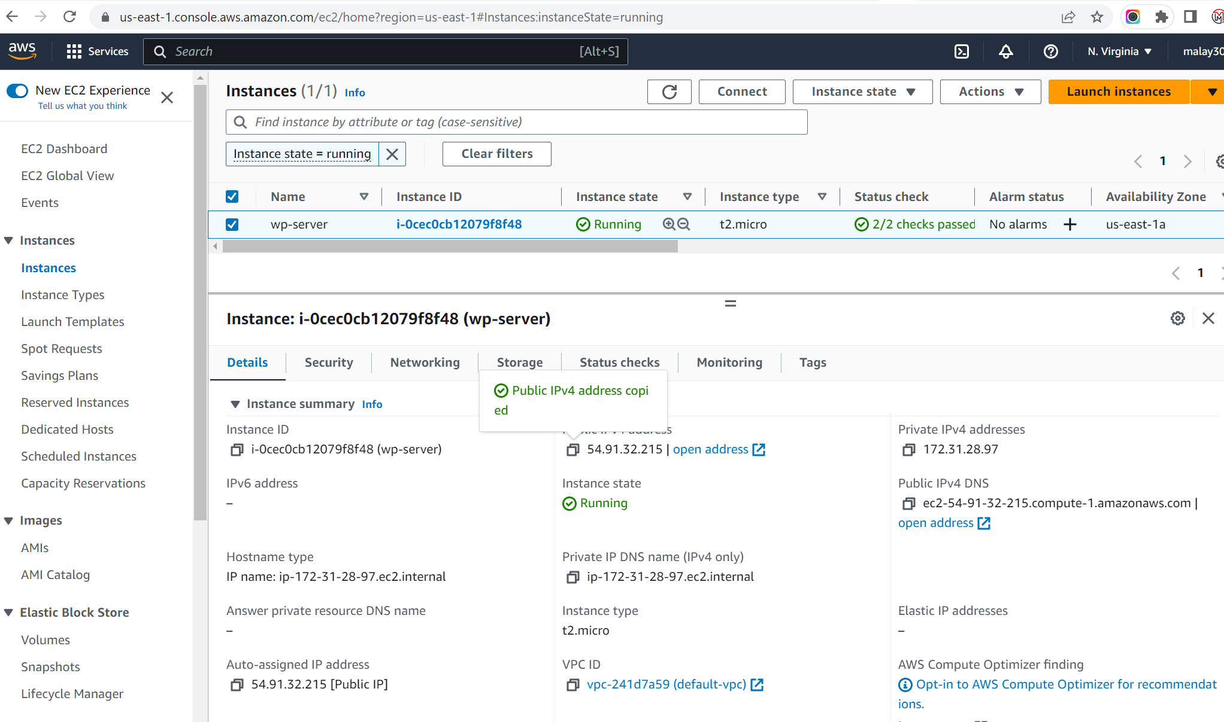Created a command-line script, preferably in Bash to perform the following tasks:

1. Check if docker and docker-compose is installed on the system. If not present, install the missing packages.

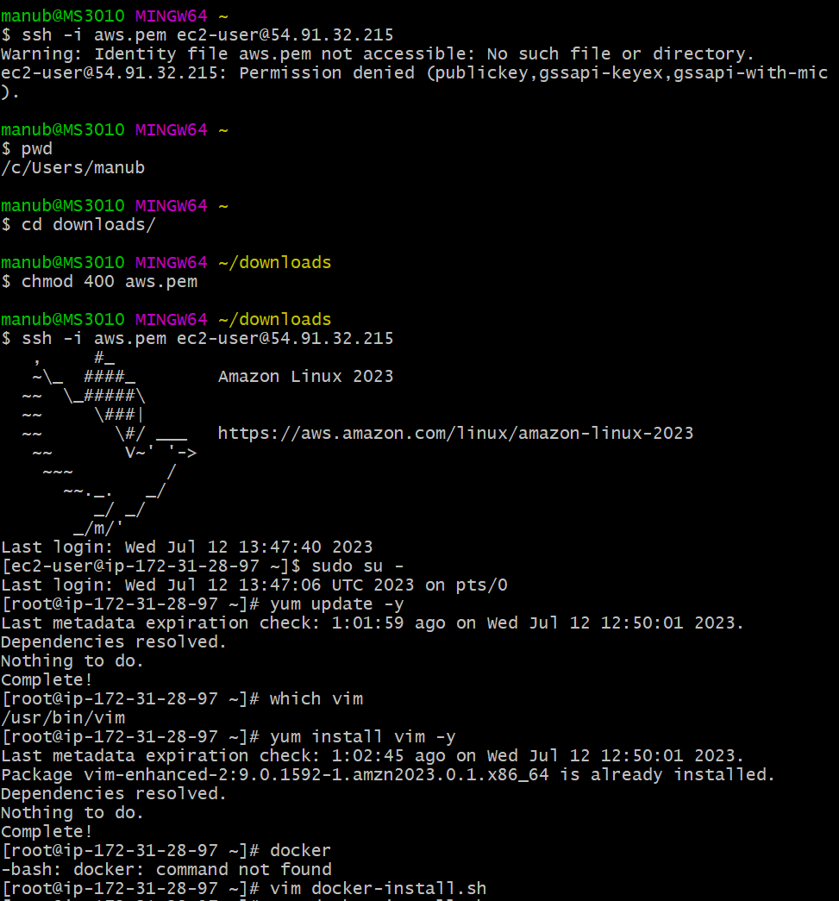



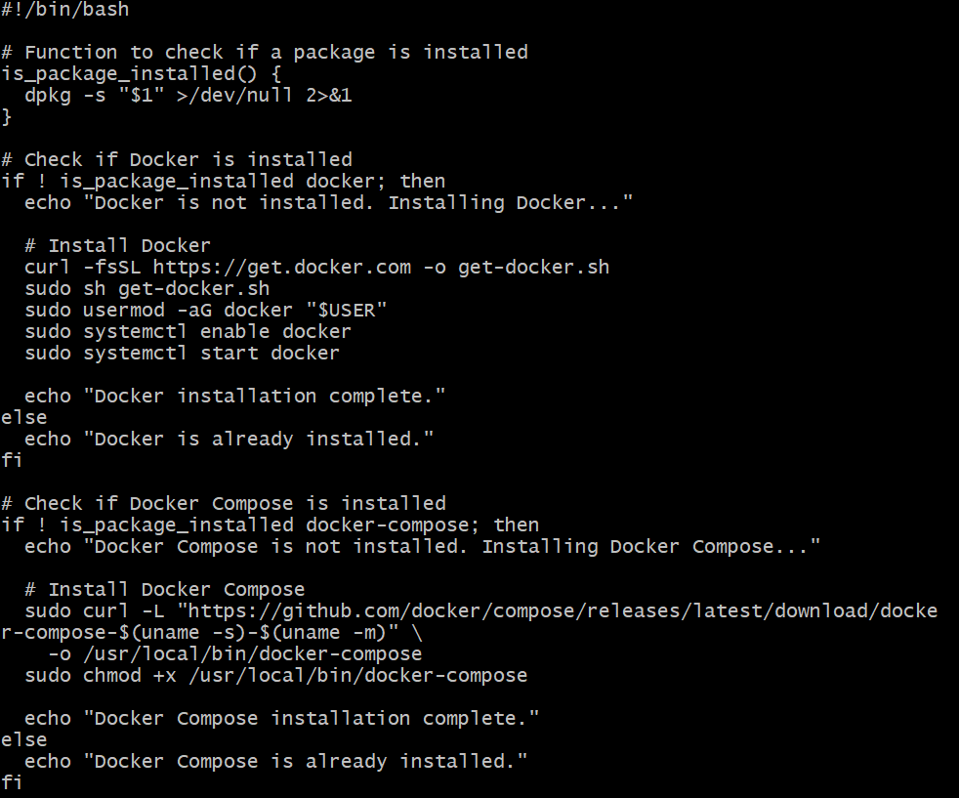

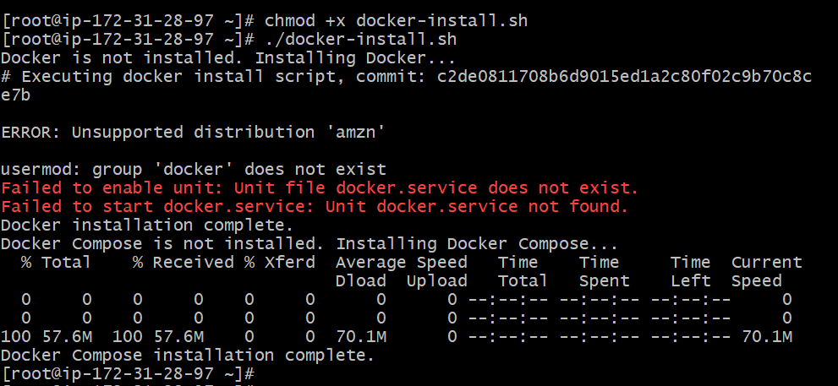

1. The script should be able to create a WordPress site using the latest WordPress Version. Please provide a way for the user to provide the site name as a command-line argument.

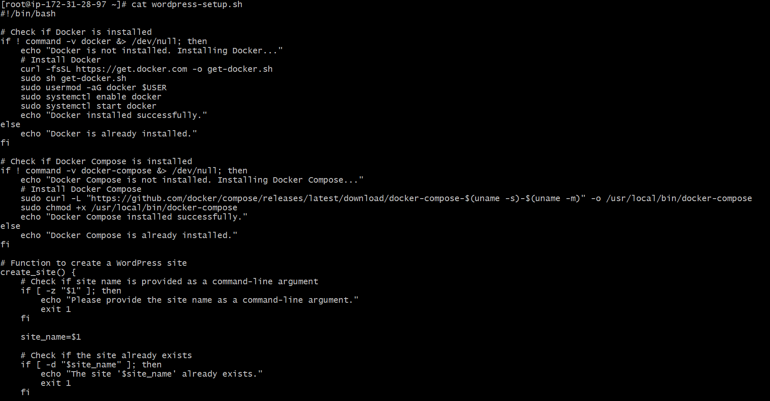

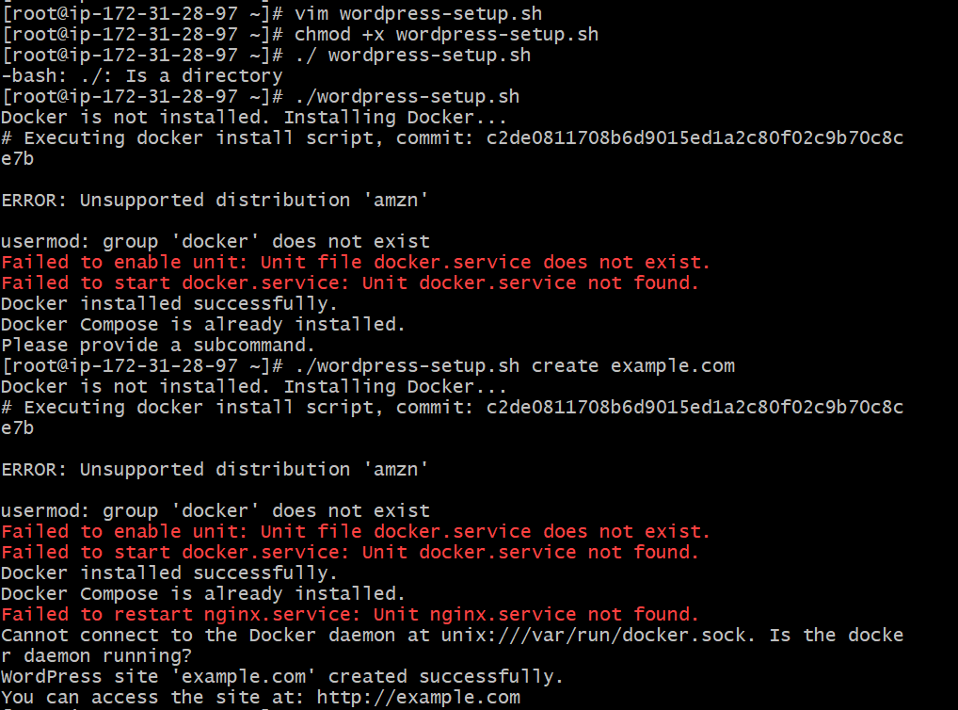

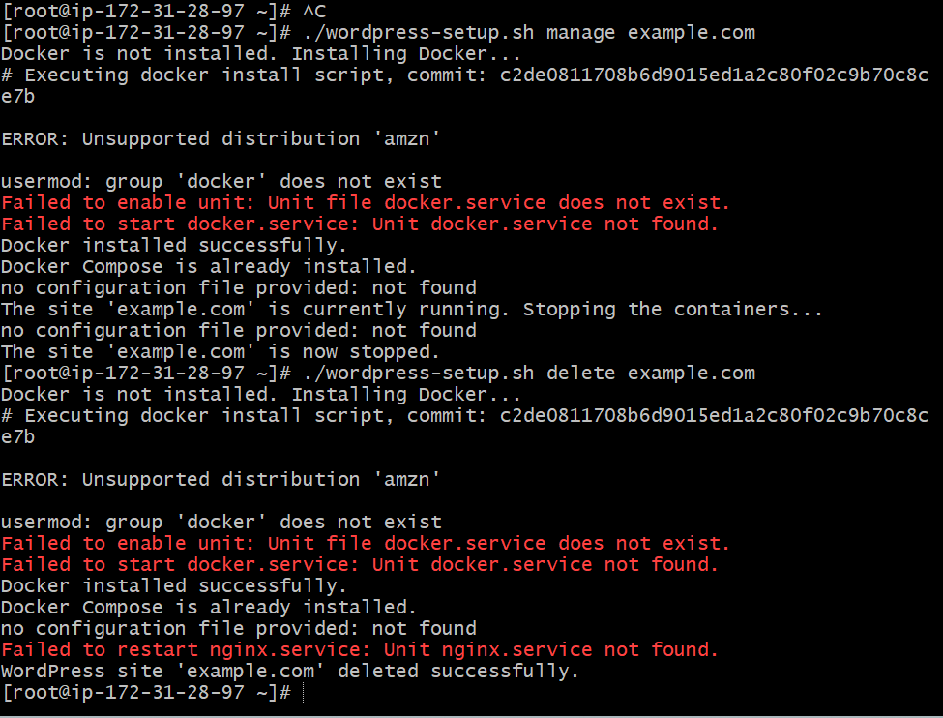

1. It must be a LEMP stack running inside containers (Docker) and a docker-compose file is a must.

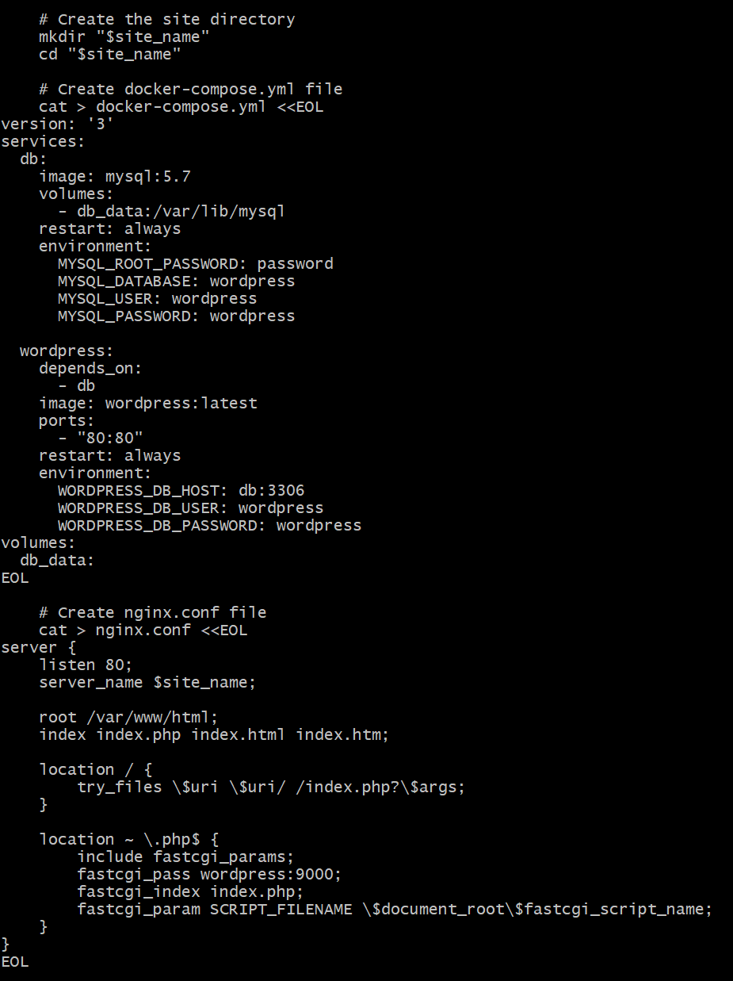

1. Create a /etc/hosts entry for *example.com* pointing to localhost. Here we are assuming the user has provided *example.com*
2. Prompt the user to open *example.com* in a browser if all goes well and the site is up and healthy.

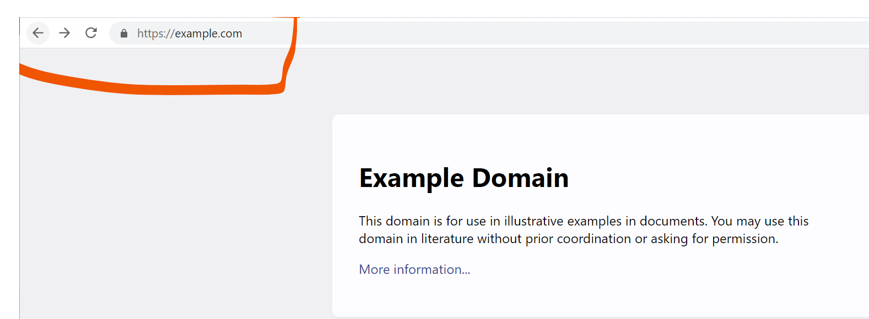

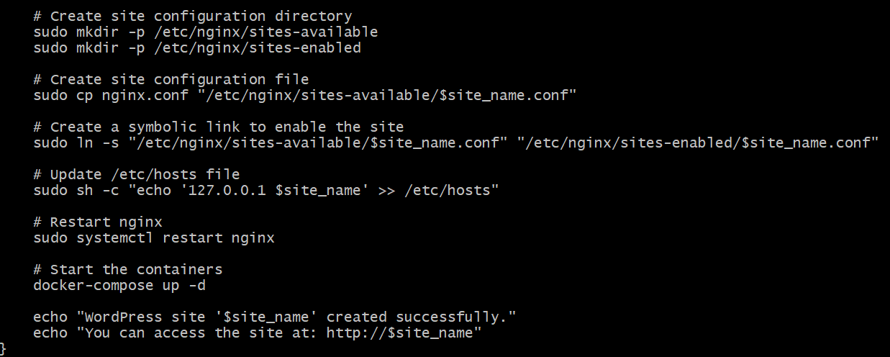

1. Add another subcommand to enable/disable the site (stopping/starting the containers)

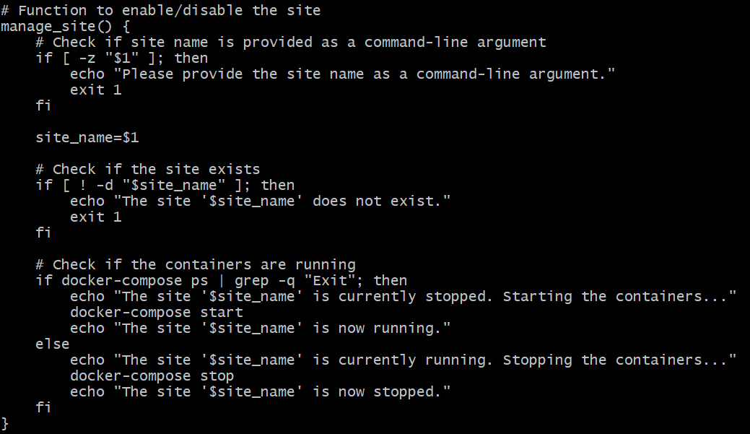

1. Add one more subcommand to delete the site (deleting containers and local files).

