Technical design document FOR SkoAL PWA

Project Code | 100418039
Project Name | Skoal PWA

Prepared/Modified by | Role | Date of Preparation
Manohar B, Vijay Jain | Consultant | 07/06/2017
Reviewed by | Role | Date of Review
 |  | 7/07/2017
Approved by | Role | Date of Approval
Circulation List |  | Version Number of the template:1.1
Version Number | 1.0

Table of Contents

Scope: 3
System architecture diagram 5
Skola PWA best practices 6
Infrastructure service 7
Azure Key Vault: 8
API Management Services: 8
Azure AD Token GENERATION: 8
JWT Token management: 9
Session Management: 9
Security: 9
Exception Handling & Logging: 9
Caching: 10
HTML Libraries 10
JS library 10
CSS library 10
Dependencies / Assumptions 11
Sequence Diagrams 12
Home Screen 12
COUPONS Screen 13
Product Finder Screen 14
My Profile Screen 15
Components description 17
List Of UI Components 17
Instruction Screen 17
Home Screen 18
Coupons Screen 20
Product Finder Screen 22
Products Screen 25
My Profile 35
List Of Design Classes 37
Configuration Files 43
Action Flow Matrix 44

Scope:
Skoal brand will introduce a new way (Skoal Progressive Web Application) to engage its Adult Tobacco Consumers of 21 years of age or older and to allow them to locate stores selling Skoal products, to receive and redeem mobile coupons and manage their Skoal user profile. Skoal PWA will leverage the phone’s capabilities through GPS locator to identify stores participating in the mobile coupon program.
1. | Skoal PWA shall have following 5 tabs in the mentioned order in Fixed Footer for ATC21+ to use.  - Home  - Coupons  - Product Finder  - Products  - Profile  Each tab shall be highlighted by a specific color after its selection.  Header Skoal brand image and Footer tabs shall consistently display in Skoal PWA.
2. | All Skoal PWA tabs shall display the appropriate SGW or FDA product warning message for the standard but configurable length of time before displaying the respective tab contents once ATC21+ logs in and / or navigates to any tab within the PWA.
3. | Offline User Experience:  Skoal PWA shall display appropriate popup message if internet connection is not available before or after ATC21+ logs in.
4. | Log Out:  - Skoal PWA shall provide ability to log out to ATC21+. ‘Log Out’ button shall be available on all tabs after Footer Hyperlinks. Skoal PWA shall show log out confirmation message once ATC21+ clicks on ‘Log Out’ button.  - Skoal PWA shall log out ATC21+ automatically after predetermined minutes (15 minutes) of inactivity.  - Skoal PWA shall log out ATC21+ if they close the Skoal PWA.
REFRENCE: Skoal PWA BRD v1.2 FINAL

System architecture diagram

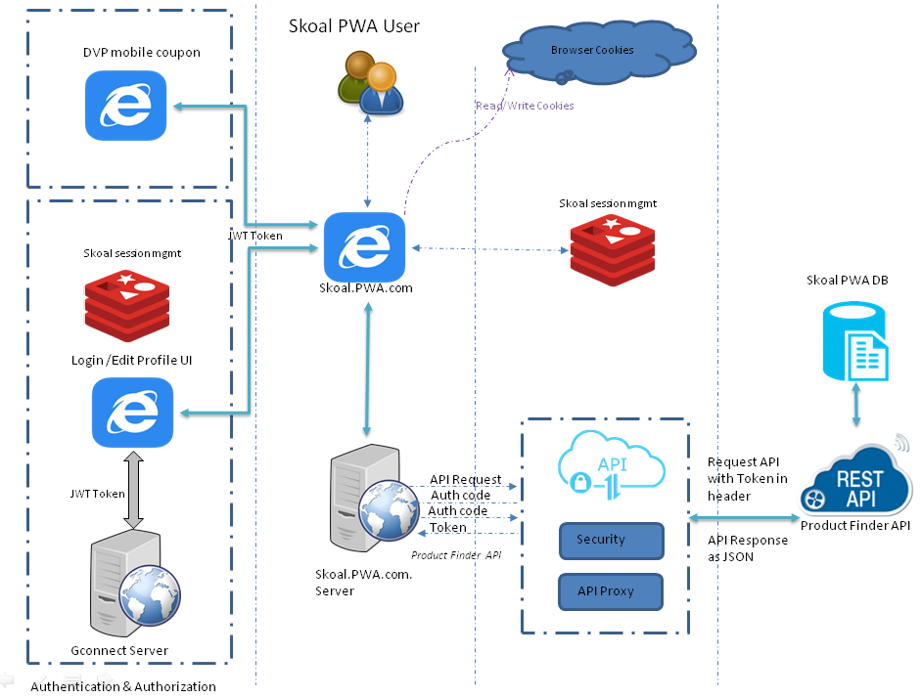

Skola PWA best practices
- Skoal PWA will use MVC 6.0 framework, Dependency Injection pattern (loosely coupled architecture)
- Minification and bundling all JS and CSS files
- Optimum usage of cache component for static UI/data rendering
- Effective usage of Redis cache for fetching data from a large dataset
- Don’t wait for the data to display the UI. Display the view first then get the data and update the view.
- Avoid double scroll bar in UI.
- Use the right image size (don't scale images in HTML).
- Avoid 404 errors for images.
- Reduce the number of DOM elements search/traverse
- Avoid tweaking layout in JavaScript.
- ID and Tag selectors are the faster selectors in JQuery since they map directly to native JavaScript methods. If class selectors are used, limit the scope of the search by tag first. IE will loop through the entire DOM to get your element which is very slow. (Prefix classes with tag name)

Infrastructure service

Azure Key Vault:

Azure key vault helps to Safe guard cryptographic keys and other secrets used by cloud apps and services. Will be using Azure key vault to store SQL connection string.

Key Vault Features:
- Increase security and control over keys and password
- Applications have no direct access to keys
- Reduce latency with cloud scale and global redundancy
- Create and import encryption keys in minutes
- This component is to get SQL connection string from azure.

API Management Services:
API Management Services helps to quickly create consistent and modern API gateways for existing back-end services hosted anywhere, secure and protect them from abuse and overuse and get insights into usage and health. Plus, automate and scale developer onboarding to help get your API program up and running.
Store finder API will be accessed via Azure API management for better performance and security.

Azure AD Token GENERATION:
To invoke store finder API as well as Key Vault, PWA should first acquire an Azure AD token using below details.
Azure AD Token URL | https://login.microsoftonline.com/535b2d87-664f-415a-b7fa-fd3f1086d450/oauth2/token
Header | Content-Type - application/x-www-form-urlencoded
Method Type | POST  BODY should contain  grant_type:client_credentials  client_id: 9abadd69-11cc-40c3-ad22-3b8f3292a9ad  client_secret: NFtDK35UkGxwvSN9CApAYdID8790u9uPZYG3Aytf5LE=

JWT Token management:

JWT (JSON Web Token) is an important piece in ensuring trust and security in your application. JWT allow claims, such as user data, to be represented in a secure manner. JWT has three parts as header, payload and signature. Due to smaller in size JWT can be transferred using hidden variable or query string parameter by default JWT is in encoded form. For extra layer of security will use AES5 encryption and decryption algorithm.

Session Management:

When user log in to the Skoal PWA, the application framework will create user session using Redis session management. At the startup.cs file will configure Redis as session provider as well as will specify default session timeout. Redis session provider is cookie based session provider.

There will be a session management/extension mechanism between Skoal PWA and GConnect for login and Edit profile functionality.

Diagram for session Extension

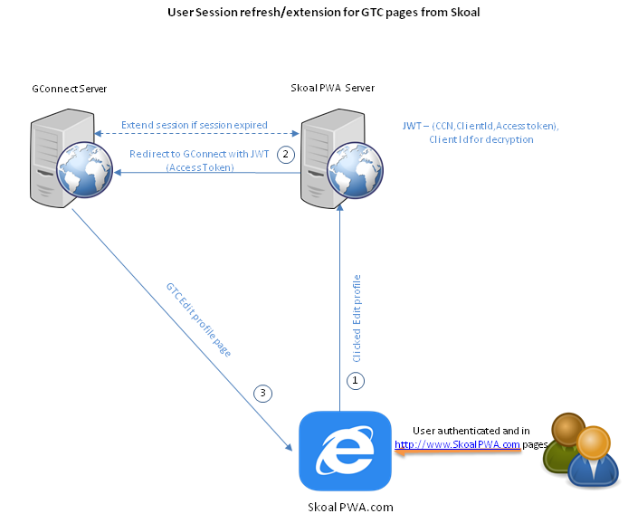

Security:

Login to Skoal PWA will internally redirects to GConnect form based authentication using JWT token query parameter for user authentication and authorization. Skoal PWA will also implement authentication filter on controller or method level to verify IsUserAuthenticated using cookie based session.

Exception Handling & Logging:

Exception handling is the process of responding to the occurrence, during computation, of exceptions – anomalous or exceptional conditions requiring special processing – often changing the normal flow of program execution.

Skoal PWA app should have the capability for logging custom error which will be logged whenever there is an internal application error. Exception handling can be done both at server side and client side. To provide the custom messages, error pages needs to be configured at server side.

Skoal PWA will utilize Azure ApplicationInsight SDK to log custom as well as system exceptions at both client side and server side.

Caching:
One of the most important factors in building high-performance; scalable service is the ability to store data objects, in memory the initial time they are requested. We can cache, or store, these items on the server or other software in the request stream. This allows you to avoid recreating information that satisfied a previous request, particularly information that demands significant processor time or other resources.
Since we are hosting Skoal PWA application in AZURE environment, Redis Cache will be used to store the data objects & browser cache/session storage/local storage depending upon page contents.
Redis store will hold key/value and expiration time can be set on it.

HTML Libraries

JS library
- JQuery - jQuery is a fast, small, and feature-rich JavaScript library. It makes things like HTML document traversal and manipulation, event handling, animation, and Ajax much simpler with an easy-to-use API that works across a multitude of browsers.

CSS library
- Foundation - is a responsive CSS framework. It provides a set of style sheets that provide basic style definitions for all key HTML components. These provide a browser and system-wide uniform, modern appearance for formatting text, tables and form elements.
- CSS3 - is the latest evolution of the Cascading Style Sheets language. It brings a lot of long-awaited novelties, like rounded corners, shadows, gradients, transitions or animations, as well as new layouts like multi-columns, flexible box or grid layouts.

Dependencies / Assumptions

Dependencies:
- GTC should be ready to handle incoming requests for Skoal PWA login and Edit Profile functionalities.
- DVP should be ready to handle incoming requests for Skoal PWA Mobile Coupon functionality.
Assumptions:
- User authentication & authorization will be handled by GTC component
- Skoal PWA is primarily targeted for Android and iOS mobile platforms.
- Skoal PWA awareness and download instructions page shall be available for mobile device only.
- Skoal PWA will be launched in default mobile browser.
- User sessions for Skoal branded website (www.skoal.com) and PWA shall be separate.
- Skoal PWA Products tab shall be in synch with Products tab of Skoal branded website (www.skoal.com). Any changes to Products tab of Skoal branded website shall be separately implemented for Skoal PWA Products tab.
- Product Finder view will by default load with user profile zip code, if location services are allowed page will reload and use current geolocation to display products.

Sequence Diagrams

Home Screen

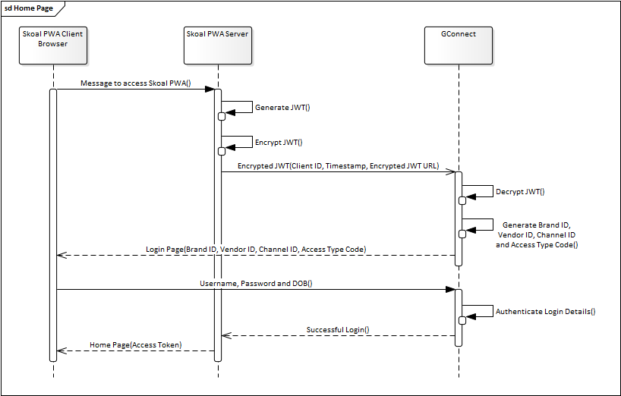

COUPONS Screen

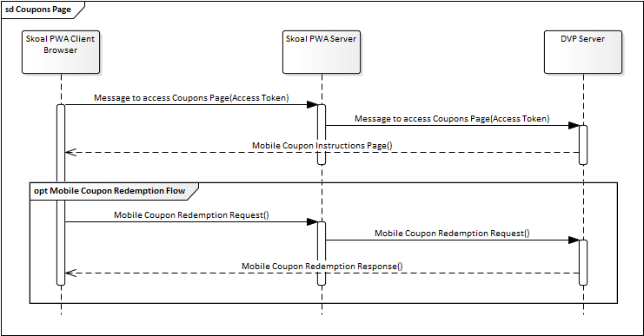

Product Finder Screen

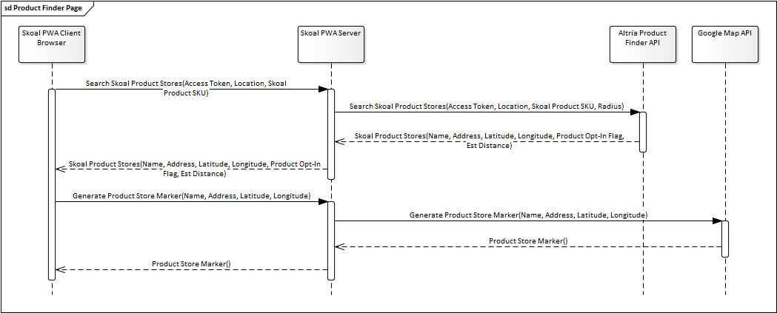

My Profile Screen
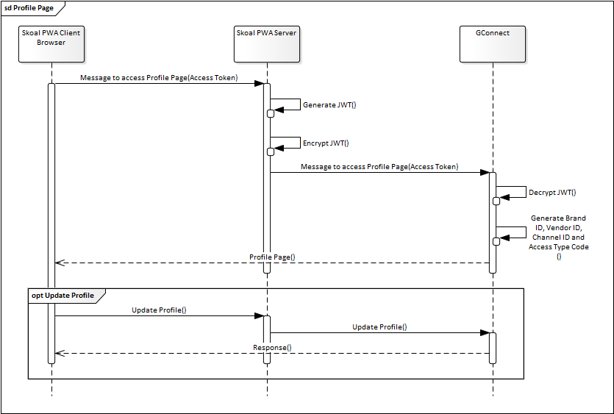

Components description

List Of UI Components

Instruction Screen
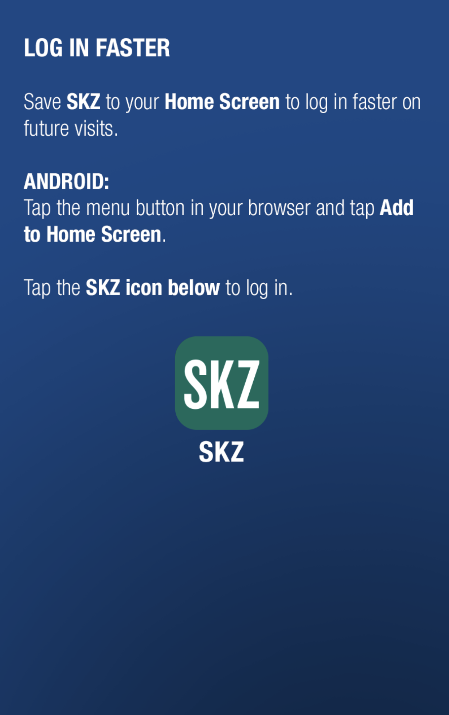

Data Field | Control Type
Heading Text  (Log in faster) | <h1>
Save SKZ to your Home Screen for to Log In faster on Future visits. | Label
Subheading Text  (ANDROID). | Div
Android Description | Label
Subheading Text (IOS) | Div
IOS Description | Label
Heading Text  (EXPLORE SKZ HEADLINE) | Div
Tap to launch SKZ on your mobile phone | Label
SKZ Icon | Image

Home Screen
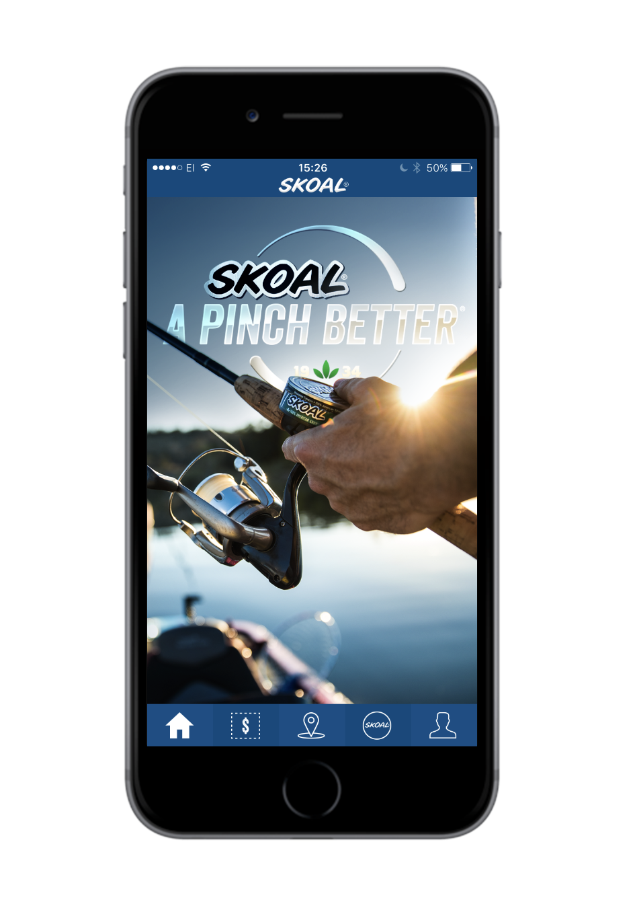
Data Field | Control Type
SGW /FDA Warning Screen() | Div
Brand Header | Div
Brand Image | Div
Footer | Div

Coupons Screen

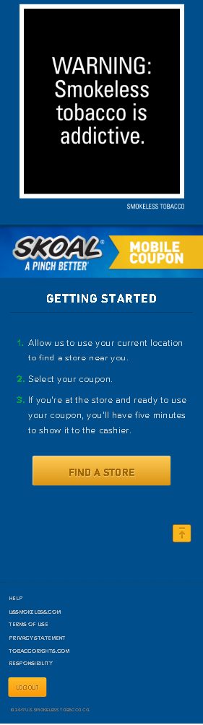

Product Finder Screen

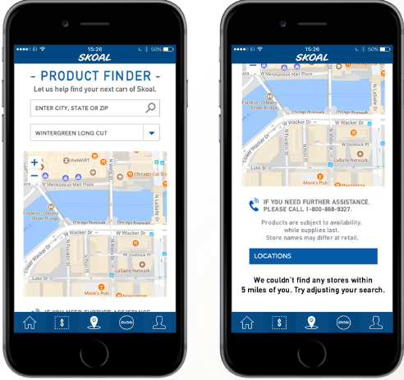

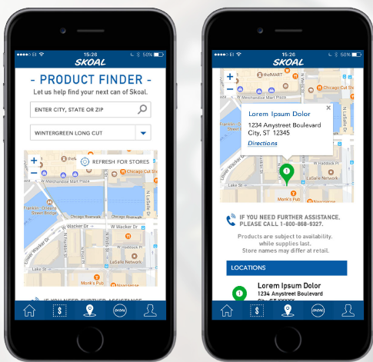

Data Field | Control Type
Heading Text (-PRODUCT FINDER-) | Label or DIV
Subheading Text  (LET US HELP FIND YOUR NEXT CAN OF SKAOL.) | Div
Enter State, City, Zip | Textbox

Products Screen

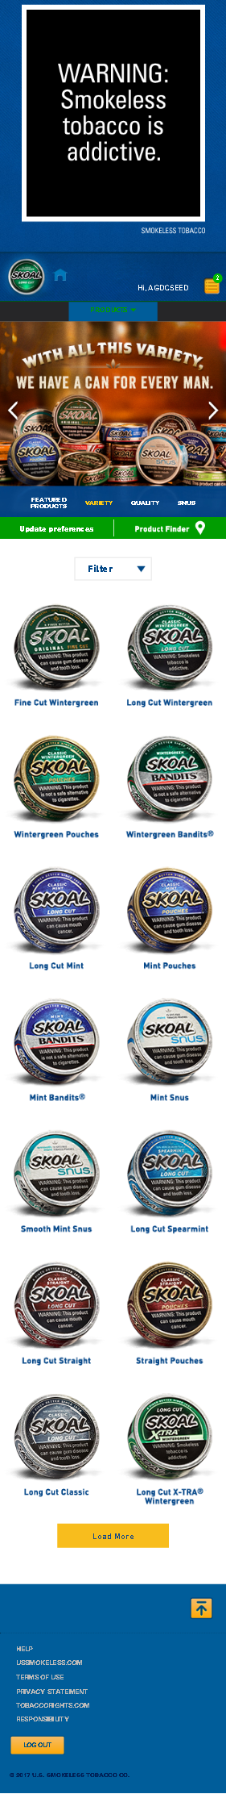

Data Field | Control Type
Image Slider(Skoal snus smoke free, spit free, hassle free) | Image Slider
Names of the images in the slider(Featured Products, Variety, Quality, Snus) | Image Slider
Update Preferences | Button
Product Finder and location symbol | Button
Form and Flavor are 2 drop downs which works as filters to filter the products. | Dropdowns

Data Field | Control Type
Load More | Button
Up Arrow Symbol | Button
Horizontal line | <hr/>
Help, Terms Of Use, Privacy Statement, Responsibility | HTML links
LogOut | Button

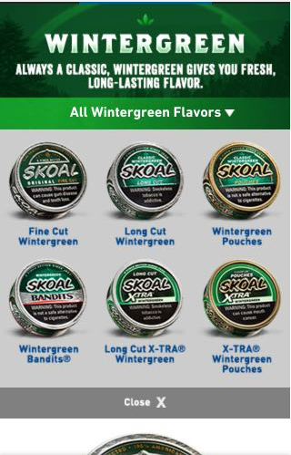

Data Field | Control Type
Heading Text (WINTER GREEN)(Changes based on product selected) | Label
Sub Heading Text (Always a Classic, Wintergreen gives you fresh long-lasting flavor.) | Label
All Winter Green Flavors | <p>
6 Winter green product boxes and their names | Image
Close | Image

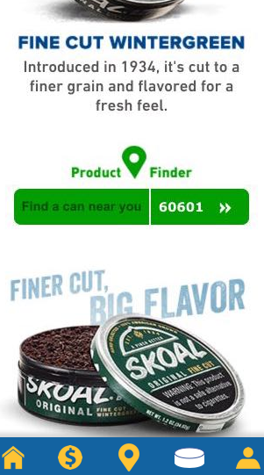

Data Field | Control Type
Skoal Product image | Image
Sub Heading Text (Fine Cut Winter Green) | Label
Description (Introduced in 1934, It’s cut to a finer green and flavoured for a fresh feel.) | Label
Find a can near you | Label
Enter PIN Value | ZipCode
>> | Button
Product Finder | Button
Finer Cut, Big Flavour and Skoal product box opened | Image

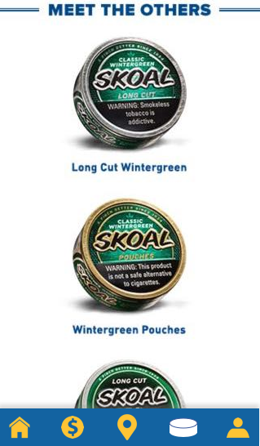

Data Field | Control Type
Meet the Others | Image
Skoal product box and product name | Image

My Profile
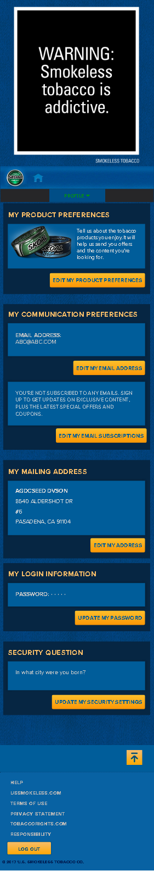

List Of Design Classes

1 Instruction Screen

Class Names | Details
HomeController
  Methods | Used For
  ActionResult Instruction() | Used to render the view for instruction page and display it.
2 Home Screen

Class Names | Details
HomeController
  Methods | Used For
  ActionResult Index() | Used to render the view for home page and display it.

3 Coupons Screen

Class Names | Details
JWTController
  Methods | Used For
  ActionResult RedirecttoDVP(string Jwt, string ClientId) | Used to show Coupons page of DVP Application.

4 Product Finder Screen

Class Names |  | Details
LocationController
  Methods | Used For
  ActionResult GetByAddress( string Authorization, string CurrentAddress, string CurrentCity , string CurrentState , string CurrentZipCode , int Radius , string Brand , string SKU )  ActionResult GetByZip( string Authorization, string CurrentZipCode, int Radius, string Brand, string SKU )  ActionResult Get( string Authorization, float CurrentLatitude, float CurrentLongitude , int Radius , string Brand, string SKU) | Used to get the Skoal stores from the current location of the user
LocationController ViewModel
  Properties | Used For
  string Authorization { get; set; }
  string CurrentAddress { get; set; } | Used for to get the Information from Google ApI
  string CurrentCity { get; set; } | Used for to get the Information from Google ApI
  string CurrentState { get; set; } | Used for to get the Information from Google ApI
  string CurrentZipCode { get; set; }
  int Radius{ get; set; }
  string Brand { get; set; }
  float CurrentLatitude{ get; set; }
  float CurrentLongitude{ get; set; }
  string SKU { get; set; }

5 Products Screen

Class Names | Details
ProductsController
  Methods | Used For
  ActionResult getProductsList(string Form, string Flavor) | Used to get all the skoal brand products based on filters.
  ActionResult updateSkoalPreferences(string Jwt) | Used to update ATC21+ skoal preferences.
  ActionResult findProductStoreWithZip(string Zip, string ProductName) | Used to Render Login View With Brand specific CSS based on ClientId and cookie existence ,ccn id.
  ActionResult meetTheOthers(string ProductName) | Suggestions based on the product which we open.
  ActionResult getProductDetails(string ProductName) | Used to get the details of the particular product.
ProductsViewModel
  Properties | Used For
  string ProductName{ get; set; } | Used to access the product info in products controller.
  Image ProductImage{ get; set;} | Used to access the product info in products controller.
  string FormType { get; set; } | Used to access the product info in products controller.
  string FlavorType { get; set; } | Used to access the product info in products controller.
ProductListViewModel
  Properties | Used For
  List<Products> ProductsList { get; set; } | Used to access the products info in products controller.
  List<SelectListItem> Form { get; set; } | Used to access the products info in products controller.
  List<SelectListItem> Flavor { get; set; } | Used to access the products info in products controller.

6 My Profile

Class Names | Details
JWTController
  Methods | Used For
  ActionResult RedirecttoGTC(string Jwt, string ClientId) | Used to show My Profile page of GTC Application.

Configuration Files

JSON files are used as configuration file type in Skoal PWA. Most of the configurations are cached and used for consecutive use.

File Name | Description
appsettings.json | This file will contain the Application related configuration values  e.g. "CacheExpirationMinutes": 80  "JwtExpirationSeconds": 20000  "SessionExpirationMinutes": 15
bundleconfig.json | Having the Js files related to Product Finder page and make a singe file  e.g. ""wwwroot/js/site.min.js" "  "wwwroot/css/site.min.css"
Manifest.json | This file will contain the basic metadata about application configuration values.  e.g. "name": "skoalpwa”,  "version” ": “1.0”,

Action Flow Matrix

1 Instruction Screen

Add To Home, Button
Used to add PWA to the home screen from where user can access it.

2 Home Coupons Screen
N/A
3 Coupons Screen
Coupons Page ($) button Click:
User will be redirected to DVP coupon page.
4 Product Finder Screen
Direction (Hyperlink):
Display the direction from current location to the Skoal store location.
5 Products Screen
Update Preferences button Click:
Will be redirected to My profile page in GTC.
Product Finder Button Click:
Will be redirected to Product Finder page.

Form Drop down Click:
Shows all the different types of products offered by Skoal.

Flavor Drop down Click:
Shows all kind of flavors available in Skoal.

Product Image Click:
Will be redirected to particular product details page.

Load more Button Click:
Shows the remaining Skoal products.

Up Arrow button Click:
Will be moved to top of the page.

Footers Link Click:
Will be redirected to respective pages.

Log out Button Click:
ATC21+ will be logged out from the application.

All Wintergreen Flavours Click:
Displays wintergreen products in other forms.

>> Button Click:
Validates ZIP and redirects to Product finder page with entered zip and product name.

See All Products button Click:
Will be redirected to Product listing page.

6 My Profile Screen

My Profile Page($) button Click:
User will be redirected to GConnect My Profile page.

