**R analytics Dashboard using Shiny**

**Submitted**



**By Manu Sharma**

**19A**

**About the data**

This report presents an analysis of crime data from the years 2001 to 2010. The data includes information on various crime-related metrics, such as the number of cases acquitted or discharged, the number of cases charged but not laid, and the number of cases convicted, among others. The analysis aims to provide insights into the trends and patterns of crime over the three-year period.

**Analysis**

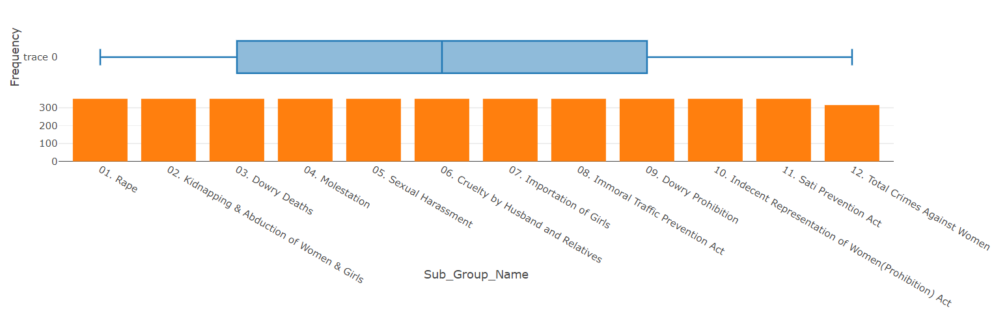

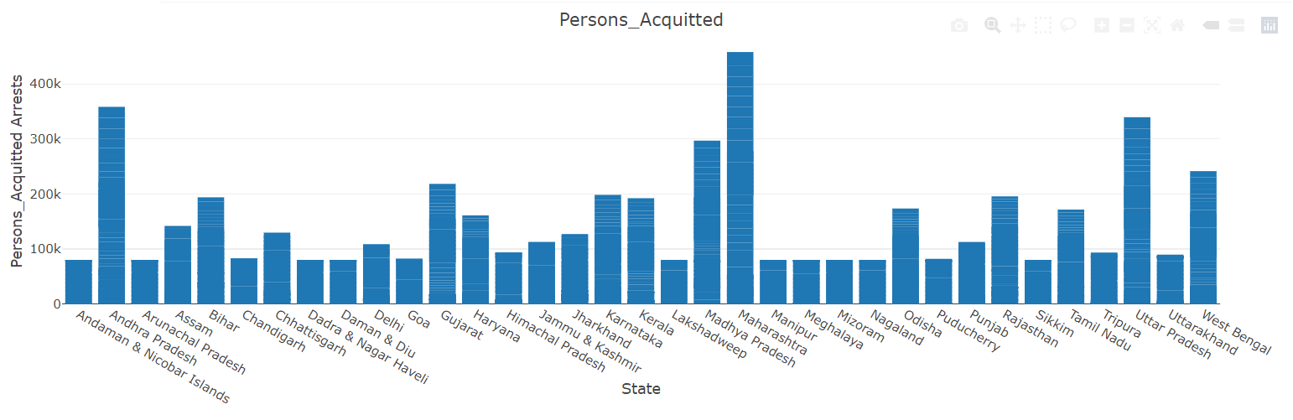

* Maximum acquitted persons from the states of Maharashtra, Uttar Pradesh and Andhra Pradesh.

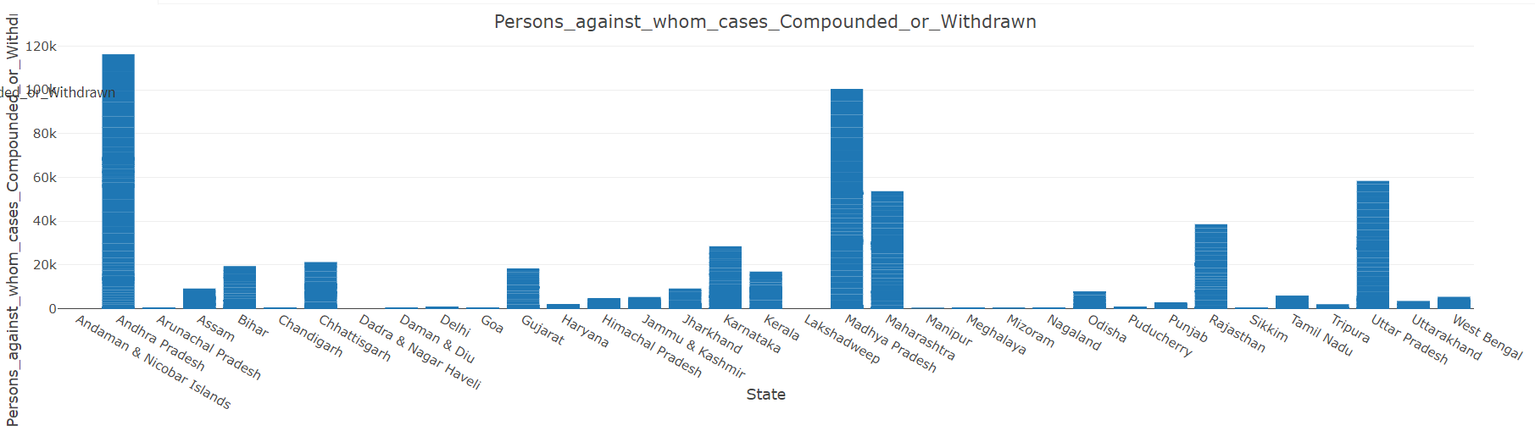

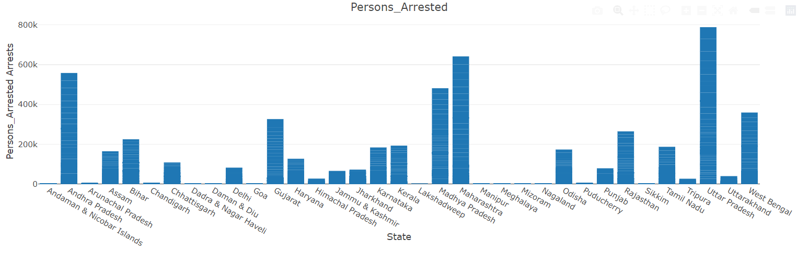

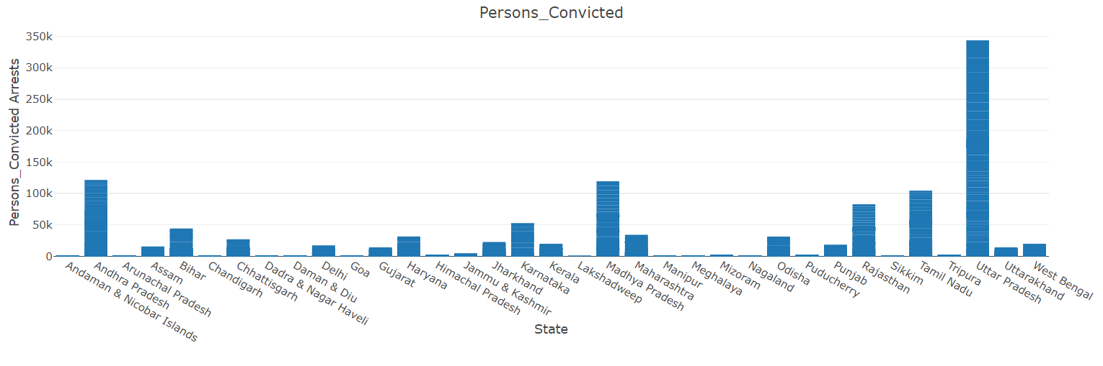

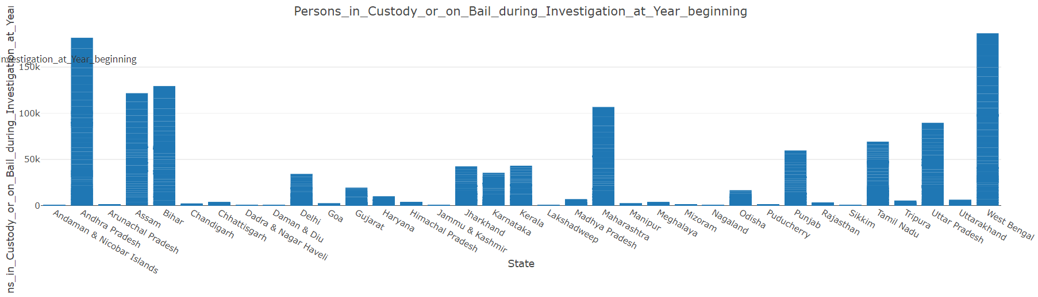

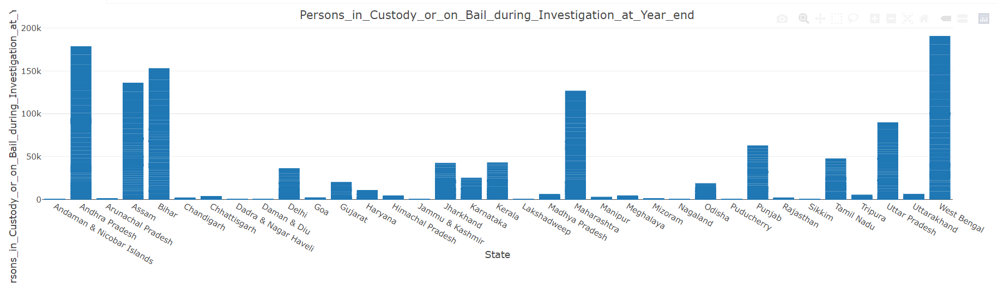

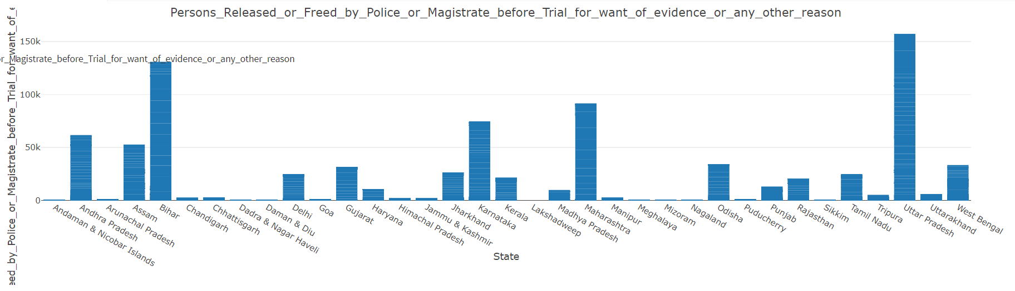

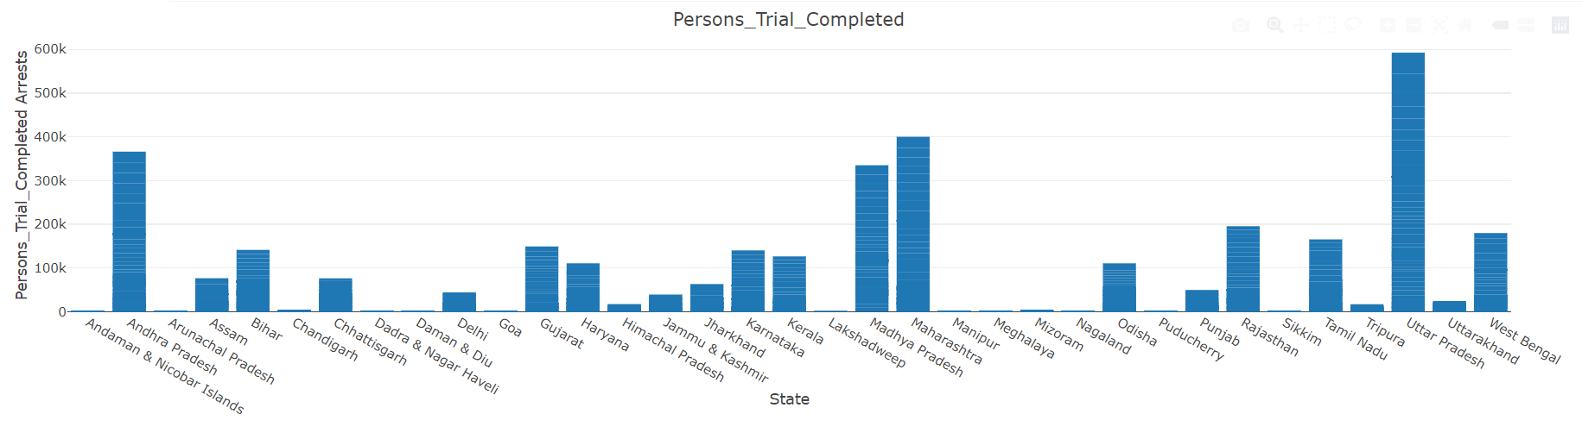

**Key Parameters**

* Area Name Year Group Name Sub Group Name Cases Acquitted or Discharged
* Cases charge sheets were not laid but Final Report submitted
* Cases Charge sheeted Cases Compounded or Withdrawn Cases Convicted
* Cases Declared False on Account of Mistake of Fact or of Law
* Cases Investigated Chargesheets Submitted
* Cases not Investigated or in which investigation was refused
* Cases Pending Investigation at Year End
* Cases Pending Investigation from previous year Cases Pending Trial at Year End
* Cases Pending Trial from the previous year Cases Reported Cases Sent for Trial
* Cases Trials Completed Cases Withdrawn by the Govt
* Cases withdrawn by the Govt during investigation Total Cases for Trial

**Data Quality Checks**

1. **Missing Values:** Checked for missing values in each column to ensure data completeness.
2. **Outliers:** Identified and handled outliers in numerical columns.

**Conclusion**

The analysis of the crime data from 2001 to 2010 provides valuable insights into the trends and patterns of crime over the ten-year period. The increasing number of cases reported, charged, acquitted, convicted, and sent for trial suggests a rise in crime rates. However, the increasing number of cases withdrawn by the government during investigation and the increasing number of cases declared false on account of mistake of fact or of law may indicate improvements in the criminal justice system's efficiency and accuracy. Further analysis is needed to understand the underlying factors contributing to these trends.