**Faculty of Arts & Law**

*This is to certify that***Brijraj Singh**

*has been conferred the degree of***Bachelor of Arts  
BA (Honours in Economics)***having fulfilled the prescribed requirements in the academic year 2016-17 with CGPA of 7.68*

*Given Under the Seal of Manipal University Jaipur, Rajasthan-India | On This Date: September 07,2017* 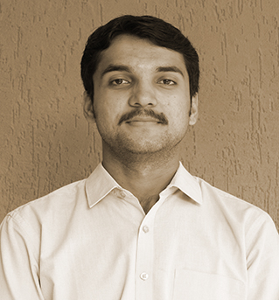

Reg No:141202008   
 Sl. No:MUJ101446

**Faculty of Arts & Law**

*This is to certify that***Abhimanyu Singh**

*has been conferred the degree of***Bachelor of Arts  
BA (Honours in Economics)***having fulfilled the prescribed requirements in the academic year 2016-17 with CGPA of 7.27*

*Given Under the Seal of Manipal University Jaipur, Rajasthan-India | On This Date: September 07,2017* 

Reg No:141202009   
 Sl. No:MUJ101447

**Faculty of Arts & Law**

*This is to certify that***Varun Kumar Manglam**

*has been conferred the degree of***Bachelor of Arts  
BA (Honours in Economics)***having fulfilled the prescribed requirements in the academic year 2016-17 with CGPA of 7.83*

*Given Under the Seal of Manipal University Jaipur, Rajasthan-India | On This Date: September 07,2017* 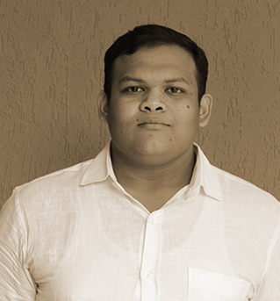

Reg No:141202011   
 Sl. No:MUJ101448

**Faculty of Arts & Law**

*This is to certify that***Toral Sharma**

*has been conferred the degree of***Bachelor of Arts  
BA (Honours in Economics)***having fulfilled the prescribed requirements in the academic year 2016-17 with CGPA of 8.99*

*Given Under the Seal of Manipal University Jaipur, Rajasthan-India | On This Date: September 07,2017* 

Reg No:141202012   
 Sl. No:MUJ101449

**Faculty of Arts & Law**

*This is to certify that***Abhigya Hissaria**

*has been conferred the degree of***Bachelor of Arts  
BA (Honours in Economics)***having fulfilled the prescribed requirements in the academic year 2016-17 with CGPA of 8.8*

*Given Under the Seal of Manipal University Jaipur, Rajasthan-India | On This Date: September 07,2017* 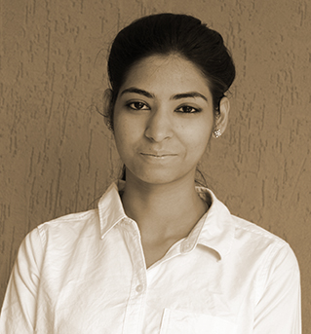

Reg No:141202019   
 Sl. No:MUJ101450

**Faculty of Arts & Law**

*This is to certify that***Garima Khandelwal**

*has been conferred the degree of***Bachelor of Arts  
BA (Honours in Psychology)***having fulfilled the prescribed requirements in the academic year 2016-17 with CGPA of 8.18*

*Given Under the Seal of Manipal University Jaipur, Rajasthan-India | On This Date: September 07,2017* 

Reg No:141202003   
 Sl. No:MUJ101451

**Faculty of Arts & Law**

*This is to certify that***Aalvi Srivastav**

*has been conferred the degree of***Bachelor of Arts  
BA (Honours in Psychology)***having fulfilled the prescribed requirements in the academic year 2016-17 with CGPA of 8.44*

*Given Under the Seal of Manipal University Jaipur, Rajasthan-India | On This Date: September 07,2017* 

Reg No:141202006   
 Sl. No:MUJ101452

**Faculty of Arts & Law**

*This is to certify that***Swapnil Ranjan Chaudhary**

*has been conferred the degree of***Bachelor of Arts  
BA (Honours in Psychology)***having fulfilled the prescribed requirements in the academic year 2016-17 with CGPA of 7.04*

*Given Under the Seal of Manipal University Jaipur, Rajasthan-India | On This Date: September 07,2017* 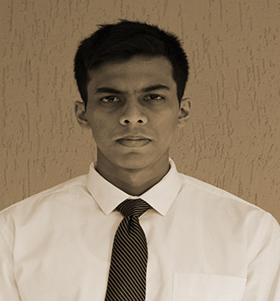

Reg No:141202022   
 Sl. No:MUJ101453