**Faculty of Science**

*This is to certify that***Tejraj Singh Rathore**

*has been conferred the degree of***Bachelor of Computer Applications***having fulfilled the prescribed requirements in the academic year 2016-17 with CGPA of 7.03*

*Given Under the Seal of Manipal University Jaipur, Rajasthan-India | On This Date: September 07,2017* 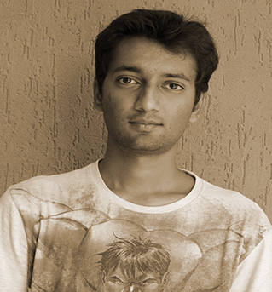

Reg No:141102001   
 Sl. No:MUJ102094

**Faculty of Science**

*This is to certify that***Tanmay Saxena**

*has been conferred the degree of***Bachelor of Computer Applications***having fulfilled the prescribed requirements in the academic year 2016-17 with CGPA of 5.59*

*Given Under the Seal of Manipal University Jaipur, Rajasthan-India | On This Date: September 07,2017* 

Reg No:141102002   
 Sl. No:MUJ102095

**Faculty of Science**

*This is to certify that***Astha Jangid**

*has been conferred the degree of***Bachelor of Computer Applications***having fulfilled the prescribed requirements in the academic year 2016-17 with CGPA of 9.12*

*Given Under the Seal of Manipal University Jaipur, Rajasthan-India | On This Date: September 07,2017* 

Reg No:141102004   
 Sl. No:MUJ102096

**Faculty of Science**

*This is to certify that***Gautam Saini**

*has been conferred the degree of***Bachelor of Computer Applications***having fulfilled the prescribed requirements in the academic year 2016-17 with CGPA of 6.46*

*Given Under the Seal of Manipal University Jaipur, Rajasthan-India | On This Date: September 07,2017* 

Reg No:141102005   
 Sl. No:MUJ102097

**Faculty of Science**

*This is to certify that***Sauvik Kalyan Roy**

*has been conferred the degree of***Bachelor of Computer Applications***having fulfilled the prescribed requirements in the academic year 2016-17 with CGPA of 9.59*

*Given Under the Seal of Manipal University Jaipur, Rajasthan-India | On This Date: September 07,2017* 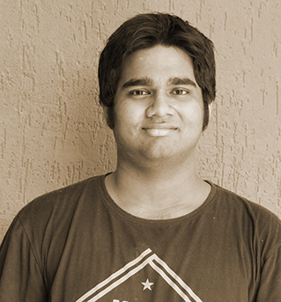

Reg No:141102006   
 Sl. No:MUJ102098

**Faculty of Science**

*This is to certify that***Sartaj Singh Mangat**

*has been conferred the degree of***Bachelor of Computer Applications***having fulfilled the prescribed requirements in the academic year 2016-17 with CGPA of 6.0*

*Given Under the Seal of Manipal University Jaipur, Rajasthan-India | On This Date: September 07,2017* 

Reg No:141102009   
 Sl. No:MUJ102099

**Faculty of Science**

*This is to certify that***Prabhu Nikita Vasudev**

*has been conferred the degree of***Bachelor of Computer Applications***having fulfilled the prescribed requirements in the academic year 2016-17 with CGPA of 6.6*

*Given Under the Seal of Manipal University Jaipur, Rajasthan-India | On This Date: September 07,2017* 

Reg No:141102011   
 Sl. No:MUJ102100

**Faculty of Science**

*This is to certify that***Rajeshwar Gupta**

*has been conferred the degree of***Bachelor of Computer Applications***having fulfilled the prescribed requirements in the academic year 2016-17 with CGPA of 6.28*

*Given Under the Seal of Manipal University Jaipur, Rajasthan-India | On This Date: September 07,2017* 

Reg No:141102013   
 Sl. No:MUJ102101

**Faculty of Science**

*This is to certify that***Parth Khaneja**

*has been conferred the degree of***Bachelor of Computer Applications***having fulfilled the prescribed requirements in the academic year 2016-17 with CGPA of 7.95*

*Given Under the Seal of Manipal University Jaipur, Rajasthan-India | On This Date: September 07,2017* 

Reg No:141102016   
 Sl. No:MUJ102102

**Faculty of Science**

*This is to certify that***Jayant Raj Pandey**

*has been conferred the degree of***Bachelor of Computer Applications***having fulfilled the prescribed requirements in the academic year 2016-17 with CGPA of 8.58*

*Given Under the Seal of Manipal University Jaipur, Rajasthan-India | On This Date: September 07,2017* 

Reg No:141102017   
 Sl. No:MUJ102103

**Faculty of Science**

*This is to certify that***Shourya Wadhwa**

*has been conferred the degree of***Bachelor of Computer Applications***having fulfilled the prescribed requirements in the academic year 2016-17 with CGPA of 5.55*

*Given Under the Seal of Manipal University Jaipur, Rajasthan-India | On This Date: September 07,2017* 

Reg No:141102021   
 Sl. No:MUJ102104