**Faculty of Management and Commerce**

*This is to certify that***Nagendra Jeet**

*has been conferred the degree of***Bachelor of Commerce***having fulfilled the prescribed requirements in the academic year 2016-17 with CGPA of 6.15*

*Given Under the Seal of Manipal University Jaipur, Rajasthan-India | On This Date: September 07,2017* 

Reg No:130902023   
 Sl. No:MUJ101524

**Faculty of Management and Commerce**

*This is to certify that***Sagar Maheshwari**

*has been conferred the degree of***Bachelor of Commerce***having fulfilled the prescribed requirements in the academic year 2016-17 with CGPA of 8.62*

*Given Under the Seal of Manipal University Jaipur, Rajasthan-India | On This Date: September 07,2017* 

Reg No:140902003   
 Sl. No:MUJ101525

**Faculty of Management and Commerce**

*This is to certify that***Saloni Agrawal**

*has been conferred the degree of***Bachelor of Commerce***having fulfilled the prescribed requirements in the academic year 2016-17 with CGPA of 8.95*

*Given Under the Seal of Manipal University Jaipur, Rajasthan-India | On This Date: September 07,2017* 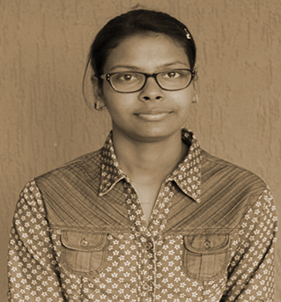

Reg No:140902004   
 Sl. No:MUJ101526

**Faculty of Management and Commerce**

*This is to certify that***Suman Maholiya**

*has been conferred the degree of***Bachelor of Commerce***having fulfilled the prescribed requirements in the academic year 2016-17 with CGPA of 9.12*

*Given Under the Seal of Manipal University Jaipur, Rajasthan-India | On This Date: September 07,2017* 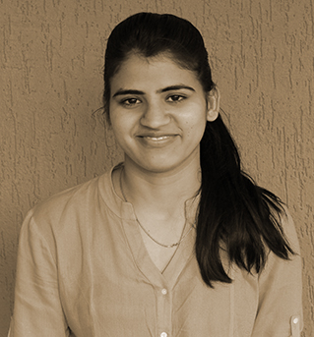

Reg No:140902005   
 Sl. No:MUJ101527

**Faculty of Management and Commerce**

*This is to certify that***Urmila Maholiya**

*has been conferred the degree of***Bachelor of Commerce***having fulfilled the prescribed requirements in the academic year 2016-17 with CGPA of 8.44*

*Given Under the Seal of Manipal University Jaipur, Rajasthan-India | On This Date: September 07,2017* 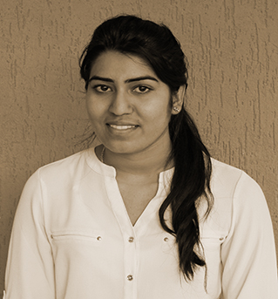

Reg No:140902006   
 Sl. No:MUJ101528

**Faculty of Management and Commerce**

*This is to certify that***Akash Kumar Lamba**

*has been conferred the degree of***Bachelor of Commerce***having fulfilled the prescribed requirements in the academic year 2016-17 with CGPA of 6.73*

*Given Under the Seal of Manipal University Jaipur, Rajasthan-India | On This Date: September 07,2017* 

Reg No:140902007   
 Sl. No:MUJ101529

**Faculty of Management and Commerce**

*This is to certify that***Sahil Hussain**

*has been conferred the degree of***Bachelor of Commerce***having fulfilled the prescribed requirements in the academic year 2016-17 with CGPA of 6.72*

*Given Under the Seal of Manipal University Jaipur, Rajasthan-India | On This Date: September 07,2017* 

Reg No:140902008   
 Sl. No:MUJ101530

**Faculty of Management and Commerce**

*This is to certify that***Satveer Singh Shekhawat**

*has been conferred the degree of***Bachelor of Commerce***having fulfilled the prescribed requirements in the academic year 2016-17 with CGPA of 8.59*

*Given Under the Seal of Manipal University Jaipur, Rajasthan-India | On This Date: September 07,2017* 

Reg No:140902010   
 Sl. No:MUJ101531

**Faculty of Management and Commerce**

*This is to certify that***Samiksha Siwach**

*has been conferred the degree of***Bachelor of Commerce***having fulfilled the prescribed requirements in the academic year 2016-17 with CGPA of 9.73*

*Given Under the Seal of Manipal University Jaipur, Rajasthan-India | On This Date: September 07,2017* 

Reg No:140902011   
 Sl. No:MUJ101532

**Faculty of Management and Commerce**

*This is to certify that***Pradhuman Singh Rathore**

*has been conferred the degree of***Bachelor of Commerce***having fulfilled the prescribed requirements in the academic year 2016-17 with CGPA of 7.65*

*Given Under the Seal of Manipal University Jaipur, Rajasthan-India | On This Date: September 07,2017* 

Reg No:140902017   
 Sl. No:MUJ101533

**Faculty of Management and Commerce**

*This is to certify that***Aruditi Trigunayat**

*has been conferred the degree of***Bachelor of Commerce***having fulfilled the prescribed requirements in the academic year 2016-17 with CGPA of 9.05*

*Given Under the Seal of Manipal University Jaipur, Rajasthan-India | On This Date: September 07,2017* 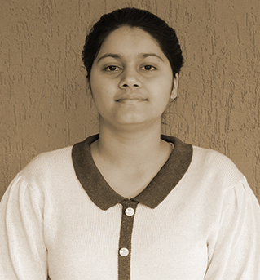

Reg No:140902018   
 Sl. No:MUJ101534

**Faculty of Management and Commerce**

*This is to certify that***Vikrant Yadav**

*has been conferred the degree of***Bachelor of Commerce***having fulfilled the prescribed requirements in the academic year 2016-17 with CGPA of 6.15*

*Given Under the Seal of Manipal University Jaipur, Rajasthan-India | On This Date: September 07,2017* 

Reg No:140902019   
 Sl. No:MUJ101535

**Faculty of Management and Commerce**

*This is to certify that***Rajat Yadav**

*has been conferred the degree of***Bachelor of Commerce***having fulfilled the prescribed requirements in the academic year 2016-17 with CGPA of 6.09*

*Given Under the Seal of Manipal University Jaipur, Rajasthan-India | On This Date: September 07,2017* 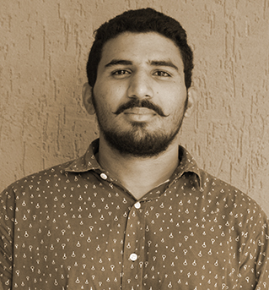

Reg No:140902020   
 Sl. No:MUJ101536

**Faculty of Management and Commerce**

*This is to certify that***Mohit Sharma**

*has been conferred the degree of***Bachelor of Commerce***having fulfilled the prescribed requirements in the academic year 2016-17 with CGPA of 6.07*

*Given Under the Seal of Manipal University Jaipur, Rajasthan-India | On This Date: September 07,2017* 

Reg No:140902021   
 Sl. No:MUJ101537

**Faculty of Management and Commerce**

*This is to certify that***Rohit Chaudhary**

*has been conferred the degree of***Bachelor of Commerce***having fulfilled the prescribed requirements in the academic year 2016-17 with CGPA of 6.3*

*Given Under the Seal of Manipal University Jaipur, Rajasthan-India | On This Date: September 07,2017* 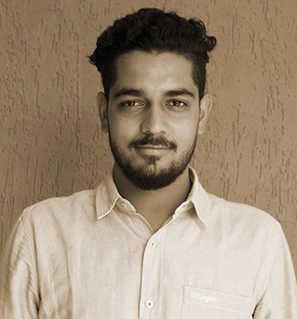

Reg No:140902031   
 Sl. No:MUJ101538

**Faculty of Management and Commerce**

*This is to certify that***Anshul Yadav**

*has been conferred the degree of***Bachelor of Commerce***having fulfilled the prescribed requirements in the academic year 2016-17 with CGPA of 5.85*

*Given Under the Seal of Manipal University Jaipur, Rajasthan-India | On This Date: September 07,2017* 

Reg No:140902033   
 Sl. No:MUJ101539

**Faculty of Management and Commerce**

*This is to certify that***Mukesh Choudhary**

*has been conferred the degree of***Bachelor of Commerce***having fulfilled the prescribed requirements in the academic year 2016-17 with CGPA of 7.51*

*Given Under the Seal of Manipal University Jaipur, Rajasthan-India | On This Date: September 07,2017* 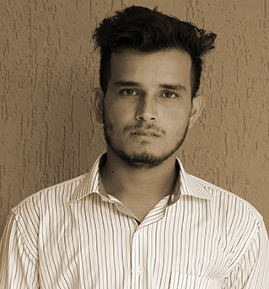

Reg No:140902034   
 Sl. No:MUJ101540

**Faculty of Management and Commerce**

*This is to certify that***Om Prakash Choudhary**

*has been conferred the degree of***Bachelor of Commerce***having fulfilled the prescribed requirements in the academic year 2016-17 with CGPA of 7.29*

*Given Under the Seal of Manipal University Jaipur, Rajasthan-India | On This Date: September 07,2017* 

Reg No:140902035   
 Sl. No:MUJ101541

**Faculty of Management and Commerce**

*This is to certify that***Kunal Khatri**

*has been conferred the degree of***Bachelor of Commerce***having fulfilled the prescribed requirements in the academic year 2016-17 with CGPA of 6.1*

*Given Under the Seal of Manipal University Jaipur, Rajasthan-India | On This Date: September 07,2017* 

Reg No:140902036   
 Sl. No:MUJ101542

**Faculty of Management and Commerce**

*This is to certify that***Mudit Kashyap**

*has been conferred the degree of***Bachelor of Commerce***having fulfilled the prescribed requirements in the academic year 2016-17 with CGPA of 7.75*

*Given Under the Seal of Manipal University Jaipur, Rajasthan-India | On This Date: September 07,2017* 

Reg No:140902037   
 Sl. No:MUJ101543

**Faculty of Management and Commerce**

*This is to certify that***Himanshu Jhorar**

*has been conferred the degree of***Bachelor of Commerce***having fulfilled the prescribed requirements in the academic year 2016-17 with CGPA of 6.66*

*Given Under the Seal of Manipal University Jaipur, Rajasthan-India | On This Date: September 07,2017* 

Reg No:140902039   
 Sl. No:MUJ101544

**Faculty of Management and Commerce**

*This is to certify that***Pooja Choudhary**

*has been conferred the degree of***Bachelor of Commerce***having fulfilled the prescribed requirements in the academic year 2016-17 with CGPA of 7.29*

*Given Under the Seal of Manipal University Jaipur, Rajasthan-India | On This Date: September 07,2017* 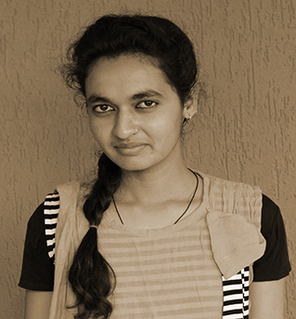

Reg No:140902040   
 Sl. No:MUJ101545

**Faculty of Management and Commerce**

*This is to certify that***Monu Choudhary**

*has been conferred the degree of***Bachelor of Commerce***having fulfilled the prescribed requirements in the academic year 2016-17 with CGPA of 6.57*

*Given Under the Seal of Manipal University Jaipur, Rajasthan-India | On This Date: September 07,2017* 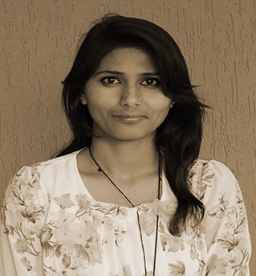

Reg No:140902041   
 Sl. No:MUJ101546

**Faculty of Management and Commerce**

*This is to certify that***Vimal Godara**

*has been conferred the degree of***Bachelor of Commerce***having fulfilled the prescribed requirements in the academic year 2016-17 with CGPA of 5.79*

*Given Under the Seal of Manipal University Jaipur, Rajasthan-India | On This Date: September 07,2017* 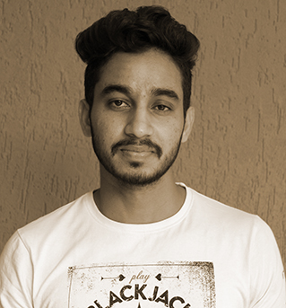

Reg No:140902043   
 Sl. No:MUJ101547

**Faculty of Management and Commerce**

*This is to certify that***Subhash Kumawat**

*has been conferred the degree of***Bachelor of Commerce***having fulfilled the prescribed requirements in the academic year 2016-17 with CGPA of 5.97*

*Given Under the Seal of Manipal University Jaipur, Rajasthan-India | On This Date: September 07,2017* 

Reg No:140902044   
 Sl. No:MUJ101548

**Faculty of Management and Commerce**

*This is to certify that***Lal Chand Sharma**

*has been conferred the degree of***Bachelor of Commerce***having fulfilled the prescribed requirements in the academic year 2016-17 with CGPA of 6.05*

*Given Under the Seal of Manipal University Jaipur, Rajasthan-India | On This Date: September 07,2017* 

Reg No:140902045   
 Sl. No:MUJ101549

**Faculty of Management and Commerce**

*This is to certify that***Vishnu Sharma**

*has been conferred the degree of***Bachelor of Commerce***having fulfilled the prescribed requirements in the academic year 2016-17 with CGPA of 6.4*

*Given Under the Seal of Manipal University Jaipur, Rajasthan-India | On This Date: September 07,2017* 

Reg No:140902046   
 Sl. No:MUJ101550

**Faculty of Management and Commerce**

*This is to certify that***Naman Gupta**

*has been conferred the degree of***Bachelor of Commerce***having fulfilled the prescribed requirements in the academic year 2016-17 with CGPA of 8.17*

*Given Under the Seal of Manipal University Jaipur, Rajasthan-India | On This Date: September 07,2017* 

Reg No:140902048   
 Sl. No:MUJ101551

**Faculty of Management and Commerce**

*This is to certify that***Piyush Kalwani**

*has been conferred the degree of***Bachelor of Commerce***having fulfilled the prescribed requirements in the academic year 2016-17 with CGPA of 9.96*

*Given Under the Seal of Manipal University Jaipur, Rajasthan-India | On This Date: September 07,2017* 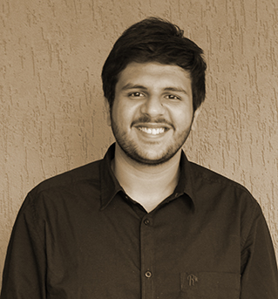

Reg No:140902056   
 Sl. No:MUJ101552

**Faculty of Management and Commerce**

*This is to certify that***Mahendra Kumar Sharma**

*has been conferred the degree of***Bachelor of Commerce***having fulfilled the prescribed requirements in the academic year 2016-17 with CGPA of 6.85*

*Given Under the Seal of Manipal University Jaipur, Rajasthan-India | On This Date: September 07,2017* 

Reg No:140902058   
 Sl. No:MUJ101553

**Faculty of Management and Commerce**

*This is to certify that***Rakesh Choudhary**

*has been conferred the degree of***Bachelor of Commerce***having fulfilled the prescribed requirements in the academic year 2016-17 with CGPA of 6.39*

*Given Under the Seal of Manipal University Jaipur, Rajasthan-India | On This Date: September 07,2017* 

Reg No:140902060   
 Sl. No:MUJ101554

**Faculty of Management and Commerce**

*This is to certify that***Kavita Joshi**

*has been conferred the degree of***Bachelor of Commerce***having fulfilled the prescribed requirements in the academic year 2016-17 with CGPA of 8.99*

*Given Under the Seal of Manipal University Jaipur, Rajasthan-India | On This Date: September 07,2017* 

Reg No:140902061   
 Sl. No:MUJ101555

**Faculty of Management and Commerce**

*This is to certify that***Ankit Lokanda**

*has been conferred the degree of***Bachelor of Commerce***having fulfilled the prescribed requirements in the academic year 2016-17 with CGPA of 7.22*

*Given Under the Seal of Manipal University Jaipur, Rajasthan-India | On This Date: September 07,2017* 

Reg No:140902064   
 Sl. No:MUJ101556