**Faculty of Management and Commerce**

*This is to certify that***Vivekanand Pandit**

*has been conferred the degree of***Bachelor of Hotel Management***having fulfilled the prescribed requirements in the academic year 2016-17 with CGPA of 7.26*

*Given Under the Seal of Manipal University Jaipur, Rajasthan-India | On This Date: September 07,2017* 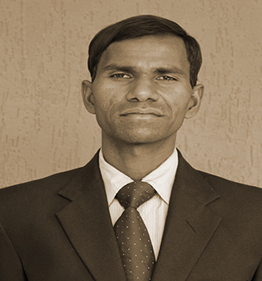

Reg No:120903013   
 Sl. No:MUJ101557

**Faculty of Management and Commerce**

*This is to certify that***Shubham Baranwal**

*has been conferred the degree of***Bachelor of Hotel Management***having fulfilled the prescribed requirements in the academic year 2016-17 with CGPA of 7.64*

*Given Under the Seal of Manipal University Jaipur, Rajasthan-India | On This Date: September 07,2017* 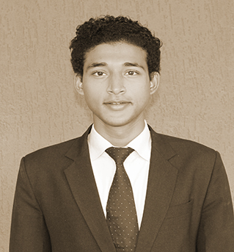

Reg No:130903001   
 Sl. No:MUJ101558

**Faculty of Management and Commerce**

*This is to certify that***Shashank Parasrampuria**

*has been conferred the degree of***Bachelor of Hotel Management***having fulfilled the prescribed requirements in the academic year 2016-17 with CGPA of 6.77*

*Given Under the Seal of Manipal University Jaipur, Rajasthan-India | On This Date: September 07,2017* 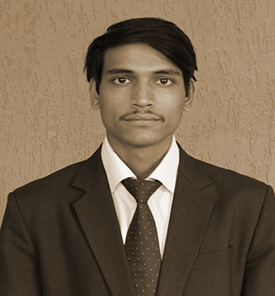

Reg No:130903003   
 Sl. No:MUJ101559

**Faculty of Management and Commerce**

*This is to certify that***Shubham Jain**

*has been conferred the degree of***Bachelor of Hotel Management***having fulfilled the prescribed requirements in the academic year 2016-17 with CGPA of 8.12*

*Given Under the Seal of Manipal University Jaipur, Rajasthan-India | On This Date: September 07,2017* 

Reg No:130903004   
 Sl. No:MUJ101560

**Faculty of Management and Commerce**

*This is to certify that***Chaitanya Singh**

*has been conferred the degree of***Bachelor of Hotel Management***having fulfilled the prescribed requirements in the academic year 2016-17 with CGPA of 7.51*

*Given Under the Seal of Manipal University Jaipur, Rajasthan-India | On This Date: September 07,2017* 

Reg No:130903006   
 Sl. No:MUJ101561

**Faculty of Management and Commerce**

*This is to certify that***Nav Ratan Sharma**

*has been conferred the degree of***Bachelor of Hotel Management***having fulfilled the prescribed requirements in the academic year 2016-17 with CGPA of 6.03*

*Given Under the Seal of Manipal University Jaipur, Rajasthan-India | On This Date: September 07,2017* 

Reg No:130903008   
 Sl. No:MUJ101562

**Faculty of Management and Commerce**

*This is to certify that***Hemant Kumar Phoolwari**

*has been conferred the degree of***Bachelor of Hotel Management***having fulfilled the prescribed requirements in the academic year 2016-17 with CGPA of 7.79*

*Given Under the Seal of Manipal University Jaipur, Rajasthan-India | On This Date: September 07,2017* 

Reg No:130903009   
 Sl. No:MUJ101563