**Faculty of Science**

*This is to certify that***Anjali Ujwala Gopinath**

*has been conferred the degree of***Bachelor of Science  
B.Sc (Biotechnology, Bioscience & Chemistry)***having fulfilled the prescribed requirements in the academic year 2016-17 with CGPA of 9.12*

*Given Under the Seal of Manipal University Jaipur, Rajasthan-India | On This Date: September 07,2017* 

Reg No:141001001   
 Sl. No:MUJ102104

**Faculty of Science**

*This is to certify that***Faseeha Akbar Shaikh**

*has been conferred the degree of***Bachelor of Science  
B.Sc (Biotechnology, Bioscience & Chemistry)***having fulfilled the prescribed requirements in the academic year 2016-17 with CGPA of 7.94*

*Given Under the Seal of Manipal University Jaipur, Rajasthan-India | On This Date: September 07,2017* 

Reg No:141001003   
 Sl. No:MUJ102105

**Faculty of Science**

*This is to certify that***Divya Agarwal**

*has been conferred the degree of***Bachelor of Science  
B.Sc (Biotechnology, Bioscience & Chemistry)***having fulfilled the prescribed requirements in the academic year 2016-17 with CGPA of 7.89*

*Given Under the Seal of Manipal University Jaipur, Rajasthan-India | On This Date: September 07,2017* 

Reg No:141001007   
 Sl. No:MUJ102106

**Faculty of Science**

*This is to certify that***Hamsika Kesavan**

*has been conferred the degree of***Bachelor of Science  
B.Sc (Biotechnology, Bioscience & Chemistry)***having fulfilled the prescribed requirements in the academic year 2016-17 with CGPA of 9.35*

*Given Under the Seal of Manipal University Jaipur, Rajasthan-India | On This Date: September 07,2017* 

Reg No:141001010   
 Sl. No:MUJ102107

**Faculty of Science**

*This is to certify that***Sakshi Sharma**

*has been conferred the degree of***Bachelor of Science  
B.Sc (Biotechnology, Bioscience & Chemistry)***having fulfilled the prescribed requirements in the academic year 2016-17 with CGPA of 7.63*

*Given Under the Seal of Manipal University Jaipur, Rajasthan-India | On This Date: September 07,2017* 

Reg No:141001012   
 Sl. No:MUJ102108

**Faculty of Science**

*This is to certify that***Raj Kumar Sharma**

*has been conferred the degree of***Bachelor of Science  
B.Sc (Biotechnology, Bioscience & Chemistry)***having fulfilled the prescribed requirements in the academic year 2016-17 with CGPA of 6.66*

*Given Under the Seal of Manipal University Jaipur, Rajasthan-India | On This Date: September 07,2017* 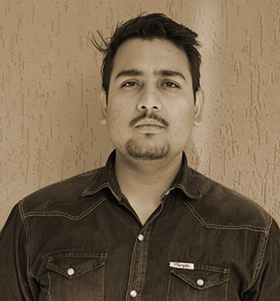

Reg No:141001013   
 Sl. No:MUJ102109

**Faculty of Science**

*This is to certify that***Ragini Sandeep Miglani**

*has been conferred the degree of***Bachelor of Science  
B.Sc (Biotechnology, Bioscience & Chemistry)***having fulfilled the prescribed requirements in the academic year 2016-17 with CGPA of 7.4*

*Given Under the Seal of Manipal University Jaipur, Rajasthan-India | On This Date: September 07,2017* 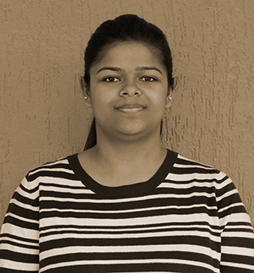

Reg No:141001023   
 Sl. No:MUJ102110

**Faculty of Science**

*This is to certify that***Simmone Siddiqui**

*has been conferred the degree of***Bachelor of Science  
B.Sc (Biotechnology, Bioscience & Chemistry)***having fulfilled the prescribed requirements in the academic year 2016-17 with CGPA of 9.48*

*Given Under the Seal of Manipal University Jaipur, Rajasthan-India | On This Date: September 07,2017* 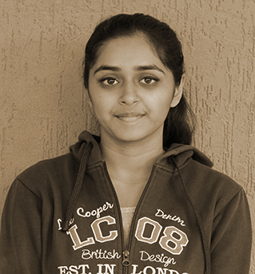

Reg No:141001026   
 Sl. No:MUJ102111

**Faculty of Science**

*This is to certify that***Sarah Gaur**

*has been conferred the degree of***Bachelor of Science  
B.Sc (Biotechnology, Bioscience & Chemistry)***having fulfilled the prescribed requirements in the academic year 2016-17 with CGPA of 8.86*

*Given Under the Seal of Manipal University Jaipur, Rajasthan-India | On This Date: September 07,2017* 

Reg No:141001027   
 Sl. No:MUJ102112

**Faculty of Science**

*This is to certify that***Soumya Singh**

*has been conferred the degree of***Bachelor of Science  
B.Sc (Botany, Psychology & Bio - Technology)***having fulfilled the prescribed requirements in the academic year 2016-17 with CGPA of 8.64*

*Given Under the Seal of Manipal University Jaipur, Rajasthan-India | On This Date: September 07,2017* 

Reg No:141001016   
 Sl. No:MUJ102113

**Faculty of Science**

*This is to certify that***Dinesh Choudhary**

*has been conferred the degree of***Bachelor of Science  
B.Sc (Chemistry, Botany, Biology)***having fulfilled the prescribed requirements in the academic year 2016-17 with CGPA of 6.25*

*Given Under the Seal of Manipal University Jaipur, Rajasthan-India | On This Date: September 07,2017* 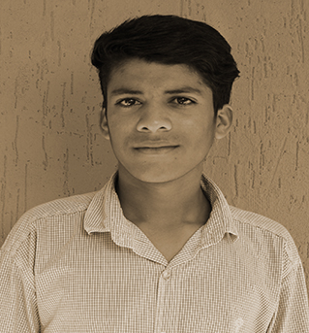

Reg No:141001019   
 Sl. No:MUJ102114

**Faculty of Science**

*This is to certify that***Ramesh Chand Choudhary**

*has been conferred the degree of***Bachelor of Science  
B.Sc (Chemistry, Botany, Biology)***having fulfilled the prescribed requirements in the academic year 2016-17 with CGPA of 5.98*

*Given Under the Seal of Manipal University Jaipur, Rajasthan-India | On This Date: September 07,2017* 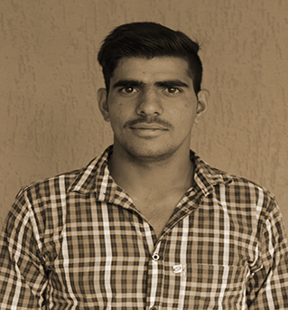

Reg No:141001021   
 Sl. No:MUJ102115

**Faculty of Science**

*This is to certify that***Mahesh Kumar Kumawat**

*has been conferred the degree of***Bachelor of Science  
B.Sc (Chemistry, Botany, Biology)***having fulfilled the prescribed requirements in the academic year 2016-17 with CGPA of 6.46*

*Given Under the Seal of Manipal University Jaipur, Rajasthan-India | On This Date: September 07,2017* 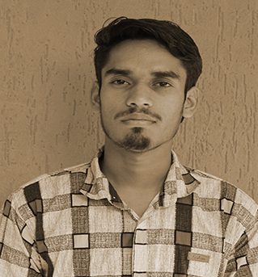

Reg No:141001029   
 Sl. No:MUJ102116

**Faculty of Science**

*This is to certify that***Saniya Khan**

*has been conferred the degree of***Bachelor of Science  
B.Sc (Chemistry, Botany, Biology)***having fulfilled the prescribed requirements in the academic year 2016-17 with CGPA of 8.39*

*Given Under the Seal of Manipal University Jaipur, Rajasthan-India | On This Date: September 07,2017* 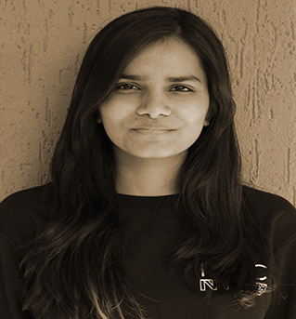

Reg No:141001032   
 Sl. No:MUJ102117

**Faculty of Science**

*This is to certify that***Sampda Tomar**

*has been conferred the degree of***Bachelor of Science  
B.Sc (Psychology, Bio-Science & Bio-Technology)***having fulfilled the prescribed requirements in the academic year 2016-17 with CGPA of 8.45*

*Given Under the Seal of Manipal University Jaipur, Rajasthan-India | On This Date: September 07,2017* 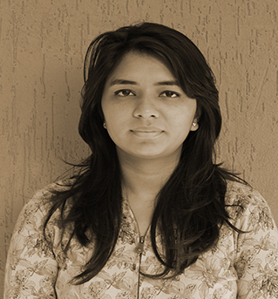

Reg No:141001014   
 Sl. No:MUJ102118

**Faculty of Science**

*This is to certify that***Varun Sharma**

*has been conferred the degree of***Bachelor of Science  
B.Sc (Psychology, Bio-Science & Bio-Technology)***having fulfilled the prescribed requirements in the academic year 2016-17 with CGPA of 6.49*

*Given Under the Seal of Manipal University Jaipur, Rajasthan-India | On This Date: September 07,2017* 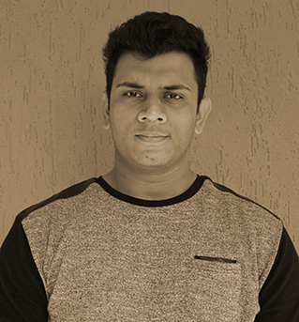

Reg No:141001015   
 Sl. No:MUJ102119

**Faculty of Science**

*This is to certify that***Jaya Ramsinghani**

*has been conferred the degree of***Bachelor of Science  
B.Sc (Psychology, Bio-Science & Bio-Technology)***having fulfilled the prescribed requirements in the academic year 2016-17 with CGPA of 8.66*

*Given Under the Seal of Manipal University Jaipur, Rajasthan-India | On This Date: September 07,2017* 

Reg No:141001017   
 Sl. No:MUJ102120

**Faculty of Science**

*This is to certify that***Prachi Malpani**

*has been conferred the degree of***Bachelor of Science  
B.Sc (Psychology, Bio-Science & Bio-Technology)***having fulfilled the prescribed requirements in the academic year 2016-17 with CGPA of 8.72*

*Given Under the Seal of Manipal University Jaipur, Rajasthan-India | On This Date: September 07,2017* 

Reg No:141001028   
 Sl. No:MUJ102121