**Faculty of Arts & Law**

*This is to certify that***Saloni Bahl**

*has been conferred the degree of***Master of Law  
LLM (Criminal Law)***having fulfilled the prescribed requirements in the academic year 2016-17 with CGPA of 8.36*

*Given Under the Seal of Manipal University Jaipur, Rajasthan-India | On This Date: September 07,2017* 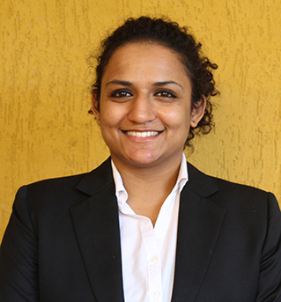

Reg No:161403004   
 Sl. No:MUJ101440

**Faculty of Arts & Law**

*This is to certify that***Anamika Bishnoi**

*has been conferred the degree of***Master of Law  
LLM (Criminal Law)***having fulfilled the prescribed requirements in the academic year 2016-17 with CGPA of 7.83*

*Given Under the Seal of Manipal University Jaipur, Rajasthan-India | On This Date: September 07,2017* 

Reg No:161403006   
 Sl. No:MUJ101441

**Faculty of Arts & Law**

*This is to certify that***Himani Hazari**

*has been conferred the degree of***Master of Law  
LLM (Criminal Law)***having fulfilled the prescribed requirements in the academic year 2016-17 with CGPA of 8.33*

*Given Under the Seal of Manipal University Jaipur, Rajasthan-India | On This Date: September 07,2017* 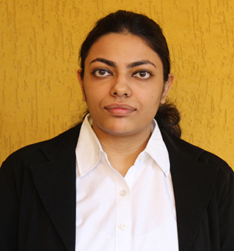

Reg No:161403008   
 Sl. No:MUJ101442

**Faculty of Arts & Law**

*This is to certify that***Riya Kanwar**

*has been conferred the degree of***Master of Law  
LLM (Criminal Law)***having fulfilled the prescribed requirements in the academic year 2016-17 with CGPA of 8.93*

*Given Under the Seal of Manipal University Jaipur, Rajasthan-India | On This Date: September 07,2017* 

Reg No:161403012   
 Sl. No:MUJ101443

**Faculty of Arts & Law**

*This is to certify that***Kuldeep Sharma**

*has been conferred the degree of***Master of Law  
LLM (Criminal Law)***having fulfilled the prescribed requirements in the academic year 2016-17 with CGPA of 7.08*

*Given Under the Seal of Manipal University Jaipur, Rajasthan-India | On This Date: September 07,2017* 

Reg No:161403014   
 Sl. No:MUJ101444

**Faculty of Arts & Law**

*This is to certify that***Hans Honey Khari**

*has been conferred the degree of***Master of Law  
LLM (Criminal Law)***having fulfilled the prescribed requirements in the academic year 2016-17 with CGPA of 9.58*

*Given Under the Seal of Manipal University Jaipur, Rajasthan-India | On This Date: September 07,2017* 

Reg No:161403016   
 Sl. No:MUJ101445