Assignment🡪

Que : Create an EFS and connect it to 3 different EC2 instances. Make sure that all instances have different operating systems. For instance, Ubuntu, Red Hat Linux and Amazon Linux 2.

Soln :

a)First lets create our Ec2 instances

From here we can select in which region we need to create our data center.

To go to EC2 service in console just navigate as below:

On clicking home page will open:

Now to create our new instance just click on launch instance (highlighted above).

On clicking it will open a form.

All configuration step by step:

a)First Give the Name of the Instance.

b)Now select an AMI.

An AMI is a template that contains the software configuration (operating system, application server, and applications) required to launch your instance. Search or Browse for AMIs if you don’t see what you are looking for below

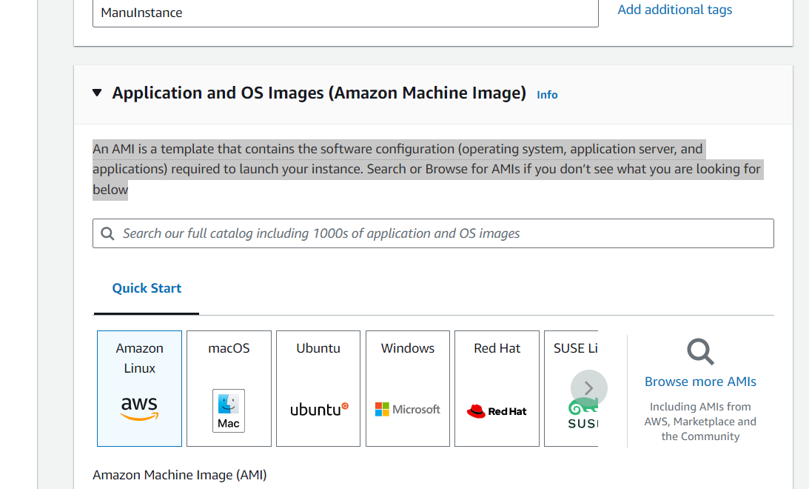

AMI is nothing OS + preinstalled software + mapping of volumes attached to it.

we have select Amazon Linux for now as it is free.

c)Now we have to select our Instance type.

(how many cpus or how much ram we are going to need).

Something like that open.

Just enter any name.

Select what type of algorithm u want need for encryption.

If u are using putty to connect than download ppk otherwise pem.

On clicking create it will download private key in your system.

Now here comes the network tab.

For now just create a security group and remain it whatever it is.

We have to do some changes just click on edit.

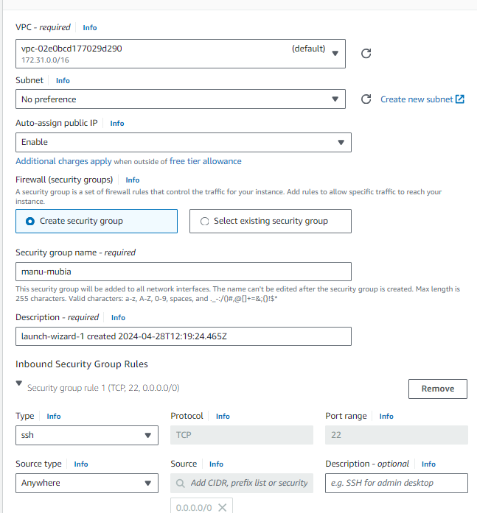

Don’t forgot to enable auto-assign public ip.

Add security-group rules if u need to add http/https enability.

Now select storage for data whatever u required.

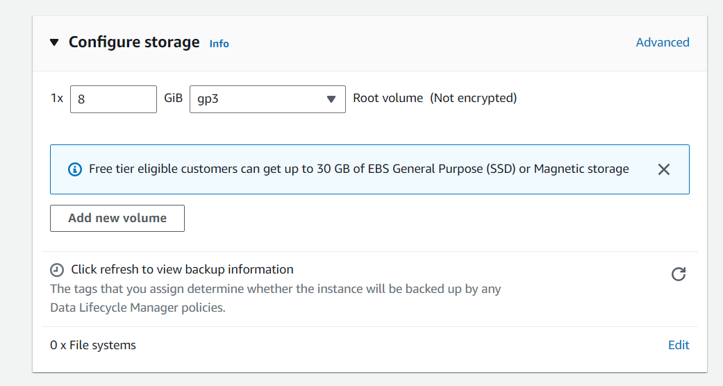

Now launch our instance and we can see it running in EC2 console.

Like this create one for ubuntu and red hat.

After this u can see three instances on console.

Now we have to create EFS. 🡪

Now go to services and search EFS.

And click on create file system , a popup will appear.

In this we can choose which zones we can connect through mount targets with shared storage.

Mount target works as connectivity between zones and EFS.

Mount target is just an endpoint.

On clicking next new pop up will open.

These are policy for more flexibility we will talk about it later.(IAM)

Now when we will click create.

We can see all details by selecting our file system.

Now after creating them, we have to mount this storage to them like we have done in EBS.

No go to our file system storage 🡪 attach

When u click on attach a pop up will come.

Here we can see our availability zones where we have created the mount targets.

And the command to connect it with them.

Now in our instances we can see in which availability zones they are created.

For now we will choose connect with dns. And the mount helper url to connect.

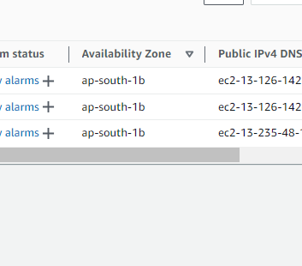

Remember : while creating security group if u select subnet in different zone instance also created in different zone.

Now we have to mount our storage in all three of them.

a)go to command prompt and connect it with our amazon instance first.

First go to the directory where we have put our private key.Now run this command

ssh -i manu-mumbai.pem [ec2-user@](mailto:ec2-user@13.126.142.95)13.126.142.183 // ip

b) now create a directory to mount our storage

sudo mkdir /amazon

c) now copy the command from popup and edit it with our directory name.

sudo mount -t efs -o tls fs-08fa7b5e5ace97dd8:/ /amazon

it will give error because first we have to install efs file system in linux.

Use command

sudo yum install -y amazon-efs-utils

than hit above command.

If u r getting connection timeout create new security group for all instances.

Remember : which security group u chose in file system have inpound NFS protocol enabled.

Now after running the command check storage mount by command.

Df -h

U can see our storage is mounted there.

------------------------------------------------

Now for ubuntu🡪

Steps are same but with some difference :

a)to connect with console run this command

ssh -i manu-mumbai.pem ubuntu@3.110.47.124 // user is ubuntu here

to install file storage use this command

sudo apt-get install nfs-common //different from linux one.

All the other command are same use nfs client to connect here.

===================================

Now for redhat🡪

sudo yum install -y nfs-utils

Rest are same