**Tasks To Be Performed:**

1. Create a sample Python Lambda function.

2. Set the Lambda Trigger as SQS and send a message to test invocations.

Let first create one sqs service before starting the assignment.

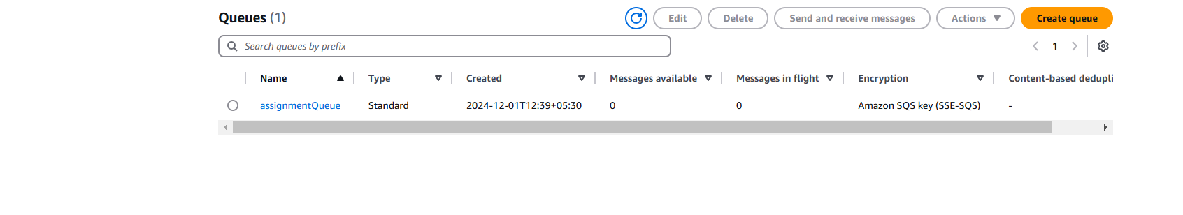

Now lets create the lambda.

Click on create function.

Fill basic configuration , we have selected python for it.

We have selected a basic execution role.

Create function.

Now go into the code.



And enter the below code and deploy the code.

Now we will add a trigger in our function.

We have given our sqs queue in trigger configuration.

Now it is added

Now try to send and poll message in queue.

And go into logs.

we can see all the events in logs.