**Linear and Logistic Regression**

MACHINE LEARNING->

It is a subset of the artificial intelligence which give the machine the ability to learn

Without explicitly programmed.

In this data is the key and the algorithm

Like🡪 Netflix recommending movie

DEEP LEARNING🡪

It is a subset of machine learning.

Deep learning is a machine learning technique that teaches computers to do what comes naturally to humans: learn by example. Deep learning is a key technology behind driverless cars, enabling them to recognize a stop sign, or to distinguish a pedestrian from a lamppost.

LINEAR REGRESSION🡪

Using a linear relation between two variables we are going to predict the values.

Y=f(x)

Here y and x is dependent on each other and y value depends on x.

Like definition of line

Y = mx + c

M is the angle of line from x axis.

C is the position on yaxis which touches the line..

From this equation we can find points on graphs.

In below diagram first we find c by plotiing x = 0 and y=3

Then we find the value of m(scope).

At last u will find y = 2x+3.

So from the outputs we can assume the logic here if it is in a logical pattern(linear relation).

We use correlation(r) to find linear relation between two variables.

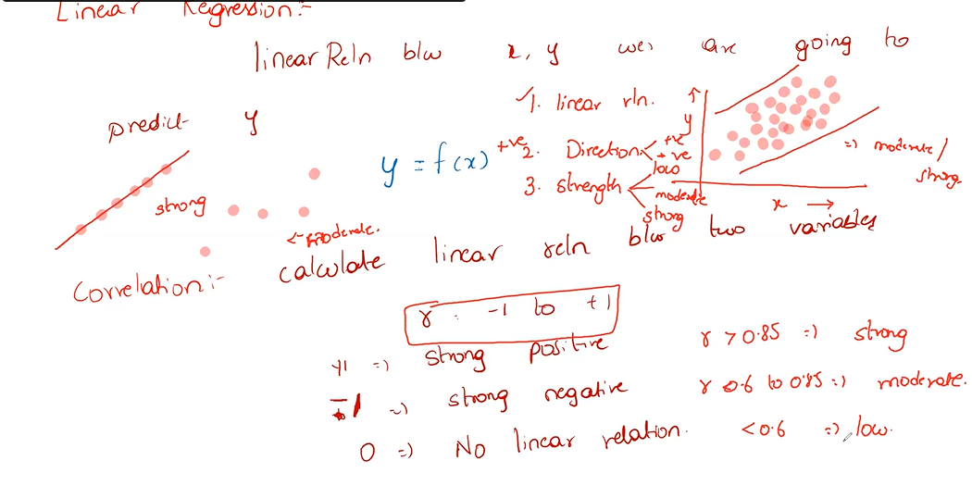

If slope is 0 we don’t have any linear relation r=0

We will take only those columns which have r>0.85(strong) for linear regression.

Rows🡪datapoints, observations, records

Columns🡪dimensions,variables,features.

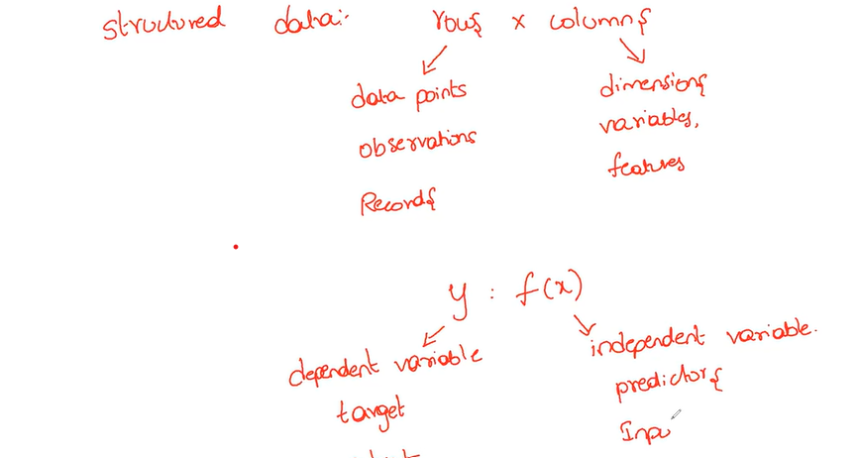

Some points to remember.

Input 🡪contionous/categorical

Output🡪linear

Always

Check(EDA)🡪

Datatype should be same

No duplicate

No na

Outliner analysis

Check distribution for int/float columns

What is discrete and continuous value?

The primary difference, though, between discrete and continuous data is that discrete data is a finite value that can be counted whereas continuous data has an infinite number of possible values that can be measured.

+++++++++++++++++++++++++++++++++++++++++++++++++++++++++++++++++++++++++++++++++

Always learn algorithm by this:

a)what problem we are solving

b)geometric intuition

c)mathematical intuition