OUsability testing -Bergen Swamp Preservation Society Website
Introduction
The Bergen Swamp Preservation Society is an educational institution whose purpose is to conserve the flora and fauna of its Upstate New York properties. The societies three main priorities are
- To conserve the flora and fauna of the lands owned by the society.
- To offer schools, colleges, and accredited groups access for the purpose of research and study.
- To publish scientific and cultural information pertaining to the Society lands.
Purpose
As a team of six at RIT, we collaborated with the designer and developer of the new website for Bergen Swamp Preservation Society, to conduct an extensive usability study of the website. The website provided details about the membership, directions, events, photos and research interests. The user experience and the how closely the website matches the user’s conceptual model was evaluated during this study. The study focused on potential usability issues on the website, collect participants feedback and suggestions with the result of improving the website. The results of the study indicated the general usability issues and suggests improvements.
Methodology
The usability testing was an exploratory study, consisting of 5 participants. In addition to them, 2 other participants were used in pilot test to fine tune the tasks assigned to the participants during the final test.
Each participant was given five tasks. The task order was shuffled between participants to counterbalance any results skewed by transfer of learning. Qualitative data was collected by asking participants question after each task and at the end of the entire session. To analyse the tasks quantitatively, we recorded the number of on clicks and time to complete the task. The task was considered complete when the participant decided to stop. The success criteria for the tasks were predetermined by the team and designer from the results of the pilot tests.
At the end of the session, each participant was compensated with a $20 amazon gift card.
Setup
Test sessions were conducted under controlled settings, in the usability testing lab, at the B. Thomas Golisano College of Computing and Information Sciences, Rochester Institute of Technology (RIT), Rochester, New York
Morae Screen recorder and observer were used on the test system and observer systems respectively. A webcam was used to record the participants’ reactions to the tasks.

<Flyer>
<UT LAB>
<Graphs>

HCI for Mobile Wearable and Ubiquitous Devices – Inconspicuous interactions
Introduction
The urge to stay connected and updated led us to a world infested with wearables. The main objective of wearables is to not only convey the arrival or update of information, but also to change our interactions from heads down to face up. However, these devices and the interactions used to attend notifications emanating from them are still frowned upon owing to their attention-grabbing nature. Our study attempts to enhance the experience of receiving and attending to notifications by encouraging face-up interactions over their heads-down counterparts.
Methodology
Prototype
<image 3d>
<image picture>
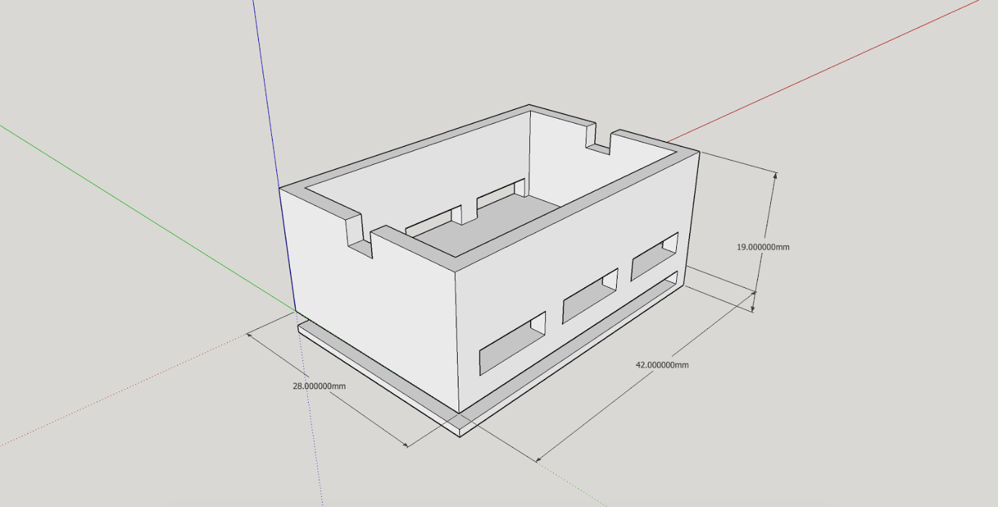
The project began with the exploration of suitable SoC components and circuits. One of the best possible out-of-box options available that suited the requirements was Particle.io’s Photon, a lightweight Wi-Fi bundle. In order to embrace a modular design, we chose a 150mAh Li-ion battery to power the entire setup. A 5v/100mA vibration motor and a bright 3V LED strip were used for vibration and light-based modalities respectively.
User Study
A total of 16 participants (9F, 7M) were recruited for the study. The user study was designed to capture the participant’s likeness and perceived effectiveness of the feedback modalities in both a social setting and a personal setting. It consisted of two phases and was carried out in public spaces such as the library and the cafe at the Rochester Institute of Technology.
The first phase was designed to test how distracting the device is to people around the wearer of the prototype.
The second phase tested different intensities of light and vibration to locate the ideal intensity that provided notifications without jarring the users out of their current activity.
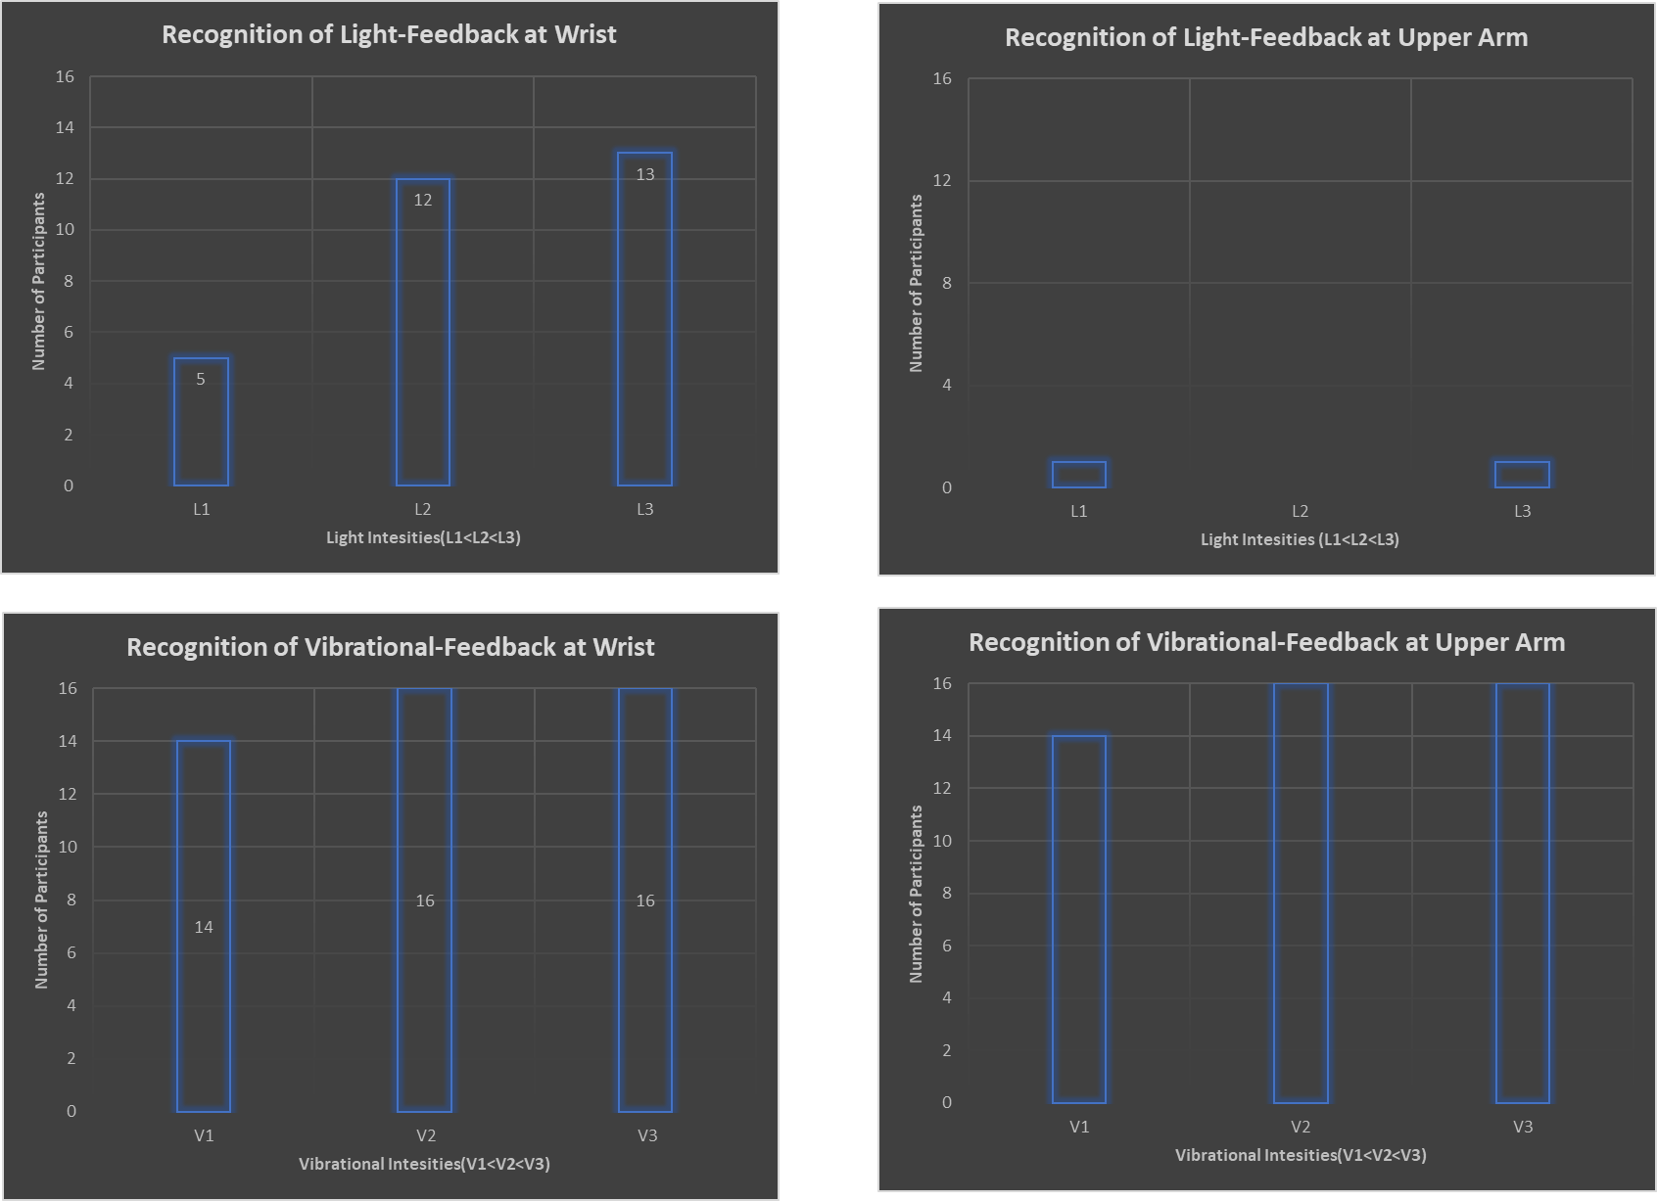

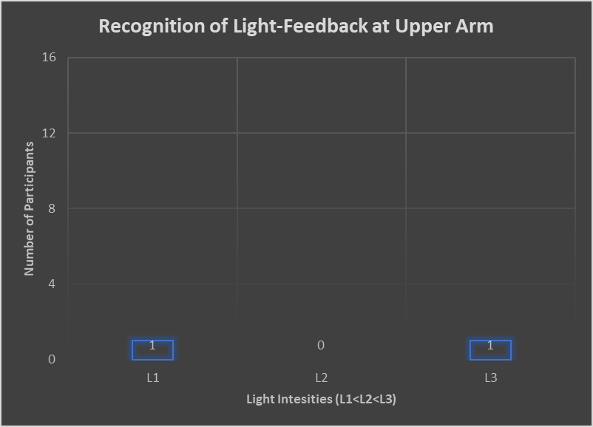
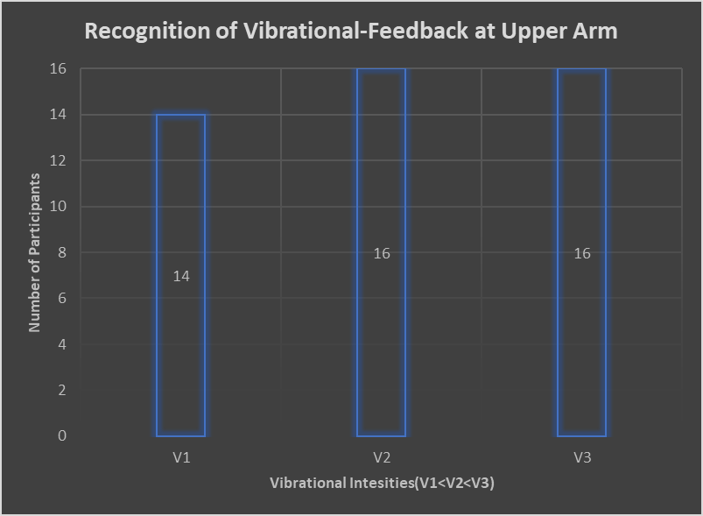

User Centered Design Principles – Indago
Introduction
As user experience designers and researchers, we have all come across similar problems, especially while recruiting the right participants for a study. This is motivation behind Indago (search out, try to find/procure by seeking), an app that helps create a community of people who share an affinity for research. As a 4-member team, we worked right from the inception to the prototyping of the app. The service that Indago provides helps researchers to find the participants they need for their research studies, helps individuals find opportunities to participate in interesting and rewarding research.
Target Audience
<icons for researcher, participant and organizations>
Process
Affinity Diagram
Vision
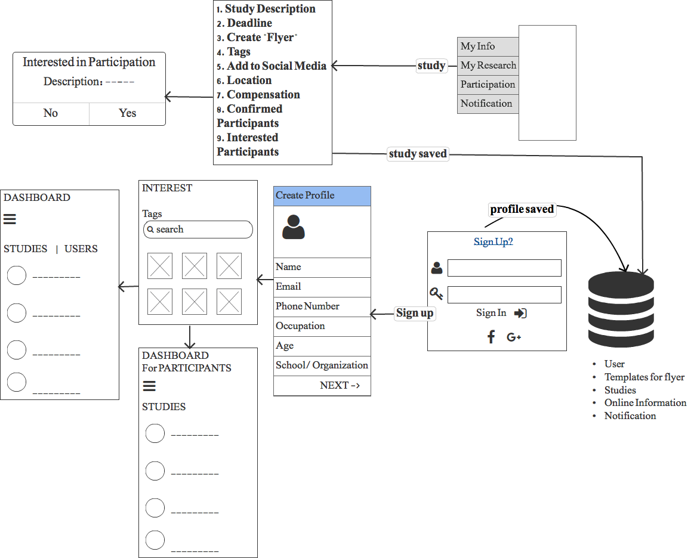Story Boarding
Creating Profile
Creating Study
User Search
Wireframes

On The Way – Personal Project
Inception
While working in Bangalore, India, my daily commute to and from office was always the most boring part of the day. Sitting in traffic listing to people honk or listening to the radio I always wished I had to someone to talk to. This situation gave birth to OnMyWay, a ride sharing app to help students and working professionals alike, to find rides and make friends on their everyday route.
Transport is one of the biggest expenses for both students and office goers and Carpooling helps reduce it. This app tries to make the task of finding a carpool or even a bike pool, with the right people, easier.
Process
- Data Flow
- Wireframing
- Prototyping
Data Flow
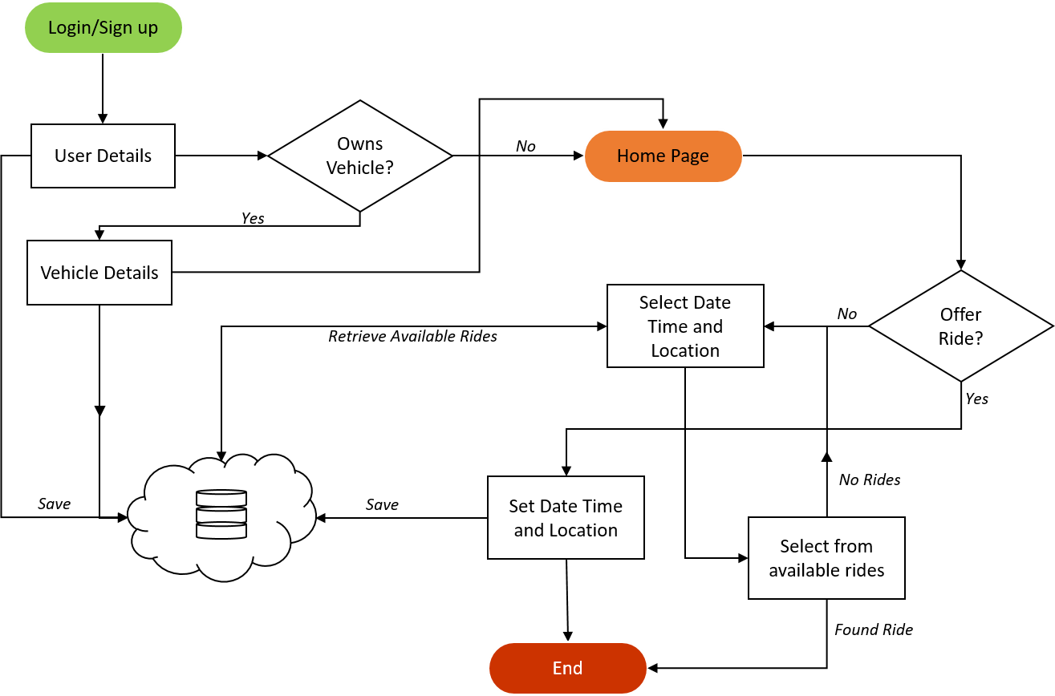
Wireframing

Prototyping

