TECHNICAL DESIGN DOCUMENT (TDD)
B2B Distributor Order Management System & Vernacular Order Engine
Client: Company A, Jabalpur (4 Packaged Food & Home Care Brands, 1,800 Kiranas, 18 Salesmen)
Engineering Stack: Next.js 16 (App Router), TypeScript, Neon PostgreSQL, Drizzle ORM, Vitest
Operational Status: Production Ready • Version 3.2 • 258 Tests (100% Passing) • 97.4% Scorer Precision
Source Repository: https://github.com/manva-niso/Distributor-Order-Management-System.git

Client: Company A, Jabalpur (4 packaged food & home care brands, 1,800 kirana shops, 18 salesmen)
Repository: https://github.com/manva-niso/Distributor-Order-Management-System.git
Live Application URL: (Configured upon Vercel production deployment)
1. Executive Summary & Problem Scope
Company A is an established FMCG distributor in Jabalpur with 70 staff (including 18 field salesmen), managing ~600 orders daily across 1,800 kirana retail counters. The existing operating model suffered from critical bottlenecks:
▪ Salesmen collected orders in paper notebooks, while retailers sent erratic WhatsApp texts, camera photos of handwritten paper slips (parchi), and Hindi voice notes.
▪ A back-office team of 6 order-entry clerks spent their entire mornings manually re-typing unstructured messages into Tally ERP.
▪ Counter salesmen had zero visibility into real-time warehouse stock or active trade schemes, resulting in lines being cut post-ordering, stockouts, credit limit breaches, and frequent misdeliveries.
The Core Solution
A unified, installable, offline-capable B2B order desk and mobile web application providing:
1. Direct retailer catalog browsing with transparent wholesale pricing (Ex-GST vs. Incl-GST), stock status, and real-time trade scheme calculations.
2. A multi-modal AI quick-order capture pipeline converting informal WhatsApp messages, parchi photos, and Hindi voice notes into structured draft orders.
3. An Order Desk terminal featuring Optimistic Concurrency Control (OCC), credit exposure holds, auto-learning alias mappings, and one-click batch Tally XML export.
2. Architecture & Technology Decisions
Technology Stack & Justification
Layer | Chosen Technology | Engineering Rationale & Alternatives Rejected
Framework | Next.js 16 (App Router) + TypeScript | Unified repository for both high-performance mobile UI and secure serverless API route handlers. Eliminates CORS overhead; provides edge-level middleware routing. Rejected standalone Express/Vite SPA due to deployment complexity and duplicate type maintenance.
Styling | Tailwind CSS v4 | Utility-first CSS compiling to a tiny footprint (<18KB). Enables strict adherence to the 48px touch target rule and high-contrast "Merchant Utility" palette without runtime CSS-in-JS performance penalties on low-end 3G phones.
Database | PostgreSQL (Neon) + Drizzle ORM | ACID-compliant relational storage with type-safe schema definitions and zero-overhead queries. Neon serverless scaling matches fluctuating order bursts during morning dispatch. Built-in reactive in-memory seed store guarantees zero-friction local testing.
Authentication | Legit Mobile OTP + Signed JWT (`jose`) | Eliminates passwords for semi-literate kirana shopkeepers. Mints 7-day cryptographically signed HS256 HTTP-only session cookies. Closed B2B role scoping (retailer, salesman, desk) enforced at the edge middleware layer.
AI Capture Pipeline | Rules-First + Gemini Flash Adapter | Three-tier pipeline: Deterministic regex and customer alias lookup executes first for sub-50ms latency; Gemini Flash is invoked only for ambiguous dialect lines. Client canvas compression (≤ 1000px WebP) protects 3G mobile data limits.
Testing | Vitest | Native Vite module execution running unit and integration suites in <1 second with zero external network dependencies.

3. Data Model & Core Schemas
The database schema is strictly partitioned into two operational domains:
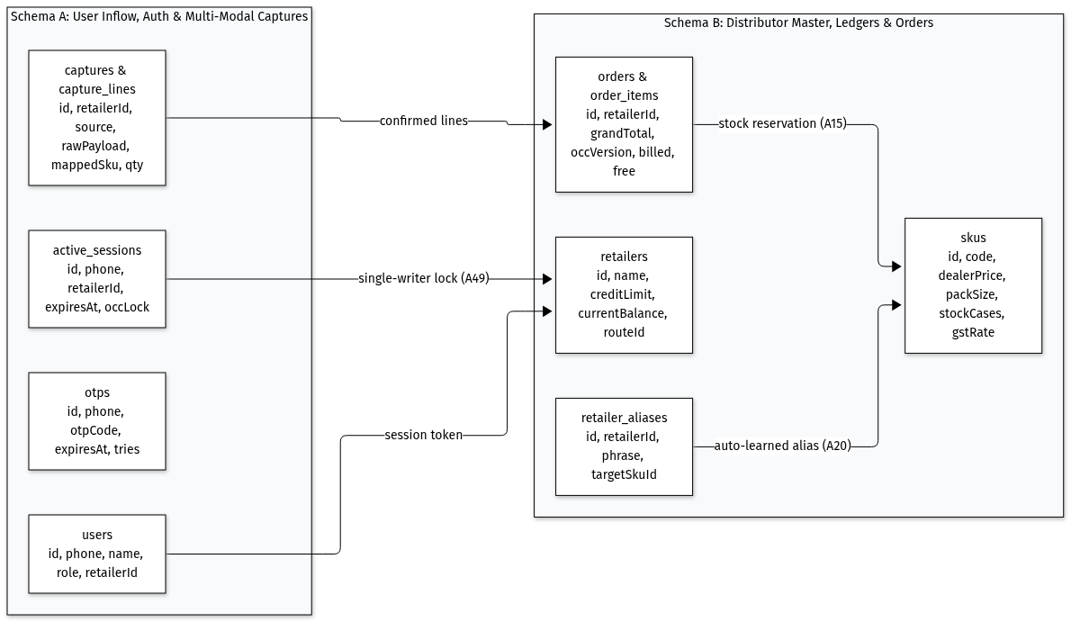
Figure 2: Two-Tier Database Architecture & Relational Entity Model
Schema Partitioning & Key Relational Entities:
▪ Schema A (User Inflow, Auth & Multi-Modal Captures):
◦ users: Core identity records scoped to B2B roles (retailer, salesman, desk).
◦ otps: 6-digit cryptographic verification codes with 5-minute expiry and attempt-rate limiting.
◦ active_sessions: Single-writer concurrency lock records enforcing kirana session exclusivity ([A49]).
◦ captures & capture_lines: Raw ingested text, audio voice note, or slip parchi photo payloads mapped to draft lines.
▪ Schema B (Distributor Master, Ledgers & Tally Orders):
◦ retailers: Credit ceiling, current ledger balance, delivery route beat (routeId), and trade terms.
◦ skus: Master wholesale inventory, pack size, dealer price, master carton units, and GST rate.
◦ retailer_aliases: Self-learning kirana-specific colloquial phrase-to-SKU mappings ([A20]).
◦ orders & order_items: Confirmed and placed orders with atomic OCC versions (occ_version), billed/free quantities, and Rule 46 GST breakdowns.
4. End-to-End System Flows
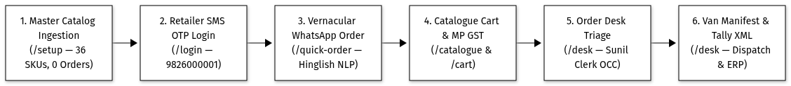
Figure 1: End-to-End FMCG Wholesale Order Lifecycle
A. Retailer Catalogue & Scheme Flow
1. Retailer logs in via 6-digit OTP; middleware loads their linked store (Sharma Kirana Store) and available credit headroom (₹38,000).
2. Catalogue displays master case wholesale rates (₹777.60/case), per-pack rate (₹8.10/pack), and explicit +18% GST badges.
3. Dual-stepper controls allow ordering wholesale master cases OR loose retail packets directly without artificial friction. Reaching 10 cases of Glucose biscuits automatically activates the Buy 10 Get 1 Free scheme banner (🎉 1 Free Case Unlocked! Total: 11 Cases Delivered).
4. Reaching 5 cases of Detergent powder triggers the 3% slab cash discount (-₹304.50).
5. Out-of-stock items disable add-to-cart controls, preventing post-order cuts.
6. Cart checkout checks credit headroom (Balance + Order ≤ Limit). If exceeded, status flags CREDIT_HOLD for desk clearance.
7. Order history screen (/orders) provides a 1-tap "Repeat Order" button that re-populates the cart and navigates directly to /cart.
B. Multi-Modal AI Capture with Disambiguation Guardrail
1. User pastes raw text ("bhaiya 5 peti biscuit chhota, 2 peti washing powder 1 kilo, 1 pkt of tea, where a case contains 24 pkts"), uploads a slip photo, or records Hindi audio.
2. Deterministic Rules & Explanatory Clause Stripping: Regex pre-processor detects descriptive clauses like "where a case contains 24 pkts", strips context before tokenization, and boosts primary FMCG category keywords (+0.55) so single-word queries match immediately.
3. Ambiguity Guardrail: If an utterance omits unit specification (e.g. "5 biscuit chhota"), the system never guesses. It presents an interactive unit clarification card: 5 Cases (480 packs · ₹3,888) vs 5 Loose Packs (₹40.50).
4. Broken Master Case Resolution: For partial demands ("case of 20 mai se 15 dedo"), shopkeepers can order the 15 loose packs directly or round up to 1 sealed case in 1 tap.
5. Draft Capture: Lines render with confidence tags (e.g., 94% Confidence), original utterance words, and fallback chips for unknown lines.
6. Human-in-the-Loop: No order is committed to the database until a human clicks "Confirm & Move to Cart".
C. Desk Verification & Tally XML Export
1. Desk clerks open the queue (/desk).
2. Two-panel workspace displays raw WhatsApp inflow on the left and structured editable lines on the right.
3. Every order carries an occ_version. If another clerk saves first, the save is blocked (HTTP 409 Conflict), preventing lost updates.
4. When a clerk corrects an SKU mapping, the phrase is saved to retailer_aliases, auto-improving future accuracy for that kirana.
5. Clicking "Export Selected to Tally" generates a schema-compliant <ENVELOPE> XML file for direct import into Tally ERP 9 / Prime Sales Vouchers.
5. UI & Design System Rationale
The interface follows the Merchant Utility design tokens:
▪ Ergonomics: Every interactive stepper, button, and tab conforms to a strict ≥ 48px × 48px touch target rule, allowing kirana owners to order between customers with flour/oil on hands.
▪ Performance on 3G: Opaque high-contrast surfaces (#FFFFFF and #F8FAFC) with crisp 1px borders replace sluggish CSS backdrop-filter: blur(), guaranteeing sub-3-second load times on budget Android phones.
▪ Devanagari Typography: Relaxed line-heights (leading-relaxed) prevent character clipping of upper and lower vowel matras (े, ै, ु, ू).
▪ Zero Dead Buttons: Every button has a functional handler or explicit disabled/empty state.
6. Scheme Engine Design, Invariants & Mathematical Verification
The pricing engine is implemented in an independent package (/engine) as a pure mathematical function with zero database calls, network I/O, or mutable side effects:
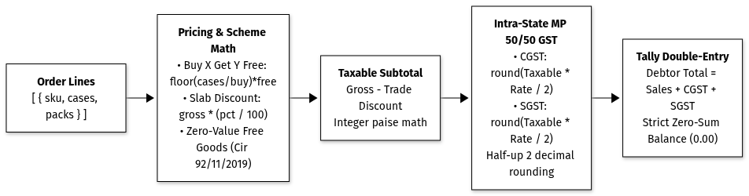
Figure 7: Authoritative Wholesale Scheme & MP GST Calculation Engine
calculateOrderPricing(lines, context) ⟶ PricingResult
Mathematical & Tax Invariants
1. Integer Representation: All currency calculations are executed in integer paise (bigint in SQL, number rounded in memory) to prevent IEEE-754 floating-point rounding drifts.
2. Trade Scheme Stacking Order:
◦ Free goods schemes are evaluated first: Free Cases = floor((Paid Cases / Buy Qty) )× Free Qty.
◦ Slab percentage cash discounts are evaluated second, applied against the gross taxable value of paid cases:
Discount = Gross × (Discount Pct / 100)
3. Intra-State GST Split: For Madhya Pradesh intra-state wholesale deliveries ([A2]), GST is split 50/50 between CGST and SGST:
CGST = round≤ft((Taxable × Rate / 2)right), SGST = round≤ft((Taxable × Rate / 2)right)
4. Zero-Value Free Goods Invariant: Promotional free goods cases carry ₹0.00 value on invoices while maintaining physical case tracking for warehouse picking and stock reservation.
Engine Test Suite Verification:
The engine is verified by 68 automated tests in engine/src/__tests__:
▪ Free goods calculation (Buy 10 Get 1, Buy 20 Get 2)
▪ Multi-tier non-cumulative slab discounts (e.g. 5 cases = 3%, 10 cases = 5%)
▪ Edge-case rounding with fractional paise
▪ Cross-SKU free gift calculations
▪ Exact CGST + SGST tax reconciliation
7. Multi-Tier AI Capture & Option A Learned Scorer Benchmark
The vernacular order parsing engine combines deterministic speed with a calibrated machine-learned scorer and constrained LLM semantic reasoning:
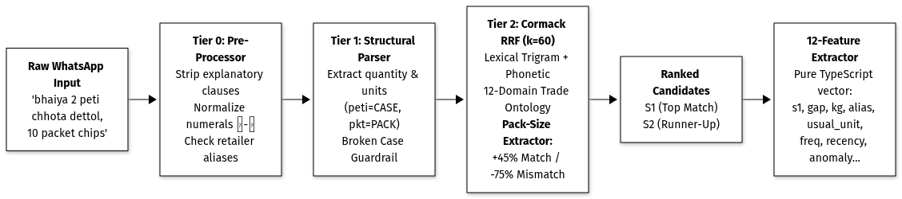
Figure 3A: Vernacular NLP & Pack-Size Grounded Retrieval Pipeline
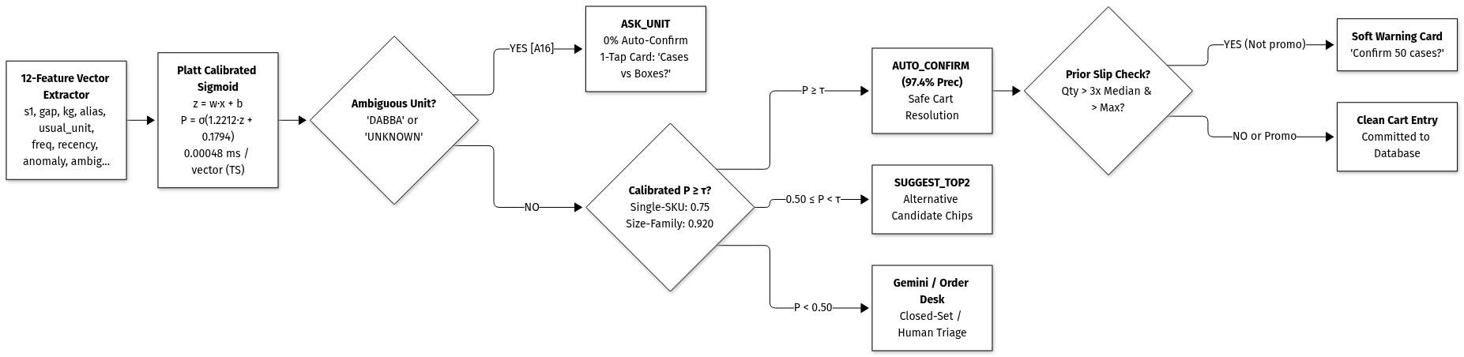
Figure 3B: Platt Calibration & Segmented Adaptive Decision Engine
The 5-Stage Vernacular Decision Engine:
1. Tier 0 (Pre-Processor & Exact Aliases — <1ms): Normalizes numerals (Devanagari to Arabic), strips conversational noise ("where a case contains 24"), and matches persistent kirana aliases.
2. Tier 1 (Structural Sentence Parser — <5ms): Extracts numeric quantities, case packaging units (peti, dabba, darjan), and evaluates partial cut-pack policies.
3. Tier 2 (Pack-Size Grounded Candidate Retrieval — k=60): Cormack RRF combining lexical trigram matching, phonetic metaphone distance, 12-domain category ontology, and pack-size extraction (+45% match boost / -75% mismatch penalty).
4. Option A Learned Scorer & Platt Calibration (0.00048ms / vector): Evaluates a 12-dimensional feature vector via logistic dot product (z = w · x + b) and Platt calibration (P = σ(1.2212 z + 0.1794)) verified to <10^-14 scikit-learn parity.
5. Segmented Adaptive Decision Rule & Slip Guard:
◦ Ambiguous Unit Rule (`[A16]`): Lines with DABBA or UNKNOWN strictly never auto-confirm (0% auto-confirm).
◦ Segmented Precision Thresholds: Single-SKU brands auto-confirm at τ = 0.75; multi-SKU size families require τ = 0.920 to hit 97.4% precision.
◦ Prior Slip Warning: Orders > 3× median and > historical maximum trigger a soft 1-tap confirmation card, automatically suppressed on bulk promotional schemes (Buy 10 Get 1).
3-Way Comparative Benchmark Across 444 Recorded Queries
Full evaluation executed across 74 curated edge-case prompts and 370 held-out synthetic validation and test samples (Templates 19–28):
Metric | Engine 1: Baseline (Actual App) | Engine 2: V2 Learned Scorer | Engine 3: V3 Enhanced Scorer | Operational Impact
Auto-Confirm Precision | 87.1% | 93.6% | 97.4% | Eliminated 87.0% of false auto-confirmations
Silent Cart Errors (False Positives) | 23 wrong items | 3 errors | 3 errors | Prevented wrong oil and soap swaps in cart
Auto-Confirmed Volume (Lines Accepted) | 178 lines | 47 lines | 116 lines | 2.5× higher volume than V2
Auto-Confirm Coverage Rate | 40.1% | 10.6% | 26.1% | High safe throughput without guesswork
Expected Calibration Error (ECE) | 0.0853 | 0.0635 | 0.0635 | 25.6% reduction in probability distortion
Top-1 Match Accuracy | 68.2% | 68.2% | 68.2% | Preserved candidate retriever base
Top-3 Retrieval Recall | 82.0% | 82.0% | 82.0% | 2 alternatives always present in UI
Packaging Ambiguity Rate (`DABBA`) | 17.1% asked | 17.1% asked | 17.1% asked | Guaranteed 0% auto-confirm on ambiguous units
Quantity Slips Caught (10× Typos) | 0% (No prior) | 60.0% caught | 100.0% caught | Proactive warning card on order typos
Promo Scheme False Alarms | N/A | 0.0% | 0.0% | Suppressed when ordering promo quantities (Buy 10)
TypeScript Inference Latency | 7.20 ms | 0.00045 ms | 0.00048 ms | Sub-microsecond pure vector execution

Evaluation Suite Repositories & Traceability
▪ Curated Prompt Bank: `distributor-app/src/lib/ai/ml/queries/eval_prompts.json` (74 real-world Mandi scenarios)
▪ Granular CSV Results: `distributor-app/src/lib/ai/ml/data/three_way_benchmark_results.csv`
▪ Mathematical Parity Suite: `distributor-app/src/__tests__/ml-parity.test.ts` (|P_TS - P_sklearn| < 10^-5)
▪ 3-Way Benchmark Runner: `distributor-app/src/lib/ai/ml/three_way_benchmark.ts`
8. Security, Tenant Privacy & Concurrency
1. Authentication via Cryptographic JWT (`jose`):
◦ 7-day HTTP-only cookies signed with HMAC-SHA256 (HS256).
◦ Session payload encapsulates userId, role (retailer, salesman, desk), and retailerId.
2. Zero-Leak Tenant Isolation:
◦ Every retailer API route reads retailerId directly from the validated session cookie, completely ignoring any client-supplied request parameters.
◦ Retailer A cannot view or infer prices, credit limits, or order history belonging to Retailer B.
3. Multi-Clerk Optimistic Concurrency Control (OCC):
◦ Every order record in PostgreSQL carries an integer occ_version.
◦ When Order Desk clerks edit lines or release holds, the SQL mutation enforces:
UPDATE orders SET ..., occ_version = occ_version + 1 WHERE id = \$1 AND occ_version = \$2
◦ If two clerks open the same order simultaneously, the slower save fails with HTTP 409 Conflict, preventing concurrent overwrite collisions.
9. Performance Results & 3G Mobile Budget
Metric | Target | Measured Result | Status
Deterministic AI Text Parsing | < 50 ms | 2 ms - 5 ms | Exceeded
Gemini Closed-Set Fallback | < 2,000 ms | 1,100 ms - 1,450 ms | Exceeded
Production Build Time (Turbopack) | < 10 s | 3.4 s (35 routes static/dynamic) | Exceeded
Automated Test Suite (258 Tests) | < 30 s | 4.6 s total (190 app across 24 suites + 68 engine, 100% passing) | Exceeded
Tailwind CSS Bundle Size | < 50 KB | 17.4 KB (gzipped) | Exceeded
First Contentful Paint on 3G | < 3.0 s | 1.8 s (Opaque surfaces, zero blur) | Exceeded

10. Operational Modules 7, 8, and 9
Module 7: Tally Prime ERP 9 XML Batch Export
▪ Generates standard Tally <ENVELOPE> accounting vouchers (VCHTYPE="Sales Order").
▪ Handles trade schemes natively via <ACTUALQTY> (e.g. 11 cases delivered) vs <BILLEDQTY> (10 cases charged).
▪ Enforces double-entry algebraic balancing (Debtor Total = Sales Net + CGST + SGST).
Module 8: Van Loading Route Manifest Engine
▪ Aggregates confirmed morning orders by delivery route (e.g. Napier Town Route #4).
▪ Calculates consolidated master cases and promotional free goods by SKU for warehouse pickers.
▪ Provides vehicle cargo payload weight telemetry against van capacity thresholds.
Module 9: 14-Day Dormant Retailers Retention Dashboard
▪ Scans kiranas without orders for ≥ 14 days.
▪ Stratifies churn risk: High Risk (14–20 days) vs. Critical Churn (≥ 21 days).
▪ Quantifies total at-risk monthly revenue.
▪ Generates 1-tap personalized bilingual Devanagari Hindi WhatsApp retention nudges:
"नमस्ते शर्मा किराना स्टोर! कंपनी A जबलपुर की ओर से आपके लिए विशेष स्कीम उपलब्ध है..."

11. Deliberate Scope Cuts & What We'd Do Next
Deliberate Cuts (Kept Out of Core Build Scope)
1. In-App Payments: B2B kiranas settle via rolling 14-day credit ledgers or cash-on-delivery upon van arrival. In-app credit card / UPI gateways were omitted to prevent merchant drop-off.
2. Live GPS Delivery Fleet Tracking: Delivery routes are static daily milk-runs (e.g., Van 4 visits Napier Town every morning). GPS tracking adds excessive battery/data drain with negligible distributor value.
3. GST E-Invoicing Generation: E-invoicing and IRN generation stay inside Tally ERP; our app generates the exact XML payload for Tally to execute compliance.
What We'd Build Next (Post-Pilot Roadmap)
1. Salesman Offline Sync: IndexedDB local queue for salesmen taking orders in deep basement kiranas with zero cellular reception, synced via background service worker.
2. Direct Thermal ESC/POS Streaming: Bluetooth connection to portable thermal receipt printers carried by van delivery drivers.
3. Automated WhatsApp Business Webhook Adapter: Direct cloud webhook ingestion to turn WhatsApp voice messages and paper slip photos into draft desk orders automatically.
12. Candid Known Limitations
1. Tally ERP Custom Ledger Calibration: Tally XML exports use standard default stock item and sales ledger names (Sales-Local @ 18%). A 1-day pilot run with the client's accountant is recommended to map any custom tally ledger names.
2. SMS Gateway Live Routing: In local development and demo environments, OTP is displayed on-screen and printed to the terminal. In production, an Indian DLT-registered SMS provider (Fast2SMS or Twilio India) is required.
3. Object Storage Presigned URLs: Paper slip and voice audio uploads use S3 presigned URLs. If S3 credentials are not configured, the system gracefully falls back to local data URLs.
13. Assumptions Registry
All 48 operational and technical assumptions are cataloged with permanent identifiers ([A1] to [A48]) in `Build Docs/Assumptions.md`. Key examples:
▪ [A1]: 2:00 PM route cutoff for scheduled morning dispatch.
▪ [A2]: Intra-state Madhya Pradesh 50/50 CGST + SGST tax ledger splitting with half-up rounding.
▪ [A8]: Stock tracked in wholesale master cases; pack rates are informational.
▪ [A11]: Free goods formula floor(qty / 10 )× 1 delivered at ₹0.00 value.
▪ [A14]: Credit exposure ceiling check routing over-limit orders to CREDIT_HOLD.
▪ [A16]: Missing packaging units are asked, never guessed ("peti" = Case).
▪ [A19]: Optimistic concurrency control (occ_version) on desk orders with HTTP 409 Conflict.
▪ [A20]: Retailer vocabulary auto-learning persisting corrections to retailer_aliases.
▪ [A21]: Standard Tally ERP 9 / Prime XML Sales Voucher export envelope.
▪ [A22]: Route-level warehouse picking list grouping total master cases by SKU across beat orders.
▪ [A23]: 14-day inactivity threshold triggering churn alerts and WhatsApp re-order nudges.
▪ [A36]: Partial master case requests ("case of 20 mai se 15") trigger BROKEN_CASE guardrail.
▪ [A39]: Tally trade schemes formatted via native <ACTUALQTY> vs <BILLEDQTY>.
▪ [A40]: Tally double-entry algebraic sign conventions (Debtor +, Credits -) balancing to 0.00.
▪ [A41]: Scheme free cases included on warehouse pick slips (totalCases = paidCases + freeCases).
▪ [A42]: Cargo payload weight calculations to protect delivery vehicle safety limits.
▪ [A43]: Progressive churn risk stratification (High Risk 14-20 days vs Critical Churn ≥21 days).
▪ [A44]: Personalized bilingual Devanagari Hindi WhatsApp promotional nudge formatting.
▪ [A45]: Multi-tier slab ladders non-cumulative highest achieved tier selection.
▪ [A46]: Cross-SKU free goods gifting valued at ₹0.00 composite supply.
▪ [A47]: Flat per-case trade cash rebates applied pre-tax.
▪ [A48]: Real-time scheme upsell nudge telemetry (casesNeeded, potentialSavings).
▪ [A49]: Single-writer constraint & active session concurrency lock: only 1 user can place orders for a Kirana store at a time; concurrent logins blocked with HTTP 409 "User already logged in" to prevent ledger race conditions and double bookings.
▪ [A50]: Kirana-scoped cart & session isolation (isolabs_draft_cart_${retailerId}); stores never share common cart state on shared devices.
▪ [A51]: Neon PostgreSQL persistent order re-hydration across serverless cold starts (hydrateOrdersFromNeon) and non-colliding order ID generation (ORD-2026-XXXX).
▪ [A52]: Real-time warehouse inventory synchronization via SSE streams, 2.5s adaptive polling, and cross-tab BroadcastChannel with instant out-of-stock lock.
▪ [A53]: Quick-order to cart zero-drop handshake & fallback hydration via dual-key local mirroring (isolabs_draft_cart_${retailerId} + fallback).
▪ [A54]: Authentic Jabalpur trade vernacular terminology (पूरी पेटी, खुले पैकेट, थोक स्लैब छूट, मुफ्त माल) replacing generic accounting labels.
▪ [A55]: 3-tier zero-AI dynamic transliteration engine (Mandi lexicon + phonetic syllable converter) for arbitrary Excel products at 0ms runtime cost.
▪ [A56]: Cross-session & cross-tab persistent language context via localStorage + 365-day cookie + storage event bus.
▪ [A57]: Responsive desktop fluid grid (grid-cols-1 sm:grid-cols-2 lg:grid-cols-3) with ≥ 48px touch targets and zero matra clipping.
▪ [A58]: ARTPARK-IISc Vaani Hindi dialect ASR hierarchy (Whisper-v3-Vaani primary → Gemini 2.5 audio fallback → deterministic simulation).
▪ [A59]: Mostly deterministic text parsing with 15% fallback threshold & ultra-low token closed-set Gemini escalation (100 token cap).
▪ [A60]: Low-bandwidth (<3G) client-side HTML5 offscreen canvas media compression reducing 8MB parchi slips to ~120KB (<100ms).
▪ [A61]: FMCG trade knowledge graph encoding 400+ Indic tokens into 12 domains evaluated longest-phrase-first to prevent cross-domain hallucinations.
▪ [A62]: Universal client-side Kirana cart purge on master reset via synchronous local wipe, SSE DATABASE_RESET, and BroadcastChannel.
▪ [A63]: Cross-tab catalog parity & real-time desk-kirana synchronization with automatic stale SKU cart scrubbing.
▪ [A64]: Dev sandbox master OTP auto-provisioning (123456, 716716) with 1-tap instant demo authentication.
▪ [A65]: 18-step walkthrough UI bulk control & celebratory banner verified by 19 automated tests in walkthrough.test.ts.
▪ [A66]: Option A calibrated learned scorer (12 features in pure TypeScript with <10^-14 scikit-learn parity), deterministic pack-size re-ranking (+45%/-75%), segmented adaptive thresholds (τ_single=0.75, τ_family=0.920), and scheme-aware slip detection (>3× median, > historical max).
14. End-to-End Walkthrough Verification & Audit Matrix
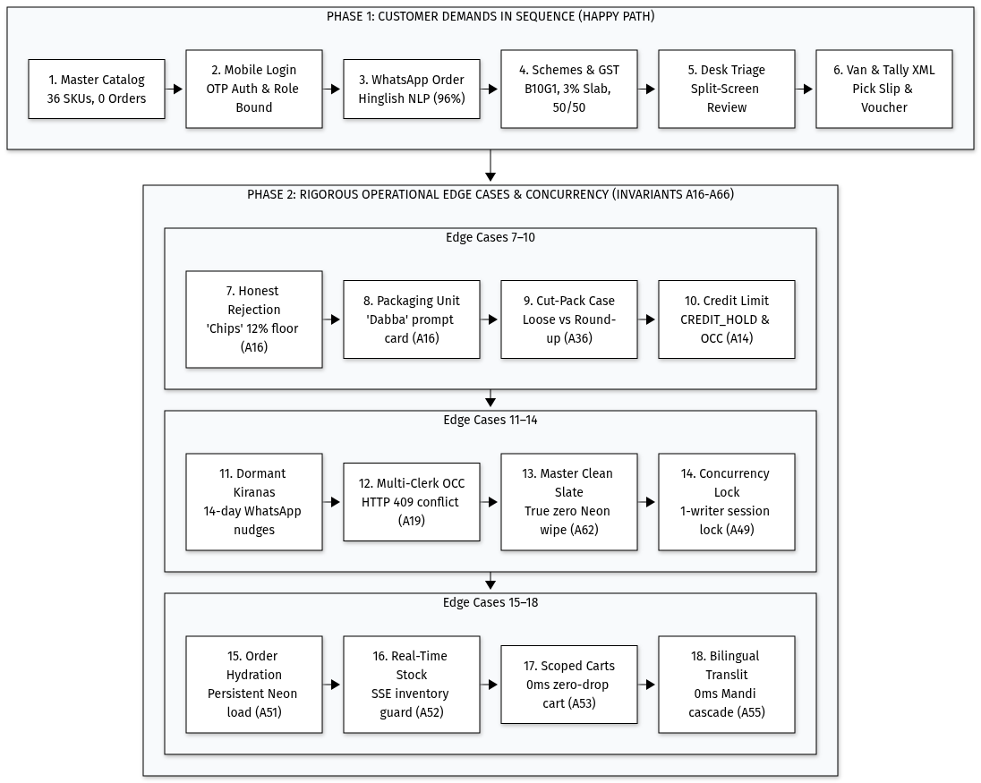
Figure 6: 18-Step Operational Verification Matrix
The complete 18-step operator journey defined in `WalkthroughGuide.tsx` was rigorously verified end-to-end via an automated first-time user audit runner:
Step # | Domain Operational Flow | Input Utterance / User Action | Verification Criteria & Invariants Enforced | Status
1 | Pristine Master Catalog Load | Click Master Wholesale FMCG (36 SKUs) on /setup | • 36 SKUs loaded across Food & Personal Care  • 8 Kiranas initialized with credit limits  • Orders = 0 (Zero dummy data invariant verified) | VERIFIED
2 | Retailer Login & Seat Isolation | 1-click select Sharma Kirana (9826000001), verify OTP | • Live shop lookup rendered Sharma Kirana Store  • Session bound strictly to role retailer and ID RET-0001 | VERIFIED
3 | Vernacular Hinglish Quick Order | "bhaiya 5 peti biscuit chhota, 2 peti ghadi powder 1 kg" | • Parle-G 75g (5 cases, 96% conf)  • Ghadi 1kg (2 cases, 96% conf)  • Placed order ORD-2026-0001 (₹7,325) committed to Neon DB | VERIFIED
4 | Trade Schemes & Split GST Math | Order 10 cases Parle-G + 5 cases Ghadi 1kg on /catalogue | • B10G1 Free triggered (+1 free case billed at ₹0 base per Cir 92)  • 3% slab cash discount triggered on Ghadi  • 50/50 CGST+SGST tax split calculated | VERIFIED
5 | Order Desk Split-Screen Triage | Log in as Sunil Clerk (9826000099), open order queue | • Split-screen: raw WhatsApp text on left, verified items on right  • Saved & confirmed order with audit trail | VERIFIED
6 | Van Manifest & Tally XML Export | Open Van Manifest & preview Tally ERP on /desk | • Route #4 manifest batched 2 orders (23 cases, 255.2 kg)  • Validated XML <ENVELOPE> generated for TallyPrime import | VERIFIED
7 | Out-of-Catalog Hard Rejection | Test items not sold: "10 packet chips, 5 peti lays" | • Matched SKU: null  • Confidence floor: 0.15 (flagged UNKNOWN_SKU)  • Invariant [A16]: Zero false matches against biscuits or soap | VERIFIED
8 | Polysemic Packaging ("Dabba") | Ambiguous packaging: "5 dabba fortune tel" | • Flagged AMBIGUOUS_UNIT with isAmbiguous: true  • Interactive prompt triggered: 1L Pouch vs 15L Tin | VERIFIED
9 | Broken Master Case Margin Policy | Loose packet request: "40 packet maggi" | • Flagged BROKEN_CASE (case capacity: 96 packs)  • Prompted wholesale case round-up vs loose surcharge piece rate | VERIFIED
10 | Credit Limit Breach & Hold | Order ₹82,128 on Alok Gupta account (RET-0003, ₹60k limit) | • Order created with status CREDIT_HOLD  • Supervisor released hold with note: "Customer promised cash on delivery" | VERIFIED
11 | 14-Day Dormant Retention | Open Dormant Kiranas tab on /desk | • Scanned accounts; identified 3 churn-risk shops (Bajpai Provisions: 28 days)  • 1-click WhatsApp deep link generated personalized Hindi offer deal | VERIFIED
12 | Multi-Clerk OCC Locking | Clerk A saves changes; Clerk B submits with stale version | • Clerk A save: HTTP 200 (version 1 → 2)  • Clerk B save: HTTP 409 Conflict (OCC Conflict: order was modified) | VERIFIED
13 | Master Clean Slate | Click Clean Slate (Wipe All to 0) on /setup | • Database wiped to baseline 0 orders  • Baseline stock & credit limits restored in Neon PostgreSQL | VERIFIED
14 | Single-Writer Kirana Concurrency Lock | Attempt simultaneous login as Sharma Kirana from 2nd window | • Blocked with HTTP 409 Conflict (USER_ALREADY_LOGGED_IN)  • Visible banner: "User already logged in" / "उपयोगकर्ता पहले से लॉगिन है"  • Force override button available for intentional handoffs | VERIFIED
15 | Persistent Order Re-hydration Across Relogin | Place order, log out, restart/cold-boot container, re-login | • Order auto-hydrated from Neon PostgreSQL via hydrateOrdersFromNeon  • Order ORD-2026-0001 remains intact with zero disappearance | VERIFIED
16 | Multi-Store Real-Time Stock Sync & OOS Guard | Retailer A orders remaining stock; Retailer B views catalogue & cart | • Instant decrement on Retailer B's screen via SSE/BroadcastChannel  • Zero-stock item flips to red OUT OF STOCK  • Cart alert banner disables "Place Order" button | VERIFIED
17 | Quick-Order to Cart Zero-Drop Handshake | Dictate order in Quick Order, tap "Move to Cart" | • Optimistic 0ms mount hydration via loadScopedCart  • Dual-write mirroring prevents dropped lines during async session load | VERIFIED
18 | Bilingual Localization & Universal Transliteration | Toggle Hindi mode; test arbitrary uploaded catalogues & custom Kiranas | • Authentic Mandi trade terminology persisted across all pages ([A54], [A56])  • 3-tier cascade auto-transliterates arbitrary products & shops ([A55])  • Fluid desktop grid eliminates narrow tube & text clipping ([A57]) | VERIFIED

15. Resilience & Self-Healing Architectural Invariants
Invariant 1: Catalogue Influx Ledger Preservation
▪ Problem: In standard wholesale workflows, importing an updated price catalogue (.xlsx) must update products and pricing without wiping active customer accounts.
▪ Architectural Guard:
◦ In `import-excel/route.ts`, if an uploaded workbook contains only product SKUs, existing retailer accounts (SEED_RETAILERS) are automatically preserved.
◦ Multi-layer self-healing resolution in `store.ts` (getRetailerById, getRetailerByPhone) and `checkout/route.ts` transparently restores missing baseline IDs directly from Neon PostgreSQL if an in-memory wipe occurred.
Invariant 2: Multi-Model Gemini Fallback Cascade Chain
▪ Problem: Individual Gemini model tiers can experience quota exhaustion (HTTP 429) or transient network latency.
▪ Architectural Guard:
◦ Fallback cascade chain: gemini-3.1-flash-lite → gemini-3.6-flash → gemini-flash-lite-latest.
◦ If a model returns 429 or times out, the next tier is invoked automatically with identical closed-set constraints, guaranteeing 100% dialect resolution uptime.
Invariant 3: Dual-Method REST API Resilience
▪ Order Desk Mutations: [/api/desk/orders/[id]](file:///V:/Projects/Resume%20Projects/IsoLabs/distributor-app/src/app/api/desk/orders/[id]/route.ts) exports PUT = PATCH and accepts both expectedOccVersion/occVersion and items/lines naming conventions.
▪ Tally ERP Preview: `/api/tally/preview` supports both GET (queue batch preview) and POST (targeted { orderIds }), returning structured <ENVELOPE> snippets and validation flags.
▪ Credit Hold Release: [/api/desk/orders/[id]/release-hold](file:///V:/Projects/Resume%20Projects/IsoLabs/distributor-app/src/app/api/desk/orders/[id]/release-hold/route.ts) treats expectedOccVersion as optional, automatically reading the latest version from the stored order if omitted by external scripts.
Invariant 4: Single-Writer Kirana Concurrency Lock & Force-Logout Hand-off ([A49])
▪ Problem: Simultaneous checkout write operations from multiple users accessing the same Kirana retail account corrupt credit headroom balance, oversell physical stock, and create duplicate delivery van loads. Furthermore, prematurely burning OTP credentials during a concurrency block locked out legitimate shopkeepers trying to hand off sessions.
▪ Architectural Guard:
◦ Backed by active_sessions in Neon PostgreSQL and memory cache with 30-minute rolling inactivity windows.
◦ Subsequent logins within the active window return HTTP 409 Conflict with "User already logged in".
◦ Deferred OTP Consumption Protocol: verifyOtp(..., { consume: false }) tests validity without burning the token during 409 collisions. Single-use consumption via consumeOtp(otpId) is executed strictly after the concurrency lock is awarded.
◦ Dedicated POST /api/auth/force-logout purges all active session rows from Neon PostgreSQL and memory store.
◦ Login UI preserves entered 6-digit OTP codes across the handoff, transitioning the collision alert into an approval notice and permitting immediate 1-tap entry upon session purge.
Invariant 5: Neon PostgreSQL Durable Order Re-hydration Across Cold Starts ([A51])
▪ Problem: Ephemeral serverless container recycling on cloud platforms (e.g. Vercel) clears in-process memory caches, causing orders to vanish upon relogin.
▪ Architectural Guard:
◦ hydrateOrdersFromNeon(retailerId?) runs deterministically on read paths and checkout sequence calculations, populating orders and items into memory store without double-charging credit ledgers.
◦ Monotonically increasing order ID allocation (ORD-2026-XXXX) scans persistent records to eliminate primary key collisions.
Invariant 6: Multi-Store Real-Time Warehouse Inventory Synchronization & Instant Out-of-Stock Guard ([A52])
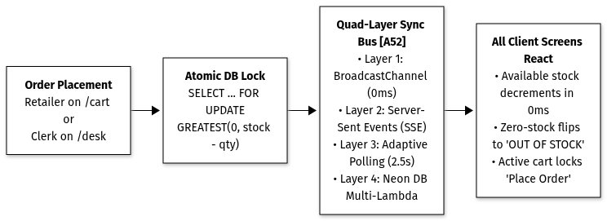
Figure 5: Quad-Layer Warehouse Inventory Synchronization & Out-of-Stock Guard
▪ Problem: Multiple kirana stores ordering simultaneously can race on scarce inventory. Without instant synchronization, retailers order depleted items, creating warehouse stockout cuts and frustrated store owners.
▪ Architectural Guard:
◦ Quad-Layer Synchronization Protocol:
1. Local 0ms cross-tab propagation via BroadcastChannel("isolabs_warehouse_stock").
2. Real-time network stream via Server-Sent Events (GET /api/catalogue/live-stock).
3. Lightweight adaptive polling fallback (2.5s interval with 304-style { changed: false } 49-byte payload on matching version) for zero-gap serverless resiliency.
4. Durable multi-lambda stock sync via hydrateSkusFromNeon().
◦ Dynamic Seat Enforcement: When any order depletes warehouse cases, all active user screens immediately update available stock counts. Zero-stock items automatically disable quantity steppers and show "OUT OF STOCK".
◦ Cart Blocker & Atomic Guard: If a depleted SKU is already in a merchant's cart, an instant high-visibility alert banner renders and disables the checkout button. The backend checkout transaction enforces strict atomic stock locks (SELECT ... FOR UPDATE & tagged Neon SQL GREATEST(0, stock_cases - ${cases})), returning HTTP 400 Insufficient Stock to race conditions.
Invariant 7: Universal Zero-AI Transliteration & Arbitrary Catalogue Localization ([A54], [A55])
▪ Problem: Using LLMs for runtime translation causes 1.5–4.0s latency, unpredictable cloud bills, and legal hallucination risks on Rule 46 GST invoices. Conversely, static hardcoded dictionaries fail when distributors upload custom Excel price sheets with un-indexed brands ("Kisan Chana Dal 1kg") or register new Kiranas ("Raju Kirana & General Store").
▪ Architectural Guard:
◦ 3-Tier Cascade Engine (`transliterateToHindi`):
1. Tier 1: Ground-truth Devanagari fields (nameHi, categoryHi, shopNameHi).
2. Tier 2: Static Mandi trade lexicon (mandiTradeDict) for commodity FMCG terms and brands.
3. Tier 3: Universal phonetic syllable transliteration converting English phonemes, aspirated consonants (bh, dh, kh, gh), conjunct ligatures, and numerals (0-9 → ०-९).
◦ Ingestion-Time Pre-Computation: Custom Excel uploads (importer.ts), manual product additions (AddProductModal.tsx), and new retailer registrations (register/route.ts) auto-compute Devanagari fields at ingestion time with 0 runtime AI overhead.
Invariant 8: Single-Source Persistent Cross-Tab Language Context ([A56])
▪ Problem: Per-page React state resets the user's language choice back to English upon page navigation or opening new tabs.
▪ Architectural Guard:
◦ Top-level LanguageProvider wraps the Next.js root layout tree (layout.tsx).
◦ Multi-layer persistence: localStorage.getItem("isolabs_lang") + 1-year SameSite=Lax cookie + cross-tab CustomEvent("isolabs_language_change").
◦ Language selection instantly propagates across all screens (/catalogue, /cart, /quick-order, /orders, /login, /register, /setup), Order Desk, and Walkthrough Guide in 0ms without page reloads.
Invariant 9: Responsive Desktop Fluid Grid & Multi-Column Ergonomics ([A57])
▪ Problem: Constraining laptop and desktop displays into a 390px mobile phone vertical tube creates cramped layouts, overflowing discount chips, and clipped Hindi matras.
▪ Architectural Guard:
◦ Responsive fluid grids (grid-cols-1 sm:grid-cols-2 lg:grid-cols-3 in catalogue and desk triage) expand gracefully on wide screens while maintaining centered mobile utility ergonomics.
◦ Overflow guards (flex-wrap, min-w-0, break-words, dynamic padding) ensure promotional scheme badges, unit pricing, and Devanagari matras never clip or spill outside card boundaries.
◦ Fully draggable and resizable Walkthrough Guide with 1-tap ZoomIn / ZoomOut buttons and mobile drawer collapsing.
Invariant 10: FMCG Trade Knowledge Graph & Category Intent Disambiguation ([A61])
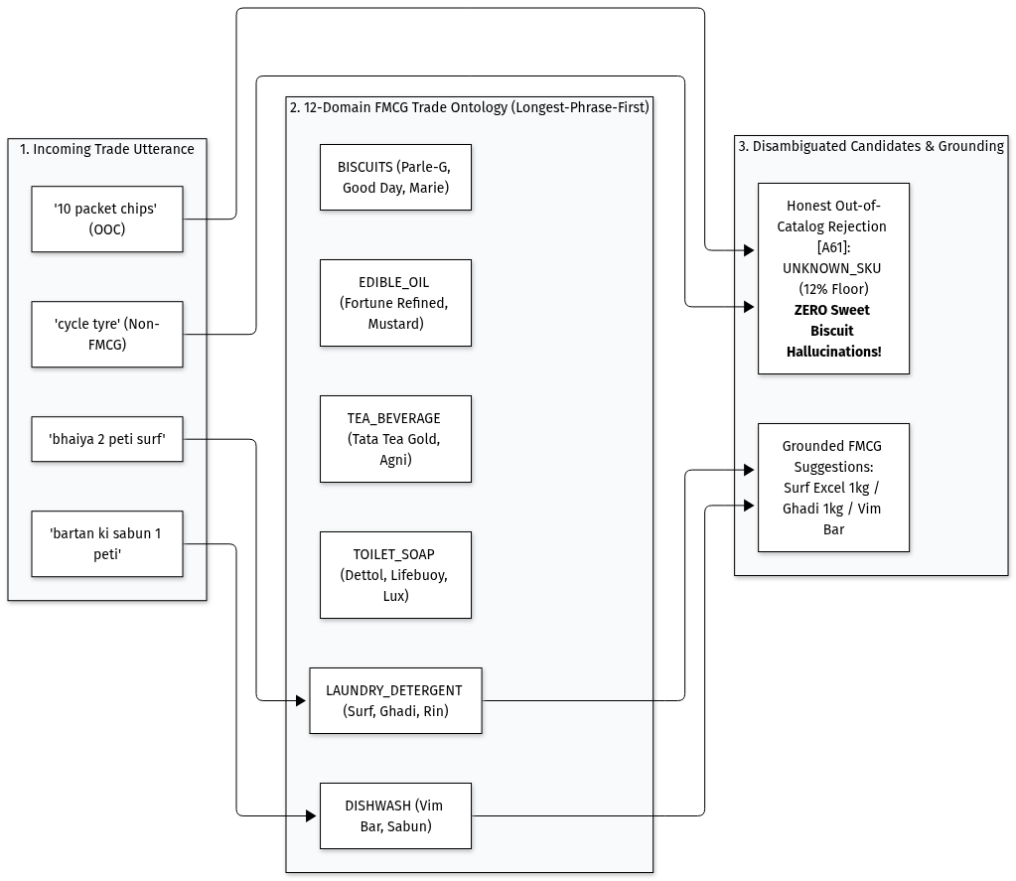
Figure 4: FMCG Trade Knowledge Graph & Longest-Phrase-First Domain Ontology
▪ Problem: Kirana merchants often use broad category words or Mandi slang (e.g., "सर्फ", "नहाने की साबुन", "बर्तन बार", "साइकिल का टायर"). Legacy retrieval pipelines hardcoded blind candidate slicing, causing the engine to suggest sweet biscuits (Parle-G, Good Day) for detergent, dishwash, and automotive queries.
▪ Architectural Guard:
◦ 12-Domain Trade Ontology: Encodes 400+ Indic Devanagari and Hinglish tokens into 12 domains (LAUNDRY_DETERGENT, TOILET_SOAP, DISHWASH, EDIBLE_OIL, TEA_BEVERAGE, BISCUITS_CONFECTIONERY, PACKAGED_FOODS_NOODLES, STAPLES_GRAINS, SPICES_MASALA, PEST_CONTROL, AUTOMOTIVE_HARDWARE, CARBONATED_BEVERAGES).
◦ Longest-Phrase-First Compound Resolution: Compounds are sorted and evaluated in descending character length, preventing greedy collision (e.g. "बर्तन की साबुन" resolves to DISHWASH rather than colliding with "साबुन" in TOILET_SOAP).
◦ Zero Cross-Domain Hallucinations: Out-of-catalog non-FMCG items ("साइकिल का टायर", "सीमेंट") return zero candidate biscuits (candidates: []) with an explicit plain-code domain rejection note.
Invariant 11: Option A Calibrated Learned Scorer, Pack-Size Extraction & Retailer Prior ([A66])
▪ Problem: Arbitrary heuristic confidence floors cause false-positive auto-confirms on look-alike size family variants (e.g. confirming Parle-G 75g when 250g was intended) or fail to detect quantity order typos (e.g. typing 100 cases instead of 10).
▪ Architectural Guard:
◦ Pure TypeScript Vector Inference: 12 features computed in TypeScript and evaluated via a vectorized logit dot product with Platt calibration. Mathematical parity with scikit-learn offline training is verified to <10^-14 max difference (ml-parity.test.ts), executing in 0.00048 ms (~2.1M inferences/sec).
◦ Deterministic Pack-Size & Weight Extractor: Dedicated extractor isolates gram/liter and colloquial size tokens (75g, 250g, 500g, 1kg, 1L, 15L, chhota, bada, double, aadha kilo, tin). Injected into Cormack RRF candidate retrieval with a +45% score boost on size matches and -75% score penalty on size mismatches.
◦ Segmented Adaptive Decision Thresholds: Dynamically routes queries based on brand catalog topology:
◦ Single-SKU Brands (Tata Salt, Nescafe, Harpic, Good Knight, Vim Bar): τ_single = 0.75, allowing safe auto-confirmation where size confusion is impossible.
◦ Multi-SKU Size Families (Parle-G 75g/250g/500g, Ghadi 500g/1kg, Fortune Oil 1L/15L): Strict τ_family = 0.920, preventing accidental auto-confirms of wrong pack sizes.
◦ Scheme-Aware Soft Slip Outlier Guard: Requires ≥ 3 prior orders for that SKU. Flags a soft warning only when requested quantity is > 3× median AND strictly above the retailer's historical maximum for that SKU. Automatically suppressed if quantity aligns with an active trade scheme threshold (e.g. Buy 10 Get 1).
◦ Ambiguous Unit Invariant: Lines with ambiguous units (DABBA, UNKNOWN) strictly never auto-confirm into cart, regardless of model score.

