KUBERNETES - Installation guide for ubuntu 18.04 LTS

STEP[1] : Install Docker

a) If the OS reside in virtualbox install Docker else proceed to STEP [2].

b) Older versions of Docker were called docker or docker-engine.
If these are installed, uninstall them, along with associated dependencies:

$ sudo apt-get remove docker docker-engine docker.io containerd runc

c) Update ubuntu

$ sudo apt-get update

d) Install packages to allow apt to use a repository over HTTPS:

$ sudo apt-get install \apt-transport-https \ca-certificates \ curl \gnupg-agent \software-properties-common

e) Add Docker’s official GPG key:

$ curl -fsSL https://download.docker.com/linux/ubuntu/gpg | sudo apt-key add -
--------------------------------------------------------------------------------------------------------------------------------------------------
Note : If OS is running in VirtualBox some may show curl need to be installed, in such scenario install curl:

$ sudo apt install curl

$ sudo curl version
- - - - - - - - - - - - - - - - - - - - - - - - - - - - - - - - - - - - - - - - - - - - - - - - - - - - - - - - - - - - - - - - - - - - - - - - - - - -

$ sudo apt-key fingerprint 0EBFCD88

- - - - - - - - - - - - - - - - - - - - - - - - - - - - - - - - - - - - - - - - - - - - - - - - - - - - - - - - - - - - - - - - - - - - - - - - - - - -
Output:

pub rsa4096 2017-02-22 [SCEA]
9DC8 5822 9FC7 DD38 854A E2D8 8D81 803C 0EBF CD88
uid [ unknown] Docker Release (CE deb) <docker@docker.com>
sub rsa4096 2017-02-22 [S]
f) Use the following command to set up the stable repository:

$ sudo add-apt-repository \"deb [arch=amd64] https://download.docker.com/linux/ubuntu \$(lsb_release -cs) \stable"

g) Update ubuntu

$ sudo apt-get update

f) Install the latest version of Docker Engine - Community and containerd

$ sudo apt-get install docker-ce docker-ce-cli containerd.io

g) Install latest version by this command

$ sudo apt install docker-ce docker-ce-cli containerd.io

h) Verify that Docker Engine-Community is installed correctly

$ sudo docker run hello-world

This command downloads a test image and runs it in a container. When the container runs, it prints an informational message and exits.

Docker Installed Successfully

STEP[2] : Install Minikube and kubernetes

a) To check if virtualization is supported on Linux, run the following command

$ grep -E --color 'vmx|svm' /proc/cpuinfo

Note: The output should be non empty

b) Install Minikube via direct download

$ sudo -Lo minikube https://storage.googleapis.com
minikube/releases/latest/minikube-linux-amd64 \
&& chmod +x miniku
c) add the Minikube executable to your path:

$ sudo mkdir -p /usr/local/bin/
$ sudo install minikube /usr/local/bin/
e) Confirm Installation:

$ sudo minikube start –vm-driver=<driver_name>

Note: In virtual Box

$ sudo minikube start –vm-driver=none

Warning: The minikube is incomplete till the installation of kubernetes.

f) Download the Kubernetes latest release with the command:

$ sudo curl -LO https://storage.googleapis.com/kubernetes- release/release/
`curl -s https://storage.googleapis.com/kubernetes-release/
release/stable.txt`/bin/linux/amd64/kubectl

$ curl -LO https://storage.googleapis.com/kubernetes-release/ release/v1.17.0/bin/linux/amd64/kubectl

/|\
|
|
[To download specific version]

g) Make the kubectl binary executable:

$ sudo chmod +x ./kubectl

f) Move the binary in to your PATH.

$ sudo mv ./kubectl /usr/local/bin/kubectl

h) Start Minikube

$ sudo minikube start

Expected Result:

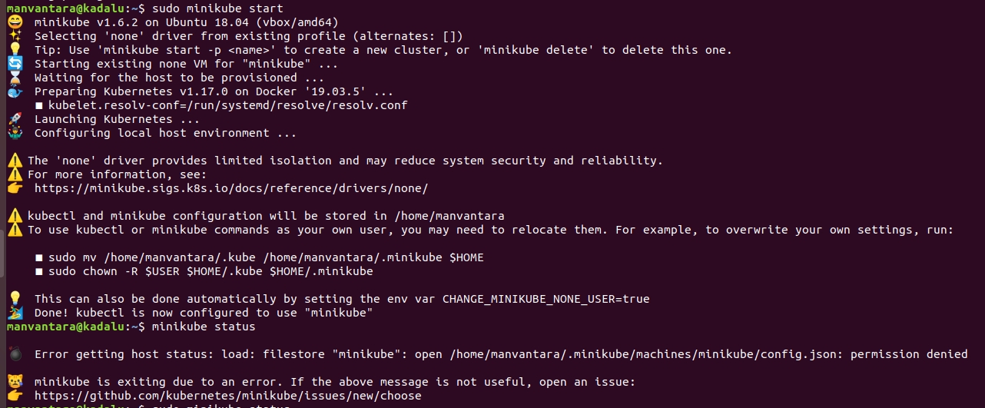

i) Check minikube status and kubernetes version

$ sudo minikube status
------------------------------------------------------------------
Expected Output:

host: Running
kubelet: Running
apiserver: Running
kubeconfig: Configured
------------------------------------------------------------------

$ sudo kubectl version

Good to work on K8

