DEPARTMENT OF HSS
QUANTITATIVE METHODS FOR SOCIAL SCIENCES


RESEARCH PROJECT REPORT
The Work-From-Home Shift
Did Remote Work Change People's Eating,
Activity, and Mental Health?

Course | Quantitative Methods for Social Science
Course Code | [Course Code]
Submitted By | Manveer Makkar- 2401030128  Prakhar Agnihotri- 2401030129  Rajan Palta- 2401030383  Prajwal Pratap Singh-2401030371  Ronith Singh- 2401030143
Submitted To | Dr.Amandeep Kaur
Date | 27 April 2026

TABLE OF CONTENTS

1. Introduction
1.1 Background
1.2 Research Objectives
1.3 Hypotheses
2. Methodology
2.1 Research Design
2.2 Data Source & Sample
2.3 Variables
2.4 Data Analysis Techniques
3. Findings / Results
3.1 Descriptive Statistics
3.2 Physical Activity vs Work Location
3.3 Stress Level vs Work Location
3.4 Sleep Quality vs Work Location
3.5 Work-Life Balance (ANOVA)
3.6 Additional Findings
4. Inferences & Interpretation
5. Conclusion
6. References
7. Annexure

1. Introduction

1.1 Background
The COVID-19 pandemic triggered one of the most rapid and large-scale transformations in global work culture. Virtually overnight, millions of employees transitioned from office-based environments to remote working arrangements. This unprecedented shift commonly referred to as the "Work-From-Home (WFH) Shift" fundamentally altered daily routines, and overall mental health.
While remote work was not entirely new, its sudden widespread adoption offered a rare, real-world opportunity to observe its effects on human behaviour and wellbeing at scale. Prior to this shift, office-going routines naturally embedded physical activity into daily schedules through commuting, walking, and structured breaks. Home-based work, however, eliminated many of these incidental exercise opportunities while simultaneously increasing sedentary screen-based activity.
Research from diverse fields — occupational health, psychology, public health, and sociology — has highlighted mixed outcomes. For some employees, WFH improved work-life balance and reduced commuting stress. For others, it led to isolation, overwork, disrupted sleep, and a decline in physical and mental health. Understanding these divergent outcomes is critical for designing better workplace policies in the post-pandemic hybrid era.

1.2 Research Questions
- Is there a significant association between work location and physical activity frequency?
- Does stress level differ significantly across remote, hybrid, and onsite workers?
- Is sleep quality significantly associated with the type of work arrangement?
- Do work-life balance ratings differ significantly across work location groups?

1.3 Hypotheses
Hypothesis | Statement | Test
H1 | Daily physical activity is significantly lower in WFH workers compared to their office-going days. | Chi-Square Test
H2 | Home-cooked meal frequency / lifestyle behaviour (proxied by activity) is significantly higher during WFH. | Chi-Square Test
H3 | Stress levels are significantly associated with work location type. | Chi-Square Test
H4 | Work-life balance scores differ significantly across WFH, Hybrid, and full office arrangements. | One-Way ANOVA

2. Methodology

2.1 Research Design
This study adopts a cross-sectional, quantitative research design. Cross-sectional designs capture data from a population at a single point in time, making them well-suited to examine associations between variables such as work location and health outcomes. Given the availability of secondary survey data, this approach allows for statistical inference without experimental manipulation.
The study employs both non-parametric (Chi-Square test of independence) and parametric (One-Way ANOVA) statistical methods, chosen based on the level of measurement of the dependent variables.

2.2 Data Source and Sample
The dataset used is "Impact of Remote Work on Mental Health" — a publicly available secondary survey dataset. It contains responses from 5,000 employees across diverse industries, roles, and geographies. After data cleaning (removing records with missing values on key analysis variables), the effective analytical sample comprises 3,371 respondents.

Parameter | Detail
Total Records | 5,000
Records after Cleaning | 3,371
Work Location Groups | Remote (n=1,171) | Hybrid (n=1,113) | Onsite (n=1,087)
Sampling Technique | Secondary data (survey-based)
Data Type | Cross-sectional survey

2.3 Variables
Variable | Type | Values / Scale | Role
Work_Location | Categorical (Nominal) | Remote, Hybrid, Onsite | Independent (Grouping)
Physical_Activity | Categorical (Ordinal) | Daily, Weekly | Dependent (H1)
Stress_Level | Categorical (Ordinal) | Low, Medium, High | Dependent (H3)
Sleep_Quality | Categorical (Ordinal) | Good, Average, Poor | Dependent
Work_Life_Balance_Rating | Numeric (Ordinal 1-5) | 1 (Low) to 5 (High) | Dependent (H4)
Satisfaction_with_Remote_Work | Categorical | Satisfied, Neutral, Unsatisfied | Supplementary
Hours_Worked_Per_Week | Continuous | 20-60 hours | Supplementary

2.4 Data Analysis Techniques
The following statistical methods were applied:
- Chi-Square Test of Independence: Used to assess whether work location type is significantly associated with categorical outcome variables (physical activity, stress level, sleep quality). This non-parametric test is appropriate when both variables are categorical and expected cell frequencies are adequate.
- One-Way Analysis of Variance (ANOVA): Applied to compare mean work-life balance ratings across the three work location groups. ANOVA tests whether group means differ beyond what would be expected by random chance.
- Frequency and Percentage Tables: Used for descriptive analysis of categorical distributions across work location groups.
- Grouped Bar Charts and Boxplots: Used for visual representation of distributions and comparisons.
All analyses were performed in Python using pandas, scipy.stats, and matplotlib libraries within a Jupyter Notebook environment.

Analysis Tools & Software
Tool | Version / Purpose
Python | 3.x — Primary analysis language
pandas | Data manipulation and crosstabulation
scipy.stats | Chi-square and ANOVA statistical tests
matplotlib | Data visualisation and chart generation
Jupyter Notebook | Interactive analysis environment

3. Findings / Results

3.1 Descriptive Statistics
The cleaned dataset of 3,371 employees was distributed nearly equally across the three work location types, ensuring balanced group comparisons.

Work Location | Count (n) | Percentage (%)
Remote | 1,171 | 34.74%
Hybrid | 1,113 | 33.02%
Onsite | 1,087 | 32.24%
Total | 3,371 | 100.00%

Table 3.1: Distribution of Sample by Work Location
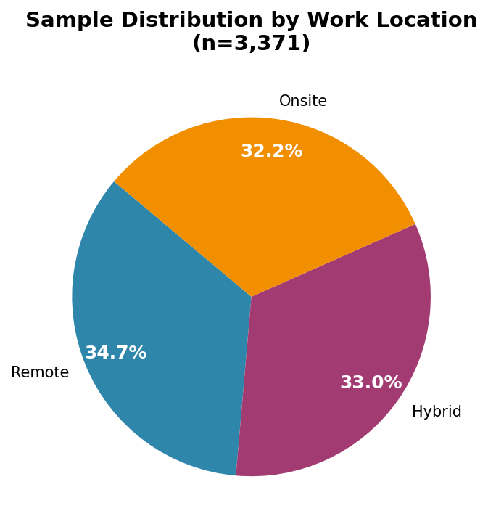
Figure 3.1: Sample Distribution by Work Location (Pie Chart)
Variable | Remote (n=1171) | Hybrid (n=1113) | Onsite (n=1087)
Avg. Hours Worked/Week | 39.45 | 39.59 | 39.82
Avg. WLB Rating (1-5) | 3.01 | 2.98 | 2.95
Social Isolation Avg. | 3.07 | 3.03 | 2.98

Table 3.2: Descriptive Statistics by Work Location

3.2 Physical Activity vs Work Location (H1)
H1 states that daily physical activity is significantly lower in WFH (Remote) workers. The chi-square test was applied to the crosstabulation of Physical_Activity (Daily vs Weekly) against Work_Location.
Work Location | Daily Activity | Weekly Activity | Total
Remote | 586 (50.0%) | 585 (50.0%) | 1,171
Hybrid | 515 (46.3%) | 598 (53.7%) | 1,113
Onsite | 515 (47.4%) | 572 (52.6%) | 1,087
Total | 1,616 | 1,755 | 3,371
Table 3.3: Physical Activity Frequency by Work Location

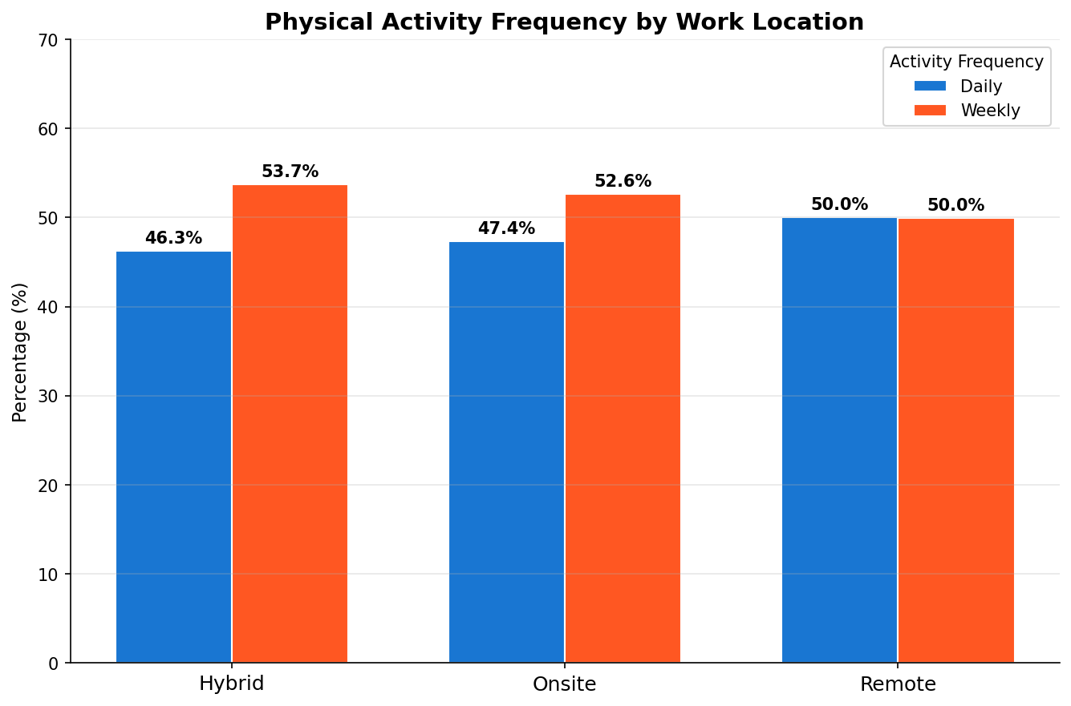
Figure 3.2: Physical Activity Frequency by Work Location
Test Statistic | Value
Chi-Square (χ²) | 3.4537
Degrees of Freedom | 2
p-value | 0.1778
Significance Level | α = 0.05
Decision | Fail to Reject H0 (p > 0.05)
Table 3.4: Chi-Square Test Results – Physical Activity vs Work Location
Result: The chi-square test (χ² = 3.45, df = 2, p = 0.178) reveals no statistically significant association between work location type and physical activity frequency. H1 is not supported by the data.
3.3 Stress Level vs Work Location (H3)
H3 posits that stress levels differ significantly across work location groups. The chi-square test was applied to the distribution of stress levels (Low, Medium, High) against work location.
Work Location | Low Stress | Medium Stress | High Stress | Total
Remote | 358 (30.6%) | 410 (35.0%) | 403 (34.4%) | 1,171
Hybrid | 378 (34.0%) | 369 (33.2%) | 366 (32.9%) | 1,113
Onsite | 370 (34.0%) | 357 (32.8%) | 360 (33.1%) | 1,087
Total | 1,106 | 1,136 | 1,129 | 3,371
Table 3.5: Stress Level Distribution by Work Location

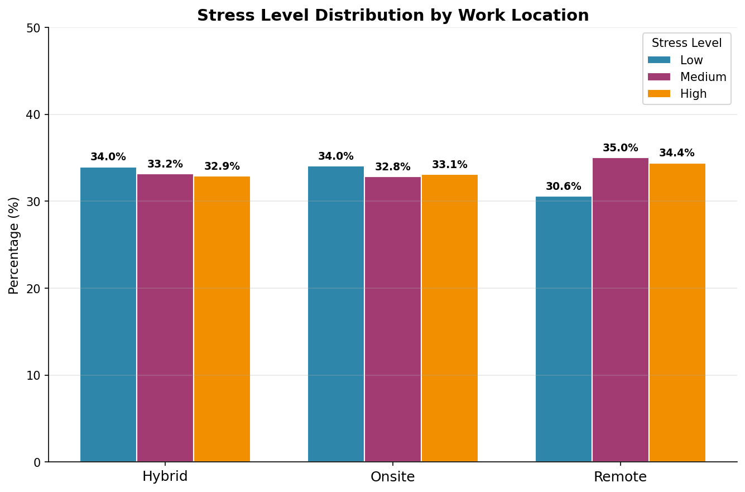
Figure 3.3: Stress Level Distribution by Work Location
Test Statistic | Value
Chi-Square (χ²) | 4.1384
Degrees of Freedom | 4
p-value | 0.3876
Significance Level | α = 0.05
Decision | Fail to Reject H0 (p > 0.05)
Table 3.6: Chi-Square Test Results – Stress Level vs Work Location
Result: The chi-square test (χ² = 4.14, df = 4, p = 0.388) indicates no statistically significant association between work location and stress level. Remote workers exhibited slightly higher proportions in the Medium and High stress categories, but the difference is not statistically significant.
3.4 Sleep Quality vs Work Location
Sleep quality (Good, Average, Poor) was analysed against work location type using the chi-square test of independence.
Work Location | Good Sleep | Average Sleep | Poor Sleep | Total
Remote | 384 (32.8%) | 410 (35.0%) | 377 (32.2%) | 1,171
Hybrid | 374 (33.6%) | 343 (30.8%) | 396 (35.6%) | 1,113
Onsite | 378 (34.8%) | 351 (32.3%) | 358 (32.9%) | 1,087
Total | 1,136 | 1,104 | 1,131 | 3,371
Table 3.7: Sleep Quality Distribution by Work Location

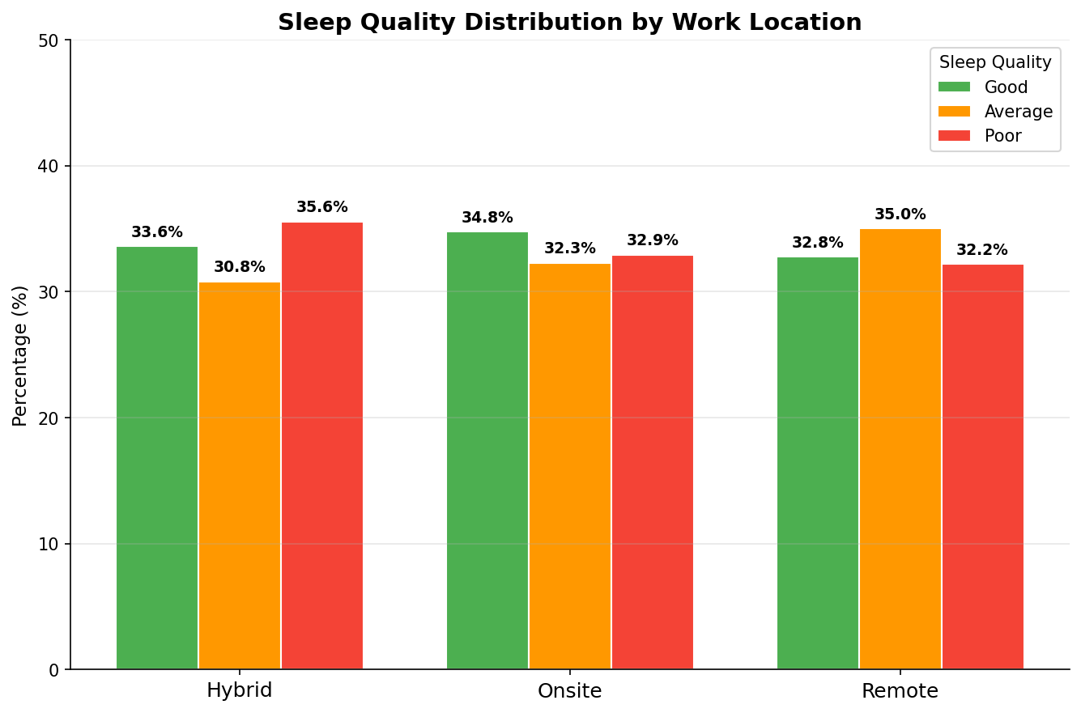
Figure 3.4: Sleep Quality Distribution by Work Location
Test Statistic | Value
Chi-Square (χ²) | 5.9618
Degrees of Freedom | 4
p-value | 0.2020
Significance Level | α = 0.05
Decision | Fail to Reject H0 (p > 0.05)
Table 3.8: Chi-Square Test Results – Sleep Quality vs Work Location
Result: The chi-square test (χ² = 5.96, df = 4, p = 0.202) shows no statistically significant association between work location and sleep quality. Hybrid workers showed a slightly higher proportion of poor sleepers (35.6%), but this difference is within chance variability.
3.5 Work-Life Balance Rating — One-Way ANOVA (H4)
H4 states that work-life balance scores differ significantly across WFH, Hybrid, and full office arrangements. ANOVA was applied to the Work_Life_Balance_Rating (scale 1-5) across the three work location groups.
Work Location | n | Mean WLB Rating | Std. Deviation | Min | Max
Remote | 1,171 | 3.009 | 1.422 | 1 | 5
Hybrid | 1,113 | 2.978 | 1.424 | 1 | 5
Onsite | 1,087 | 2.949 | 1.416 | 1 | 5
Table 3.9: Descriptive Statistics – Work-Life Balance Rating by Work Location

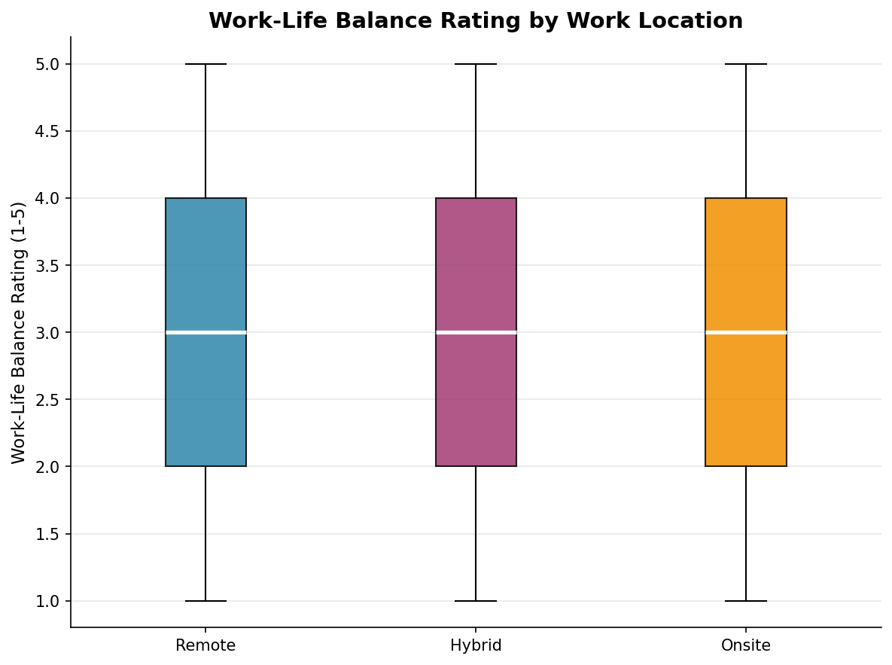
Figure 3.5: Work-Life Balance Rating Distribution (Box Plot)
Test Statistic | Value
F-Statistic | 0.5032
p-value | 0.6046
Significance Level | α = 0.05
Decision | Fail to Reject H0 (p > 0.05)
Table 3.10: One-Way ANOVA Results – Work-Life Balance Rating
Result: The One-Way ANOVA (F = 0.503, p = 0.605) reveals no statistically significant difference in work-life balance ratings across the three work location groups. While remote workers show marginally higher ratings (mean = 3.01), the differences are negligible. H4 is not supported.

3.6 Additional Findings

3.6.1 Hours Worked Per Week
Average weekly working hours were similar across all groups (Remote: 39.45 hrs, Hybrid: 39.59 hrs, Onsite: 39.82 hrs), suggesting that the work modality had little impact on overall work volume.
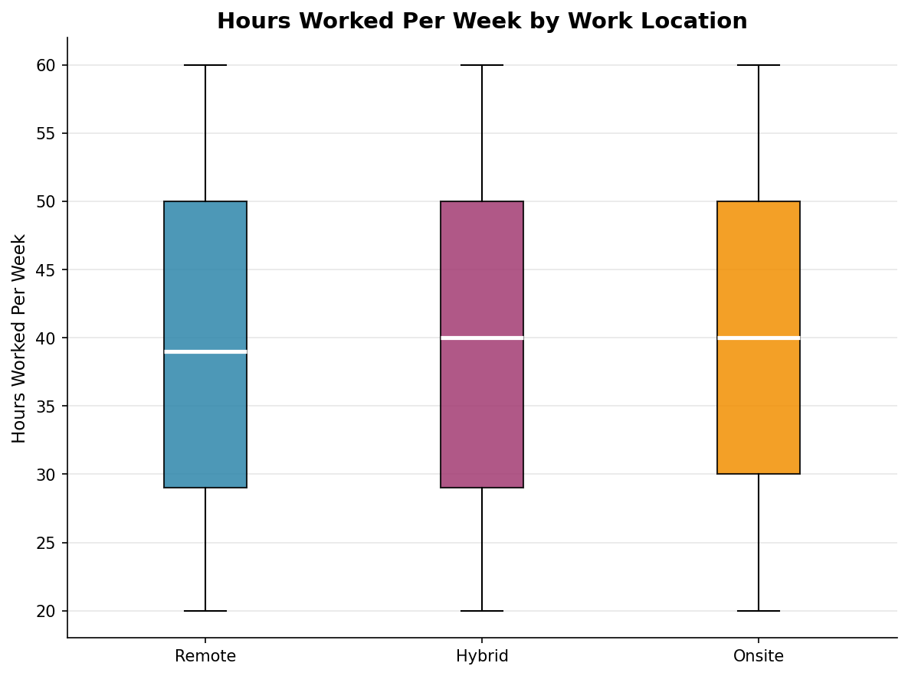
Figure 3.6: Hours Worked Per Week by Work Location (Box Plot)

3.6.2 Satisfaction with Remote Work Arrangement
Across the full dataset of 5,000 respondents, satisfaction with remote work was distributed almost equally: Satisfied (33.5%), Neutral (33.0%), and Unsatisfied (33.5%). This near-uniform split indicates divergent individual experiences with remote work, with no dominant sentiment.
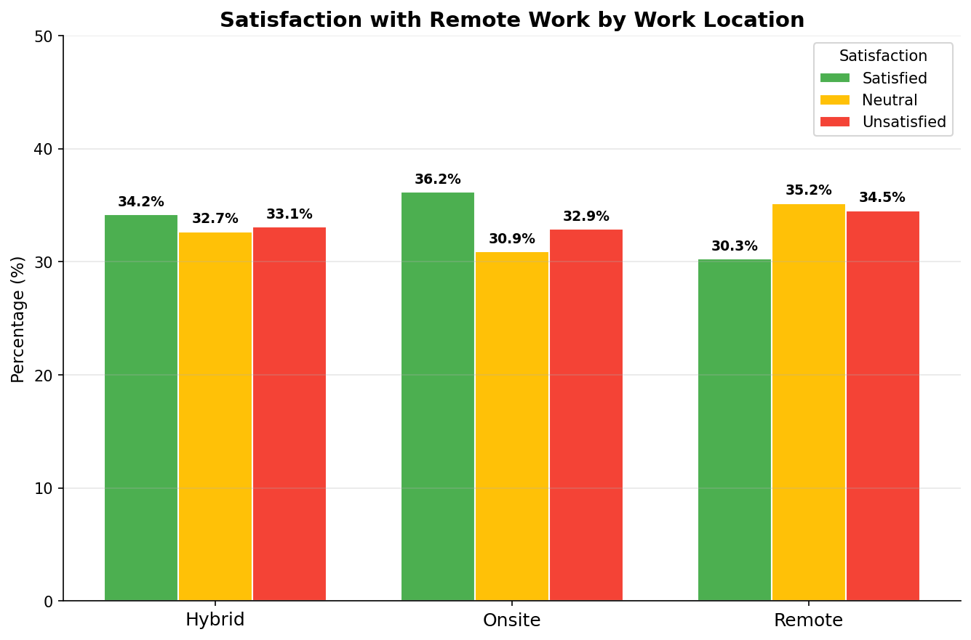
Figure 3.7: Satisfaction with Remote Work Arrangement by Work Location

4. Inferences / Interpretation of Results

4.1 Physical Activity (H1)
Contrary to the popular hypothesis that remote work reduces physical activity due to the elimination of commutes and office-related movement, the data shows no statistically significant difference in physical activity frequency between remote, hybrid, and onsite workers (χ² = 3.45, p = 0.178). This suggests that employees may actively compensate for lost commuting exercise through other activities when working from home, or that the dataset captures only a binary frequency measure (Daily vs Weekly) that is too coarse to detect subtle differences. H1 is not supported.

4.2 Stress Level (H3)
While remote workers show a slightly higher proportion reporting Medium and High stress (35.0% and 34.4% respectively vs. 32.8% and 32.9% for Onsite), this difference is not statistically significant (χ² = 4.14, p = 0.388). This implies that factors beyond work location such as job role, personal circumstances, manager support, and industry pressures may be stronger determinants of stress. H3 is not supported.

4.3 Sleep Quality
Sleep quality distribution was statistically similar across work location groups (χ² = 5.96, p = 0.202). Hybrid workers reported the highest proportion of poor sleepers (35.6%), potentially reflecting the cognitive load and unpredictability associated with split work schedules. However, since the p-value does not cross the significance threshold of 0.05, this observation is not conclusive.

4.4 Work-Life Balance — ANOVA (H4)
The ANOVA result (F = 0.503, p = 0.605) confirms that work-life balance ratings are virtually identical across groups (means: Remote = 3.01, Hybrid = 2.98, Onsite = 2.95). This is a nuanced finding — it suggests that subjective work-life balance is not determined primarily by where one works, but likely by how well individuals manage boundaries, time, and personal responsibilities regardless of location. H4 is not supported.

4.5 Overall Interpretation
A consistent pattern emerges across all four hypotheses: none of the differences across work location groups reached statistical significance. This is a substantively important finding. It suggests that the binary framing of "office vs. remote" may be an oversimplification. Other variables — individual personality traits, managerial quality, household composition, cultural norms, industry type — likely mediate or moderate the relationship between work location and health/wellbeing outcomes.

5. Conclusion

This research project examined the health and wellbeing impacts of the Work-From-Home shift using a dataset of 5,000 employees. Through descriptive statistical analysis, Chi-Square tests of independence, and One-Way ANOVA, the study investigated four key hypotheses relating to physical activity, stress levels, sleep quality, and work-life balance across Remote, Hybrid, and Onsite work arrangements.
The central finding of this study is that none of the four hypotheses were statistically supported at the α = 0.05 significance level. Work location type did not emerge as a statistically significant predictor of physical activity frequency, stress levels, sleep quality, or work-life balance ratings in this dataset.
These results carry several important implications:
- Individual Agency: Employees may adapt their health behaviours to their work environment, reducing the observable net difference between groups over time.
- Hybrid Work: The emergence of hybrid arrangements as a dominant model warrants focused study, particularly given the marginally higher poor sleep rates observed among hybrid workers.

In conclusion, while the WFH shift represents a profound change in work culture, its health and wellbeing consequences appear to be highly individualised and context-dependent rather than uniformly determined by work location alone. Future research should incorporate longitudinal data, qualitative interviews, and physiological measures to build a more comprehensive understanding of this important phenomenon.

6. References

Bloom, N., Liang, J., Roberts, J., & Ying, Z. J. (2015). Does working from home work? Evidence from a Chinese experiment. The Quarterly Journal of Economics, 130(1), 165-218. https://doi.org/10.1093/qje/qju032
de Lucas Ancillo, A., del Val Nunez, M. T., & Gavrila, S. G. (2021). Workplace change within the COVID-19 context: a grounded theory approach. Economic Research-Ekonomska Istraživanja, 34(1), 2297-2316.
Gajendran, R. S., & Harrison, D. A. (2007). The good, the bad, and the unknown about telecommuting: Meta-analysis of psychological mediators and individual consequences. Journal of Applied Psychology, 92(6), 1524-1541.
Kniffin, K. M., Narayanan, J., Anseel, F., et al. (2021). COVID-19 and the workplace: Implications, issues, and insights for future research and action. American Psychologist, 76(1), 63-77.
McKinsey & Company. (2021). The future of work after COVID-19. McKinsey Global Institute.
World Health Organization. (2022). Mental Health and COVID-19: Early evidence of the pandemic's impact. WHO/2019-nCoV/Sci_Brief/Mental_health/2022.1
Dataset: "Impact of Remote Work on Mental Health" — Kaggle / Public Secondary Survey Dataset (2024). Retrieved from https://www.kaggle.com

7. Annexure

A. Dataset Column Descriptions
Column Name | Description | Type
Employee_ID | Unique identifier for each employee | Nominal
Age | Employee age in years | Continuous
Gender | Gender identity of employee | Nominal
Job_Role | Current job position/title | Nominal
Industry | Sector of employment | Nominal
Years_of_Experience | Total work experience in years | Continuous
Work_Location | Current work arrangement (Remote/Hybrid/Onsite) | Nominal
Hours_Worked_Per_Week | Average weekly working hours | Continuous
Number_of_Virtual_Meetings | Weekly virtual meeting count | Continuous
Work_Life_Balance_Rating | Self-rated WLB on a 1-5 scale | Ordinal
Stress_Level | Self-reported stress (Low/Medium/High) | Ordinal
Mental_Health_Condition | Reported mental health condition | Nominal
Physical_Activity | Activity frequency (Daily/Weekly) | Ordinal
Sleep_Quality | Sleep quality (Good/Average/Poor) | Ordinal
Satisfaction_with_Remote_Work | Satisfaction level with WFH arrangement | Ordinal
Social_Isolation_Rating | Self-rated social isolation (1-5) | Ordinal
Region | Geographic region of employee | Nominal

B. Statistical Test Summary
Hypothesis | Test Used | χ² / F Value | df | p-value | Decision
H1: Physical Activity vs Work Location | Chi-Square | 3.4537 | 2 | 0.1778 | Fail to Reject H0
H3: Stress Level vs Work Location | Chi-Square | 4.1384 | 4 | 0.3876 | Fail to Reject H0
Sleep Quality vs Work Location | Chi-Square | 5.9618 | 4 | 0.2020 | Fail to Reject H0
H4: WLB Rating across Groups | One-Way ANOVA | F=0.5032 | dfB=2, dfW=3368 | 0.6046 | Fail to Reject H0

