CHAPTER 6: RESULTS AND SNAPSHOTS
This chapter presents the working screenshots of the PlaceIt Campus Placement Portal, demonstrating all key features implemented for both students and the Training and Placement Officer (TPO).

6.1 Home Page
The landing page of the PlaceIt portal greets visitors with a dynamic hero section showcasing live statistics — active placement drives, companies registered, students placed, and registered students. Navigation provides quick access to Student Login and TPO Login.
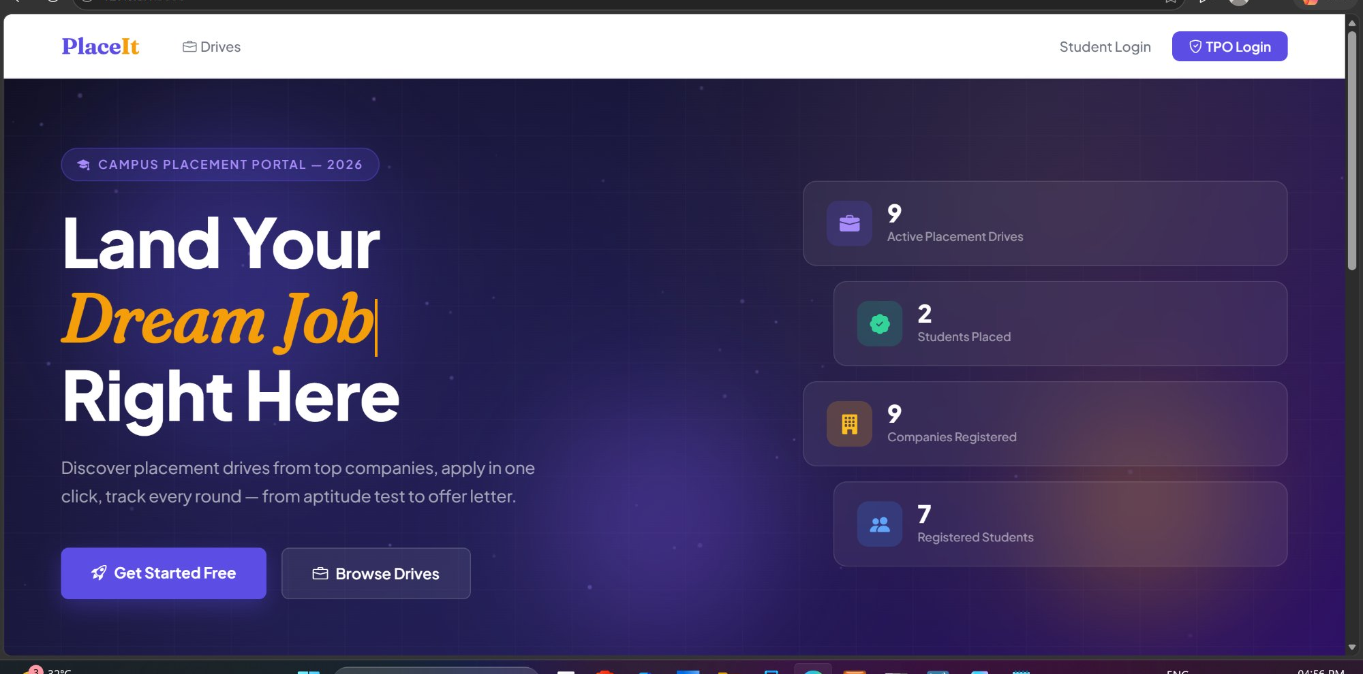
Figure 6.1 – PlaceIt Home Page with Live Statistics

6.2 Student Registration
New students register by filling in their full name, email address, phone number, branch, year, CGPA, active backlogs, city, state, and selecting relevant skills. The form provides real-time inline validation (e.g., valid email, valid CGPA, password strength indicator) before account creation.
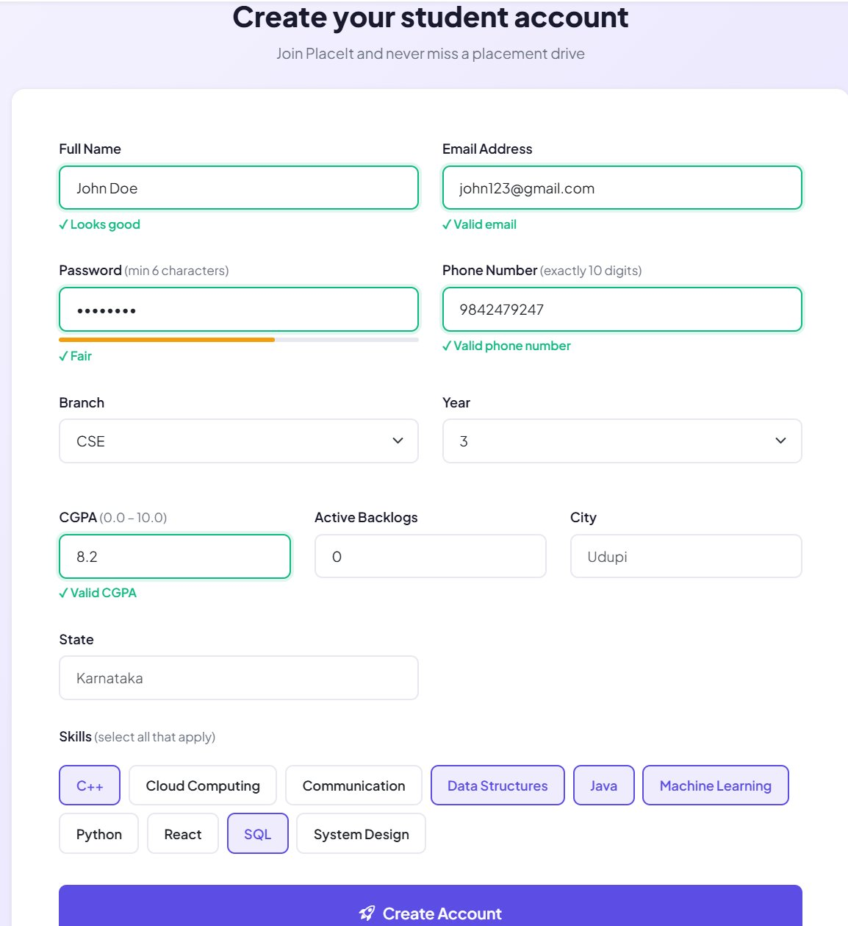
Figure 6.2 – Student Registration Form with Inline Validation

6.3 Student Login
Registered students log in using their email address and password. A success notification confirms account creation upon first registration. A demo credential is displayed at the bottom for testing purposes.
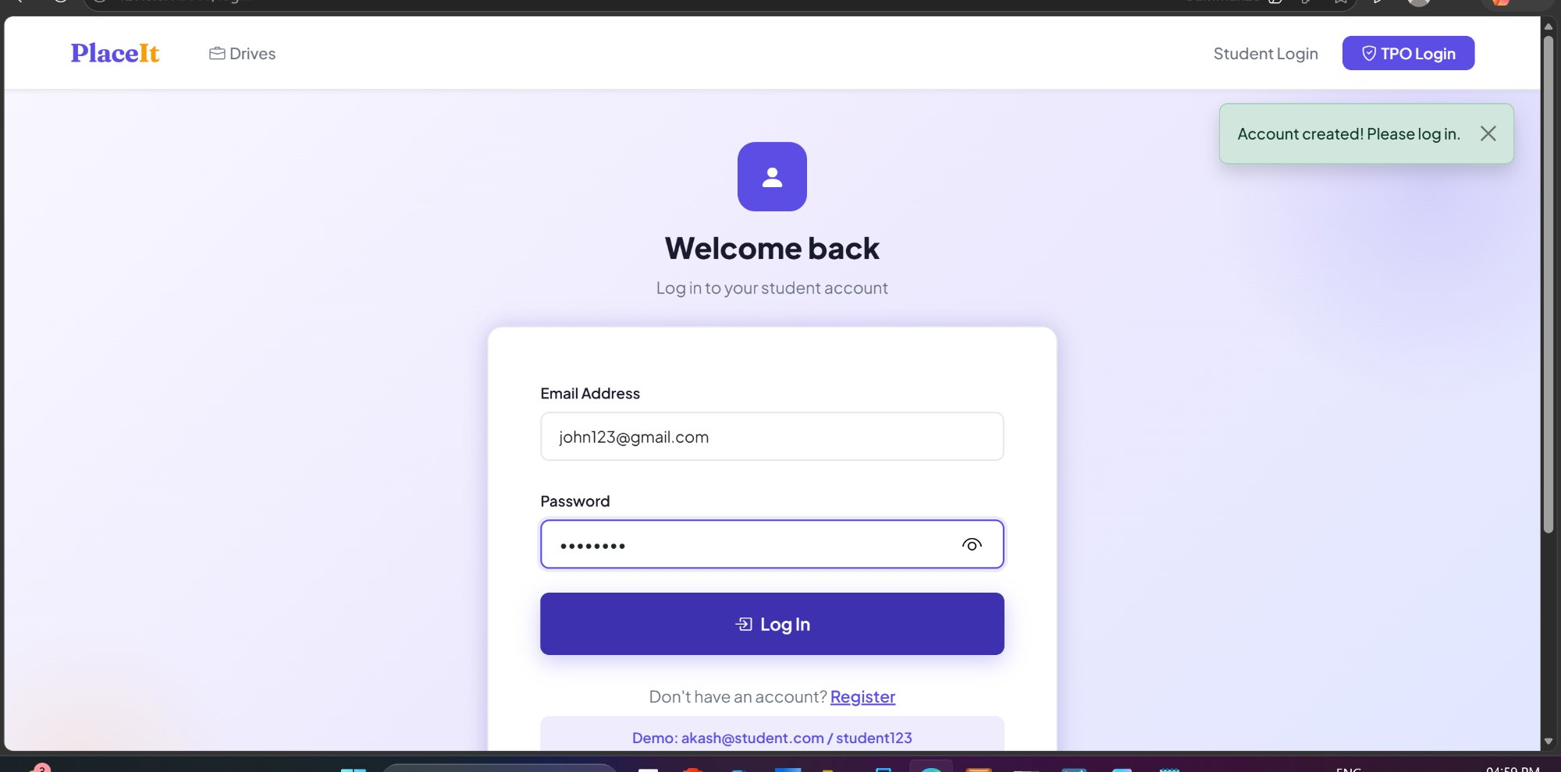
Figure 6.3 – Student Login Page

6.4 Student Dashboard
After login, the student is directed to a personalized dashboard showing a summary of placement activity — total applications submitted, shortlisted count, in-process count, and selections. Quick action cards allow navigation to Browse Drives, My Applications, and My Profile. Recent applications are listed below.
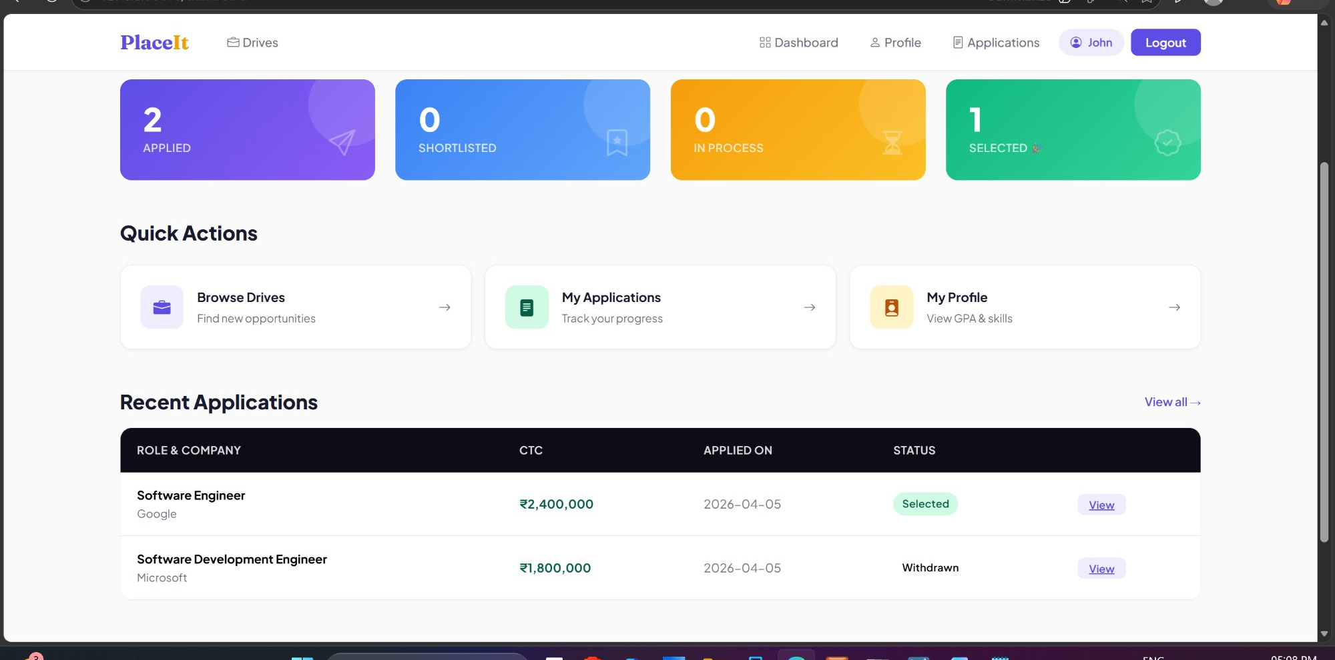
Figure 6.4 – Student Dashboard with Application Statistics

6.5 Student Profile
The student profile page displays academic details (branch, year, CGPA, backlogs), contact information (email and phone), skills, and a placement summary showing total applications submitted and selections received.
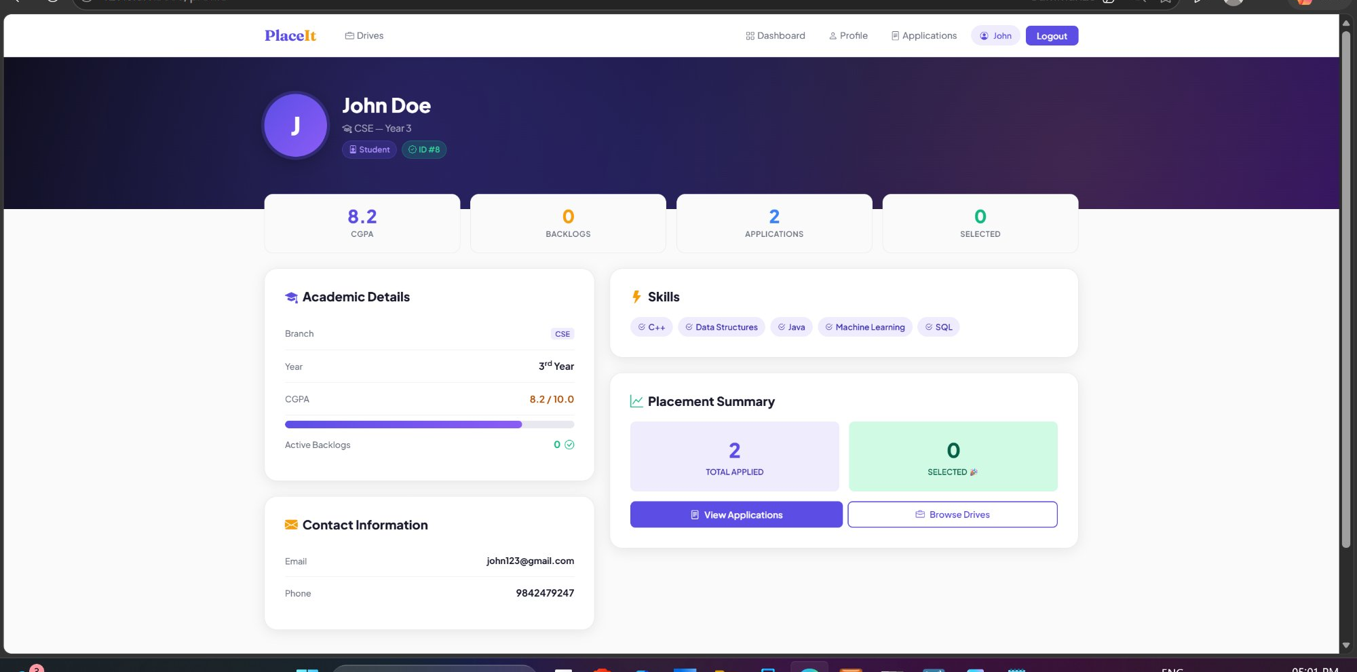
Figure 6.5 – Student Profile Page

6.6 Drives Listing
All active placement drives are listed in a card-based layout. Each card shows the company name, location, industry sector, job role, CTC offered, drive date, CGPA eligibility criterion, eligible branches, and the current number of applicants. Students can apply directly from this page.
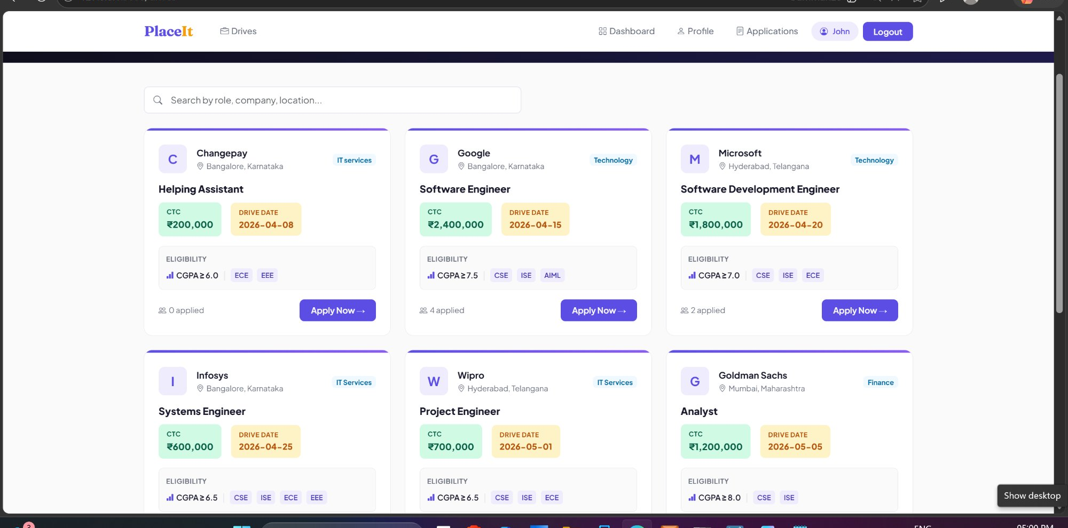
Figure 6.6 – Placement Drives Listing with Eligibility Details

6.7 Application Details
The My Applications page lists all drives a student has applied to, showing the role, company, industry, CTC, drive date, application date, and current status (Applied, Shortlisted, In Process, Selected, or Withdrawn). A View button provides individual application details.
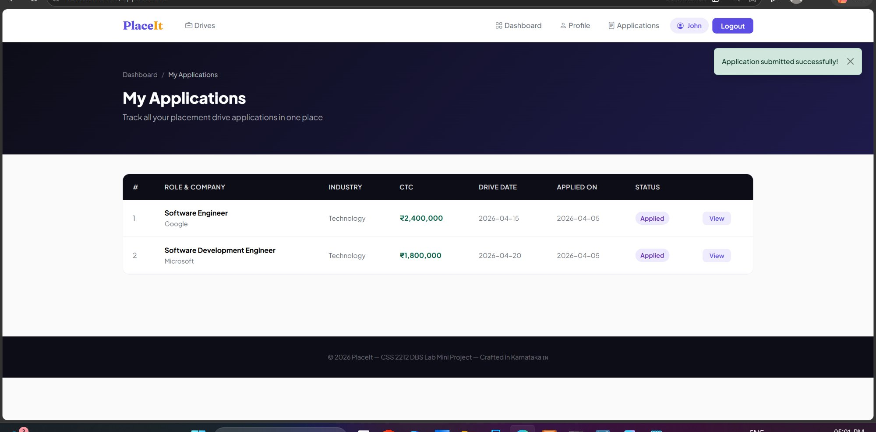
Figure 6.7 – My Applications Page with Status Tracking

6.8 TPO Login
The Training and Placement Officer accesses a dedicated TPO Portal login page with a dark-themed interface, clearly distinguished from the student login. Demo credentials are provided at the bottom for evaluation.
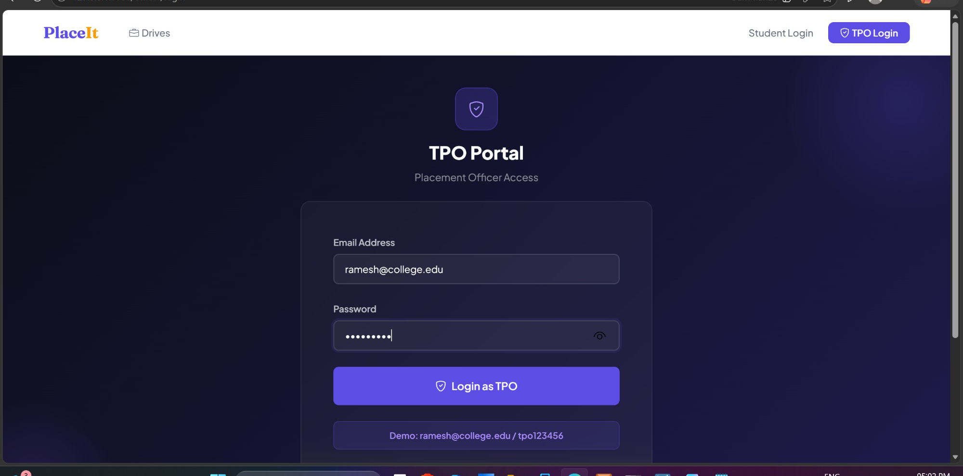
Figure 6.8 – TPO Portal Login Page

6.9 TPO Dashboard
The TPO Dashboard provides a comprehensive overview — total drives posted, total applications received, students placed, and active students. Below the summary, all placement drives are listed in a table with applicant counts and options to manage or delete each drive.
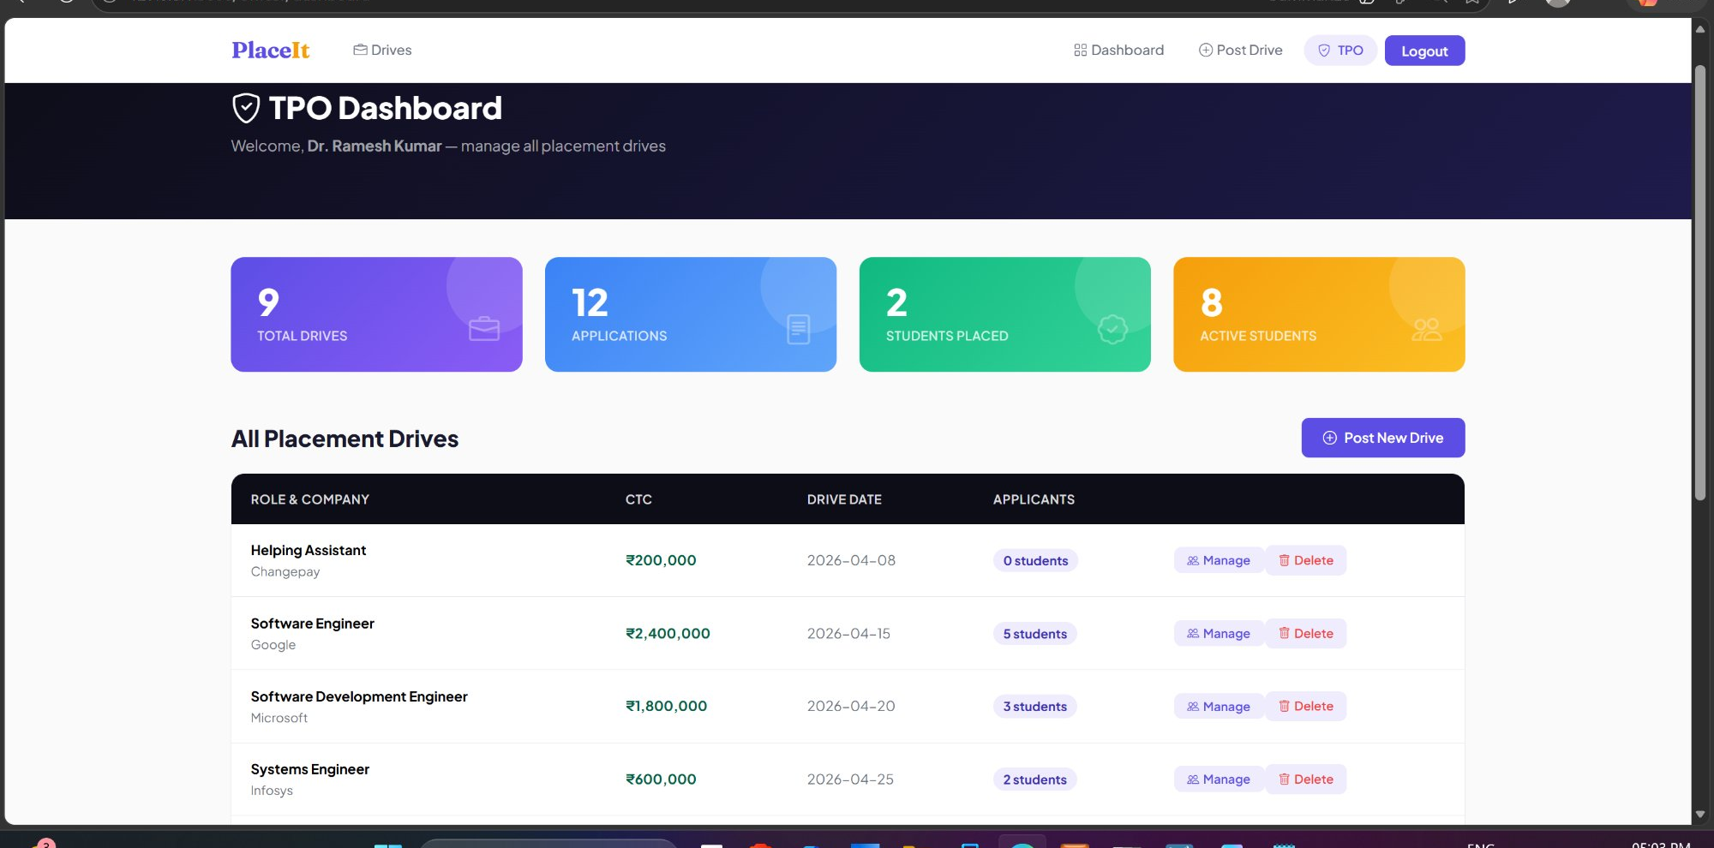
Figure 6.9 – TPO Dashboard with Drive Management

6.10 Post New Placement Drive
The TPO can post new placement drives by selecting a company, entering the job role/title, CTC per annum, drive date, minimum CGPA required, and selecting eligible branches. A "Company not listed?" option allows the TPO to add new companies on the fly.
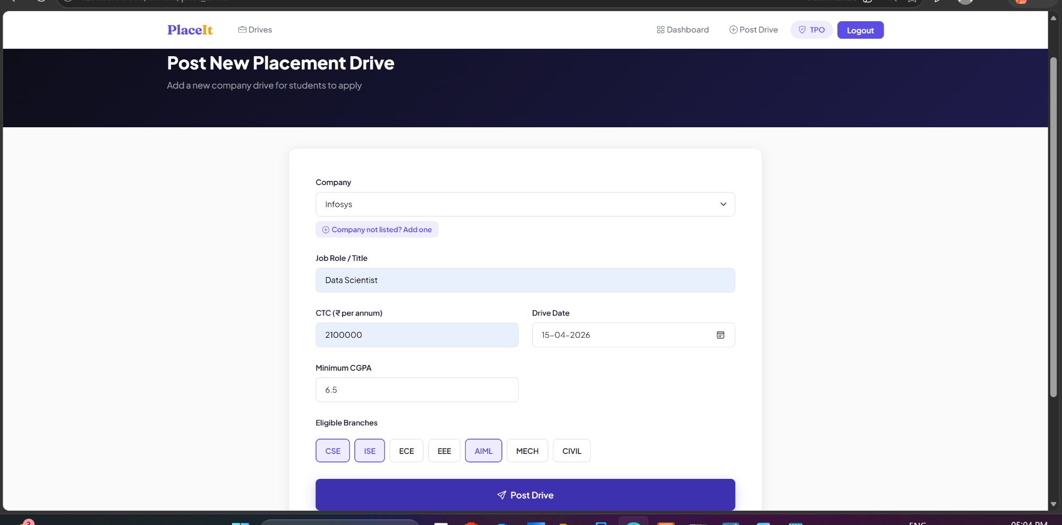
Figure 6.10 – Post New Placement Drive Form

6.11 View Applicants
When the TPO clicks "Manage" on a drive, the applicant management page shows all applicants with their name, email, branch, CGPA, backlog count, application date, and current status. Summary badges at the top indicate total, shortlisted, and selected counts. Selection rounds defined for the drive are also displayed.
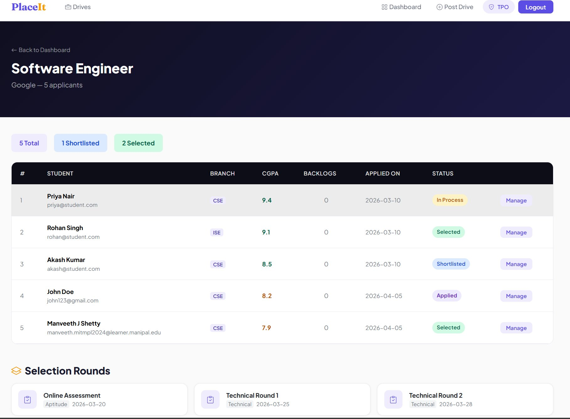
Figure 6.11 – Applicant Management Page for a Drive

6.12 Auto-Withdrawal Demo
PlaceIt enforces a one-offer policy: once a student is marked as "Selected" for any drive, all their other pending applications are automatically withdrawn by the system. The student dashboard clearly reflects the updated statuses — one application showing "Selected" (Google – Software Engineer) and the other automatically marked as "Withdrawn" (Microsoft – Software Development Engineer).

Figure 6.12 – Auto-Withdrawal of Other Applications upon Selection

