ProjectPulse
Functional Specification Document

────────────────────────────────────────────────────────────

Document Type | Functional Specification Document
Version | v2.1.0
Audience | Product Managers / Developers / QA Engineers / Business Analysts
Date | 14 June 2026
Confidentiality | Internal - Restricted

Document Control

Field | Value
Document Title | ProjectPulse - Functional Specification Document
Version | v2.1.0
Status | Approved
Author(s) | ProjectPulse Product Team
Reviewer(s) | Engineering Lead / QA Lead / Product Manager
Review Date | 14 June 2026
Classification | Internal - Restricted
Next Review | Quarterly or upon major feature release

Table of Contents

I | PART I — System Architecture & Foundations | —
1 | Product Philosophy & Design Principles | 5
2 | Application Architecture | 7
3 | Data Model & Full Schema Reference | 10
4 | Performance Caching: buildDashCache | 18
5 | Global Configuration & Settings Model | 20
II | PART II — Module Functional Specifications | —
6 | Executive Overview Dashboard | 23
7 | Live Insights & Analytics | 28
8 | Hierarchical Delivery Matrix | 32
9 | Gantt Timeline | 38
10 | Weekly Scheduler & Conflict Resolver | 42
11 | RAID Register | 48
12 | Team Capacity Hub | 53
13 | Defect Tracker | 57
14 | Reports & Board Packs | 62
15 | Audit Log & Activity Streams | 66
16 | Schedule Baselines | 70
17 | System Configuration | 74
III | PART III — Cross-Cutting Concerns | —
18 | Security & Data Privacy | 78
19 | Performance & Scalability Limits | 80
20 | Browser Compatibility Matrix | 81
A | Appendix A — Keyboard Shortcuts | 82
B | Appendix B — Formula Reference Card | 83
C | Appendix C — Glossary | 85

PART I
System Architecture & Foundations
────────────────────────────────────────

Application design, state model, data schemas, caching, and configuration.

1 Product Philosophy & Design Principles

ProjectPulse is built on five foundational design principles that govern every architectural and UX decision in the product.

Zero Friction
The application must be usable immediately, without installation, configuration, or network connectivity. Every feature must be accessible within two clicks from any view. Complexity is hidden behind progressive disclosure.

Real-Time Truth
All displayed metrics must reflect the current state of the data at all times. There are no 'refresh' or 'recalculate' buttons. Every state mutation triggers an immediate, synchronous UI update via the render pipeline.

Non-Destructive by Default
All high-risk operations (sandbox mutations, baseline restores, bulk edits) operate on copies of the data or are reversible via the Audit Log. The user's live schedule is never modified without explicit confirmation.

Governance as a Feature
Accountability is built into every workflow. Status transitions enforce mandatory comments. RAID items require owners. Defects are traced to tasks. Every mutation is permanently logged. The product treats governance as a first-class product requirement.

Performance at Scale
The O(n) buildDashCache architecture ensures that analytics remain sub-millisecond regardless of task count. All SVG visualisations (Gantt, Health Gauge, heatmaps) are rendered natively without third-party charting libraries.

2 Application Architecture

2.1 Single-Page Application Model
ProjectPulse is implemented as a monolithic Single-Page Application (SPA) delivered as a single HTML file (projectpulse.html). All JavaScript logic, CSS styles, and SVG assets are inlined or bundled within this file. There is no module bundler, no build step, and no external CDN dependencies for core functionality.
- Single file delivery: projectpulse.html contains all application logic.
- No network requests at runtime (except optional file sync on supported browsers).
- All state is maintained in a single JavaScript object P (the global state store).
- The render pipeline is triggered by calling render() after every state mutation.

2.2 Global State Object (P)
All application state is stored in a single JavaScript object P. The following top-level keys constitute the complete state topology:
Key | Type | Contents
P.name | string | Project name. Displayed in the header and on exported documents.
P.desc | string | Project description. Shown on cover pages of exported reports.
P.tasks | Task[] | Array of all task objects (parent and child). The primary data entity.
P.members | Member[] | Array of all team member profiles.
P.raids | RAID[] | Array of all RAID register entries.
P.defects | Defect[] | Array of all defect records.
P.baselines | Baseline[] | Array of all captured baseline snapshot records.
P.log | LogEntry[] | Append-only array of all activity log entries (max 500).
P.settings | object | Global settings: effortUnit, hoursPerDay, daysPerWeek, workDays, alertPrefs.
P.dropdowns | object | All configurable dropdown option arrays keyed by field name.
P.cache | object | Computed analytics cache (hydrated by buildDashCache). Never persisted directly.
P.sandboxTasks | Task[]|null | In-memory sandbox clone. Null when sandbox is inactive.

2.3 localStorage Persistence Model
ProjectPulse persists all project data to the browser's localStorage under the key pp-data. Serialization uses JSON.stringify() with a custom replacer to ensure P.cache and P.sandboxTasks are excluded from persistence.
- Key: pp-data — stores the full serialised P object minus cache and sandbox.
- Save trigger: Every state mutation calls save() which debounces writes by 10 seconds.
- Manual save: Ctrl+S forces an immediate synchronous localStorage write.
- Storage limit: Browser localStorage is typically ~5MB per origin. Sufficient for 500+ tasks with full activity logs.
- File sync: On Chrome/Edge, the File System Access API allows optional sync to a local .xlsx file.

2.4 Auto-Save Mechanism
The auto-save mechanism uses a debounce pattern to batch rapid successive mutations into a single localStorage write, preventing performance degradation during inline bulk editing operations.
function save() {
clearTimeout(P._saveTimer);
P._saveTimer = setTimeout(() => {
localStorage.setItem('pp-data', JSON.stringify(P, saveReplacer));
}, 10000); // 10-second debounce
}
[TIP]
Ctrl+S bypasses the debounce timer and triggers an immediate synchronous save. This is recommended before closing the browser tab or switching networks.

2.5 Render Pipeline
The render pipeline is the core update mechanism. It is called after every state mutation and follows this fixed execution sequence:
- buildDashCache(P) — recomputes all analytics in O(n) single-pass.
- renderActiveView() — re-renders the currently active module view.
- updateNavBadges() — updates notification badges on the navigation bar.
- updateHealthPulse() — refreshes the top-bar health pulse indicator.

3 Data Model & Full Schema Reference

This section documents the complete field-level schema for every primary data entity managed by ProjectPulse. All entities are stored as plain JavaScript objects within their respective arrays in the global state object P.

3.1 Task Schema
The Task is the primary unit of work in ProjectPulse.
Field | Type | Constraint | Default | Description
id | string | Unique, auto-gen | TASK-NNN | Auto-generated unique identifier. Format: TASK-001.
name | string | Required |  | Task title displayed in all views.
status | string | Enum (dropdowns) | Not Started | Current workflow status. Must be a valid VALID_TRANSITIONS key.
priority | string | Enum | Medium | Critical / High / Medium / Low.
category | string | Enum |  | Classification from configured Category dropdown.
module | string | Enum |  | Associated module from Module dropdown.
moduleType | string | Enum |  | Server / GUI / Interface.
assignee | string | Member name |  | Assigned member. Must match a member in P.members.
release | string |  |  | Target release label (e.g. v1.0.0).
startDate | YYYY-MM-DD |  |  | Current planned start date.
dueDate | YYYY-MM-DD |  |  | Current planned due date.
actCompletionDate | YYYY-MM-DD |  |  | Actual date work was completed (null if incomplete).
baselineStartDate | YYYY-MM-DD | Immutable post-capture |  | Frozen baseline start date.
baselineDueDate | YYYY-MM-DD | Immutable post-capture |  | Frozen baseline due date.
forecastDueDate | YYYY-MM-DD | System computed |  | Velocity-based projected completion date.
slippageReason | string |  |  | Free-text explanation for schedule slippage beyond baseline.
complexity | string | Enum | Medium | Easy (0.5x) / Medium (1.0x) / Complex (1.5x).
progress | number | 0-100 | 0 | Percentage completion. Aggregated from subtasks if present.
estEffort | number | >= 0 | 0 | Estimated effort in active effort unit.
actEffort | number | >= 0 | 0 | Actual logged effort in active effort unit.
baselineEffort | number | >= 0 | 0 | Baseline effort captured at snapshot time.
dependsOn | string[] | Task IDs | [] | Array of prerequisite Task IDs. Must be acyclic.
notes | string |  |  | Multi-line task description and notes.
subtasks | Subtask[] |  | [] | Array of child step/screen items.
guiScreens | string[] |  | [] | Linked GUI screen names (for GUI module tasks).
updatedAt | ISO 8601 |  | now | Timestamp of last modification. Updated on every save.
parentId | string |  |  | Parent task ID. Empty string for root-level tasks.

3.2 Subtask Schema
Field | Type | Description
id | string | Unique identifier within parent task. Format: ST-NNN.
name | string | Subtask title.
status | string | Same valid statuses as parent Task.
category | string | Feature / Bug / Improvement / GUI Screen / etc.
done | boolean | True when status is Completed. Used for progress aggregation.
effort | number | Estimated effort in active effort unit.
actEffort | number | Actual effort logged.
progress | number | 0-100. Contributes to parent task progress via weighted average.
type | string | step (development task) or screen (GUI screen).
actCompletionDate | YYYY-MM-DD | Actual completion date. Used by Activity Heatmap date resolution.

3.3 Member Schema
Field | Type | Description
id | string | Unique identifier. Format: MEM-NNN.
name | string | Full name. Used as assignee reference in tasks and defects.
role | string | Role from configured Role dropdown. Used by Copilot for Smart Reassignment.
status | string | Active / On Leave / Other Assignment / Serving Notice Period / Departed.
plannedLeaves | object[] | Array of {start: YYYY-MM-DD, end: YYYY-MM-DD} leave date ranges.
weeklyHourCap | number | Maximum standard hours per week. Default: 40.
utilisationRate | number | 0.0-1.0. Fraction of standard time dedicated to project work. Default: 1.0.

3.4 RAID Item Schema
Field | Type | Description
id | string | Unique identifier. Format: RAID-NNN.
type | string | Risk / Assumption / Issue / Dependency.
title | string | Short descriptive title.
description | string | Full description of the item.
status | string | Identified / Active / Mitigated / Closed / Realized.
impact | string | High / Medium / Low (qualitative scale).
probability | string | High / Medium / Low (qualitative scale for Risks).
severity | string | S1 Critical / S2 Major / S3 Moderate / S4 Minor.
exposureScore | number | Computed: probability_int x impact_int using 1-3 scale. Max 9.
owner | string | Member name. Required for Active items.
mitigation | string | Mitigation / resolution strategy text. Required for Active items.
targetDate | YYYY-MM-DD | Target closure date. Required for Active items.
raisedDate | YYYY-MM-DD | Date the item was logged.
closedDate | YYYY-MM-DD | Date the item was closed or mitigated.

3.5 Defect Schema
Field | Type | Description
id | string | Unique identifier. Format: DEF-NNN.
title | string | Defect title. Required.
type | string | Functional Bug / UI/UX Issue / Performance / Security / Data Issue / Suggestion.
severity | string | S1 Blocker / S2 High / S3 Medium / S4 Low.
priority | string | Critical / High / Medium / Low.
status | string | New / Assigned / Fixed / Retest / Closed / Rejected / Deferred.
linkedType | string | task / subtask / screen — type of linked entity.
linkedId | string | ID of the linked task (TASK-NNN) or subtask (ST-NNN).
assignee | string | Developer assigned to fix. Must match a member name.
reporter | string | Person who logged the defect.
desc | string | Full defect description.
steps | string | Step-by-step reproduction instructions.
raisedDate | YYYY-MM-DD | Date the defect was logged.
closedDate | YYYY-MM-DD | Date the defect was resolved or closed.

3.6 Activity Log Entry Schema
Field | Type | Description
ts | ISO 8601 | Timestamp of the log entry recorded at millisecond precision.
user | string | Name of the active team member who performed the action.
action | string | Created / Updated / Status Changed / Deleted.
taskId | string | ID of the primary entity affected.
taskName | string | Name of the primary entity at time of action.
field | string | The specific field that changed (e.g. status, dueDate).
oldVal | any | Previous value before mutation.
newVal | any | New value after mutation.
subtaskId | string | Optional. References a specific subtask if the change was at subtask level.
actCompletionDate | YYYY-MM-DD | Optional. Retrospective actual completion date for activity date resolution.

4 Performance Caching: buildDashCache

The buildDashCache(P) function is the analytics backbone of ProjectPulse. It performs a single O(n) pass over the entire task and log dataset to produce an O(1) lookup cache (P.cache) that powers every widget, chart, and KPI in the application.

4.1 Cache Architecture
The cache object P.cache contains the following pre-computed structures:
Cache Key | Type | Contents
totalTasks | number | Count of all non-cancelled, non-completed parent tasks.
completedTasks | number | Count of tasks with status == Completed.
overdueTasks | number | Count of active tasks where dueDate < today and status != Completed/Cancelled.
blockedTasks | number | Count of tasks with status == On Hold or with unresolved dependency violations.
activeRaidCount | number | Count of RAID items with status in {Identified, Active}.
criticalRaids | number | Count of RAID items with exposureScore >= 15.
openDefects | Defect[] | Array of defects with status not in {Closed, Rejected}.
s1Blockers | number | Count of open defects with severity == S1 Blocker.
s2Critical | number | Count of open defects with severity == S2 High.
velocityHistory | number[] | Array of weekly complexity-points-completed for the past 12 weeks.
burnUpData | object | Time-series arrays for Scope and Completion lines on the burn-up chart.
heatmapData | object | 30-day activity density map keyed by date string (YYYY-MM-DD).
memberAlloc | object | Weekly allocation hours per member per week for the Scheduler grid.
evmMetrics | object | Pre-computed PV, EV, AC, SV, SPI, CV values.
depMap | object | Dependency lookup map: taskId -> [predecessorIds]. O(1) lookup.

4.2 Cache Invalidation Policy
The cache has no TTL (time-to-live). It is fully rebuilt from scratch on every call to buildDashCache(), which is invoked as the first step of every render() call. Since render() is called after every state mutation, the cache is always perfectly consistent with the current state.
[INFO]
P.cache is intentionally excluded from localStorage persistence. If the page is refreshed, the cache is rebuilt from the persisted P.tasks, P.members, etc. data on the first render() call after page load.

5 Global Configuration & Settings Model

All system-wide settings are stored in the P.settings object and P.dropdowns object. Changes to settings take effect immediately across all views without requiring a reload.

5.1 P.settings Fields
Field | Type | Valid Values | Effect
effortUnit | string | hrs / days / months | Globally switches all effort labels and rescales displayed values.
hoursPerDay | number | 1-24 (default: 8) | Used to convert between hours and days when switching effort units.
daysPerWeek | number | 1-7 (default: 5) | Working week length. Affects capacity calculations and date math.
workDays | string[] | Subset of [Mon,Tue,Wed,Thu,Fri,Sat,Sun] | Specifies which days are working days for date arithmetic.
alertPrefs | object | {} | Future: alert threshold preferences per metric.

5.2 P.complexityFactors
Complexity Level | Default Multiplier | Configurable? | Effect on Velocity
Easy | 0.5x | Yes | Complexity points = estEffort x 0.5. Tasks count less toward velocity.
Medium | 1.0x | Yes | Complexity points = estEffort x 1.0. Baseline multiplier.
Complex | 1.5x | Yes | Complexity points = estEffort x 1.5. Tasks count more toward velocity.

[WARNING]
Changing complexity multipliers in Settings -> Complexity Factors triggers an immediate full cache rebuild, updating all velocity, EVM, and burn-up chart calculations across the application.

PART II
Module Functional Specifications
────────────────────────────────────────

Complete specification of all 12 product modules — formulas, workflows, state machines, and business rules.

6 Executive Overview Dashboard

The Executive Overview Dashboard is the primary health monitoring interface of ProjectPulse. It aggregates signals from all other modules into three composite KPI metrics and a radial health gauge. All calculations are computed in real time on every render cycle.
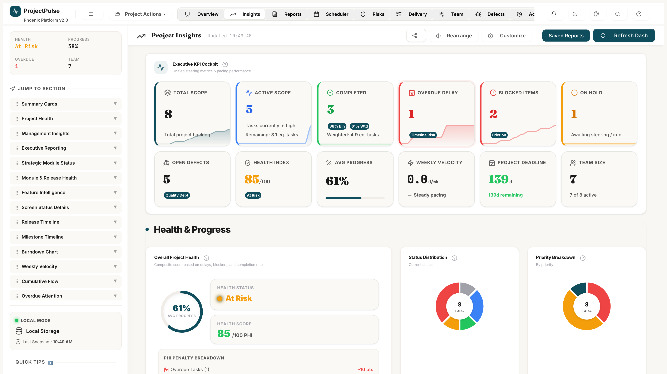
Figure 6.1 — Executive Overview Dashboard: KPI Cards, Health Gauge, and Predictive Sandbox

6.1 Health Index — Formula Derivation
The Health Index is a composite score (0-100) computed from four weighted drag factors:
Health = 100 - (Overdue/Active * 50) - (Blocked/Active * 30) - (OnHold/Active * 20) - (criticalRaids * 5) - (s1Blockers * 10) - (s2Critical * 5)
Where:
Variable | Source | Description
Overdue | P.cache.overdueTasks | Active tasks past their due date.
Blocked | P.cache.blockedTasks | Tasks on hold or with unresolved dependencies.
OnHold | computed inline | Tasks with status == On Hold.
Active | P.cache.totalTasks | Total non-Completed, non-Cancelled tasks.
criticalRaids | P.cache.criticalRaids | RAID items with exposureScore >= 15.
s1Blockers | P.cache.s1Blockers | Open defects with severity == S1 Blocker.
s2Critical | P.cache.s2Critical | Open defects with severity == S2 High.

[BUSINESS RULE]
The Health Index is floored at 0 and capped at 100. Completed and Cancelled tasks are excluded from the Active denominator. The index cannot go negative.

6.2 Delivery Confidence — Velocity-Based Model
Delivery Confidence is the probability of delivering all remaining work within the planned timeline, estimated from rolling velocity vs. remaining backlog.
Confidence = MIN(100, MAX(30, (weeklyVelocity * weeksRemaining) / remainingPoints * 100))
Variable | Calculation
weeklyVelocity | 3-week rolling average of completed complexity points per week. Excludes holiday weeks.
weeksRemaining | Calendar weeks between today and the latest task due date in the active schedule.
remainingPoints | SUM(estEffort * complexityFactor) for all incomplete tasks.

[INFO]
Delivery Confidence is floored at 30% to prevent alarming users when no historical velocity data exists (e.g., a newly created project). The 30% floor communicates uncertainty rather than impossibility.

6.3 Active RAID Count
activeRAID = COUNT(P.raids WHERE status IN {Identified, Active})
This metric counts all RAID items not yet resolved. It is displayed as a KPI card and contributes to the Health Index via the criticalRaids sub-component.

6.4 Dynamic Health Gauge — SVG Engine
The Health Gauge is an animated radial SVG arc rendered natively in the browser. The arc angle maps the Health Index (0-100) to a 270-degree arc (range: 0 to 270 degrees).
arcAngle = healthIndex / 100 * 270 (degrees)
Colour thresholds:
Health Range | Gauge Colour | Glow Effect | Interpretation
80-100 | Green (#27AE60) | Green neon glow | Project healthy. Maintain pace.
50-79 | Amber (#E67E22) | Amber glow | Warning. One or more risk factors active.
0-49 | Red (#C0392B) | Red pulsing glow | Critical. Immediate intervention required.

6.5 What-If Predictive Sandbox — Full Workflow
The Sandbox provides a non-destructive simulation environment. The following workflow governs sandbox activation, mutation, and resolution.
- User clicks 'Enable Sandbox' toggle on the Overview Dashboard.
- System deep-clones P.tasks into P.sandboxTasks. P.tasks remains unmodified.
- All scheduler and Gantt views switch to render from P.sandboxTasks.
- User adjusts Capacity Slider or Scope Multiplier to model the scenario.
- System recalculates forecast dates across all P.sandboxTasks proportionally.
- 'Commit Changes' button: overwrites P.tasks with P.sandboxTasks, clears sandbox, triggers save().
- 'Discard' button: sets P.sandboxTasks = null, reverts all views to P.tasks.

Sandbox Control | Input | Effect on P.sandboxTasks
Capacity Slider | -10% to -50% | Multiplies each task's duration by 1/(1-reduction). E.g. -20% extends all task durations by 1.25x.
Scope Multiplier | 1.1x to 2.0x | Multiplies estEffort of all Incomplete tasks by the factor. Pushes forecast dates outward proportionally.
Commit Changes | — | Copies sandboxTasks to P.tasks. Logs a Sandbox Commit entry in P.log. Calls save().
Discard | — | Sets P.sandboxTasks = null. Restores views to live P.tasks. No log entry created.

[CAUTION]
Always capture a Schedule Baseline (see Section 16) before clicking Commit. A Commit operation is irreversible without a baseline to restore from.

7 Live Insights & Analytics

The Insights module is the analytical intelligence layer of ProjectPulse. It surfaces Earned Value Management metrics, velocity data, burn-up projections, and activity heatmaps — all computed in real time from the P.cache structures built by buildDashCache().

7.1 Full EVM Metric Suite
ProjectPulse implements the full PMI-standard EVM framework. All six core EVM metrics are computed and displayed as live KPI cards.
Metric | Abbr. | Formula | Green Threshold | Interpretation
Planned Value | PV | totalBudget x (daysElapsed / totalDays) | N/A | Budget that should have been consumed by today per original plan.
Earned Value | EV | totalBudget x (completedPoints / totalPoints) | EV >= PV | Value of work actually delivered relative to plan.
Actual Cost | AC | SUM(actEffort) x blendedRate | AC <= EV | Real cost of resources consumed to date.
Schedule Variance | SV | EV - PV | SV >= 0 | Positive = ahead of schedule. Negative = behind schedule.
Schedule Performance Index | SPI | EV / PV | SPI >= 1.0 | SPI < 1.0 = schedule slippage. SPI > 1.0 = ahead of schedule.
Cost Variance | CV | EV - AC | CV >= 0 | Positive = under budget. Negative = over budget.

7.2 Burn-Up Chart Rendering
The burn-up chart displays three lines plotted on a weekly time axis:
- Scope Line (Blue): SUM(estEffort x complexityFactor) for all tasks at each week. Rises when scope is added.
- Completion Line (Green): Cumulative SUM of completed task complexity points per week, using actCompletionDate for attribution.
- Projection Line (Dashed Amber): Linear extrapolation from current completion to 100% scope, based on rolling 3-week velocity.
Projection formula:
weeksToComplete = remainingPoints / weeklyVelocity
projectedEndDate = today + weeksToComplete weeks
[INFO]
The projection line is only displayed when at least 3 weeks of velocity data exist. On newly created projects, only the Scope and Completion lines are shown.

7.3 30-Day Activity Heatmap & Date Resolution
The 30-Day Activity Heatmap is a calendar-style grid where each cell represents one calendar day. Cell colour intensity reflects the number of task state changes attributed to that day.
Date Resolution Algorithm:
- For each log entry in P.log, check if actCompletionDate is present and non-null.
- If actCompletionDate is present: attribute the activity to that date.
- If actCompletionDate is absent: attribute the activity to the log entry timestamp (ts).
- Aggregate activity counts per date into heatmapData[dateString].
- Render: lighter cells = fewer activities, darker teal cells = more activities.
[BUSINESS RULE]
This retrospective date resolution is essential for teams who log completed work after the fact. Without it, all activity would cluster on the log entry dates rather than the actual completion dates, producing misleading velocity data.

8 Hierarchical Delivery Matrix

The Delivery Matrix is the operational backbone of ProjectPulse. It is a high-density, spreadsheet-style task grid that manages the full task hierarchy, inline editing, status workflows, dependency mapping, and effort tracking.
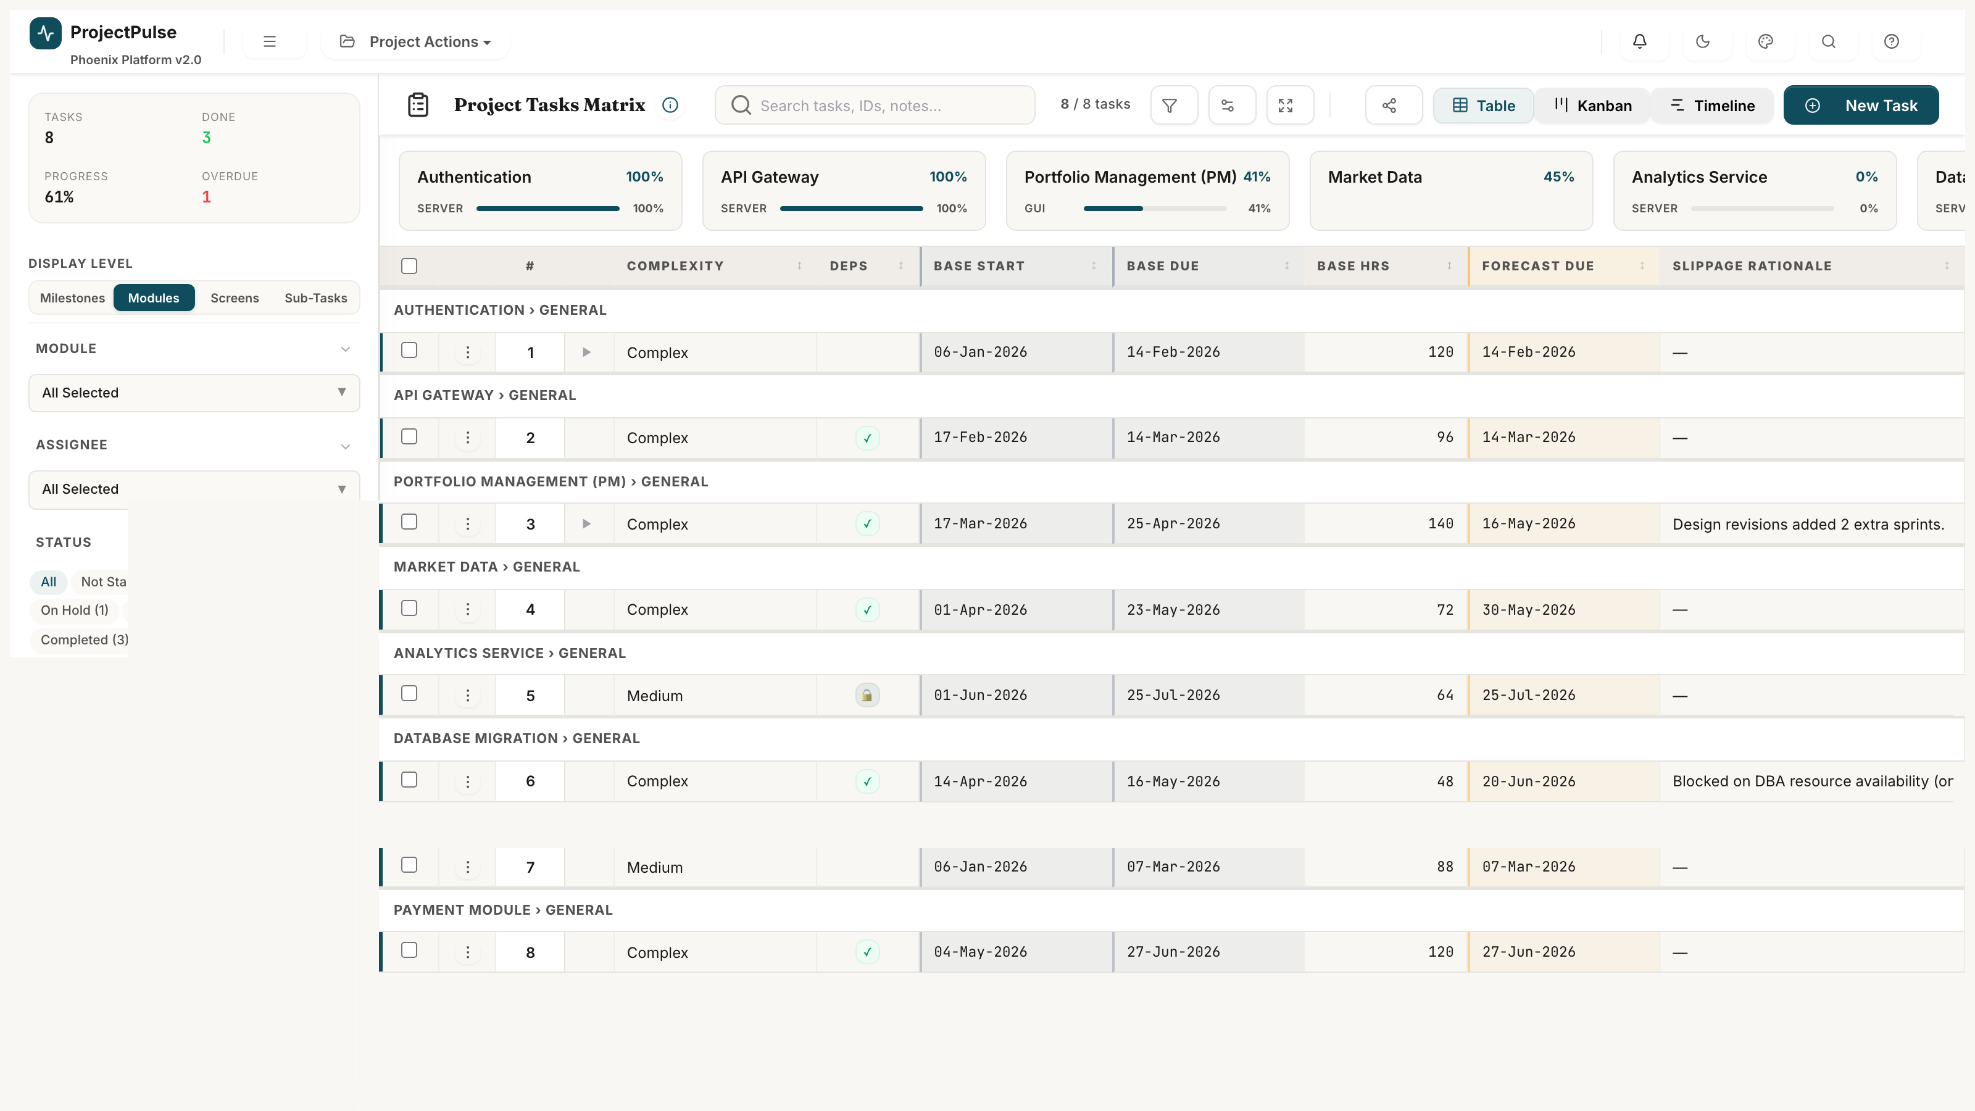
Figure 8.1 — Hierarchical Delivery Matrix: parent tasks, subtasks, status pills, inline editing

8.1 Parent-Child Tree Rendering
The task list is rendered as a flattened depth-first traversal of the task tree. Root tasks (parentId == '') are rendered at depth 0. Child tasks are rendered immediately after their parent, indented by 24px per depth level.
function flattenTree(tasks, parentId='', depth=0) {
return tasks
.filter(t => t.parentId === parentId)
.flatMap(t => [{ ...t, _depth: depth },
...flattenTree(tasks, t.id, depth+1)]);
}

8.2 Inline Edit Cell Lifecycle
Every cell in the Delivery Matrix supports inline editing. The lifecycle is:
- User double-clicks a cell. The cell renders an input control (text, number, date, or select).
- The input is pre-populated with the current field value and focused automatically.
- User modifies the value and either presses Enter or clicks outside (blur event).
- The new value is validated against field constraints (type check, enum membership).
- If valid: the task object in P.tasks is updated, a log entry is appended to P.log, render() is called.
- If invalid: the input is highlighted in red and the original value is restored on blur.

8.3 Task Status State Machine
Status transitions follow the VALID_TRANSITIONS rule set. Not all transitions are permitted. Attempting an invalid transition displays an error toast.
From Status | To Status | Guard / Condition | Required Effect
Not Started | In Progress | No guard | Log Status Changed entry.
Not Started | Cancelled | No guard | Log Status Changed entry.
In Progress | Under Review | No guard | Log Status Changed entry.
In Progress | On Hold | Comment required | Log Status Changed with comment.
In Progress | Cancelled | Comment required | Log Status Changed with comment.
Under Review | Completed | No guard | Set actCompletionDate = today. Log entry.
Under Review | In Progress | No guard | Log Status Changed entry.
Under Review | Cancelled | Comment required | Log Status Changed with comment.
On Hold | In Progress | No guard | Log Status Changed entry.
On Hold | Under Review | No guard | Log Status Changed entry.
On Hold | Cancelled | Comment required | Log Status Changed with comment.
Completed | In Progress | No guard (re-open) | Clear actCompletionDate. Log re-open.
Cancelled | Not Started | No guard (re-activate) | Log Status Changed entry.

8.4 Complexity Scoring Model
complexityPoints(task) = task.estEffort * P.complexityFactors[task.complexity]
Complexity points are used for velocity calculation and EVM metrics. Changing the complexity level of a task immediately updates its point contribution.

8.5 Progress Aggregation Formula
parentProgress = SUM(subtask.progress * subtask.effort) / SUM(subtask.effort)
Parent task progress is the effort-weighted average of all child subtask progress values. If a parent task has no subtasks, progress is set directly on the parent.

8.6 Multi-Dimensional Filter Engine
The sidebar filter panel applies multiple simultaneous filters using AND logic. All active filters must be satisfied for a task to appear in the result set.
- Module, Status, Priority, Assignee, Release, Category, Module Type — all support multi-select.
- Full-text search scans: task ID, name, assignee, notes, and all subtask names.
- Active filter pills are displayed above the task list for transparency. Each pill has an 'x' to remove it.
- Filter state persists across view switches within the same session.

8.7 Dependency Linking Model
Task dependencies are stored as a string array (dependsOn[]) of predecessor task IDs. The dependency graph is enforced to be acyclic — the system prevents creation of circular dependencies.
- Cycle detection: before adding task B to task A's dependsOn array, the system checks if A is already a transitive predecessor of B via BFS on the dependency graph.
- Violated dependencies (successor scheduled before predecessor) are highlighted in red in the Gantt view and listed in the Scheduler's Diagnostics panel.

9 Gantt Timeline

The Gantt Timeline provides a time-anchored visual schedule rendered as an SVG canvas within the browser. Task bars, dependency arrows, the today marker, and baseline overlay bars are all rendered as SVG elements.
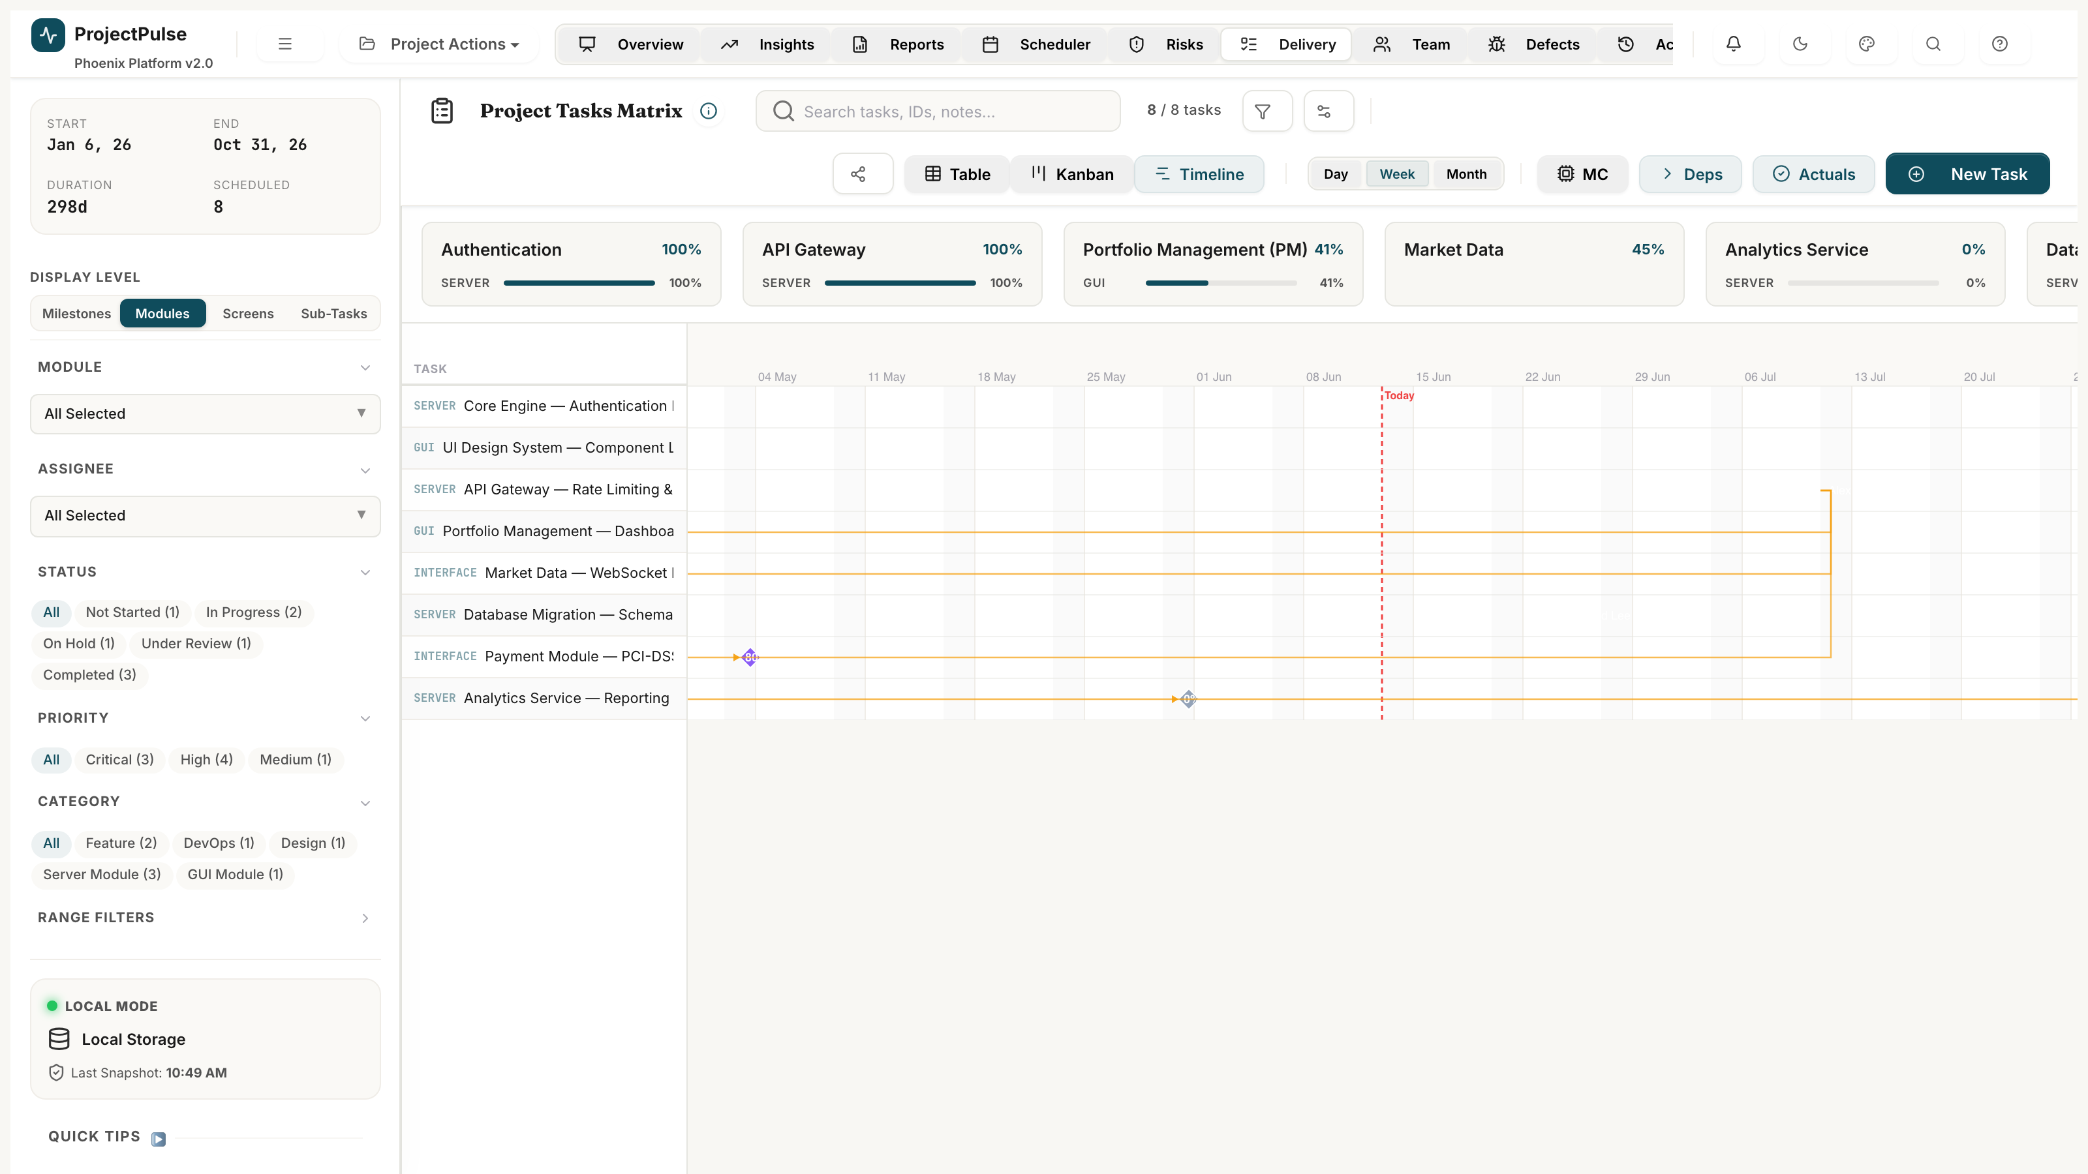
Figure 9.1 — Gantt Timeline: dependency arrows, baseline overlay, and today marker

9.1 SVG Canvas Coordinate Model
The Gantt canvas is a single SVG element scaled to fit the current zoom level and task count.
taskBarX = (startDate - viewStartDate) * pixelsPerDay
taskBarWidth = (dueDate - startDate) * pixelsPerDay
taskBarY = taskIndex * rowHeight
Zoom Level | pixelsPerDay | Visible Horizon
Day | 60px | 4 weeks
Week | 12px | 6 months
Month | 4px | 18 months
Quarter | 1.5px | 3 years

9.2 Dependency Arrow Rendering
Dependency arrows are rendered as cubic Bezier SVG <path> elements connecting the right edge of the predecessor bar to the left edge of the successor bar.
- Green arrows: Predecessor status == Completed.
- Blue arrows: Active dependency — predecessor in progress.
- Red arrows: Violated dependency — successor.startDate < predecessor.dueDate.
Bezier path formula:
d = `M ${x1} ${y1} C ${x1+40} ${y1} ${x2-40} ${y2} ${x2} ${y2}`

9.3 Drag-to-Reschedule
Task bars on the Gantt timeline are draggable. The drag-reschedule workflow:
- mousedown on a task bar: stores initial mouse X position and task start/end dates.
- mousemove: calculates deltaX in pixels, converts to deltaDays = deltaX / pixelsPerDay.
- Visual preview: task bar moves with cursor. Ghost bar shows original position.
- mouseup: applies deltaDays to task.startDate and task.dueDate. Calls render().
- If cascade: propagates deltaDays to all downstream dependent tasks transitively.
[WARNING]
Drag-reschedule modifies the live P.tasks schedule. Use Sandbox Mode to experiment safely before applying changes to the live plan.

10 Weekly Scheduler & Conflict Resolver

The Weekly Scheduler is the resource capacity management engine. It maps every active team member's allocation against their weekly capacity, detects conflicts, and offers automated resolution via the Copilot engine.
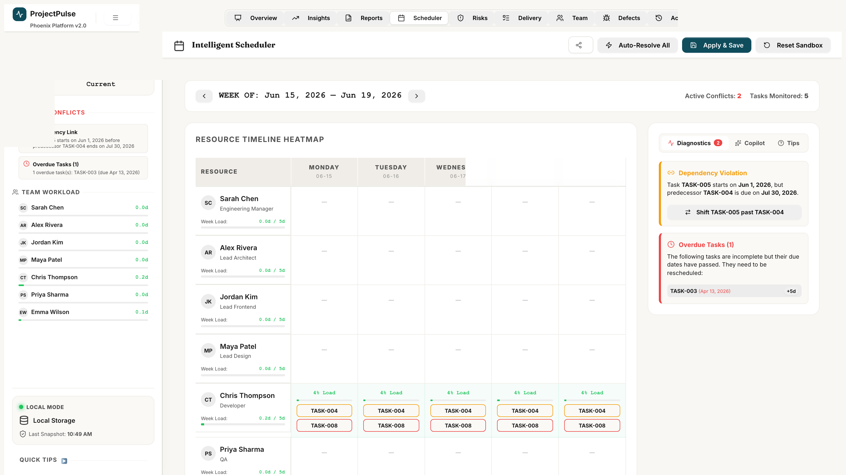
Figure 10.1 — Weekly Scheduler: resource heatmap, conflict diagnostics, and Copilot Cockpit

10.1 Weekly Capacity Formula
weeklyCapacity(member, week) = hoursPerDay * daysPerWeek * utilisationRate - leaveHours(member, week)
where leaveHours(member, week) = number of work-day hours the member is on planned leave during that week.

10.2 Weekly Allocation Calculation
weeklyAllocation(member, week) = SUM(task.estEffort / task.durationWeeks
FOR EACH task WHERE task.assignee == member.name
AND task.startDate <= week.end AND task.dueDate >= week.start)
Task effort is spread evenly across its duration in weeks. A task spanning 4 weeks contributes estEffort/4 hours to each covered week.

10.3 Heatmap Cell State Classification
State | Condition | Hex Colour | Cell Label | Action Required
On Leave | weeklyCapacity == 0 (leave recorded) | #374151 | 0h / 0h | No tasks should be assigned.
Over-allocated | allocation > capacity | #7F1D1D | XXh / YYh | Reassign tasks or extend dates.
Optimal | 0.8 * capacity <= allocation <= capacity | 14532D | XXh / YYh | No action required.
Under-utilised | allocation < 0.7 * capacity | #374151 | XXh / YYh | Consider additional assignments.

10.4 Conflict Detection Engine
The conflict detector scans for three types of scheduling conflicts:
Conflict Type | Detection Condition | Severity
Over-Allocation | weeklyAllocation(member, week) > weeklyCapacity(member, week) | High
Dependency Violation | task.startDate < predecessor.dueDate for any predecessor in task.dependsOn | High
Scheduling Gap | A task has no assignee and its start date is within 7 days | Medium

10.5 Copilot — Three Resolution Heuristics
The autoResolveAllSchedulerConflicts() engine evaluates tasks in sandbox state and applies heuristics sequentially until all conflicts are resolved:
Heuristic | Name | Logic | Pre-condition | Post-condition
A | Auto-Sequence | For each dependency violation (Task_A -> Task_B overlap): set Task_B.startDate = Task_A.dueDate + 1 day. Recalculate Task_B.dueDate = Task_B.startDate + originalDuration. | Both tasks in sandbox. | Task_B starts after Task_A ends.
B | Smart Reassignment | For each over-allocated member M: find an active member M2 where M2.role == M.role AND weeklyAllocation(M2, week) + taskEffort/durationWeeks <= weeklyCapacity(M2, week). Reassign the smallest task from M to M2. | Role-matched member with spare capacity exists. | M's allocation drops below capacity.
C | Cascading Date Shift | For each task on the critical path whose dueDate has shifted: collect all transitive dependents via BFS. For each dependent, push startDate and dueDate forward by the same delta, preserving durations. | Dependency graph is acyclic. | All dependent tasks are scheduled after their predecessors.

[BUSINESS RULE]
All Copilot resolutions are applied to P.sandboxTasks only. The Diagnostics panel shows the proposed changes in full before the user clicks Commit.

10.6 Sandbox Lifecycle — State Machine
From Status | To Status | Guard / Condition | Required Effect
INACTIVE | ACTIVE (CLEAN) | User enables Sandbox toggle | Deep-clone P.tasks into P.sandboxTasks.
ACTIVE (CLEAN) | ACTIVE (DIRTY) | User adjusts Capacity or Scope sliders | Mutations applied to P.sandboxTasks only.
ACTIVE (DIRTY) | ACTIVE (DIRTY) | User runs Copilot resolver | Additional mutations applied to P.sandboxTasks.
ACTIVE (DIRTY) | COMMITTED | User clicks Commit Changes | Copy P.sandboxTasks to P.tasks. Log entry. Call save(). Set P.sandboxTasks=null.
ACTIVE (CLEAN) | INACTIVE | User clicks Discard | Set P.sandboxTasks=null. Views revert to P.tasks.
ACTIVE (DIRTY) | INACTIVE | User clicks Discard | Set P.sandboxTasks=null. All sandbox changes lost.

11 RAID Register

The RAID Register is the risk governance engine of ProjectPulse. It provides a structured framework for identifying, scoring, tracking, and mitigating project risks, assumptions, issues, and dependencies.
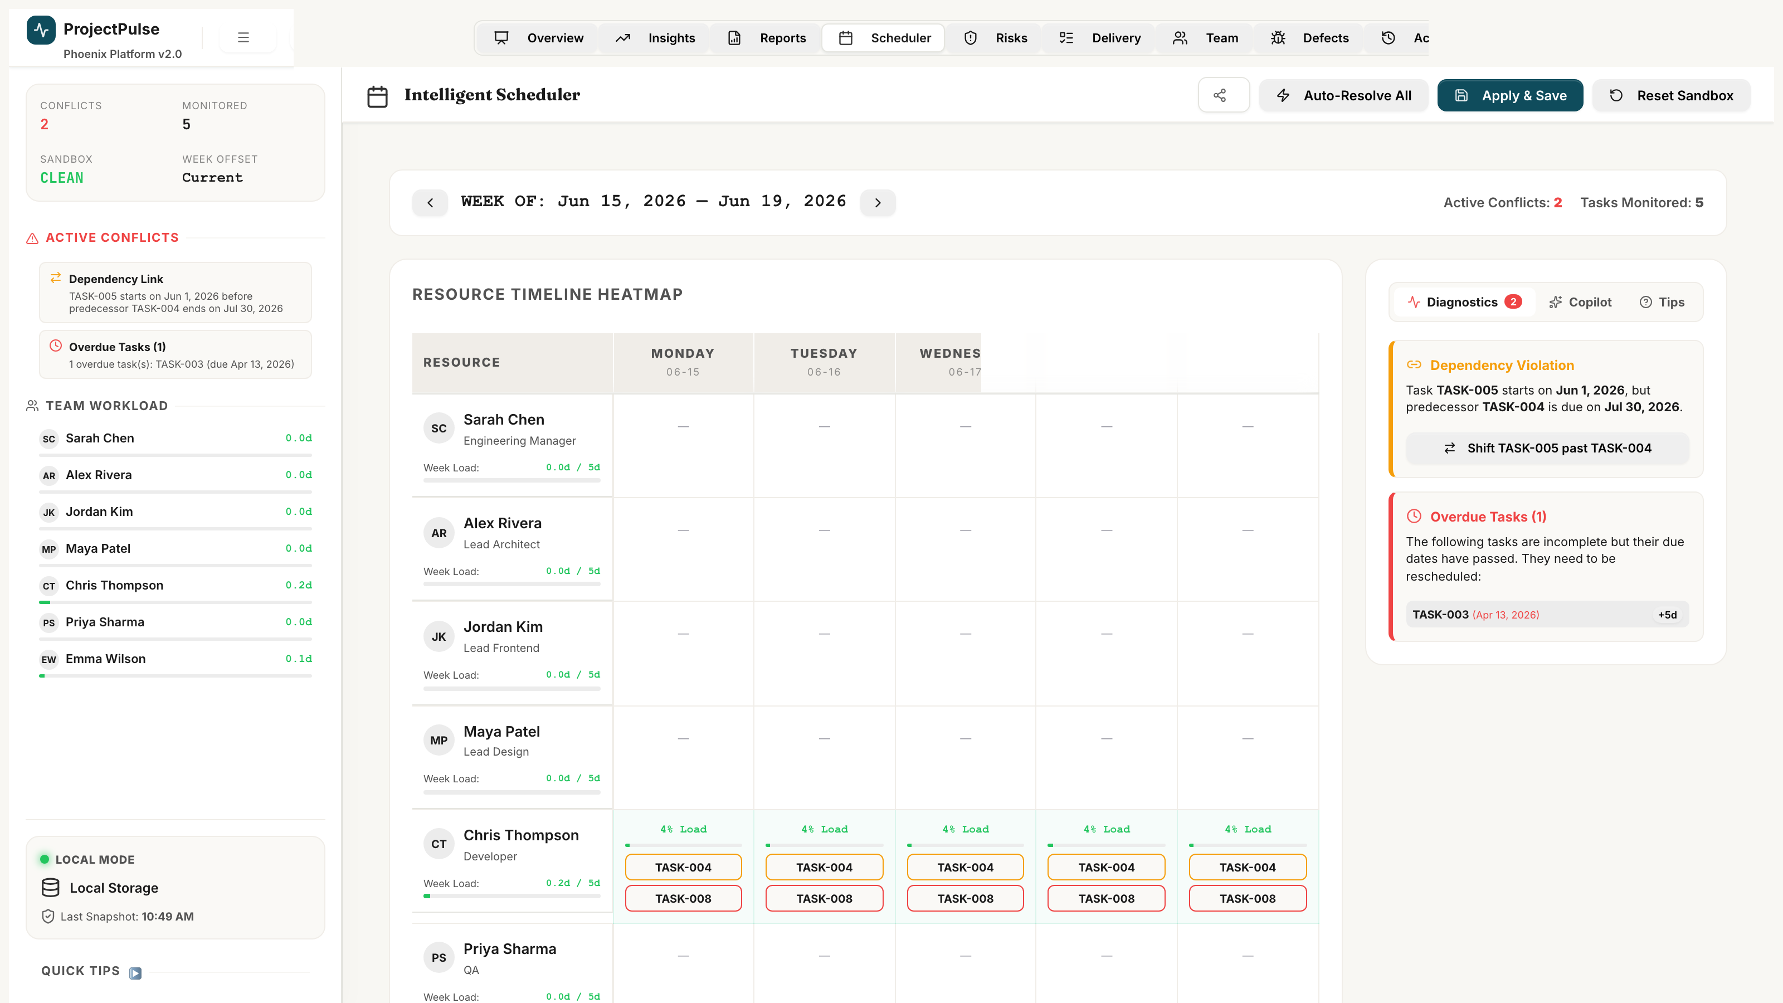
Figure 11.1 — Unified RAID Register: risk matrix, RAID items, and exposure scoring

11.1 Classification Model
Type | Definition | Who Raises It | Management Action
Risk | A potential future event that could negatively impact timeline, scope, or quality. | Any team member | Mitigate, transfer, or accept before the event occurs.
Assumption | A factor believed to be true for planning purposes without verified evidence. | Project Manager / Analyst | Validate through testing or stakeholder confirmation.
Issue | An active, current problem impacting timeline, scope, or budget. | Any team member | Resolve immediately via assigned owner with clear mitigation strategy.
Dependency | A reliance on an external team, system, vendor, or deliverable. | Lead Engineer / PM | Map to task schedules. Monitor checkpoint dates. Escalate delays immediately.

11.2 Exposure Scoring Matrix (Risks)
Exposure Score = Probability (1-3) x Impact (1-3) [max = 9]
Probability Label | Int Value | Impact Label | Int Value | Score Range | Rating
High | 3 | High | 3 | 7-9 | Critical (Red)
Medium | 2 | Medium | 2 | 4-6 | Medium (Amber)
Low | 1 | Low | 1 | 1-3 | Low (Green)

Score Range | Rating | Colour | Management Protocol
7-9 | Critical | Red | Immediate mitigation plan required. Executive escalation mandatory. Contributes -5% to Health Index.
4-6 | Medium | Amber | Weekly monitoring. Mitigation plan within 5 business days.
1-3 | Low | Green | Logged and reviewed bi-weekly. No immediate action required.

11.3 RAID Item Status Lifecycle
From Status | To Status | Guard / Condition | Required Effect
Identified | Active | Owner and mitigation plan assigned | Send notification to owner. Log status change.
Active | Mitigated | Mitigation actions completed | Set closedDate. Log status change. Recalculate Health Index.
Active | Realized | Risk event has occurred (for Risks) | Convert to Issue. Log status change.
Mitigated | Closed | Effectiveness confirmed over 2+ weeks | Set closedDate. Permanently archived.
Mitigated | Active | Mitigation proved ineffective | Clear closedDate. Reassign owner. Log re-activation.
Identified | Closed | Item found invalid upon triage | Set closedDate. Log closure.

11.4 Dashboard Health Integration
healthPenalty = criticalRaids * 5 (deducted from Health Index)
Only RAID items with exposureScore >= 7 (Critical) and status in {Identified, Active} contribute to the Health Index penalty. Mitigated, Closed, and Low/Medium items do not deduct from Health.
[CONSTRAINT]
Governance requirement: every Active RAID item must have an Owner, a Mitigation Strategy, and a Target Closure Date. The application enforces these three fields before allowing an item to transition from Identified to Active.

12 Team Capacity Hub

The Team Capacity Hub manages all team resource profiles, capacity parameters, leave calendars, and utilisation data. It is the single source of truth for all resource-related calculations in the Scheduler, Copilot, and EVM modules.
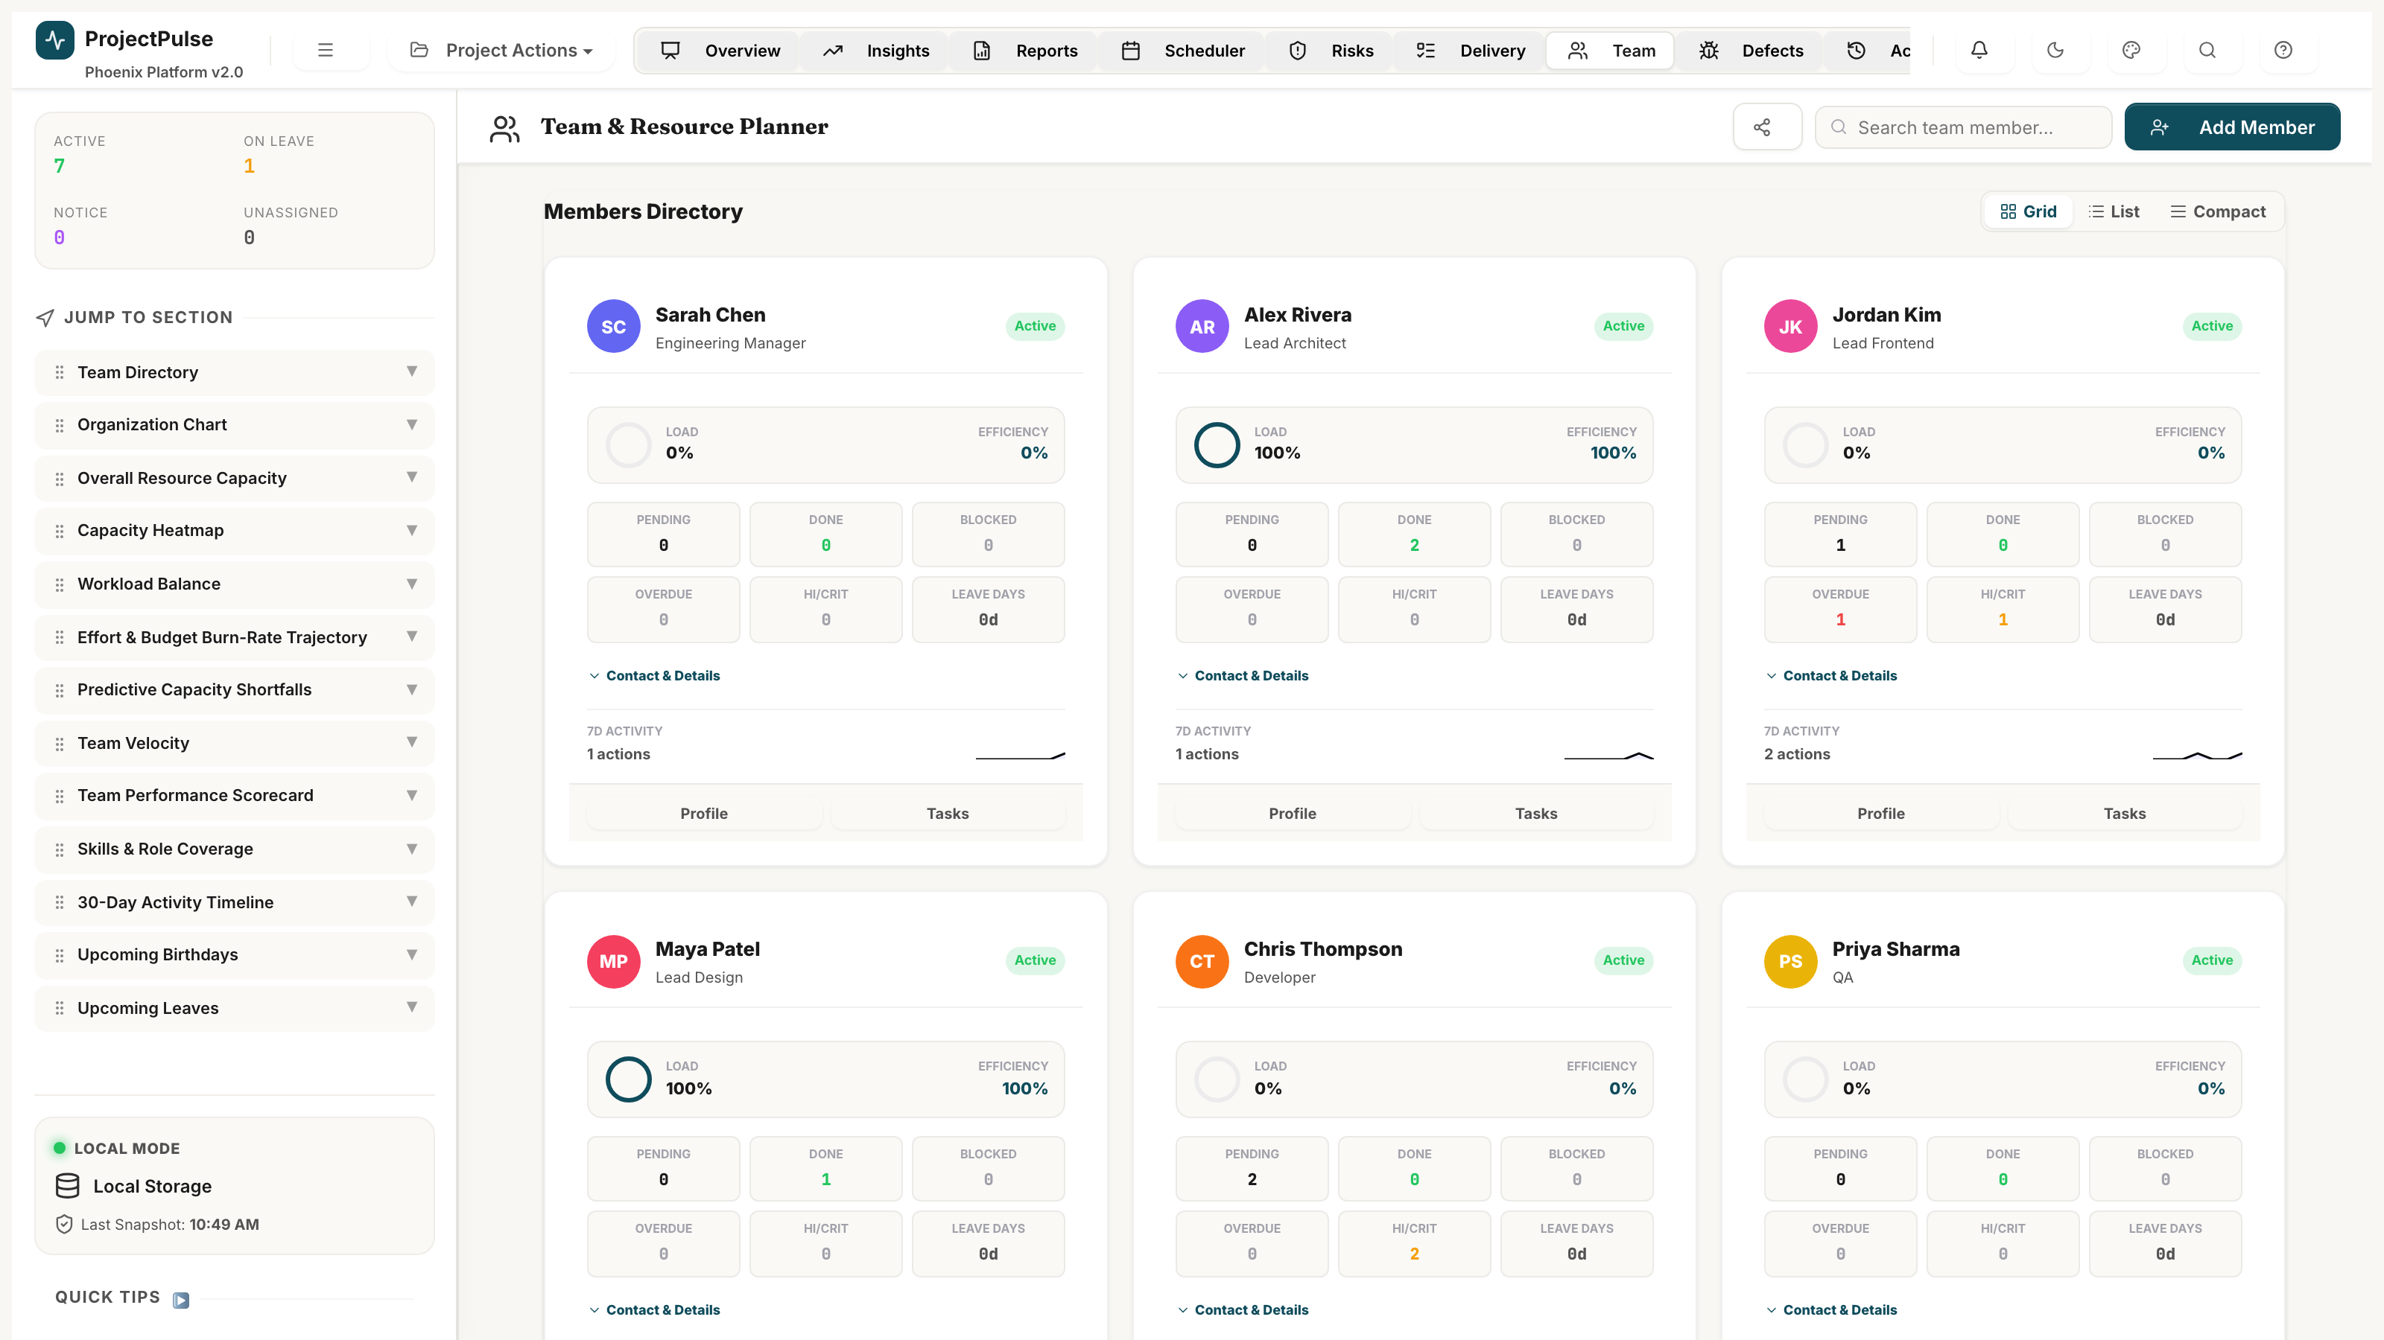
Figure 12.1 — Team Capacity Hub: member profiles, utilisation bars, and leave calendar

12.1 Effective Weekly Capacity Formula
effectiveCapacity(member, week) =
(hoursPerDay * daysPerWeek * member.utilisationRate)
- SUM(workHoursOnLeave(member, week))
where:
- workHoursOnLeave: counts the number of configured working day hours within any overlap between member.plannedLeaves and the given week's date range.
- Members with status != Active have effectiveCapacity = 0 for all weeks.

12.2 Member Status Lifecycle
From Status | To Status | Guard / Condition | Required Effect
Active | On Leave | Leave period starts | effectiveCapacity set to 0 for leave weeks.
On Leave | Active | Leave period ends | effectiveCapacity restored to normal.
Active | Other Assignment | Member temporarily reassigned | Excluded from Scheduler capacity. Tasks remain assigned.
Active | Serving Notice Period | Resignation submitted | Excluded from future task assignments in Copilot.
Serving Notice | Departed | Employment ended | Excluded from all capacity and assignment logic.

12.3 Role-Based Assignment Constraints
The Copilot's Smart Reassignment heuristic (Section 10.5, Heuristic B) only swaps tasks between members with identical roles. This prevents incorrect cross-functional reassignments (e.g., a QA task being assigned to a Developer).
[INTEGRATION]
Role names are configured in Settings -> Dropdown Manager -> Role. Ensure role names are consistent across all member profiles for Copilot to function correctly.

13 Defect Tracker

The Defect Tracker manages the full software defect lifecycle from initial logging through assignment, fix, retest, and closure. Defect data is integrated into the Health Index and linked to tasks for full traceability.
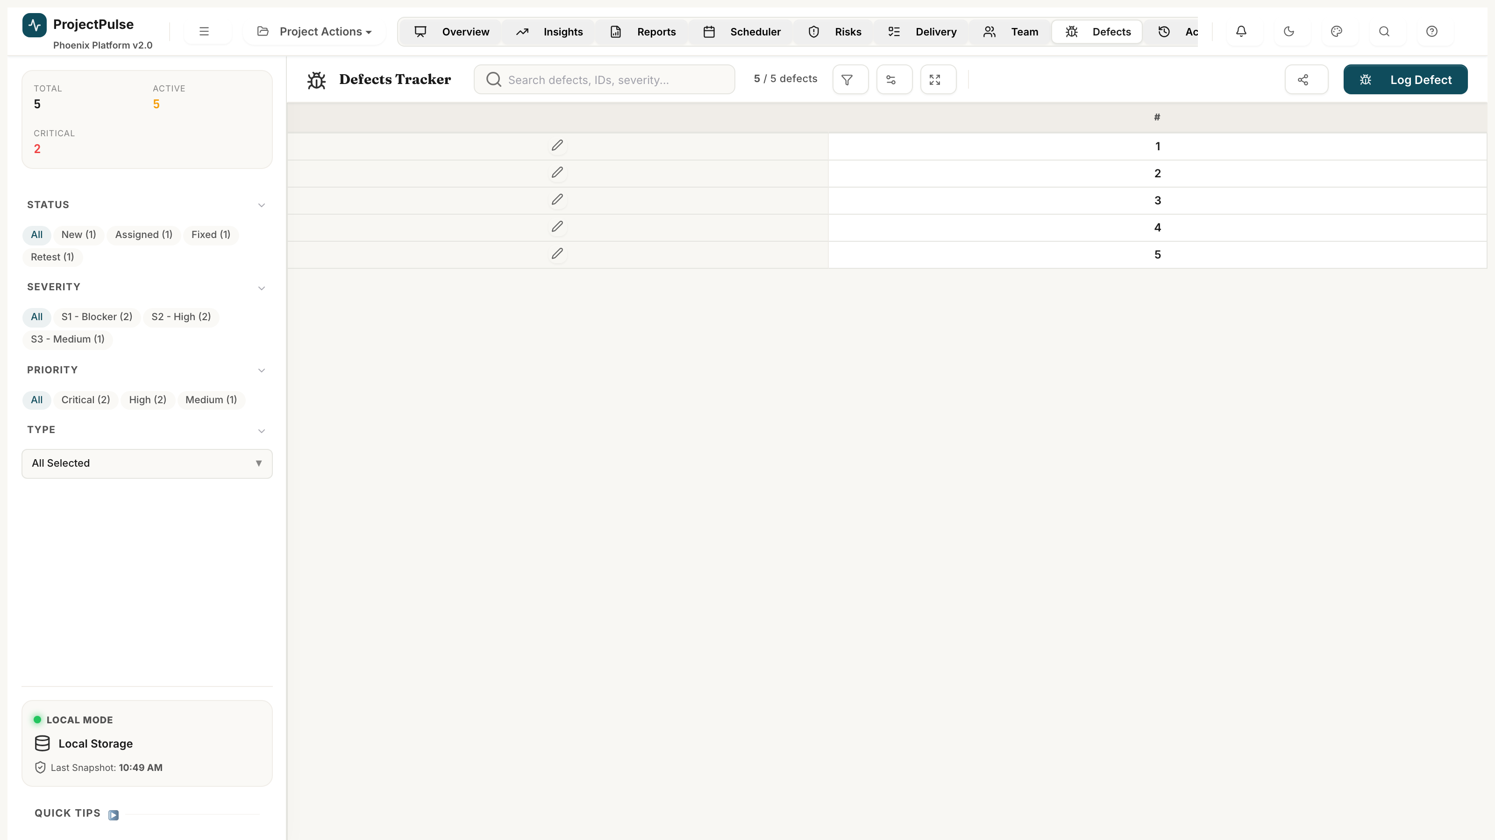
Figure 13.1 — Defect Tracker: severity cards, defect register, and lifecycle workflow

13.1 Severity Matrix & SLA Targets
Severity | Code | Definition | Health Index Impact | SLA Target
Blocker | S1 | Critical function completely broken. No workaround. Application unusable. | -10% per active Blocker | 24 hours
High | S2 | Major functionality impaired. Temporary workaround exists but is impractical. | -5% per active High | 48 hours
Medium | S3 | Significant issue. Clear and stable workaround available. | -2% per active Medium | 5 business days
Low | S4 | Trivial cosmetic issue, spelling error, or minor UI inconsistency. | -0.5% per active Low | 10 business days

healthDefectPenalty = (s1count*10) + (s2count*5) + (s3count*2) + (s4count*0.5)

13.2 Defect Status Lifecycle
From Status | To Status | Guard / Condition | Required Effect
New | Assigned | Owner allocated by Engineering Manager | Log Status Changed. Notify assignee.
Assigned | Fixed | Developer applies code fix | Log Status Changed. SLA timer stops.
Fixed | Retest | Fix deployed to test environment | Log Status Changed. Notify QA.
Retest | Closed | QA verifies fix is correct | Set closedDate. Health penalty removed.
Retest | Assigned | QA finds fix incomplete (re-open) | Log Status Changed. Notify developer.
New | Rejected | Defect is by design or not reproducible | Set closedDate. Log rejection reason.
Assigned | Rejected | Investigation reveals non-defect | Set closedDate. Log rejection reason.
Assigned | Deferred | Fix postponed to future release | Log Status Changed with release target.

13.3 S1 Blocker Escalation Workflow
- S1 Blocker logged: Red alert banner immediately appears on Overview Dashboard.
- 24-hour SLA countdown timer starts from defect creation timestamp.
- If defect remains in New or Assigned status after 24 hours: in-app notification sent to Engineering Manager.
- SLA breach is flagged in the Defect Tracker with a red SLA badge.
- Defect remains flagged until status transitions to Fixed or beyond.

14 Reports & Board Packs

The Reports module provides one-click generation of an Executive Board Pack and a professional multi-sheet Excel workbook export with live formulas.
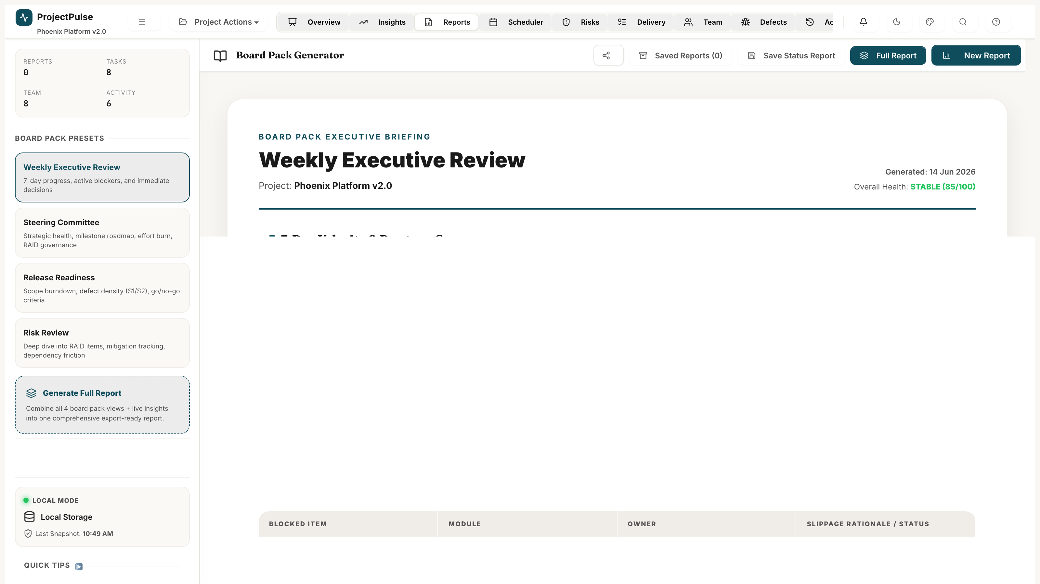
Figure 14.1 — Reports & Board Packs: export builder, preview panel, workbook sheet map

14.1 Executive Board Pack — Generation Workflow
The Board Pack is assembled programmatically from live P.cache data:
- Project Summary Narrative: auto-generated paragraph from health signals, milestone status, and top risks.
- Health Trend Sparkline: 8-week history of Health Index from P.cache.velocityHistory.
- Critical Path Tasks: all tasks on the critical path within 5 days of or past their due date.
- Top 5 RAID Items: RAID items ranked by exposureScore descending, with owner and mitigation summary.
- Team Velocity: 4-week rolling average from P.cache.velocityHistory.

14.2 Excel Workbook Architecture — 8 Sheets
Sheet | Contents | Live Formulas
System State | Project name, description, settings, effort unit, last saved timestamp, file sync path. | No
Tasks | Full task register: all fields, baseline dates, variance calculations, slippage reasons. | Yes (variance)
Team | Member directory: roles, statuses, capacity parameters, leave records. | No
RAID Register | All RAID items: type, exposure score, owner, mitigation, status lifecycle. | Yes (exposure)
Defects | Complete defect log: severity, priority, status, SLA, linked tasks, repro steps. | Yes (SLA)
Activity Log | Last 500 audit log entries: timestamps, users, actions, diff payloads. | No
Baselines | All captured baseline snapshots with per-task variance calculations. | Yes (variance)
Releases | Release version registry with status and target dates. | No

14.3 Excel Cell Colour Coding Rules
Colour | Background Hex | Text Hex | Applied When
Green | #D1E7DD | #0F5132 | Status = Completed / Closed / Mitigated / Low RAID exposure.
Yellow | #FFF3CD | #664D03 | Status = In Progress / Under Review / Medium risk / Deferred.
Red | #F8D7DA | #842029 | Status = Blocked / Overdue / Critical risk / S1-S2 Defect.
Grey | #F8F9FA | #6C757D | Status = Cancelled / Rejected / On Hold / Departed member.

[TIP]
Excel cells in the Tasks sheet contain live formulas for Variance Days and Effort Variance. Stakeholders can modify the workbook after export without breaking these calculations.

15 Audit Log & Activity Streams

The Audit Log provides a complete, immutable, chronological record of every state mutation in the application. It is append-only and forms the basis for both accountability reporting and session rollback.
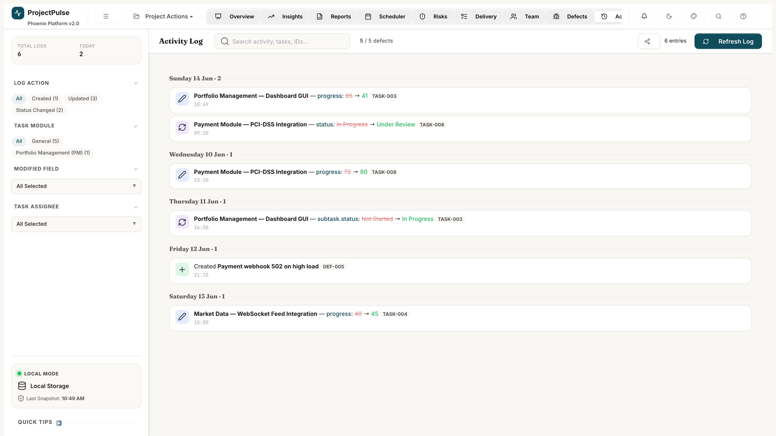
Figure 15.1 — Audit Log: chronological activity stream with diff payloads

15.1 Immutability Model
Log entries are appended to P.log using Array.push(). No update or delete operations are permitted on existing log entries. The application UI provides no mechanism to edit or remove a log entry — they are strictly immutable.
[WARNING]
The 500-entry auto-pruning policy removes the oldest entries when the log exceeds 500 records. Export the log to Excel before reaching this limit if a permanent audit record is required.

15.2 Session Rollback Algorithm
The rollback system computes the inverse of all log entries between the current state and the target restore point, then applies them in reverse chronological order.
- User selects a target log entry (the desired restore point).
- System collects all log entries with ts > target.ts in reverse chronological order.
- For each collected log entry, the inverse operation is computed:
- Created -> Deleted (remove entity from array).
- Updated -> Updated (swap oldVal/newVal, restore previous value).
- Status Changed -> Status Changed (restore previous status).
- Deleted -> Created (restore entity from snapshot in log entry).
- Inverse operations are applied sequentially to P.tasks/P.raids/P.defects/P.members.
- render() is called after all inverses are applied.
- A new 'Rollback' entry is appended to P.log describing what was restored.
- save() is called to persist the restored state.

16 Schedule Baselines

Schedule Baselines capture a named, timestamped snapshot of all task planned dates and efforts. They serve as the immutable reference for calculating schedule variance and enabling plan restoration.

16.1 Three Date Set Model
Date Set | Task Fields | Lifecycle | Purpose
Planned Dates | startDate, dueDate, estEffort | Updated during execution | Current target dates that resources work towards.
Baseline Dates | baselineStartDate, baselineDueDate, baselineEffort | Frozen at capture; updated at each new snapshot | Immutable reference for variance calculation.
Actual Dates | actCompletionDate, actEffort | Set when task is completed | Real completion dates used for EVM and velocity reporting.

16.2 Snapshot Capture Algorithm
- User enters baseline name and description in Settings -> Schedule Baselines.
- User clicks 'Capture Snapshot'.
- System iterates over all tasks in P.tasks.
- For each task: copies startDate -> baselineStartDate, dueDate -> baselineDueDate, estEffort -> baselineEffort.
- A baseline record {id, name, description, timestamp, taskSnapshots[]} is appended to P.baselines.
- The Activity Log records a 'Baseline Captured' entry.
- save() is called.

16.3 Variance Calculation Formulas
varianceDays(task) = (task.dueDate - task.baselineDueDate) in calendar days
effortVariance(task) = task.estEffort - task.baselineEffort
Positive varianceDays = behind schedule. Positive effortVariance = scope increase vs. baseline.

16.4 Restore Workflow
- User selects a historical baseline from Settings -> Schedule Baselines.
- User clicks 'Restore'. Confirmation dialog shown.
- System overwrites each task's startDate, dueDate, estEffort with values from the baseline snapshot.
- System recalculates baselineStartDate, baselineDueDate, baselineEffort to match restored values.
- Full cache rebuild and render() call.
- 'Baseline Restored' entry appended to P.log.
- save() called.
[CAUTION]
A restore operation overwrites all current planned dates. Always capture a 'Current State' snapshot before restoring a historical baseline, so you can return to the pre-restore position if needed.

17 System Configuration

The Administration panel (Settings icon in the navigation bar) centralises all system-wide configuration. Changes take effect immediately.
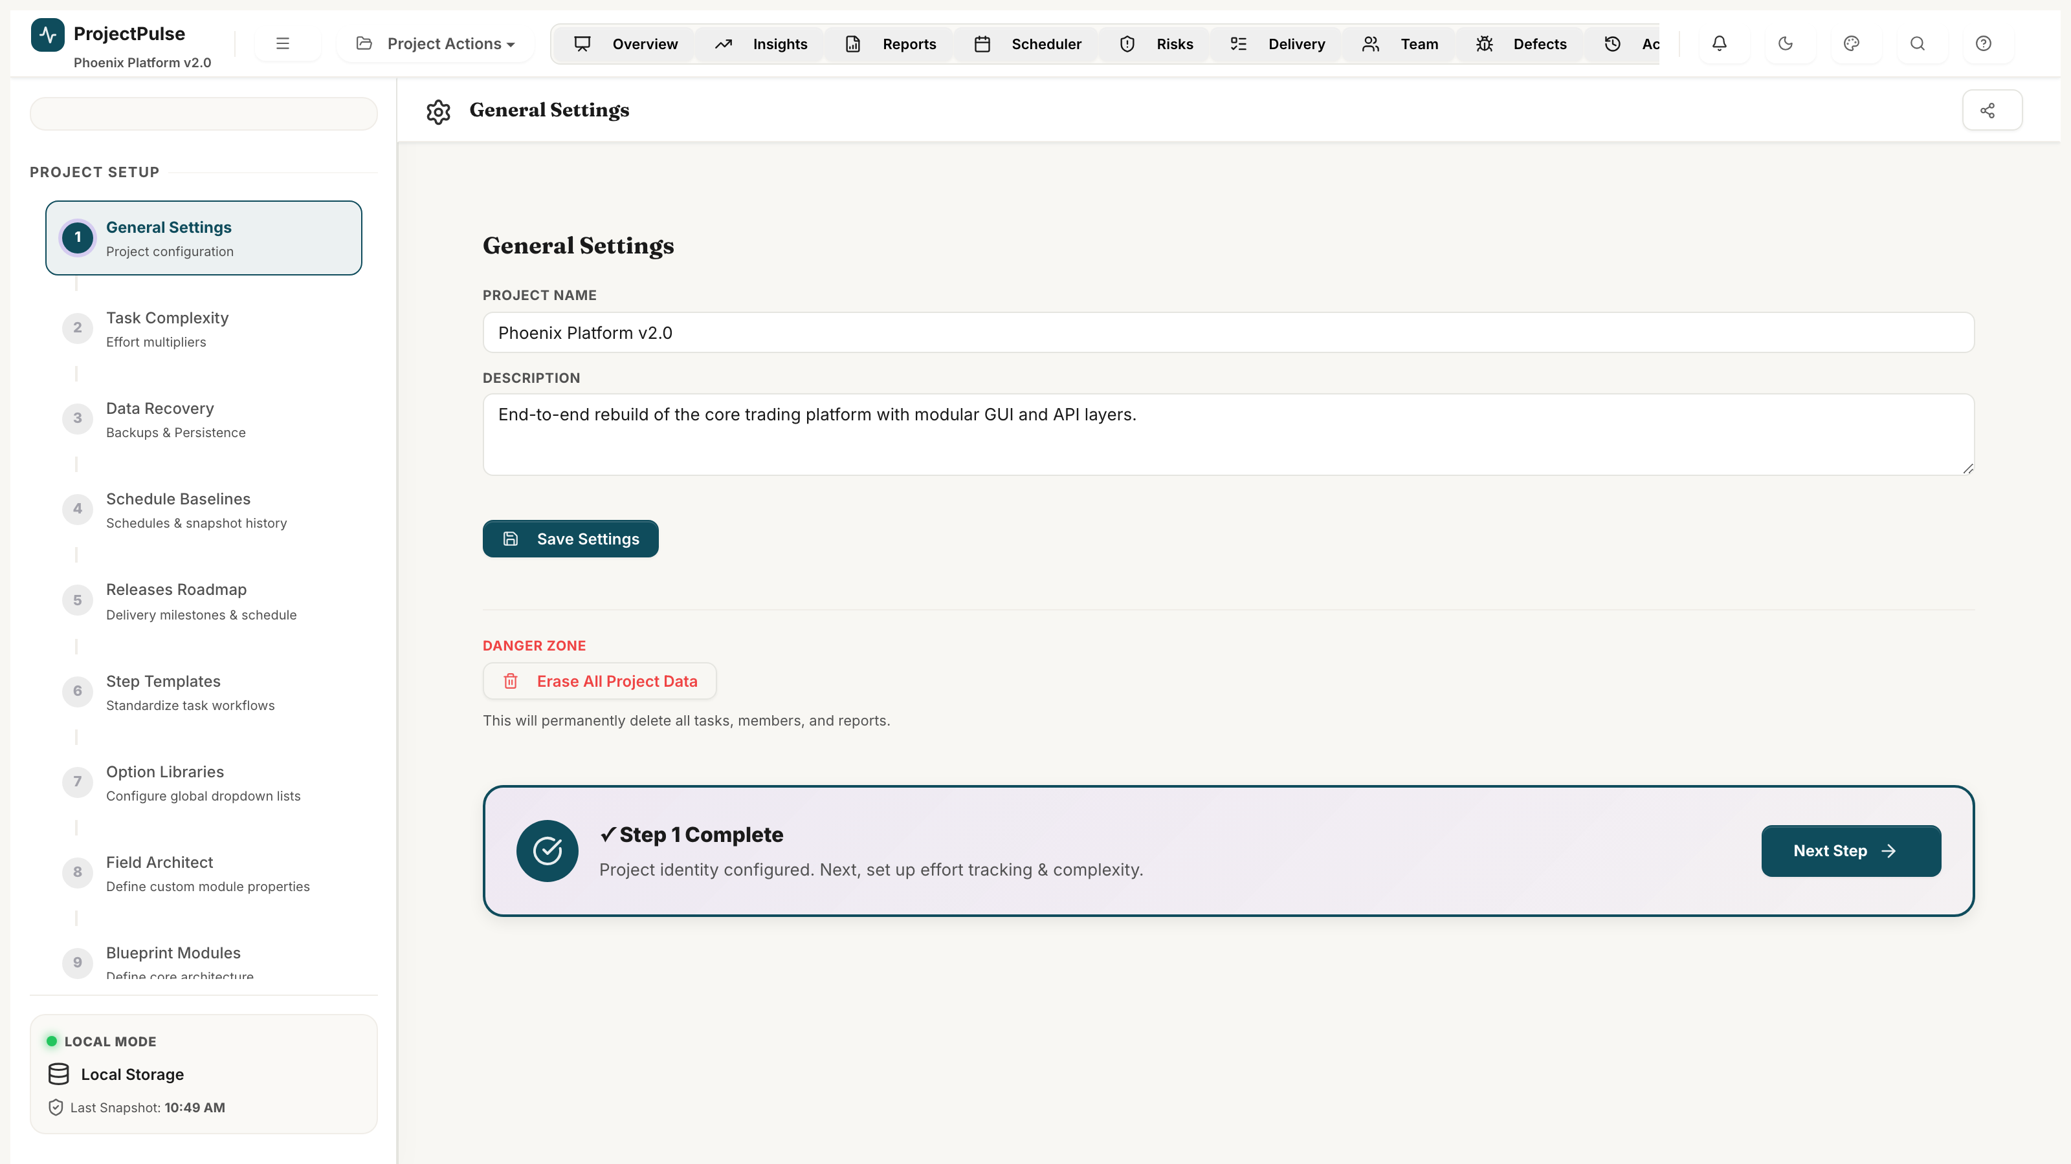
Figure 17.1 — System Configuration: general settings, dropdown manager, and custom fields

17.1 Dropdown Configuration Manager
All categorical dropdown option lists in ProjectPulse are stored in P.dropdowns and are fully configurable via the Dropdown Manager:
- Navigate to Settings -> Dropdown Manager.
- Select the dropdown to modify (e.g., Module, Category, Role).
- Add new options, edit existing labels, or drag-and-drop to reorder.
- Click Save. New options appear immediately in all inline edit selects.

[WARNING]
Removing a dropdown option that is currently assigned to active tasks will NOT delete those tasks or their data — the old value is preserved on existing records. However, the old value will not appear as a selectable option for new assignments.

17.2 Custom Fields Engine
Custom Fields extend the Task and Defect schemas with project-specific attributes:
Attribute | Value
Supported Types | Text, Number, Date, Dropdown (with custom option list), Checkbox
Scope | Custom fields are defined independently for Tasks and for Defects
Visibility | Custom fields appear as additional columns in Delivery Matrix and Defect Tracker
Persistence | Custom field values stored in task.customFields[fieldId] = value
Export | Custom field columns are included in the Tasks and Defects sheets of the Excel workbook

17.3 Theme Engine
ProjectPulse ships with 20 curated visual themes managed by a CSS custom property switching system. Theme selection is persisted in localStorage independently of the main project data (key: pp-theme).
- Dark Themes (10): Nexus, Obsidian, Fintech, Codename, Workflow, Bento, and 4 additional dark palettes.
- Light Themes (10): Emerald, Terracotta, Cloud, Daybreak, and 6 additional light palettes.
- Dark/Light Override: Forces dark or light rendering mode regardless of theme selection.
- Theme switch: applies immediately via document.documentElement.setAttribute('data-theme', themeName).

PART III
Cross-Cutting Concerns
────────────────────────────────────────

Security, performance limits, browser compatibility, and error handling.

18 Security & Data Privacy

As a zero-backend application, ProjectPulse does not transmit project data to any external server. All data remains within the browser's localStorage on the user's local device.
- No server: no API endpoints, no authentication tokens, no network data transmission during normal operation.
- localStorage isolation: data is scoped to the page origin and is not accessible by other websites.
- Export security: Excel exports are generated in-browser and downloaded directly. No data passes through a server.
- File sync: the optional File System Access API sync is initiated by explicit user gesture and requires user permission for each file access.
[WARNING]
Organizations with sensitive project data should ensure the projectpulse.html file is served from a secure, access-controlled web server rather than opened directly from the filesystem if multiple users share a device.

19 Performance & Scalability Limits

Resource | Practical Limit | Technical Reason
Tasks | Up to 500 tasks recommended | localStorage 5MB cap. Above 500 tasks with full logs may approach limit.
Activity Log | 500 entries (auto-pruned) | Fixed cap enforced in code. Older entries removed when limit reached.
Baselines | No hard limit | Each baseline snapshot stores per-task date triples. 20 baselines x 500 tasks = ~1MB.
Team Members | No hard limit (50 practical) | Scheduler grid becomes unwieldy beyond ~50 rows.
Render Performance | Smooth up to ~300 tasks | DOM virtualisation not implemented. Above 300 rows may cause perceptible render lag.

20 Browser Compatibility Matrix

Browser | Minimum Version | Full Support | File Sync API
Google Chrome | 110+ | Yes | Yes (File System Access API)
Microsoft Edge | 110+ | Yes | Yes (File System Access API)
Mozilla Firefox | 115+ | Yes | No (API not supported)
Apple Safari | 16+ | Yes | No (API not supported)
Mobile Chrome | 110+ | Partial (grid views limited) | No
Mobile Safari | 16+ | Partial (grid views limited) | No

APPENDICES
Reference Material
────────────────────────────────────────

Keyboard shortcuts, formula reference, and glossary.

Appendix A — Keyboard Shortcuts Reference

Shortcut | Action | Scope
Ctrl + S | Force immediate save to localStorage. | Global
Ctrl + Z | Undo last inline cell edit. | Delivery Matrix
Ctrl + F | Focus the search / filter bar. | Delivery Matrix, Defects
Escape | Close open modal, flyout, or dropdown. | Global
Enter | Confirm inline cell edit. | Delivery Matrix
Tab | Move to next editable cell. | Delivery Matrix
Shift + Tab | Move to previous editable cell. | Delivery Matrix
Arrow Keys | Navigate between grid cells. | Delivery Matrix
Ctrl + Click | Multi-select tasks for bulk operations. | Delivery Matrix
Space | Toggle expand/collapse on selected parent row. | Delivery Matrix

Appendix B — Formula Reference Card

Formula | Module | Reference
Health = 100 - (Overdue/Active*50) - (Blocked/Active*30) - (OnHold/Active*20) - (critRaids*5) - (s1*10) - (s2*5) | Overview | Section 6.1
Confidence = MIN(100, MAX(30, velocity*weeksRemaining/remainingPoints*100)) | Overview | Section 6.2
arcAngle = healthIndex/100*270 | Overview Gauge | Section 6.4
PV = totalBudget * (daysElapsed/totalDays) | Insights EVM | Section 7.1
EV = totalBudget * (completedPoints/totalPoints) | Insights EVM | Section 7.1
SV = EV - PV | Insights EVM | Section 7.1
SPI = EV / PV | Insights EVM | Section 7.1
complexityPoints = estEffort * complexityFactor | Delivery Matrix | Section 8.4
parentProgress = SUM(st.progress * st.effort) / SUM(st.effort) | Delivery Matrix | Section 8.5
effectiveCapacity = hoursPerDay * daysPerWeek * utilisationRate - leaveHours | Scheduler | Section 10.1
ExposureScore = probability_int * impact_int | RAID | Section 11.2
healthDefectPenalty = s1*10 + s2*5 + s3*2 + s4*0.5 | Defects | Section 13.1
varianceDays = dueDate - baselineDueDate | Baselines | Section 16.3
effortVariance = estEffort - baselineEffort | Baselines | Section 16.3

Appendix C — Glossary

Term | Definition
actCompletionDate | The actual date work was finished, used for retrospective activity attribution.
Baseline | A named, timestamped snapshot of planned task dates and efforts.
buildDashCache | The O(n) single-pass analytics aggregation function that populates P.cache.
Complexity Factor | A multiplier (0.5x / 1.0x / 1.5x) applied to task effort for velocity scoring.
Copilot | The automated conflict resolution engine in the Weekly Scheduler.
Delivery Confidence | The velocity-based probability of delivering all remaining work on schedule.
EVM | Earned Value Management — a PMI-standard project performance measurement framework.
Exposure Score | RAID risk score: probability_int x impact_int. Ranges 1-9.
Health Index | Composite project health score (0-100) derived from overdue tasks, risks, and defects.
localStorage | Browser-native key-value storage used to persist project data.
P | The global JavaScript state object containing all project data.
pp-data | The localStorage key under which the serialised P object is stored.
RAID | Risks, Assumptions, Issues, and Dependencies — the four governance entity types.
Sandbox | The non-destructive simulation environment for what-if scenario modelling.
SPI | Schedule Performance Index: EV / PV. < 1.0 = schedule slippage.
SV | Schedule Variance: EV - PV. Negative = behind schedule.
VALID_TRANSITIONS | The authoritative map of permitted task status transitions enforced by the state machine.
Velocity | Rolling 3-week average of completed complexity points per week.

