ProjectPulse
Product Capabilities Document

────────────────────────────────────────────────────────────

Document Type | Product Capabilities Document
Version | v2.1.0
Audience | Executives · Sales · Leadership · Prospects
Date | 14 June 2026
Confidentiality | Commercial in Confidence

Table of Contents

— | Executive Summary | 3
1 | Product Overview | 4
2 | The 12 Core Capabilities | 6
3 | Key Differentiators | 18
4 | Capability Matrix | 20
5 | Application Screenshots Gallery | 21
A | Appendix — Technical Compatibility | 26

Executive Summary

ProjectPulse is a comprehensive, browser-based project intelligence workstation designed for modern software delivery teams. It combines real-time health monitoring, resource optimisation, risk governance, and stakeholder reporting into a single, zero-installation platform that runs entirely in the browser with no backend infrastructure required.

Three Core Value Pillars
Pillar | Promise | Key Capabilities
VISIBILITY | Know the true state of your project at every moment — not just at the weekly status meeting. | Real-time Health Index · EVM Analytics · 30-Day Heatmap · Burn-up Projections · Audit Trail
CONTROL | Act on problems before they become crises. Every risk, resource constraint, and dependency is surfaced and actionable. | RAID Register · Weekly Scheduler · Conflict Resolver · Gantt Timeline · Defect Lifecycle
INTELLIGENCE | Make data-driven decisions with confidence. Simulate scenarios, forecast outcomes, and present board-ready insights in one click. | Predictive Sandbox · Copilot Auto-Resolver · EVM Metrics · Executive Board Packs · Schedule Baselines

Who Is ProjectPulse For?
Persona | Primary Use | Key Views
Engineering Manager | Day-to-day project oversight, conflict resolution, resource management. | Overview · Scheduler · Team Hub
Product Manager | Delivery progress, stakeholder communication, risk governance. | Delivery Matrix · RAID Register · Reports
Executive / Sponsor | High-level health signals, milestone confidence, board reporting. | Overview Dashboard · Board Packs
QA Lead | Defect lifecycle management, severity tracking, release readiness. | Defect Tracker · Reports
Lead Engineer | Task planning, dependency management, baseline tracking. | Gantt Timeline · Delivery Matrix · Baselines

1 Product Overview

ProjectPulse is architected as a single-page application (SPA) that runs entirely within the browser. There is no server to configure, no database to provision, and no deployment to manage. All project data is persisted locally via the browser's localStorage API and can be exported at any time to a professionally formatted Excel workbook.

1.1 The 12 Core Modules
# | Module | One-Line Description
1 | Executive Overview Dashboard | Real-time health signals, KPI cards, and the predictive what-if sandbox.
2 | Live Insights & Analytics | Full EVM suite, burn-up projections, velocity tracking, and 30-day activity heatmap.
3 | Hierarchical Delivery Matrix | Spreadsheet-style task grid with parent-child hierarchies, inline editing, and status workflows.
4 | Gantt Timeline | Interactive visual timeline with dependency arrows, drag-to-reschedule, and baseline overlay.
5 | Weekly Scheduler | Resource capacity heatmap with over-allocation detection and Copilot auto-resolution.
6 | RAID Register | Unified Risk, Assumption, Issue, and Dependency register with exposure scoring.
7 | Team Capacity Hub | Member profiles, capacity parameters, leave management, and utilisation tracking.
8 | Defect Tracker | Full bug lifecycle from logging through fix, retest, and closure — linked to tasks.
9 | Reports & Board Packs | One-click Executive Board Pack and multi-sheet Excel workbook export.
10 | Audit Log | Immutable activity stream with full diff payloads and session rollback.
11 | Schedule Baselines | Snapshot-based baseline management with variance and slippage analysis.
12 | System Configuration | Flexible dropdown management, custom fields, 20 visual themes, and effort unit switching.

1.2 Architecture at a Glance
Attribute | Value
Deployment Model | Zero-backend — runs entirely in the browser
Data Persistence | Browser localStorage (pp-data key) + Excel export
Rendering Engine | Native HTML5, CSS3, SVG — no framework dependencies
Analytics Engine | O(n) single-pass buildDashCache computation model
Export Technology | ExcelJS (in-browser workbook generation)
Theme System | 20 curated visual themes with dark/light mode override
Browser Support | Chrome 110+, Edge 110+, Firefox 115+, Safari 16+

2 The 12 Core Capabilities

Each of the 12 modules delivers a distinct, high-value capability. Together they form a complete project intelligence platform that eliminates the need for multiple disconnected tools.

2.1 Executive Command Centre
The Overview Dashboard gives project leadership an always-current, single-pane view of project health. The composite Health Index (0–100) aggregates overdue tasks, blocked items, critical risks, and open defects into a single RAG signal — so you know instantly whether to escalate or celebrate. The Predictive Sandbox lets managers simulate capacity reductions and scope expansions before committing to any plan change.
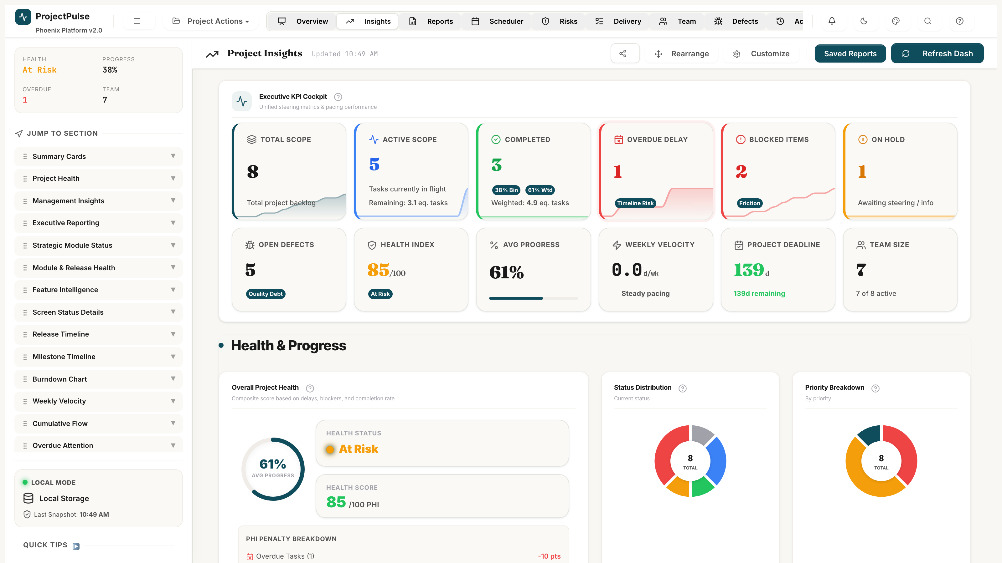
Figure 2.1 — Executive Overview Dashboard: Health Gauge, KPI Cards, and Predictive Sandbox

2.2 Live Analytics & EVM Intelligence
The Insights module transforms raw task and effort data into the industry-standard Earned Value Management (EVM) metric suite — Planned Value, Earned Value, Schedule Variance, and Cost Performance Index — updated in real time. A burn-up chart projects the exact week of project completion based on rolling 3-week velocity, giving management an evidence-based delivery forecast.

2.3 Hierarchical Delivery Matrix
The Delivery Matrix is the operational backbone of ProjectPulse — a high-density, spreadsheet-style task grid supporting unlimited parent-child hierarchies. Every deliverable, epic, task, and subtask is managed here with inline editing, a controlled status workflow, dependency linking, and multi-dimensional filtering.
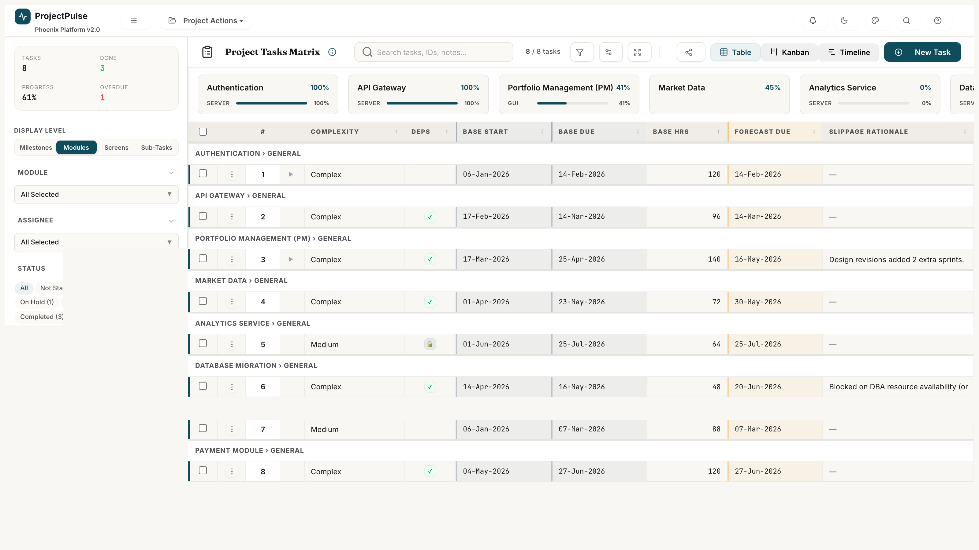
Figure 2.3 — Hierarchical Delivery Matrix: parent tasks, subtasks, status pills, inline editing

2.4 Visual Gantt & Dependency Graph
The Gantt Timeline provides a time-anchored visual schedule with interactive task bars, dependency arrows (colour-coded by health: green=resolved, red=violated), baseline overlay ghost bars, and drag-to-reschedule with optional cascading date propagation. Four zoom levels (Day/Week/Month/Quarter) support both sprint-level and programme-level views.
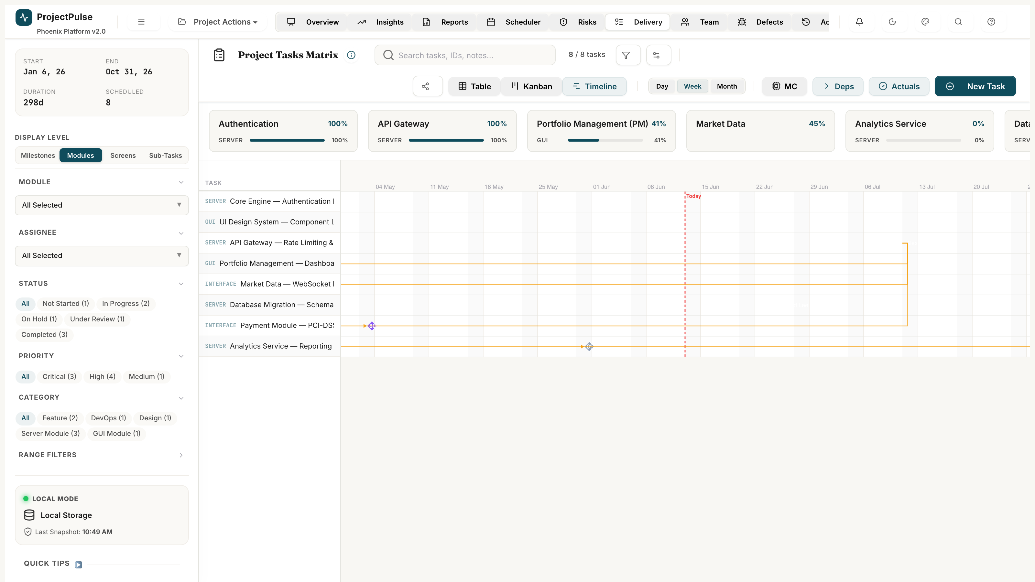
Figure 2.4 — Gantt Timeline: dependency arrows, baseline overlay, and drag-to-reschedule

2.5 Smart Resource Scheduler
The Weekly Scheduler maps every team member's allocated hours against their weekly capacity across a rolling 12-week horizon. Over-allocated cells glow crimson; optimal cells glow green. The Copilot engine applies three automated resolution heuristics — Auto-Sequence, Smart Reassignment, and Cascading Date Shift — to eliminate conflicts in a single click.
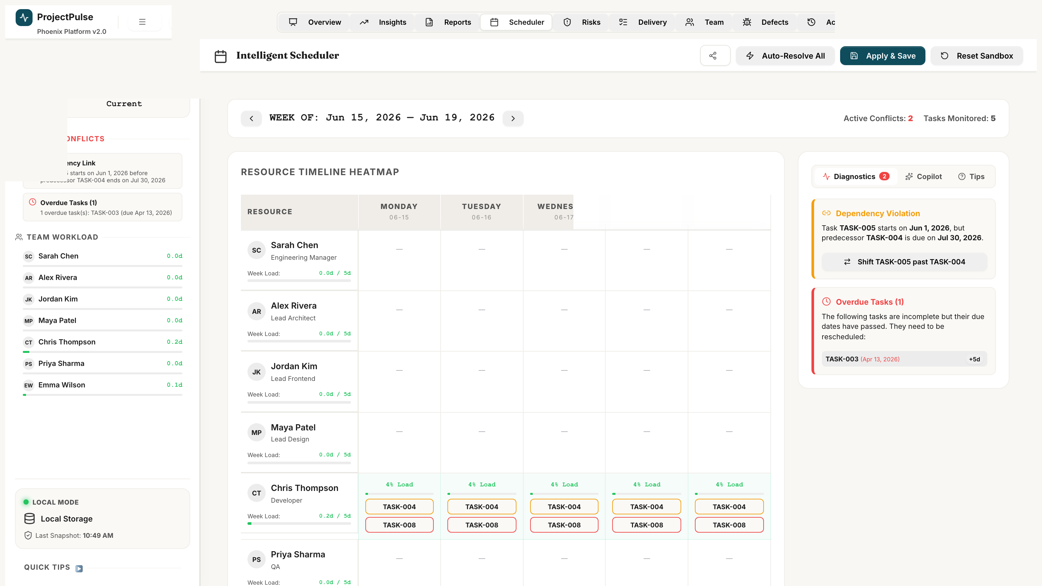
Figure 2.5 — Weekly Scheduler: resource heatmap, over-allocation alerts, and Copilot Cockpit

2.6 RAID Risk Governance
The RAID Register consolidates all Risks, Assumptions, Issues, and Dependencies into a single searchable register with a formal 5x5 exposure scoring matrix. Critical items (Exposure Score >= 15) automatically surface on the Executive Dashboard and deduct points from the Health Index until mitigated.
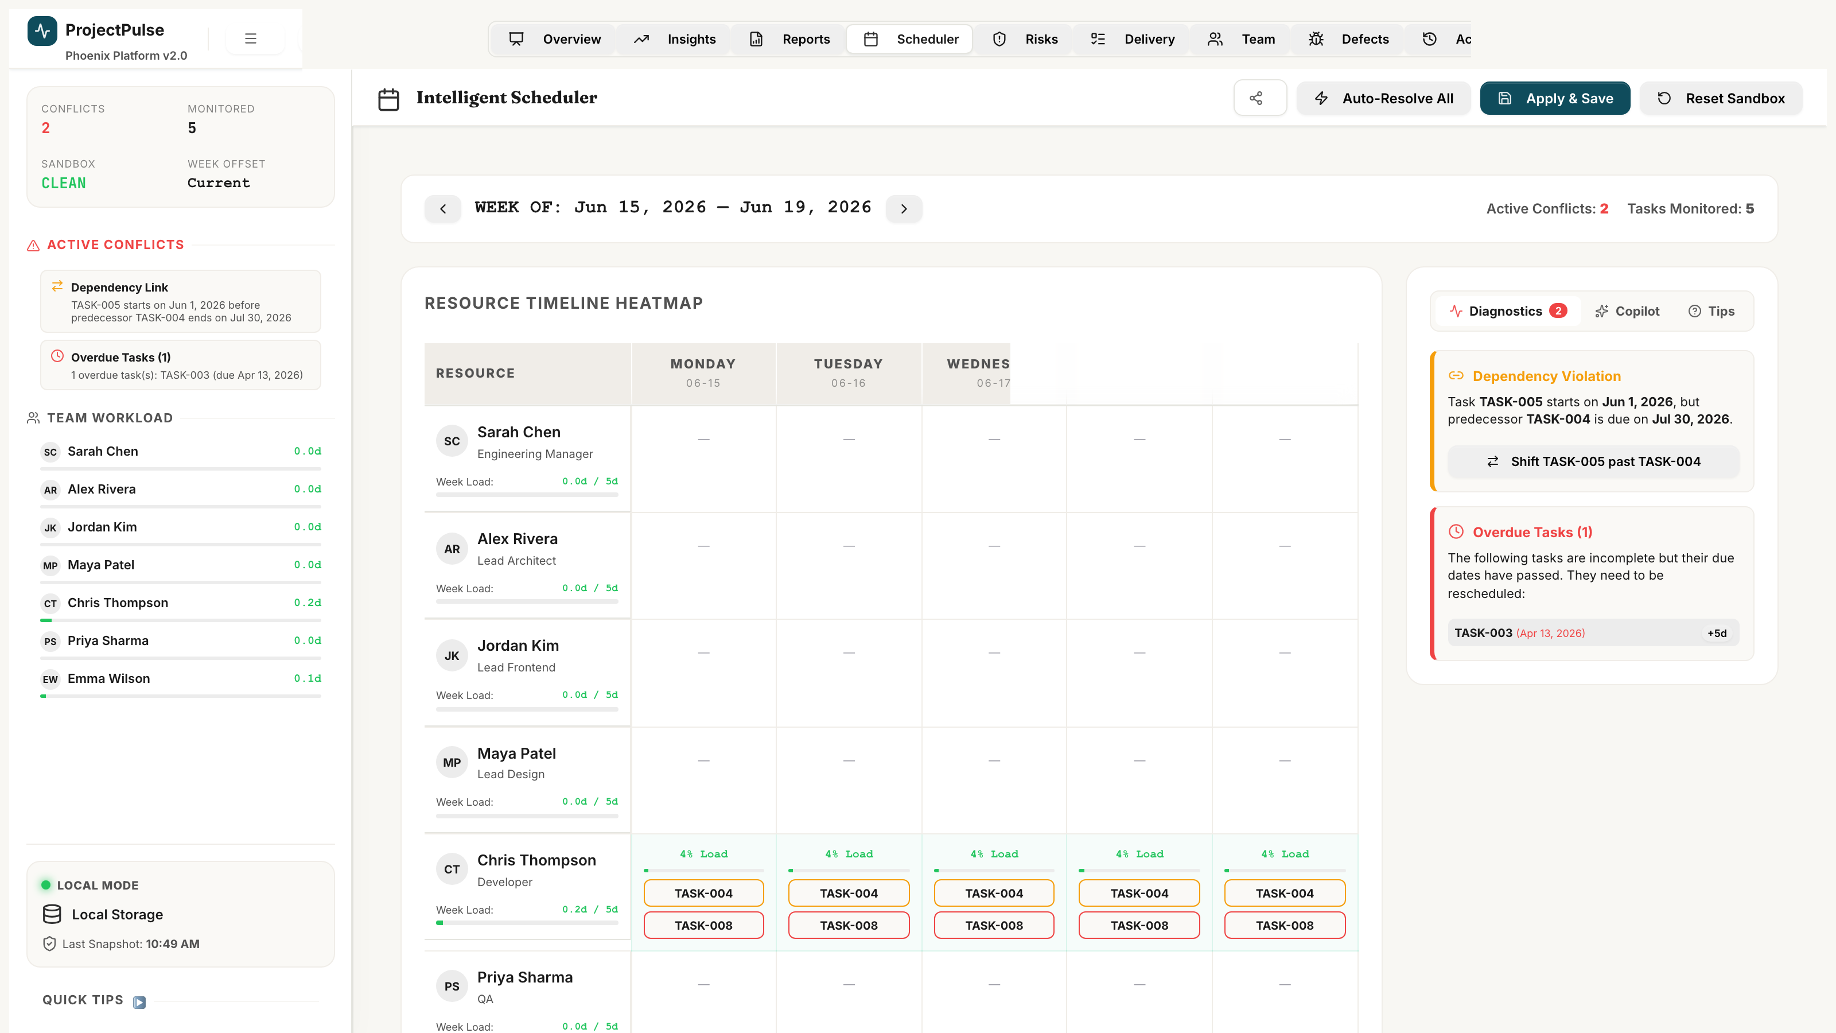
Figure 2.6 — Unified RAID Register: risk matrix, RAID items, and exposure scoring

2.7 Team Capacity Hub
The Capacity Hub maintains rich member profiles with role assignments, weekly hour caps, utilisation rates, and planned leave calendars. All scheduling calculations — from the Weekly Scheduler's heatmap to the Copilot's Smart Reassignment — draw their capacity data from this module in real time.
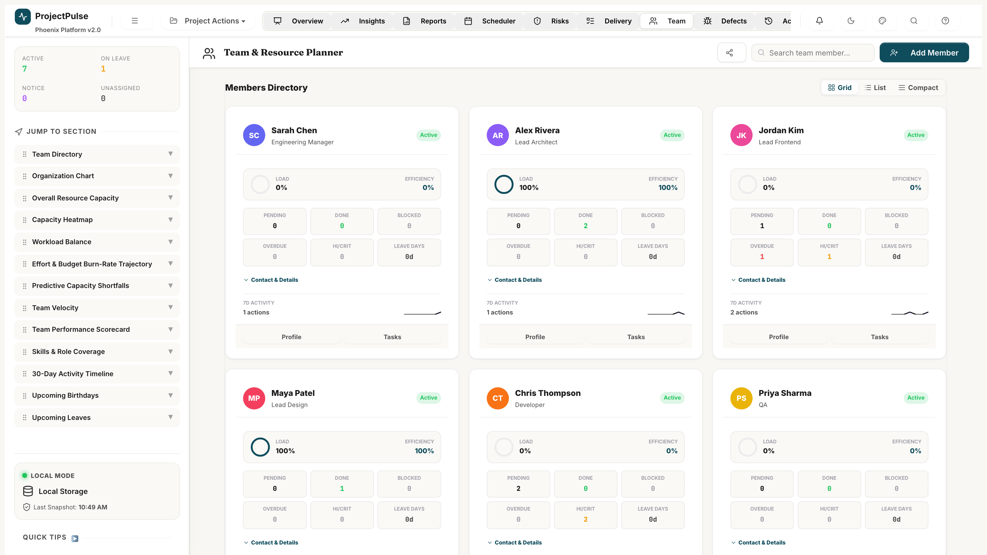
Figure 2.7 — Team Capacity Hub: member utilisation bars and leave calendar integration

2.8 Defect Lifecycle Management
The Defect Tracker provides a formal bug lifecycle from initial logging through assignment, fix, retest, and closure. S1 Blocker defects trigger dashboard alerts and SLA countdown timers. Every defect is linked to a specific task, subtask, or GUI screen for full traceability, and open defects automatically impact the Health Index.
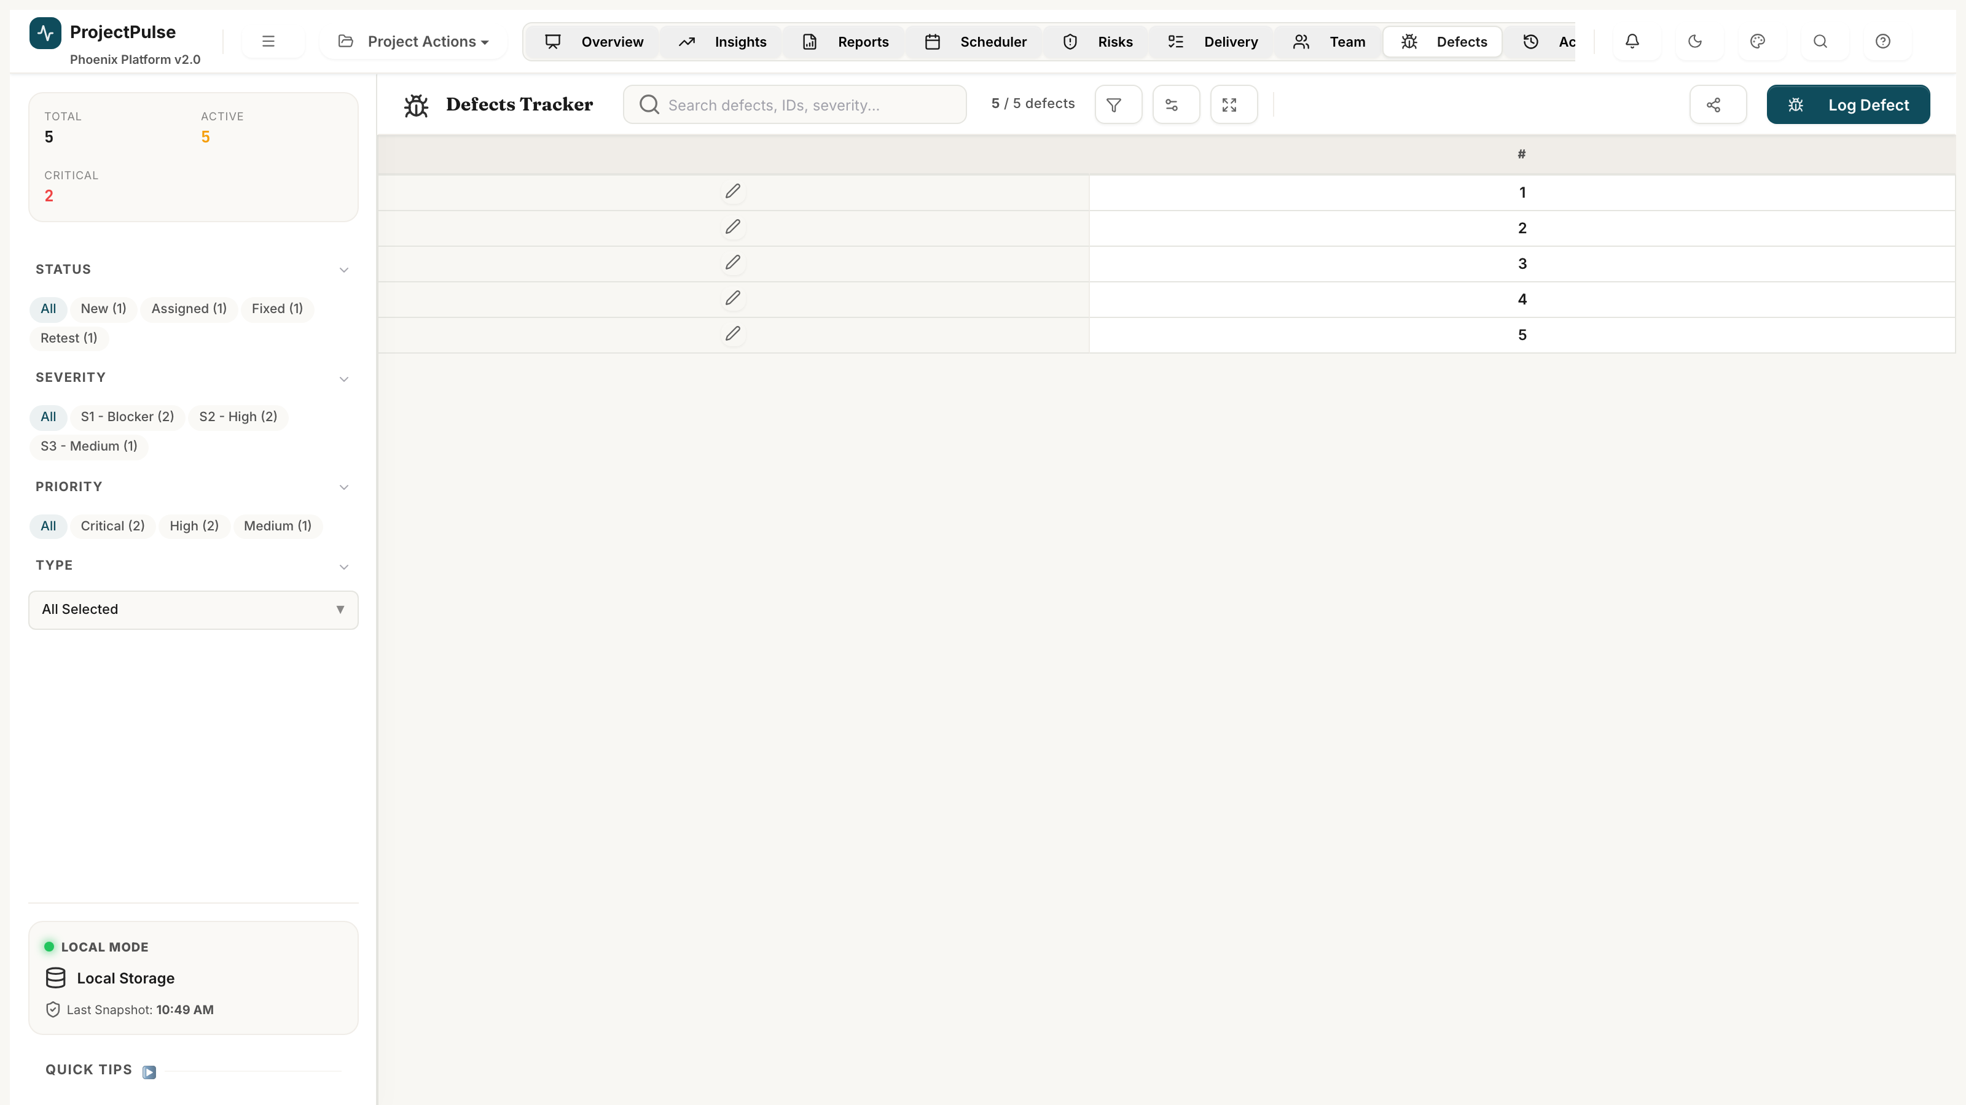
Figure 2.8 — Defect Tracker: severity cards, defect register, and lifecycle workflow

2.9 Stakeholder Board Packs & Reporting
ProjectPulse generates a full Executive Board Pack — project narrative, health trend sparkline, top risks, velocity trend, and critical path highlights — and exports the complete project dataset to an 8-sheet Excel workbook with live formulas, colour-coded status cells, and executive-ready formatting. No spreadsheet maintenance required.
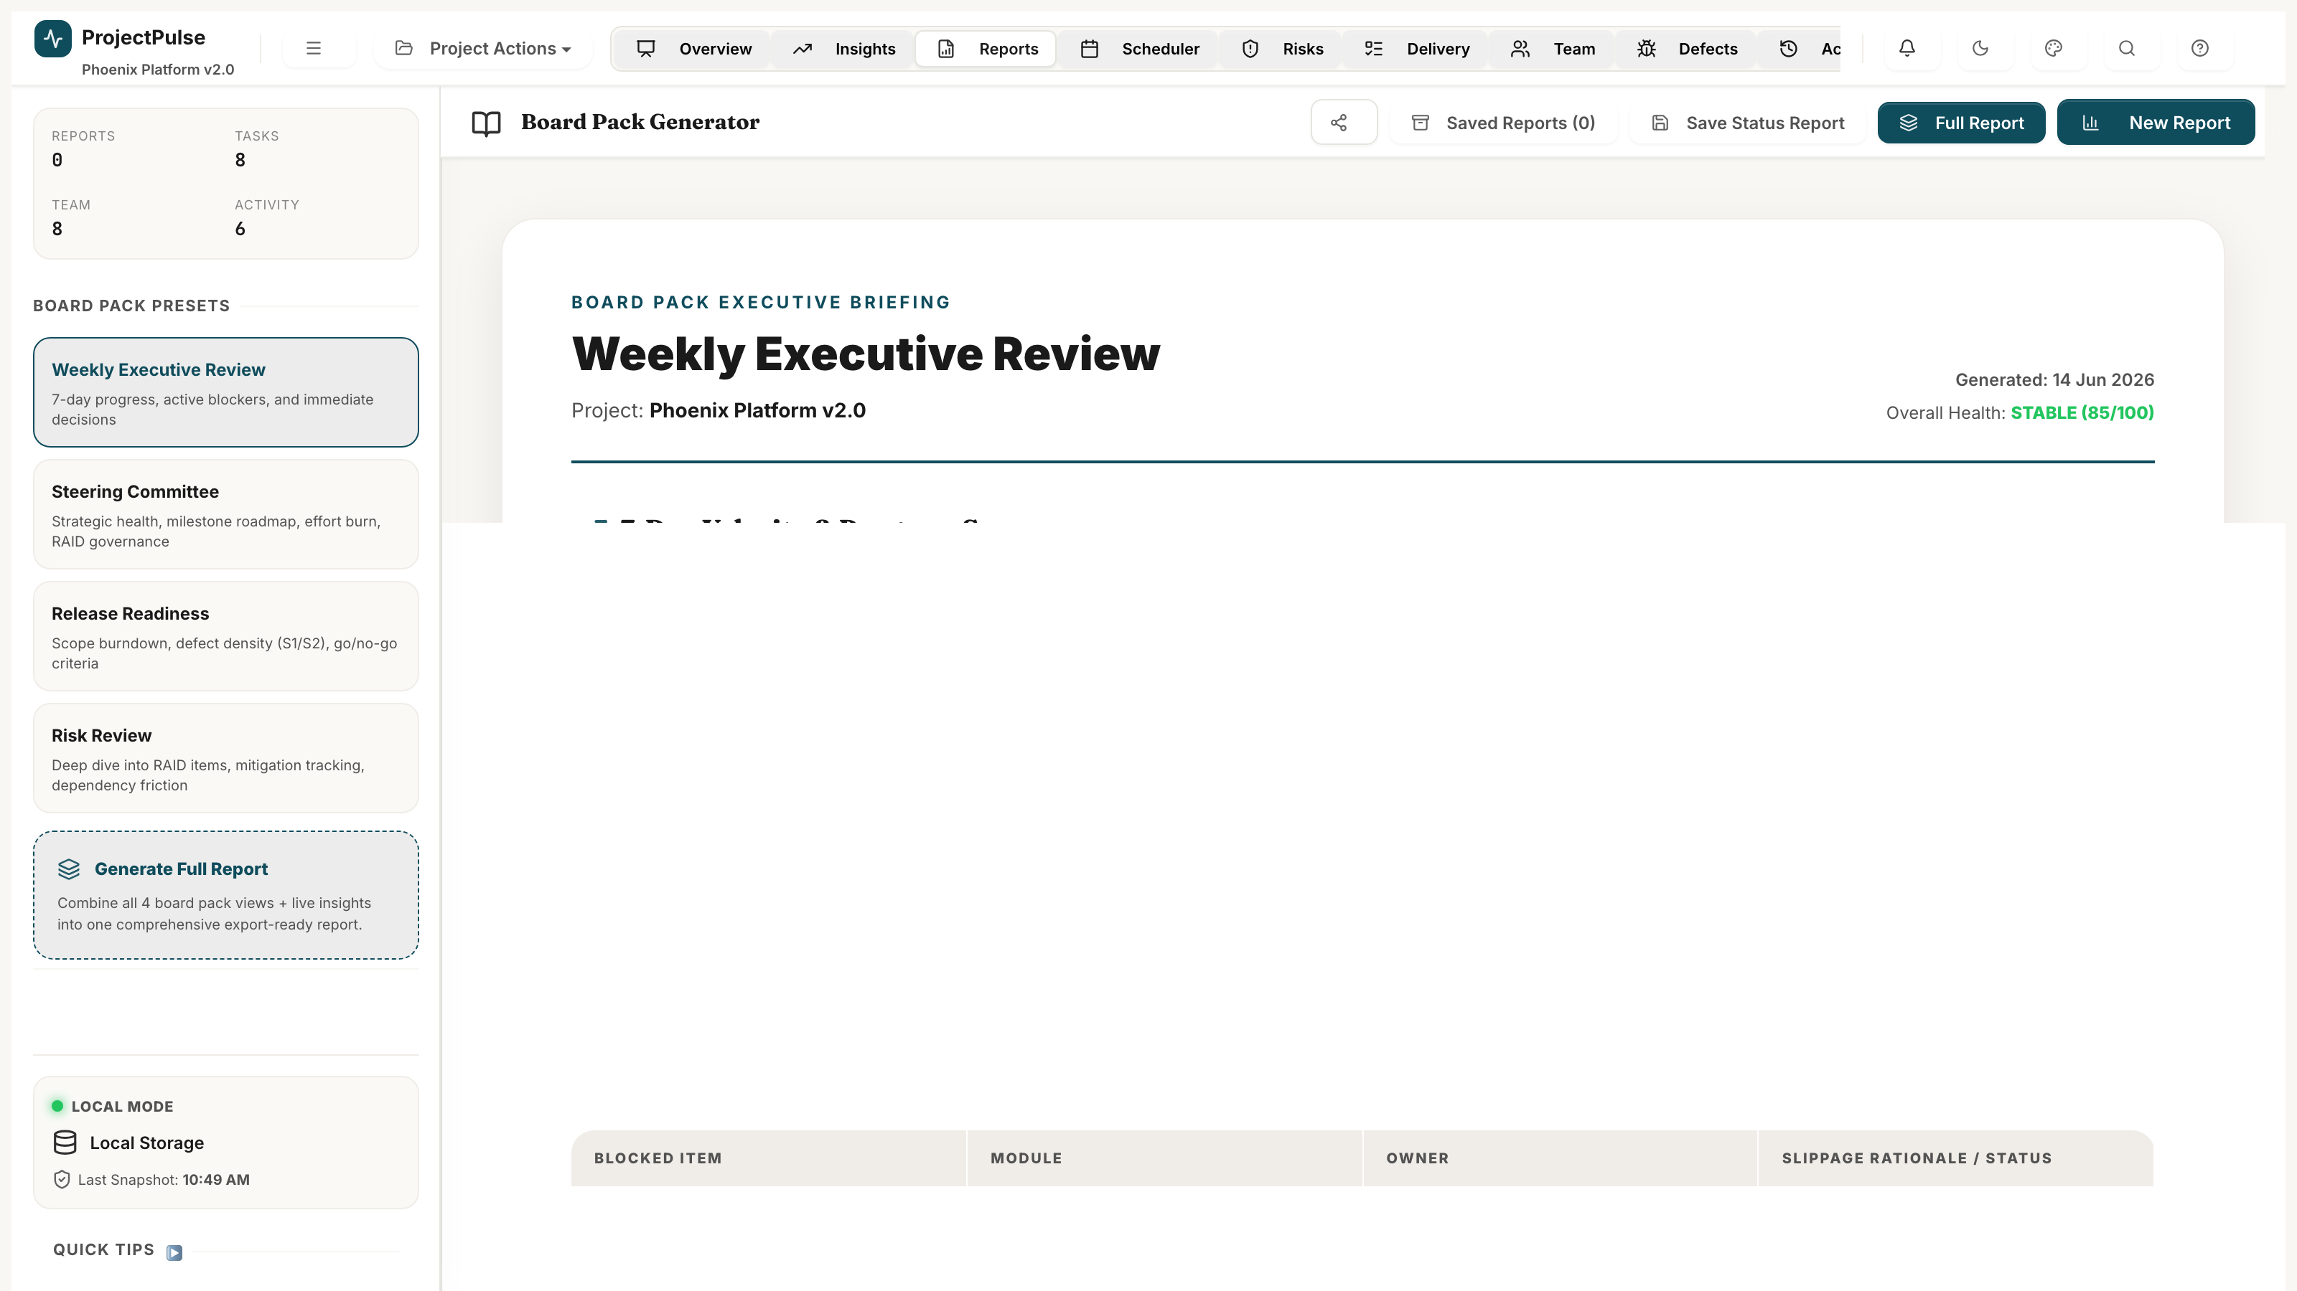
Figure 2.9 — Reports & Board Packs: export controls, preview panel, workbook sheet map

2.10 Immutable Audit Trail
Every state mutation — task creation, status change, RAID update, member modification — is captured in an immutable, timestamped audit log with full before/after diff payloads. Teams can trace any change back to who made it, when, and why. Full session rollback to any prior state is available in one click.
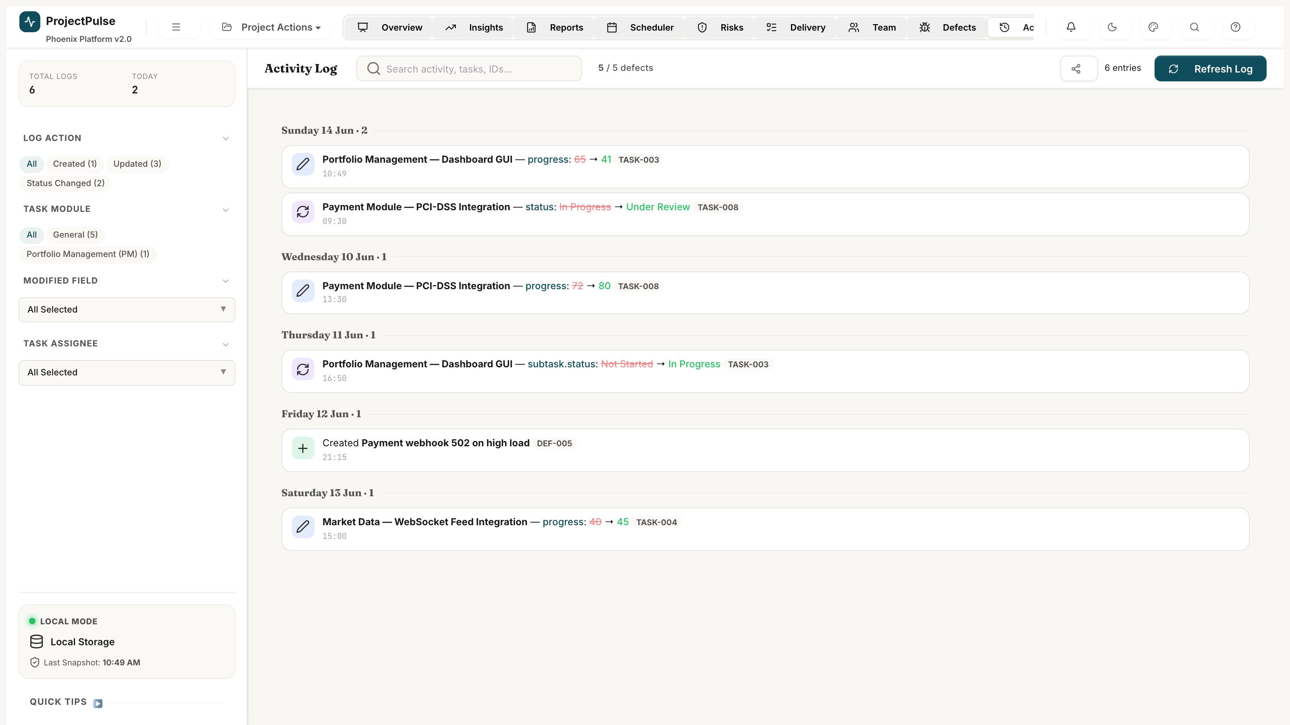
Figure 2.10 — Audit Log: chronological activity stream with diff payloads

2.11 Schedule Baseline History
ProjectPulse tracks three parallel date sets per task (Planned, Baseline, Actual) and supports unlimited named baseline snapshots — taken at kickoff, phase gates, or re-scopes. Schedule variance and slippage analysis are calculated automatically, and any baseline can be restored in one click.

2.12 Flexible Configuration & Theming
All categorical dropdowns (Status, Priority, Module, Role, etc.) are fully configurable via the Dropdown Manager. Custom Fields extend the Task and Defect schemas with project-specific attributes. The effort unit (hrs/days/months) switches globally with one setting. Twenty curated visual themes with dark/light override ensure the interface matches your team's preference.
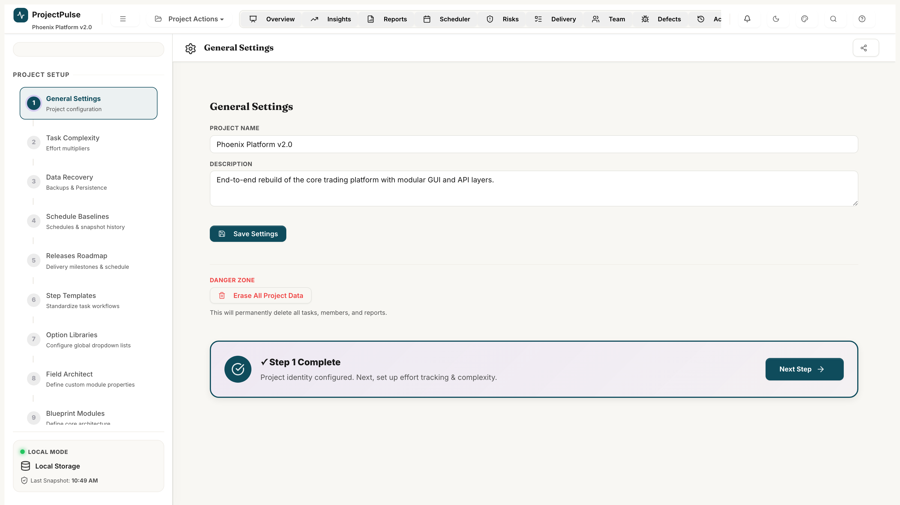
Figure 2.12 — System Configuration: settings panel, dropdown manager, custom fields

3 Key Differentiators

ProjectPulse is purpose-built for software delivery teams who need more than a task list. The following capabilities set it apart from generic project management tools.

Health Intelligence Engine
Unlike tools that report status manually, ProjectPulse continuously computes a composite Health Index from four real signals: overdue tasks, blocked items, unmitigated critical risks, and open S1/S2 defects. The index degrades in real time as problems accumulate and recovers as they are resolved — giving leadership a live, truthful project health signal at all times.

What-If Predictive Sandbox
The Predictive Sandbox is a non-destructive simulation environment that lets managers model capacity reductions (e.g., losing 20% of resource availability) or scope expansions (e.g., 1.2x complexity multiplier) and observe the projected impact on delivery dates — without touching the live schedule. Changes can be committed or discarded with a single click.

Automated Copilot Conflict Resolution
When the Weekly Scheduler detects over-allocations or dependency violations, the Copilot engine can resolve all conflicts automatically using three heuristics: sequencing overlapping dependent tasks, redistributing work to role-matched resources with available capacity, and cascading date shifts across the critical path. The proposed resolution is previewed before any change is applied.

Zero-Backend Architecture
ProjectPulse requires no server, no database, no deployment pipeline, and no DevOps overhead. It runs entirely in the browser. Teams can be operational in under five minutes with no IT involvement. Data lives locally and exports to Excel on demand — giving teams full data ownership and portability.

4 Capability Matrix

The table below maps each ProjectPulse module to the key capabilities it delivers. A tick indicates that the capability is fully supported within that module.
Module | Real-Time Data | Inline Editing | Export | Analytics | Scheduling | Governance
Overview Dashboard | Yes | — | — | Yes | Yes | —
Live Insights | Yes | — | — | Yes | — | —
Delivery Matrix | Yes | Yes | Yes | — | — | —
Gantt Timeline | Yes | Yes | — | — | Yes | —
Weekly Scheduler | Yes | Yes | — | — | Yes | —
RAID Register | Yes | Yes | Yes | — | — | Yes
Team Capacity Hub | Yes | Yes | Yes | — | Yes | —
Defect Tracker | Yes | Yes | Yes | — | — | Yes
Reports & Board Packs | Yes | — | Yes | Yes | — | —
Audit Log | Yes | — | Yes | — | — | Yes
Schedule Baselines | Yes | — | Yes | Yes | — | —
Configuration | Yes | Yes | — | — | — | —

5 Application Screenshots Gallery

The following screenshots show ProjectPulse loaded with a representative software delivery project ('Phoenix Platform v2.0'), demonstrating the application at full operational capacity.

Screenshot: Executive Overview Dashboard — Health Gauge, KPI Cards, and Predictive Sandbox

Screenshot: Hierarchical Delivery Matrix — parent tasks, subtasks, status pills, and inline controls

Screenshot: Gantt Timeline — dependency arrows, baseline overlay, and today marker

Screenshot: Weekly Scheduler — resource heatmap, over-allocation detection, and Copilot Cockpit

Screenshot: RAID Register — risk classification, exposure scoring, and item lifecycle

Screenshot: Team Capacity Hub — member profiles, utilisation bars, and leave calendar

Screenshot: Defect Tracker — severity cards, defect register, and lifecycle workflow

Screenshot: Reports & Board Packs — export builder and workbook preview

Screenshot: Audit Log — chronological activity stream with diff payloads

Screenshot: System Configuration — general settings, dropdown manager, and custom fields

Appendix — Technical Compatibility & Deployment

Item | Specification
Browser Support | Chrome 110+, Microsoft Edge 110+, Firefox 115+, Safari 16+
Installation | None — open projectpulse.html in any supported browser
Internet Connection | Not required — fully offline-capable
Data Storage | Browser localStorage (~5MB per origin, sufficient for 500+ tasks)
Export Format | Microsoft Excel (.xlsx) — generated in-browser via ExcelJS
File Sync | Optional file system sync via File System Access API (Chrome/Edge only)
Screen Resolution | Minimum 1280 x 768px recommended for full grid views
Mobile Support | Responsive layout for tablet (768px+). Limited functionality on mobile.

