ProjectPulse
User Manual with Illustrations

────────────────────────────────────────────────────────────

Document Type | User Manual with Illustrations
Version | v2.1.0
Audience | End Users | Project Managers | Team Leads | QA Engineers
Date | 14 June 2026
Confidentiality | Internal Use

Table of Contents

1 | Getting Started | 3
2 | Executive Overview Dashboard | 5
3 | Live Insights & Analytics | 8
4 | Hierarchical Delivery Matrix | 11
5 | Gantt Timeline | 17
6 | Weekly Scheduler & Conflict Resolution | 21
7 | RAID Register | 26
8 | Team Capacity Hub | 30
9 | Defect Tracker | 33
10 | Reports & Board Packs | 37
11 | Audit Log | 40
12 | System Configuration | 43
13 | Tips, Best Practices & Troubleshooting | 47

Chapter 1 — Getting Started

This chapter explains how to open ProjectPulse for the first time, load your project, and navigate the main interface.

1.1 Opening ProjectPulse
ProjectPulse requires no installation. Follow these steps:
- Locate the projectpulse.html file on your computer or shared drive.
- Double-click the file to open it in your default web browser.
- ProjectPulse loads with a pre-populated sample project so you can explore immediately.
- To start a fresh project: click Settings (gear icon) -> General -> 'Reset Project'. Enter your project name and click Save.

[TIP]
For the best experience, use Google Chrome or Microsoft Edge version 110 or later. Firefox and Safari are also fully supported.

1.2 The Navigation Bar
The left-side navigation bar is your primary way to move between modules. Each icon represents one module:
Icon | Module | When to Use
Home/Gauge | Executive Overview Dashboard | Morning stand-up health check. Exec reporting.
Chart Bar | Live Insights & Analytics | Weekly velocity reviews. EVM reporting.
Table Grid | Delivery Matrix | Daily task management. Inline editing.
Bars (Gantt) | Gantt Timeline | Schedule planning. Dependency visualisation.
Calendar | Weekly Scheduler | Resource allocation. Conflict resolution.
Shield | RAID Register | Risk tracking. Issue management.
People | Team Capacity Hub | Member management. Leave planning.
Bug | Defect Tracker | Bug logging. QA lifecycle management.
Document | Reports & Board Packs | Stakeholder reporting. Excel export.
Clock | Audit Log | Activity review. Change investigation.
Gear | Settings / Configuration | System administration. Theme selection.

1.3 Saving Your Work
ProjectPulse saves your work automatically every 10 seconds. You will see a brief 'Saving...' indicator in the top bar. You can force an immediate save at any time by pressing Ctrl + S.
[CAUTION]
Never close the browser tab while the 'Saving...' indicator is active. Wait for it to disappear before closing to ensure your last changes are saved.

Chapter 2 — Executive Overview Dashboard

The Overview Dashboard is your project's health command centre. It gives you an instant read on how your project is performing across four critical dimensions: schedule, risk, quality, and delivery confidence.
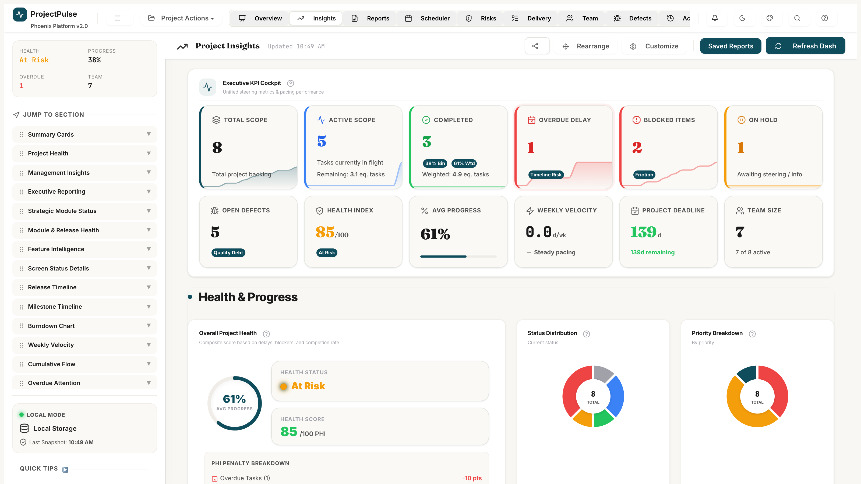
Figure 2.1 — The Executive Overview Dashboard showing the Health Gauge, KPI cards, and Predictive Sandbox.

2.1 Reading the Health Gauge
The large radial gauge in the top-left is your project's Health Index (0-100). The arc colour tells you the overall status at a glance:
Colour | Health Range | What It Means | Recommended Action
Green | 80-100 | Project is healthy. Risks and issues are under control. | Continue current pace.
Amber | 50-79 | One or more risk factors are active. Attention needed. | Review RAID register. Address overdue tasks.
Red | 0-49 | Critical situation. Multiple problems require immediate resolution. | Escalate to leadership. Resolve S1 defects and critical risks.

2.2 Understanding the Three KPI Cards
Below the gauge are three key performance indicator cards:
- Delivery Confidence (%): The probability of delivering all remaining work on time based on current velocity. 80%+ is green.
- Schedule Performance Index (SPI): Industry standard EVM metric. 1.0 = exactly on schedule. Below 1.0 = behind schedule.
- Active RAID Items: Total count of open Risks, Assumptions, Issues, and Dependencies. Lower is better.

2.3 Using the What-If Predictive Sandbox
The Sandbox lets you safely model scenarios — like losing a team member or adding scope — without touching your live schedule. Here is how to use it:
- Click the 'Enable Sandbox' toggle on the right side of the Dashboard.
- The Sandbox indicator banner appears, confirming you are in simulation mode.
- Use the Capacity Slider to model a reduction (e.g., slide to -20% to simulate losing one of five team members).
- Use the Scope Multiplier to model scope growth (e.g., 1.2x if 20% more work has been discovered).
- Watch the projected completion date update instantly.
- If happy with the simulation: click 'Commit Changes' to apply. Otherwise, click 'Discard' to cancel.

[TIP]
The Sandbox never modifies your live schedule unless you click 'Commit Changes'. Discarding has no effect on your actual project data.

Chapter 3 — Live Insights & Analytics

The Insights module gives you deep visibility into project performance through EVM metrics, velocity trends, burn-up projections, and activity patterns.

3.1 Reading EVM Metrics
The EVM (Earned Value Management) cards show the financial health of your project. You do not need to enter cost data — ProjectPulse uses effort hours as the cost proxy.
- SPI (Schedule Performance Index): 1.0 = on schedule. Above 1.0 = ahead. Below 1.0 = behind.
- SV (Schedule Variance): Positive = delivering ahead of plan. Negative = behind plan.
- Green cards = healthy. Amber = watch. Red = needs action.

[INFO]
EVM metrics are most meaningful after 2+ weeks of task completions. On new projects, give the analytics a week to calibrate.

3.2 Reading the Burn-Up Chart
The burn-up chart shows your project's progress trajectory:
- Blue Line (Scope): Total work to be done. A rising line means scope has been added.
- Green Line (Completion): Cumulative work completed each week.
- Dashed Amber Line (Projection): Where the green line is heading based on current velocity.
If the amber projection line crosses the blue scope line before your project end date, you are on track to deliver. If it projects past your end date, review your schedule.

3.3 Interpreting the 30-Day Activity Heatmap
The heatmap shows how active your team has been each day over the past 30 days. Darker teal cells = more task state changes. Lighter cells = quiet days.
- Gaps (white days) may indicate blockers or weekend/holidays.
- Uniform activity is a sign of a well-paced team.
- Activity spikes at the end of weeks may indicate date-driven completion behaviour.

Chapter 4 — Hierarchical Delivery Matrix

The Delivery Matrix is where the day-to-day work happens. Every task, subtask, assignee, date, status, and effort is managed here.
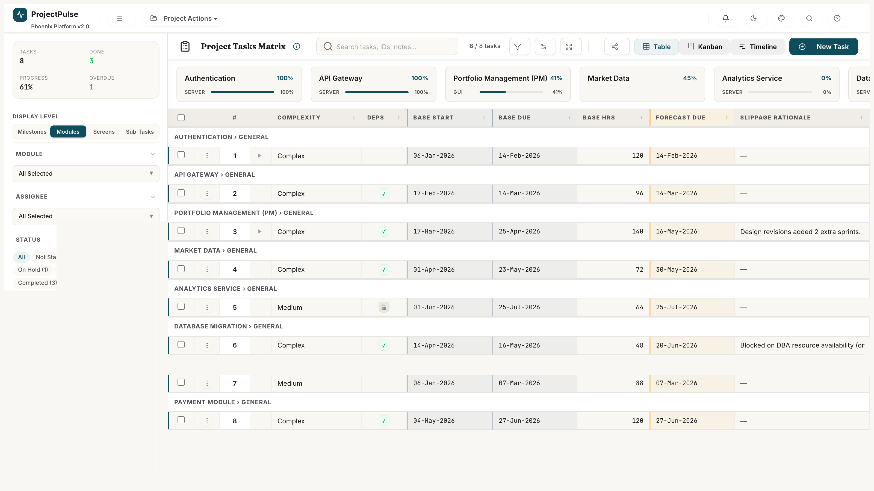
Figure 4.1 — The Delivery Matrix showing parent tasks, subtasks, status pills, and inline editing controls.

4.1 Creating Your First Task
- Click the '+ Add Task' button in the top-right of the Delivery Matrix.
- A new row appears at the bottom of the task list with default values.
- Click any field in the row to start editing it inline.
- Enter the task name, then press Tab to move to the next field.
- Set the Status (defaults to 'Not Started'), Assignee, Priority, Start Date, and Due Date.
- Press Enter on the last field or click anywhere else to save the row.

4.2 Adding Subtasks
- Click the expand arrow ▶ on any parent task row to reveal the subtask area.
- Click '+ Add Subtask'.
- Enter the subtask name and category (e.g., Feature / GUI Screen / Test Case).
- Set the subtask status and effort estimate.
- The parent task's progress bar automatically updates based on subtask completion.

4.3 Updating Task Status
- Double-click the Status cell on any task row.
- A dropdown appears with the available next statuses (invalid transitions are hidden).
- Select the new status.
- If the transition requires a comment (e.g., moving to On Hold or Cancelled), a dialog appears.
- Enter your comment and click Confirm.
- The status pill updates immediately and the change is recorded in the Audit Log.

4.4 Filtering Tasks
- Click the Filter icon in the top-right toolbar to open the filter panel.
- Select one or more values in any filter category (Status, Assignee, Module, Priority, etc.).
- The task list updates immediately to show only matching tasks.
- Active filters appear as coloured pills above the task list. Click the 'x' on any pill to remove that filter.
- Use the Search box to find tasks by name, ID, notes, or assignee.

[TIP]
Multiple filters are combined with AND logic — only tasks matching ALL active filters appear. To reset all filters at once, click the 'Clear All' button in the filter panel.

4.5 Linking Task Dependencies
- Open a task by clicking the task name to open the Task Detail panel.
- Scroll to the 'Depends On' section.
- Click '+ Add Dependency'.
- Search for and select the predecessor task.
- Click Confirm. The dependency is added and visible in the Gantt view.

[WARNING]
ProjectPulse prevents circular dependencies. If you attempt to add a dependency that would create a loop (e.g., Task A depends on Task B which already depends on Task A), an error message is shown and the dependency is not saved.

Chapter 5 — Gantt Timeline

The Gantt Timeline gives you a visual, time-anchored view of your entire schedule. Use it for planning, identifying bottlenecks, and communicating timelines to stakeholders.
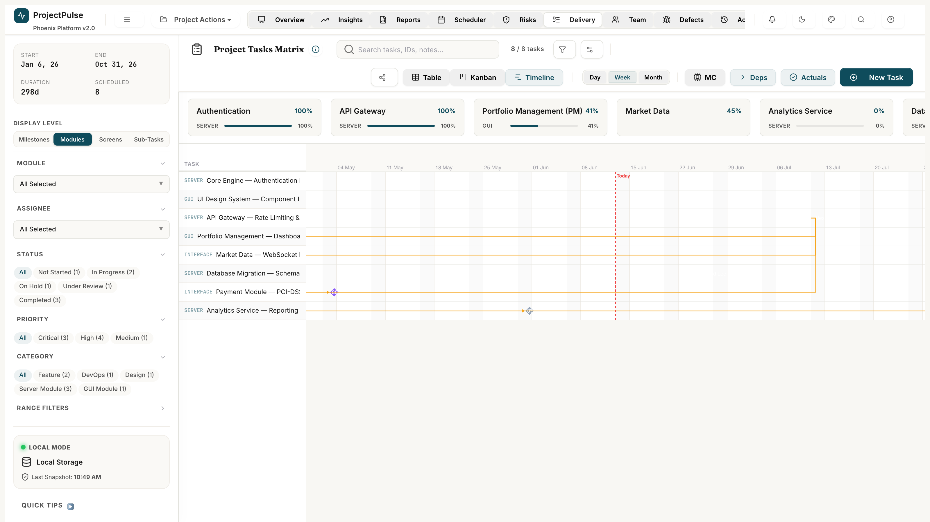
Figure 5.1 — The Gantt Timeline with task bars, dependency arrows, baseline overlay, and today marker.

5.1 Navigating the Timeline
- Use the Zoom controls (Day / Week / Month / Quarter) in the toolbar to adjust the visible time horizon.
- Scroll horizontally to move forward or backward in time.
- Click 'Today' to jump the view to the current date.
- The red vertical line marks today's date.

5.2 Reading Dependency Arrows
Arrows connecting task bars represent dependencies. Colour indicates health:
- Green arrow: The predecessor task is complete. Dependency is resolved.
- Blue arrow: The predecessor task is in progress. Dependency is active.
- Red arrow: VIOLATION — the successor task starts before the predecessor finishes. Needs attention.

5.3 Rescheduling Tasks by Drag
- Click and hold on a task bar.
- Drag it left (earlier) or right (later) to the new start date.
- A ghost bar shows the original position while you drag.
- Release to confirm. The task's Start and Due dates are updated automatically.
- If 'Cascade Dependents' is enabled, all downstream tasks shift by the same number of days.

5.4 Enabling Baseline Overlay
- Click the 'Show Baseline' toggle in the Gantt toolbar.
- Semi-transparent ghost bars appear behind the current task bars showing the captured baseline dates.
- Tasks ahead of baseline: current bar is to the left of the ghost bar.
- Tasks behind baseline: current bar is to the right of the ghost bar (schedule slippage).

Chapter 6 — Weekly Scheduler & Conflict Resolution

The Weekly Scheduler shows you exactly how much work is assigned to each team member each week — and alerts you immediately when someone is over-allocated.
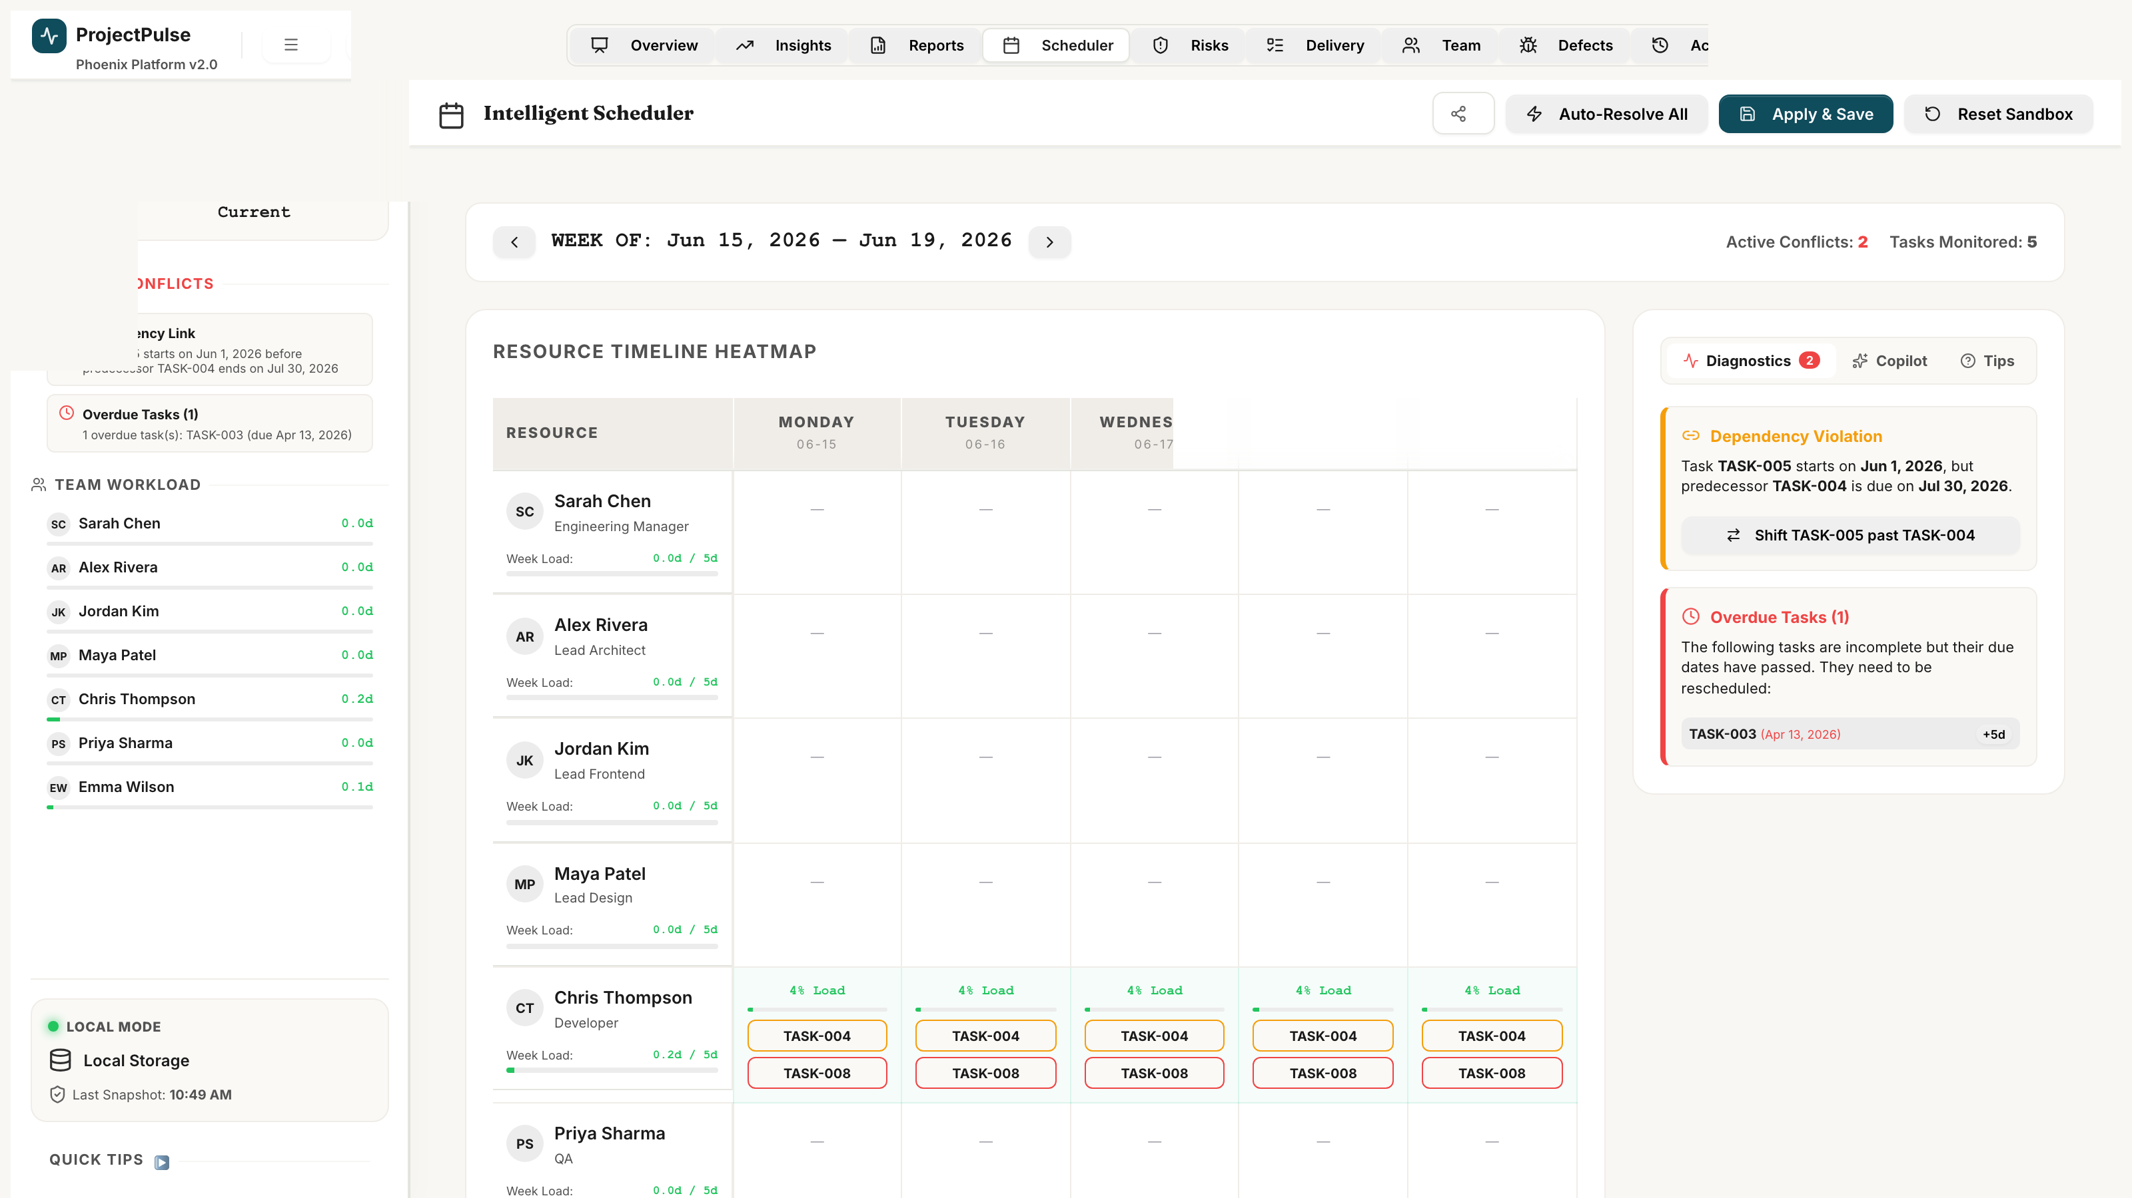
Figure 6.1 — The Weekly Scheduler heatmap showing member allocations, over-allocation (red), and the Copilot panel.

6.1 Reading the Resource Heatmap
Each row is a team member. Each column is a week. Each cell shows:
- Allocated hours / Available capacity (e.g., 38h / 40h).
- Green cells: Allocation is within capacity. No action needed.
- Red cells: Over-allocation. More hours assigned than the member can work that week.
- Grey cells: The member is on leave. No capacity available that week.

6.2 Resolving Conflicts Manually
- Click on a red (over-allocated) cell to see which tasks are causing the conflict.
- A panel appears listing all tasks assigned to that member in that week.
- Click any task to open it in the Delivery Matrix inline editor.
- Adjust the task dates, reassign to another team member, or reduce estimated effort.
- The heatmap refreshes automatically to reflect your changes.

6.3 Using the Copilot — Automated Conflict Resolution
The Copilot can automatically resolve all resource conflicts in one click. It works safely in Sandbox mode so you can review the changes before committing them.
- Click 'Enable Sandbox' at the top of the Scheduler.
- Click 'Open Copilot Cockpit'. The diagnostics panel shows all detected conflicts.
- Review the list of conflicts: over-allocations, dependency violations, unassigned tasks.
- Click 'Resolve All Conflicts'. The Copilot analyses each conflict and applies one of three fixes:
- Auto-Sequence: Pushes conflicting tasks end-to-end so dependencies are not violated.
- Smart Reassign: Moves a task to a role-matched team member with spare capacity.
- Cascade Date Shift: Adjusts all downstream dependent tasks to maintain schedule coherence.
- Review the 'Proposed Changes' summary in the Copilot panel.
- Click 'Commit' to apply changes to your live schedule, or 'Discard' to cancel.

[BUSINESS RULE]
The Copilot is designed to make smart, conservative choices. It will never reassign a task to a member with a different role, and it always preserves task durations when shifting dates.

Chapter 7 — RAID Register

The RAID Register is your project's formal risk and issue management system. Use it to track all Risks, Assumptions, Issues, and Dependencies throughout the project lifecycle.
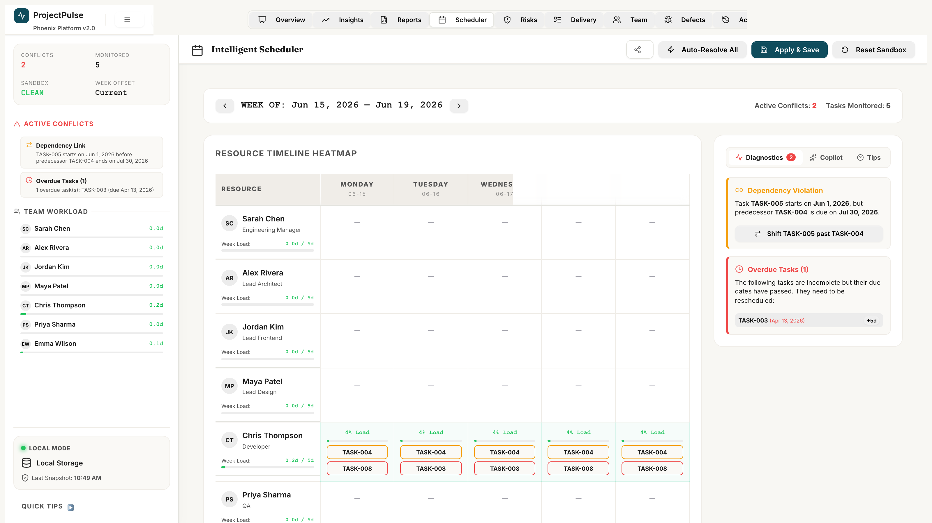
Figure 7.1 — The RAID Register showing the risk exposure matrix and the item list.

7.1 Logging a New RAID Item
- Navigate to the RAID Register module.
- Click '+ Add Item'.
- Select the Type: Risk / Assumption / Issue / Dependency.
- Enter a clear, specific title (e.g., 'Key backend developer may leave before Phase 2 completion').
- Fill in Description, Impact, Probability (for Risks), and Severity.
- Assign an Owner from the team member list.
- Enter a Mitigation Strategy and a Target Closure Date.
- Click Save. The Exposure Score is calculated automatically.

7.2 Understanding the Exposure Score
Exposure Score = Probability x Impact. Both use a 1-3 scale:
Score | Label | Recommended Action
7-9 | Critical (Red) | Immediate action required. Escalate to project sponsor. Report weekly.
4-6 | Medium (Amber) | Active monitoring required. Mitigation plan must be agreed within 5 days.
1-3 | Low (Green) | Log and review bi-weekly. No immediate action unless score increases.

7.3 Managing Item Lifecycle
Each RAID item has a status that reflects where it is in the management lifecycle:
- Identified: Newly logged. Awaiting owner assignment and mitigation planning.
- Active: Owner assigned. Mitigation in progress. Monitored weekly.
- Mitigated: Mitigation actions completed. Monitoring for recurrence over 2 weeks.
- Realized (Risks only): The risk event occurred. Item should be converted to an Issue.
- Closed: Item fully resolved. Archived for reporting purposes.

Chapter 8 — Team Capacity Hub

The Team Capacity Hub is where you manage your team — adding members, setting their work capacity, and recording planned leave.
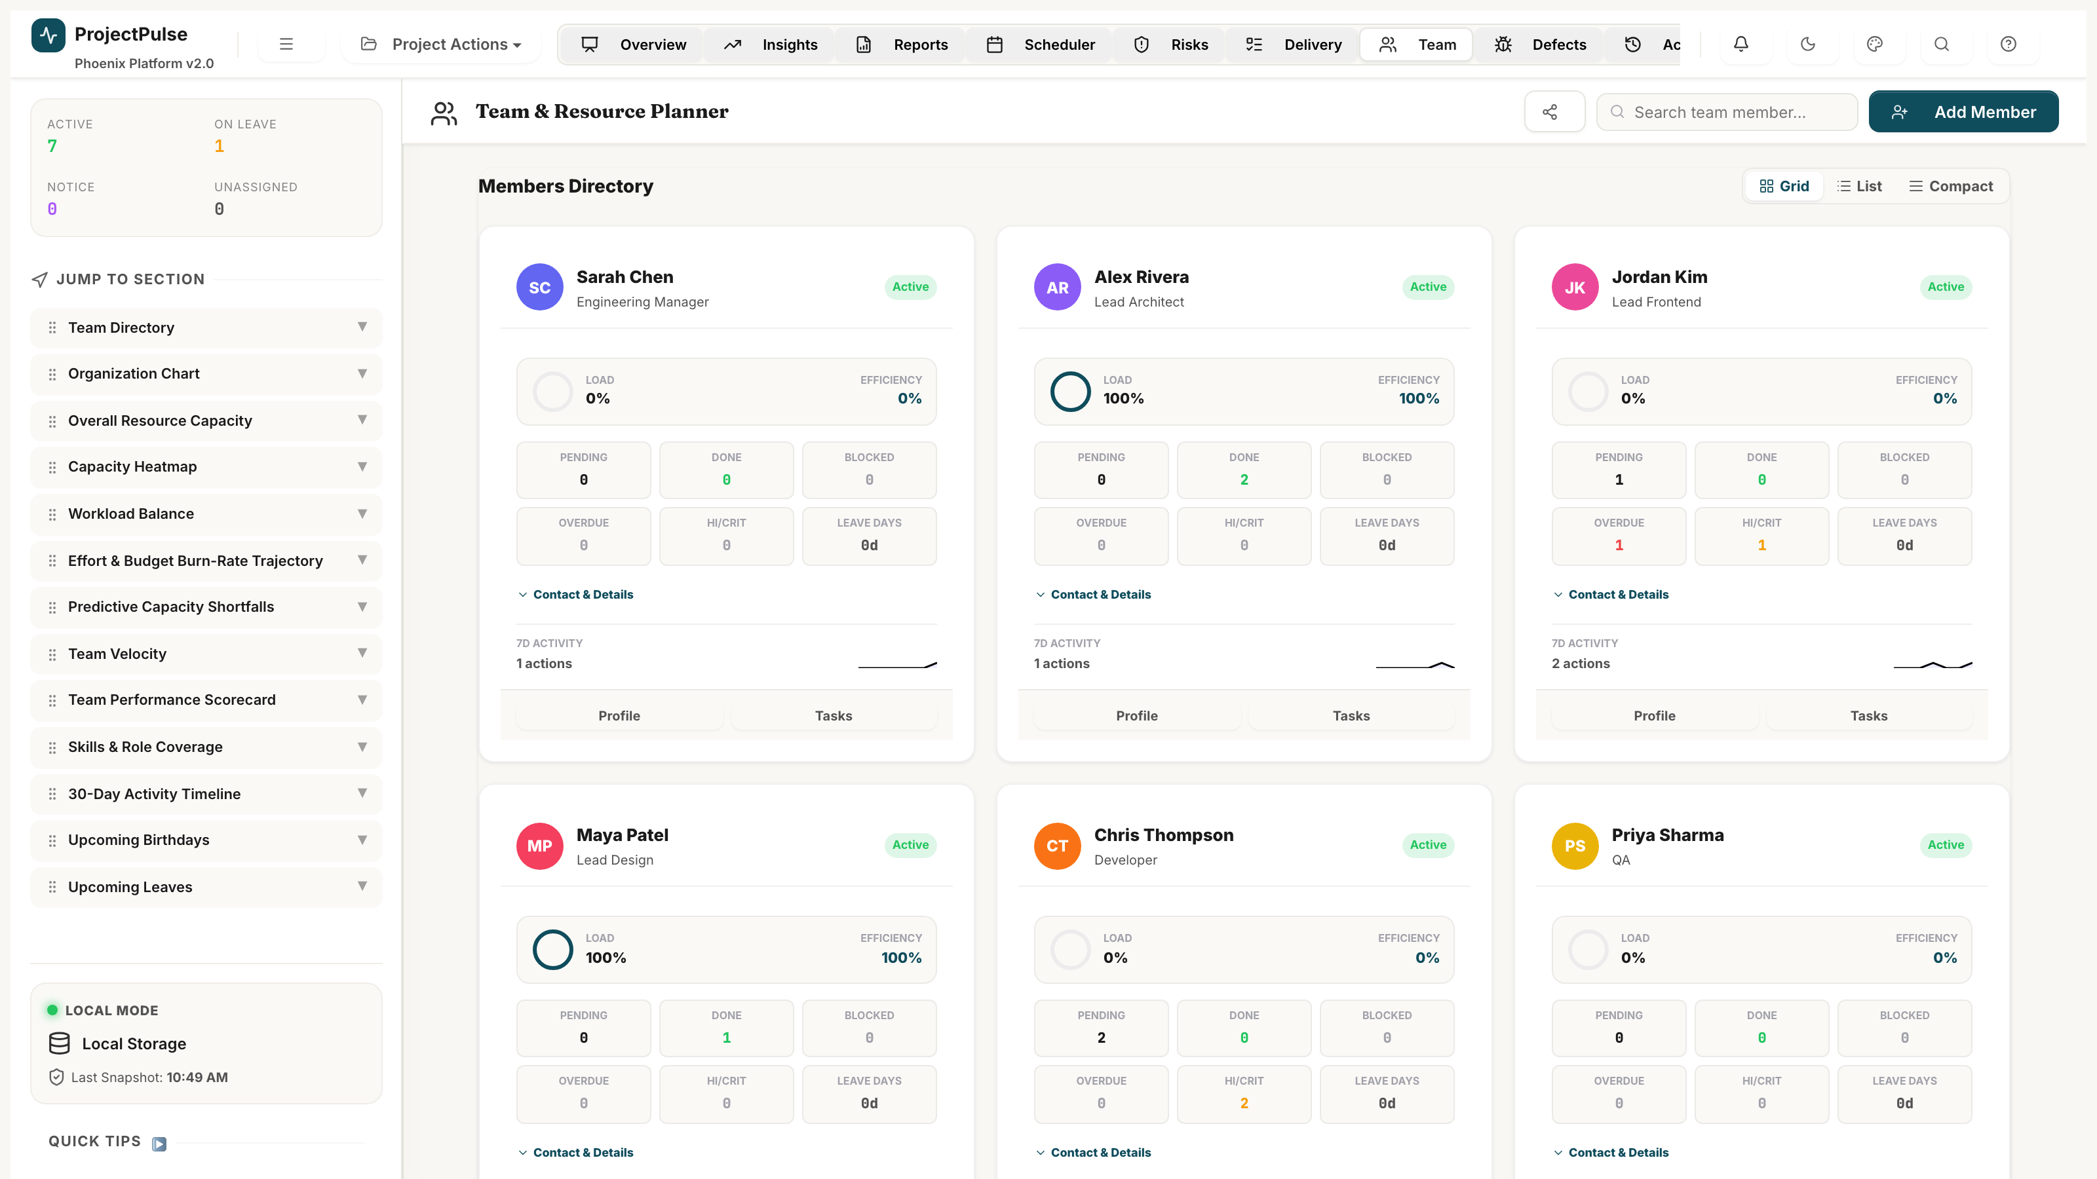
Figure 8.1 — The Team Capacity Hub showing member cards, utilisation bars, and the add member form.

8.1 Adding a Team Member
- Click '+ Add Member' in the Team Capacity Hub.
- Enter the member's full name, role (e.g., Backend Developer, QA Engineer), and current status (Active).
- Set their Weekly Hour Cap (default: 40 hours) and Utilisation Rate (1.0 = full time, 0.5 = part time).
- Click Save. The member now appears in all assignee dropdowns and the Scheduler heatmap.

8.2 Recording Planned Leave
- Click on a team member's card to open their profile.
- Click '+ Add Leave' in the Leave Calendar section.
- Select the leave start date and end date.
- Click Save. The Scheduler will show the member's cells for that period as 'On Leave' (grey, zero capacity).

8.3 Member Status Management
Updating a member's status affects their availability across all scheduling calculations:
- Active: Normal capacity available. Can be assigned to tasks.
- On Leave: Zero capacity for leave period. Scheduler shows grey cells.
- Other Assignment: Temporarily excluded from capacity. Existing task assignments remain.
- Serving Notice Period: Cannot be assigned to new tasks. Copilot will not reassign work to them.
- Departed: Fully removed from capacity calculations. Existing assignments remain for record.

Chapter 9 — Defect Tracker

The Defect Tracker manages all software defects from initial discovery through resolution and closure. Use it to ensure all bugs are tracked, assigned, and resolved within agreed SLA timeframes.
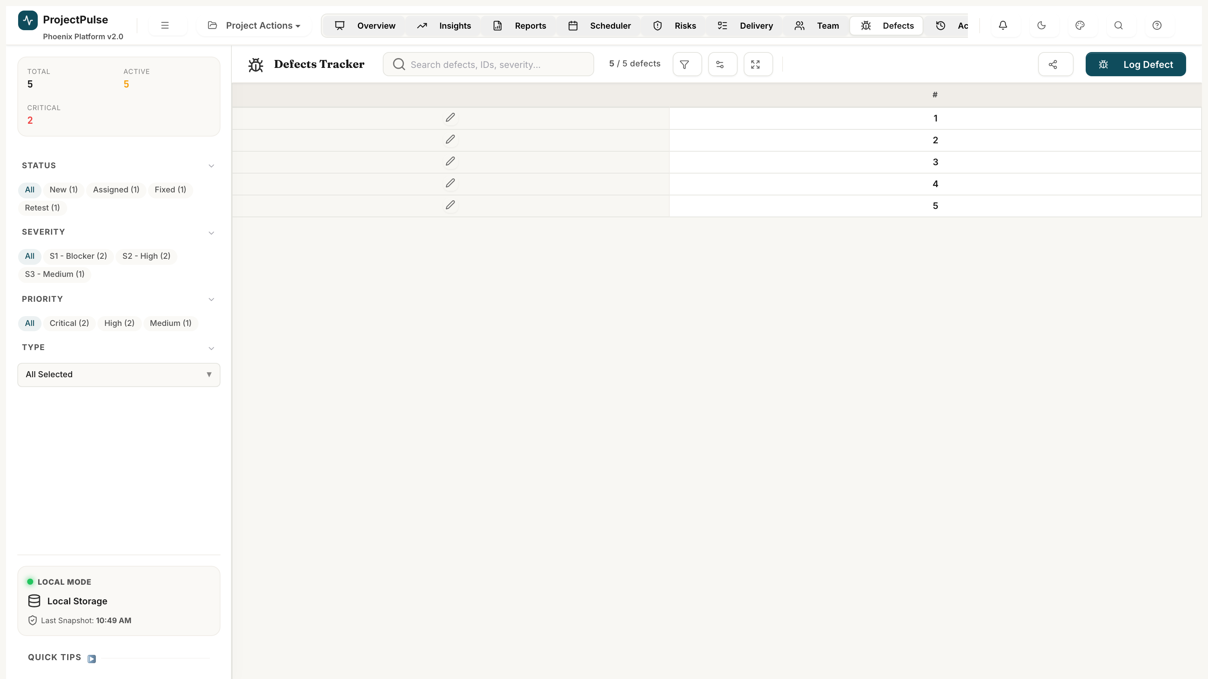
Figure 9.1 — The Defect Tracker showing severity summary cards, the defect register, and the log defect form.

9.1 Logging a Defect
- Click '+ Log Defect' in the Defect Tracker.
- Enter a clear, descriptive title (e.g., 'Gantt timeline fails to load with 200+ tasks').
- Select the Defect Type: Functional Bug / UI-UX Issue / Performance / Security / Data Issue / Suggestion.
- Select Severity: S1 Blocker / S2 High / S3 Medium / S4 Low. This affects the Health Index and SLA timer.
- Select Priority: Critical / High / Medium / Low.
- Link to a Task: select the task or subtask the defect was found in.
- Enter detailed Reproduction Steps so the developer can replicate the bug.
- Click Save.

[CAUTION]
S1 Blocker defects trigger an immediate red alert banner on the Overview Dashboard and a 24-hour SLA countdown. Assign an S1 immediately after logging.

9.2 Managing the Defect Lifecycle
Move defects through their lifecycle using the Status dropdown:
- New -> Assigned: Engineering Manager assigns a developer.
- Assigned -> Fixed: Developer resolves the bug and logs fix details.
- Fixed -> Retest: QA is notified and retests the fix in the test environment.
- Retest -> Closed: QA confirms the fix is correct. Defect removed from Health Index.
- Retest -> Assigned (re-open): QA finds the fix incomplete. Developer is reassigned.
- Any -> Rejected: Defect is by design or cannot be reproduced. Requires a rejection reason.

Chapter 10 — Reports & Board Packs

The Reports module lets you generate professional stakeholder deliverables in one click — an Executive Board Pack for leadership, and a comprehensive Excel workbook for detailed project records.
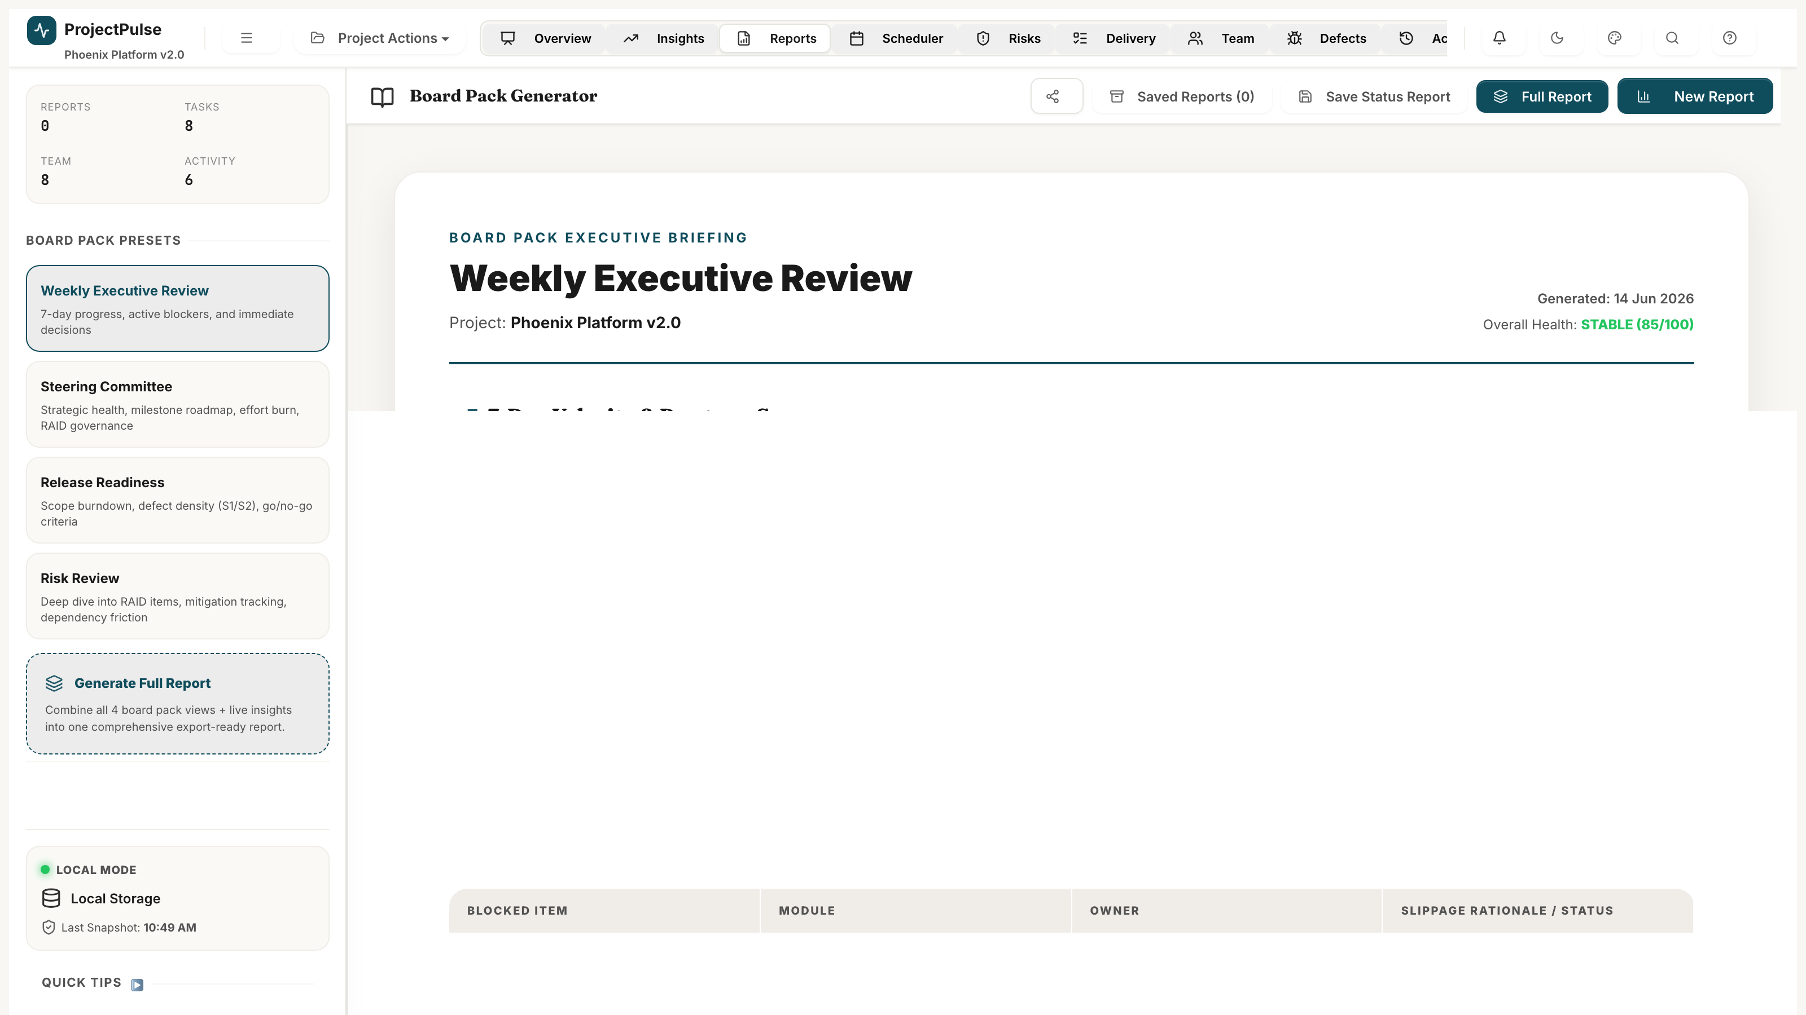
Figure 10.1 — The Reports module with export options, workbook sheet map, and Board Pack preview.

10.1 Generating the Executive Board Pack
- Navigate to the Reports module.
- Click 'Generate Board Pack'.
- The Board Pack is assembled automatically from live project data and displayed in the preview panel.
- Review the Board Pack contents: Project Summary, Health Trend, Critical Path, Top Risks, and Team Velocity.
- Click 'Print' to send to a printer or 'Save as PDF' to generate a PDF file.

10.2 Exporting to Excel
- Click 'Export to Excel' in the Reports module.
- A file download is triggered. Save the file to your preferred location.
- The Excel workbook contains 8 sheets: System State, Tasks, Team, RAID Register, Defects, Activity Log, Baselines, and Releases.
- Each sheet uses colour-coded cells: Green = complete/healthy, Yellow = in progress, Red = blocked/overdue, Grey = cancelled.

[INFO]
The Excel workbook is a live snapshot of your project data at the moment of export. For an up-to-date workbook, always export immediately before sharing with stakeholders.

Chapter 11 — Audit Log

The Audit Log maintains a complete, immutable record of every change made to your project. Use it to investigate unexpected changes, track accountability, or roll back to a prior state.
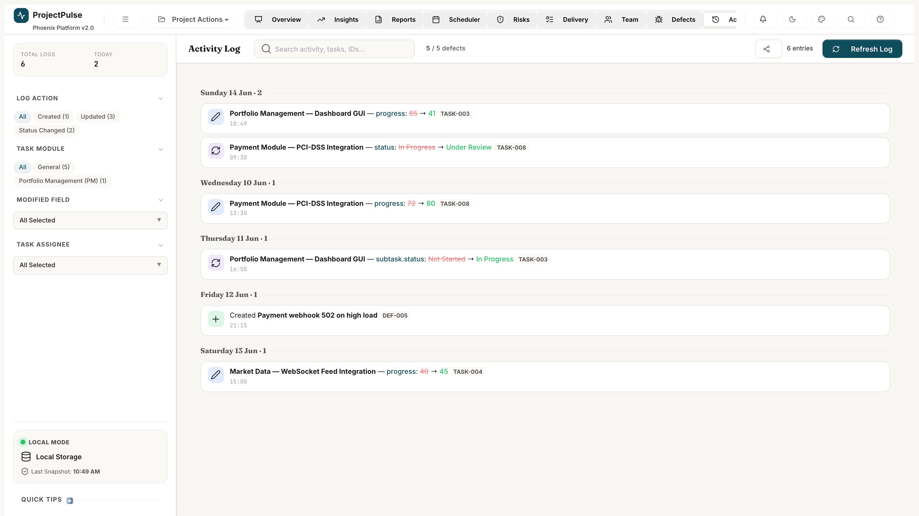
Figure 11.1 — The Audit Log showing the chronological activity stream with timestamps and change details.

11.1 Reading the Audit Log
Each entry in the Audit Log shows:
- Timestamp: Exact date and time of the change.
- User: The team member who made the change (set via the active user indicator in the top bar).
- Action: Created / Updated / Status Changed / Deleted.
- Entity: The task, defect, RAID item, or member that was changed.
- Change Details: Old value -> New value (e.g., 'Status: In Progress -> Under Review').

11.2 Rolling Back to a Prior State
If an incorrect change was made, you can restore your project to any prior state captured in the Audit Log:
- Find the log entry immediately BEFORE the unwanted change in the Audit Log.
- Click 'Restore to This Point' on that log entry.
- A confirmation dialog explains what will be restored.
- Click Confirm. The application restores all changes made after that point.
- A 'Rollback' entry is added to the Audit Log recording what was restored.

[CAUTION]
Rollback is a powerful but permanent operation. After rolling back, all changes made AFTER the restore point are lost. Ensure you have captured an Excel export before performing a rollback if you may need those records.

Chapter 12 — System Configuration

The Settings panel (gear icon in the navigation bar) lets you customise ProjectPulse to match your project's terminology, working calendar, and visual style.
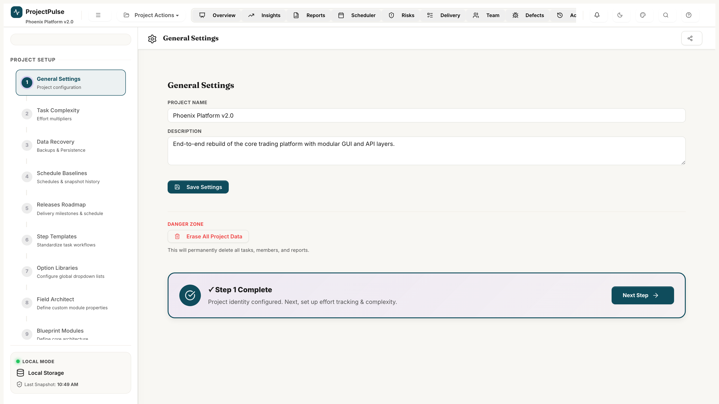
Figure 12.1 — The Settings panel showing General Settings, Dropdown Manager, and Theme Selector.

12.1 Configuring the Working Calendar
- Navigate to Settings -> General.
- Set Hours Per Day (default: 8) — how many work hours constitute a working day.
- Set Days Per Week (default: 5) — your team's standard working week length.
- Toggle specific days on/off under 'Working Days' to mark non-working days.
- Set your preferred Effort Unit: hours (hrs), days, or months.
- Click Save. All effort displays and capacity calculations update immediately.

12.2 Customising Dropdowns
- Navigate to Settings -> Dropdown Manager.
- Select the dropdown you want to customise (e.g., Module, Category, Role).
- Click '+ Add Option' to add a new value.
- Drag items to reorder them. Click 'Edit' to rename. Click the trash icon to remove.
- Click Save. New options appear immediately in all relevant selects.

12.3 Changing the Visual Theme
- Navigate to Settings -> Appearance.
- Browse the 20 available themes in the theme gallery.
- Click any theme to preview it instantly.
- Toggle 'Force Dark Mode' or 'Force Light Mode' to override the theme's default mode.
- Theme selection is saved automatically.

12.4 Managing Schedule Baselines
- Navigate to Settings -> Schedule Baselines.
- Click 'Capture Current Snapshot'. Enter a name (e.g., 'Phase 1 Kickoff') and description.
- Click Save. The snapshot records all task planned dates and effort values at this moment.
- To view baseline overlay on the Gantt, enable 'Show Baseline' in the Gantt toolbar.
- To restore a historical baseline: click Restore next to the snapshot. Confirm the dialog.
[TIP]
Best practice: Capture a baseline at project kickoff and again at each major phase gate or re-scope. This gives you a clear record of schedule evolution over the project lifetime.

Chapter 13 — Tips, Best Practices & Troubleshooting

13.1 Daily Recommended Workflow
Time | Action | Module
Morning Stand-up | Check Health Index and KPI cards. Review overdue tasks and blocked items. | Overview Dashboard
Task Updates | Update task statuses and log actual effort. | Delivery Matrix
Scheduler Check | Scan the heatmap for new over-allocations introduced by date changes. | Weekly Scheduler
RAID Review | Update RAID item statuses. Log any new risks or issues. | RAID Register
Weekly (Friday) | Capture a baseline snapshot. Generate and review the Board Pack. | Settings / Reports

13.2 Pro Tips
- Ctrl+S: Save your project immediately at any time without waiting for the 10-second auto-save.
- Ctrl+F: Jump directly to the search bar in the Delivery Matrix or Defect Tracker.
- Tab navigation: Use Tab and Shift+Tab to move between cells in the Delivery Matrix.
- Bulk status update: Ctrl+Click multiple tasks, then right-click to bulk-change status.
- Export before major changes: Always export to Excel before a rollback or baseline restore.

13.3 Troubleshooting Common Issues
Symptom | Likely Cause | Resolution
Data disappeared after page refresh | localStorage was cleared by browser privacy settings. | Export to Excel regularly. Enable File Sync in Settings to maintain a file backup.
Gantt bars not visible | Tasks have no start/due dates set, or all dates are outside the current view window. | Ensure tasks have start and due dates. Click 'Today' to re-centre the Gantt view.
Health Index stays at 0 | All tasks are Completed or Cancelled (no active tasks for denominator). | Expected behaviour for completed projects. Add new tasks to reset the denominator.
Copilot greyed out | Sandbox mode is not enabled. | Click 'Enable Sandbox' before opening the Copilot Cockpit.
EVM metrics show '--' | No tasks have been completed yet (EV = 0). | EVM metrics calculate once at least one task is marked Completed.
Member not appearing in Scheduler | Member status is not 'Active'. | Navigate to Team Capacity Hub and set the member's status to Active.

