ProjectPulse
Product Capabilities & User Manual

────────────────────────────────────────────────────────────

The definitive functional reference guide covering every module, feature,
workflow, and configuration option in the ProjectPulse workstation.

Document Type | Product Capabilities & User Manual
Version | v2.1.0
Audience | Project Leads · Executives · Developers · QA Engineers
Date | 21 June 2026
Confidentiality | Internal Use — Commercial in Confidence

Table of Contents

1 | Executive Overview Dashboard | 5
2 | Live Project Insights & Analytics | 10
3 | Hierarchical Delivery Matrix | 15
4 | Gantt Timeline & Dependency Management | 22
5 | Intelligent Weekly Scheduler & Conflict Resolver | 28
6 | Unified RAID Register | 35
7 | Team Capacity Hub & Role Management | 41
8 | Defect Tracker & Bug Lifecycle | 46
9 | Reports & Stakeholder Board Packs | 52
10 | Audit Log & Activity Streams | 56
11 | Schedule Baselines & Snapshot History | 60
12 | System Configuration Reference | 65
A | Appendix A — Keyboard Shortcuts | 70
B | Appendix B — Data Schema Reference | 72

1 Executive Overview Dashboard

The Executive Overview Dashboard is the command centre of ProjectPulse. It surfaces the three core health signals of the project — Health Index, Delivery Confidence, and Active RAID Count — in a single, always-visible pane. Every metric on this screen is computed in real time from the live state of tasks, resources, risks, and defects without requiring a page refresh or manual recalculation.
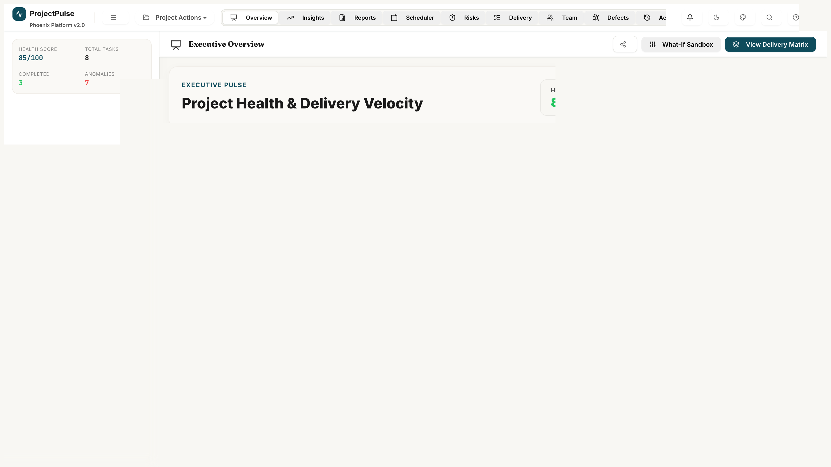
Figure 1.1 — Executive Overview Dashboard with KPI cards, Health Gauge, and Predictive Sandbox

1.1 Key Performance Indicator Cards
Three large KPI cards occupy the top ribbon of the dashboard. Each card updates automatically whenever underlying data changes.
Metric | Description | Calculation Logic | Target Threshold
Health Index | Composite score reflecting overall project vitality. | 100 − (Overdue/Active × 50) − (Blocked/Active × 30) − (On Hold/Active × 20) | ≥ 80% — Green
Delivery Confidence | Probability of delivering on schedule based on team velocity vs. remaining backlog. | Matches remaining task count against 4-week rolling average velocity. Deficit degrades confidence to a floor of 30%. | ≥ 85% — Green
Active RAID Elements | Total open Risk, Assumption, Issue, and Dependency items. | COUNT(raids WHERE status ∈ {Identified, Active}) | 0 — Goal

ℹ NOTE
The Health Index excludes Completed and Cancelled tasks from its 'Active' denominator. Only tasks that are genuinely in-flight and at risk contribute to health degradation.

1.2 Dynamic Health Gauge
Below the KPI cards sits the radial SVG Health Gauge — a premium animated dial that provides an at-a-glance summary of the Health Index. The gauge uses a dynamic arc drawn in real time by the browser's SVG engine, with a glow effect that intensifies as health improves.
- Green glow (80–100%): Project is healthy and on track.
- Amber arc (50–79%): Warning — one or more risk factors require attention.
- Red arc (<50%): Critical — immediate management intervention required.
- Hover interaction: Reveals a breakdown tooltip listing each drag factor and its percentage contribution (e.g., 'Overdue Tasks: −8%', 'Defects: −12%').

1.3 What-If Predictive Sandbox
The Predictive Sandbox is a non-destructive simulation environment that lets project managers explore 'what-if' scenarios without altering the live project state. The sandbox operates on an in-memory clone of the master schedule (P.sandboxTasks), leaving P.tasks completely unchanged.
Control | Action | Effect on Simulation
Toggle Sandbox | Activates/deactivates sandbox mode. | Switches state context from master to sandbox clone.
Capacity Slider | Reduce team availability by a percentage (e.g. −20%). | Extends forecast due dates proportionally across assigned tasks.
Scope Multiplier | Increase task complexity by a factor (e.g. 1.2×). | Inflates estimated effort and pushes projected delivery dates outward.
Commit Changes | Applies sandbox mutations to the live project. | Overwrites master schedule with simulated dates. Irreversible without a baseline restore.
Discard | Rolls back all sandbox mutations. | Restores the live schedule to its pre-simulation state instantly.

⚠ WARNING
Always capture a Schedule Baseline (Chapter 11) before committing sandbox changes. This ensures you can restore the original plan if the simulation produces undesirable outcomes.

2 Live Project Insights & Analytics

The Insights tab is the analytical engine of ProjectPulse. It transforms raw task logs and effort records into actionable intelligence: Earned Value Management (EVM) metrics, burn-up projections, velocity sparklines, and 30-day activity heatmaps. All computations are powered by the buildDashCache() function — an O(n) single-pass aggregator that processes the full task and log dataset once to produce O(1) lookup structures that power every widget.
[Screenshot: 02_insights_analytics]
Figure 2.1 — Live Insights: EVM metrics, Burn-up Chart, and Velocity Dashboard

2.1 Performance Metric Caching (buildDashCache)
To ensure smooth animations and sub-millisecond render times, ProjectPulse caches all computed analytics in a single P.cache object. The cache is hydrated every time task data or resource allocations change, and before every render cycle.
- Single-pass O(n) aggregation — iterates the task list exactly once per cache build.
- Calculates time-series arrays for cumulative completion tracking.
- Pre-computes dependency lookup maps to eliminate redundant nested searches.
- Generates sparkline data points for all health metric history charts.

2.2 Earned Value Management (EVM)
ProjectPulse implements the full PMI-standard EVM framework. Metrics are displayed as live cards updated on every cache refresh.
Metric | Formula | Interpretation
Planned Value (PV) | Total Budget × (Time Elapsed / Total Timeline) | Budget that should have been consumed by today's date per the original plan.
Earned Value (EV) | Total Budget × % Completion | Value of work actually delivered relative to the plan.
Actual Cost (AC) | Σ(logged hours) × avg. blended resource rate | Real resources consumed to date.
Schedule Variance (SV) | EV − PV | Positive = ahead of schedule. Negative = behind schedule.
Schedule Performance Index (SPI) | EV ÷ PV | SPI < 1.0 indicates schedule slippage. SPI > 1.0 indicates ahead-of-schedule delivery.
Cost Variance (CV) | EV − AC | Positive = under budget. Negative = over budget.

2.3 Burn-up & Burn-down Projections
The central chart in the Insights view is an interactive burn-up chart that provides a visual projection of project completion.
- Scope Line (Blue): Total planned complexity points over time. Rises when scope is added.
- Completion Line (Green): Accumulated complexity points of all tasks with status 'Completed'. Rising steeply indicates a healthy delivery pace.
- Dynamic Projection (Dashed Amber): Linear extrapolation based on the rolling 3-week velocity, estimating the exact calendar week of project completion.

2.4 30-Day Activity Heatmap
A calendar heatmap shows contribution density across the past 30 calendar days. Each cell represents a single day; colour intensity reflects the number of task state changes logged by the team on that day. This view is powered by the retrospective activity date resolution system introduced in the June 2026 release — log entries reference actCompletionDate rather than insertion timestamps, giving an accurate picture of when work was actually completed rather than when it was logged.
💡 TIP
Velocity is calculated as the 3-week rolling average of completed complexity points per week. Weeks where no tasks were completed are excluded from the rolling window to avoid artificially suppressing the velocity figure during holiday periods.

3 Hierarchical Delivery Matrix

The Delivery Matrix is the operational backbone of ProjectPulse — a high-density, spreadsheet-style task grid that supports multi-level parent-child hierarchies, inline editing, dependency mapping, effort estimation, and real-time status tracking. Every deliverable, epic, task, and subtask in the project lives in this view.
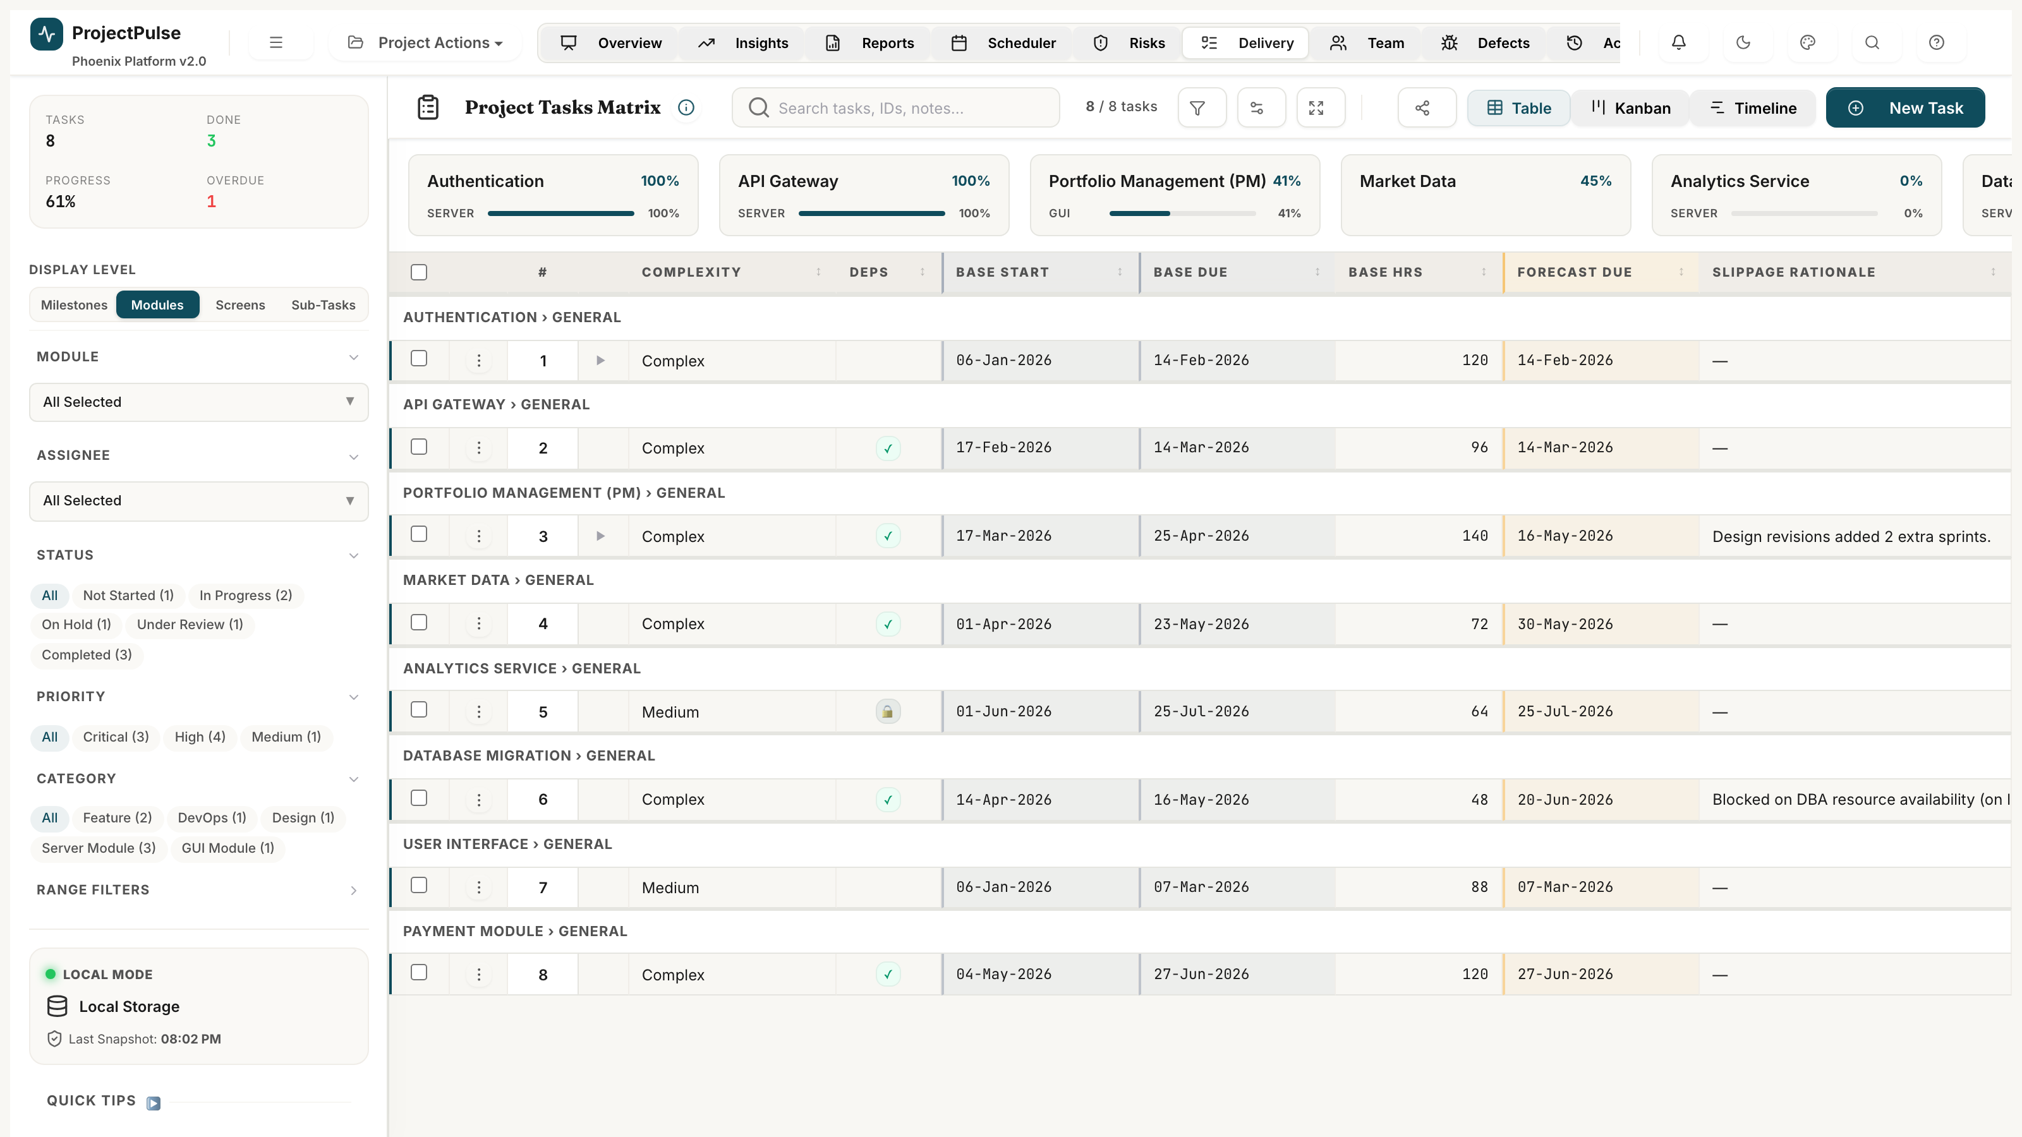
Figure 3.1 — Hierarchical Delivery Matrix showing parent tasks, child subtasks, status pills, and inline controls

3.1 Parent-Child Task Hierarchies
Tasks can be structured into multi-level trees. Parent tasks (Epics or Deliverables) aggregate metrics from all child tasks:
- Parent Tasks: Display summary progress as the weighted average of child task progress.
- Child Tasks / Subtasks: Individual action items with their own assignees, dates, effort, and complexity.
- Expand/Collapse: Click the chevron icon on any parent row to toggle child visibility.
- Indentation: Child rows are visually indented 24px per nesting level for clear hierarchy display.

3.2 Spreadsheet-Style Inline Editing
The matrix operates like a live spreadsheet — every cell is directly editable without opening a modal:
- Double-click any cell to activate an inline input field (text, number, date, or dropdown).
- Press Enter or click outside (blur) to save changes. Changes are immediately reflected in the dashboard.
- Dropdown cells enforce valid system options — no free-text entry for controlled fields like Status, Priority, Complexity, or Module.
- Ctrl+Z undoes the last inline edit within the session.

3.3 Task Status Lifecycle
Status transitions follow a controlled workflow. Not all transitions are permitted — the system enforces the following state machine:
From Status | Permitted Transitions | Comment Required?
Not Started | In Progress, Cancelled | No
In Progress | Under Review, On Hold, Cancelled | Required for On Hold, Cancelled
Under Review | Completed, In Progress, Cancelled | Required for Cancelled
On Hold | In Progress, Under Review, Cancelled | Required for Cancelled
Completed | In Progress (re-open) | No
Cancelled | Not Started (re-activate) | No

3.4 Column Management & Visibility
The visible column set, order, and column widths are fully configurable:
- Right-click any column header to show the Column Visibility panel.
- Drag column headers horizontally to reorder them.
- Drag the right edge of a column header to resize it. All configurations persist across sessions via localStorage.

3.5 Complexity & Effort Estimation
ProjectPulse uses a three-tier complexity model that scales estimated effort:
Complexity Level | Effort Multiplier | Recommended Use Case
Easy | 0.5× | Well-understood tasks with clear requirements and low dependency.
Medium | 1.0× | Standard development tasks with moderate ambiguity.
Complex | 1.5× | Tasks with significant unknowns, cross-team dependencies, or novel engineering challenges.

ℹ NOTE
The Effort Unit (hrs / days / months) is a global system setting configured in Administration → General Settings. All effort values across the entire application honour this setting — switching units automatically recalculates all displayed values.

3.6 Filtering & Sorting
The left sidebar provides a powerful multi-dimensional filter panel:
- Filter by Module, Status, Priority, Assignee, Release, Category, and Module Type simultaneously.
- Click any column header once to sort ascending; click again to sort descending.
- Active filters are displayed as removable pills at the top of the filter sidebar.
- The search bar performs live full-text search across Task IDs, names, assignees, and notes.

4 Gantt Timeline & Dependency Management

The Gantt Timeline provides a time-anchored visual representation of the project schedule. Tasks appear as horizontal bars spanning their start-to-due date range, with dependency arrows linking predecessor and successor tasks. Toggle to the Timeline view by clicking 'Timeline' in the Delivery Matrix toolbar.
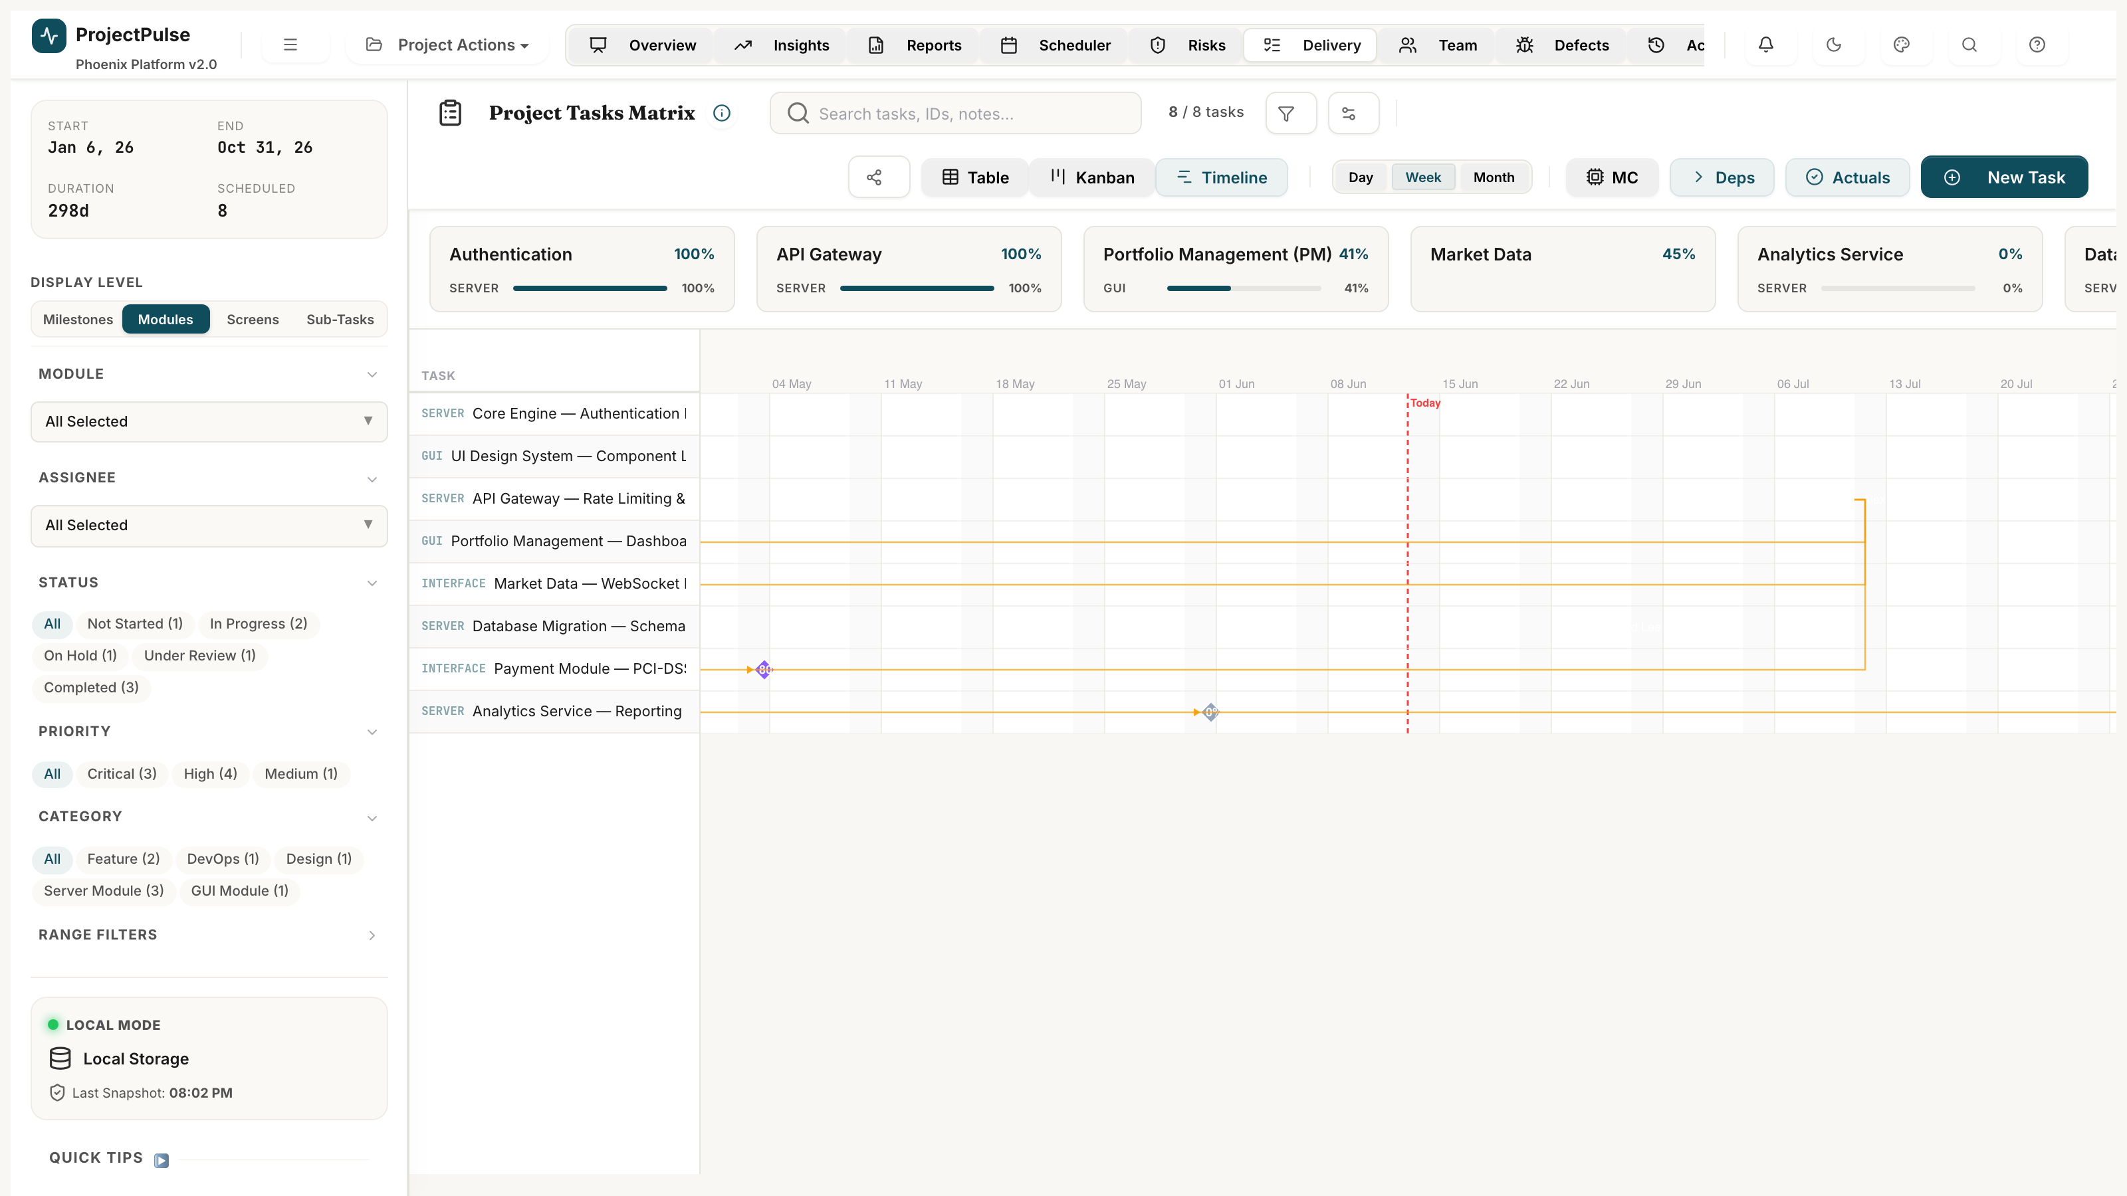
Figure 4.1 — Gantt Timeline with dependency arrows, critical path highlighting, and baseline comparison overlay

4.1 Timeline Controls
The timeline toolbar provides granular navigation controls:
- Zoom Levels: Day / Week / Month / Quarter — adjust the time-axis resolution.
- Scroll: Click-drag the timeline canvas to pan left/right across the schedule.
- Today Line: A vertical amber marker indicates today's date on the timeline.
- Baseline Overlay: Toggle the baseline date range (shown as a ghost bar behind each task bar) to visually compare planned vs. actual schedule positions.

4.2 Dependency Arrows
Finish-to-Start dependency relationships between tasks are rendered as curved SVG arrows connecting predecessor task bars to successor task bars.
- Blue arrows: Active dependencies where the predecessor is still incomplete.
- Green arrows: Resolved dependencies (predecessor is Completed).
- Red arrows: Violated dependencies — the successor's start date precedes the predecessor's due date (scheduling conflict).

4.3 Drag-to-Reschedule
Task bars on the timeline are interactive:
- Drag the bar body horizontally to shift the start and due date together (preserving duration).
- Drag the right edge of the bar to extend or shorten the duration.
- Cascading: When a task's dates shift, all downstream dependent tasks can optionally cascade their dates forward automatically.

⚠ WARNING
Cascading date shifts in the Gantt view operate on the live schedule by default. To experiment safely without affecting the live plan, activate Sandbox Mode first (available via the Scheduler view).

5 Intelligent Weekly Scheduler & Conflict Resolver

The Weekly Scheduler is the resource-levelling engine of ProjectPulse. It maps team capacity against assigned task efforts across a rolling 12-week horizon, surfacing over-allocations, dependency violations, and scheduling conflicts — and offering automated resolution heuristics via the Copilot engine.
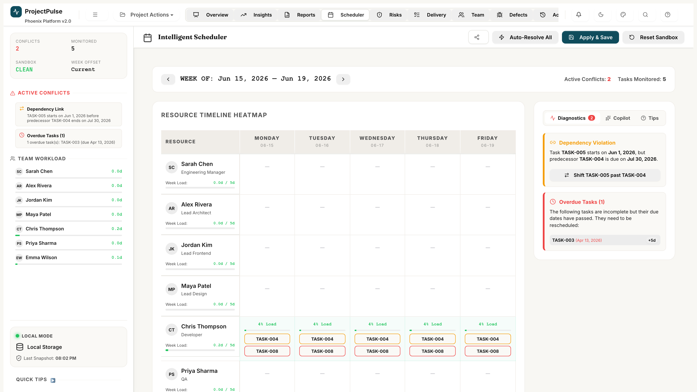
Figure 5.1 — Weekly Scheduler: Resource Heatmap Grid, Conflict Diagnostics, and Copilot Cockpit

5.1 The Weekly Heatmap Grid
The central element of the Scheduler is a two-dimensional heatmap grid: team members on the vertical axis and calendar weeks on the horizontal axis. Each cell displays the resource's allocated hours vs. their weekly capacity:
Cell State | Display | Condition | Action Required
Over-allocated | Neon crimson glow — e.g. '48h / 40h' | Allocated hours > Capacity | Reassign or extend task dates.
Optimal | Green highlight — e.g. '38h / 40h' | 80%–100% of capacity used | No action required.
Under-utilised | Slate grey — e.g. '22h / 40h' | < 70% of capacity used | Consider additional task assignments.
On Leave | Hatched pattern — '0h / 0h' | Leave recorded in Capacity Hub | No tasks should be assigned.

5.2 Left Navigation Sidebar
The scheduler sidebar provides four real-time widgets:
- Statistics Bar: Shows Active Conflicts count, Monitored Tasks, Sandbox State (CLEAN / DIRTY), and current Week Offset.
- Team Workload Widget: A progress-bar checklist showing total weekly allocated days per active team member.
- Active Conflicts Widget: Stacks all detected scheduling overlaps and dependency violations with Lucide indicator icons.
- Quick Tips: Contextual guidance on heatmap interpretation, sandbox usage, and date-shifting shortcuts.

5.3 Right-Side Diagnostics Cockpit
A three-tab cockpit panel on the right side provides planning intelligence:
- Diagnostics Tab: Lists every active conflict with its type (Over-allocated / Dependency Violation / Gap), affected resource, and impacted weeks.
- Copilot Tab: Offers one-click automated resolution actions. Each action shows a preview of changes before applying.
- Tips Tab: Displays keyboard shortcuts and sandbox state reminders.

5.4 Automated Conflict Resolution Heuristics
The autoResolveAllSchedulerConflicts() engine evaluates tasks in the sandbox state and applies three sequential heuristics:
Heuristic | Name | Logic | Pre-condition
A | Auto-Sequence | If Task_A → Task_B dependency exists and they overlap, Task_B's start date is shifted to Task_A's end date + 1 day. | Both tasks must be in sandbox mode.
B | Smart Reassignment | If Resource R1 is over-allocated and Resource R2 shares the same Role with available capacity, tasks are re-assigned to R2. | A role-matched resource with spare capacity must exist.
C | Cascading Date Shift | If a critical-path task is delayed, all transitively dependent future tasks are pushed forward, maintaining established buffer periods. | Task dependency graph must be acyclic.

⚠ WARNING
All automated resolutions are applied to the Sandbox state only. Review the proposed changes in the Diagnostics tab before clicking 'Commit' to apply them to the live schedule.

5.5 Interactive Tooltips
Hovering over elements in the heatmap reveals live contextual data:
- Grid Cells: Lists all tasks assigned to that resource for that week, total allocated hours, and remaining available hours.
- Task Chips: Shows task status, parent deliverable name, priority level, and precise start/end dates.

6 Unified RAID Register

The RAID Register is the risk governance engine of ProjectPulse. It consolidates all Risks, Assumptions, Issues, and Dependencies into a single searchable register with formal exposure scoring, owner assignment, mitigation planning, and escalation tracking.

Figure 6.1 — Unified RAID Register with 5×5 Risk Matrix Heatmap and categorised RAID items

6.1 RAID Classification Model
Every RAID entry is categorised into one of four types:
Type | Definition | Primary Management Action
Risk | A potential future event that could negatively impact the project. | Mitigate, transfer, or accept before the event occurs.
Assumption | A factor believed to be true for planning purposes, without verified evidence. | Validate through testing or stakeholder confirmation to eliminate associated risk.
Issue | An active problem currently impacting timeline, scope, or budget. | Resolve immediately via assigned owner and mitigation strategy.
Dependency | A reliance on an external team, system, third-party vendor, or deliverable. | Map to task schedules. Monitor checkpoint dates. Escalate delays immediately.

6.2 Threat Exposure Scoring
For Risk-type items, threat exposure is calculated using the industry-standard 5×5 probability-impact matrix:
Exposure Score = Probability (1–5) × Impact (1–5)
Score Range | Rating | Colour Indicator | Management Protocol
15 – 25 | Critical | Red (🔴) | Immediate mitigation plan required. Executive escalation mandatory.
8 – 12 | Medium | Amber (🟡) | Weekly monitoring. Mitigation plan to be prepared within 5 business days.
1 – 6 | Low | Green (🟢) | Logged and reviewed bi-weekly. No immediate action required.

6.3 RAID Item Lifecycle
RAID items progress through the following status workflow:
- Identified: Newly logged item awaiting triage and owner assignment.
- Active: Triaged and assigned — mitigation in progress.
- Mitigated: Actions taken; item is under monitoring to confirm effectiveness.
- Closed: Fully resolved with no residual risk.
- Realized: Risk event has occurred and become an active Issue.

6.4 Required Fields for Active RAID Items
To maintain governance standards, every Active RAID item must have all of the following:
- Owner — An active team member assigned from the Capacity Hub.
- Mitigation / Resolution Strategy — A detailed textual description of the action plan.
- Target Closure Date — The deadline by which the issue must be resolved or the assumption validated.

⛔ CAUTION
RAID items with Exposure Score ≥ 15 automatically contribute to the Health Index degradation on the Executive Overview Dashboard. Each unmitigated Critical risk deducts a fixed 5% from the Health Index.

7 Team Capacity Hub & Role Management

The Team Capacity Hub is the resource management control centre of ProjectPulse. It maintains team member profiles, capacity parameters, role assignments, utilisation statistics, and planned leave calendars. All scheduling and conflict detection in the Weekly Scheduler is derived from the capacity data managed here.
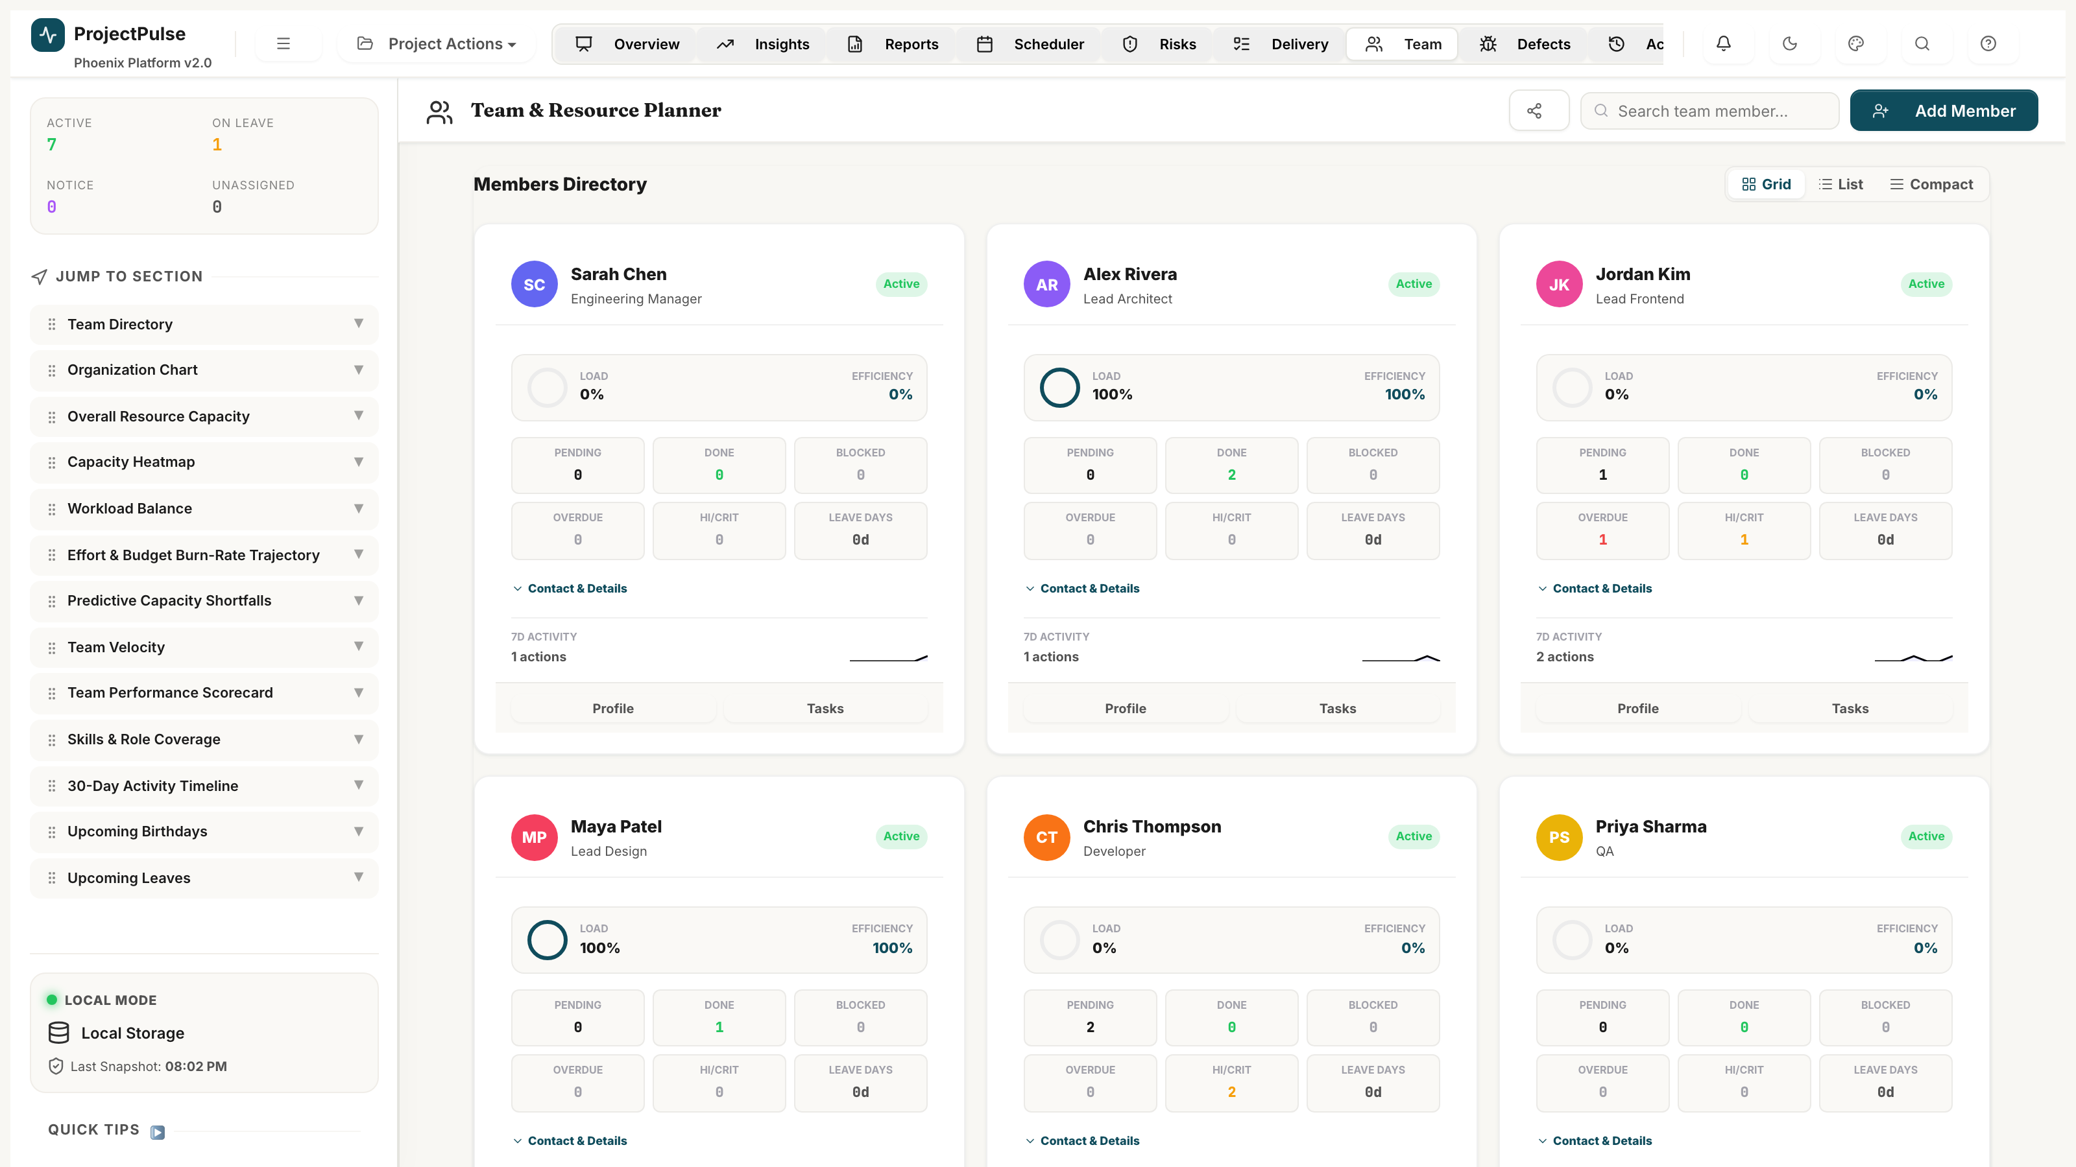
Figure 7.1 — Team Capacity Hub: Member profiles, utilisation bars, and leave calendar integration

7.1 Adding and Managing Team Members
To add a new team member:
- Navigate to the Team view via the top navigation bar.
- Click '+ Add Member' in the top-right toolbar.
- Enter the member's Name, Role, and initial Status.
- Optionally configure Weekly Hour Cap (default: 40h) and Utilisation Rate (default: 100%).
- Save. The member immediately appears in the Scheduler's resource grid.

7.2 Capacity Parameters
Each team member has the following configurable capacity parameters:
Parameter | Default | Description
Weekly Hour Cap | 40h | Maximum standard hours the member works per week.
Utilisation Rate | 100% | Percentage of standard time dedicated to project work. A member at 80% utilisation contributes 32 project hours per 40h week, reserving 8h for admin.
Status | Active | Active members appear in Scheduler and can be assigned tasks. On Leave, Serving Notice, and Departed members are excluded from capacity calculations.
Planned Leaves | None | Date ranges marked as leave. The Scheduler reduces that member's available hours to 0 for those weeks.

7.3 Dynamic Workload Balancing
The Capacity Hub displays a real-time utilisation indicator for each member:
- Under-Utilised (< 70%): Blue indicator. The system suggests additional task assignments based on the member's role profile.
- Balanced (70%–100%): Green indicator. Optimal resource loading.
- Over-allocated (> 100%): Red warning flag. The Weekly Scheduler Diagnostics will list this resource as a conflict and recommend reassignment or date extension.

7.4 Role-Based Assignment Logic
Roles restrict which tasks a member can be automatically reassigned to during conflict resolution. The Smart Reassignment heuristic (Scheduler → Copilot) only swaps resources that share the same Role.
Role | Typical Responsibilities
Engineering Manager | Project oversight, resource coordination, escalation management.
Lead Architect | System design, technical standards, code review ownership.
Lead Frontend | UI engineering, component library, performance optimisation.
Lead Design | UX research, design system, visual prototyping.
Developer | Feature implementation, unit testing, code review.
QA | Test planning, defect logging, regression validation.
DevOps | Infrastructure, CI/CD pipelines, environment management.
Analyst | Requirements gathering, reporting, stakeholder communication.

8 Defect Tracker & Bug Lifecycle

The Defect Tracker enables QA teams and developers to log, triage, prioritise, assign, track, and close software defects through a formal lifecycle. Defect data is integrated into the Health Index calculation on the Executive Overview Dashboard and linked to specific tasks in the Delivery Matrix.
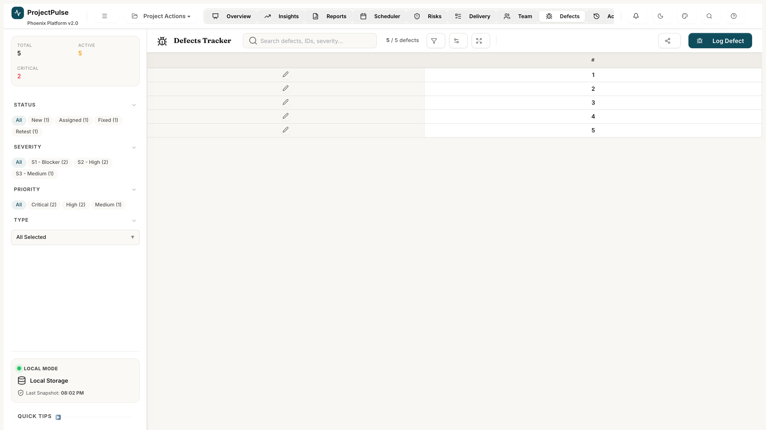
Figure 8.1 — Defect Tracker: Summary cards, severity-coded defect table, and bug lifecycle diagram

8.1 Defect Severity Matrix
Every defect must be assigned a severity level at the time of logging. Severity determines SLA response times and health index impact:
Severity | Code | Definition | Health Impact | SLA Target
Blocker | S1 | Critical function completely broken. No workaround exists. Application unusable. | −10% per active Blocker | 24 hours
Critical | S2 | Major functionality impaired. Temporary workaround exists but is impractical. | −5% per active Critical | 48 hours
Major | S3 | Significant issue. Clear and stable workaround available. | −2% per active Major | 5 business days
Minor | S4 | Trivial cosmetic issue, spelling error, or minor UI inconsistency. | −0.5% per active Minor | 10 business days

8.2 Bug Lifecycle & Status Workflow
Defects flow through the following mandatory status transitions. A defect cannot skip stages — the transition must be sequential:
Status | Description | Responsible Party
New | Defect logged. Awaiting triage and owner assignment. | Reporter
Assigned | Owner allocated. Development investigation begun. | Engineering Manager
Fixed | Code fix applied by development. Awaiting QA validation. | Developer
Retest | Fix deployed to test environment. QA conducting verification testing. | QA Engineer
Closed | Fix verified by QA. Defect permanently closed. | QA Engineer
Rejected | Defect determined to be invalid (by design or not reproducible). | Engineering Manager
Deferred | Fix postponed to a future release cycle with stakeholder approval. | Project Manager

8.3 Linking Defects to Tasks
Every defect must be linked to a specific entity to maintain traceability:
- Link Type: Task, Subtask, or GUI Screen.
- Linked ID: The specific entity ID (e.g., TASK-004, ST-005).
- The Delivery Matrix displays a defect count badge on the linked task row for instant visibility.
- The Task Detail flyout lists all linked defects with their severity and status.

8.4 Logging a New Defect — Step by Step
- Navigate to the Defects view via the top navigation bar.
- Click '+ Log Defect' in the top toolbar.
- Complete the defect form: Title, Type, Severity, Priority, Linked Task, Assignee, Reporter, Description, and Reproduction Steps.
- Click 'Save'. The defect is immediately added to the register with status 'New'.
- The linked task's health contribution is recalculated and the dashboard updates in real time.

⛔ CAUTION
S1 Blocker defects trigger an immediate red alert banner on the Executive Overview Dashboard. Blockers that remain open beyond their 24-hour SLA are escalated to the Engineering Manager via in-app notification.

9 Reports & Stakeholder Board Packs

ProjectPulse features a professional report generation engine that compiles real-time project data into presentation-ready board packs, structured Excel workbooks, and printable PDF status reports — all in one click.
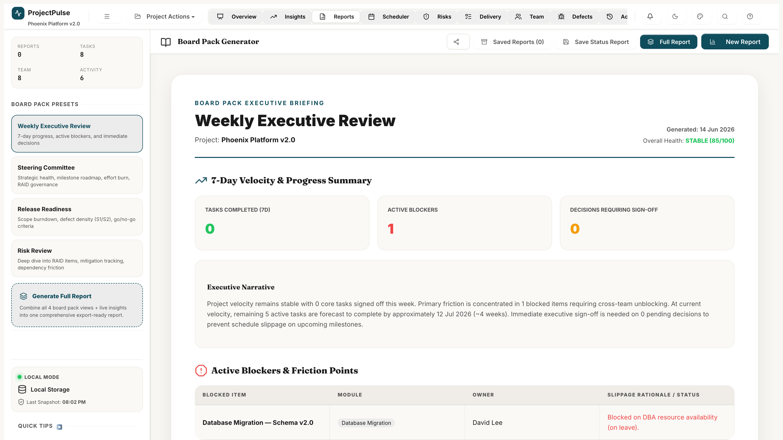
Figure 9.1 — Reports & Board Packs: Report builder, export controls, and preview panel

9.1 Executive Board Pack
The Board Pack compiles a complete project narrative suitable for executive and steering committee review:
- Project Summary Narrative: Auto-generated high-level status paragraph, summarising key achievements, blockers, and next steps.
- Aggregated Health Trend Graph: A Bezier-curve sparkline chart showing the Health Index over the past 8 weeks.
- Critical Path Highlights: Tasks on the critical path that are within 5 days of or past their due dates.
- Top 5 Risks: RAID items ranked by Exposure Score (Probability × Impact), with their owners and mitigation summaries.
- Team Velocity Trend: 4-week rolling average of completed story points.

9.2 Excel Workbook Export
The full project workbook is generated using the ExcelJS library in the browser. The export is a multi-sheet workbook with professional formatting:
Sheet | Contents
System State | Project metadata, settings, effort unit, last saved timestamp, and file sync path.
Tasks | Full task register with all fields, baseline dates, variance calculations, and slippage reasons.
Team | Member directory with roles, statuses, capacity parameters, and leave records.
RAID Register | All Risk, Assumption, Issue, and Dependency items with exposure scores and mitigation details.
Defects | Complete defect log with severity, priority, status, linked tasks, and reproduction steps.
Activity Log | Last 500 audit log entries with timestamps, users, actions, and diff payloads.
Baselines | All captured baseline snapshots with per-task variance calculations.
Releases | Release version registry with status and target dates.

9.3 Excel Cell Colour Coding
Exported Excel cells are colour-coded for instant readability:
Colour | Hex Code | Applied To
Green | #D1E7DD / #0F5132 | Completed tasks, mitigated risks, closed defects, low RAID exposure.
Yellow | #FFF3CD / #664D03 | In-progress tasks, medium risks, deferred defects.
Red | #F8D7DA / #842029 | Blocked / overdue tasks, critical risks, S1/S2 defects.
Grey | #F8F9FA / #6C757D | Cancelled, Rejected, or On Hold items.

💡 TIP
Exported spreadsheets contain live Excel formulas (SUM, AVERAGE, IF, COUNTIF) rather than static values where applicable. This means the workbook remains interactive and can be extended with additional analysis by stakeholders.

10 Audit Log & Activity Streams

ProjectPulse maintains an immutable, comprehensive audit trail of every state mutation — task CRUD operations, status transitions, defect lifecycle changes, RAID updates, and resource modifications. The Activity Log provides full accountability and change tracking capabilities.
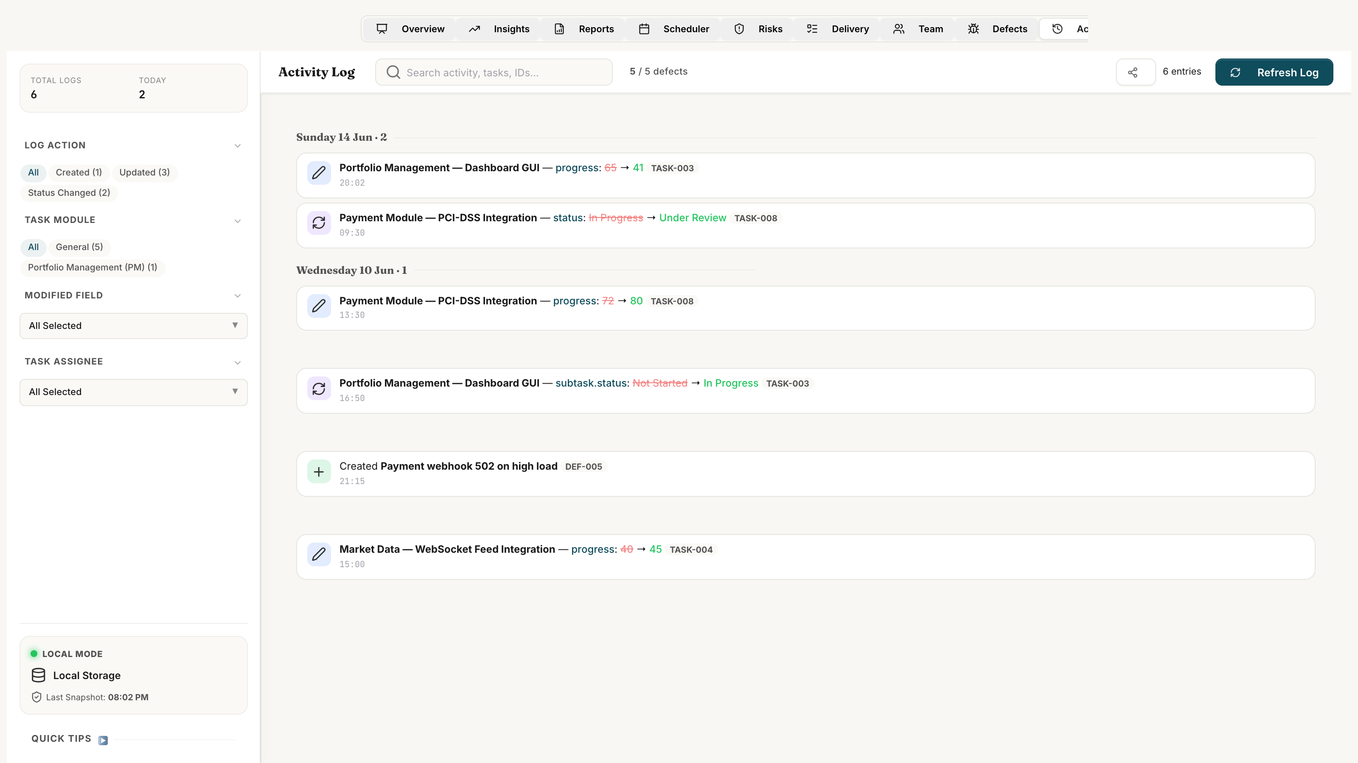
Figure 10.1 — Audit Log: Chronological activity stream with user identifiers and diff payloads

10.1 What Gets Logged
Every significant state change generates an immutable log entry:
Action Type | Trigger | Fields Captured
Created | New task, defect, RAID, or member added. | Entity ID, name, all initial field values, timestamp, user.
Updated | Any field value changed on an existing entity. | Entity ID, field name, old value, new value, timestamp, user.
Status Changed | Status field specifically transitions to a new value. | Entity ID, old status, new status, mandatory comment (for restricted transitions), timestamp, user.
Deleted | Task, defect, or RAID item permanently removed. | Entity ID, entity name, full field snapshot at time of deletion.

10.2 Log Entry Structure
Each log entry contains the following structured fields:
- ts: ISO 8601 timestamp recorded to the millisecond.
- user: Name of the active team member who performed the action.
- action: Category of change — Created, Updated, Status Changed, or Deleted.
- taskId / taskName: Reference to the primary entity affected.
- field: The specific field that changed (e.g., 'status', 'dueDate', 'subtask.status').
- oldVal / newVal: Structured diff payload capturing before and after values.
- subtaskId: Optional — references a specific subtask if the change was at subtask level.
- actCompletionDate: Optional — retrospective actual completion date for activity date resolution.

10.3 Retrospective Activity Date Resolution
A key capability introduced in the June 2026 release is retrospective completion date resolution. Log entries may record an actCompletionDate that differs from the log insertion timestamp (ts). When this field is present, all dashboard widgets — including the 30-Day Activity Timeline, Weekly Velocity charts, Member Heatmaps, and Status Reports — use the actCompletionDate as the activity date rather than the log timestamp. This allows teams to accurately record when work was actually done, even if it was logged retrospectively days later.

10.4 State Reconstruction
The Activity Log provides detailed before/after diff payloads for every logged transaction. While there is no automated rollback feature directly in the Activity Log view, managers can use these payloads to manually reconstruct prior states. The procedure is as follows:
- Identify the target entity and the historical timestamp when the incorrect change occurred.
- Locate the corresponding log entry containing the before/after details.
- Review the 'Old Value' in the diff details to find the original state of the field.
- Manually edit the target entity using the inline editing tables or flyout edit views to restore the previous value.
For project-wide rollbacks, managers can use baseline snapshots (Settings -> Schedule Baselines) or restore database backups (Settings -> Data Recovery / Backups) to revert to previous saved states.

⚠ WARNING
The Activity Log is auto-pruned to the last 500 entries to prevent unbounded localStorage growth. Export the log to Excel before reaching this limit if you need a permanent audit record beyond 500 entries.

11 Schedule Baselines & Snapshot History

Schedule Baselines capture a static, approved snapshot of the project plan at a specific milestone — such as project kickoff, a phase gate, or after a major re-scope. Baselines serve as the immutable reference point for calculating schedule variance, analysing slippage, and restoring the plan if assumptions change.
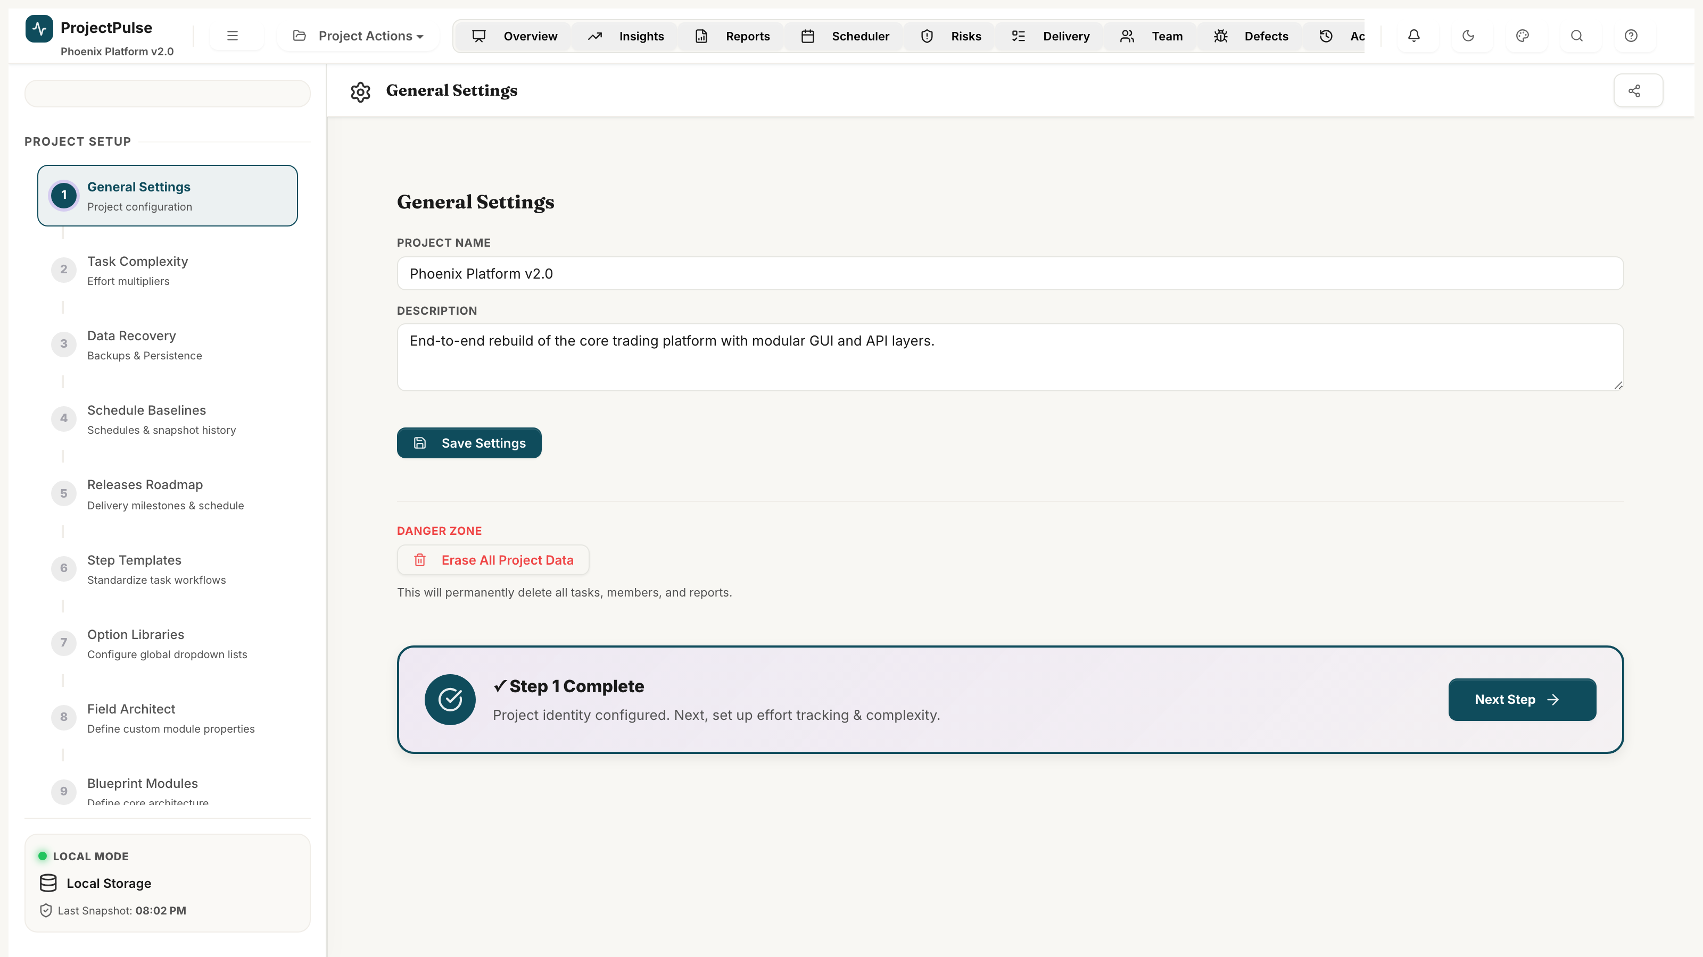
Figure 11.1 — Schedule Baselines & Snapshot History panel in Project Settings

11.1 Three Date Sets Explained
ProjectPulse tracks three parallel sets of dates for every task:
Date Set | Fields | Purpose
Planned Dates | startDate, dueDate, estEffort | The current working target dates that resources are actively working towards. These evolve during execution.
Baseline Dates | baselineStartDate, baselineDueDate, baselineEffort | The frozen reference dates captured at a specific baseline snapshot point. Used to calculate variance. Immutable after capture.
Actual Dates | actCompletionDate, actEffort | The real dates and effort recorded when tasks are completed. Used for EVM, velocity, and activity reporting.

11.2 Capturing a Baseline Snapshot
- Open Project Settings by clicking the ⚙ gear icon in the top navigation bar.
- Select 'Schedule Baselines' from the left sidebar within Settings.
- Enter a Baseline Name (e.g., 'Initial Kickoff Plan', 'Sprint 3 Reforecast') and a Description.
- Click 'Capture Snapshot'.

What happens when a snapshot is captured:
- All active tasks' baseline fields are overwritten with their current planned values.
- A snapshot record is generated for every task and appended to the P.baselines array.
- The snapshot is timestamped and named for future reference.

11.3 Variance & Slippage Analysis
Once a baseline is captured, variance is automatically calculated and displayed:
Metric | Formula | Interpretation
Variance Days | Planned/Actual Date − Baseline Date | +5d = 5 days behind schedule. −3d = 3 days ahead of schedule.
Effort Variance | estEffort − baselineEffort | Positive = scope increase. Negative = scope reduction.
Slippage Reason | Free-text field on the task flyout | Documented justification for schedule slippage. Captured in subsequent baseline snapshots and exported to Excel.

11.4 Restoring a Baseline
From the Schedule Baselines panel, select any historical snapshot and click 'Restore'. This action:
- Overwrites all current planned dates (startDate, dueDate, estEffort) with the snapshot's recorded values.
- Resets baseline dates to match the restored snapshot.
- Triggers a full recalculation of dashboard metrics, EVM figures, and schedule variance.

⛔ CAUTION
Restoring a baseline is irreversible without another snapshot to return to. Always capture a 'Current State' baseline snapshot before restoring a historical one, so you can return to your pre-restore position if needed.

12 System Configuration Reference

The Administration panel (⚙ Settings) centralises all system-wide configuration options. Changes take effect immediately across all views without requiring a page reload.

Figure 12.1 — System Configuration: General Settings, Dropdown Manager, and Custom Fields panel

12.1 General Settings
Core application behaviour is controlled by these settings:
Setting | Options | Effect
Effort Unit | hrs / days / months | Globally switches the unit label and rescales all effort values across the application.
Hours per Day | 1–24 (default: 8) | Used to convert between hours and days when switching effort units.
Days per Week | 1–7 (default: 5) | Defines the working week length for capacity calculations.
Working Days | Mon–Sun toggles | Specifies which days of the week are working days. Affects capacity calculations and date math.
Auto-Save | On / Off | Enables 10-second idle debounced auto-save to localStorage.

12.2 Dropdown Configuration Manager
All categorical dropdowns (Status, Priority, Category, Module, Role, etc.) are fully configurable. To modify a dropdown:
- Open Settings → 'Dropdown Manager'.
- Select the dropdown category to modify (e.g., 'Module').
- Add new options, edit existing labels, or reorder items via drag-and-drop.
- Click 'Save'. New options appear immediately in all views.

⚠ WARNING
Removing a dropdown option that is currently assigned to active tasks will not delete those tasks or their data — the old value is preserved on existing records. However, it will no longer appear as a selectable option for new assignments.

12.3 Custom Fields
Custom Fields allow teams to extend the Task and Defect schemas with project-specific attributes:
- Supported Types: Text, Number, Date, Dropdown, Checkbox.
- Scope: Custom fields can be defined independently for Tasks and for Defects.
- Visibility: Custom fields appear as additional columns in the Delivery Matrix and Defect Tracker, and are included in Excel exports.
- Persistence: Custom field values are stored alongside standard fields in localStorage and in the Excel workbook.

12.4 Complexity Factor Multipliers
The default complexity multipliers (Easy: 0.5×, Medium: 1.0×, Complex: 1.5×) can be adjusted in Settings → 'Complexity Factors'. Changing these values recalculates all velocity and EVM metrics immediately.

12.5 Theme & Visual Configuration
ProjectPulse ships with 20 curated visual themes:
- Dark Themes: Nexus, Obsidian, Fintech, Codename, Workflow, Bento.
- Light Themes: Emerald, Terracotta, Cloud, and 12 additional curated palettes.
- Dark/Light Mode Override: Force dark or light mode regardless of the selected theme.
- Theme selection is persisted per session and stored to the Excel workbook on export.

Appendix A — Keyboard Shortcuts

The following keyboard shortcuts are available globally across all views:
Shortcut | Action | Scope
Ctrl + S | Force immediate save to localStorage and linked file. | Global
Ctrl + Z | Undo last inline edit. | Delivery Matrix
Ctrl + F | Focus the search / filter bar. | Delivery Matrix, Defects
Escape | Close open modal, flyout, or dropdown. | Global
Enter | Confirm inline cell edit. | Delivery Matrix
Tab | Move to next editable cell. | Delivery Matrix
Shift + Tab | Move to previous editable cell. | Delivery Matrix
Arrow Keys | Navigate between cells in grid. | Delivery Matrix
Ctrl + Click | Multi-select tasks for bulk operations. | Delivery Matrix
Space | Toggle expand/collapse on selected parent task. | Delivery Matrix

Appendix B — Data Schema Reference

The following tables document the full field-level schema for the primary data entities managed by ProjectPulse. All data is persisted in localStorage (pp-data key) and exported to the Excel workbook on save.

B.1 Task Schema
Field | Type | Description
id | string | Unique identifier (e.g., TASK-001). Auto-generated.
name | string | Task title. Required.
status | string | Current status. Must match valid transition from VALID_TRANSITIONS.
priority | string | Critical / High / Medium / Low.
category | string | Classification from configured Category dropdown.
module | string | Associated module name from Module dropdown.
moduleType | string | Server / GUI / Interface.
assignee | string | Assigned member name.
release | string | Target release version (e.g., v1.0.0).
startDate | YYYY-MM-DD | Current planned start date.
dueDate | YYYY-MM-DD | Current planned due date.
actCompletionDate | YYYY-MM-DD | Actual completion date (null if incomplete).
baselineStartDate | YYYY-MM-DD | Frozen baseline start date.
baselineDueDate | YYYY-MM-DD | Frozen baseline due date.
forecastDueDate | YYYY-MM-DD | System-calculated forecast due date based on velocity.
slippageReason | string | Free-text explanation if task slips beyond baseline.
complexity | string | Easy / Medium / Complex.
progress | number | 0–100 percentage completion.
estEffort | number | Estimated effort in active effortUnit.
actEffort | number | Actual logged effort in active effortUnit.
baselineEffort | number | Baseline effort in active effortUnit.
dependsOn | string[] | Array of prerequisite Task IDs.
notes | string | Multi-line task description and notes.
subtasks | Subtask[] | Array of child step/screen items.
guiScreens | string[] | Linked GUI screen names.
updatedAt | ISO 8601 | Timestamp of last modification.
parentId | string | Parent task ID for sub-rows (empty string for root tasks).

B.2 Defect Schema
Field | Type | Description
id | string | Unique identifier (e.g., DEF-001). Auto-generated.
title | string | Defect title. Required.
type | string | Functional Bug / UI/UX Issue / Performance / Security / Data Issue / Suggestion.
severity | string | S1 Blocker / S2 High / S3 Medium / S4 Low.
priority | string | Critical / High / Medium / Low.
status | string | New / Assigned / Fixed / Retest / Closed / Rejected / Deferred.
linkedType | string | task / subtask / screen — type of linked entity.
linkedId | string | ID of the linked task, subtask, or screen.
assignee | string | Developer assigned to fix.
reporter | string | Person who logged the defect.
desc | string | Full defect description.
steps | string | Step-by-step reproduction instructions.

