
ENTERPRISE EDITION // VERSION 2.0.0
ProjectPulse 2.0
Product Capability, End-User Operations & Technical Specification Manual
Comprehensive three-in-one reference covering executive governance capabilities, screen-by-screen operator guides, health & EVM formulas, RBAC rules, 13 explicit finite state machines, ExcelJS schemas, and Capacitor iOS/Android builds.
ARCHITECTURAL CAPABILITY SUMMARY
6 JOURNEY HUBS  19 Integrated Modules | 40 BUILT-IN THEMES  WCAG Luminance Guarded | 13 STATE MACHINES  Zero Implicit Transitions | 4 NATIVE PLATFORMS  Web, iOS, Android, Safari QR
DOCUMENT CONTROL & SPECIFICATION METADATA
Document Identifier | PP-2.0-MAN-001 (Unified Capability, User & Spec Edition) | Application Package | projectpulse@2.0.0 (com.projectpulse.app)
Source Baseline | Git Commit b8d0b01 (main) | Platform Targets | Web SPA, Mobile Safari QR, iOS App, Android APK
Architecture Scope | 6 Hubs • 19 Screens • 4 RBAC Personas • 40 Themes | State Governance | 13 Explicit State Machines + localStorage Persistence
Export & Integration | ExcelJS Multi-Sheet .xlsx • Capacitor Share • Gemini AI | Intended Audience | CXO Sponsors, PMO Leads, Engineers, QA & Architects

Document Control, Audience Guide & Revision Log
This manual serves concurrently as the executive Product Capability Manual, screen-by-screen End-User Guide, and formal Technical Product Specification for ProjectPulse 2.0. All module inventories, mathematical formulas, RBAC permission tables, finite state machines, and build artifacts documented herein are verified directly against source revision b8d0b01.
Reader Role | Primary Recommended Chapters | Key Takeaways
Executives & SteerCo | Chapters 1, 2, 3, 7 | Health penalty model, Monte Carlo P50/P90 forecasts, CXO Email Briefings, RAID escalation
PMO & Delivery Managers | Chapters 2, 4, 5, 6, 9 | Release Roadmap gates, 3-level WBS matrix, Gantt critical path, 8-week capacity, ExcelJS export
Engineers & QA Leads | Chapters 5, 7, 9, 10 | Task dependency locks, ALM PDN smoke gates, Defect triage cycle, Mobile & Safari QR launch
Platform & Solution Architects | Chapters 1, 8, 9, 10 | 40-theme contrast & CSS architecture, 13 explicit FSM invariants, Capacitor native runbook
Table of Contents
Word automatically populates exact Roman and Decimal page numbers upon opening (updateFields enabled). In QuickLook or third-party viewers, use the navigable bookmarks below or accept Word's Update Fields prompt.
1. Executive Product Overview & Capability Architecture
1.1 Core Value Proposition & Multi-Surface Experience
1.2 Technology Stack & Cross-Platform Matrix
2. Onboarding, RBAC Governance & Navigation System
2.1 Workspace Onboarding & Session Bootstrapping
2.2 RBAC Role Permission & Screen Access Matrix
2.3 Six-Hub Information Architecture & 19 Screen Catalog
2.4 Keyboard Shortcuts, Command Palette & Context Help
3. Insights, Executive Overview, Intelligence Cockpit & Reports
3.1 Weighted Health Score Penalty Model
3.2 Project Intelligence Cockpit: Monte Carlo, What-If & EVM
3.3 Pulse Reports, CXO Email Briefing & Gemini AI PulseScan
4. Planning, Scope, Release Roadmap & Functional Matrix
4.1 Release Roadmap & 6-Phase Lifecycle Pipeline
4.2 Functional Matrix (3-Level WBS) & Inline Feature Intelligence
5. Delivery, Execution, Gantt Timeline & ALM Pipeline
5.1 Tasks Matrix, Collapsible KPI Strip & Three Execution Views
5.2 Interactive Gantt Timeline & Dependency Guarding
5.3 ALM Deliveries & 4-Axis Deployment Release Gate
6. People, Team Hub & 5-Day Resource Capacity Scheduler
7. Quality, Defect Workshop, RAID Register & Governance
8. Workspace Customization, Field Architect & 40-Theme Engine
8.1 Dynamic Field Architect & Merged Contextual Help
8.2 Forty Built-In Themes, WCAG Contrast & View Transitions Spell
9. Data Architecture, State Machines & ExcelJS Specification
9.1 Complete Inventory of 13 Explicit Finite State Machines
9.2 ExcelJS Multi-Tab Workbook Schema & Hybrid Save Sequence
10. Mobile Ecosystem, Safari QR Launcher & Build Verification
10.1 Desktop-to-Mobile Safari QR Code Launcher
10.2 Capacitor 8.6 Native Build Artifacts & Verification Appendix

Index of Visual Figures & Screenshots
Figure 1: ProjectPulse 2.0 End-to-End Platform & Module Architecture (Archify Vector Capture)
Figure 2: Executive Overview Screen Running on Desktop Web (Glass Light Theme, 1440x900)
Figure 3: RBAC Persona Access Coverage Across All 6 Journey Hubs & 19 Screens
Figure 4: Health Score Penalty Model & Delivery Risk Weights
Figure 5: Project Intelligence Cockpit — Monte Carlo Predictive Completion & Strategic What-If Sandbox
Figure 6: Pulse Reports & Structured CXO Email Briefing Composer
Figure 7: End-to-End User & Data Governance Workflow Across All Four Operational Stages
Figure 8: Functional Matrix — 3-Level Traceability Tree & Feature Rollout Controls
Figure 9: Project Tasks Matrix (Grid Mode with Minimized Pill KPI Bar & Inline Progress Controls)
Figure 10: Tasks Timeline (Gantt Mode) with Module Swimlanes, Dependency Connectors & Lock Indicators
Figure 11: Software Deliveries & Deployment Schedule (PDN Pipeline Matrix)
Figure 12: Resource Capacity & Scheduling — 8-Week Heatmap Grid & Interactive Spotlight
Figure 13: Field Architect Schema Studio — Custom Field Definitions & Domain Mapping
Figure 14: Reactive Data Flow: Inputs -> stateMachines.ts -> ProjectContext -> Telemetry & Exports
Figure 15: Entity Lifecycle Architecture: Explicit State Machines & Multi-Stage Gate Transitions
Figure 16: Six Primary State Machine Domains Covered Across 13 Explicit Implementations
Figure 17: Round-Trip ExcelJS Import/Export & Capacitor Native OS Share Sequence
Figure 18: Responsive Mobile Web vs Native Capacitor iOS Runtime Parity
Figure 19: Desktop Topbar QR Modal Auto-Discovering LAN Wi-Fi URLs via GET /api/network-info
Index of Specification & Reference Tables
Table 1: ProjectPulse 2.0 Verified Technology Stack
Table 2: Platform Feature Parity Matrix (Web, Mobile Safari QR, iOS, Android)
Table 3: Role-Based Action Permissions (src/store/AuthContext.tsx)
Table 4: Complete 6-Hub Navigation & Module Inventory
Table 5: Global Keyboard Shortcuts & Command Palette Bindings (src/config/viewHelpData.ts)
Table 6: Capacity Utilization Color Bands & Overload Classification
Table 7: Governance Entity Workflows & Normalization Rules
Table 8: Formal Specification of All 13 Explicit State Machines
Table 9: ExcelJS Generated & Supported Import Worksheets (src/services/excelService.ts)
Table 10: Verified Native Mobile Build Targets & Distribution Artifacts
Table 11: Developer & Operator Build Runbook Commands (package.json)

USER PRO TIP: Quick-Start Executive Operator Cheat Sheet
Open Global Command Jump: Press / or Cmd+K from any view.
Instant Keyboard Navigation: Tap G then O (Overview), D (Intelligence), T (Tasks), L (Timeline), C (Capacity), S (Settings).
Export Full Multi-Sheet Excel Workbook: Press Cmd+E / Ctrl+E or click Share & Export -> Excel.
Launch on iPhone Safari in 2 Seconds: Click the QR icon in the Desktop Topbar and scan with iOS Camera.

PART I — CAPABILITY MANUAL // SECTION 1

1. Executive Product Overview & Capability Architecture
ProjectPulse 2.0 is a local-first, offline-resilient enterprise Application Lifecycle Management (ALM), delivery governance, and executive telemetry platform. Designed for program directors, engineering managers, technical leads, and executive steering committees, ProjectPulse unifies strategic roadmap planning, task and dependency execution, resource capacity heatmapping, defect triage, RAID governance, and multi-tab ExcelJS reporting in a single cross-platform runtime.
PRODUCT SPECIFICATION: Platform Identity & Architectural Footprint
Application Identifier: com.projectpulse.app (Package: projectpulse@2.0.0, Git Revision: b8d0b01).
Workspace Scope: 6 Journey Hubs, 19 Screen Modules, 4 RBAC Personas, 40 Design Themes, 13 Explicit Finite State Machines, and 4 Platform Targets (Desktop Web, Mobile Safari QR, iOS App, Android APK).

1.1 Core Value Proposition & Multi-Surface Experience
- Zero-Latency Local-First State Engine: All primary workspace mutations persist synchronously in reactive client state and localStorage (pp-data), enabling instant filtering, Gantt interaction, and scenario modeling without mandatory cloud round-trips.
- Deterministic Telemetry with Optional AI Diagnostics: Health scoring, schedule variance, Earned Value Management (EVM), and overdue/blocker deductions run deterministically on-device. When configured, the optional Express backend proxies Gemini (gemini-3-flash-preview) via POST /api/analyze for natural-language executive PulseScan advisories.
- Round-Trip Enterprise ExcelJS Interoperability: Program managers can import multi-sheet .xlsx databases directly into ProjectContext or generate board-ready multi-tab workbooks containing formatted KPI cards, traceability outlines, and delivery templates.
- Hybrid Native Packaging (Capacitor 8.6): Identical React 19 SPA bundles compile into native iOS (ProjectPulse.app) and Android (ProjectPulse-v2.0.0-*.apk) packages with native share-sheet exports, complemented by a zero-install LAN QR launcher for instant mobile Safari preview.
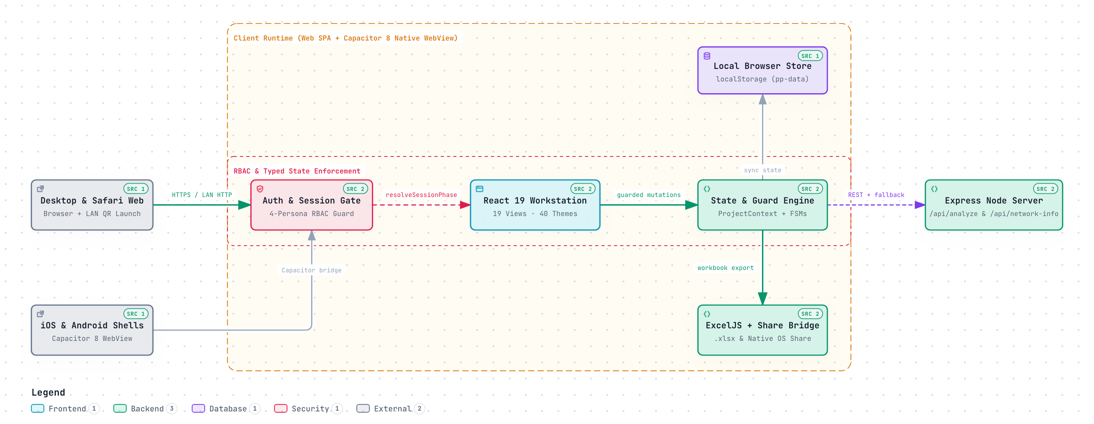
Figure 1 — ProjectPulse 2.0 End-to-End Platform & Module Architecture (Archify Vector Capture)

1.2 Technology Stack & Cross-Platform Matrix
Table 1: ProjectPulse 2.0 Verified Technology Stack
Layer | Technology & Version | Source / Configuration | Architectural Role
Frontend Core | React 19.0.1, TypeScript ~5.8.2 | package.json, src/main.tsx | Component tree, typed state selectors, concurrent UI transitions
Build & Dev Bundler | Vite 6.2.3, esbuild 0.25.0, tsx 4.21.0 | package.json, vite.config.ts | HMR dev bundling and production dist/server.cjs bundling
Styling & Motion | Tailwind CSS 4.1.14, Motion 12.23.24, Lucide 0.546.0 | src/index.css, src/utils/designSpells.ts | CSS variable theming, collapsible strips, View Transitions API circular reveal
Data Viz & Export | Recharts 3.8.1, ExcelJS 4.4.0, date-fns 4.1.0 | src/services/excelService.ts, exportService.ts | Charts, Monte Carlo visuals, multi-worksheet .xlsx workbooks
Mobile Native Shell | Capacitor 8.6.0 (Core, iOS, Android, Filesystem 8.1.5, Share 8.0.3) | capacitor.config.ts, ios/, android/ | Native container, Cache file write, OS Share Sheet handoff
Backend & AI Proxy | Express 4.21.2, @google/genai 1.29.0, uqr 0.1.3 | server.ts, src/services/aiService.ts | POST /api/analyze Gemini proxy, GET /api/network-info LAN discovery

Table 2: Platform Feature Parity Matrix (Web, Mobile Safari QR, iOS, Android)
Capability | Desktop Web | Mobile Safari (QR) | iOS Native (.app) | Android (.apk)
All 6 Journey Hubs & 19 Screens | Full | Responsive Bottom Nav | Responsive Bottom Nav | Responsive Bottom Nav
Excel .xlsx Import & Export | Browser Download | Safari File Sheet | OS Share Sheet (Cache URI) | OS Share Sheet (Cache URI)
Keyboard Chords (G + Key, Cmd+K) | Full | Command Bar Search | External Keyboard / Search | External Keyboard / Search
LAN QR Code Launcher Icon | Visible in Topbar | Hidden / Target Client | Hidden (Native Guard) | Hidden (Native Guard)
Offline LocalStorage Persistence | Full | Full | WebView Persistent Store | WebView Persistent Store
GEMINI_API_KEY AI PulseScan | Via Express Proxy | Via Host LAN Express | Local Fallback unless Hosted | Local Fallback unless Hosted

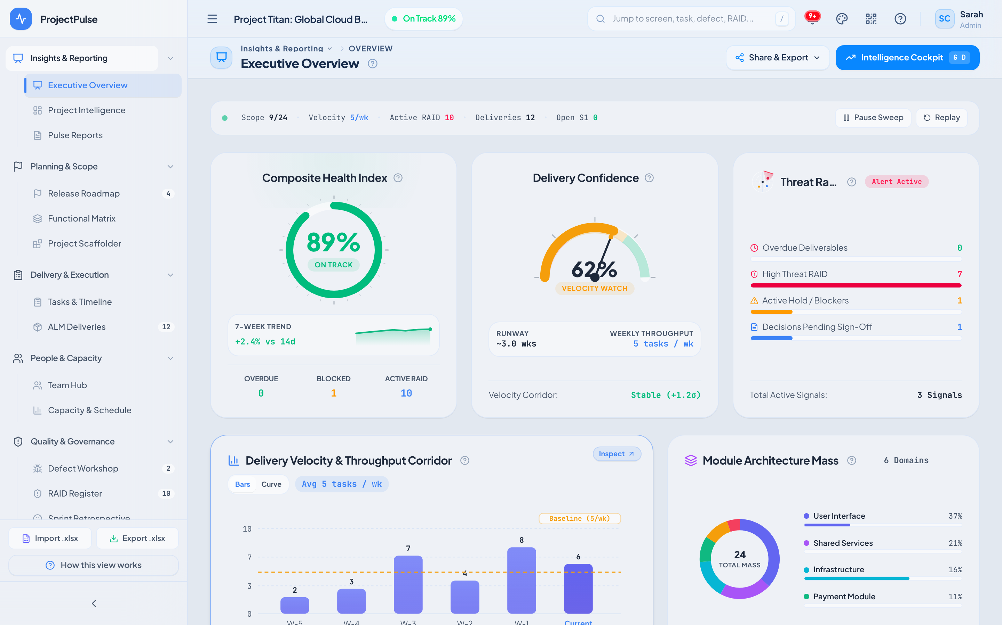
Figure 2 — Executive Overview Screen Running on Desktop Web (Glass Light Theme, 1440x900)
PART II — END-USER MANUAL // SECTION 2

2. Onboarding, RBAC Governance & Navigation System
Access to ProjectPulse 2.0 is governed by a deterministic session phase state machine (resolveSessionPhase) and a four-persona Role-Based Access Control (RBAC) engine defined in src/store/AuthContext.tsx. Users authenticate cleanly without network latency and can initialize workspaces from blank templates, flagship demo datasets, or existing .xlsx workbooks.

2.1 Workspace Onboarding & Session Bootstrapping
Step 1 Persona Selection (Auth Phase: unauthenticated): On initial launch, choose one of four pre-configured enterprise personas: Admin (Full Schema & System Control), Project Manager (Delivery, Resource & Governance Lead), Developer (Task, Defect & Delivery Executor), or Stakeholder (Read-Only Executive Consumer).
Step 2 Setup Mode (Auth Phase: onboarding): When no active project exists in localStorage, SetupView presents three clean paths: Load Flagship Demo (Project Titan: Global Cloud Banking with tasks, deliveries, defects, RAID items, releases, and 10 team members), Import .xlsx Workbook (drop any compatible multi-tab Excel database), or Create Blank Workspace.
Step 3 RBAC Guard & Deep-Link Enforcement: If a user attempts to navigate via hash URL (#/fields or #/settings) to a route excluded from their role's allowedViews, the session resolver enters denied and renders a shielded Access Denied guard with a single-click return to overview.

2.2 RBAC Role Permission & Screen Access Matrix
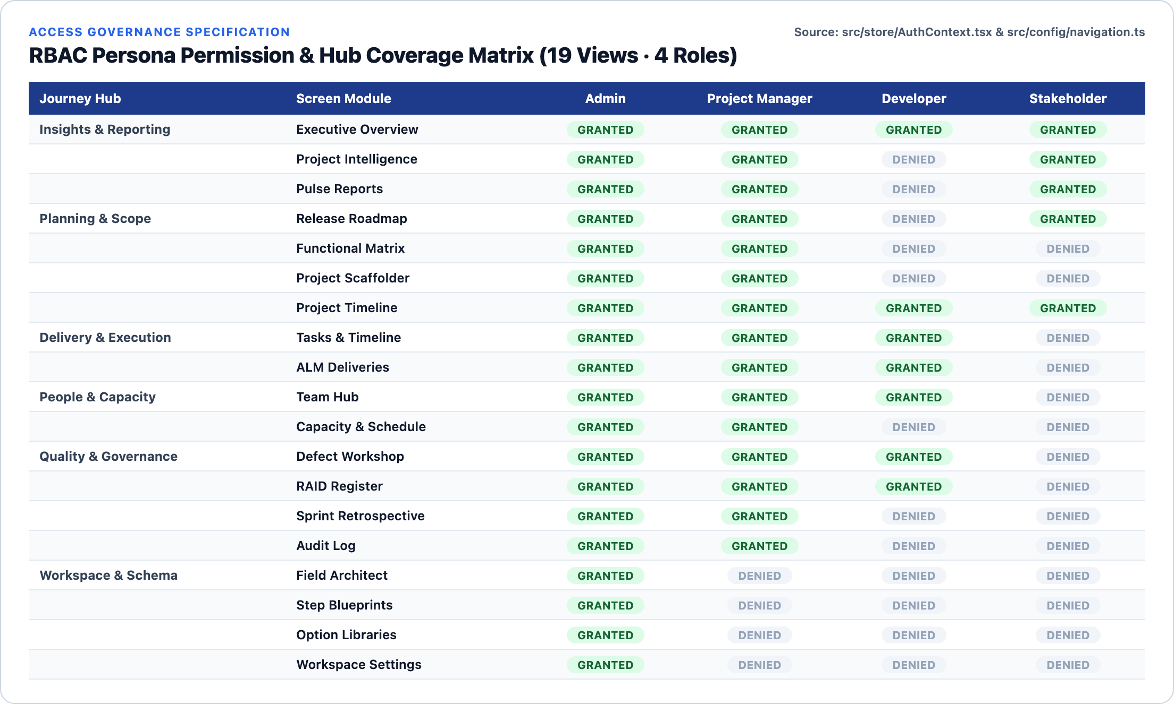
Figure 3 — RBAC Persona Access Coverage Across All 6 Journey Hubs & 19 Screens
Table 3: Role-Based Action Permissions (src/store/AuthContext.tsx)
Permission Flag | Admin | Project Manager | Developer | Stakeholder
canCreateTask | GRANTED | GRANTED | GRANTED | DENIED
canEditTask | GRANTED | GRANTED | GRANTED | DENIED
canDeleteTask | GRANTED | GRANTED | DENIED | DENIED
canManageSettings | GRANTED | DENIED | DENIED | DENIED
canManageUsers | GRANTED | DENIED | DENIED | DENIED
canExportExcel | GRANTED | GRANTED | DENIED | DENIED
canManageDeliveries | GRANTED | GRANTED | GRANTED | DENIED
canManageReleases | GRANTED | GRANTED | DENIED | DENIED
canManageRAID | GRANTED | GRANTED | DENIED | DENIED
Allowed Screen Count | 19 / 19 Views | 15 / 19 Views | 7 / 19 Views | 5 / 19 Views

2.3 Six-Hub Information Architecture & 19 Screen Catalog
ProjectPulse 2.0 consolidates all workflows into six intuitive sidebar Journey Hubs (NAV_HUBS in src/config/navigation.ts). Each module features a standardized PageHeader displaying breadcrumb ancestry, live record counters, collapsible KPI summary strips, Share & Export controls, and contextual help (?).
Table 4: Complete 6-Hub Navigation & Module Inventory
Journey Hub | Screen Module | Route Key | Shortcut | Primary User Purpose
1. Insights & Reporting | Executive Overview | overview | G O | Health dial, release radar, early warning signals, module gravity
1. Insights & Reporting | Project Intelligence | dashboard | G D | Monte Carlo P50/P90, What-If Sandbox, EVM & Velocity charts
1. Insights & Reporting | Pulse Reports | reports | G R | Consolidated reporting, CXO Email Briefing preview & AI narrative
2. Planning & Scope | Release Roadmap | releases | — | 6-phase stage gates, baseline milestone tracking & target sign-off
2. Planning & Scope | Functional Matrix | features | G F | 3-level WBS tree (L1 Module -> L2 Feature -> L3 Screen) & rollout
2. Planning & Scope | Project Scaffolder | scaffolder | — | 2-step wizard converting blueprints & templates directly into WBS tasks
2. Planning & Scope | Project Timeline | timeline | G L | Standalone cross-project Gantt view with dependency arrows & critical path
3. Delivery & Execution | Tasks & Timeline | tasks | G T | Unified execution workspace: DataGrid, Kanban Board & embedded Gantt
3. Delivery & Execution | ALM Deliveries | deliveries | — | PDN deployment matrix, pipeline stages, smoke gates & sign-off ledger
4. People & Capacity | Team Hub | team | — | Roster cards, hierarchical org tree & verified skill tag assignments
4. People & Capacity | Capacity & Schedule | capacity | G C | 8-week heatmap, 5-day scheduler, overload alerts & workload balancing
5. Quality & Governance | Defect Workshop | defects | G B | QA defect triage, severity bands, SLA aging & quick-cycle state stepper
5. Quality & Governance | RAID Register | risks | G K | Risks, Assumptions, Issues, Dependencies & Steering Decision log
5. Quality & Governance | Sprint Retrospective | retro | — | Went Well / To Improve / Action Items board with action item conversion
5. Quality & Governance | Audit Log | log | — | Immutable timestamped changelog covering mutations, imports & sign-offs
6. Workspace & Schema | Field Architect | fields | — | Dynamic schema builder customizing cols, defCols, delCols & custom fields
6. Workspace & Schema | Step Blueprints | steps | — | Reusable delivery/onboarding step checklist templates for scaffolding
6. Workspace & Schema | Option Libraries | dropdowns | — | Centralized dropdown option manager for statuses, modules & environments
6. Workspace & Schema | Workspace Settings | settings | G S | System parameters, 40 themes gallery, baselines, snapshots & RBAC overrides

2.4 Keyboard Shortcuts, Command Palette & Context Help
Power users operate ProjectPulse without touching the mouse via a deterministic two-key chord state machine (1200ms G-chord timeout window) and instant Command Bar search.
Table 5: Global Keyboard Shortcuts & Command Palette Bindings (src/config/viewHelpData.ts)
Key Binding | Category | Triggered Action
/ or Cmd+K | Navigation | Focus Global Search & Quick-Jump across screens, tasks, defects, and RAID items
G then O / D / R | Navigation | Chord jumps to Executive Overview (O), Intelligence Cockpit (D), or Pulse Reports (R)
G then T / L / F | Navigation | Chord jumps to Tasks Matrix (T), Gantt Timeline (L), or Functional Matrix (F)
G then C / B / K / S | Navigation | Chord jumps to Capacity (C), Defect Workshop (B), RAID Register (K), or Settings (S)
Cmd+E / Ctrl+E | Actions | Generate & export full multi-worksheet .xlsx Excel workbook (respects RBAC)
F1 or ? | Dialogs | Open contextual View Help Modal including Dynamic Merged Field Reference Guide
Esc | Dialogs | Dismiss open modal, flyout drawer, Command Bar results, or alert panel
Double-Click Cell | Actions | Activate quick inline edit in supported spreadsheet table cells

PART II & III — ANALYTICS & SPEC // SECTION 3

3. Insights, Executive Overview, Intelligence Cockpit & Reports
Hub 1 (Insights & Reporting) transforms raw operational entities—tasks, subtasks, deliverables, defects, and RAID logs—into weighted health indices, Monte Carlo schedule forecasts, Earned Value telemetry, and executive-ready CXO email briefings.

3.1 Weighted Health Score Penalty Model
Unlike naive task-completion percentages that hide critical slippage behind low-priority work, ProjectPulse calculates real-time health in src/utils/projectUtils.ts using normalized active-backlog deductions across three risk vectors: Overdue tasks (-50 max weight), Blocked dependencies (-30 max weight), and On-Hold stalls (-20 max weight).
FORMULA SPECIFICATION // getHealthScore(tasks) — src/utils/projectUtils.ts (Lines 78–100)
Active = { t in tasks | t.status != 'Completed' AND t.status != 'Cancelled' }
If |Active| == 0 => HealthScore = 100
Score = 100 - (Overdue / |Active|) * 50 - (Blocked / |Active|) * 30 - (OnHold / |Active|) * 20
HealthScore = clamp(round(Score), 0, 100)
Where Overdue = active tasks with daysDiff(t.dueDate) < 0; Blocked = active tasks with >= 1 unfinished predecessor in dependsOn; OnHold = tasks with status === 'On Hold'.
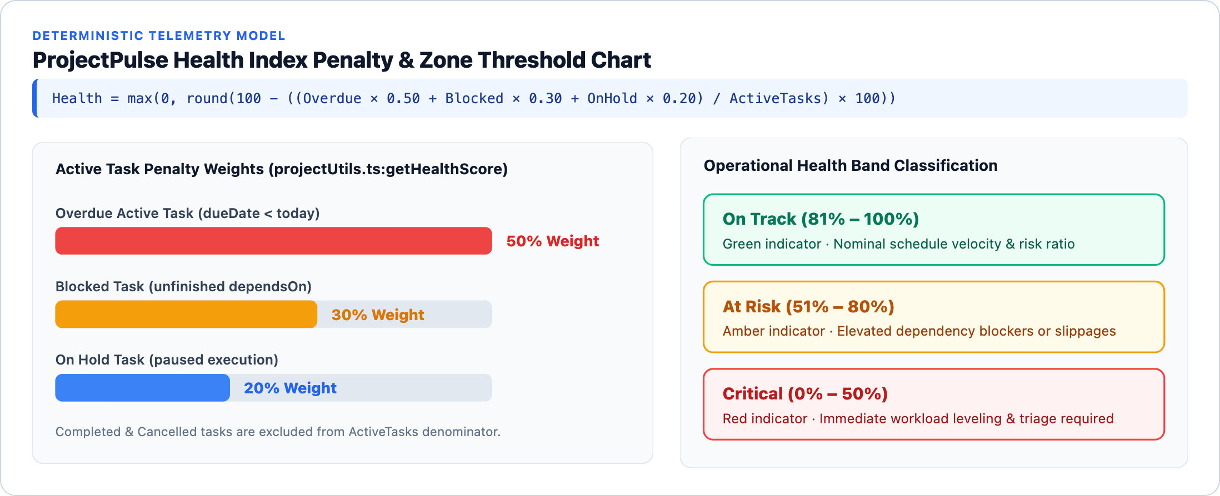
Figure 4 — Health Score Penalty Model & Delivery Risk Weights

3.2 Project Intelligence Cockpit: Monte Carlo, What-If & EVM
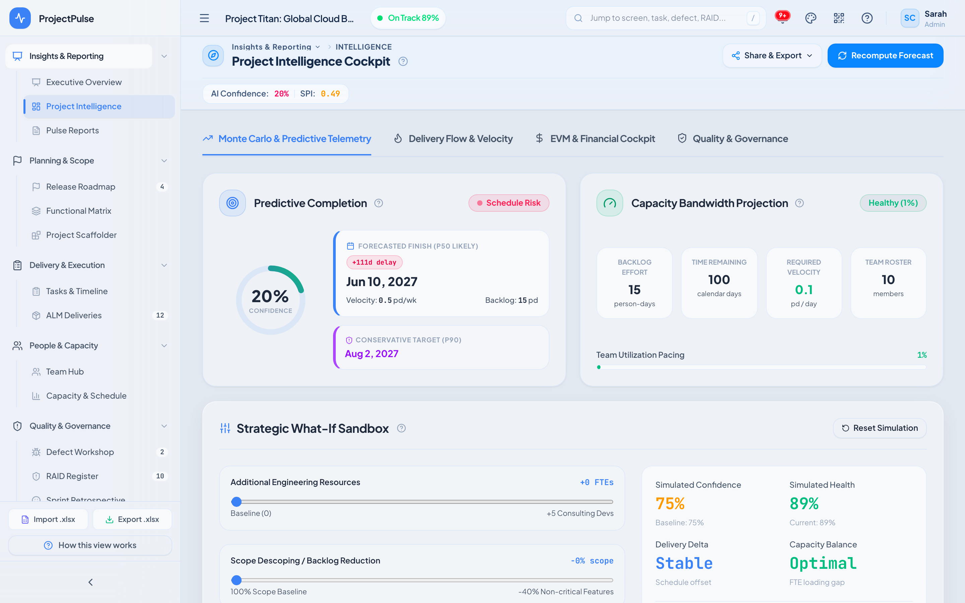
Figure 5 — Project Intelligence Cockpit — Monte Carlo Predictive Completion & Strategic What-If Sandbox
- Predictive Completion (P50 / P90): Computes backlog remaining in person-days, measures rolling weekly burn velocity, and surfaces both Likely (P50) and Conservative (P90) completion dates plus schedule slip deltas.
- Strategic What-If Sandbox: Interactive simulation sliders allow project managers to model adding +0 to +5 consulting FTEs or descoping 0%–40% of non-critical features, updating Simulated Confidence, Health, and Capacity Balance live without mutating committed baseline data.
- Four Deep-Dive Telemetry Tabs: Navigate cleanly between Monte Carlo & Predictive Telemetry, Delivery Flow & Velocity (CFD & Burnup/Burndown), EVM & Financial Cockpit (SPI, CPI, PV/EV/AC variance), and Quality & Governance.

3.3 Pulse Reports, CXO Email Briefing & Gemini AI PulseScan
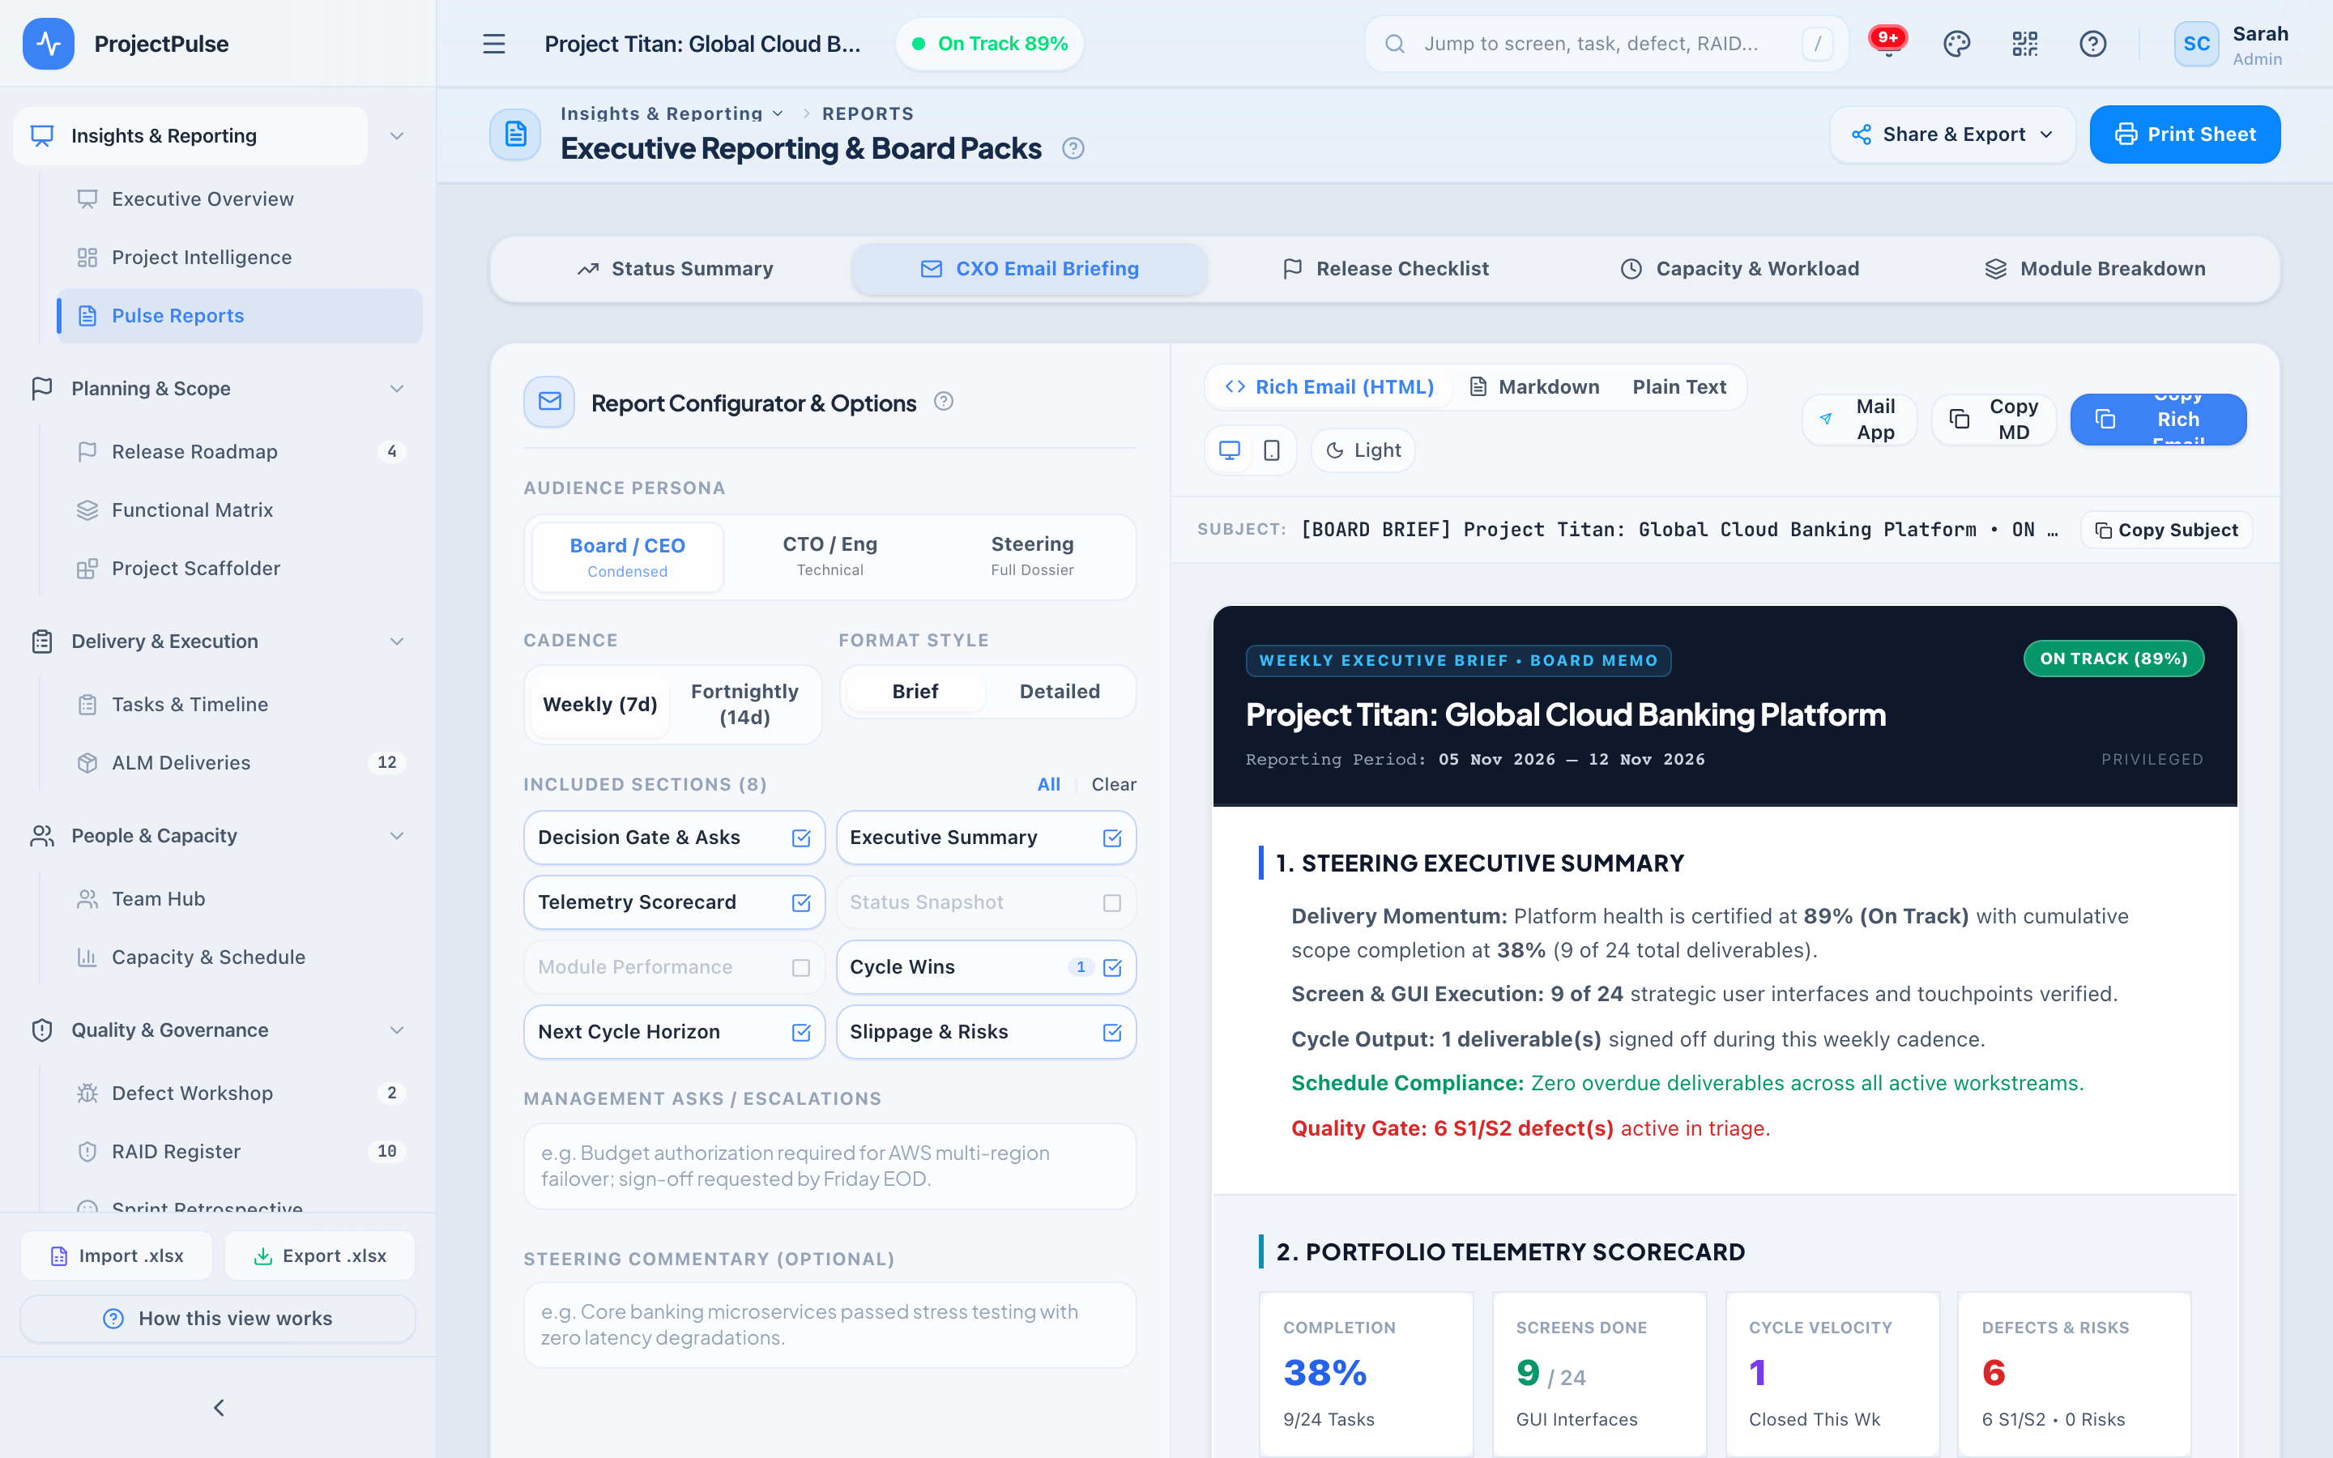
Figure 6 — Pulse Reports & Structured CXO Email Briefing Composer
Pulse Reports pairs deterministic analytics with one-click stakeholder communication. Leaders can trigger AI Executive PulseScan (POST /api/analyze backed by Gemini gemini-3-flash-preview) or fall back seamlessly to local heuristic diagnosis when offline or unconfigured. The CXO Email Briefing builder composes a crisp, copy-ready executive summary covering health status, top active milestones, open S1/S2 blockers, and governance actions.
PART II — PLANNING WORKFLOWS // SECTION 4

4. Planning, Scope, Release Roadmap & Functional Matrix
Hub 2 (Planning & Scope) links strategic executive releases down to modular Functional Matrix features, individual screens, and auto-generated execution tasks via a structured 3-tier Work Breakdown Structure (WBS).
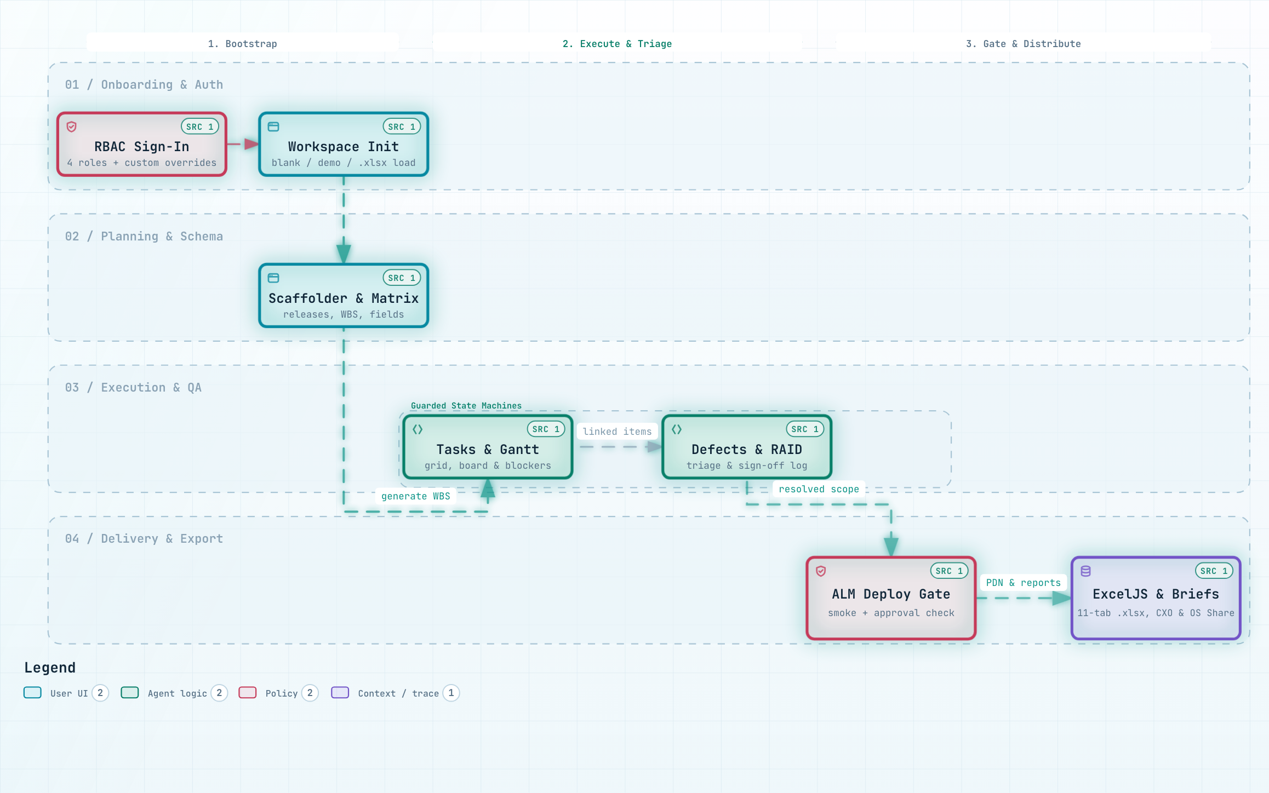
Figure 7 — End-to-End User & Data Governance Workflow Across All Four Operational Stages

4.1 Release Roadmap & 6-Phase Lifecycle Pipeline
Release records follow a strict 6-phase monotonic pipeline managed in src/utils/stateMachines.ts:

4.2 Functional Matrix (3-Level WBS) & Inline Feature Intelligence
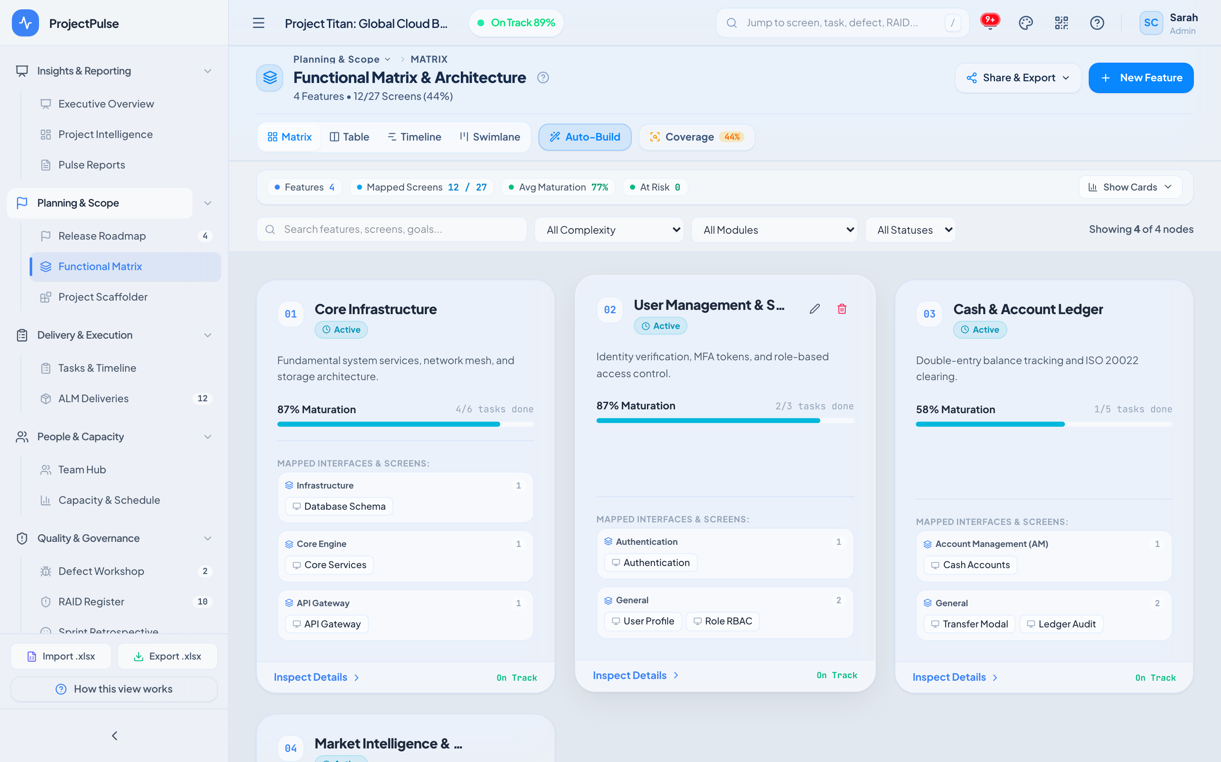
Figure 8 — Functional Matrix — 3-Level Traceability Tree & Feature Rollout Controls
- Hierarchy Levels: L1 Module (e.g., Core Engine, Authentication, Market Data) -> L2 Feature with priority & target release -> L3 Screen with build/design/test status tracking.
- Rollup Metrics: Parent modules dynamically aggregate feature counts, linked tasks, linked defects, and completion readiness.
- Task Scaffolder Integration: Selecting any Step Blueprint in Project Scaffolder expands standardized engineering, QA, and deployment checklists into actionable Tasks with aligned module tags and due-date offsets.
PART II — EXECUTION MANUAL // SECTION 5

5. Delivery, Execution, Gantt Timeline & ALM Pipeline
Hub 3 (Delivery & Execution) houses day-to-day engineering velocity across two tightly integrated modules: Project Tasks Matrix (with Grid, Kanban Board, and Gantt Timeline sub-modes) and ALM Deliveries (managing Production Delivery Notes — PDNs — through gated environment deployments).

5.1 Tasks Matrix, Collapsible KPI Strip & Three Execution Views
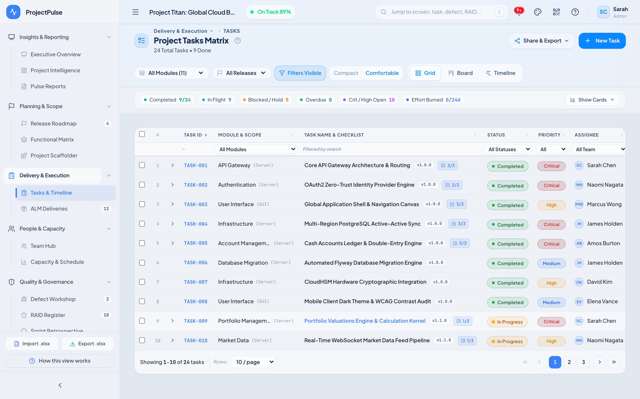
Figure 9 — Project Tasks Matrix (Grid Mode with Minimized Pill KPI Bar & Inline Progress Controls)
To preserve vertical viewport real estate for data-heavy grids and timelines, Tasks, Deliveries, and Capacity feature a shared CollapsibleSummaryStrip component. By default, high-level KPI metrics render as a single sleek horizontal summary pill bar showing live totals (Completed, In Flight, Blocked / Hold, Overdue, Crit/High Open, Effort Burned). Clicking 'Show Cards' smoothly animates open the full KPI card deck on demand.

5.2 Interactive Gantt Timeline & Dependency Guarding
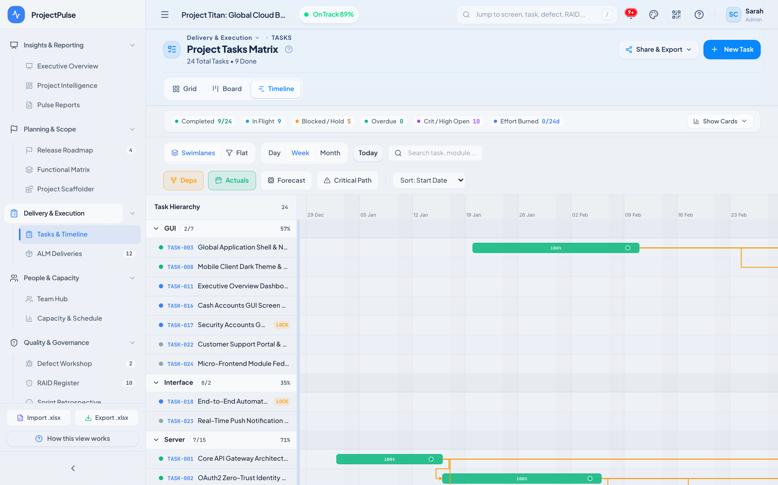
Figure 10 — Tasks Timeline (Gantt Mode) with Module Swimlanes, Dependency Connectors & Lock Indicators
GUARD & GOVERNANCE RULE: Hard Dependency State Guard (resolveTaskTransition)
When a task specifies unfinished predecessor IDs in dependsOn, attempting to promote it from Not Started to In Progress, Review, or Completed via Kanban drag-and-drop or Task Grid is blocked deterministically with an explicit toast listing the blocking task IDs.
Conversely, moving a task to Completed automatically forces progress = 100 and stamps actualDate to today if unset; parent tasks dynamically compute weighted progress rollups from subtasks via computeSubtaskRollup.

5.3 ALM Deliveries & 4-Axis Deployment Release Gate
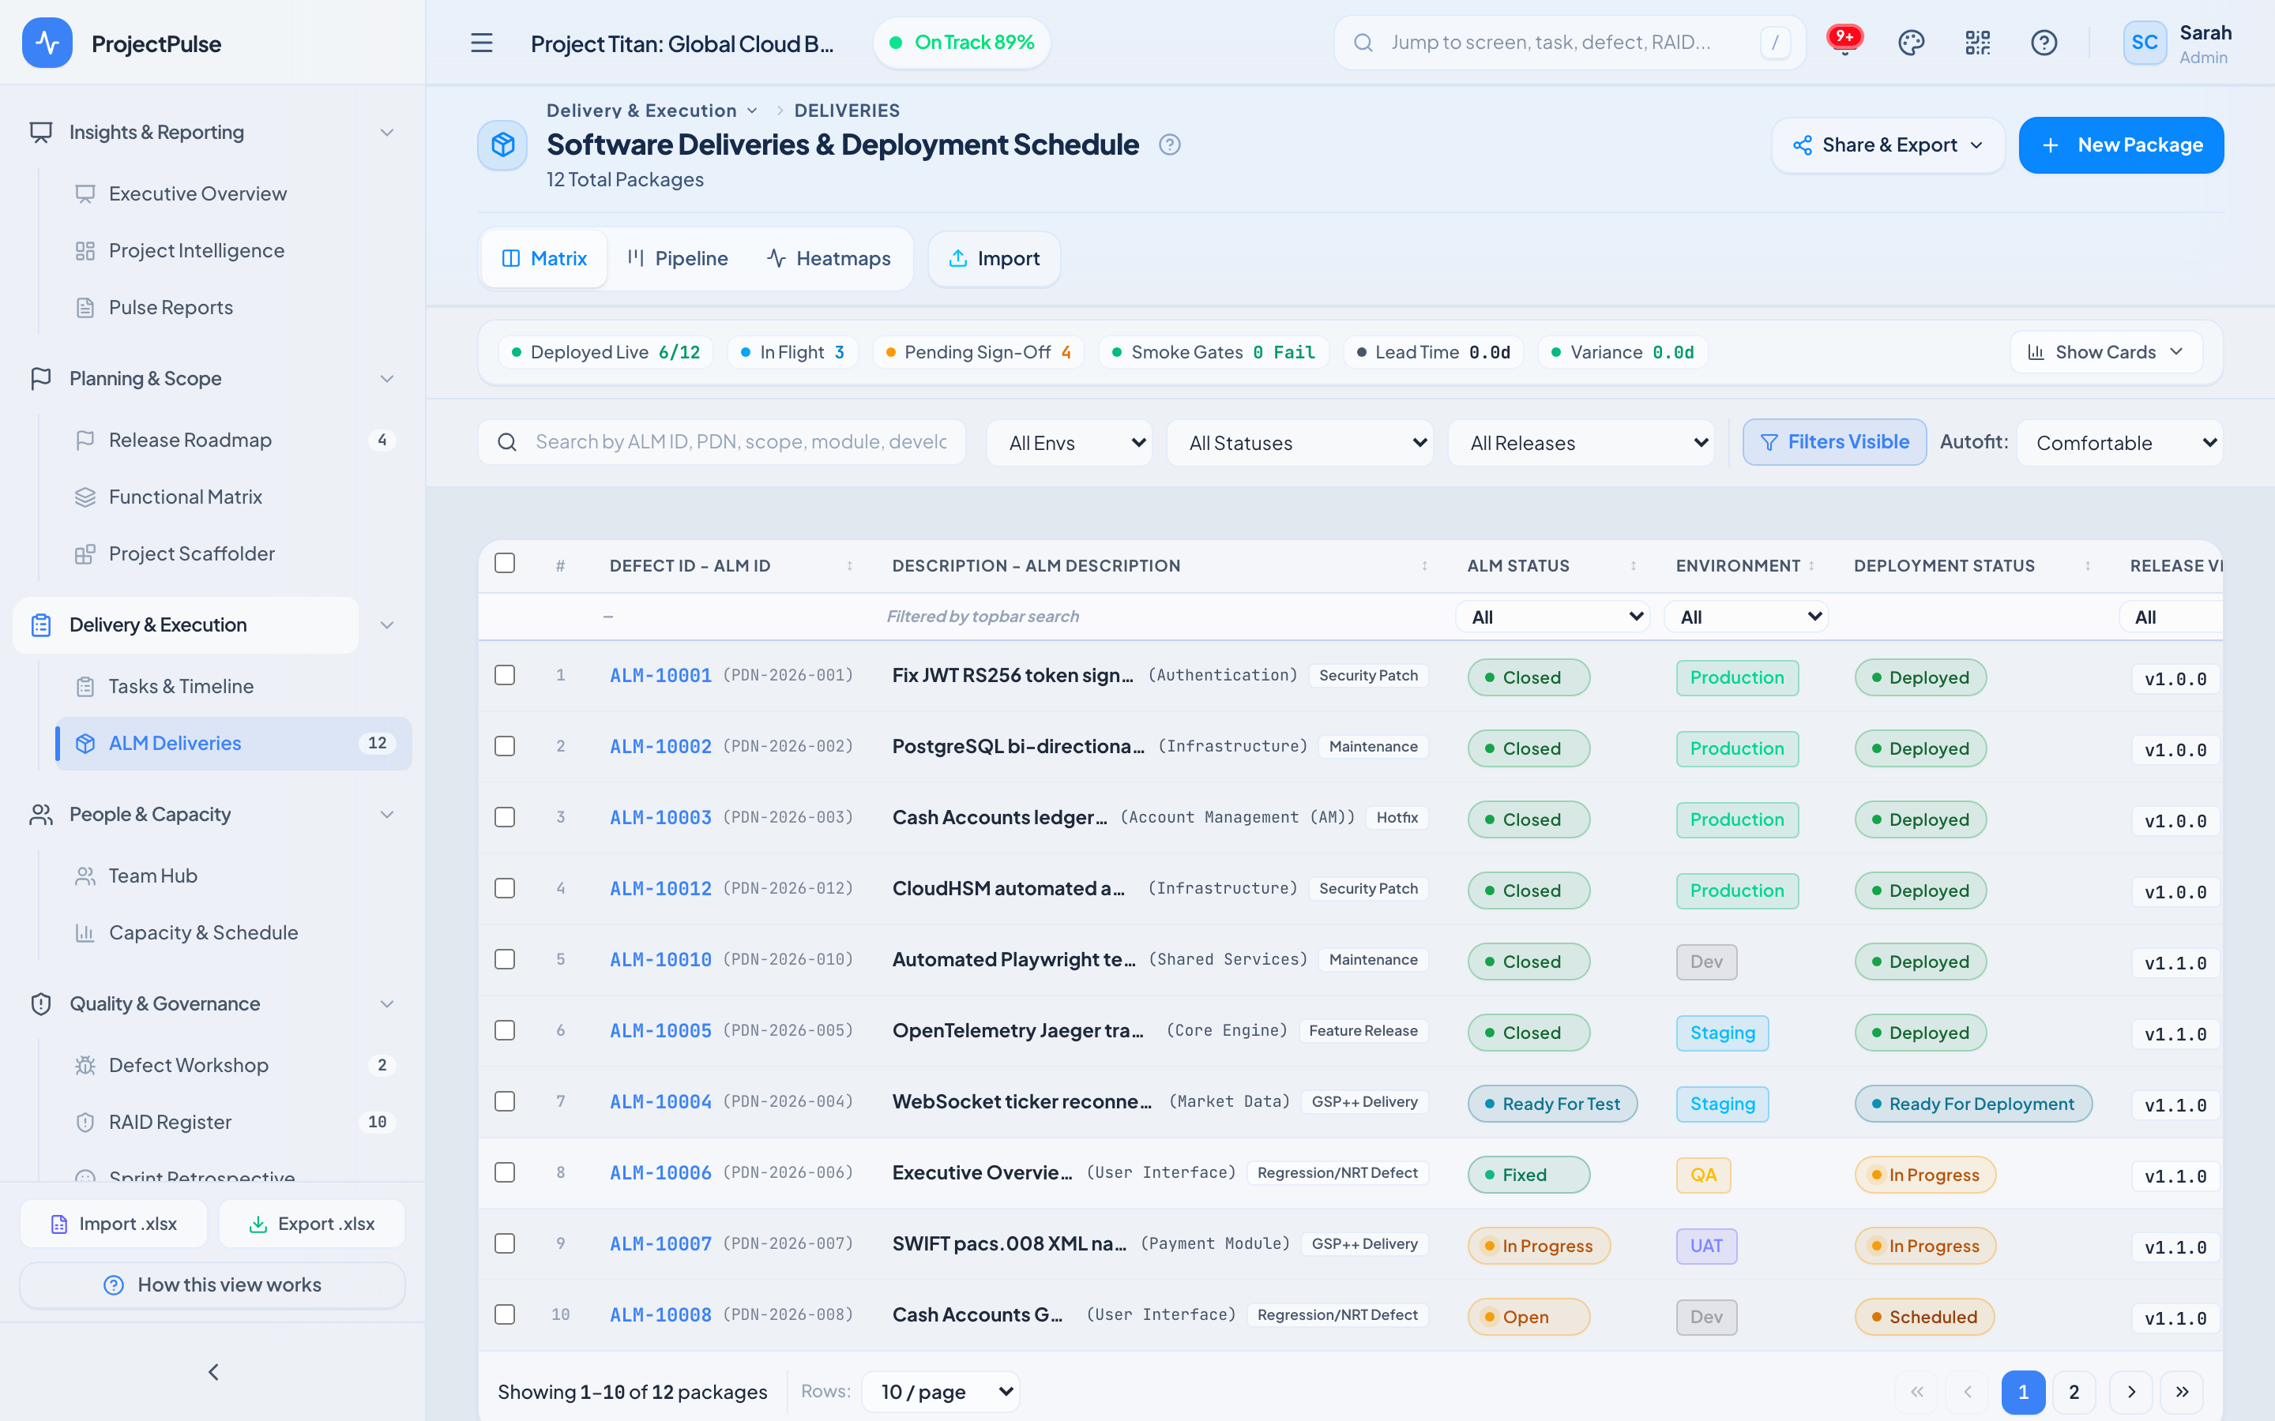
Figure 11 — Software Deliveries & Deployment Schedule (PDN Pipeline Matrix)
Every ALM Delivery package tracks four orthogonal quality and governance axes:
INVARIANT / SECURITY GATE: ALM Deployment Stage Gate (transitionDeliveryStage)
A package CANNOT transition into Deployed if signOffStatus === 'Rejected' OR smokeTestStatus === 'Failed'. Upon passing all checks and promoting to Deployed, the FSM enforces an invariant cascade setting almStatus = 'Closed' and smokeTestStatus = 'Passed' unless already signed off.
PART II — RESOURCE MANAGEMENT // SECTION 6

6. People, Team Hub & 5-Day Resource Capacity Scheduler
Hub 4 (People & Capacity) aligns human bandwidth with sprint commitments. Effort estimates on active tasks distribute linearly across working days (Mon–Fri, configurable 1–7 workdays and Cap/Wk hours/days) over an 8-week rolling window.
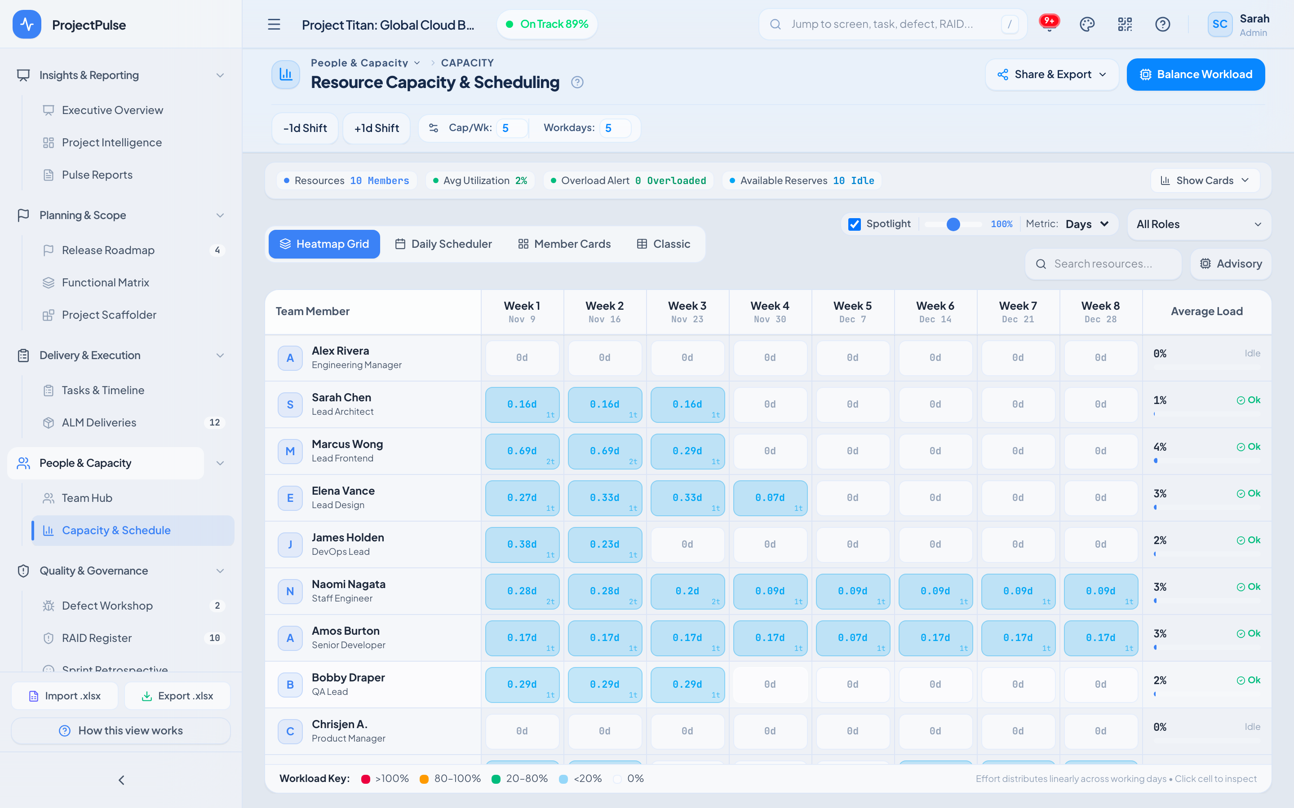
Figure 12 — Resource Capacity & Scheduling — 8-Week Heatmap Grid & Interactive Spotlight
Table 6: Capacity Utilization Color Bands & Overload Classification
Utilization Threshold | Badge Hue | Operational Classification | Recommended Action
0% (0.00d) | Neutral Mist | Idle / Available Reserve | Candidate for new feature scaffolding or balancing intake
1% to <20% | Ice Blue | Light Allocation | Safe buffer capacity for ad-hoc defect triage
20% to 80% | Emerald Green | Optimal Sustainable Band | Balanced engineering cadence; maintain baseline
80% to 100% | Amber Warning | High Load / Near Saturation | Avoid concurrent critical-path assignments
> 100% | Rose Critical | Overload Alert Triggered | Click 'Balance Workload' or open Advisory Drawer to shift due dates

Four coordinated sub-modes operate seamlessly inside CapacityView:
PART II — GOVERNANCE MANUAL // SECTION 7

7. Quality, Defect Workshop, RAID Register & Governance
Hub 5 (Quality & Governance) enforces engineering rigor through four auditable ledgers: Defect Workshop, RAID & Decision Register, Sprint Retrospective, and the immutable Audit Log.
Table 7: Governance Entity Workflows & Normalization Rules
Governance Module | Explicit States & Cycle | Automatic Normalization & Side Effects
Defect Workshop | New -> Assigned -> In Progress -> Fixed -> Retest -> Closed (or Deferred) | Reopen flow resets Reopen count, stamps updated log entry, and recalculates Severity SLA urgency
RAID Register | Identified -> Active -> Mitigated -> Closed -> Realized | normRaidImpact() & normRaidProb() normalize S1/S2/Critical -> High and S4/Minor -> Low for score sorting
Steering Decisions | Pending Sign-off -> Approved | Rejected | Appealed | Linked to RAID entries; Rejected decisions surface escalation warnings in Executive Overview
Sprint Retro | Categories: Went Well | To Improve | Action Items (Status: Open -> Completed) | One-click 'Promote to Task' converts retrospective action items directly into tracked backlog tasks
Audit Log | Append-only chronological mutation stream | Records timestamp, actor persona, action verb, target entity ID, and Excel/Snapshot events

PART II & III — CONFIGURATION // SECTION 8

8. Workspace Customization, Field Architect & 40-Theme Engine
Hub 6 (Workspace & Schema) empowers workspace Administrators to tailor the schema, reusable templates, option lists, snapshots, and visual identity of ProjectPulse 2.0 without modifying application source code.
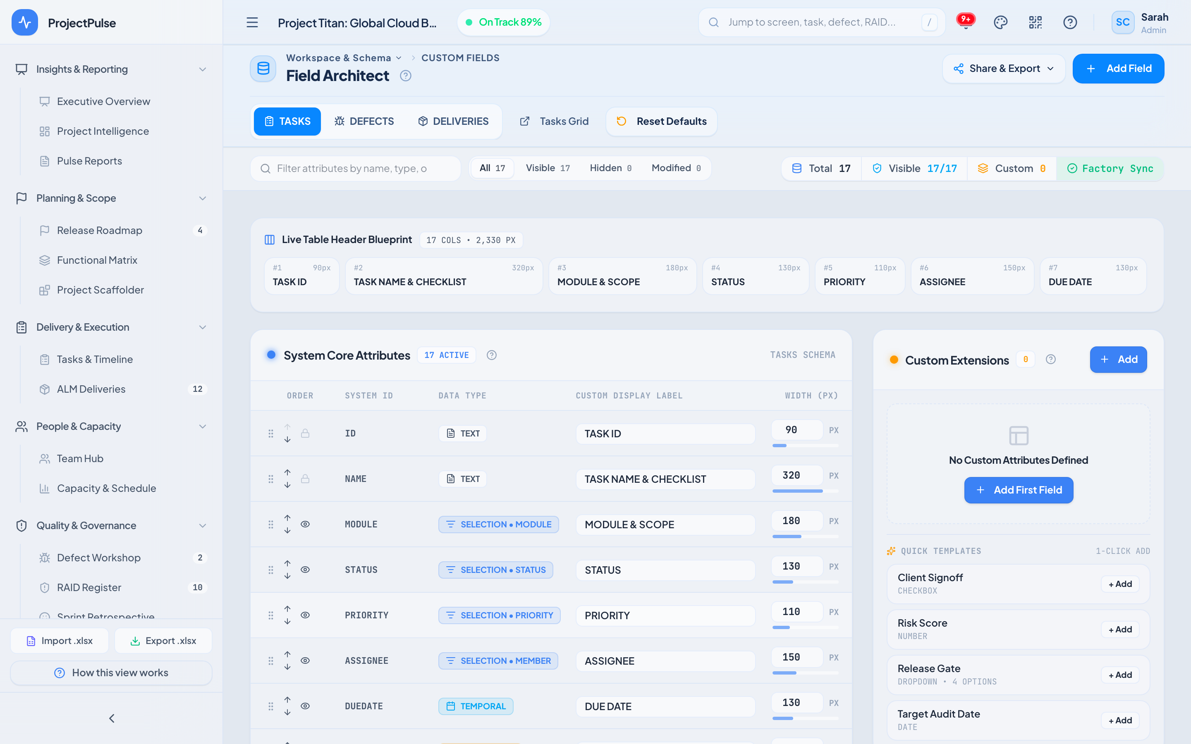
Figure 13 — Field Architect Schema Studio — Custom Field Definitions & Domain Mapping

8.1 Dynamic Field Architect & Merged Contextual Help
Columns configured in Field Architect (standard overrides across state.cols, state.defCols, state.delCols plus custom fieldDefinitions) propagate immediately into Task Grids, Deliveries Tables, Excel exports, AND the View Help Modal via getMergedFieldGuide()—ensuring documentation inside the app always matches live schema reality.

8.2 Forty Built-In Themes, WCAG Contrast & View Transitions Spell
SettingsView exposes 40 curated light and dark themes across eight visual backdrop archetypes: clean, glass, dots, aura, hud, brutal, editorial, and bento (verified in src/components/shared/ThemeGrid.tsx). Each theme preview renders live mini-metrics using its exact palette, typography (Inter, Plus Jakarta Sans, Fraunces, Outfit, Syne, Satoshi), border radius (0px brutalist to 16px glass), and backdrop effect.
FORMULA SPECIFICATION // getContrastInk(hex) & runCircularThemeTransition() — ThemeGrid.tsx / designSpells.ts
Relative Luminance: L = 0.2126 * lin(R) + 0.7152 * lin(G) + 0.0722 * lin(B)
Foreground Ink = (L > 0.36) ? '#09090b' : '#ffffff'
Animation: document.startViewTransition() -> clip-path circle(0 -> R at clickXY)
Guarantees accessible foreground ink across extreme bright accents (e.g., Brutalist #f0ff00, Obsidian #00ff7f, Pulse #38BDF8) while animating theme switches smoothly at 60fps from pointer coordinates.
PART III — TECHNICAL SPECIFICATION // SECTION 9

9. Data Architecture, State Machines & ExcelJS Specification
ProjectPulse 2.0 replaces implicit ad-hoc flag combinations with a deterministic reactive state pipeline. Every mutation—whether triggered from UI drag-and-drop, inline spreadsheet editing, wizard generation, or Excel import—routes through centralized validation and finite state machine (FSM) guards prior to committing into ProjectContext and flushing to localStorage.
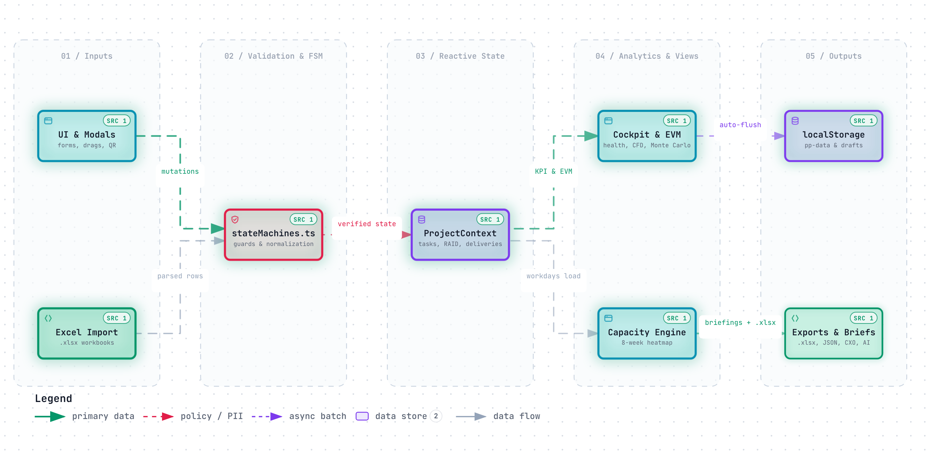
Figure 14 — Reactive Data Flow: Inputs -> stateMachines.ts -> ProjectContext -> Telemetry & Exports
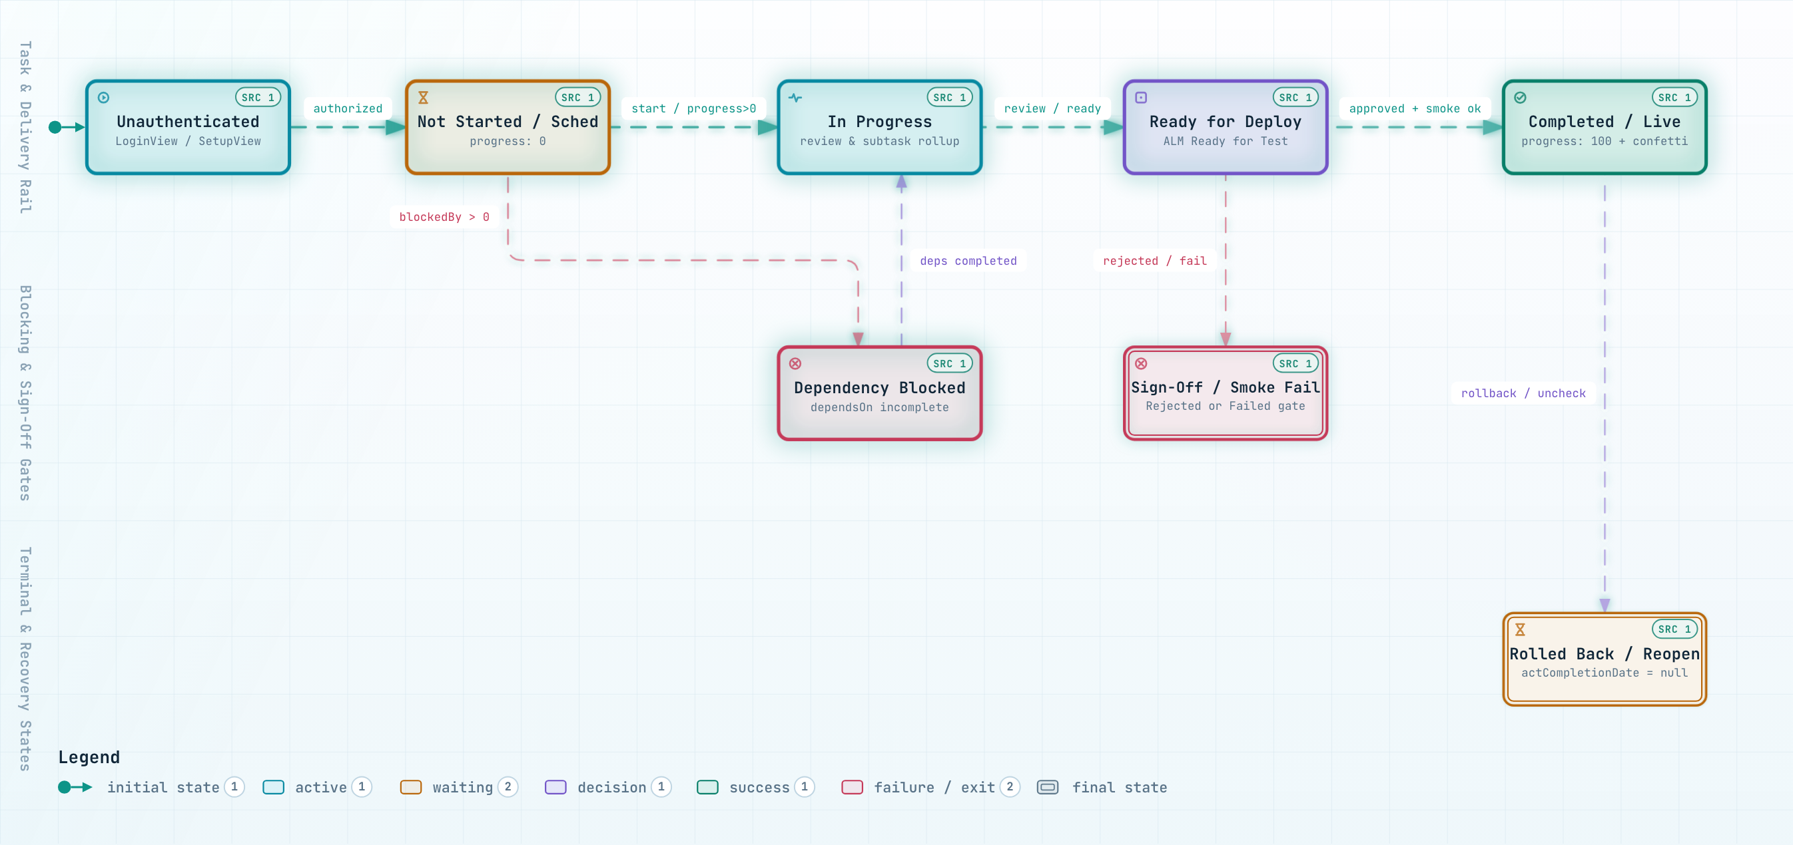
Figure 15 — Entity Lifecycle Architecture: Explicit State Machines & Multi-Stage Gate Transitions

9.1 Complete Inventory of 13 Explicit Finite State Machines
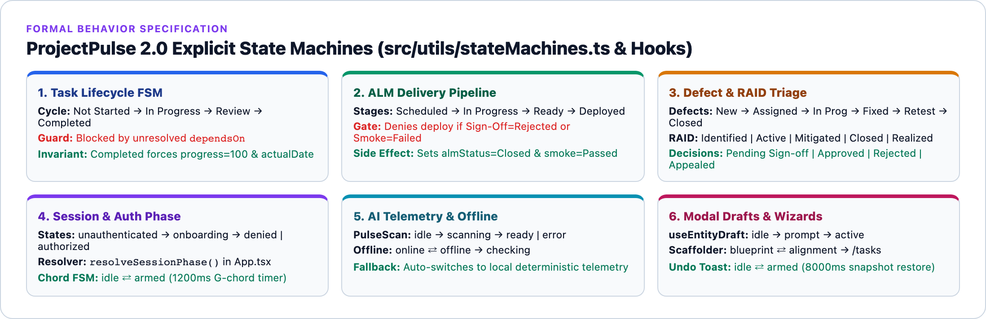
Figure 16 — Six Primary State Machine Domains Covered Across 13 Explicit Implementations
Table 8: Formal Specification of All 13 Explicit State Machines
# | State Machine | Source Module | Explicit States & Guard / Invariant
01 | Task Lifecycle FSM | stateMachines.ts | Not Started -> In Progress -> Review -> Completed (+ On Hold, Cancelled). Guarded by unfinished dependsOn.
02 | Subtask Rollup FSM | stateMachines.ts | Maps sibling subtask counts & percentages via computeSubtaskRollup() into deterministic parent progress.
03 | ALM Delivery Pipeline | stateMachines.ts | Scheduled -> In Progress -> Ready -> Deployed. Hard gate blocks Deployed on Sign-Off=Rejected or Smoke=Failed.
04 | ALM Defect Status Cycle | stateMachines.ts | New -> Assigned -> In Progress -> Fixed -> Retest -> Closed (+ Deferred) via DEFECT_QUICK_CYCLE.
05 | RAID Item Lifecycle | stateMachines.ts | Identified -> Active -> Mitigated -> Closed -> Realized with probability/impact normalization.
06 | Steering Decision FSM | stateMachines.ts | Pending Sign-off -> Approved | Rejected | Appealed with explicit transition whitelist.
07 | Release Stage Pipeline | stateMachines.ts | Planned -> Dev -> QA -> UAT -> Live -> Completed (+ Delayed exception loop).
08 | Retro Item Action Cycle | stateMachines.ts | Open <-> Completed toggle with optional backlog Task promotion.
09 | Auth & Session Phase | stateMachines.ts, App.tsx | unauthenticated -> onboarding -> denied | authorized computed cleanly via resolveSessionPhase().
10 | AI PulseScan Async FSM | aiService.ts, Overview/Reports | idle -> scanning -> ready | error with automatic deterministic offline fallback.
11 | Connectivity Probe FSM | OfflineBanner.tsx | online <-> offline -> checking triggered via browser network events & retry heartbeat.
12 | Entity Draft Restoration | useEntityDraft.ts | idle -> prompt -> active managing unsaved modal recovery without accidental overwrite.
13 | Keyboard Chord & Undo Toast | useGlobalShortcuts / ProjectContext | G-chord: idle <-> armed (1200ms); Undo Snapshot Toast: idle <-> armed (8000ms snapshot restore).

9.2 ExcelJS Multi-Tab Workbook Schema & Hybrid Save Sequence
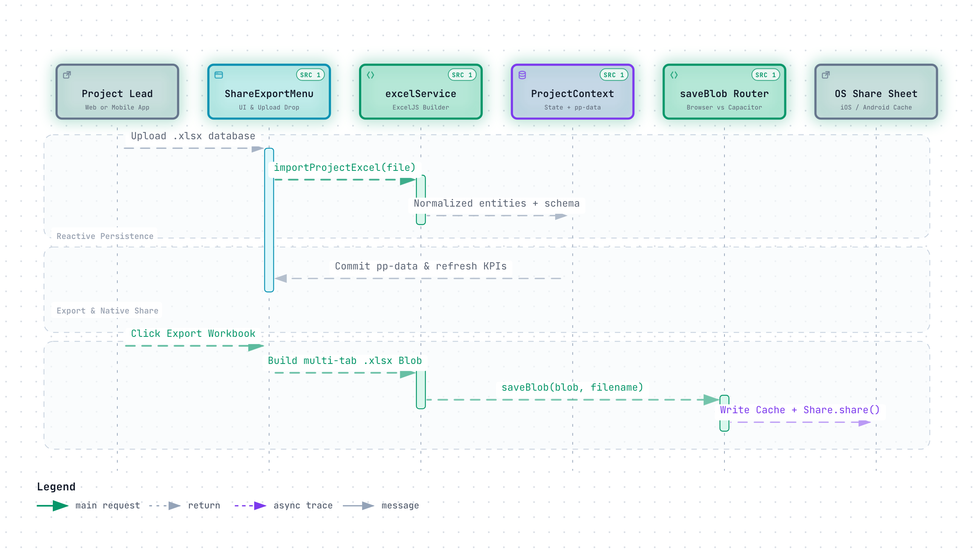
Figure 17 — Round-Trip ExcelJS Import/Export & Capacitor Native OS Share Sequence
Table 9: ExcelJS Generated & Supported Import Worksheets (src/services/excelService.ts)
Worksheet Name | Generator / Scope | Key Columns & Structural Highlights
Executive Dashboard | Full Workbook Export | Formatted top KPI summary cards, Health score, release milestone status, module breakdown
Tasks & Subtasks | Unified Outline Export | Collapsible outline hierarchy combining parent tasks, dependent IDs, effort, and subtask rollups
Feature Rollouts | Matrix Export | L1/L2/L3 feature readiness, build status, target release mapping, linked defect counts
Release Plan | Roadmap Export | Phase gates, target dates, sign-off status, and milestone risk indicators
Feature Details & Traceability Matrix | Detailed Matrix Workbook | Screen-level design/build/test status plus 3-tier Feature & Screen Traceability outline
Deliveries & Deliveries_Template | PDN Pipeline Export | ALM ID, PDN tag, environment, deployment status, smoke gate, sign-off, variance, template
Defects / RAID Items / Decisions | Governance Export | Structured governance tables with status badges, impact/probability normalized columns
Team Members / Data Dictionary / Audit Logs | Workspace Metadata | Roster capacities, Field Architect schema dictionary, chronological activity history

ARCHITECTURE NOTE: Hybrid Export Routing (saveBlob in src/utils/projectUtils.ts)
When executing in a desktop or mobile web browser, saveBlob(blob, filename) creates an ephemeral object URL and triggers a download anchor. Inside Capacitor iOS/Android shells (Capacitor.isNativePlatform() === true), saveNativeBlob() converts the binary payload to Base64, writes it to Directory.Cache via @capacitor/filesystem, and opens the native iOS UIActivityViewController or Android Share Sheet via @capacitor/share.
PART III — DEPLOYMENT & APPENDIX // SECTION 10

10. Mobile Ecosystem, Safari QR Launcher & Build Verification
ProjectPulse 2.0 delivers first-class native binaries for iOS and Android alongside a seamless zero-install Desktop-to-Safari QR handoff for rapid stakeholder reviews on local Wi-Fi networks.
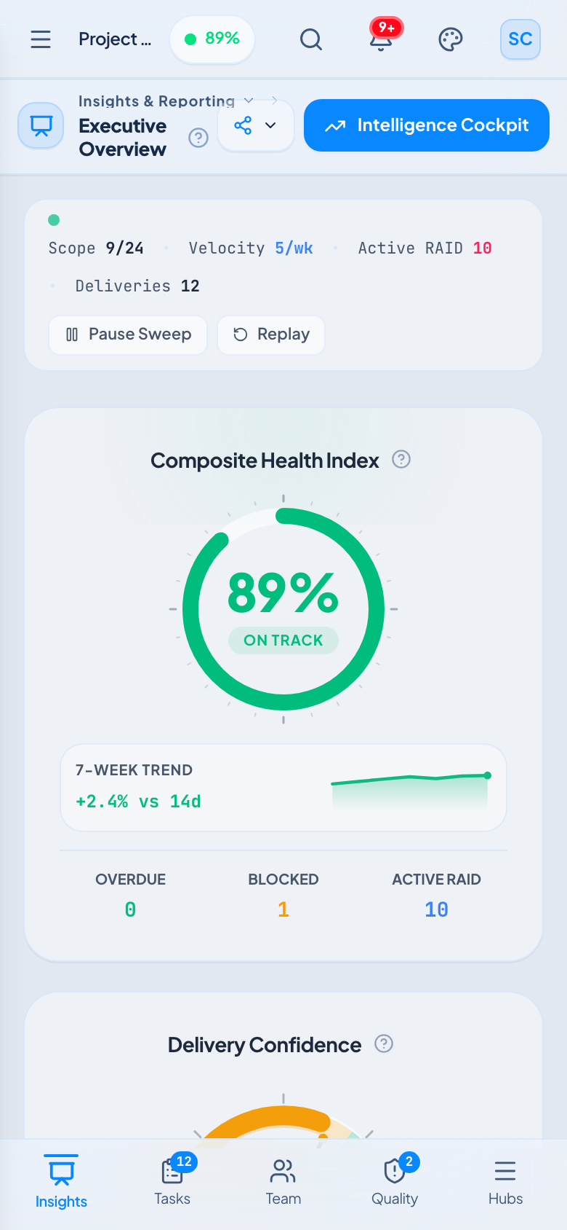  Mobile Web Responsive Viewport (390x844) | 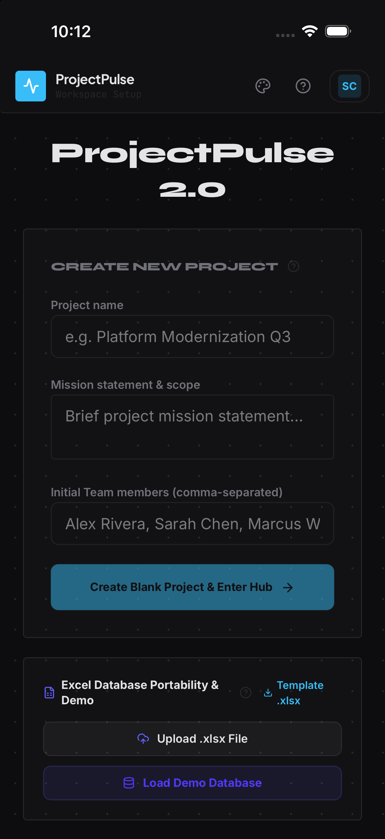  Native iOS Simulator (ProjectPulse.app — iOS 26.2)
Figure 18 — Responsive Mobile Web vs Native Capacitor iOS Runtime Parity

10.1 Desktop-to-Mobile Safari QR Code Launcher
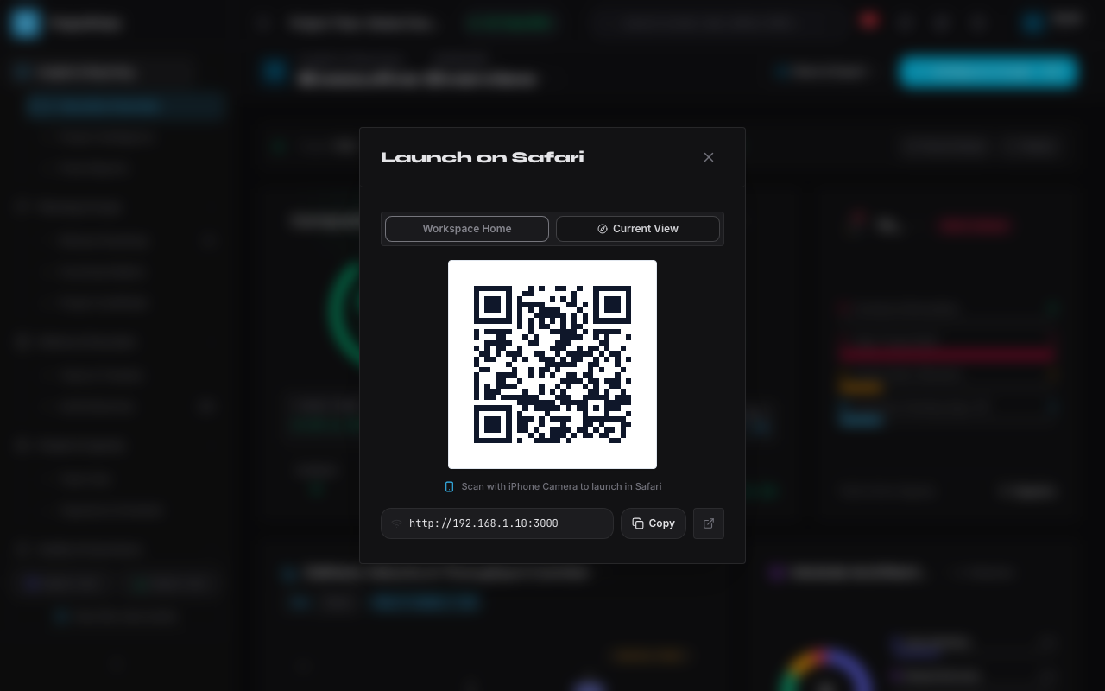
Figure 19 — Desktop Topbar QR Modal Auto-Discovering LAN Wi-Fi URLs via GET /api/network-info
- Loopback Detection & LAN Discovery: When opened on localhost or 127.0.0.1, MobileLaunchQrModal queries GET /api/network-info on the Node/Express server, which ranks active IPv4 non-internal interfaces (prioritizing en0/wlan/eth and 192.168.x.x subnets) into copyable, scannable URLs.
- Target Mode Switch (Home vs Current View): Users can toggle between launching the root workspace or deep-linking directly to their active hash route (e.g., #/tasks or #/intelligence).
- Zero-Dependency QR Encoding: Generated locally in-browser as crisp inline SVG matrices via uqr without calling external QR image APIs.

10.2 Capacitor 8.6 Native Build Artifacts & Verification Appendix
Table 10: Verified Native Mobile Build Targets & Distribution Artifacts
Target Platform | Build Output & Path | SDK / Toolchain Spec | Verification & Signing Notes
Android Debug APK | ProjectPulse-v2.0.0-debug.apk (6.2 MB) | Capacitor Android 8.6.0, minSdk 24, targetSdk 36 | Built via ./android/gradlew assembleDebug; v2 debug-signed for instant sideload
Android Release APK | ProjectPulse-v2.0.0-release-unsigned.apk (5.0 MB) | Gradle assembleRelease (Unsigned) | Ready for organization keystore signing (jarsigner / apksigner)
iOS Simulator App | ProjectPulse.app (Debug x86_64/arm64) | Xcode 26.2, iOS 26.2 Simulator SDK, Swift SPM | Verified clean launch on iPhone 17 Pro Simulator with native bottom inset handling
iOS Device Archive | ProjectPulse.app (Release-iphoneos) | Xcode iphoneos SDK (Unsigned SPM) | Ready for enterprise Apple Developer provisioning profile archival into .ipa

Table 11: Developer & Operator Build Runbook Commands (package.json)
NPM / Shell Command | Execution Scope | Expected Artifact / Outcome
npm run dev | Local Full-Stack Server (tsx server.ts) | Serves Vite HMR SPA + /api/analyze + /api/network-info on port 3000
npm run build | Production Web & Server Bundle | Generates static dist/ frontend + bundled dist/server.cjs
npm run lint | TypeScript Compiler Check (tsc --noEmit) | Validates strict type soundness across all 68 TypeScript modules
npm run mobile:sync | Build Web + Capacitor Native Sync | Copies dist/ assets into ios/App and android/app native shells
npm run mobile:android:apk | Full Sync + Gradle Debug APK Build | Outputs verified APK ready for ADB install or direct mobile transfer
npm run mobile:ios:sim | Full Sync + Xcode Simulator Build | Compiles ios/DerivedData/Build/Products/Debug-iphonesimulator/App.app

